West Paw: B Corp Operations Inventory Management
Contents
West Paw: B Corp Operations Inventory Management 1
The Company 2
Company History 2
B-Corp Status 3
Environmental: 3
Social 4
Products 5
Plant Layout and Inventory Holding Costs 5
Production Process 6
Inventory 7
Current Practices 7
Data 9
New Proposal: Revised Inventory Model 10
Calculations 11
Model Comparison 12
2019 12
2020 13
Production 13
Recommendation 13
Exhibit 1: B-Corp Certification Details 15
Exhibit 2: List of products offered by West Paw 16
Pet toys (plastic and plush): 16
Pet Beds and Mats: 17
Collars and Leashes: 17
Images of select products 17
Exhibit 3: Plant diagram and AutoCad plan 19
Exhibit 4: Area measurements 21
Exhibit 5: Process Flow Chart 22
Exhibit 6: Inventory levels and charts 23
Exhibit 7: Lead times by revenue category 28
Exhibit 8: Fill rate by revenue category (before revision) 29
Exhibit 9: Inventory summary statistics 30
Exhibit 10: Inventory and Sales, 26-week model 31
Exhibit 11: Inventory and Sales, 16-week model 33
Exhibit 12: Inventory and Sales, 4-week model 35
Exhibit 13: Inventory Models Summary 37
Exhibit 14: Inventory Model Comparison Statistics 43
Exhibit 15: Average weekly production by inventory model, revenue category 46
Exhibit 16: Production Volume (Q) per week 47

The Company
As of May 2020, West Paw Design Inc is a privately-owned B-Corp certified pet products company. Specifically, it produces plastic and plush toys, beds, mats, collars, and leashes for both cats and dogs. Its motto is to be “dog’s best friend”.
Based in Bozeman, Montana, with roughly 100 employees, West paw specializes in environmentally friendly, premium quality pet products that command premium prices. The company sees itself as “a force for good”, combining sustainability and durability to offer unique, top quality products. Its target customer personas are middle aged, higher income “pet parents” who are concerned with the durability, safety, and environmental impact (from production to disposal and recovery) of their pet products. West Paw products are recognized to be extremely durable, with some customers mentioning their West Paw toys have lasted for generations of pets without significant damage. West Paw also offers a comprehensive warranty, offering to replace or refund any products that fail to meet customers’ expectations, and they encourage customers to return plastic products for recycling at the end of the product’s lifecycle.

Company History
West Paw was founded in 1996 after founder and President/CEO Spencer Williams bought a small local pet toy company in Livingston, MT. 4 years later, the company had grown from 5 to 15 employees and moved 26 miles west, to Bozeman, MT. Inspired by his childhood growing up at a ranch as well as by the area’s natural beauty - at the foot of 5 mountain ranges and close to Yellowstone national park – Mr. Williams committed to building a state-of-the-art, ecologically-friendly facility that put pets, people, and the environment first.
Today, the company is 23 years old, has roughly 100 employees, $6 million in profit (out of $10 million in revenue), and its products are sold at 6,000 retailers in the US and in over 100 countries abroad, both through retail and direct to consumer channels (including e-commerce, which makes up approximately 33% of sales).

B-Corp Status
West Paw is a certified B Corporation - the world’s first pew-product B Corp, which recognizes it as a business committed to the highest sustainability standards across a variety of environmental, corporate, social, and economic metrics. (More details regarding B-Corp status and its significance can be found on Exhibit 1). West Paw has been certified since August 2013. West Paw’s Impact Score in 2013 was 94.6 and climbed to 97.7 in 2015. Its current overall score is 93.0.
West Paw has also been awarded a “Best for the World: Environment” recognition in annually in 2014 through 2017, a “Best Place to Work in Montana” distinction, an “Employer of Choice” award in 2014, has declared “We are still in” (committing to the Paris climate agreement even after the USA left the agreement) and is a founding member of the Pet Sustainability Coalition. Additionally, West Paw pays its employees for volunteer hours and has donated to dog parks around Bozeman, including founding the Story Mill Community Park’s off-leash dog park.
West Paw’s sustainability initiatives include:

Environmental:
- Infinitely recyclable ZogoFlex toys: ZogoFlex line toys (80% of West Paw’s revenues) can be returned to West Paw for the plastic to be ground up and 100% reutilized in new ZogoFlex toys. West Paw encourages customers to mail back any ZogoFlex toys for recycling through the “Join the loop” program.
- Finished goods are stored in reused and reusable banana boxes, preventing the use of plastic totes and keeping the boxes off landfill.
- They incorporate IntelliLoft, a recycled plastic fiber, in both plastic toys and the filling for soft products (pet beds and stuffed animal toys).
- West Paw is a founding member of the Pet Industry Sustainability Coalition and the Montana Coalition for the Outdoors.

Social
- West Paw is a certified Best Place to Work, offering mental health support, flexible time, paid time off to volunteer, maternity, and paternity leave. Additionally, they prioritize offering stable, full-benefit employment, and strong employer-employee relationships over hiring part-time, seasonally, or out-contracting workers.
- West Paw maintains an open management practice wherein all employees are invited to meetings where they are briefed on company performance, successes, concerns, etc.
- WestPaw sources its workforce and materials locally.
- WestPaw responded to the 2020 COVID-19 crisis by switching most of their plush product capacity and employees toward working on creating PPE surgical masks, which are crucial equipment for healthcare workers and were at the time in experiencing severe shortages. Located in the Montana county with the most COVID-19 cases, they were uniquely positioned to help the state. The masks were donated to local hospitals, with excess production offered for sale to non-first responders.
Beyond their commitment to sustainability and social impact, West Paw is committed to providing top-quality customer service. According to COO Scott Ogeka, besides offering their “Love It” guarantee for products, West Paw is committed to and takes pride in shipping more than 99% of orders within 1 business day, and they value their close relationships with partner retailers.

Products
A list of West Paw Products is presented in Exhibit 1. Each product design is produced in 2 to 3 colors. Products in the Zogoflex category are toys made of injection molded plastic and are infinitely recyclable. They include a variety of chew, toss, tug-o-war, and treat-concealing toys. Zogoflex toys are produced by melting ground plastic (raw material or ground-up recycled toys) and foam and injecting it into molds operated by a combination of triple axis robots and human operators. Injection molding products are the least labor intensive, as they are machine produced and only rely on operators to load, unload, and operate the machine. West paw owns two injection molding machines, at which most Zogoflex products are produced by rotating through which mold and type of plastic is input into the machine. A select few Zogoflex models are sourced through an outside contractor.
Plush toys are similar to children’s stuffed animals. They are pet toys made up of a plush fabric exterior and soft plastic stuffing, some of which also include squeaker valves and embroidered details, like eyes. They are produced by human operators with cutting and sewing machines. Similarly, beds and mats are flat plush products made of a fabric exterior and soft stuffing, in various sizes. They are produced through the same process. Cut/sew products are West Paw’s most labor-intensive products.
Collars and leashes are made of combinations of fabric, plastic, and metal buckles or hooks. They are also produced by cut-sew operators rather than machine-produced, although they are not as labor intensive.

Plant Layout and Inventory Holding Costs
West Paw’s production process, administrative work, and inventory storage are centralized in a single facility in Bozeman, MT. The layout of the plant is presented in Exhibit 2. Historically, West Paw has not accounted for inventory costs because inventory is kept within the same space that is leased for production and overhead work.
West Paw stores products in the empty space around their operations. Measurement of the available space from AutoCAD models of the plant suggest that 44% of the space is available for finished good storage, with an additional 10% being used for raw material storage currently. West Paw’s COO has estimated that, currently, only 30% of plant space holds inventory (finished goods, work in progress, and raw material), leaving 24% of space available but unused. The overall ground level measures approximately 21,770 square feet (roughly 2022 square meters). Measurements for the different areas are presented in Exhibit 3.
Rent for the facility is approximately $32,500 per month, or $390,000 per year. Computing the percentage of this value corresponding to inventory holding, we obtain a yearly inventory cost of $81,900 for the 30% currently used, out of $150,313 that correspond the total inventory holding space available. At the moment, this space is not otherwise utilized even if the inventory does not take up the entirety of the space, and costs are incurred at a flat rate for the whole facility. However, the additional room may become a key asset in future plans of expansion., requiring visibility into how current space is utilized and at what cost.

Production Process
The diagram in Exhibit 4 represents the production process for both plastic (Zogoflex) toys and cut/sow products (beds, mats, collars, leashes, and plush toys).
Zogoflex products are produced through plastic injection molding, with one mold and one color at a time. Pellets of virgin plastic (uncolored) raw material, colorant, and re-ground scrap products of the target color are placed into a hopper and pumped into an injection molding machine. The machine melts the plastic, compresses it to the right pressure and inject it into a mold. Cycle times and throughput rates depend on the mold’s size and complexity.
Once processed by the machine, products are dumped by a robotic arm into a pool that cools down and rinses them. From there’ products are manually moved onto a drying rack and later stored in boxes of (unpackaged) finished goods.
The production of cut/sow products is not automated. Fabric and filing are manually cut and machine sown into the right shape by operators. Afterwards, an operator also embroiders the West Paw logo or any other embroidery parts (e.g. eyes on plush Rowdie toys) onto the product. Afterwards, products are manually placed into boxes of unpackaged finished goods.
Boxes of finished goods from both the injection molding and the cut/sow finished goods are transferred to Dorothy, a packaging machine, where they are placed and stapled onto their respective packaging labels. When production demand exceeds Dorothy’s capacity or the machine experiences downtime, packaging can be also conducted manually as a complementary process. Packaged products are then placed into boxes and taken to the Picking area, where outgoing orders are put together.
The West Paw production requires significant familiarity with the IM machines and with the cut-sew processes. Operators need to be able to operate the machines or put together a variety of products, as well as troubleshoot any mechanical issues that may arise over their shift. Different tasks are ranked based on the seniority and training level required to carry them out. New hires may only be able to work on a select number of tasks, which increases as they get additional training while on the job. More experienced employees are tasked with training newer ones.
Employees can and are encourages to go through training to expand their abilities beyond basic tasks. In exchange, they receive incremental hourly raises as they acquire new skills. In turn, West Paw benefits from having higher-trained employees, as this helps prevent or reduce shutdowns due to malfunction and facilitates shifting employees between different process areas as needed. Cross-training is a key tool in being able to offer flexible schedules, significant time off, and in being able to adjust production to respond to demand. However, training requires time, so West Paw strives to retain employees and reduce employee turnover as much as possible.

Inventory

Current Practices
Based on spreadsheets and information provided by Mr. Ogeka, we can summarize the current model as follows: West Paw sets weekly production levels for each product category based on a calculation using data regarding: weekly inventory targets for each SKU in a given category, Weekly average demand for each of those SKUs, and weekly sales forecast for the whole category. The revenue category target inventory is calculated with the following formula:
Weekly Target Inventory for Category C = $\frac{\sum_{i}^{N}{Weekly T_{i} }× Weekly μ_{C} }{\sum_{i}^{N}{Weekly μ_{i}}}$,
where N is the total number of SKUs in revenue category C and i ϵ C represents each individual SKU. The Target Inventory for each SKU i (T_{i}) is computed based on historical weekly demand, lead time and a z derived from the desired Service Level according to the following formula:
$$T_{i}= μ_{i}×lead time+z × σ_{i} \frac{lead time}{2}$$
Where z = 2.2, µ_{i} is the average weekly demand of the last 26 weeks for SKU i multiplied by a forecast lever provided by the sales team, and σ_{i} is the standard deviation of µ_{i}. Lead times for the different revenue categories are presented in Exhibit 6.
Category aggregate inventory targets are used to determine if the target inventory for the week was met. Targets for individual SKUs are used to determine the number of units of a given SKU to order in each week’s production plan and to prioritize production of SKUs.
The resulting inventory levels, sales, and production volumes per week for 2019 and 2020 are detailed in Exhibit 5. Values for 2020 from April onward are projected as of March 2020. The fill rate for each revenue category is presented in Exhibit 7. Since the data was provided on March 2020, April through December of 2020 are based on forecasts.
In 2019, inventory levels showed an upward trend for Mats, Beds, and Collars and Leashes, but seemed to be decreasing for Zogoflex and Plush toys. All inventory levels show significant fluctuations within the year, although there is no shared pattern between categories or defined seasonality. Inventory levels cycle up and down with sales, and there is significant excess inventory at all times for all products except for one week in the Zogoflex category. It should be noted that inventory as presented in the charts is ending inventory, after accounting for that week’s sales. As currently managed, West Paw’s inventory can meet all sales without a backlog and with significant reserves. In 2019, Zogoflex’s inventory was the lowest as a percentage of sales, even though Zogoflex is the category with the longest lead time.
With the current plan, all 2020 inventories show an upward trend and exceed sales comfortably. The inventory distribution is curved, with the peak in inventory levels happening during the Winter months, which is consistent with West Paw’s low season. However, the variation in inventory throughout the year is much larger than the variation in sales.
A comparison of inventory and sales trends for 2019 and 2020 are presented in Exhibit 8. Most notably, all average inventory levels are higher in 2020 than 2019 except for collars and leashes, and Zogoflex inventories show a 4x+ increase in 2020.
To sum up, the current inventory model is based on the last 26 weeks of demand by SKU, 98% service level and half of each category’s lead time. The results observed from these inventory policies suggest that West Paw is carrying excess inventory. At the same time, their inventory levels show large fluctuations beyond what would be expected based on demand fluctuations, probably a result of calculating demand by SKU (pooling of measures reduces variability, while disaggregation increases it). Such excess inventory levels and variability increase the likelihood that West Paw will need to rely on temporary workers or excess overtime during parts of the year to build their inventory up. Both overtime and temporary workers are more expensive per hour than regular labor, and new/temporary workers tend to be less effective, due to lower training and lower familiarity with the process. Additionally, the use of overtime and temporary labor contradict some of West Paw’s people-first policies.

Data
The data used for analyzing current inventory policies was provided by West Paw’s COO, Scott Ogeka. The data was provided through copies of West Paw’s capacity models for 2019 and 2020. These capacity models contain actual weekly production, sales, starting and ending inventory for each of the revenue categories discussed for 2019 and the first 9 weeks of 2020. The summary charts and summary statistics shown for the original inventory policy are based on this data.
Besides weekly data for sales, inventory and production, the models contain the labor minutes per unit, average wholesale value per unit, average material value per unit, average inventory value per unit and margin percentage for each category. The capacity models also contain average weekly demand, target inventory level, material cost, wholesale value, lead time, quantity on hand, labor minutes, labor cost per unit and per SKU, as well as the hours of labor (and machine hours, when applicable) available for each product category as of March 2020.
Three new models are provided and described below (4-week model, 16-week model, and 26-week model), all of which build off of the weekly sales data provided. For each week, prior weeks’ demand is used µ_{C} and σ_{C} are derived to determine optimal weekly target inventories. The 26-week model is the closes to West Paw’s original inventory policy, using 26 weeks rolling µ_{C} and σ_{C} values. Because of the need to use the past 26 weeks’ sales to establish any given week’s µ_{C} and σ_{C}, and data is available from week 1 of 2019 on, inventory target calculations begin on week 27. The 16- and 4-week models use the past 16 and 4 weeks of sales to calculate µ_{C} and σ_{C}, respectively, so inventory target calculations for them begin on weeks 17 and 5.
Additionally, the provided capacity models contain forecasted sales, production and inventory data for weeks 11-52 of 2020. Inventory targets are calculated for the entirety of both 2019 and 2020.
Since the data is a combination of actuals (2019 – week 9 of 2020) and forecasts (week 10 of 2020 onward), the results derived for each time interval should be interpreted differently:
- For the time periods for which actual values are available and optimal inventory targets calculated (weeks after the end of the µ_{C} and σ_{C} calculation period through week 9 of 2020), the values offered by the new model can be compared to actuals for the same interval. For this interval the alternative models represent what would have been the outcome of the period had West Paw employed the proposed inventory model.
- For weeks 10 through 52 of 2020, actuals are not available. Instead, the models’ results are based on sales forecasts. In this case, model results should be interpreted as an illustration of the inventory forecasts that this model would lead to, and their implications, assuming that West Paw’s sales forecasts remain the same.

New Proposal: Revised Inventory Model
Exhibit 9 shows revised inventory, sales and production targets at the revenue category level for each revenue category for the second half of 2019 and all of 2020, using the first 26 weeks of 2019 to estimate $μ_{C}$ and $σ_{C}$. Exhibit 10 shows the same calculations but using only 16 weeks for $μ_{C}$ and $σ_{C}.$ Exhibit 11 uses 4 weeks for $μ_{C}$ and $σ_{C}.$Summary statistics regarding how the different models compare to the original inventory approach are presented in Exhibit 12 for 2019 and Exhibit 12 for 2020.

Calculations
The proposed revision uses a periodic review model with weekly reviews, so as to coincide with the set of each week’s production schedule. Demand volume and distribution is kept equal to 2019 weekly levels across all models.
In all the options presented, target inventories are set equal to average demand for the category times the exposure period plus a safety stock equal to the standard deviation of demand times the square root of the exposure period and a z of 2.054, which corresponds to the target service level of 98%. The exposure period corresponds to the sum of a given product category’s lead time plus the review period of one week.
In symbolic representation, the calculation is as follows:
$SL=98\%$ $z=2.054$ $L\left(z\right)=0.01$ $LT=Lead Time$ $P=1 week$ $T_{C}= μ_{C}\left(LT+P\right)+σ_{C}(z)\sqrt{LT+P}$,
where $T_{C}$ represents the target inventory position, which is composed by the demand during the exposure period (LT +P) and the safety stock ($σ_{C}(z)\sqrt{LT+P}$).Depending on the alternative, σ_{C} and µ_{C} are rolling standard deviation and average values based on the last 26, 16 or 4 weeks respectively. For 2019, the first n ϵ {4, 16 ,26} weeks of the year are used to calculate the first σ_{C} and µ_{C} in the model (for week n+1), and therefore not considered part of the resulting inventory model. This means that the 26-week 2019 model only returns T_{c} values for weeks 27 through 52, the 16-week model returns weeks 17 through 52 and the 4-week model returns weeks 5 through 52. For 2020, the last n weeks of 2019 are used to calculate the σ_{c} and µ_{c} of week 1, so the whole year can be computed regardless of n.
Given T_{c}, the production quantity for the week, Q, is determined as the amount necessary to reach T_{c} given the current inventory level for the given product category (I_{c}).
$$Q=Min(0, T_{C}-I_{C})$$
In turn, $I_{c}$ is calculated as the difference between that week’s starting inventory level minus sales for that category on that week (S_{c}), such that:
$$I_{C}=I_{C,starting}-S_{C}$$
In evaluating all models, fill rate is calculated as:
$$1-\frac{L(z)σ_{C}}{μ_{C}}$$

Model Comparison

2019
When µ_{c} and σ_{c} are computed based on the prior 26 weeks, the 2019 model suggests that there is excess inventory of all plush products (toys, beds, mats) but insufficient inventory of Zogoflex, and to a lesser extent of collar and leash products. The new inventory target calculation also shows a lower standard deviation of inventory for all products except Zogoflex.
The need for additional Zogoflex inventory can be explained by the fact that Zogoflex products have a much larger (4.3x) lead time and the highest inventory turns but present the lowest inventory to sales ratio in 2019. Similarly, the standard deviation increases in the model proposed here is a result of the necessary build in inventory required to reach the new, higher target.
Looking at the 16-week and 4-week adjustments, the average inventory for collars and leashes becomes smaller due to a lower short-term variability of demand reflected in a lower standard deviation. The 16-week model shows the least demand variability for this product category. All other categories have the smallest standard deviation when 26 weeks of demand are used for computation. However, if should be noted that the 26-week model only considers the second half of 2019 (weeks 27-52), so some seasonality variation is lost. The 16-week model returns the lowest average target inventory for each revenue category except plush toys, which have the smallest target inventory when 26 weeks are used. All models reach a fill rate that exceeds 99.8%, surpassing West Paw’s target. Average inventory, average target inventory and standard deviation of inventory comparisons for the different models are presented in Exhibit 13.

2020
Looking at 2020 values and projections, all models suggest excess inventory in all revenue categories, with the exception of collars and leashes, which the model suggest should carry a higher inventory. However, the new inventory models suggest that inventory levels should be slightly higher at the beginning of the year for all categories besides mats, and decrease (compared to plan) in quarters 2 through 4. The 26-week model also recommends a lower plush toys inventory at the beginning of the year compared to plan.
In all cases except Zogoflex, the lower the n of a model, the higher the standard deviation but the lower the average inventory carried. As a result, the models with n = 4 weeks have a smaller target inventory for all non-injection molding product categories considered. Zogoflex has a lower average inventory, average target inventory and standard deviation in the 26-week model.

Production
In terms of average production volume, Exhibit 15 compares the average production volume for each category. All models suggest a very similar average weekly production to West Paw’s original plan, with a slight reduction in production of collars and leashes and a slight increase in Zogoflex average production. Additionally, the revised models produce flatter production volume charts after the adjustment period. In terms of n, all 26-weeks models generate flatter production quantities per week, whereas more variability is introduced the lower the n used. However, the impact of a lower n on production volume variability is much lower for cut-sew products than for Zogoflex. Comparison charts are included in Exhibit 16.

Recommendation
Given the results presented, West Paw would benefit from switching to inventory target calculations that rely on a periodic review model, which accounts for their target service level, demand averages, and variability over the lead time of each product as well as during the between-review period. This would lead to flatter inventories that are responsive to demand and achieve over 99.8% fill rate without incurring excess inventory.
Flattening inventories with a similar production volume would allow West Paw to both meet expected demand and prepare for unforeseeable variations in demand without needing to manage great fluctuations in production levels and inventory buildup throughout the year. This would reduce the likelihood of incurring overtime and fluctuating between high-production “crunch” periods and low-production “slow” months. Additionally, reducing and flattening the inventory levels carried would reduce the cash flows that are tied up in inventory by close to $100,000 based on 2020 volumes, and reduce the risk that inventory will become damaged, obsolete or go missing while it sits in storage.
Following a clearly specified periodic review model based on demand statistics, service level, and lead times would also make it easier for West Paw to have visibility into how inventory levels are affected by changes in the business. It would also facilitate response and make the system more responsive to changes in either production or demand. If lead times change due to production process modifications (additional capacity, planned downtime, etc.) or demand changes, the model could be easily adjusted by simply plugging in the new lead times or demand information. In this manner, West Paw could ensure maximum responsiveness with the least inventory necessary at any given point, as a function of their circumstances.
Finally, West Paw would benefit from implementing a 4-week rolling calculation for demand averages and standard deviations for all cut-sew revenue categories, while keeping the 26-week average and standard deviation for Zogoflex. This is consistent with the length of demand cycles for each revenue category as seen in the sales charts, and would allow for the same level of service (99.8% + fill rate) with less average inventory. With these n values, products would retain low variability in production quantities per week.
All calculations used in arriving at this conclusion are presented in the companion spreadsheet.

Exhibit 1: B-Corp Certification Details
The B Lab, which grants B Corp certifications, claims in its website:
“Certified B Corporations are businesses that meet the highest standards of verified social and environmental performance, public transparency, and legal accountability to balance profit and purpose. B Corps are accelerating a global culture shift to redefine success in business and build a more inclusive and sustainable economy.
Certifying as a B Corporation goes beyond product- or service-level certification. B Corp Certification is the only certification that measures a company’s entire social and environmental performance. The B Impact Assessment evaluates how your company’s operations and business model impact your workers, community, environment, and customers. From your supply chain and input materials to your charitable giving and employee benefits, B Corp Certification proves your business is meeting the highest standards of verified performance.”
B Corp Certification is based on a B Impact Assessment which companies complete and submit to B Lab. B Lab then verifies the score obtained by a company in the assessment, requests all necessary supporting documentation, and grants certification if warranted.
Distribution of West Paw’s score throughout Impact Areas is
- Governance: 14.8
- Workers: 22.8
- Community: 20.1
- Environment: 35.3

Exhibit 2: List of products offered by West Paw

Pet toys (plastic and plush):
- Gentle Chewers:
  - Zisc Flying Disc
  - Tizzi Dog Toy
  - Bumi Tug Toy,
- Medium Chewers:
  - Skamp
  - Zwig
  - Rando
  - Boz Dog Ball
  - Wox Dog Toy
  - Dash Dog Frisbee,
  - Toppl Treat Toy
- Tough Chewers:
  - Rumpus Chew Toy
  - Hurley Dog Bone
  - Jive Dog Ball
  - Quizl Treat Toy
  - Tux Treat Toy
- Light Play:
  - Floppy Dog Toys
- Moderate Play:
  - Furry Friends Dog Toys
  - Big Sky Dog Toys
- Rough Play:
  - Rowdies

Pet Beds and Mats:
- HeyDay Bed (with intelliLoft filling)
- Big Sky Nap
- Big Sky Blanket

Collars and Leashes:
- Strolls Collar
  - With Reflective Stripe
- Strolls Leash
  - Traffic Handle
- Strolls Tether
  - Traffic Handle
- Outings Leash
  - Traffic Handle
- Outings Collar
Images of select products:
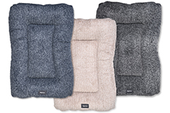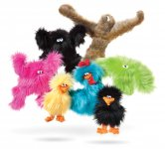
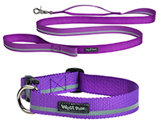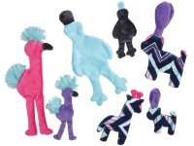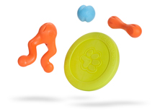
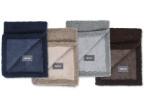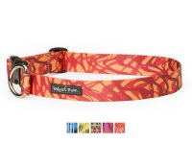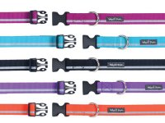

Exhibit 3: Plant diagram and AutoCad plan

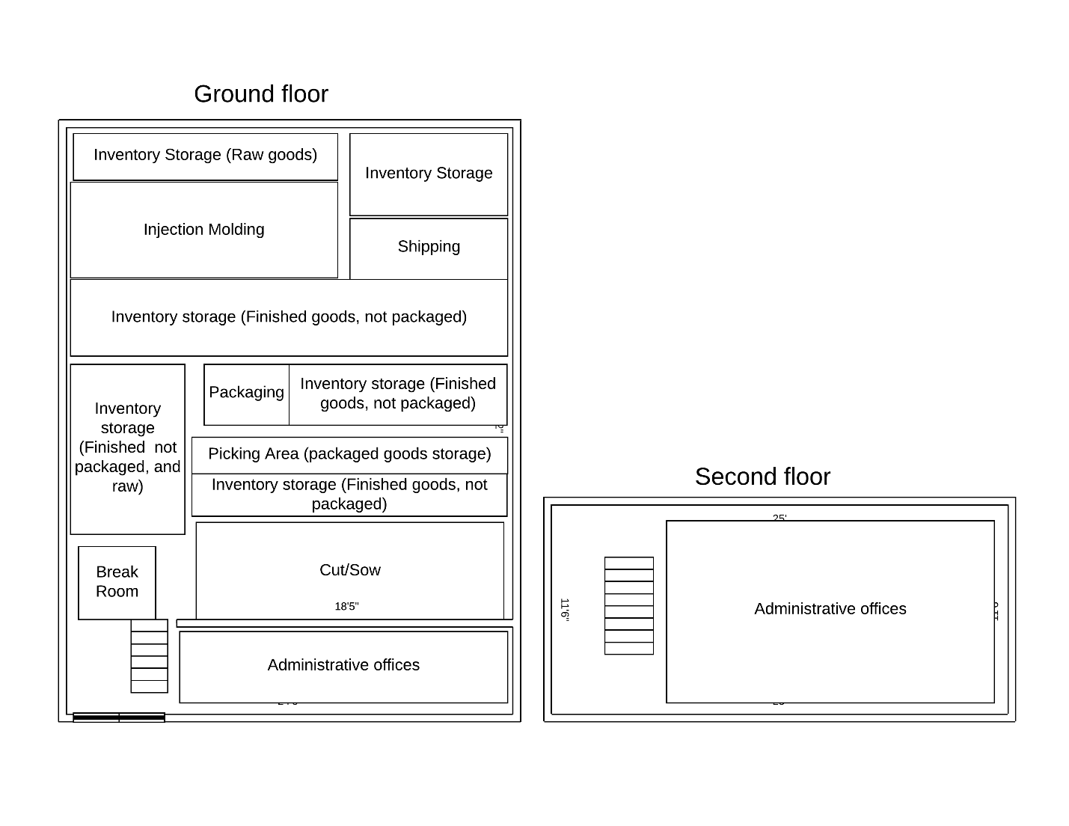

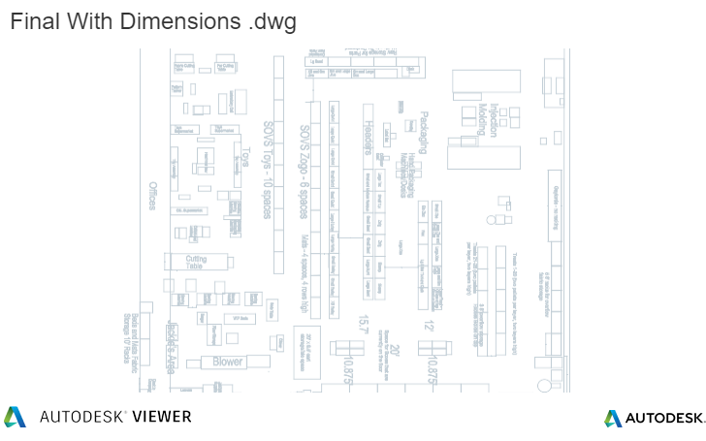

Exhibit 4: Area measurements
Area | Inches Squared | Feet Squared | % of total | Cost $
Total | 3,134,958.28 | 21,770.54 | 100% | $390,000.00
Ground Level | 2,194,470.80 | 15,239.38 | 70% | $273,000.00
Operating | 1,408,854.59 | 9,783.71 | 45% | $122,686.58
Offices front | 219,022.97 | 1,520.99 | 7% | $19,073.07
Cut sew | 720,907.00 | 5,006.30 | 23% | $62,778.38
Packaging | 108,895.62 | 756.22 | 3% | $9,482.90
IM | 360,029.00 | 2,500.20 | 11% | $31,352.22
Raw Material Storage | 161,771.34 | 1,123.41 | 5% | $14,087.45
Raw plush | 27,297.00 | 189.56 | 1% | $2,377.09
Raw IM | 134,474.34 | 933.85 | 4% | $11,710.36
WIP Storage | 173,763.17 | 1,206.69 | 6% | $15,131.73
Contract manufactured, unpackaged goods | 173,763.17 | 1,206.69 | 6% | $15,131.73
Available for Finished goods | 1,390,569.18 | 9,656.73 | 44% | $121,094.24

Exhibit 5: Process Flow Chart
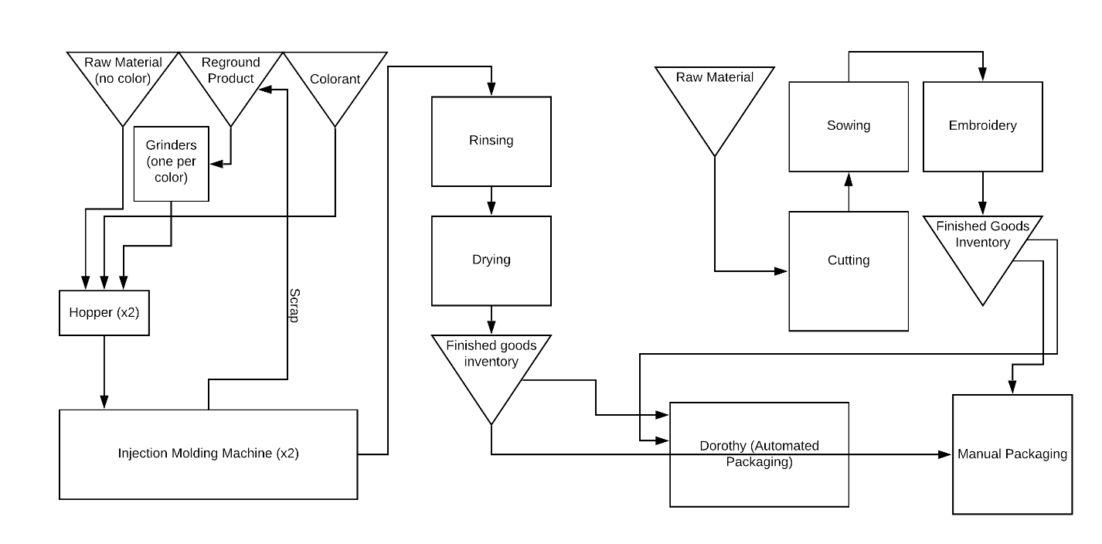

Exhibit 6: Inventory levels and charts
2019:

2020:

Exhibit 7: Lead times by revenue category
Category |  | Lead Time (weeks)
Zogoflex |  | 4.3
Plush Toys |  | 1
Beds |  | 1
Mats |  | 1
Collars & Leashes |  | 1
Packaging |  | 4.3

Exhibit 8: Fill rate by revenue category (before revision)
 | Fill rate | Expected Lost Sales
Zogoflex | 99.91626% | 14.25
Plush Toys | 99.90174% | 2.53
Beds | 99.94380% | 0.06
Mats | 99.84048% | 0.95
Collars & Leashes | 99.82763% | 22.32

Exhibit 9: Inventory summary statistics
2019 | Standard deviation of weekly demand | Average Weekly Demand | Coefficient of Variation | Average Inventory | Inventory turns | Days of inventory
Zogoflex | 2,915.06 | 17,012.83 | 0.17 | 31,348.06 | 28.22 | 12.93
Plush Toys | 517.79 | 2,575.30 | 0.20 | 12,948.05 | 10.34 | 35.29
Beds | 12.84 | 111.69 | 0.11 | 265.01 | 21.92 | 16.65
Mats | 25.15 | 244.71 | 0.10 | 596.42 | 21.34 | 17.11
Collars & Leashes | 2,899.59 | 1,514.46 | 1.91 | 9,829.51 | 8.01 | 45.56
2020
Zogoflex | 5,073.99 | 19,603.36 | 0.26 | 143,440.94 | 7.24 | 50.39
Plush Toys | 807.06 | 2,054.57 | 0.39 | 13,381.37 | 8.14 | 44.85
Beds | 42.71 | 157.46 | 0.27 | 654.27 | 12.76 | 28.62
Mats | 51.25 | 239.18 | 0.21 | 1,261.02 | 10.05 | 36.31
Collars & Leashes | 2,072.61 | 547.60 | 3.78 | 1,836.25 | 15.81 | 23.09

Exhibit 10: Inventory and Sales, 26-week model
2019

2020:

Exhibit 11: Inventory and Sales, 16-week model
2019:

2020:

Exhibit 12: Inventory and Sales, 4-week model
2019

2020

Exhibit 13: Inventory Models Summary
2019
Weekly measures
Original Inventory Management (Whole year)

Average Inventory | 31,348.06 | 12,948.05 | 265.01 | 596.42 | 9,829.51
Inventory Standard Deviation | 7,892.43 | 4,566.87 | 150.38 | 194.67 | 3,613.80
Average Production | 1,998.47 | 167.04 | 243.13 | 128.25 | 596.76
Average Fill Rate | 100% | 100% | 100% | 100% | 100%
Original Inventory Management (Minus first 26 weeks)

Average Inventory | 29,833.69 | 9,624.54 | 376.95 | 663.28 | 12,347.38
Inventory Standard Deviation | 3,440.48 | 2,956.49 | 132.82 | 200.09 | 2,418.81
Average Production | 19,441.64 | 1,656.25 | 174.58 | 232.07 | 143.22
Average Fill Rate | 100% | 100% | 100% | 100% | 100%
Original Inventory Management (Minus first 16 weeks)

Average Inventory | 29,194.75 | 11,139.76 | 328.84 | 645.49 | 11,195.57
Inventory Standard Deviation | 3,559.87 | 3,699.43 | 137.90 | 197.12 | 3,024.21
Average Production | 20,050.88 | 1,830.85 | 167.19 | 242.19 | 238.27
Average Fill Rate | 100% | 100% | 100% | 100% | 100%
Original Inventory Management (Minus first 4 weeks)

Average Inventory | 29,542.65 | 12,881.51 | 277.31 | 620.20 | 10,219.32
Inventory Standard Deviation | 20,743.83 | 1,448.78 | 58.77 | 107.92 | 3,533.59
Average Production | 4,554.68 | 4,562.09 | 149.99 | 179.78 | 3,415.84
Average Fill Rate | 100% | 100% | 100% | 100% | 100%

Alternative Model
26-weeks
Average Inventory | 102,858.49 | 3,263.48 | 251.40 | 551.88 | 11,495.70
Inventory Standard Deviation | 16,432.47 | 772.01 | 17.59 | 252.77 | 8,732.21
Average Production | 11,709.43 | 1,435.34 | 186.69 | 482.88 | 10,702.99
Avg Fill rate (2019-26 weeks) | 99.87409% | 99.89972% | 99.90221% | 99.83437% | 99.85399%
Inventory change (units) | (71,510.43) | 9,684.57 | 13.61 | 44.54 | (1,666.19)
Cash flow change from inventory raw material reduction | $(175,200.55) | $21,887.12 | $94.86 | $300.01 | $ (4,215.47)

Alternative Model
16-weeks
Average Inventory | 84,329.30 | 5,584.87 | 242.20 | 1,420.98 | 24,763.66
Inventory Standard Deviation | 38,534.04 | 1,201.70 | 34.23 | 564.34 | 11,780.01
Average Production | 27,530.74 | 1,875.18 | 161.02 | 703.93 | 8,901.12
Avg Fill rate (2019-26 weeks) | 99.87982% | 99.91373% | 99.93012% | 99.84927% | 99.88812%
Inventory change (units) | (52,981.24) | 7,363.18 | 22.81 | 52.56 | 607.53
Cash flow change from inventory raw material reduction | $(129,804.04) | $16,640.80 | $158.98 | $354.02 | $1,537.04

Alternative Model
4-weeks
Average Inventory | 84,501.28 | 5,320.03 | 235.00 | 1,303.78 | 18,981.70
Inventory Standard Deviation | 40,227.28 | 895.40 | 33.61 | 508.34 | 7,810.75
Average Production | 44,074.09 | 2,421.48 | 150.91 | 900.43 | 8,964.06
Avg Fill rate (2019-26 weeks) | 99.91232% | 99.95353% | 99.96521% | 99.91486% | 99.95253%
Inventory change (units) | (39,674.49) | 7,455.40 | 58.08 | 70.24 | 658.43
Cash flow change from inventory raw material reduction | $ (97,202.49) | $16,849.20 | $404.87 | $473.15 | $1,665.82

2020, first ten weeks (actuals)
Original Inventory Management
Average Inventory | 91,079.48 | 6,323.61 | 184.45 | 622.88 | 1,721.02
Inventory Standard Deviation | 9,583.55 | 739.92 | 79.89 | 119.08 | 159.80
Average Production | 11,276.34 | 3,317.00 | 105.31 | 259.62 | 2,770.70
Average Fill Rate | 100% | 100% | 100% | 100% | 100%

Alternative Model
26-weeks
Average Inventory | 109,495.88 | 6,196.92 | 307.66 | 523.47 | 6,119.92
Inventory Standard Deviation | 1,286.22 | 365.42 | 37.02 | 21.47 | 1,368.73
Average Production | 16,004.69 | 2,304.99 | 111.49 | 201.32 | 490.44
Avg Fill rate (2019-26 weeks) | 99.87553% | 99.87553% | 99.87553% | 99.87553% | 99.87553%
Inventory change (units) | (18,416.40) | 126.69 | (123.21) | 99.41 | (4,398.90)
Cash flow change from inventory raw material reduction | $ (45,120.17) | $ 286.32 | $ (858.87) | $ 669.64 | $ (11,129.21)

Alternative Model
16-weeks
Average Inventory | 106,039.15 | 7,400.00 | 307.41 | 536.57 | 6,781.97
Inventory Standard Deviation | 1,957.92 | 1,615.24 | 35.62 | 23.78 | 1,456.33
Average Production | 16,243.88 | 1,627.75 | 113.10 | 200.14 | 514.18
Avg Fill rate (2019-26 weeks) | 99.87854% | 99.87854% | 99.87854% | 99.87854% | 99.87854%
Inventory change (units) | (14,959.67) | (1,076.39) | (122.95) | 86.31 | (5,060.95)
Cash flow change from inventory raw material reduction | $ (36,651.19) | $ (2,432.65) | $ (857.09) | $ 581.39 | $ (12,804.20)

Alternative Model
4-weeks
Average Inventory | 105,687.57 | 6,705.96 | 211.15 | 496.21 | 7,631.33
Inventory Standard Deviation | 7,176.12 | 2,255.23 | 67.37 | 26.48 | 1,663.35
Average Production | 16,624.95 | 1,559.85 | 99.75 | 190.26 | 586.27
Avg Fill rate (2019-26 weeks) | 99.84776% | 99.84776% | 99.84776% | 99.84776% | 99.84776%
Inventory change (units) | (14,608.09) | (382.35) | (26.70) | 126.66 | (5,910.31)
Cash flow change from inventory raw material reduction | $ (35,789.81) | $ (864.11) | $ (186.14) | $ 853.21 | $ (14,953.08)

2020 last 42 weeks (forecasts)
Original Inventory Management
Average Inventory | 151,210.31 | 14,386.07 | 739.35 | 1,379.88 | 1,846.52
Inventory Standard Deviation | 25,183.73 | 7,381.17 | 230.49 | 514.17 | 209.35
Average Production | 19,782.76 | 1,883.44 | 167.80 | 245.72 | 212.57
Average Fill Rate | 100% | 100% | 100% | 100% | 100%

Alternative Model
26-weeks
Average Inventory | 109,263.27 | 5,636.68 | 402.87 | 535.93 | 3,676.64
Inventory Standard Deviation | 12,379.53 | 577.20 | 48.04 | 45.43 | 1,869.05
Average Production | 12,379.53 | 577.20 | 48.04 | 45.43 | 1,869.05
Avg Fill rate (2019-26 weeks) | 99.85087% | 99.85087% | 99.85087% | 99.85087% | 99.85087%
Inventory change (units) | 41,947.04 | 8,749.39 | 336.47 | 843.94 | (1,830.12)
Cash flow change from inventory raw material reduction | $102,770.24 | $ 19,773.62 | $ 2,345.47 | $ 5,684.77 | $ (4,630.20)

Alternative Model
16-weeks
Average Inventory | 110,575.01 | 5,358.56 | 346.95 | 528.39 | 4,324.58
Inventory Standard Deviation | 17,467.95 | 679.82 | 37.90 | 60.04 | 1,873.41
Average Production | 20,684.75 | 1,984.94 | 176.25 | 227.30 | -
Avg Fill rate (2019-26 weeks) | 99.86338% | 99.86338% | 99.86338% | 99.86338% | 99.86338%
Inventory change (units) | 40,635.30 | 9,027.51 | 392.40 | 851.48 | (2,478.06)
Cash flow change from inventory raw material reduction | $ 99,556.48 | $ 20,402.17 | $ 2,735.33 | $ 5,735.55 | $ (6,269.50)

Alternative Model
4-weeks
Average Inventory | 112,297.15 | 4,863.73 | 206.10 | 505.72 | 5,264.06
Inventory Standard Deviation | 25,848.51 | 1,093.48 | 42.91 | 108.00 | 1,873.41
Average Production | 20,087.81 | 1,927.67 | 173.86 | 226.71 | -
Avg Fill rate (2019-26 weeks) | 99.90282% | 99.90282% | 99.90282% | 99.90282% | 99.90282%
Inventory change (units) | 38,913.16 | 9,522.33 | 533.24 | 874.16 | (3,417.54)
Cash flow change from inventory raw material reduction | $ 95,337.24 | $ 21,520.47 | $ 3,717.13 | $ 5,888.30 | $ (8,646.39)

Exhibit 14: Inventory Model Comparison Statistics
2019, weekly
Average Inventory
Revenue Category | Zogoflex | Plush Toys | Beds | Mats | Collars & Leashes
Current Model, last 26 weeks | 29,833.69 | 9,624.54 | 376.95 | 663.28 | 12,347.38
Current Model, last 16 weeks | 29,194.75 | 11,139.76 | 328.84 | 645.49 | 11,195.57
Current Model, last 4 weeks | 29,542.65 | 12,881.51 | 277.31 | 620.20 | 10,219.32
26-week revision | 102,858.49 | 3,263.48 | 251.40 | 551.88 | 11,495.70
16-week revision | 102,366.97 | 5,584.87 | 242.20 | 543.86 | 9,221.98
4-week revision | 99,549.73 | 5,492.65 | 206.93 | 526.17 | 9,171.08

Inventory Standard Deviation
Revenue Category | Zogoflex | Plush Toys | Beds | Mats | Collars & Leashes
Current Model, last 26 weeks | 3,440.48 | 2,956.49 | 132.82 | 200.09 | 2,418.81
Current Model, last 16 weeks | 3,559.87 | 3,699.43 | 137.90 | 197.12 | 3,024.21
Current Model, last 4 weeks | 4,554.68 | 4,562.09 | 149.99 | 179.78 | 3,415.84
26-week revision | 16,432.47 | 772.01 | 17.59 | 35.98 | 3,332.01
16-week revision | 18,799.88 | 1,201.70 | 34.23 | 110.70 | 2,597.00
4-week revision | 20,743.83 | 1,448.78 | 58.77 | 107.92 | 3,533.59

Average Target Inventory
Revenue Category | Zogoflex | Plush Toys | Beds | Mats | Collars & Leashes
26-week revision | 106,157.35 | 3,398.78 | 254.40 | 547.48 | 11,090.23
16-week revision | 105,247.18 | 5,763.98 | 251.42 | 540.69 | 10,763.49
4-week revision | 100,618.66 | 5,612.05 | 237.21 | 515.43 | 11,311.28

2020, weekly
Average Inventory
Revenue Category | Zogoflex | Plush Toys | Beds | Mats | Collars & Leashes
Current Model | 141,997.38 | 13,140.40 | 652.48 | 1,263.04 | 1,831.86
26-week revision | 109,292.70 | 5,716.54 | 388.57 | 533.61 | 4,039.81
16-week revision | 109,953.09 | 5,685.03 | 340.91 | 529.27 | 4,690.10
4-week revision | 111,175.16 | 5,152.09 | 207.26 | 504.66 | 5,614.28

Inventory Standard Deviation
Revenue Category | Zogoflex | Plush Toys | Beds | Mats | Collars & Leashes
Current Model | 32,191.07 | 7,418.23 | 297.67 | 551.12 | 202.80
26-week revision | 11,398.82 | 581.09 | 57.77 | 42.85 | 1,999.59
16-week revision | 16,147.89 | 1,176.04 | 40.24 | 55.98 | 2,015.00
4-week revision | 24,073.94 | 1,504.83 | 47.48 | 99.88 | 2,023.73

Average Target Inventory
Revenue Category | Zogoflex | Plush Toys | Beds | Mats | Collars & Leashes
26-week revision | 109,255.48 | 5,725.73 | 388.28 | 534.79 | 2,614.29
16-week revision | 110,037.20 | 5,533.76 | 339.84 | 530.16 | 1,929.80
4-week revision | 110,964.22 | 4,881.17 | 202.09 | 505.00 | 767.16
2020, whole year
2020, weekly
Average Inventory
Revenue Category | Zogoflex | Plush Toys | Beds | Mats | Collars & Leashes
Current Model | 141,997.38 | 13,140.40 | 652.48 | 1,263.04 | 1,831.86
26-week revision | 109,292.70 | 5,716.54 | 388.57 | 533.61 | 4,039.81
16-week revision | 109,953.09 | 5,685.03 | 340.91 | 529.27 | 4,690.10
4-week revision | 111,175.16 | 5,152.09 | 207.26 | 504.66 | 5,614.28

Inventory Standard Deviation
Revenue Category | Zogoflex | Plush Toys | Beds | Mats | Collars & Leashes
Current Model | 32,191.07 | 7,418.23 | 297.67 | 551.12 | 202.80
26-week revision | 11,398.82 | 581.09 | 57.77 | 42.85 | 1,999.59
16-week revision | 16,147.89 | 1,176.04 | 40.24 | 55.98 | 2,015.00
4-week revision | 24,073.94 | 1,504.83 | 47.48 | 99.88 | 2,023.73

Average Target Inventory
Revenue Category | Zogoflex | Plush Toys | Beds | Mats | Collars & Leashes
26-week revision | 109,255.48 | 5,725.73 | 388.28 | 534.79 | 2,614.29
16-week revision | 110,037.20 | 5,533.76 | 339.84 | 530.16 | 1,929.80
4-week revision | 110,964.22 | 4,881.17 | 202.09 | 505.00 | 767.16

Exhibit 15: Average weekly production by inventory model, revenue category

Exhibit 16: Production Volume (Q) per week
Original models:
2019

2020

26-weeks
2019

2020

16-weeks
2019

2020

4-weeks
2019

2020

From: https://www.westpaw.com/our-story/community/west-paw-story
From: https://www.westpaw.com/sites/default/files/WestPaw_BenefitReport2018.pdf
From: https://www.westpaw.com/our-story/our-community/who-we-are
From: https://www.westpaw.com/our-story/our-vision/what-it-means-be-force-good
From: https://www.westpaw.com/masks
From: https://www.westpaw.com/dog-toys/play, https://www.westpaw.com/beds/relax, https://www.westpaw.com/collars-leashes
From B Corporation’s website: https://bcorporation.net/about-b-corps
From: https://www.westpaw.com/dog-toys
From: https://www.westpaw.com/beds/relax
From: https://www.westpaw.com/collars-leashes
From: https://www.westpaw.com/
Provided by Zakkary Cates, Plastic Products Technical Engineer at West Paw
Provided by Scott Ogeka, Chief Operating Officer at West Paw
Provided by Scott Ogeka, Chief Operating Officer at West Paw

