Exercício Redes

a)

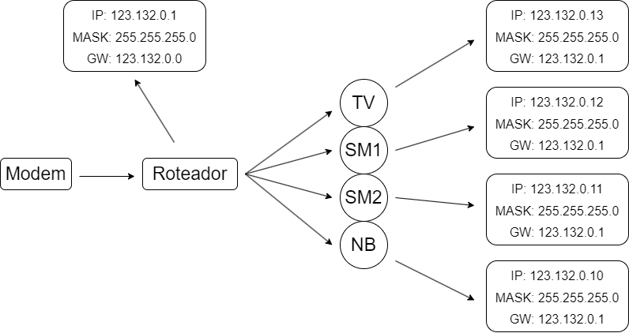

b)

|  |  |  |  |
| --- | --- | --- | --- |
| EQUIP | IP | Máscara | GW |
| ROT1 | 123.231.0.1 | 255.255.255.0 |  |
| PC | 123.231.0.10 | 255.255.255.0 | 123.231.0.1 |
| TV | 123.231.0.11 | 255.255.255.0 | 123.231.0.1 |
| SM | 123.231.0.12 | 255.255.255.0 | 123.231.0.1 |
|  |  |  |  |
| ROT2 | 123.231.0.5 | 255.255.255.0 |  |
| SM1 | 123.231.0.50 | 255.255.255.0 | 123.231.0.5 |
| SM2 | 123.231.0.51 | 255.255.255.0 | 123.231.0.5 |
| NB1 | 123.231.0.52 | 255.255.255.0 | 123.231.0.5 |
| NB2 | 123.231.0.53 | 255.255.255.0 | 123.231.0.5 |

c)

|  |  |  |  |
| --- | --- | --- | --- |
| EQUIP | IP | Máscara | GW |
| Modem | 196.120.10.1 | 255.255.255.0 |  |
| ROT1 | 196.120.10.4 | 255.255.255.0 | 196.120.10.1 |
| 196.235.10.1 |  |
| SM1 | 196.235.10.4 | 255.255.255.0 | 196.235.10.1 |
| SM2 | 196.235.10.8 | 255.255.255.0 | 196.235.10.1 |
| SM3 | 196.235.10.6 | 255.255.255.0 | 196.235.10.1 |
| CAMIP1 | 196.235.10.2 | 255.255.255.0 | 196.235.10.1 |
| CAMIP2 | 196.235.10.7 | 255.255.255.0 | 196.235.10.1 |
| NB | 196.235.10.5 | 255.255.255.0 | 196.235.10.1 |
| TV | 196.235.10.3 | 255.255.255.0 | 196.235.10.1 |
|  |  |  |  |
| ROT2 | 196.120.10.3 | 255.255.255.0 | 196.120.10.1 |
| 196.234.10.1 |  |
| SM1 | 196.234.10.4 | 255.255.255.0 | 196.234.10.1 |
| SM2 | 196.234.10.8 | 255.255.255.0 | 196.234.10.1 |
| SM3 | 196.234.10.6 | 255.255.255.0 | 196.234.10.1 |
| NB | 196.234.10.5 | 255.255.255.0 | 196.234.10.1 |
| TV | 196.234.10.3 | 255.255.255.0 | 196.234.10.1 |
|  |  |  |  |
| ROT3 | 196.120.10.5 | 255.255.255.0 | 196.120.10.1 |
| 196.233.10.1 |  |
| SM1 | 196.233.10.3 | 255.255.255.0 | 196.233.10.1 |
| SM2 | 196.233.10.4 | 255.255.255.0 | 196.233.10.1 |
| SM3 | 196.233.10.5 | 255.255.255.0 | 196.233.10.1 |
| NB | 196.233.10.6 | 255.255.255.0 | 196.233.10.1 |
| TV | 196.233.10.2 | 255.255.255.0 | 196.233.10.1 |
|  |  |  |  |
| ROT4 | 196.120.10.6 | 255.255.255.0 | 196.120.10.1 |
| 196.232.10.1 |  |
| SM1 | 196.232.10.2 | 255.255.255.0 | 196.232.10.1 |
| SM2 | 196.232.10.4 | 255.255.255.0 | 196.232.10.1 |
| SM3 | 196.232.10.5 | 255.255.255.0 | 196.232.10.1 |
| NB | 196.232.10.6 | 255.255.255.0 | 196.232.10.1 |
| TV | 196.232.10.3 | 255.255.255.0 | 196.232.10.1 |
|  |  |  |  |
| ROT5 | 196.120.10.7 | 255.255.255.0 | 196.120.10.1 |
| 196.228.10.1 |  |
| SM1 | 196.228.10.2 | 255.255.255.0 | 196.228.10.1 |
| SM2 | 196.228.10.5 | 255.255.255.0 | 196.228.10.1 |
| SM3 | 196.228.10.3 | 255.255.255.0 | 196.228.10.1 |
| NB | 196.228.10.4 | 255.255.255.0 | 196.228.10.1 |
| TV | 196.228.10.6 | 255.255.255.0 | 196.228.10.1 |
|  |  |  |  |
| ROT6 | 196.120.10.2 | 255.255.255.0 | 196.120.10.1 |
| 196.231.10.1 |  |
| SM1 | 196.231.10.2 | 255.255.255.0 | 196.231.10.1 |
| SM2 | 196.231.10.4 | 255.255.255.0 | 196.231.10.1 |
| SM3 | 196.231.10.5 | 255.255.255.0 | 196.231.10.1 |
| NB | 196.231.10.3 | 255.255.255.0 | 196.231.10.1 |
| TV | 196.231.10.6 | 255.255.255.0 | 196.231.10.1 |
|  |  |  |  |
| ROT7 | 196.120.10.8 | 255.255.255.0 | 196.120.10.1 |
| 196.229.10.1 |  |
| SM1 | 196.229.10.4 | 255.255.255.0 | 196.229.10.1 |
| SM2 | 196.229.10.5 | 255.255.255.0 | 196.229.10.1 |
| SM3 | 196.229.10.2 | 255.255.255.0 | 196.229.10.1 |
| NB | 196.229.10.3 | 255.255.255.0 | 196.229.10.1 |
| TV | 196.229.10.6 | 255.255.255.0 | 196.229.10.1 |
|  |  |  |  |
| ROT8 | 196.120.10.9 | 255.255.255.0 | 196.120.10.1 |
| 196.230.10.1 |  |  |
| SM1 | 196.230.10.4 | 255.255.255.0 | 196.230.10.1 |
| SM2 | 196.230.10.6 | 255.255.255.0 | 196.230.10.1 |
| SM3 | 196.230.10.2 | 255.255.255.0 | 196.230.10.1 |
| NB | 196.230.10.3 | 255.255.255.0 | 196.230.10.1 |
| TV | 196.230.10.5 | 255.255.255.0 | 196.230.10.1 |

d)

Tabela

|  |  |  |  |
| --- | --- | --- | --- |
| EQUIP | IP | Máscara | GW |
| Modem | 196.120.10.1 | 255.255.255.0 |  |
| RT2 | 196.120.10.2 | 255.255.255.0 | 196.120.10.1 |
| 192.168.1.5 |  |
| PC1 | 192.168.1.50 | 255.255.255.0 | 192.168.1.5 |
| PC2 | 192.168.1.51 | 255.255.255.0 | 192.168.1.5 |
| PC3 | 192.168.1.52 | 255.255.255.0 | 192.168.1.5 |
| PC4 | 192.168.1.53 | 255.255.255.0 | 192.168.1.5 |
| PC5 | 192.168.1.54 | 255.255.255.0 | 192.168.1.5 |
| PC6 | 192.168.1.55 | 255.255.255.0 | 192.168.1.5 |
| PC7 | 192.168.1.56 | 255.255.255.0 | 192.168.1.5 |
| PC8 | 192.168.1.57 | 255.255.255.0 | 192.168.1.5 |
| PC9 | 192.168.1.58 | 255.255.255.0 | 192.168.1.5 |
| PC10 | 192.168.1.59 | 255.255.255.0 | 192.168.1.5 |
| PC11 | 192.168.1.60 | 255.255.255.0 | 192.168.1.5 |
| PC12 | 192.168.1.61 | 255.255.255.0 | 192.168.1.5 |
| IMP | 192.168.1.62 | 255.255.255.0 | 192.168.1.5 |
|  |  |  |  |
| RT1 | 196.120.10.3 | 255.255.255.0 | 196.120.10.1 |
| 192.168.0.1 |  |
| PC1 | 192.168.0.10 | 255.255.255.0 | 192.168.0.1 |
| PC2 | 192.168.0.11 | 255.255.255.0 | 192.168.0.1 |
| PC3 | 192.168.0.12 | 255.255.255.0 | 192.168.0.1 |
| PC4 | 192.168.0.13 | 255.255.255.0 | 192.168.0.1 |
| PC5 | 192.168.0.14 | 255.255.255.0 | 192.168.0.1 |
| PC6 | 192.168.0.15 | 255.255.255.0 | 192.168.0.1 |
| PC7 | 192.168.0.16 | 255.255.255.0 | 192.168.0.1 |
| PC8 | 192.168.0.17 | 255.255.255.0 | 192.168.0.1 |

Diagrama:

