**Documentação de Redes**

Mapa Lógico

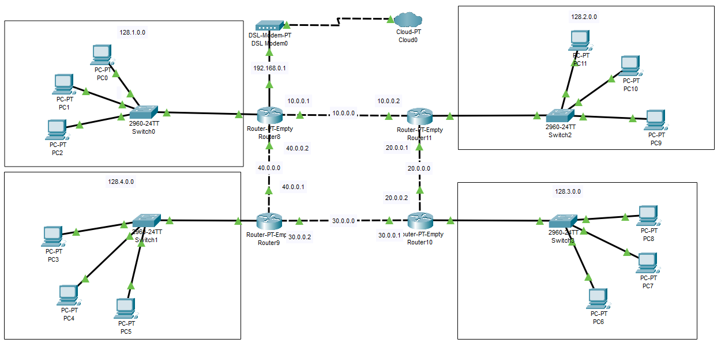

Tabela de Equipamentos

|  |  |  |  |  |  |
| --- | --- | --- | --- | --- | --- |
| Nº | Nome do Equipamento | IP | Máscara | Gateway | 1º Salto |
| 1 | Modem | IP MODEM |  |  |  |
| 2 | Roteador 8 | IP MODEM 128.1.0.1 | 255.255.0.0 |  |  |
| 3 | PC 0 | 128.1.0.10 | 255.255.0.0 | 128.1.0.1 | Switch0 |
| 4 | PC 1 | 128.1.0.11 | 255.255.0.0 | 128.1.0.1 | Switch0 |
| 5 | PC 2 | 128.1.0.12 | 255.255.0.0 | 128.1.0.1 | Switch0 |
|  | | | | | |
| 6 | Roteador 9 | IP MODEM 128.2.0.1 | 255.255.0.0 |  |  |
| 7 | PC 3 | 128.2.0.10 | 255.255.0.0 | 128.2.0.1 | Switch1 |
| 8 | PC 4 | 128.2.0.11 | 255.255.0.0 | 128.2.0.1 | Switch1 |
| 9 | PC 5 | 128.2.0.12 | 255.255.0.0 | 128.2.0.1 | Switch1 |
|  | | | | | |
| 10 | Roteador 10 | IP MODEM 128.3.0.1 | 255.255.0.0 |  |  |
| 11 | PC 6 | 128.3.0.10 | 255.255.0.0 | 128.3.0.1 | Switch2 |
| 12 | PC 7 | 128.3.0.11 | 255.255.0.0 | 128.3.0.1 | Switch2 |
| 13 | PC 8 | 128.3.0.12 | 255.255.0.0 | 128.3.0.1 | Switch2 |
|  | | | | | |
| 14 | Roteador 11 | IP MODEM 128.4.0.1 | 255.255.0.0 |  |  |
| 15 | PC 9 | 128.4.0.10 | 255.255.0.0 | 128.4.0.1 | Switch3 |
| 16 | PC 10 | 128.4.0.11 | 255.255.0.0 | 128.4.0.1 | Switch3 |
| 17 | PC 11 | 128.4.0.12 | 255.255.0.0 | 128.4.0.1 | Switch3 |

Lista de Roteadores e Redes

|  |  |  |  |  |  |
| --- | --- | --- | --- | --- | --- |
| Nº | Nome do Equipamento | Porta | IP | Máscara | Redes Conectadas |
| 1 | Roteador 8 | Gig6/0 | 128.1.0.1 | 255.255.255.0 | 128.1.0.0 |
|  | | Gig7/0 | 10.0.0.1 | 255.0.0.0 | 10.0.0.0 |
|  | | Gig8/0 | 40.0.0.2 | 255.0.0.0 | 40.0.0.0 |
| 2 | Roteador 9 | Gig7/0 | 128.4.0.1 | 255.255.255.0 | 128.4.0.0 |
|  | | Gig8/0 | 30.0.0.2 | 255.0.0.0 | 30.0.0.0 |
|  | | Gig9/0 | 40.0.0.1 | 255.0.0.0 | 40.0.0.0 |
| 3 | Roteador 10 | Gig7/0 | 128.3.0.1 | 255.255.255.0 | 128.3.0.0 |
|  | | Gig8/0 | 20.0.0.2 | 255.0.0.0 | 20.0.0.0 |
|  | | Gig9/0 | 30.0.0.1 | 255.0.0.0 | 30.0.0.0 |
| 4 | Roteador 11 | Gig7/0 | 128.2.0.1 | 255.255.255.0 | 128.2.0.0 |
|  | | Gig8/0 | 10.0.0.2 | 255.0.0.0 | 10.0.0.0 |
|  | | Gig9/0 | 20.0.0.1 | 255.0.0.0 | 20.0.0.0 |

Lista de Roteamento Estático

|  |  |  |  |  |
| --- | --- | --- | --- | --- |
| Nº | Nome do Equipamento | Rede | Máscara | Próximo Salto |
| 1 | Roteador 8 | | | |
|  | | 128.2.0.0 | 255.255.0.0 | 10.0.0.2 |
|  | | 128.4.0.0 | 255.255.0.0 | 40.0.0.1 |
|  | | 128.3.0.0 | 255.255.0.0 | 10.0.0.2 |
|  | | 128.3.0.0 | 255.255.0.0 | 20.0.0.2 |
|  | | 128.3.0.0 | 255.255.0.0 | 40.0.0.1 |
|  | | 128.3.0.0 | 255.255.0.0 | 30.0.0.1 |
| 2 | Roteador 9 | | | |
|  | | 128.1.0.0 | 255.255.0.0 | 40.0.0.2 |
|  | | 128.3.0.0 | 255.255.0.0 | 30.0.0.1 |
|  | | 128.2.0.0 | 255.255.0.0 | 30.0.0.1 |
|  | | 128.2.0.0 | 255.255.0.0 | 20.0.0.1 |
|  | | 128.2.0.0 | 255.255.0.0 | 40.0.0.2 |
|  | | 128.2.0.0 | 255.255.0.0 | 10.0.0.2 |
| 3 | Roteador 10 | | | |
|  | | 128.2.0.0 | 255.255.0.0 | 20.0.0.1 |
|  | | 128.4.0.0 | 255.255.0.0 | 30.0.0.2 |
|  | | 128.1.0.0 | 255.255.0.0 | 30.0.0.2 |
|  | | 128.1.0.0 | 255.255.0.0 | 40.0.0.2 |
|  | | 128.1.0.0 | 255.255.0.0 | 20.0.0.1 |
|  | | 128.1.0.0 | 255.255.0.0 | 10.0.0.1 |
| 4 | Roteador 11 | | | |
|  | | 128.1.0.0 | 255.255.0.0 | 10.0.0.1 |
|  | | 128.3.0.0 | 255.255.0.0 | 20.0.0.2 |
|  | | 128.4.0.0 | 255.255.0.0 | 10.0.0.1 |
|  | | 128.4.0.0 | 255.255.0.0 | 40.0.0.1 |
|  | | 128.4.0.0 | 255.255.0.0 | 20.0.0.2 |
|  | | 128.4.0.0 | 255.255.0.0 | 40.0.0.2 |