a)

|  |  |  |  |  |  |
| --- | --- | --- | --- | --- | --- |
| Nº | Nome do Equipamento | IP | Máscara | Gateway | Nome da Rede |
| 0 | Roteador | 192.168.0.1 | 255.255.255.0 |  | 125.90.10.0 |
| 1 | TV | 192.168.0.10 | 255.255.255.0 | 192.168.0.1 | 125.90.10.0 |
| 2 | SM1 | 192.168.0.11 | 255.255.255.0 | 192.168.0.1 | 125.90.10.0 |
| 3 | SM2 | 192.168.0.12 | 255.255.255.0 | 192.168.0.1 | 125.90.10.0 |
| 4 | NB | 192.168.0.13 | 255.255.255.0 | 192.168.0.1 | 125.90.10.0 |

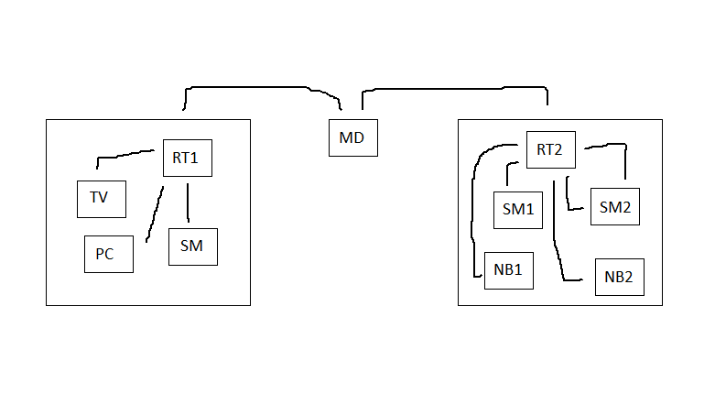b)

IP: 192.168.0.1

MASK: 255.255.255.0

GW:

IP: 192.168.1.5

MASK: 255.255.255.0

GW: 192.168.0.1

IP: 192.168.1.52

MASK: 255.255.255.0

GW: 192.168.1.5

IP: 192.168.1.50

MASK: 255.255.255.0

GW: 192.168.1.5

IP: 192.168.1.51

MASK: 255.255.255.0

GW: 192.168.1.5

IP: 192.168.1.53

MASK: 255.255.255.0

GW: 192.168.1.5

IP: 192.168.0.13

MASK: 255.255.255.0

GW: 192.168.0.1

IP: 192.168.0.12

MASK: 255.255.255.0

GW: 192.168.0.1

IP: 192.168.0.11

MASK: 255.255.255.0

GW: 192.168.0.1

IP: 192.168.0.10

MASK: 255.255.255.0

GW: 192.168.0.1

c)

IP: 191.10.10.4

MASK: 255.255.255.0

GW: 191.10.10.1

IP: 191.10.10.3

MASK: 255.255.255.0

GW: 191.10.10.1

IP: 191.10.10.2

MASK: 255.255.255.0

GW: 191.10.10.1

IP: 191.10.10.5

MASK: 255.255.255.0

GW: 191.10.10.1

RT2

RT1

RT3

RT4

Modem

Switch

RT5

IP: 191.10.10.1

MASK: 255.255.255.0

GW:

RT6

v

IP: 191.10.10.6

MASK: 255.255.255.0

GW: 191.10.10.1

RT8

RT7

IP: 191.10.10.7

MASK: 255.255.255.0

GW: 191.10.10.1

IP: 191.10.10.8

MASK: 255.255.255.0

GW: 191.10.10.1

IP: 191.10.10.9

MASK: 255.255.255.0

GW: 191.10.10.1

Apto 1

IP: 192.168.0.1

MASK: 255.255.255.0

GW:

IP: 192.168.0.14

MASK: 255.255.255.0

GW: 192.168.0.1

IP: 192.168.0.10

MASK: 255.255.255.0

GW: 192.168.0.1

TV

RT1

NB

SM2

SM1

IP: 192.168.0.11

MASK: 255.255.255.0

GW: 192.168.0.1

SM3

IP: 192.168.0.13

MASK: 255.255.255.0

GW: 192.168.0.1

IP: 192.168.0.12

MASK: 255.255.255.0

GW: 192.168.0.1

Apto 2

IP: 192.168.1.1

MASK: 255.255.255.0

GW: 192.168.0.1

IP: 192.168.1.10

MASK: 255.255.255.0

GW: 192.168.1.1

IP: 192.168.1.11

MASK: 255.255.255.0

GW: 192.168.1.1

RT2

TV

SM2

NB

SM1

IP: 192.168.1.12

MASK: 255.255.255.0

GW: 192.168.1.1

SM3

IP: 192.168.1.14

MASK: 255.255.255.0

GW: 192.168.1.1

IP: 192.168.1.13

MASK: 255.255.255.0

GW: 192.168.1.1

Apto 3

IP: 192.168.2.1

MASK: 255.255.255.0

GW: 192.168.0.1

IP: 192.168.2.10

MASK: 255.255.255.0

GW: 192.168.2.1

IP: 192.168.2.11

MASK: 255.255.255.0

GW: 192.168.2.1

TV

RT3

NB

SM2

SM1

IP: 192.168.2.12

MASK: 255.255.255.0

GW: 192.168.2.1

SM3

IP: 192.168.2.14

MASK: 255.255.255.0

GW: 192.168.2.1

IP: 192.168.2.13

MASK: 255.255.255.0

GW: 192.168.2.1

Apto 4

Apto 4

IP: 192.168.3.1

MASK: 255.255.255.0

GW: 192.168.0.1

IP: 192.168.3.10

MASK: 255.255.255.0

GW: 192.168.3.1

IP: 192.168.3.11

MASK: 255.255.255.0

GW: 192.168.3.1

TV

RT4

SM2

NB

SM1

IP: 192.168.3.12

MASK: 255.255.255.0

GW: 192.168.3.1

SM3

IP: 192.168.3.14

MASK: 255.255.255.0

GW: 192.168.3.1

IP: 192.168.3.13

MASK: 255.255.255.0

GW: 192.168.3.1

Apto 5

IP: 192.168.4.1

MASK: 255.255.255.0

GW: 192.168.0.1

IP: 192.168.4.10

MASK: 255.255.255.0

GW: 192.168.4.1

IP: 192.168.4.11

MASK: 255.255.255.0

GW: 192.168.4.1

TV

RT5

NB

SM2

SM1

IP: 192.168.4.12

MASK: 255.255.255.0

GW: 192.168.4.1

SM3

IP: 192.168.4.14

MASK: 255.255.255.0

GW: 192.168.4.1

IP: 192.168.4.13

MASK: 255.255.255.0

GW: 192.168.4.1

Apto 6

Apto 6

IP: 192.168.5.1

MASK: 255.255.255.0

GW: 192.168.0.1

IP: 192.168.5.10

MASK: 255.255.255.0

GW: 192.168.5.1

IP: 192.168.5.11

MASK: 255.255.255.0

GW: 192.168.5.1

TV

RT6

SM2

NB

SM1

IP: 192.168.5.12

MASK: 255.255.255.0

GW: 192.168.5.1

SM3

IP: 192.168.5.14

MASK: 255.255.255.0

GW: 192.168.5.1

IP: 192.168.5.13

MASK: 255.255.255.0

GW: 192.168.5.1

Apto 7

IP: 192.168.6.1

MASK: 255.255.255.0

GW: 192.168.0.1

IP: 192.168.6.10

MASK: 255.255.255.0

GW: 192.168.6.1

IP: 192.168.6.11

MASK: 255.255.255.0

GW: 192.168.6.1

TV

RT7

SM2

SM1

IP: 192.168.6.12

MASK: 255.255.255.0

GW: 192.168.6.1

NB

SM3

IP: 192.168.6.14

MASK: 255.255.255.0

GW: 192.168.6.1

IP: 192.168.6.13

MASK: 255.255.255.0

GW: 192.168.6.1

Apto 8

Apto 8

IP: 192.168.7.1

MASK: 255.255.255.0

GW: 192.168.0.1

IP: 192.168.7.10

MASK: 255.255.255.0

GW: 192.168.7.1

IP: 192.168.7.11

MASK: 255.255.255.0

GW: 192.168.7.1

RT8

CAM1

IP: 192.168.7.12

MASK: 255.255.255.0

GW: 192.168.7.1

TV

SM3

SM2

CAM2

SM1

NB



IP: 192.168.7.13

MASK: 255.255.255.0

GW: 192.168.7.1

IP: 192.168.7.14

MASK: 255.255.255.0

GW: 192.168.7.1

IP: 192.168.7.16

MASK: 255.255.255.0

GW: 192.168.7.1

IP: 192.168.7.15

MASK: 255.255.255.0

GW: 192.168.7.1