 | THE UNIVERSITY OF BRITISH COLUMBIA | Department of Computer Science  2366 Main Mall  Vancouver, BC Canada V6T 1Z4  Phone: (604) 822-3061  Fax: (604) 822-4231

PARTICIPANT & PARENT INFORMATION AND CONSENT FORM

Tamer: Touch-guided Anxiety Management via Engagement with a Robot Pet
Principal Investigator: Professor Karon MacLean, Ph.D
Department of Computer Science
University of British Columbia
(604)-822-8169
Co-investigators: Clinical Professor E. Jane Garland, MD
Department of Psychiatry
University of British Columbia
(604)-875-2737
Student Investigators: Xi Laura Cang, Graduate student
Department of Computer Science
University of British Columbia
(604) 827-3982 cang@cs.ubc.ca

Oliver Schnieder, Graduate student
Department of Computer Science
University of British Columbia
(604) 827-3982 cang@cs.ubc.ca

Paul Bucci, Undergraduate student
Department of Computer Science
University of British Columbia
(604) 827-3982 pbucci@cs.ubc.ca

Sean Liu, Undergraduate Research Assistant
Department of Computer Science
University of British Columbia
(604) 827-3982 sean.liu@mail.utoronto.ca

Sponsor: National Science and Engineering Research Council of Canada (NSERC)

INTRODUCTION
You (or your child) are being invited to take part in this research study because we feel that your participation and feedback will greatly assist us in developing anxiety-reducing robotic devices.

YOUR PARTICIPATION IS VOLUNTARY
Your participation is entirely voluntary, so it is up to you to decide whether or not to take part in this study. Your participating or not participating in this study will neither affect your access to other health care or to your child’s treatment in the clinic, nor impact your access to education services or your child’s training at school. Before you decide, it is important for you to understand what the research involves. This consent form will tell you about the study, why the research is being done, what will happen to you (or your child) during the study and the possible benefits, risks, and discomforts.

If you wish to participate or if you allow your child to participate, you will be asked to sign this form. If you do decide or allow your child to take part in this study, you are still free to withdraw at any time and without giving any reasons for your decision.

If you do not wish to participate, you do not have to provide any reason for your decision not to participate. Please take time to read the following information carefully.

WHO IS CONDUCTING THE STUDY?
The study is being conducted/funded by the National Science and Engineering Research Council of Canada (NSERC). The Principal Investigator has received funds from this agency to compensate subjects for participating in this study. You are entitled to request any details concerning this compensation from the Principal Investigator.

BACKGROUND
This project’s goal is to advance a novel tool and technique to help young children attain independent anxiety regulation skills. Engagement will be utilized to give children access to cognitive training by interacting with an expressive animatronic pet. Our research objective is to program this robot to respond physically to a combination of a child’s pattern of touch and biometrically sensed emotional state in a way that rewards patience and progress.

WHAT IS THE PURPOSE OF THE STUDY?
The purpose of this study is to examine the role of haptic (touch sense) feedback on anxiety levels. This study investigates your (or your child’s) reaction to a small robotic creature that can breath, purr and stiffen its ears, and under some conditions is touch-sensitive.

WHO CAN PARTICIPATE IN THE STUDY?
This study is open to children from ages 7-17, as well as adult subjects between the ages of 17-50. At most 100 participants will take part in this study, most of whom are children who have some kind of anxiety disorder, either mild (30%) or moderate (30%). The rest of the participants are from normal child or adult population. The former (normal child group) constitute the control group and the latter (normal adult group) will participate in pilot experiments.

WHAT DOES THE STUDY INVOLVE?
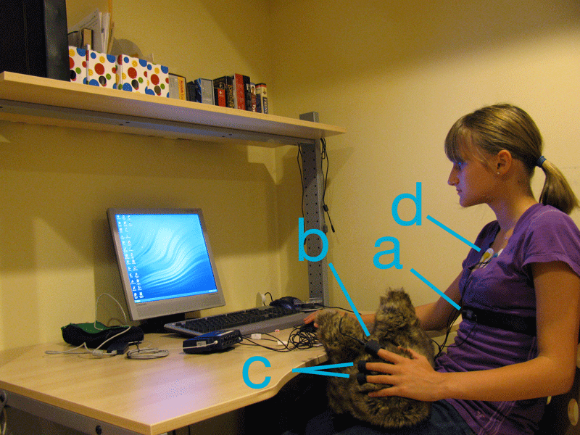
Image 1: User demonstrating possible physiological sensors: respiration rate (a), blood volume pulse (b), skin conductance (c), ECG (d).
You and/or your child may be asked to carry out a standardized anxiety test at the beginning of the study and at specific stages throughout the study. It helps to determine the level and type of your (or your child’s) anxiety. You (or your child) may be asked to wear external (i.e., non-invasive) sensors that collect some basic physiological information such as heart rate, respiration rate, some muscle activity, and perspiration. We request that you (your child) tell the experimenter if you (or s/he) find the sensor positioning uncomfortable, and adjustments will be made.

During a session, you (your child) will be invited to carry out a primary task (e.g. a computer-based cognitive task) which you (your child) may find mildly challenging; we will collect performance, to relate it to changes in anxiety state. We will invite you (your child) to answer questions in the form of questionnaires, rating scales or interviews. The study will be observed by the experimenters and will be video-recorded. These recordings may be saved and reviewed by the experimenters for later analysis, and possibly used in research presentations. Any images so used (still and video) will have identifying regions (e.g. face) obscured. The experiment may happen in multiple sessions. The time commitment required for a single session will range from one (more common) to four hours. The time required for all the sessions combined will not exceed 18-20 hours.

If your (your child’s) participation is during school hours, it will not interfere with your (your child’s) learning objectives. To minimize disruption, participation will occur in a convenient location (e.g. school staff offices if available).

Image 1 shows a photo of a child attached to the physiological sensors that will be used during these experiments. There are four primary sensors that will be used during these experiments:
- Respiration Rate: A Velcro band is worn around the abdomen outside of the clothing. Expands and contracts with the abdomen to measure respiration rate, waveform, and amplitude.
- Blood Volume Pulse: also known as a photoplethysmograph (PPG) sensor. A small black box attaches to the distal end of a finger with a Velcro strap or removable medical tape. Measures heart rate.
- Skin Conductance: Two electrodes attach to Velcro straps, each in turn is attached to the distal end of two fingers on the same hand. Measures galvanic skin response (GSR), the electrical resistance of the skin.
- ECG: Three electrodes attach to the upper right and left sides of the chest and the lower abdomen or alternatively on left and right forearms. Measures heart electrical activity.

IF YOU DECIDE TO JOIN THIS STUDY: SPECIFIC PROCEDURES
There will be multiple sections in the study. You (your child) may have a break between some sections. After completing an initial very simple anxiety check (a single question) you (your child) will be fitted with the sensors and invited to hold the creature in your (her/his) lap while working on the computer-based task. The creature may move during this experiment. As we finish, you (your child) will be asked about your (her/his) overall experience during the session. At specific times during the experiment you (your child) might be invited to repeat the simple anxiety check. If you (your child) are not sure about any instructions`, do not hesitate to ask.

WHAT ARE THE POSSIBLE HARMS AND SIDE EFFECTS OF PARTICIPATING?
There are no expected harms or side effects from participating in this experiment. The biosensors that are worn are non-intrusive, and FDA-approved safe for medical uses.

WHAT ARE THE BENEFITS OF PARTICIPATING IN THIS STUDY?
No one knows whether or not you will benefit from this study. There may or may not be direct benefits to you from taking part in this study. We hope that the information learned from this study can be used in the future to benefit others.

Upon your request, you will be put in contact about the results of the research.

WHAT HAPPENS IF I DECIDE TO WITHDRAW MY CONSENT TO PARTICIPATE?
Your (or child’s) participation in this research is entirely voluntary. You (your child) may withdraw from this study at any time. If you (or your child) choose to enter the study and then withdraw at a later time, all data collected about you (or her/him) during the enrolment in the study will be retained for analysis. By law, this data cannot be destroyed.

WHAT WILL THE STUDY COST ME?
You are not expected to incur any personal expenses as a result of your participation in this study. You will be compensated $5 for the ½ hour study session.

WILL MY TAKING PART IN THIS STUDY BE KEPT CONFIDENTIAL?
Your confidentiality will be respected. No information that discloses your identity will be released or published without your specific consent to the disclosure. Research records identifying you may be inspected in the presence of the Investigator or his or her designate by representatives of Health Canada and the UBC Research Ethics Board for the purpose of monitoring the research. However, no records which identify you by name or initials will be allowed to leave the Investigators’ offices.

WHO DO I CONTACT IF I HAVE QUESTIONS ABOUT THE STUDY DURING MY PARTICIPATION?
If you have any questions or desire further information about this study before or during participation, you can contact Prof. Karon Maclean at (604)-822-8169.

WHO DO I CONTACT IF I HAVE ANY QUESTIONS OR CONCERNS ABOUT MY RIGHTS AS A SUBJECT DURING THE STUDY?
If you have any concerns about your rights as a research subject and/or your experiences while participating in this study, contact the Research Subject Information Line in the University of British Columbia Office of Research Services by e-mail at RSIL@ors.ubc.ca or by phone at 604-822-8598.
SUBJECT CONSENT TO PARTICIPATE
I indicate that I have read, understood, and appreciated the information concerning this study:
- I have read and understood the subject information and consent form.
- I have had sufficient time to consider the information provided and to ask for advice if necessary.
- I have had the opportunity to ask questions and have had satisfactory responses to my questions.
- I understand that all of the information collected will be kept confidential and that the result will only be used for scientific objectives.
- I understand that my participation in this study is voluntary and that I am completely free to refuse to participate or to withdraw from this study at any time.
- I understand that I am not waiving any of my legal rights as a result of signing this consent form.
- I have read this form and I freely consent to participate in this study.
- I have been told that I will receive a dated and signed copy of this form.

SIGNATURES
____________________________ | ____________________________ | ____________
PRINTED NAME OF SUBJECT | SIGNATURE | DATE
____________________________ | ____________________________ | ____________
PRINTED NAME OF PRINCIPAL INVESTIGATOR / DESIGNATED REPRESENTATIVE | SIGNATURE | DATE

SUBJECT'S ASSENT TO PARTICIPATE IN RESEARCH
I have had the opportunity to read this consent form, to ask questions about my participation in this research, and to discuss my participation with my parents/guardians. All my questions have been answered. I understand that I may withdraw from this research at any time, and that this will not interfere with the availability to me of other health care or education. I have received a copy of this consent form. I assent to participate in this study.
____________________________ | ____________________________ | ____________
PRINTED NAME OF SUBJECT | SIGNATURE | DATE

SUBJECT CONSENT TO PARTICIPATE
The parent(s) / guardian(s) and the investigator are satisfied that the information contained in this consent form was explained to the child to the extent that he/she is able to understand it, that all questions have been answered, and that the child assents to participate in the research.

SIGNATURES
____________________________ | ____________________________ | ____________
PRINTED NAME OF SUBJECT’S LEGALLY ACCEPTABLE REPRESENTATIVE | SIGNATURE | DATE
____________________________ | ____________________________ | ____________
PRINTED NAME OF PRINCIPAL INVESTIGATOR / DESIGNATED REPRESENTATIVE | SIGNATURE | DATE

