
ANGLIA RUSKIN UNIVERSITY

DEPARTMENT OF ENGINEERING AND INFORMATICS

CREDIT RISK MODELLING

Joanne Tarus

STUDENT ID: 2335587

USERNAME: JJ889

EMAIL ADDRESS: JJ889@ARU.AC.KE

A project submitted in partial fulfillment for the requirement of the award of Masters of Computer Science Degree of Anglia Ruskin University.

Submitted 1st March,2026

ABSTRACT
This research addresses the growing need for accurate and data-driven credit risk assessment in modern financial institutions. Effective credit risk modelling is critical for minimizing loan defaults, maintaining portfolio quality, and ensuring regulatory compliance under evolving risk management frameworks. Traditional rule-based credit evaluation methods often lack predictive robustness and scalability, creating the need for more advanced analytical approaches. The primary problem addressed in this study is the challenge of accurately predicting borrower default using historical financial and demographic data while maintaining model interpretability and generalizability.

To address this problem, a structured machine learning methodology was adopted. The study involved data preprocessing, handling missing values and outliers, feature engineering, and exploratory data analysis to identify key risk drivers. Supervised classification algorithms, including Logistic Regression and Random Forest, were implemented to model the probability of default. Model training and validation were conducted using stratified train-test splits and cross-validation techniques to ensure robustness. Performance evaluation was carried out using Accuracy, Precision, Recall, F1-score, and ROC-AUC metrics to comprehensively assess predictive performance.

Experimental results demonstrated that ensemble-based models achieved superior discriminatory power compared to baseline statistical models, with improved ROC-AUC scores and balanced precision-recall performance. Feature importance analysis further revealed significant predictors of default risk, contributing to enhanced model interpretability.

The primary contribution of this research lies in the development of a validated, data-driven credit risk modelling framework that integrates predictive accuracy with practical applicability. The proposed approach provides financial institutions with a scalable and reliable tool for risk assessment, supporting informed lending decisions and improved portfolio management. This thesis therefore demonstrates how machine learning techniques can meaningfully enhance traditional credit risk evaluation systems.

ACKNOWLEDGEMENT
I would like to express my sincere gratitude to my supervisor for the invaluable guidance, constructive criticism, and continuous support offered throughout the development of this Credit Risk Modelling project. Their expertise in data science and risk analytics greatly shaped the direction of this research, and their insightful feedback strengthened both the technical depth and academic quality of this thesis. I am deeply appreciative of their patience, encouragement, and commitment to excellence, which inspired me to maintain high standards throughout the project.

I also extend my appreciation to the lecturers in the Department of Computer Science for equipping me with the theoretical foundation and practical skills necessary to undertake this research. The knowledge gained in areas such as machine learning, database systems, statistics, and software engineering played a critical role in the successful design and implementation of this model.

Special thanks go to my project team members and classmates for their collaboration, intellectual discussions, and peer support. Their willingness to share ideas and provide feedback contributed significantly to refining the methodology and improving the overall quality of the work.

I am profoundly grateful to my family for their unwavering support, understanding, and encouragement throughout my academic journey. Their moral support, patience, and belief in my abilities provided the motivation needed to overcome challenges encountered during this research. I also acknowledge my friends who offered encouragement and understanding during demanding periods of study and project development.

Finally, I thank everyone who contributed directly or indirectly to the successful completion of this thesis. Your support, in various forms, has been instrumental in bringing this research to fruition.

DECLARATION
I hereby declare that this Project Report entitled “Credit Risk Modelling System” is my original work and has not been presented to any other university or institution for academic credit. The work contained in this report has been carried out by me and reflects my own research, analysis, design, implementation, and interpretation of results, except where due reference and acknowledgement have been made to the work of other researchers and authors.
I confirm that all sources of information used in this project have been properly cited and referenced in accordance with the prescribed academic guidelines.
This report is submitted in partial fulfillment of the requirements for the award of the Degree of Bachelor of Science in Computer Science.

Student Name: _______________________________
Registration Number: _________________________
Signature: __________________________________
Date: ______________________________________

Contents
ABSTRACT ii
ACKNOWLEDGEMENT iv
DECLARATION v
CHAPTER ONE 1
INTRODUCTION 1
1.1 Background 1
1.2 Importance and Justification of the Study 1
1.3 Problem Statement 2
1.4 Motivation 2
1.5 Research Questions 2
1.6 Aim and Objectives 3
1.6.1 Aim 3
1.6.2 Objectives 3
1.7 Outline of the Thesis 3
CHAPTER TWO 5
LITERATURE REVIEW 5
2.1 Introduction 5
2.2 Financial Risk Management 5
2.3 Traditional Credit Risk Assessment Methods 5
2.4 Machine Learning in Credit Risk Modelling 6
2.5 Model Evaluation, Validation, and Regulatory Considerations 7
2.6 Synthesis and Current State of Knowledge 7
2.7 Research Gap and Justification of the Study 8
2.8 Contextual Diagram 8
CHAPTER THREE 10
THEORY, METHODOLOGY AND ALGORITHMS 10
3.1 Introduction 10
3.2 Theoretical Foundations of Credit Risk Modelling 10
3.3 Methodological Framework 11
3.4 Algorithms Implemented 11
3.5 Modifications and Enhancements 12
3.6 Model Evaluation and Validation 13
3.7 Critical Comparative Analysis 13
3.8 Data Flow Diagram 14
3.9 General Structure of the ER Diagram 15
3.10 Use Case Diagram 16
REFERENCES 17

Figure 1: Contextual Diagram 9
Figure 2: Data Flow Diagram 14
Figure 3: Entity Relationship Diagram 15
Figure 4: Use Case Diagram 16

CHAPTER ONE

INTRODUCTION

1.1 Background
Credit risk modelling is a fundamental component of financial risk management within banks, microfinance institutions, and other lending organizations. Credit risk refers to the probability that a borrower will fail to meet contractual debt obligations, resulting in financial loss to the lender. With the expansion of digital lending platforms and increased access to credit facilities, financial institutions are handling larger volumes of loan applications, making accurate risk assessment increasingly complex and critical.
Traditionally, creditworthiness evaluation relied on rule-based systems and expert judgment, incorporating factors such as income level, employment status, collateral, and credit history. However, these approaches often suffer from subjectivity, limited scalability, and reduced predictive accuracy. The emergence of machine learning and data-driven analytics has transformed the field by enabling institutions to build predictive models that estimate the Probability of Default (PD) using historical borrower data. These models improve risk segmentation, portfolio management, and regulatory compliance under frameworks such as Basel II and Basel III.
This project focuses on the development of a machine learning-based Credit Risk Modelling system that predicts borrower default risk using structured financial data.

1.2 Importance and Justification of the Study
Credit risk assessment directly impacts the profitability, stability, and sustainability of financial institutions. Poor credit evaluation can lead to high default rates, increased non-performing loans, capital erosion, and reputational damage. Conversely, overly strict lending policies may exclude potentially creditworthy borrowers, reducing market competitiveness.
The justification for this study lies in the need for accurate, scalable, and interpretable predictive models that enhance lending decisions. By leveraging machine learning techniques, institutions can optimize loan approval processes, reduce financial losses, enhance risk-based pricing strategies and strengthen regulatory compliance.
Given the increasing reliance on digital financial services, the integration of predictive analytics into credit evaluation systems is both timely and necessary.

1.3 Problem Statement
Financial institutions face significant challenges in accurately predicting borrower default risk due to the increasing volume, complexity, and diversity of financial data. Traditional credit scoring methods may fail to capture nonlinear relationships and hidden patterns within borrower data, leading to suboptimal risk classification.
The problem addressed in this study is the development of an effective and reliable predictive model capable of accurately distinguishing between high-risk and low-risk borrowers using historical credit data. The model must achieve strong predictive performance while maintaining interpretability and generalizability to unseen data.

1.4 Motivation
The motivation for this research stems from the growing importance of data-driven decision-making in the financial sector. As lending operations expand, manual or rule-based risk evaluation becomes inefficient and prone to bias.
From a technical perspective, credit risk modelling presents an opportunity to apply core concepts in machine learning, statistics, and data engineering to a real-world financial problem. Developing such a system not only enhances predictive capability but also demonstrates how computational intelligence can be leveraged to solve economically significant challenges.

1.5 Research Questions
This study is guided by the following research questions:
- How can machine learning techniques be used to accurately predict borrower default risk?
- Which features significantly influence credit risk classification?
- Which classification algorithm provides the best predictive performance for credit risk modelling?
- How can model performance be validated to ensure reliability and generalization?

1.6 Aim and Objectives

1.6.1 Aim
The aim of this project is to design, implement, and evaluate a machine learning-based Credit Risk Modelling system capable of predicting borrower default risk with high accuracy and reliability.

1.6.2 Objectives
To achieve the stated aim, the following objectives were pursued:
- To collect and preprocess historical credit data for analysis.
- To perform exploratory data analysis to identify patterns and significant risk factors.
- To engineer relevant features that enhance predictive performance.
- To develop and train supervised classification models for default prediction.
- To evaluate and compare model performance using appropriate metrics such as Accuracy, Precision, Recall, F1-score, and ROC-AUC.
- To interpret model outputs and assess their applicability in real-world lending scenarios.

1.7 Outline of the Thesis
This thesis is structured as follows:
- Chapter One introduces the study, presenting the background, problem statement, motivation, research questions, aims, and objectives.
- Chapter Two reviews existing literature on credit risk modelling, traditional credit scoring techniques, and machine learning approaches in financial risk analytics.
- Chapter Three describes the research methodology, including data collection, preprocessing, feature engineering, model development, and evaluation techniques.
- Chapter Four presents the implementation details, experimental results, and performance analysis of the developed models.
- Chapter Five provides conclusions, discusses the contributions of the study, outlines limitations, and suggests directions for future research.
This structure ensures a logical progression from theoretical foundations to practical implementation and evaluation of the proposed Credit Risk Modelling system.

CHAPTER TWO

LITERATURE REVIEW

2.1 Introduction
Credit risk modelling has evolved significantly over the past decades, transitioning from traditional statistical approaches to advanced machine learning techniques. This chapter reviews existing literature within the broader domain of financial risk management and narrows down to specific sub-areas relevant to this study. The review is structured into three major sub-areas: (1) Traditional Credit Risk Assessment Methods, (2) Machine Learning in Credit Risk Modelling, and (3) Model Evaluation, Validation, and Regulatory Considerations. The chapter concludes by synthesizing current knowledge and justifying the research objectives of this study.

2.2 Financial Risk Management
Financial risk management encompasses the identification, measurement, and mitigation of risks that threaten the financial stability of institutions. Among various risk categories—market risk, liquidity risk, operational risk, and credit risk—credit risk remains one of the most significant sources of financial loss for banks and lending institutions.
According to the Basel Committee on Banking Supervision (2006, 2011), effective credit risk management is fundamental to banking stability and capital adequacy. Regulatory frameworks such as Basel II and Basel III emphasize the estimation of key risk parameters including Probability of Default (PD), Loss Given Default (LGD), and Exposure at Default (EAD). These frameworks encourage the adoption of internal rating-based (IRB) approaches supported by quantitative models.
Within this broader financial risk management context, credit risk modelling serves as a core analytical mechanism for estimating borrower default risk and guiding lending decisions.

2.3 Traditional Credit Risk Assessment Methods
Early credit risk models were primarily statistical and relied heavily on financial ratios and linear classification techniques. One of the most influential early works is Altman’s Z-score model (Altman, 1968), which applied multiple discriminant analysis to predict corporate bankruptcy. This model demonstrated that financial ratios could effectively discriminate between solvent and insolvent firms.
Logistic Regression later became a dominant method in credit scoring due to its probabilistic interpretation and relative interpretability (Hosmer, Lemeshow, & Sturdivant, 2013). Logistic models estimate the likelihood of default by modeling the log-odds of the dependent variable as a linear combination of predictor variables.
Hand and Henley (1997) provide a comprehensive review of statistical classification methods in consumer credit scoring, concluding that traditional approaches perform reasonably well when relationships between predictors and default risk are approximately linear.
However, traditional statistical methods exhibit several limitations:
- Inability to capture complex nonlinear relationships
- Sensitivity to multicollinearity
- Reduced performance with high-dimensional data
- Limited adaptability to large-scale digital lending datasets
These limitations have motivated the exploration of more flexible machine learning techniques.

2.4 Machine Learning in Credit Risk Modelling
With the advancement of computational power and data availability, machine learning (ML) techniques have increasingly been applied to credit risk prediction. Unlike traditional linear models, ML algorithms can model nonlinear interactions and high-dimensional feature spaces.
Breiman (2001) introduced Random Forest, an ensemble learning method that improves predictive performance by aggregating multiple decision trees. Ensemble methods reduce overfitting and enhance generalization, making them suitable for credit classification tasks.
Friedman, Hastie, and Tibshirani (2001) emphasize the strength of machine learning techniques in handling complex predictive tasks through flexible modeling structures. Lessmann et al. (2015) conducted a benchmarking study comparing multiple classification algorithms for credit scoring and found that ensemble-based and nonlinear models frequently outperform traditional logistic regression in predictive accuracy and discrimination power.
Common machine learning techniques applied in credit risk modelling include: Logistic Regression (baseline statistical model), Decision Trees, Random Forest, Gradient Boosting Machines, Support Vector Machines and Neural Networks.
While machine learning improves predictive performance, challenges remain regarding interpretability, fairness, and regulatory compliance, particularly in highly regulated financial environments.

2.5 Model Evaluation, Validation, and Regulatory Considerations
Accurate evaluation of credit risk models is critical to ensure reliability and regulatory acceptance. Performance metrics commonly used in classification problems include: Accuracy, Precision, Recall, F1-score, Receiver Operating Characteristic- Area Under Curve (ROC-AUC)
Hosmer et al. (2013) highlight the importance of discrimination and calibration in evaluating logistic models. In credit risk contexts, ROC-AUC is particularly important because it measures the model’s ability to distinguish between defaulters and non-defaulters independent of classification thresholds.
Cross-validation and out-of-sample testing are widely recommended to prevent overfitting and ensure model generalization. Regulatory frameworks such as Basel III also require robust model validation, stress testing, and transparency in model development processes.
An emerging concern in recent literature involves model interpretability. Financial institutions require explainable models to satisfy regulatory requirements and maintain stakeholder trust. This has led to growing interest in feature importance analysis and explainable AI (XAI) techniques.

2.6 Synthesis and Current State of Knowledge
The literature demonstrates that:
- Traditional statistical models such as Logistic Regression remain widely used due to interpretability and regulatory acceptance.
- Machine learning models, particularly ensemble methods, often achieve superior predictive accuracy.
- Model evaluation must consider discrimination, calibration, and generalization performance.
- Regulatory compliance requires transparency and validation procedures.
The current state of knowledge indicates a trade-off between predictive performance and interpretability. While advanced ML models improve classification accuracy, they may introduce complexity that limits explainability in financial decision-making contexts.

2.7 Research Gap and Justification of the Study
Although extensive research has compared statistical and machine learning models for credit risk prediction, several gaps remain. Many studies focus primarily on predictive accuracy without integrating practical deployment considerations. There is a limited emphasis on combining performance evaluation with interpretability analysis in applied academic projects. Some research lacks structured end-to-end implementation covering preprocessing, feature engineering, modelling, and validation within a unified framework.
This study addresses these gaps by developing a comprehensive credit risk modelling framework that compares traditional and ensemble machine learning approaches, evaluates performance using multiple metrics, incorporates feature importance analysis to enhance interpretability, follows a structured and reproducible modelling pipeline.
While the algorithms themselves are not new, the contribution of this research lies in the systematic integration of data preprocessing, model development, evaluation, and interpretability within a cohesive, academically rigorous framework tailored for practical financial risk assessment.

2.8 Contextual Diagram
This contextual diagram of a credit risk model provides a high-level, visual representation of how the model interacts with its external environment. It defines the boundaries of the model, showing what data enters and leaves the system and which external entities it interacts with.
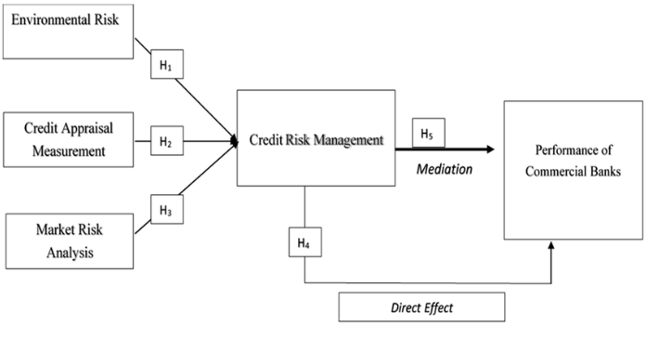
Figure 1: Contextual Diagram
(Bhatt, 2023/04/10)

CHAPTER THREE

THEORY, METHODOLOGY AND ALGORITHMS

3.1 Introduction
This chapter presents the theoretical foundations, methodologies, and algorithms underpinning the development of the Credit Risk Modelling system. The study is grounded in statistical learning theory and supervised classification techniques, with the objective of estimating the Probability of Default (PD) for individual borrowers using historical financial and demographic attributes. Rather than proposing a fundamentally new algorithm, this research adopts established modelling approaches and integrates them within a structured, end-to-end analytical framework tailored to credit risk assessment. The chapter explains the theoretical basis of the selected models, describes the methodological pipeline followed, discusses adaptations made to existing techniques, and provides a critical comparative analysis of the algorithms implemented.

3.2 Theoretical Foundations of Credit Risk Modelling
Credit risk modelling is fundamentally a probabilistic classification problem. Given a feature vector X= (X1, X2, ..., Xn) representing borrower characteristics such as income level, employment status, loan amount, and credit history, the task is to estimate the conditional probability:

where Y=1 denotes default and Y=0 denotes non-default. This formulation aligns with statistical decision theory, where the objective is to construct a decision boundary that minimizes classification error while maintaining strong generalization performance.
The theoretical framework of this study draws primarily from logistic regression theory (Hosmer, Lemeshow, & Sturdivant, 2013), ensemble learning theory (Breiman, 2001), and broader principles of statistical learning (Friedman, Hastie, & Tibshirani, 2001). Logistic regression provides a parametric probabilistic approach grounded in maximum likelihood estimation, while ensemble methods such as Random Forest are based on variance reduction and aggregation of multiple weak learners to produce a stronger predictive model.
These theories collectively provide the mathematical and computational basis for modelling borrower default risk in a supervised learning context.

3.3 Methodological Framework
The research adopted a structured data science lifecycle to ensure reproducibility, robustness, and systematic experimentation. The modelling process began with data acquisition, followed by preprocessing, exploratory data analysis, feature engineering, model development, and performance evaluation.
Data preprocessing was a critical stage in the methodology. Credit datasets often contain missing values, categorical variables, and potential outliers that can distort predictive performance. Missing values were addressed using appropriate imputation strategies to preserve dataset integrity. Categorical variables were transformed into numerical representations through encoding techniques such as one-hot encoding, enabling compatibility with machine learning algorithms. Where necessary, feature scaling was applied to standardize variable magnitudes, particularly for algorithms sensitive to feature distribution.
Exploratory Data Analysis (EDA) was conducted to understand variable distributions, detect multicollinearity, and identify patterns associated with default behavior. Correlation analysis and visualization techniques were used to assess relationships between predictors and the target variable. This phase informed feature selection decisions and improved model interpretability.
The dataset was divided into training and testing subsets using stratified sampling to preserve class proportions. This approach ensured that the minority default class was adequately represented in both subsets, thereby supporting reliable performance evaluation.

3.4 Algorithms Implemented
Two supervised classification algorithms were implemented: Logistic Regression and Random Forest. These models were selected to provide both interpretability and predictive strength.
Logistic Regression was implemented as the baseline statistical model. It models the log-odds of default as a linear combination of predictor variables:
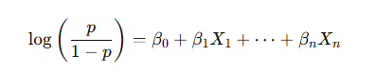
where p represents the probability of default. The parameters are estimated using maximum likelihood estimation. Logistic Regression is widely used in credit scoring because of its interpretability; the coefficients provide direct insight into the direction and magnitude of each predictor’s influence on default risk. Its transparency makes it particularly suitable for regulated financial environments.
Random Forest was implemented as an advanced ensemble learning model. This algorithm constructs multiple decision trees using bootstrap sampling and random feature selection at each split (Breiman, 2001). The final prediction is obtained through majority voting across trees. Random Forest is capable of capturing nonlinear interactions and complex feature relationships that linear models may fail to detect. Additionally, it reduces overfitting through aggregation and provides measures of feature importance, enhancing interpretability relative to other black-box models.

3.5 Modifications and Enhancements
While the theoretical foundations of the algorithms were not altered, several practical enhancements were incorporated to improve performance and robustness. Hyperparameter tuning was performed using cross-validation techniques to optimize model parameters. For Logistic Regression, regularization strength was adjusted to control model complexity and prevent overfitting. For Random Forest, parameters such as the number of trees, maximum tree depth, and minimum samples per split were optimized to balance bias and variance.
Class imbalance, a common issue in credit risk datasets where defaulters are typically fewer than non-defaulters, was addressed through stratified sampling and class weighting mechanisms. This adjustment ensured that the model did not become biased toward predicting the majority class.
Feature selection techniques were also applied to reduce redundancy and improve generalization. Correlation analysis and feature importance rankings from Random Forest were used to identify and eliminate less informative variables.
These enhancements represent methodological refinements rather than theoretical innovations, contributing to improved model stability and applicability.

3.6 Model Evaluation and Validation
Model performance was evaluated using multiple classification metrics to ensure comprehensive assessment. Accuracy provided a general measure of correct classifications, while Precision and Recall evaluated performance on the minority default class. The F1-score offered a harmonic balance between Precision and Recall.
Particular emphasis was placed on the Receiver Operating Characteristic – Area Under the Curve (ROC-AUC) metric, which measures the model’s discrimination capability across all classification thresholds. In credit risk modelling, discrimination power is critical because financial institutions often adjust decision thresholds depending on risk appetite.
Cross-validation was employed to assess model stability and reduce variance in performance estimates. This approach ensured that the results were not dependent on a single data split and improved confidence in model generalization.

3.7 Critical Comparative Analysis
A comparative analysis between Logistic Regression and Random Forest revealed key trade-offs. Logistic Regression demonstrated high interpretability and computational efficiency, making it suitable for regulatory contexts where transparency is required. However, its assumption of linearity limits its ability to capture complex relationships within the data.
Random Forest, in contrast, achieved superior predictive performance by modelling nonlinear interactions and reducing overfitting through ensemble averaging. Its ability to compute feature importance further enhanced interpretability, though not to the same level as the explicit coefficients of Logistic Regression.
The findings indicate that while Logistic Regression remains a strong benchmark model, ensemble methods such as Random Forest offer improved discrimination capability in complex credit datasets. The choice between models therefore depends on the balance between interpretability and predictive accuracy required in a given financial context.

3.8 Data Flow Diagram
This Data Flow Diagram (DFD) of credit risk model visually maps how borrower data moves through a financial system to assess the likelihood of default, transform that data into risk scores, and store the results for decision-making
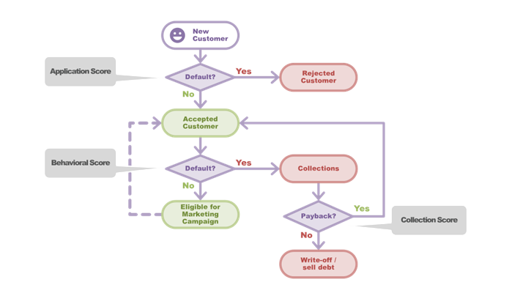
Figure 2: Data Flow Diagram
(Deepanshu Bhalla)

3.9 General Structure of the ER Diagram
This ER diagram has been designed to cover all processes of a banking system. The model includes critical entities for banking operations such as customers, accounts, transactions, employees, loan processes, and card management.
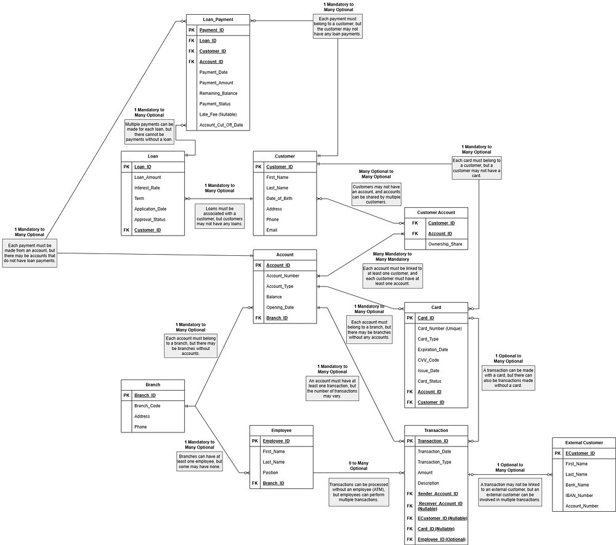
Figure 3: Entity Relationship Diagram
(İlaydanursisman, 2025)

3.10 Use Case Diagram
This use case diagram of a credit risk model provides a high-level, visual representation of how different users (actors) interact with a credit risk assessment system to achieve specific goals, such as calculating default probability, approving loans, or monitoring portfolio risk. It defines the system's scope, clarifies functional requirements, and bridges the gap between technical developers and non-technical stakeholders.
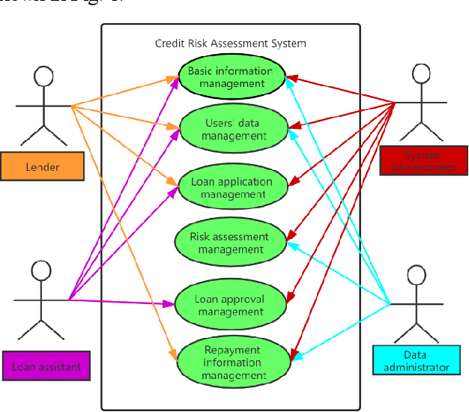
Figure 4: Use Case Diagram
(Song Wen, Bi Zeng, 2021, pp. 9-13)

REFERENCES
Altman, E. I. (1968). Financial ratios, discriminant analysis and the prediction of corporate bankruptcy. The Journal of Finance, 23(4), 589–609. https://doi.org/10.2307/2978933
Basel Committee on Banking Supervision. (2006). International convergence of capital measurement and capital standards: A revised framework (Comprehensive version). Bank for International Settlements.
Basel Committee on Banking Supervision. (2011). Basel III: A global regulatory framework for more resilient banks and banking systems. Bank for International Settlements.
Breiman, L. (2001). Random forests. Machine Learning, 45(1), 5–32. https://doi.org/10.1023/A:1010933404324
Friedman, J., Hastie, T., & Tibshirani, R. (2001). The elements of statistical learning: Data mining, inference, and prediction. Springer.
Hand, D. J., & Henley, W. E. (1997). Statistical classification methods in consumer credit scoring: A review. Journal of the Royal Statistical Society: Series A (Statistics in Society), 160(3), 523–541.
Hosmer, D. W., Lemeshow, S., & Sturdivant, R. X. (2013). Applied logistic regression (3rd ed.). Wiley.
Lessmann, S., Baesens, B., Seow, H.-V., & Thomas, L. C. (2015). Benchmarking state-of-the-art classification algorithms for credit scoring. European Journal of Operational Research, 247(1), 124–136.
Thomas, L. C., Crook, J. N., & Edelman, D. B. (2017). Credit scoring and its applications (2nd ed.). SIAM.
Witten, I. H., Frank, E., Hall, M. A., & Pal, C. J. (2016). Data mining: Practical machine learning tools and techniques (4th ed.). Morgan Kaufmann.

