**S1A Code. R code and data to regenerate figures**

**Software information:**

R Version 3.4.0

**Installation:**

* Download RStudio (open source license) from <https://www.rstudio.com/products/rstudio/download/>
* Create a new project in the S1 Data folder by opening RStudio, selecting File->New Project… -> New Directory -> Empty Project. Enter a directory name (can be anything you want), and choose S1A Code as the subdirectory. Make sure that the project is in the S1A Code folder and not in a subfolder.
* Your S1A Code folder should now look like this: (where in this case allFigures_LJD_PY is the project file)

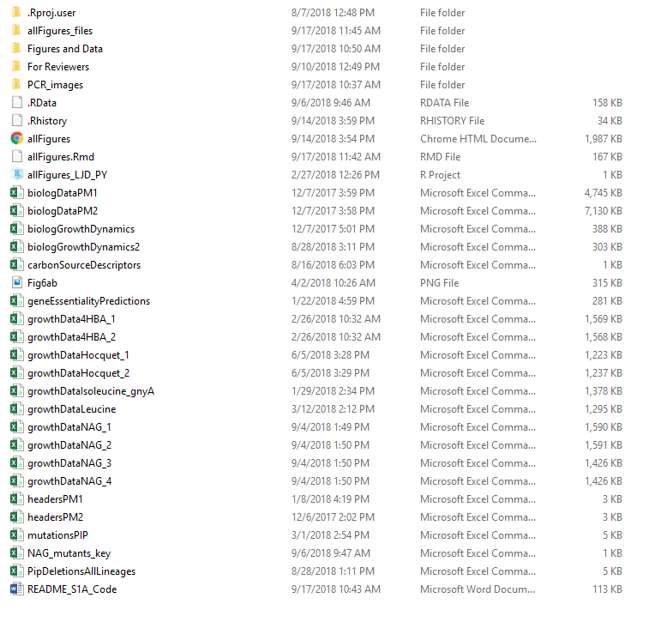

**Required R packages:**

Once RStudio is running, the following packages need to be installed in order for the supplied script to be able to run:

* readr
* dplyr
* ggplot2
* ggthemes
* tidyr
* viridis
* gridExtra
* grid
* knitr
* reshape2
* gplots
* RColorBrewer
* ggsignif
* cowplot
* ggpubr
* gtable
* png
* tiff
* vegan
* ggdendro
* scales
* growthcurver

All available using install.packages(‘packageName’), or the first chunk of code in allFigures.Rmd can be uncommented the first time the file is run.

**Scripts:**

* allFigures.Rmd

**Data files:**

* biologDataPM1.csv – All growth data on Phenotypic Microarray Plate PM1
* biologDataPM2.csv – All growth data on Phenotypic Microarray Plate PM2a
* headersPM1.csv – Carbon source labels from plate PM1
* headersPM2.csv – Carbon source labels from plate PM2a
* biologGrowthDynamics.csv – All calculated growth dynamics
* carbonSourceDescriptors.csv – Pathway descriptions for carbon sources in Figure 3
* growthDataNAG.csv (1 through 4) – Growth data from Figures 4A, 4B, S4A, S4B
* NAG_mutants_key.csv – Key between mutant labels in Figure 4B data and gene locus tags
* mutationsPIP.csv – Mutated genes in the piperacillin-evolved lineage
* geneEssentialityPredictions.csv – Predicted essential genes by carbon source
* PipDeletionsAllLineages.csv – All other genes in PIP-evolved lineages not in the large deletion of PIP-R1. Used in Figure S5B-C
* growthDataLeucine.csv – Growth data of ancestor, PIP, and *gnyA* on 40mM L-Leucine (all 4 biological replicates)
* growthData4HBA_1.csv – Half of the growth data on 4HBA
* growthData4HBA_2.csv – The other half of the growth data on 4HBA
* growthDataHocquet_1.csv – Half of the growth data of the Hocquet isolates grown on L-leucine
* growthDataHocquet_2.csv – The other half of the Hocquet growth data
* growthDataIsoleucine_gnyA.csv – Growth data from S6 Fig.
* Figures and Data folder – Empty folder where figures/data generated by the script will be saved
* PCR_images – Folder containing gel images verifying transposon insertions

**Instructions:**

* Prior to this point, RStudio must be installed with the appropriate packages and a new project must be created in the S1A Code folder.
* Open the project in the S1A Code folder.
* Open the script allFigures.Rmd in the project (File -> Open File…).
* Run the script by clicking Knit->Knit to HTML in the upper left-hand corner of the window.
* This will generate the following:
  + An HTML file containing all of the figures and figure captions
  + Figures 2-6 from the main manuscript as .pdf files
  + Figures S1-S6, and S8 as .tiff files
  + Data S1-S4 as .csv files

Figures can easily be changed to different file formats (e.g. jpg, png, etc.) or saved to different locations by changing adjusting the filenames and paths within ggsave functions. A call to ggsave can be found at the bottom of the code for each figure.