Can machine learning improve loan approval prediction relative to traditional econometric methods?

A comparison using the standard logistic regression vs a random forest.

Introduction:
Banks make decisions on whether to grant or reject loans to individuals. Although this decision depends on a number of different factors, banks primarily use credit scoring as the main determinant of loan approval. Credit scoring is a set of decision models that assess the risks in lending to a consumer via the lenders view of likely future economic scenarios. The success of credit scoring with credit cards in the 60’s meant that banks started using it for scoring loans (Thomas et al., 2017).
Accurately predicting loan approval is important to banks because it impacts their profitability. Approving a loan where the borrower ends up defaulting results in a financial loss for banks. Banks want to maximize accuracy in approving loans for individuals that don’t default. Thomas et al. (2017) explains this is because ‘credit scoring is an area where a small improvement in performance can mean a tremendous increase in profit to the lender because of the volume of lending made by the use of scoring’ (Thomas et al., 2017).
A series of poor lending decisions occurred prior to the 2008 financial crisis. Banks were lending mortgages to individuals with low credit scores and high risk of default. As house prices fell, homeowners began to default on loans leaving banks with substantial losses as their collateral was worthless. Multiple banks filed for bankruptcy and individuals lost trust in banks leading to a run on banks. This more widely affected economic conditions. In hindsight, banks have learned to exercise caution when granting loans.
Accurate credit allocation is complicated due to the problem of asymmetric information. Borrowers often don’t disclose their entire credit history and finances in order to manipulate the decision of banks towards loan approval. Banks often cannot distinguish a risky borrower from a safe one and may consequently lend to individuals with high risk of default – putting pressure on their finances. Therefore, increasing predictive accuracy in loan prediction is essential.
Despite the high risk, banks want to lend to individuals as their profits increase under full repayment. Additionally, it increases efficient capital allocation in the economy where credit scoring has proven vital to the growth in consumer credit over the last 40 years’ (Thomas et al., 2017).
In this report, loan approval will be predicted under both an econometric and machine learning (ML) model. This will be in the form of a logistic model vs a random forest where the logistic regression is recognised as the industry standard (Lessmann et al., 2015). Therefore, it will be useful to see if traditional and previously reliable models can outperform newer models. A series of metrics including a classification report, confusion matrix, ROC curve, and feature importance will be used to compare predictive accuracy and interpretability across both models.

Literature review:
Credit scoring:
As consumer lending has expanded, financial institutions have increasingly relied on automated credit-scoring systems to support lending decisions. Financial institutions increasingly require formal tools in lending decisions as loans and mortgages in the UK have exceeded £11,000m (Lessmann et al., 2015). One formal tool published by Thomas et al. (2017) is credit scoring where lenders conduct assessment of borrowers by classifying applicants into ‘good’ and ‘bad’ risk classes based on their likely future economic scenarios. Using prediction models for loan approval is necessary for banks as prediction in credit scoring is an area where small improvements yield high profits (Thomas et al., 2017).
Loan approval prediction matters economically as both consumers and banks can benefit from increasing accuracy in prediction. For example, Suhadolnik et al. (2023) remarks that one reason for increased automation in credit scoring is due to increased regulation which has increased competition leading to cheaper loans (Suhadolnik, Ueyama and Da Silva, 2023). This has increased access to credit and is the main reason for the growth in credit in the last 40 years (Thomas et al., 2017). Additionally, banks reduce the risk of approving loans that result in defaults to consequently reduce their financial losses.

Traditional econometric methods:
The logistic regression has long been regarded as the industry standard in credit scoring due to its simplicity and interpretability. It’s known to outperform linear probability models despite Henley (1995) suggesting that the logistic regression performs similar to a linear regression. This is due to applicants which lie in the ‘goods’ class experiencing probabilities between 0.2-0.8 where the logistic model is well approximated by a straight line (Hand and Henley, 1997). The logistic regression and random forest classifiers are distinctly different on an interpretability front. Whilst the logistic regression is known to be interpretable which could make it preferable depending on the objective of banks, Thomas et al. (2017) claims the aim of classification in loan approval is to ‘predict default risk, not explain it’ and it isn’t necessary that the model explains why some consumers default and some don’t (Thomas et al., 2017).
Whilst the logistic regression is strong from an interpretability standpoint due to its availability of causal inference from marginal effects, Suhadolnik et al. (2023) suggests that the logistic regression struggles with identifying relationships that are more complex than linearity, leading to questionable results. He provides a counter to this which are machine learning (ML) models that prioritize predictive performance with minimal information (Suhadolnik, Ueyama and Da Silva, 2023)
.

Machine learning:
Machine learning methods have been increasingly adopted in conducting credit risk assessments. Suhadolnik et al. (2023) remarks these new financial intermediation models have come about this due to technological advancements and regulatory changes, benefitting consumers from increased competition and decreased loan costs (Suhadolnik, Ueyama and Da Silva, 2023).
Machine learning methods have become increasingly popular in credit scoring because they often achieve higher predictive accuracy than traditional statistical models. Breiman’s (2001) findings on random forests are consistent with this, concluding that growing an ensemble of trees has led to significant improvements in classification accuracy since random forests don’t overfit (Breiman, 2001). Suhadolnik’s results confirm that ensemble methods outperform traditional algorithms such as logistic regression in credit classification. Lessmann et al. (2015) also confirms this via his study on the comparison of performance for 41 different classifiers in credit scoring where results showed that 15 models outranked the logistic regression; multiple of these being ML models (Lessmann et al., 2015).
However, despite machine learning techniques now at the forefront of credit risk assessments, Suhadolnik describes concerns with implications of financial stability due to machine learning models being difficult to interpret and understand results; affecting the strategies of financial institutions (Suhadolnik, Ueyama and Da Silva, 2023)
.

Current debate:
The current debate amongst statisticians is which method should be utilized. Whilst ML methods appear to increase predictive accuracy, the interpretability of results doesn’t compare to the traditional logistic regression. Rudin (2019) discusses that using black box models instead of already interpretable models for predictions will cause harm to society since many ML models aren’t interpretable in their predictions. Previous examples include incorrectly denied parole, poor bail decisions leading to the release of dangerous criminals, and pollution models deeming polluted air safe to breathe (Rudin, 2019).
This increase in predictive accuracy from ML models however benefits consumers and enterprises in loan approval, as Suhadolnik confirms that the automation allows for financial institutions to provide loans faster and at lower costs, promoting financial inclusion especially amongst smaller enterprises (Suhadolnik, Ueyama and Da Silva, 2023). Whilst ML models underperform from an interpretability perspective, one advantage of decision tree-based models is that the contribution of each feature to the success of the model can be calculated.
It remains clear however that the traditional logistic regression exceeds ML models on an interpretability measure since it can be evaluated through significance of parameters, confidence intervals, and causal inference from marginal effects interpretations. However, Suhadolnik counters this by discussing how the logistic model often falls short where relationships are more complex than linear ones (Suhadolnik, Ueyama and Da Silva, 2023). Unlike the logistic regression, the Random Forest can naturally capture complex nonlinear relationships and interactions between borrower characteristics without requiring them to be specified in advance.
However, in saying this, the conclusion isn’t that ML models are better because achieving higher predictive accuracy is favourable to interpretability. Overall, this depends on the objectives of banks and whether they’re aiming to maximize consumer trust, and regulatory compliance vs minimizing loan defaults. To build on this debate, this study compares both approaches on a loan approval dataset in order to evaluate both predictive performance and practical usefulness.

Data:
The dataset consists of 4269 applicants for loans and 13 variables. There are 11 input variables which contribute to the assessment of loan approval. The output variable is loan_status which defines whether the applicant was approved or rejected for the loan.
VARIABLE | Variable type | Model | Description
loan_id | Int | - | Applicant number
no_of_dependents | Int | X1i | Number of dependents of the applicant
education | Categorical | X2i | ‘Graduate’ or ‘Not graduate’
self_employed | Categorical | X3i | Employment status of the applicant ‘Yes’ or ‘No’
income_annum | Int | X4i | Annual income of the applicant
loan_amount | Int | X5i | Loan amount
loan_term | Int | X6i | Duration of the loan in years
cibil_score | Int | X7i | Credit score of the applicant
residential_assets_value | Int | X8i | Value of residental assets of applicant
commercial_assets_value | Int | X9i | Value of commercial assets of applicant
luxury_assets_value | Int | X10i | Assets of luxury value owned by applicant
bank_assets_value | Int | X11i | Assets of applicant in bank
loan_status | Categorical | y | Binary outcome variable of loan approval or rejection ‘Approved’ or ‘Rejected’

Data preparation/cleaning:
The variable loan_id was dropped from the dataset as it only defines the applicant number and doesn’t act provide any additional predictive information.
There are no missing values which need to be accounted for, however, there are 3 categorical variables which need to be encoded as binary variables as shown in the table below.
 | 0 | 1
Education | Graduate | Not Graduate
Self_Employed | No | Yes
Loan_Status | Approved | Rejected

EDA – exploratory data analysis
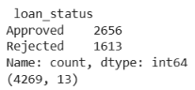

There is an uneven split of approvals to rejections 62:38, in the dataset. This is problematic because the model could prioritize predicting approvals because it has seen more of them. Therefore, the code has been accounted for this by adjusting focus towards the minority group.

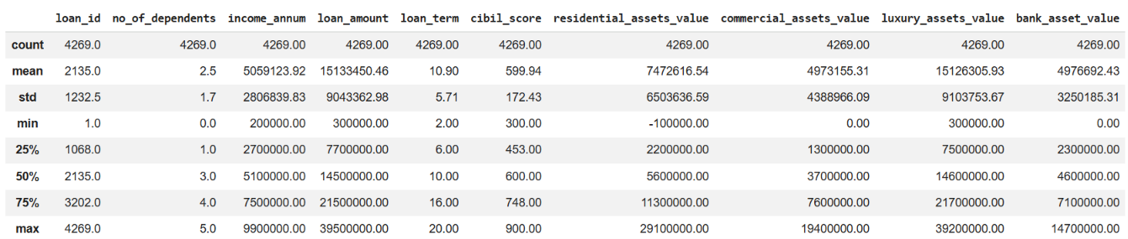
Summary statistics:

Approval and rejection averages:
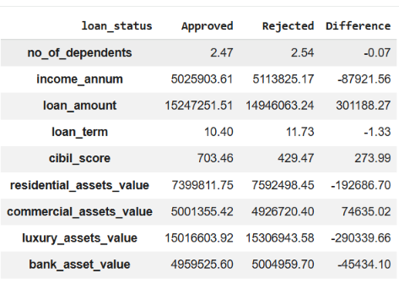

The table above shows the average values for approvals and rejections for each integer variable. For example, there is a large difference in average cibil score between applicants who were approved and rejected. Therefore, approved applicants have higher credit scores by 300 on average than rejected applicants.

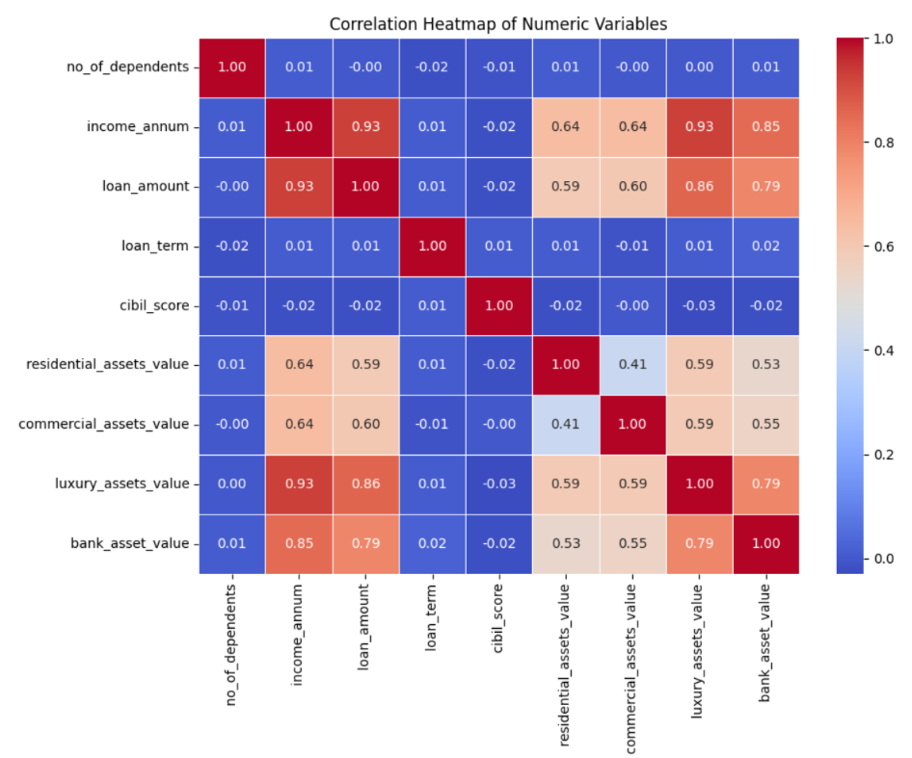
Correlation heatmap:

The correlation heatmap shows how the input variables move with each other. For example, regressors such as bank assets, luxury assets, commercial assets, residential assets, income per annum, and loan amount appear to be correlated with multiple other regressors.
This introduces a problem of multicollinearity for the logistic regression. This however is less concerning for random forests as they don’t rely on standard errors. Although this doesn’t affect conclusions since estimates remain unbiased and consistent, standard errors in the logistic regression become inflated and therefore efficiency decreases.

VIF analysis:
In order to test for multicollinearity, a VIF analysis is conducted as shown below. The VIF test scores diagnose variables as the following:
VIF Score: | Interpretation
<5 | Small concern
5-10 | Moderate concern
>10 | Severe multicollinearity

Test results:
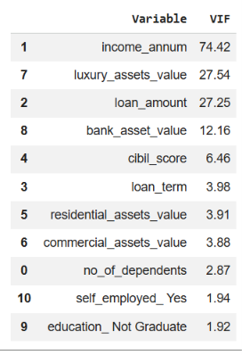

From the results, severe multicollinearity exists for variables: income per annum, luxury assets, loan amount, and bank assets – coinciding with the correlation heatmap. Therefore, standard errors will be inflated for these coefficients in the following logistic regression and consequently significance tests for these variables can be unreliable. These results are intuitive as individuals with higher incomes usually own more luxury and bank assets and take out loans of higher value.
Cibil score has a moderate VIF of 6.46, therefore its significance and coefficient is likely more reliable. As shown later in the results section, cibil score holds the most importance as a determinant for loan approval under both models. Therefore, this suggests that the variable holds high importance because it provides independent information about the creditworthiness of the applicant that other variables fail to provide.

Overall conclusions:
The direction of marginal effects remains valid under multicollinearity as coefficients remain unbiased. However, precise magnitude and statistical significance of individual marginal effects for high VIF variables are unreliable. As standard errors are inflated for these variables, t-statistics are deflated and p-values are inflated artificially. Therefore, some variables that appear insignificant may have real effects that the model can’t predict.
Therefore, individual significance tests for high VIF variables should be interpreted cautiously. However, under a likelihood ratio (LR) test where variables are jointly tested, variables may jointly contribute a meaningful fit despite multicollinearity.
The data analysis provides an initial understanding of the relationship between variables and the characteristics of the dataset. However, this cannot quantify the individual influence of each regressor or assess predictive accuracy. Therefore, econometric and ML models are used in the following section.

Methodology:
Linear Probability Model:
Typically, a Linear Probability Model (LPM) via an Ordinary Least Squares (OLS) regression would be used. The outcome variable loan status (Yi) has a binary structure related to applicant i’s approval for a loan (otherwise a rejection).
The linear model is as follows with the variables defined in the table on page 5:
$y_{i}=B_{0}+B_{1}X_{1i}+B_{2}X_{2i}+B_{3}X_{3i}+B_{4}X_{4i}+B_{5}X_{5i}+B_{6}X_{6i}+B_{7}X_{7i}+B_{8}X_{8i}+B_{9}X_{9i}+B_{10}X_{10i}+B_{11}X_{11i}+ε_{i}$
However, the LPM has multiple problems arising with its use. Firstly, the probability of loan approval can take values less than 0 and greater than 1. Secondly, the marginal effects are constant for any level of Xji. For example, an individual with a credit score of 400 and an individual with a credit score of 700 have the same increase in probability of loan approval when credit score increases by 1 unit. Lastly, there is heteroskedasticity in the model. Therefore, a more suitable alternative is to use the logistic regression.

Logistic Regression Model:
Under the logistic regression, the probability of approval is the CDF of the standard logistic distribution and is therefore guaranteed to take values between 0-1. Additionally, unlike the LPM, the logistic regression model doesn’t suffer from the same heteroskedasticity problem due to modelling a binary dependent variable with OLS. The probability of loan approval is defined via the equation below.
$P\left(y_{i} | X_{i};B\right)= \frac{exp⁡(X_{i}^{T}B)}{1+ exp⁡(X_{i}^{T}B)}= ∧\left(X_{i}^{T}B\right)= p_{i}$
Additionally, the logistic model can be interpreted as the log of odds ratio.
$ln\left(\frac{p_{i}}{1-p_{i}}\right)= X_{i}^{T}B$

The Bi’s are estimated via a maximum likelihood estimation which aggregates the Probability Mass Function (PMF) across all individuals and maximizes it by taking logarithms.
$f\left(y_{i} | X_{i};B\right)= { ∧\left(X_{i}^{T}B\right)}^{y_{i}}*{\left( 1-∧\left(X_{i}^{T}B\right)\right)}^{1-y_{i}}$
$L\left(B\right)= \prod_{i=1}^{n}{f\left(y_{i} | X_{i};B\right)}$
$ln\left(L\left(B\right)\right)=ln\left(\prod_{i=1}^{n}{{ ∧\left(X_{i}^{T}B\right)}^{y_{i}}*{\left( 1-∧\left(X_{i}^{T}B\right)\right)}^{1-y_{i}}}\right)$

The logistic regression is interpretable under marginal effects. Marginal effects are the PDF of the logistic distribution dependent on the level of xi. Marginal effects can be provided either at the mean or on average as a whole.

Logistic Density function:
$f_{L}\left(w\right)=λ\left(w\right)=∧(w)(1-∧\left(w\right))$

Marginal effects logistic regression:
$\frac{dP\left(y_{i}=1 | X_{i}\right)}{dX_{j}}=f\left(X_{i}^{T}B\right)*B_{j}$
$\frac{dP\left(y_{i} | X_{i};B\right)}{dX_{ij}}= \frac{d∧\left(X_{i}^{T}B\right)}{dX_{ij}}= λ\left(X_{i}^{T}B\right)*B_{j}$

Random Forest:
In a random forest, the model is trained using supervised learning on input-output pairs. It takes features (X) which are input variables used to make predictions and tells the machine the target variable (y) to predict. The data is split in an 80:20 training to test ratio. The model learns from training and uses this algorithm on the test set predict real world performance. However, statisticians must beware of data leakage to ensure the model doesn’t see the test set data during training as this can lead to falsely optimistic performance estimates.
A random forest is a combination of tree predictors trained in parallel to each other using a random selection of features to split each node (Breiman, 2001). Random forests are better predictors than decision trees because sufficiently deep tree will memorise training data perfectly (overfitting) and therefore perform poorly on new data.
As previously mentioned, if approvals and rejections are unbalanced, this needs to be accounted for prior to training. Therefore, the code compensates for the imbalance by forcing the model to pay more attention to the minority class (rejections).

Hyperparameter Tuning:
Hyperparameter tuning is used to improve performance in a random forest. These boosting and arcing algorithms are known to reduce bias and variance in results (Breiman, 2001). It is important because it can improve predictive accuracy. For example, it can reduce false negatives (approving loans that should be rejected) and therefore reduces the potential financial loss faced by banks.
One method is cross validation. Instead of using 1 train/test split, the model splits the data into folds and trains/tests each of them. Each hyperparameter combination is tried and scored, and the highest score is selected for use on the 20% test split.
An alternative tuning method is a grid search. A grid of possible hyperparameter values for maximum tree depth, number of estimators, minimum leaf samples etc. are input. The model tries every possible combination across each fold and selects the values that maximize the predictive accuracy.
In the code, the model has been tuned using a grid search on 5 folds. This resulted in a marginal improvement in predictive accuracy from 0.95 to 0.961.
The code has also been set so that the tree won’t make a final decision based on data for fewer than 10 applicants. For example, if a leaf only had 2 applicants which were both rejected, the model may conclude 100% rejection based on little evidence. This is overfitting and the model shouldn’t make conclusions from small samples.

Results:
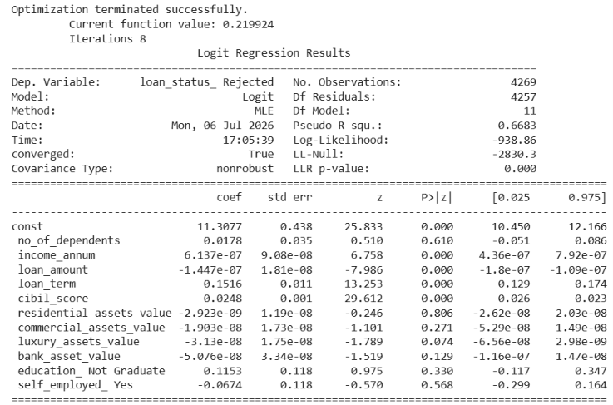
Logistic regression model interpretation:

The results from running the logistic regression are shown above. The model suggests that the variables income_annum, loan_amount, loan_term, and cibil_score are statistically significant because their p-values are below the 5% significance level. The results suggest that all remaining variables are statistically insignificant. However, due to severe multicollinearity amongst variables with high VIF values including income_annum, luxury_assets_value, loan_amount, and bank_asset_value, p-values are artificially inflated. Therefore, variables luxury_asset_value and bank_asset_value may appear insignificant but have real effects that the model cannot predict.
A likelihood ratio test has been conducted, restricting the model to include a constant and only regressors that are proven statistically significant: income_annum, loan_amount, loan_term, and cibil_score. As mentioned, despite the excluded variables being individually statistically insignificant, they jointly may contribute a meaningful fit which a LR can detect despite multicollinearity. The results however produce a p-value of 0.3135 which is greater than 0.05 and suggests that omitted variables don’t add any extra explanatory power.

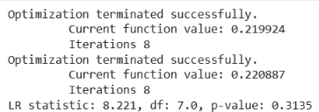

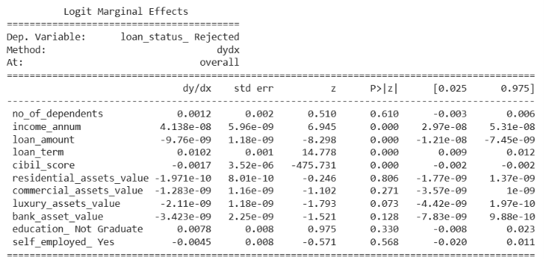
Logistic Regression Marginal effects:
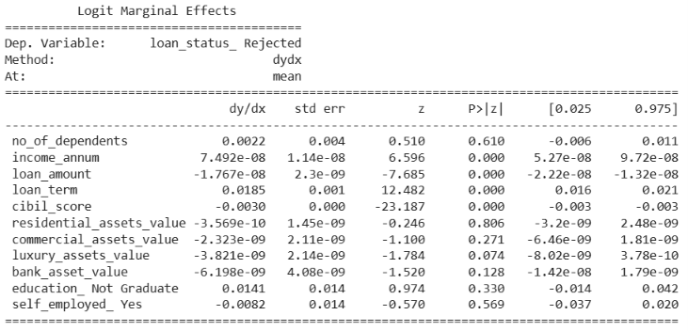

The tables above show the average marginal effects (marginal effects on average across all applicants) and the marginal effect at the mean (marginal effects for the average applicant) for loan approval.
For high VIF variables, the direction of the effect remains reliable, however, caution must be taken with quantitative claims as precision is overstated given collinearity. For example, it can be said with confidence that an increase in loan_amount by £1 decreases the probability of rejection, however, it can’t be concluded that it actually decreases the probability of rejection by -1.767e-06%.
Loan term, cibil score, and education have the largest marginal effects across both tables compared to other regressors. Focusing on the first table for all applicants on average, an additional year on a loan increases the probability of rejection by 1.02%. This intuitively makes sense as holding a loan for an additional year means that individuals have increased risk of default because there more time for an individual to be hit with negative income shocks. Additionally, an increase in credit score by 1 point decreases the probability of loan rejection by 0.17%. This is also consistent with real life as credit score measures the responsibility of an individual for repaying their liabilities on time. If an individual has proven to be trustworthy over time, banks can likely expect them to be trustworthy for future repayment.

Conclusions:
Overall, the logistic regression outperforms the random forest model from an interpretability standpoint as the random forest doesn’t provide the same level of interpretability as the logistic regression. Marginal effects in the logistic regression can be useful for banks as it provides statistics on what variables increase and decrease the probability of loan rejection whilst providing a quantitative evaluation which can be useful for managers.
However, banks should be cautious when interpreting marginal effects for variables with moderate and severe multicollinearity. Whilst the direction of marginal effects remains interpretable, exact quantitative values for high VIF variables are likely unreliable. Additionally, due to multicollinearity, variables that are statistically significant in real life may appear insignificant due to artificially inflated p-values. Therefore, banks should exercise caution when making loan approval decisions. For example, if they remove the consideration of educational factors simply because it proved to be insignificant, this could actually decrease the predictive accuracy of the model and therefore banks may be at higher risk of financial loss.

Discussion:
Evaluation metrics:
In order to compare the predictive accuracy of the 2 models, they will be evaluated amongst a series of metrics including: classification report, confusion matrix, ROC curve, and feature importance.
An important factor to consider before reaching a conclusion on which model is preferable for loan prediction is what evaluation metrics banks are targeting. For example, if banks prefer to maximize explainability, the logistic regression may be more preferable since it is easily interpretable via marginal effects in contrast to the random forest. However, it’s more likely that banks prefer to maximize precision on rejections and therefore the predictive accuracy for rejections would need to be compared for both models. As different indicators embody a different notion of classifier performance, it is therefore useful to look across multiple measures before selecting a model (Lessmann et al., 2015).
For example, false positives mean that banks reject candidates who wouldn’t have defaulted on their loans and therefore banks lose potential profitability. A false negative however occurs when a bank approves an applicant that defaults leading to financial loss. Banks typically prioritise reducing false negatives. This is because, whilst false positives have an opportunity cost of potential profit, the bank doesn’t actually make a loss whereas false negatives directly damage finances. Therefore, these errors are not equally costly so the model that accurately predicts rejection precisions is more favourable.

Classification Report:
Results:
 | Logistic Model | Random Forest - untuned | Random forest -tuned
Approval precision | 0.94 | 1.00 | 1.00
Rejection precision | 0.89 | 0.89 | 0.91
Approval recall | 0.93 | 0.92 | 0.94
Rejection recall | 0.91 | 0.99 | 0.99
F1 score approvals | 0.94 | 0.96 | 0.97
F1 score rejections | 0.90 | 0.94 | 0.95
Overall accuracy | 0.92 | 0.95 | 0.96
AUC | 0.965 | 0.997 | 0.998

All evaluation metrics were constructed using a random seed set equal to 1. In our test set, we have a support of 521 approvals and 333 rejections.
From the table of results above, the tuned random forest model outperforms the logistic regression across all predictive accuracy metrics. The random forest model has an approval precision of 100% which means that all loans that the model predicted as approved were actually approved in real life. 91% of real-life approvals were predicted by the model. 94% of rejections predicted by the model were actually rejected in real life and 99% of real-life rejections were predicted by the model. The overall accuracy of the tuned model is 96%.
This means that if the random forest was provided these variables for a list of applicants, it would approve successful loans 100% of the time that applicants wont default on and reject individuals that would default 94% of the time.
When comparing the untuned random forest model to the logistic regression, the random forest still outperforms the logistic regression except for approval recalls. Despite this, the overall accuracy of the untuned model is still higher than the logistic regression. The F1 score is also an important measure of precision and sensitivity and outperforms accuracy under unbalanced datasets (Suhadolnik, Ueyama and Da Silva, 2023). Although yet again, the random forest outperforms the logistic regression.
As the logistic regression has performed worse in terms of predictive accuracy across all components in the classification report compared to the tuned model, banks would prefer the ML model.

Confusion matrix:
Logistic Regression:
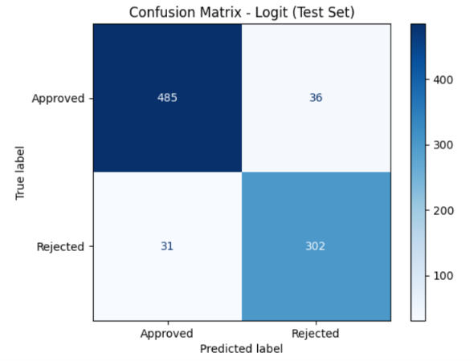

Untuned random forest:
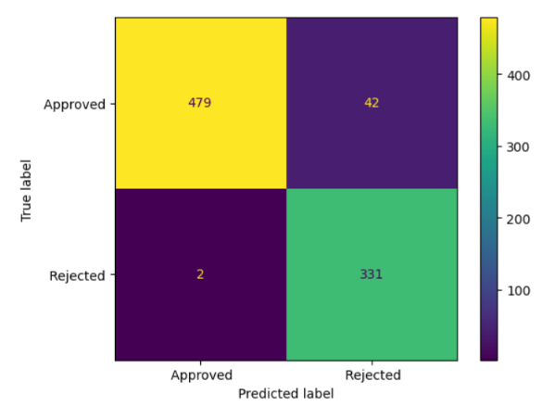

Tuned random forest:

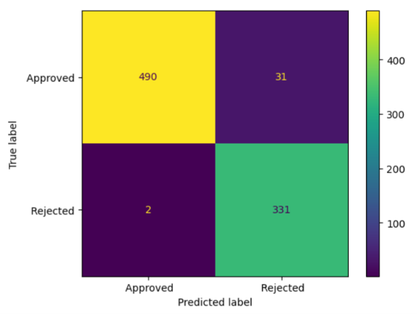

A confusion matrix provides information on where each model makes its mistakes. The rows represent loans that were actually approved/rejected in real life, and the columns show what is predicted by the model.
In the logistic regression, 485 actual approvals that were predicted correctly and 36 that were incorrectly predicted as rejections. Additionally, 302 actual rejections were predicted correctly as rejections, and 31 rejections were incorrectly predicted as approvals.
In the tuned random forest model, 490 actual approvals were correctly predicted as approvals and 31 were incorrectly predicted as rejections. This is an improvement from the untuned model where only 479 actual approvals were correctly predicted. Additionally, 331 actual rejections were correctly predicted as rejections and 2 were incorrectly predicted as approvals. After tuning, there was no improvement in rejection precision.
Overall, the confusion matrix reiterates the findings from the classification report that the random forest outperforms the logistic regression in terms of predictive accuracy.

ROC curve:
Logistic regression:

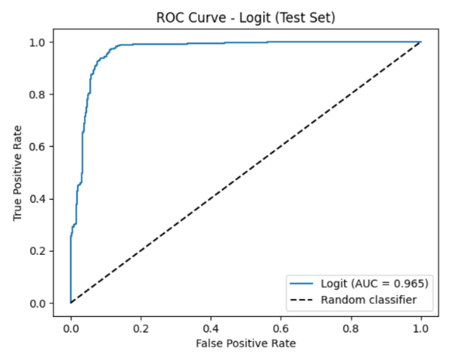

Tuned random forest:
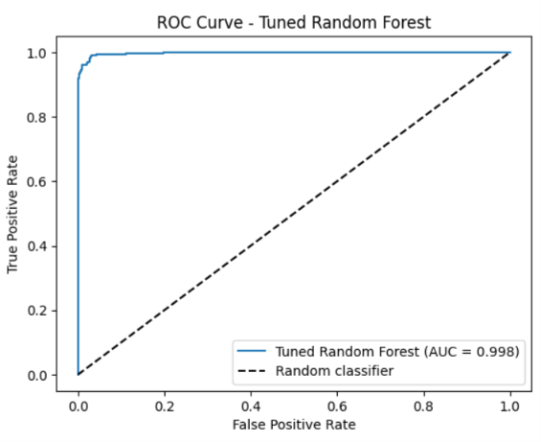

The ROC curve shows performance across all possible thresholds not just at the 0.5 cutoff. The y-axis is the true positive axis and the proportion of correctly predicted rejections out of all actual rejections – this recall should be high. The x-axis is the false positive axis which shows the proportion of incorrectly predicted approvals (as rejections) out of all actual approvals – this should be low.
For the logistic regression model at the default 0.5 cutoff (as in the confusion matrix), the ratio of actual rejections to correctly predicted rejections is 302:333 which is 91%. The ratio of actual approvals to incorrectly predicted approvals (rejections) (x-axis) is 521:36 which is 6.9%. At a lower threshold e.g. 0.3, the model catches more true rejections but also wrongly flags more approvals as rejections. Whereas at a higher threshold e.g. 0.7, the model catches less true rejections but wrongly flags less approvals as rejections.
The AUC (Area Under Curve) is a measure of performance of the model. Models with a higher AUC better discriminate between approvals and rejections regardless of the threshold. The diagonal line signifies a random guess with no predictive power, therefore an AUC = 0.5 means the model performs no better than a random guess. The AUC for the logistic regression and random forest are 0.965 and 0.998 respectively. If banks focus purely on prediction, the random forest is preferrable because it outperforms in discriminating between approved and rejected loans. Additionally, tuning didn’t have a significant effect on the AUC as this only increased by 0.001.
Although ROC evaluates performance across all possible classification thresholds, in practise banks must select a single operating cutoff. One approach suggested in the credit-scoring literature is initially to adopt a cutoff that produces a similar acceptance rate to the existing scorecard before gradually adjusting the threshold according to business objectives, profitability, risk tolerance etc (Thomas et al., 2017).

Feature importance:
Logistic regression:
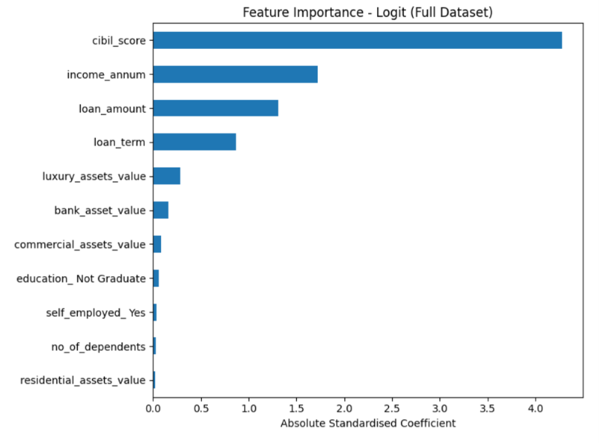

Random forest model:

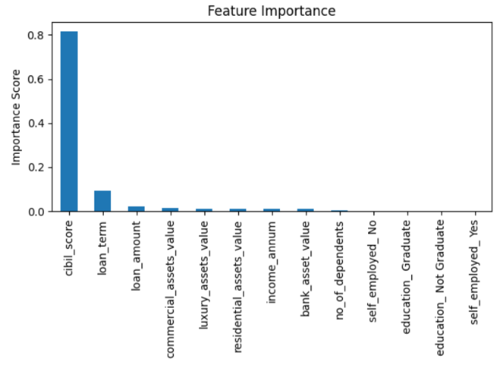

The logistic regression ranks the following features as having highest importance as predictors in loan approval in the following order: cibil score, income/annum, loan amount and loan term – these were also all of the variables that were statistically significant in the model.
The random forest model ranks cibil score above all else to be of highest importance with loan term also making a small contribution. Both models ranking cibil score as highest importance suggests banks must take extra caution when assessing credit score as an indicator for loan approval.
However, the models rank importance between these variables in different proportions. As seen by the bar charts, the random forest places nearly all importance on cibil score compared to about 45% importance from the logistic regression. This suggests that there is likely a presence of non-linear relationships between applicant characteristics and loan approvals that the random forest can better capture than a logistic regression.

Limitations:
It is important to consider that there are possible limitations to the data which can impact the accuracy of the models. For example, the data is only collected from 1 source and is just a sample, it would be ambitious to expect this data to be representative of an entire population. The data needs to be representative of people likely to apply for credit in the future (Thomas et al., 2017).
If data suffers from selection bias and is unrepresentative of the target population, a loan prediction model even from a random forest model which has proven to have a high predictive accuracy could struggle to correctly predict approvals and rejections on a different sample of data. This is likely to happen due to population drift where populations evolve over time so distributions change, therefore models need to continuously adapt to seeing new data (Hand and Henley, 1997). Using old predictions on new populations could result in a decrease in predictive accuracy.
Additionally, the data should incorporate sufficient of different types of repayment behaviour to identify which characteristics reflect this bad behaviour (Thomas et al., 2017). Our data only contains 11 input variables which could be insufficient to distinguish between defaults and successful repayments in real life.
It is also important to consider the number of good and bads in the sample and what an ideal proportion is. Should the sample be a 50:50 split of good and bads or should it reflect the good:bad odds in the population as a whole? A 50:50 appears to be preferred in order to have enough of the bad subpopulation to successfully identify their characteristics. The sample size of goods and bads also matters. Although Lewis (1992), claims 1500 goods and 1500 bads are sufficient, much larger samples are used in practise. This also depends on how we define goods and bads. One approach is to assign a bad status to all rejections since there must have been bad info on them to cause previous rejection. However, this also means that past bad judgement decisions are reinforced in the future (Thomas et al., 2017).. In our model, The results suggest that cibil score is the main determinant of goods and bads. However, we cannot be certain that bringing this criteria forward maintains the same predictive accuracy.
Finally, results may not generalise to banks. For instance, there is no information of where this data was collected from. If this data is collected solely from 1 bank, how can we be certain that the bank is making appropriate judgements? It could be the case that the criteria the bank is following for loan approvals is invalid and may still lead to future defaults whereas a different bank with different criteria could have higher success rates for predictions. If I was to continue this study, I’d attempt to find panel data in order to examine multiple lenders across the same characteristics and see if predictions differ.

Conclusion:
Overall, all performance metrics utilised in this report indicate that ML methods can improve loan approval prediction relative to traditional econometric methods in terms of predictive accuracy, given that the random forest model outperformed the logistic model across all quantitative methods of predictive accuracy. In the results from the Lessman et al. (2015) paper, out of the 41 different classification methods, multiple classifiers predict credit risk more accurately than the industry standard logistic regression (rank 16) including the random forest which ranks 12th. The random forest reduced error costs relative to the logistic regression scorecard by 5.7 when it came to misclassifying bad risks – a substantial reduction in loan defaults and financial losses for banks (Lessmann et al., 2015). Therefore, the ability of ML models to classify relationships as other than linear unlike the logistic regression becomes notably useful from a financial perspective.
However, from a managerial perspective, banks must ensure this generalizes to real-world applications as banks differ in their business objectives (Lessmann et al., 2015). When looking to maximize consumer trust, regulatory compliance, and transparency, banks seriously benefit from the interpretability aspect of traditional econometric methods that can provide causal inference for bank managers.
After analysing possible limitations including multicollinearity, biased and unrepresentative data, population drift, and appropriately defining ‘goods’ and ‘bads’, banks must also be cautious that both of these models can still fail in loan approval prediction. Whilst Thomas et al. remarks that the ‘credit scoring industry is long aware of these criticisms and either finds ways to overcome them or allow for them in decision making’, this isn’t a guarantee of success and banks may still yield losses without careful inspection of data (Thomas et al., 2017).
Overall, the findings suggest that predictive performance alone is insufficient when selecting a credit-scoring model. Rather, financial institutions must balance predictive accuracy, interpretability, regulatory requirements and business objectives when determining the most appropriate modelling approach.

References:
Thomas, L.C., Edelman, D.B. and Crook, J.N. (2017) Credit scoring and its applications. Second edition. Philadelphia: Society for Industrial and Applied Mathematics. Available at: http://epubs.siam.org/doi/book/10.1137/1.9781611974560 (Accessed: July 10, 2026).
Hand, D. J., and W. E. Henley. “Statistical Classification Methods in Consumer Credit Scoring: A Review.” Journal of the Royal Statistical Society. Series A (Statistics in Society), vol. 160, no. 3, 1997, pp. 523–41. JSTOR, http://www.jstor.org.bris.idm.oclc.org/stable/2983268. (Accessed: July 12, 2026).
Breiman, L. (2001) “Random Forests,” Machine Learning, 45(1), pp. 5–32. Available at: https://doi.org/10.1023/A:1010933404324. (Accessed: July 12, 2026).
Stefan Lessmann, Bart Baesens, Hsin-Vonn Seow, Lyn C. Thomas, Benchmarking state-of-the-art classification algorithms for credit scoring: An update of research, European Journal of Operational Research, Volume 247, Issue 1, 2015, Pages 124-136, ISSN 0377-2217, https://doi.org/10.1016/j.ejor.2015.05.030. (https://www.sciencedirect.com/science/article/pii/S0377221715004208). (Accessed: July 12, 2026).
Rudin, C. Stop explaining black box machine learning models for high stakes decisions and use interpretable models instead. Nat Mach Intell 1, 206–215 (2019). https://doi.org/10.1038/s42256-019-0048-x. (Accessed: July 13, 2026).
Suhadolnik, N., Ueyama, J. and Da Silva, S. (2023). Machine Learning for Enhanced Credit Risk Assessment: An Empirical Approach. Journal of Risk and Financial Management, [online] 16(12), p.496. doi:10.3390/jrfm16120496. (Accessed: July 13, 2026).
Loan-Approval-Prediction-Dataset. (n.d.). Www.Kaggle.Com. Retrieved July 17, 2026, from https://www.kaggle.com/datasets/architsharma01/loan-approval-prediction-dataset?select=loan_approval_dataset.csv

