The title

The title

GCA model summaries are in Appendices 2 (monolinguals) and 3 (learners). Figure 2 represents fixations towards the target verb over time. The figure suggests that all groups fixated on target verbs above chance before hearing the suffix, and that monolinguals fixated on targets earlier than L2ers.

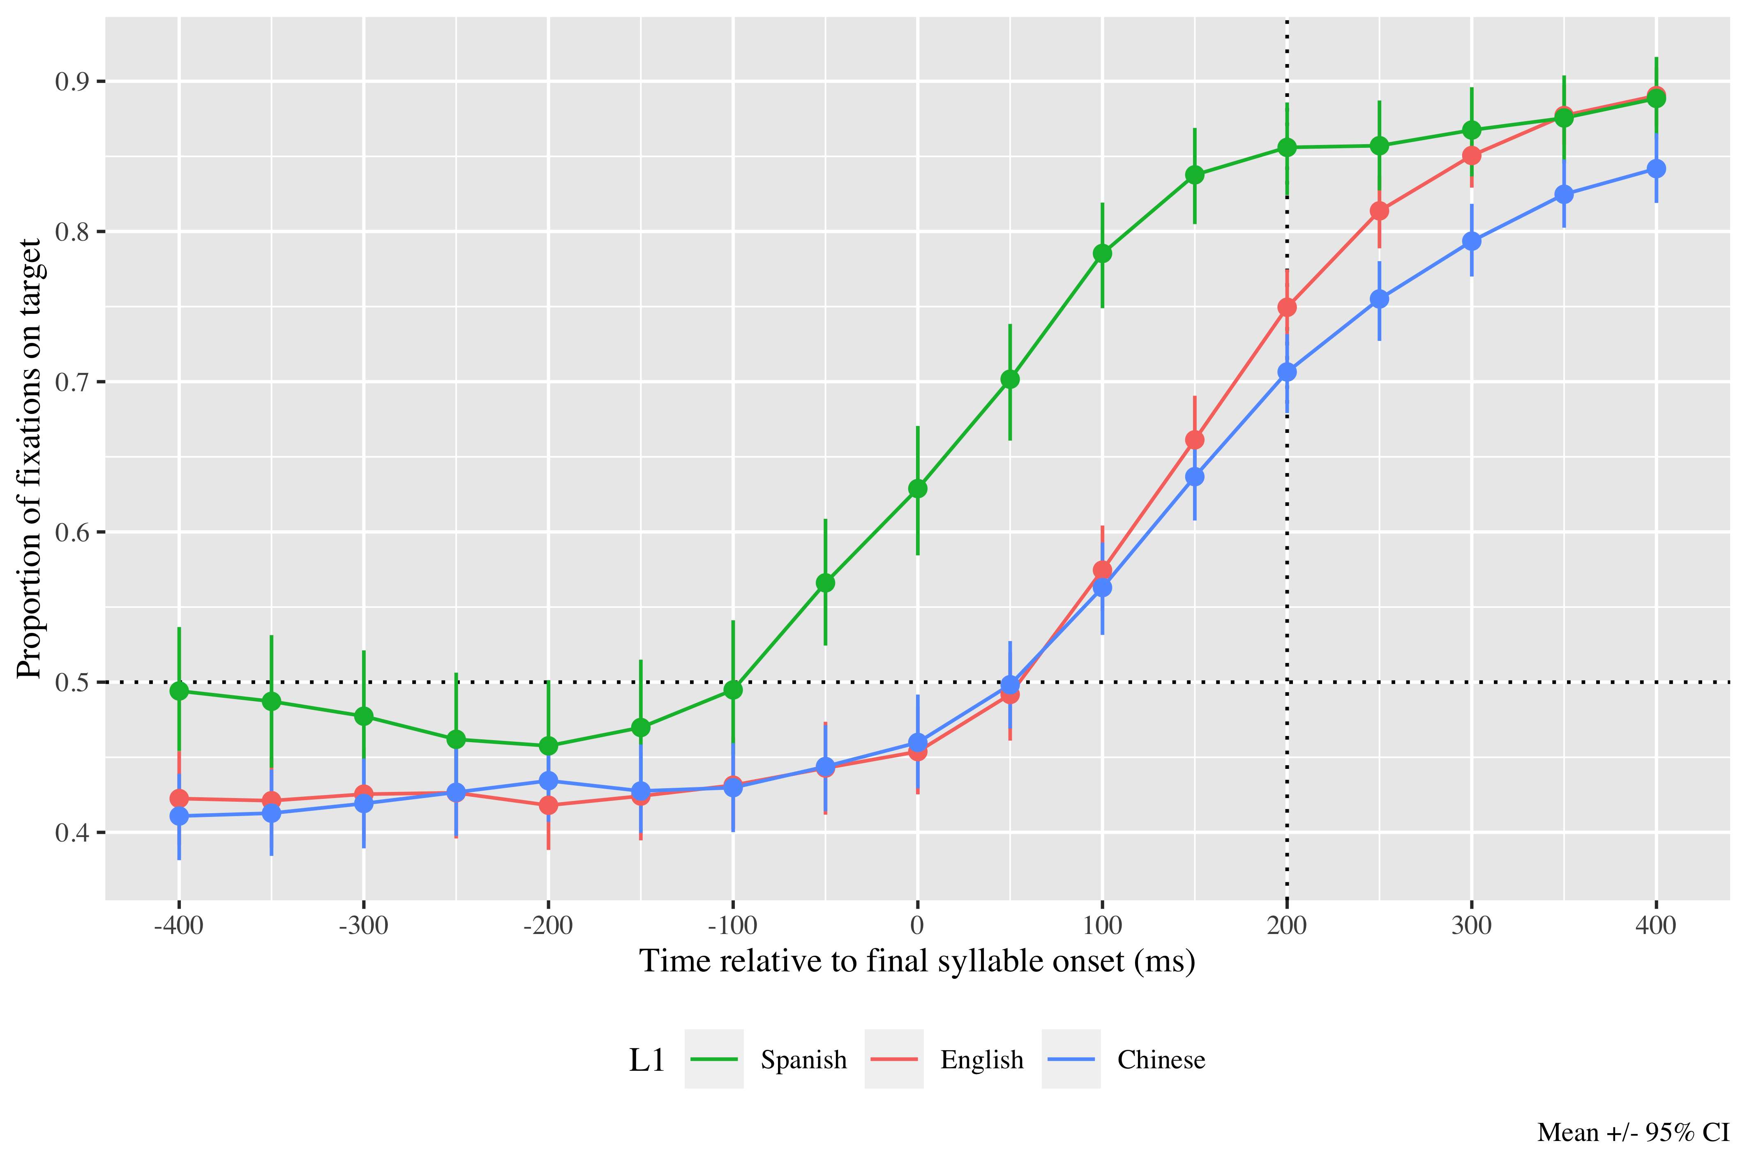

*Figure* *1:*. Figure 2. Fixations on target verbs from 400 ms before to 400 ms after the onset of verbs’ last syllable, as a function of L1 experience. Error bars represent the 95% CI across speakers in proportion of fixations on the target..

# Monolingual results

The linear (γ20 = 0.72; SE = 0.16; *t* = 4.47; *p* < .001) and quadratic time terms (γNA =  NA; SE =  NA; *t* =  NA; _p_NA NA) captured the GCA curve and were retained in the model. THe model intercept estimates the log odds of monolinguals fixating on the target above chance 200 ms after the onset of the verb’s final syllable at a 0.92 probability (lower bound = .90; upper bound = .94). These numbers reveal that monolinguals used the lexical stress pattern to predict suffixes above chance.

|  |  |  |  |  |
| --- | --- | --- | --- | --- |
| Parameter | Estimate | SE | *t* | *p* |
| Intercept (γ00) | 0.712 | 0.128 | 5.583 | < .001 |
| Time1 (γ10) | 2.589 | 0.305 | 8.497 | < .001 |
| Time2 (γ20) | 0.717 | 0.160 | 4.467 | < .001 |

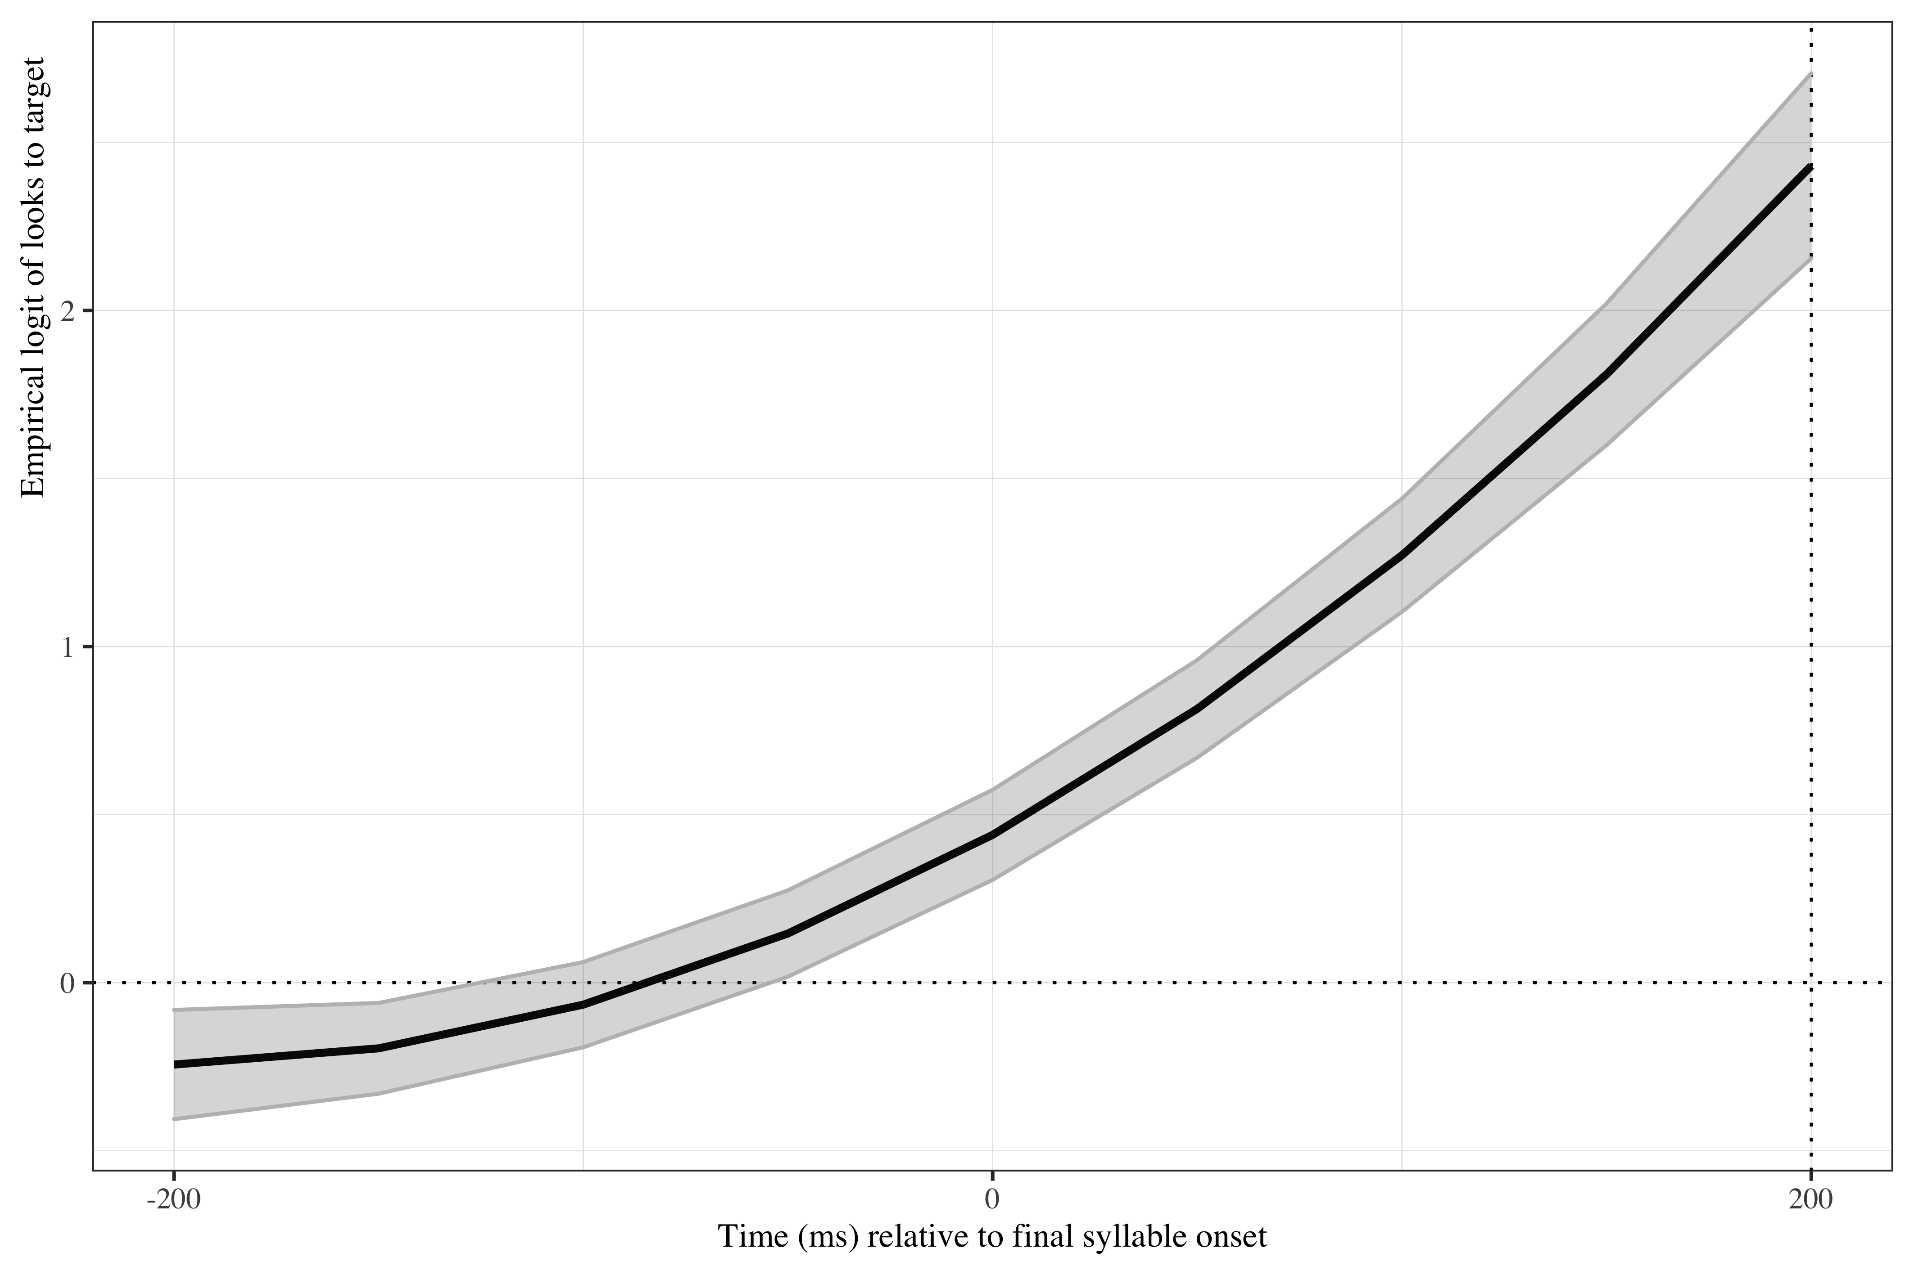

*Figure* *2:*. Figure 3. Growth curve analysis estimates of fixations on target as a function of lexical stress for the Spanish monolingual speakers during the analysis window. Lines represent model estimates, and the transparent ribbons represent ±SE. Empirical logit values on y-axis correspond to proportions of 0.12, 0.50, 0.88, and 0.98. The horizontal dotted line represents the 50% probability of fixating on the targets. The vertical dotted line indicates 200 ms after the onset of the last syllable.

# Learner results

The linear (γ10 = 1.30; SE = 0.15; *t* = 8.67; *p* < .001) and quadratic (γ20 = 0.65; SE = 0.07; *t* = 9.53; *p* < .001) time terms improved the curved fit. The probabilities of all learners fixating on targets before hearing the syllable with the suffix are above chance for all conditions (Table 2).

|  |  |  |  |  |
| --- | --- | --- | --- | --- |
| Parameter | Estimate | SE | *t* | *p* |
| Intercept (γ00) | 0.061 | 0.068 | 0.893 | .372 |
| Time1 (γ10) | 1.296 | 0.149 | 8.674 | < .001 |
| Time2 (γ20) | 0.647 | 0.068 | 9.535 | < .001 |
| DELE_z (γ01) | 0.093 | 0.061 | 1.524 | .127 |
| use_z (γ02) | −0.072 | 0.073 | −0.984 | .325 |
| Time1 × DELE_z (γ11) | 0.294 | 0.119 | 2.463 | .014 |
| Time1 × use_z (γ12) | 0.184 | 0.140 | 1.313 | .189 |
| use_z × l1_sum (γ03) | 0.057 | 0.065 | 0.882 | .378 |
| DELE_z × use_z (γ04) | −0.015 | 0.071 | −0.216 | .829 |
| Time1 × use_z:l1_sum (γ13) | 0.305 | 0.136 | 2.248 | .025 |
| Time2 × use_z:l1_sum (γ23) | −0.002 | 0.099 | −0.023 | .982 |
| Time1 × DELE_z:use_z (γ14) | 0.174 | 0.153 | 1.138 | .255 |
| DELE_z × use_z:l1_sum (γ05) | 0.004 | 0.066 | 0.063 | .949 |
| Time1 × DELE_z:use_z:l1_sum (γ15) | 0.310 | 0.142 | 2.186 | .029 |
| Time2 × DELE_z:use_z:l1_sum (γ25) | 0.039 | 0.106 | 0.364 | .716 |

Table ¿3?: Model estimates for probability of target fixations ±SE at 200 ms after the last syllable’s onset as a function of L2 proficiency and use. Their values represent the mean (0), one standard deviation below (-1), and one standard deviation above (1) for normalized scores. The first digit in the sub-index indicates whether the effect occurs on the intercept (0), the linear time term (1), or the quadratic time term (2). The second digit refers to the effects themselves (0 = intercept, 1 = Spanish proficiency, 2 = Spanish use, etc.).

Table 1:

| L1 | Spanish proficiency | Spanish use | Probability | Lower bound | Upper bound |
| --- | --- | --- | --- | --- | --- |
| English | -1 | -1 | 0.71 | 0.68 | 0.74 |
|  |  | 0 | 0.70 | 0.67 | 0.72 |
|  |  | 1 | 0.68 | 0.63 | 0.72 |
|  | 0 | -1 | 0.78 | 0.75 | 0.81 |
|  |  | 0 | 0.75 | 0.72 | 0.76 |
|  |  | 1 | 0.71 | 0.66 | 0.75 |
|  | 1 | -1 | 0.83 | 0.79 | 0.87 |
|  |  | 0 | 0.79 | 0.76 | 0.81 |
|  |  | 1 | 0.73 | 0.66 | 0.80 |
| Mandarin | -1 | -1 | 0.70 | 0.66 | 0.73 |
|  |  | 0 | 0.70 | 0.67 | 0.72 |
|  |  | 1 | 0.69 | 0.64 | 0.74 |
|  | 0 | -1 | 0.70 | 0.66 | 0.73 |
|  |  | 0 | 0.75 | 0.72 | 0.76 |
|  |  | 1 | 0.79 | 0.76 | 0.81 |
|  | 1 | -1 | 0.69 | 0.64 | 0.75 |
|  |  | 0 | 0.79 | 0.76 | 0.81 |
|  |  | 1 | 0.86 | 0.82 | 0.89 |

*Table 2*: Model estimates for probability of target fixations ±SE at 200 ms after the last syllable’s onset as a function of L2 proficiency.

There were several effects. First, there was a main effect of L2 proficiency on the linear term ( chi2; (1) = 6.499, *p* < .011). The parameter for that effect is positive (γ11 = 0.29; SE = 0.12; *t* = 2.46; *p* = .014), indicating that as proficiency increased the slope was steeper. A steeper slope indicates participants increased the number of fixations on the target faster the higher their proficiency.

There was also a main effect of L2 use on the linear term ( chi2; (1) = 14.961, *p* < .000). However, in the final model after testing all variables and interactions of interest the parameter was not significant.

There was an interaction between L1 and use on the quadratic time term ( chi2; (1) = 11.418, *p* < .001). In the final model, this effect moved to the linear time term. The positive value of the parameter indicates that for the Mandarin Chinese population the slope was steeper the higher their L2 use (γ13 = 0.31; SE = 0.14; *t* = 2.25; *p* = .025). That is, in Chinese participants, more extensive use of Spanish was associated with faster increase of gaze fixations on the target.

Finally, there was a 3-way interaction between L1, L2 proficiency and L2 use on the quadratic term ( chi2; (1) = 11.485, *p* < .001). Again, however, the parameter switched significance to the linear time term in the final model (γ15 = 0.31; SE = 0.14; *t* = 2.19; *p* = .029). As shown in Figure 5, English speakers benefited from higher proficiency towards lower levels of Spanish use. In Mandarin Chinese speakers, in contrast, higher proficiency and L2 use complemented each other, benefiting more those participants with both higher proficiency and greater L2 use, allowing them to predict faster by increasing fixations on the target faster, as represented by their steeper lines.

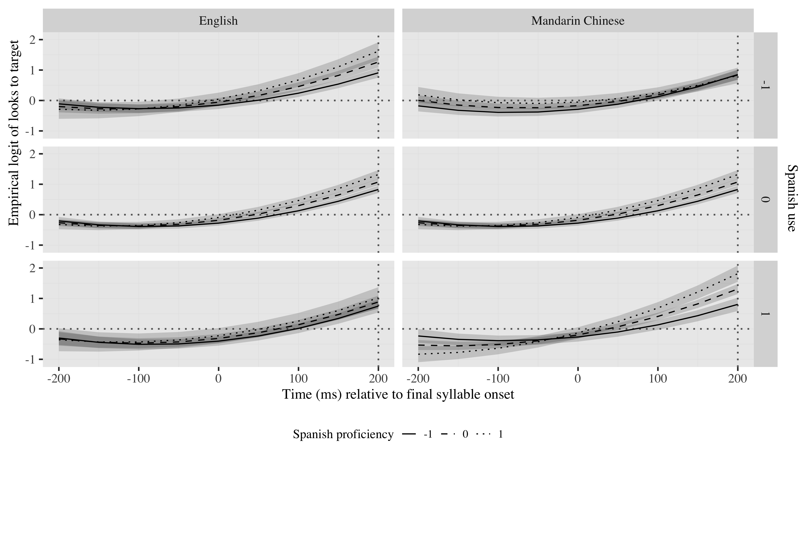

*Figure* *3:*. Figure 5. Growth curve analysis estimates of fixations on target as a function of L2 proficiency and L2 use for each L2 group during the analysis window. Lines represent model estimates, and the transparent ribbons represent ±SE. Empirical logit values on y-axis correspond to proportions of 0.12, 0.50, 0.88, and 0.98. The horizontal dotted line represents the 50% probability of fixating on the targets. The vertical dotted line indicates 200 ms after the onset of the last syllable.

We checked for multicollinearity between the fixed effects in the model using the variance inflation factor analysis, All values were below 2 (see Appendix 5), indicating there was no multicollinearity.

# Other plots

# Tables

## Model estimates at last syllable’s onset

|  |  |  |  |  |
| --- | --- | --- | --- | --- |
| Parameter | Estimate | SE | *t* | *p* |
| Intercept (γ00) | 0.712 | 0.128 | 5.583 | < .001 |
| Time1 (γ10) | 2.589 | 0.305 | 8.497 | < .001 |
| Time2 (γ20) | 0.717 | 0.160 | 4.467 | < .001 |

Appendix 2. Growth Curve Analysis fixed effects (monolinguals)

## Random effects

## Warning in names(ranef_table)[5:7] <- c("Correlations", "&nbsp;", " &nbsp;", :  
## number of items to replace is not a multiple of replacement length

|  |  |  |  |  |  |  |
| --- | --- | --- | --- | --- | --- | --- |
| Group | Parameter | Variance | SD | Correlations |  |  |
| Participant | Intercept | 0.104 | 0.323 | 1.00 |  |  |
|  | Time1 | 1.317 | 1.148 | .57 | 1.00 |  |
|  | Time2 | 0.230 | 0.480 | .32 | .81 | 1.00 |
| Item | Intercept | 0.348 | 0.590 | 1.00 |  |  |
|  | Time1 | 0.941 | 0.970 | .37 | 1.00 |  |
| Residual |  | 9.023 | 3.004 |  |  |  |

Appendix 5.Growth curve model random effects (monolinguals)

|  |  |  |  |  |  |  |  |  |  |
| --- | --- | --- | --- | --- | --- | --- | --- | --- | --- |
| Group | Parameter | Variance | SD | Correlations |  |  |  |  |  |
| Participant | Intercept | 0.128 | 0.358 | 1.00 |  |  |  |  |  |
|  | Time1 | 0.320 | 0.565 | −.03 |  |  | 1.00 |  |  |
|  | Time2 | 0.009 | 0.093 | −1.00 |  |  | −.01 | 1.00 |  |
| Item | Intercept | 0.096 | 0.310 | 1.00 |  |  |  |  |  |
|  | DELE_z | 0.022 | 0.147 | .30 | 1.00 |  |  |  |  |
|  | use_z | 0.036 | 0.190 | −.23 | .41 |  |  |  | 1.00 |
|  | l1_sum | 0.030 | 0.174 | −.48 | .26 | 1.00 |  |  | −.17 |
|  | Time1 | 0.409 | 0.640 | −.02 | .10 | −.18 | 1.00 |  | .29 |
| Residual |  | 9.968 | 3.157 |  |  |  |  |  |  |

Appendix 6: Growth curve model random effects (L2)

# References