The title

The title

GCA model summaries are in Appendices 2 (monolinguals) and 3 (learners). Figure 2 represents fixations towards the target verb over time. The figure suggests that all groups fixated on target verbs above chance before hearing the suffix, and that monolinguals fixated on targets earlier than L2ers.

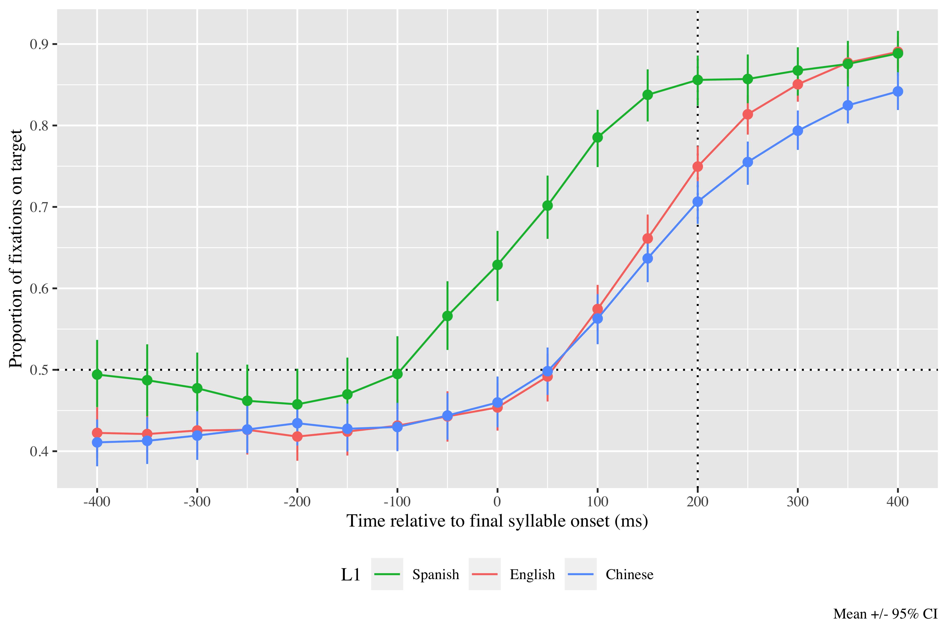

*Figure* *1:*. Figure 2. Fixations on target verbs from 400 ms before to 400 ms after the onset of verbs’ last syllable, as a function of L1 experience. Error bars represent the 95% CI across speakers in proportion of fixations on the target..

# Monolingual results

The linear (γ10 = 2.63; SE = 0.31; *t* = 8.52; *p* < .001) and quadratic time terms (γ20 = 0.68; SE = 0.16; *t* = 4.14; *p* < .001) captured the GCA curve and were retained in the model. The model intercept estimates the log odds of monolinguals fixating on the target above chance 200 ms after the onset of the verb’s final syllable at γ00 = 0.72; SE = 0.13; *t* = 5.55; *p* < .001 (proportion = .92; lower bound = .90; upper bound = .94). These numbers reveal that monolinguals fixated above chance on the target at the onset of the syllable with the suffix. These results suggest that they were using the lexical stress information in the first syllables to predict the tense suffixes.

|  |  |  |  |  |
| --- | --- | --- | --- | --- |
| Parameter | Estimate | SE | *t* | *p* |
| Intercept (γ00) | 0.722 | 0.130 | 5.548 | < .001 |
| Time1 (γ10) | 2.628 | 0.309 | 8.516 | < .001 |
| Time2 (γ20) | 0.676 | 0.163 | 4.140 | < .001 |

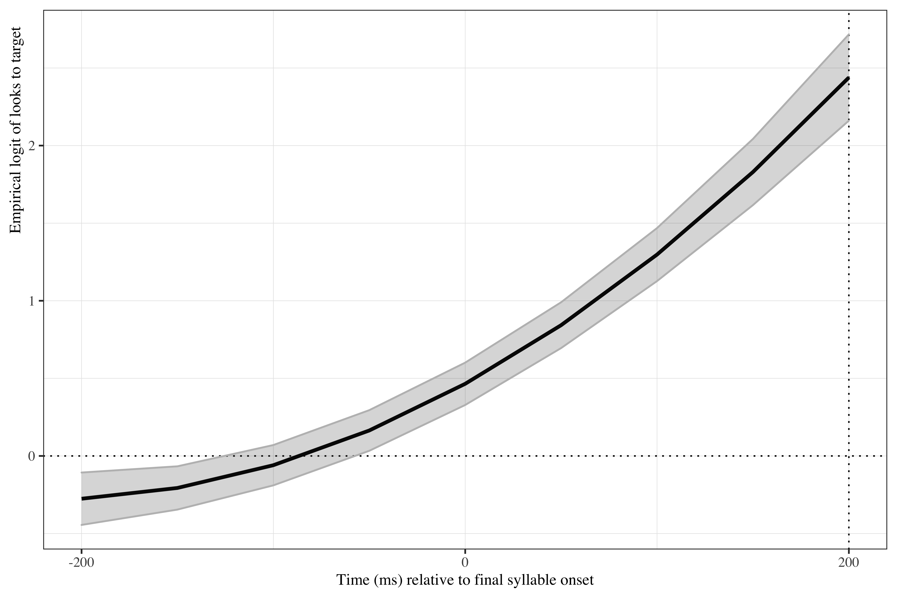

*Figure* *2:*. Figure 3. Growth curve analysis estimates of fixations on target as a function of lexical stress for the Spanish monolingual speakers during the analysis window. Lines represent model estimates, and the transparent ribbons represent ±SE. Empirical logit values on y-axis correspond to proportions of 0.12, 0.50, 0.88, and 0.98. The horizontal dotted line represents the 50% probability of fixating on the targets. The vertical dotted line indicates 200 ms after the onset of the last syllable.

# Learner results

The linear (γ10 = 2.60; SE = 0.25; *t* = 10.24; *p* < .001) and quadratic (γ20 = 1.16; SE = 0.09; *t* = 12.27; *p* < .001) time terms improved the curved fit. The log odds estimated by the model of L2 speakers fixating on the target at the onset of the second syllable in the verbs are (γNA =  NA; SE =  NA; *t* =  NA; _p_NA NA). The probabilities by condition of all learners fixating on targets before hearing the syllable with the suffix are in Table 2.

|  |  |  |  |  |
| --- | --- | --- | --- | --- |
| Parameter | Estimate | SE | *t* | *p* |
| Intercept (γ00) | 0.168 | 0.129 | 1.307 | .191 |
| Time1 (γ10) | 2.599 | 0.254 | 10.242 | < .001 |
| Time2 (γ20) | 1.160 | 0.094 | 12.273 | < .001 |
| Lexical stress (γ01) | 0.241 | 0.109 | 2.215 | .027 |
| DELE_z (γ02) | 0.229 | 0.112 | 2.049 | .040 |
| Lexical stress × DELE_z (γ03) | 0.059 | 0.101 | 0.585 | .559 |
| Time1 × Lexical stress × DELE_z (γ13) | 0.228 | 0.113 | 2.017 | .044 |
| *Table:* The first digit in the sub-index indicates whether the effect | occurs on t | he inter | cept (0), | the linear time term (1), or the quadratic time term (2). The second digit refers to the effects themselves (0 = intercept, 1 = Spanish proficiency, 2 = Spanish use, etc.). |

There was an effect of lexical stress on the intercept ( chi2; (1) = 4.286, *p* < .038). Oxytones were more likely to be fixated on than paroxytones were (γ01 = 0.24; SE = 0.11; *t* = 2.21; *p* = .027). There was a main effect of L2 proficiency ( chi2; (1) = 4.132, *p* < .042). As proficiency increased, so did the probability of fixating on the target (γ02 = 0.23; SE = 0.11; *t* = 2.05; *p* = .04). There was an interaction between lexical stress and L2 proficiency on the linear time term ( chi2; (1) = 4.063, *p* < .044). Higher proficiency contributed to a greater probability of both L2 populations fixating on the target in the oxytone condition (γ13 = 0.23; SE = 0.11; *t* = 2.02; *p* = .044).

Table 1:

| L1 experience | Stress pattern | L2 proficiency | Probability | Lower bound | Upper bound |
| --- | --- | --- | --- | --- | --- |
| English | Paroxytone (Present) | -1 | 0.86 | 0.83 | 0.89 |
|  |  | 0 | 0.87 | 0.84 | 0.89 |
|  |  | 1 | 0.87 | 0.84 | 0.90 |
|  | Oxytone (Preterite) | -1 | 0.88 | 0.85 | 0.90 |
|  |  | 0 | 0.91 | 0.90 | 0.93 |
|  |  | 1 | 0.94 | 0.92 | 0.95 |
| Mandarin | Paroxytone (Present) | -1 | 0.86 | 0.83 | 0.89 |
|  |  | 0 | 0.87 | 0.84 | 0.89 |
|  |  | 1 | 0.87 | 0.84 | 0.90 |
|  | Oxytone (Preterite) | -1 | 0.88 | 0.85 | 0.90 |
|  |  | 0 | 0.91 | 0.90 | 0.93 |
|  |  | 1 | 0.94 | 0.92 | 0.95 |

*Table 2*: Model estimates for probability of target fixations ±SE at 200 ms after the last syllable’s onset as a function of L2 proficiency. The values in the L2 proficiency column represent the mean score for our samples (0), one standard deviation below (-1), and one standard deviation above (1) for normalized scores.

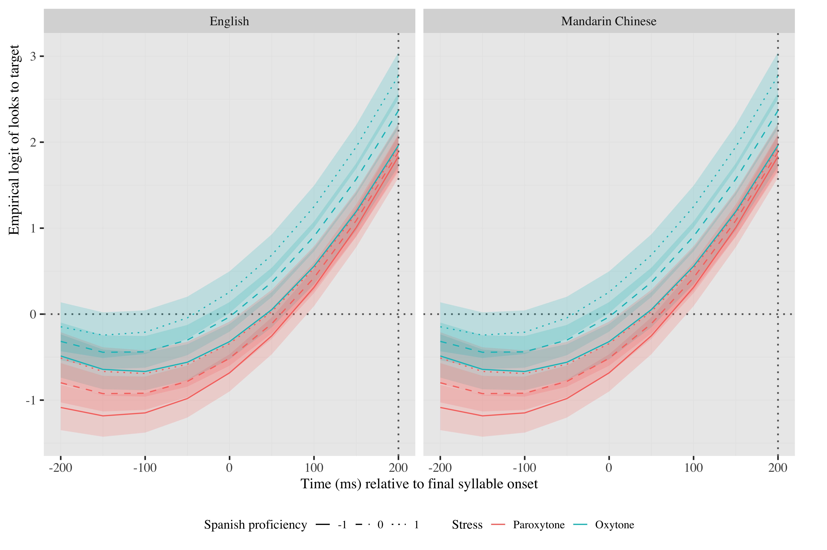

*Figure* *3:*. Figure 5. Growth curve analysis estimates of fixations on target as a function of L2 proficiency and L2 use for each L2 group during the analysis window. Lines represent model estimates, and the transparent ribbons represent ±SE. Empirical logit values on y-axis correspond to proportions of 0.27, 0.50, 0.73, 0.88, and 0.95. The horizontal dotted line represents the 50% probability of fixating on the targets. The vertical dotted line indicates 200 ms after the onset of the last syllable.

The linear (γ10 = 2.60; SE = 0.25; *t* = 10.24; *p* < .001), quadratic (γ20 = 1.16; SE = 0.09; *t* = 12.27; *p* < .001) and cubic (γ01 = 0.24; SE = 0.11; *t* = 2.21; *p* = .027) time terms were retained for the model. The log odds estimated by the model of L2 speakers fixating on the target at the onset of the second syllable in the verbs are (γNA =  NA; SE =  NA; *t* =  NA; _p_NA NA). The probabilities by condition of all learners fixating on targets before hearing the syllable with the suffix are in Table 3.

There was an effect of stress on the intercept ( chi2; (1) = 5.380, *p* < .020). Again, oxytones attracted a greater number of fixations on the target at second syllable onset than paroxytones did (γ30 = 0.09; SE = 0.07; *t* = 1.27; *p* = .205). There was a main effect of use on the linear term ( chi2; (1) = 6.752, *p* < .009). Participants with more extensive fixated on the targets faster than participants with average or low Spanish use, as evidenced by the steeper dotted line in Figure 5 (γ02 = −0.05; SE = 0.07; *t* = −0.73; *p* = .466). There was an interaction between L1 experience and stress on the quadratic time term ( chi2; (1) = 137.304, *p* < .001), but the parameter was not significant in the final model. Finally, there was an interaction between lexical stress pattern and use on the linear time term ( chi2; (1) = 4.936, *p* < .026). Participants who used Spanish more frequently fixated on the targets faster especially in the paroxytone condition in comparison to participants with lower amount of Spanish use and in comparison to the oxytone condition (γ23 = 0.02; SE = 0.07; *t* = 0.35; *p* = .727).

|  |  |  |  |  |
| --- | --- | --- | --- | --- |
| Parameter | Estimate | SE | *t* | *p* |
| Intercept (γ00) | 0.044 | 0.065 | 0.678 | .498 |
| Time1 (γ10) | 1.395 | 0.152 | 9.201 | < .001 |
| Time2 (γ20) | 0.655 | 0.074 | 8.858 | < .001 |
| Time3 (γ30) | 0.088 | 0.069 | 1.268 | .205 |
| Lexical stress (γ01) | 0.141 | 0.061 | 2.300 | .021 |
| use_z (γ02) | −0.049 | 0.067 | −0.730 | .466 |
| Time1 × use_z (γ12) | 0.348 | 0.131 | 2.649 | .008 |
| Lexical stress × l1_sum (γ03) | 0.013 | 0.047 | 0.272 | .786 |
| Lexical stress × use_z (γ04) | 0.064 | 0.063 | 1.015 | .310 |
| Time1 × Lexical stress × l1_sum (γ13) | −0.095 | 0.067 | −1.422 | .155 |
| Time2 × Lexical stress × l1_sum (γ23) | 0.023 | 0.067 | 0.349 | .727 |
| Time1 × Lexical stress × use_z (γ14) | −0.203 | 0.090 | −2.244 | .025 |

Table 2:

| L1 experience | Stress pattern | L2 use | Probability | Lower bound | Upper bound |
| --- | --- | --- | --- | --- | --- |
| English | Paroxytone (Present) | -1 | 0.69 | 0.65 | 0.73 |
|  |  | 0 | 0.73 | 0.70 | 0.76 |
|  |  | 1 | 0.76 | 0.72 | 0.80 |
|  | Oxytone (Preterite) | -1 | 0.77 | 0.74 | 0.80 |
|  |  | 0 | 0.79 | 0.76 | 0.81 |
|  |  | 1 | 0.80 | 0.77 | 0.83 |
| Mandarin | Paroxytone (Present) | -1 | 0.70 | 0.66 | 0.74 |
|  |  | 0 | 0.74 | 0.71 | 0.76 |
|  |  | 1 | 0.77 | 0.73 | 0.80 |
|  | Oxytone (Preterite) | -1 | 0.76 | 0.73 | 0.80 |
|  |  | 0 | 0.78 | 0.76 | 0.80 |
|  |  | 1 | 0.80 | 0.76 | 0.82 |

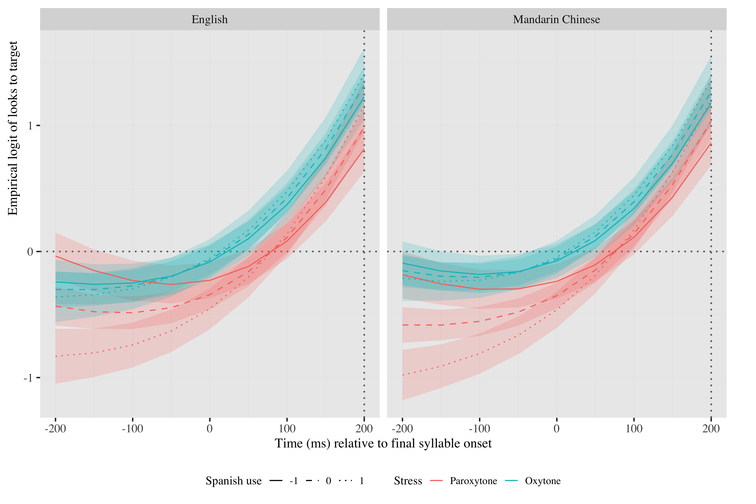

*Figure* *4:*. Figure 5. Growth curve analysis estimates of fixations on target as a function of L2 proficiency and L2 use for each L2 group during the analysis window. Lines represent model estimates, and the transparent ribbons represent ±SE. Empirical logit values on y-axis correspond to proportions of 0.27, 0.50, 0.73, 0.88, and 0.95. The horizontal dotted line represents the 50% probability of fixating on the targets. The vertical dotted line indicates 200 ms after the onset of the last syllable.

# Other plots

# Tables

## Random effects

|  |  |  |  |  |  |  |  |
| --- | --- | --- | --- | --- | --- | --- | --- |
| Group | Parameter | Variance | SD | Correlations |  |  |  |
| Participant | Intercept | 0.110 | 0.332 | 1.00 |  |  |  |
|  | Lexical stress | 0.064 | 0.253 | .16 | 1.00 |  |  |
|  | Time1 | 1.388 | 1.178 | .54 | .42 | 1.00 |  |
|  | Time2 | 0.268 | 0.518 | .33 | .48 | .76 | 1.00 |
| Item | Intercept | 0.363 | 0.602 | 1.00 |  |  |  |
|  | Time1 | 0.987 | 0.994 | .36 |  | 1.00 |  |
| Residual |  | 8.940 | 2.990 |  |  |  |  |

Appendix 5.Growth curve model random effects (monolinguals)

|  |  |  |  |  |  |  |  |  |  |
| --- | --- | --- | --- | --- | --- | --- | --- | --- | --- |
| Group | Parameter | Variance | SD | Correlations |  |  |  |  |  |
| Participant | Intercept | 0.661 | 0.813 | 1.00 |  |  |  |  |  |
|  | Lexical stress | 0.478 | 0.692 | −.10 | 1.00 |  |  |  |  |
|  | Time1 | 2.076 | 1.441 | −.07 | .11 |  |  | 1.00 |  |
|  | Time2 | 0.072 | 0.268 | −.91 | .04 |  |  | .47 | 1.00 |
| Item | Intercept | 0.356 | 0.596 | 1.00 |  |  |  |  |  |
|  | DELE_z | 0.098 | 0.312 | −.09 |  | 1.00 |  |  |  |
|  | l1_sum | 0.107 | 0.327 | −.62 |  | −.02 | 1.00 |  |  |
|  | Time1 | 1.260 | 1.123 | −.20 |  | −.08 | .09 | 1.00 |  |
| Residual |  | 16.641 | 4.079 |  |  |  |  |  |  |

Appendix 6: Growth curve model random effects (L2 proficiency)

|  |  |  |  |  |  |  |  |  |  |  |
| --- | --- | --- | --- | --- | --- | --- | --- | --- | --- | --- |
| Group | Parameter | Variance | SD | Correlations |  |  |  |  |  |  |
| Participant | Intercept | 0.150 | 0.388 | 1.00 |  |  |  |  |  |  |
|  | Lexical stress | 0.129 | 0.360 | −.17 | 1.00 |  |  |  |  |  |
|  | Time1 | 0.566 | 0.752 | .04 | .16 |  | 1.00 |  |  |  |
|  | Time2 | 0.039 | 0.198 | −.49 | −.77 |  | −.13 | 1.00 |  |  |
| Item | Intercept | 0.084 | 0.290 | 1.00 |  |  |  |  |  |  |
|  | use_z | 0.043 | 0.208 | −.38 |  |  |  |  |  | 1.00 |
|  | l1_sum | 0.031 | 0.175 | −.61 |  | 1.00 |  |  |  | −.24 |
|  | Time1 | 0.395 | 0.629 | −.04 |  | −.22 | 1.00 |  |  | .27 |
|  | Time2 | 0.026 | 0.160 | .08 |  | −.61 | .57 | 1.00 |  | .01 |
|  | Time3 | 0.014 | 0.120 | .64 |  | .09 | −.09 | −.07 | 1.00 | −.91 |
| Residual |  | 9.808 | 3.132 |  |  |  |  |  |  |  |

# References