The title

The title

GCA model formulas and summaries are in Appendices S3 (monolinguals), S4 (learners’ proficiency and L1 experience), S5 (learners’ L2 use and L1 experience) and S6 (learners’ proficiency and use). Figure 2 represents fixations towards the target verb over time. The figure suggests that all groups fixated on target verbs above chance before hearing the suffix, and that monolinguals fixated on targets earlier than L2ers.

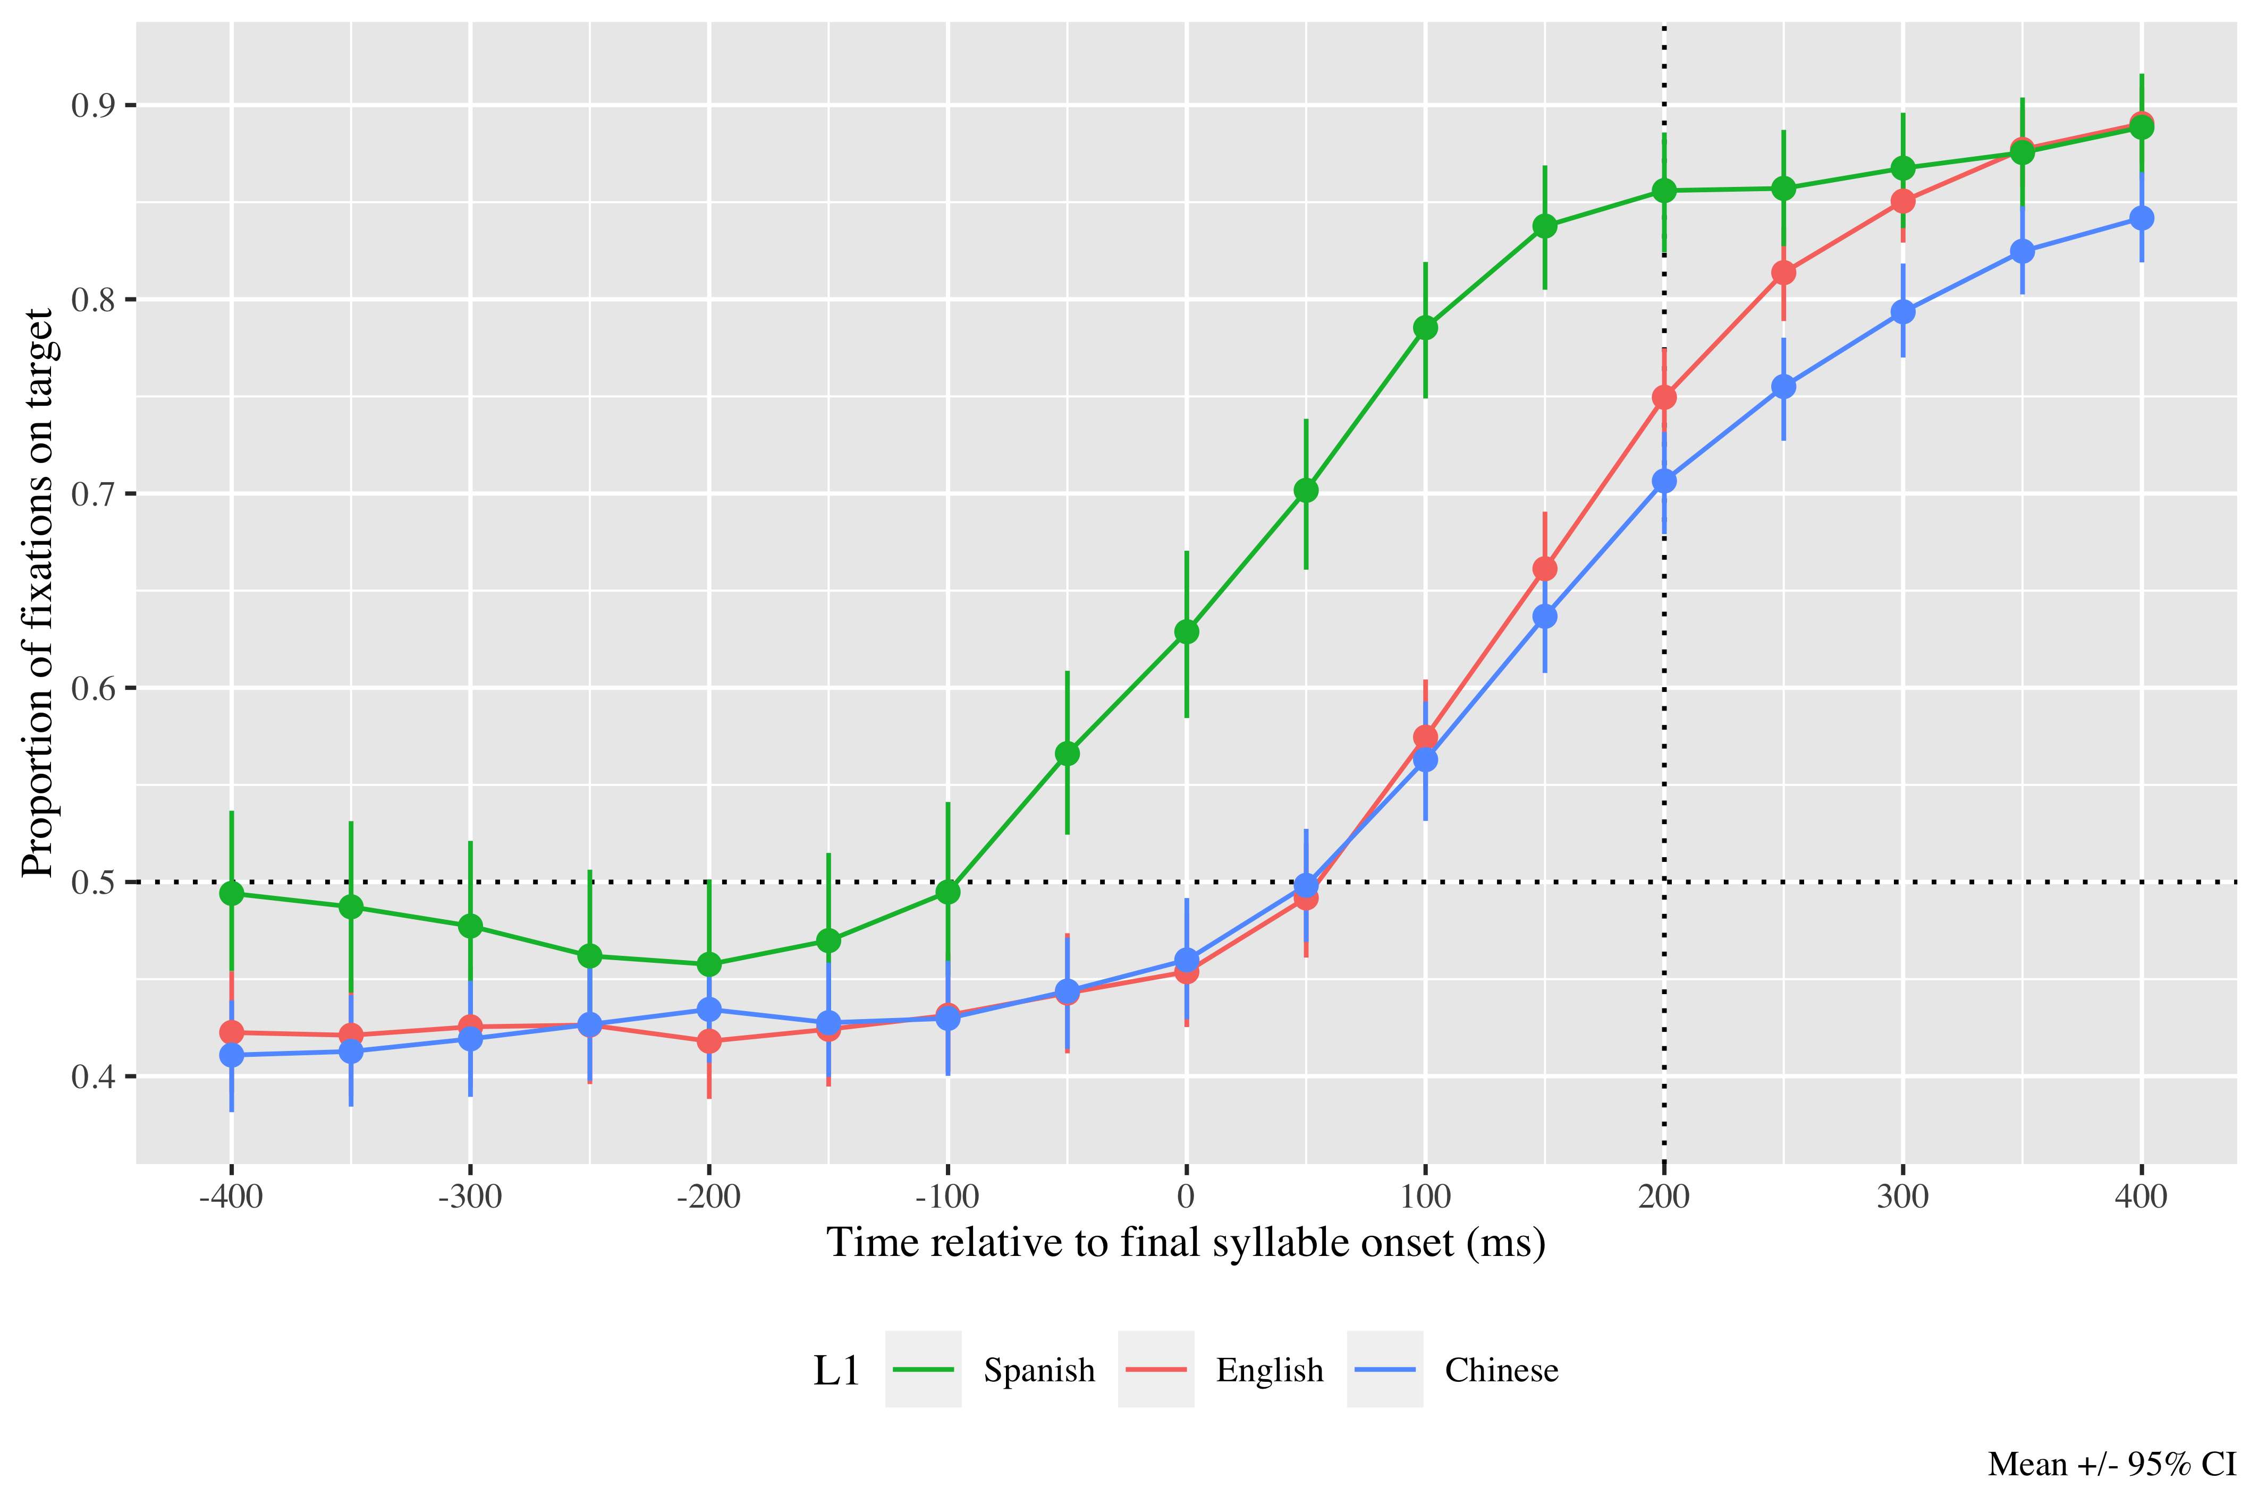

*Figure* 2. Fixations on target verbs from 400 ms before to 400 ms after the onset of verbs’ last syllable, as a function of L1 experience. Error bars represent the 95% CI across speakers in proportion of fixations on the target.

# Monolingual results

The linear (γ10 = 2.38; SE = 0.14; *t* = 17.30; *p* < .001) and quadratic time terms (γ20 = 0.54; SE = 0.13; *t* = 4.07; *p* < .001) captured the GCA curve and were retained in the model. The model intercept estimates the log odds of monolinguals fixating on the target above chance 200 ms after the onset of the verb’s final syllable at γ00 = 0.65; SE = 0.12; *t* = 5.45; *p* < .001 (proportion = .66; probability = .90; lower bound = .88; upper bound = .91). These numbers reveal that monolinguals fixated above chance on the target at the onset of the syllable with the suffix, suggesting that they were using the lexical stress information in the first syllables to predict the tense suffixes.

**Learner results**

The linear (γ10 = 1.18; SE = 0.07; *t* = 17.97; *p* < .001) and quadratic (γ20 = 0.61; SE = 0.07; *t* = 9.21; *p* < .001) time terms improved the curved fit and were thus retained. The log odds estimated by the model of L2 speakers fixating on the target at the onset of the second syllable in the verbs are (γ00 = 0.05; SE = 0.07; *t* = 0.69; *p* = .489) (proportion = .51). The probabilities by proficiency condition of all learners fixating on targets before hearing the syllable with the suffix are in Table 2.

There was an effect of lexical stress on the intercept (χ2; (1) = 4.601, *p* = .032) and the linear time term (χ2; (1) = 5.064, *p* = .024), indicating that oxytones were more likely to be predicted (γ01 = 0.11; SE = 0.05; *t* = 2.09; *p* = .037) and were predicted earlier (γ11 = 0.15; SE = 0.07; *t* = 2.33; *p* = .02). There was an effect of L2 proficiency on the intercept (χ2; (1) = 3.963, *p* = .047) and the linear time term (χ2; (1) = 12.204, *p* < .001), also evidencing that higher proficiency speakers predicted more (γ02 = 0.07; SE = 0.04; *t* = 1.89; *p* = .058) and earlier (γ12 = 0.23; SE = 0.07; *t* = 3.47; *p* < .001) than lower proficiency speakers. Finally, there was an interaction between proficiency and stress on the intercept (chi2; (1) = 5.630, *p* = .018), revealing that higher proficiency made prediction more likely especially in the oxytone condition (γ03 = 0.05; SE = 0.02; *t* = 2.37; *p* = .018).

**Table 2**

*Model estimates for probability of target fixations ±SE at 200 ms after the last syllable’s onset as a function of L2 proficiency and L1 experience. The values in the L2 proficiency column represent the mean score for our samples (0), one standard deviation below (-1), and one standard deviation above (1) for normalized scores.*

| L1 experience | Stress pattern | L2 proficiency | Probability | Lower bound | Upper bound |
| --- | --- | --- | --- | --- | --- |
| English | Paroxytone (Present) | -1 | 0.66 | 0.63 | 0.68 |
|  |  | 0 | 0.69 | 0.67 | 0.71 |
|  |  | 1 | 0.72 | 0.69 | 0.74 |
|  | Oxytone (Preterite) | -1 | 0.72 | 0.69 | 0.74 |
|  |  | 0 | 0.76 | 0.74 | 0.78 |
|  |  | 1 | 0.80 | 0.78 | 0.82 |
| Mandarin | Paroxytone (Present) | -1 | 0.66 | 0.63 | 0.68 |
|  |  | 0 | 0.69 | 0.67 | 0.71 |
|  |  | 1 | 0.72 | 0.69 | 0.74 |
|  | Oxytone (Preterite) | -1 | 0.72 | 0.69 | 0.74 |
|  |  | 0 | 0.76 | 0.74 | 0.78 |
|  |  | 1 | 0.80 | 0.78 | 0.82 |

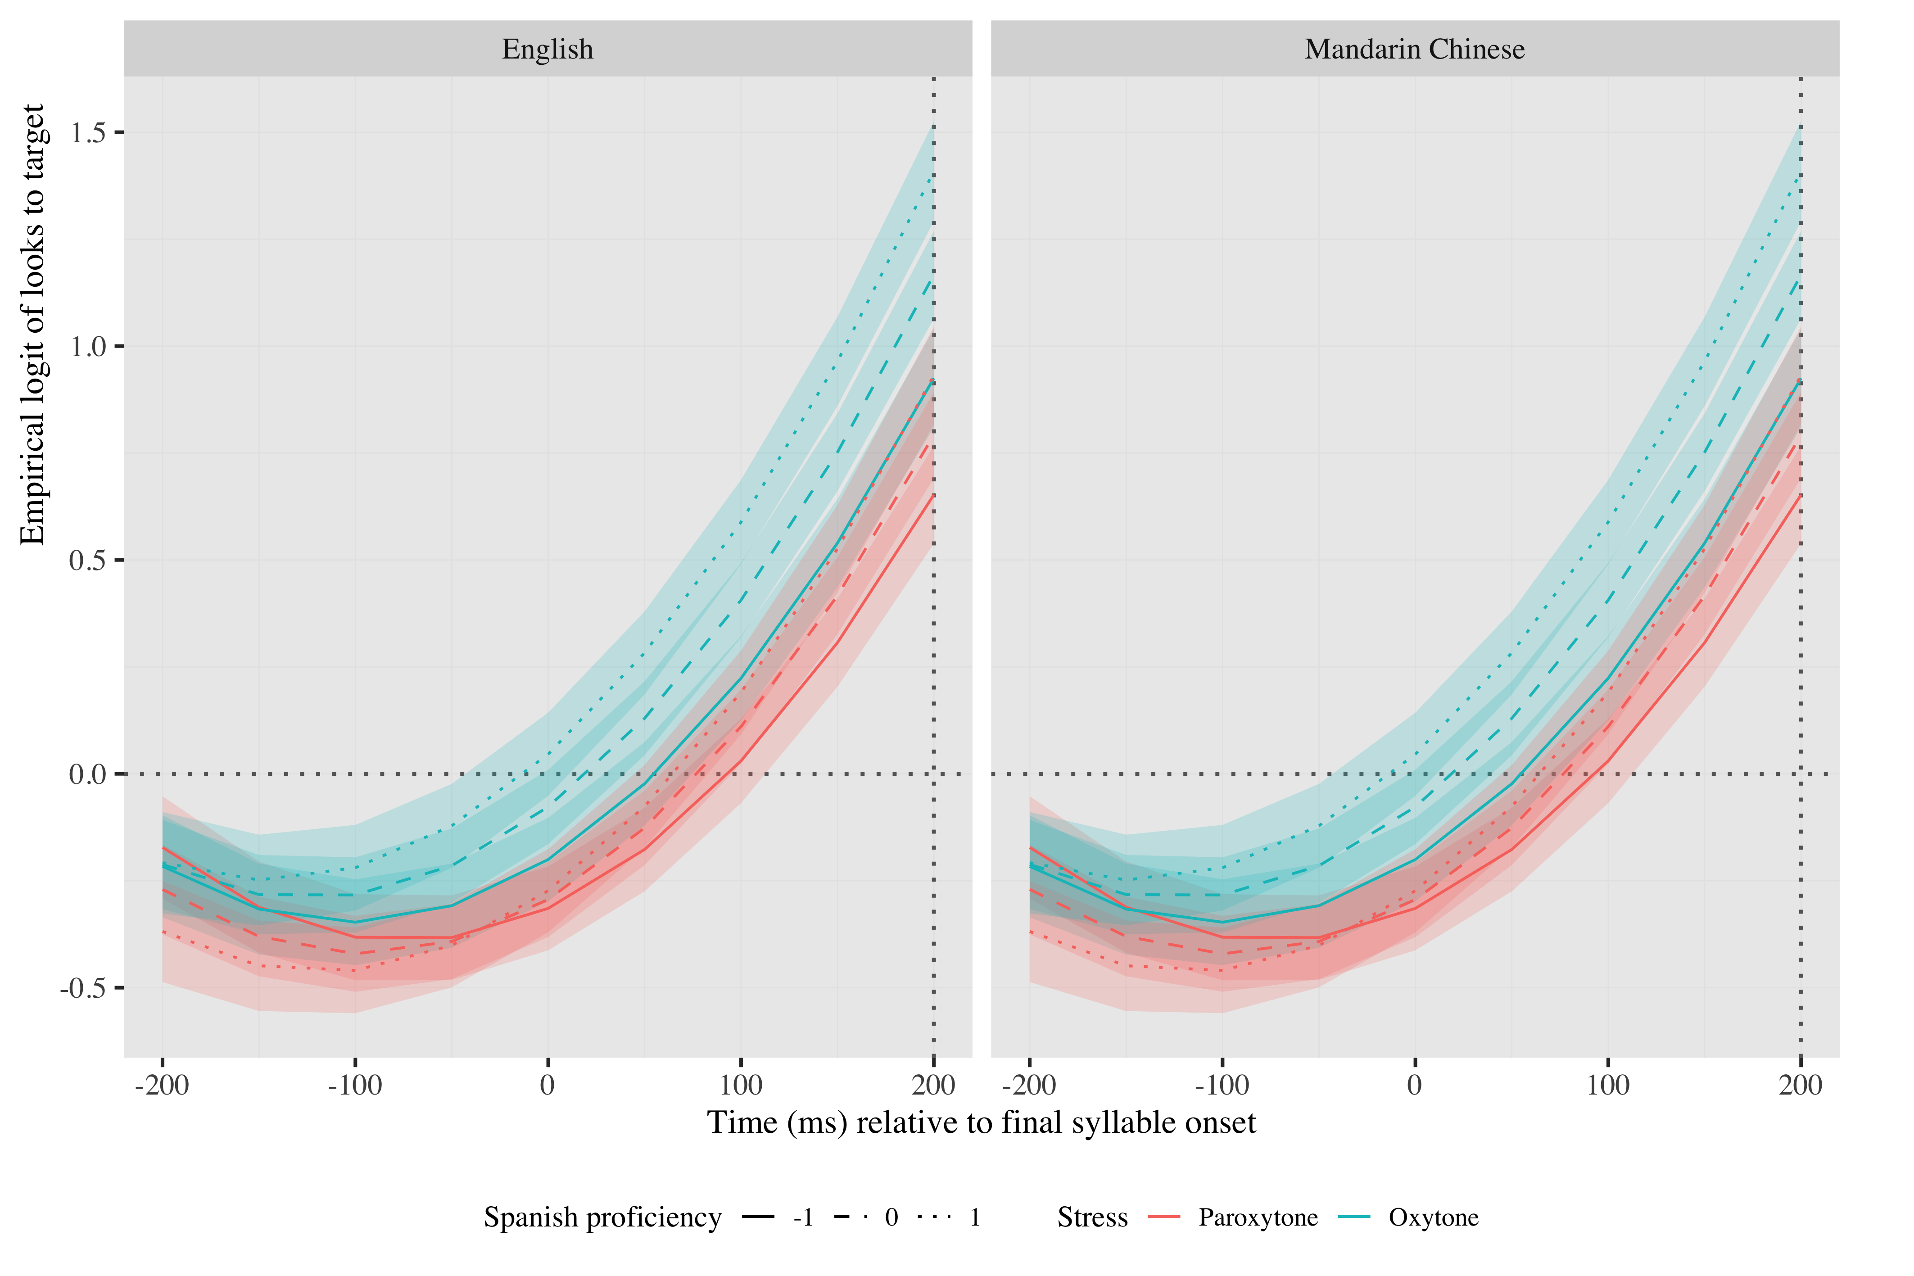

*Figure 5.* Growth curve analysis estimates of fixations on target as a function of L2 proficiency and L2 use for each L2 group during the analysis window. Lines represent model estimates, and the transparent ribbons represent ±SE. Empirical logit values on y-axis correspond to proportions of 0.27, 0.50, 0.73, 0.88, and 0.95. The horizontal dotted line represents the 50% probability of fixating on the targets. The vertical dotted line indicates 200 ms after the onset of the last syllable.

The linear (γ10 = 1.18; SE = 0.07; *t* = 17.84; *p* < .001) and quadratic (γ20 = 0.60; SE = 0.07; *t* = 9.14; *p* < .001) time terms were retained for the model. The log odds estimated by the model of L2 speakers fixating on the target at the onset of the second syllable in the verbs are (γNA =  NA; SE =  NA; *t* =  NA; _p_NA NA) (proportion = .51). The probabilities by Spanish use condition of all learners fixating on targets before hearing the syllable with the suffix are in Table 3.

There was an effect of stress on the intercept (χ2; (1) = 4.601, *p* = .032) and the linear time term (χ2; (1) = 5.064, *p* = .024). Again, oxytones were more likely (γ01 = 0.10; SE = 0.05; *t* = 1.93; *p* = .054) and earlier (γ11 = 0.15; SE = 0.07; *t* = 2.31; *p* = .021) to be predicted. There was an effect of use on the linear time term (χ2; (1) = 7.860, *p* = .005). Learners who used Spanish more extensively predicted faster than speakers with low use, as evidence by the steeper slopes in Figure 5 (γ12 = 0.18; SE = 0.06; *t* = 2.80; *p* = .005). There was an interaction between stress and L2 use on the intercept (χ2; (1) = 5.875, *p* = .015) and the linear time term (χ2; (1) = 4.694, *p* = .030). Increased use was particularly helpful in paroxytones, contributing to faster prediction in that condition (γ13 = −0.13; SE = 0.06; *t* = −2.06; *p* = .04). Lastly, there was an interaction between L1 experience, L2 use and stress on the intercept (χ2; (1) = 5.787, *p* = .016). English speakers not only predicted paroxytones faster the greater their L2 use, but they were also more likely to predict them; Chinese speakers, in contrast, predicted paroxytones faster and were more likely to predict oxytones as their L2 use increased (γ04 = 0.05; SE = 0.02; *t* = 2.41; *p* = .016) (see Figure 5).

**Table 3**

*Model estimates for probability of target fixations ±SE at 200 ms after the last syllable’s onset as a function of L2 use and L1 experience. The values in the L2 proficiency column represent the mean score for our samples (0), one standard deviation below (-1), and one standard deviation above (1) for normalized scores.*

| L1 experience | Stress pattern | L2 use | Probability | Lower bound | Upper bound |
| --- | --- | --- | --- | --- | --- |
| English | Paroxytone (Present) | -1 | 0.66 | 0.63 | 0.68 |
|  |  | 0 | 0.69 | 0.67 | 0.71 |
|  |  | 1 | 0.72 | 0.69 | 0.74 |
|  | Oxytone (Preterite) | -1 | 0.76 | 0.74 | 0.78 |
|  |  | 0 | 0.76 | 0.74 | 0.78 |
|  |  | 1 | 0.76 | 0.73 | 0.78 |
| Mandarin | Paroxytone (Present) | -1 | 0.68 | 0.65 | 0.71 |
|  |  | 0 | 0.69 | 0.67 | 0.71 |
|  |  | 1 | 0.70 | 0.67 | 0.72 |
|  | Oxytone (Preterite) | -1 | 0.74 | 0.72 | 0.76 |
|  |  | 0 | 0.76 | 0.74 | 0.78 |
|  |  | 1 | 0.78 | 0.75 | 0.80 |

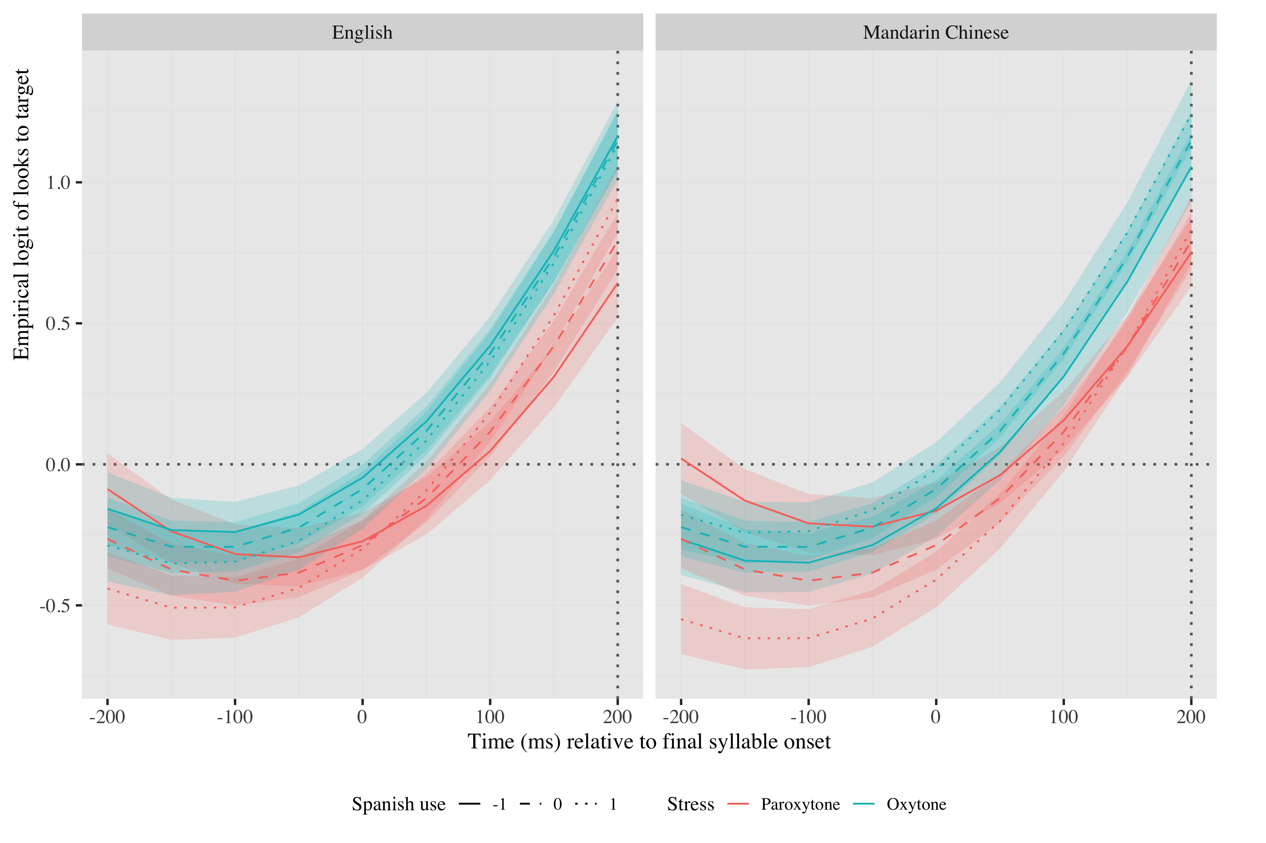

*Figure 5*. Growth curve analysis estimates of fixations on target as a function of L2 proficiency and L2 use for each L2 group during the analysis window. Lines represent model estimates, and the transparent ribbons represent ±SE. Empirical logit values on y-axis correspond to proportions of 0.27, 0.50, 0.73, 0.88, and 0.95. The horizontal dotted line represents the 50% probability of fixating on the targets. The vertical dotted line indicates 200 ms after the onset of the last syllable.

The linear (γ10 = 1.13; SE = 0.07; *t* = 16.69; *p* < .001) and quadratic (γ20 = 0.60; SE = 0.07; *t* = 9.12; *p* < .001) time terms were retained for the model. The log odds estimated by the model of L2 speakers fixating on the target at the onset of the second syllable in the verbs are (γNA =  NA; SE =  NA; *t* =  NA; _p_NA NA) (proportion = .51). The probabilities by experience condition of all learners fixating on targets before hearing the syllable with the suffix are in Table 4.

There was an effect of proficiency on the intercept (χ2; (1) = 3.874, *p* = .049) and the linear time term (χ2; (1) = 11.950, *p* = .001). Higher proficiency resulted in more likely (γ01 = 0.08; SE = 0.04; *t* = 2.05; *p* = .04) and earlier prediction (γ11 = 0.20; SE = 0.07; *t* = 2.91; *p* = .004). There was a main effect of use on the linear term (χ2; (1) = 4.111, *p* = .043), indicating speakers with higher use predicted faster (γ12 = 0.15; SE = 0.07; *t* = 2.20; *p* = .028). There was an interaction between L1 experience and proficiency on the linear time term (χ2; (1) = 3.930, *p* = .047). In Mandarin speakers, higher proficiency especially contributed to earlier prediction in comparison with lower proficient speakers, while the difference was not as large in English speakers (γ13 = −0.14; SE = 0.07; *t* = −2.14; *p* = .032). There was also an interaction between proficiency and use on the linear time term (χ2; (1) = 5.053, *p* = .025), such that increased use resulted in faster prediction particularly at higher levels of proficiency (γ14 = 0.15; SE = 0.07; *t* = 2.25; *p* = .025).

**Table 4**

*Model estimates for probability of target fixations ±SE at 200 ms after the last syllable’s onset as a function language experience. The values in the L2 proficiency column represent the mean score for our samples (0), one standard deviation below (-1), and one standard deviation above (1) for normalized scores.*

| L1 experience | L2 proficiency | L2 use | Probability | Lower bound | Upper bound |
| --- | --- | --- | --- | --- | --- |
| English | -1 | -1 | 0.69 | 0.66 | 0.72 |
|  |  | 0 | 0.68 | 0.66 | 0.70 |
|  |  | 1 | 0.67 | 0.64 | 0.70 |
|  | 0 | -1 | 0.72 | 0.70 | 0.74 |
|  |  | 0 | 0.72 | 0.70 | 0.74 |
|  |  | 1 | 0.73 | 0.71 | 0.75 |
|  | 1 | -1 | 0.74 | 0.71 | 0.77 |
|  |  | 0 | 0.76 | 0.74 | 0.78 |
|  |  | 1 | 0.78 | 0.75 | 0.80 |
| Mandarin | -1 | -1 | 0.70 | 0.67 | 0.72 |
|  |  | 0 | 0.69 | 0.66 | 0.71 |
|  |  | 1 | 0.68 | 0.65 | 0.71 |
|  | 0 | -1 | 0.72 | 0.70 | 0.74 |
|  |  | 0 | 0.72 | 0.70 | 0.74 |
|  |  | 1 | 0.73 | 0.71 | 0.75 |
|  | 1 | -1 | 0.74 | 0.71 | 0.76 |
|  |  | 0 | 0.75 | 0.73 | 0.77 |
|  |  | 1 | 0.77 | 0.75 | 0.79 |

*Figure 6*. Growth curve analysis estimates of fixations on target as a function of language experience for each L2 group during the analysis window. Lines represent model estimates, and the transparent ribbons represent ±SE. Empirical logit values on y-axis correspond to proportions of 0.27, 0.50, 0.73, 0.88, and 0.95. The horizontal dotted line represents the 50% probability of fixating on the targets. The vertical dotted line indicates 200 ms after the onset of the last syllable.

# 