Results

**4.4. Data analysis**

Statistical analyses were conducted on R (R Core Team, 2021) with the package lme4 (Bates, Mächler, Bolker, & Walker, 2014).

In the visuospatial prediction data, trials that timed out before the participant pressed the key were discarded (~25%). Those trials whose timing exceeded two standard deviations from the mean were also removed, imitating Broeker et al. (2020). The clean data was analyzed using a generalized linear mixed model. The timing of the key press was used as outcome. The predictors were speed of the trial and direction of the car (contrast-coded). Since speed had three levels, the slow condition was taken as base level, and pairwise comparisons were run between the medium and fast speeds. The model also contained by-subject random intercepts. The random effects not explained by the model were used as measure of visuospatial prediction ability for later analyses.

The gaze fixation data were downsampled to 50 ms bins and incorrect responses were filtered out (0.42% of data). A growth curve analysis (GCA, Mirman, 2016) with mixed effects was used to analyze the association between prediction abilities in the time window around the verb encompassing the departure of looks from chance levels. The time window spanned from 200 ms before to 200 ms after the onset of the last syllable in the verb. The GCA one included stress pattern, visuospatial prediction variance, the linear and quadratic orthogonal polynomial time terms as fixed effects. The linear and quadratic orthogonal polynomial time terms model the time course in the GCA. By-subject and by-item random intercepts were included. No random slopes were included as the models resulted singular when they were. The outcome data, proportion of fixations on the target at the onset of the last syllable on the verb from the eye-tracking prediction task, was modified using the weighted empirical logic transformation, as it is binary data (fixations on the target or the distractor; Barr, 2008). Main effects and interactions were assessed by means of nested model comparisons. The fixation probabilities were extracted for 200 ms after the onset of the last syllable to account for saccade planning and launching, as is standard procedure in auditory eye-tracking studies (e.g., Fischer, 1992; Saslow, 1967).

# 5. Results

A generalized linear mixed model run on the visuospatial prediction data revealed that the parameters for direction and speed were both significant. Participants pressed closer to the supposed reappearance ms in trials in which the car moved from left to right, in comparison to trials from right to left (*ß* = 0.01, SE = 0.01, *t* = 2.54, *p* = 0.011). In slow conditions participants were more accurate than in medium (*ß* = 0.07, SE = 0.01, *t* = 5.19, *p*< 0.001) and fast speed conditions (*ß* = 0.04, SE = 0.01, *t* = 2.92, *p* = 0.004) A pairwise comparison revealed that the fast speed condition was also more accurate than the medium speed condition (*ß* = 0.03, SE = 0.02, *t* = 2.03, *p* = 0.042). The variance not explained by these results was the one used in the GCA with language prediction. In order to understand better possible effects, these data were summarised using descriptive analyses (see Table 1).

*Table 1.* Descriptive statistics of the variance in the visuospatial prediction data not explained by the predictors.

|  |  |  |  |  |
| --- | --- | --- | --- | --- |
|  | *M* | *SD* | min | max |
| Visuospatial prediction variance | –0.01 | 0.19 | –0.45 | 0.21 |

Figure 3 shows the time course of participants’ fixations on the targets during our time window. As observed, participants started to direct their gaze to the target above chance before hearing the suffix. That is, they were fixating on the target above chance at the onset of the last syllable in the verbs—the syllable containing the suffix to be predicted.

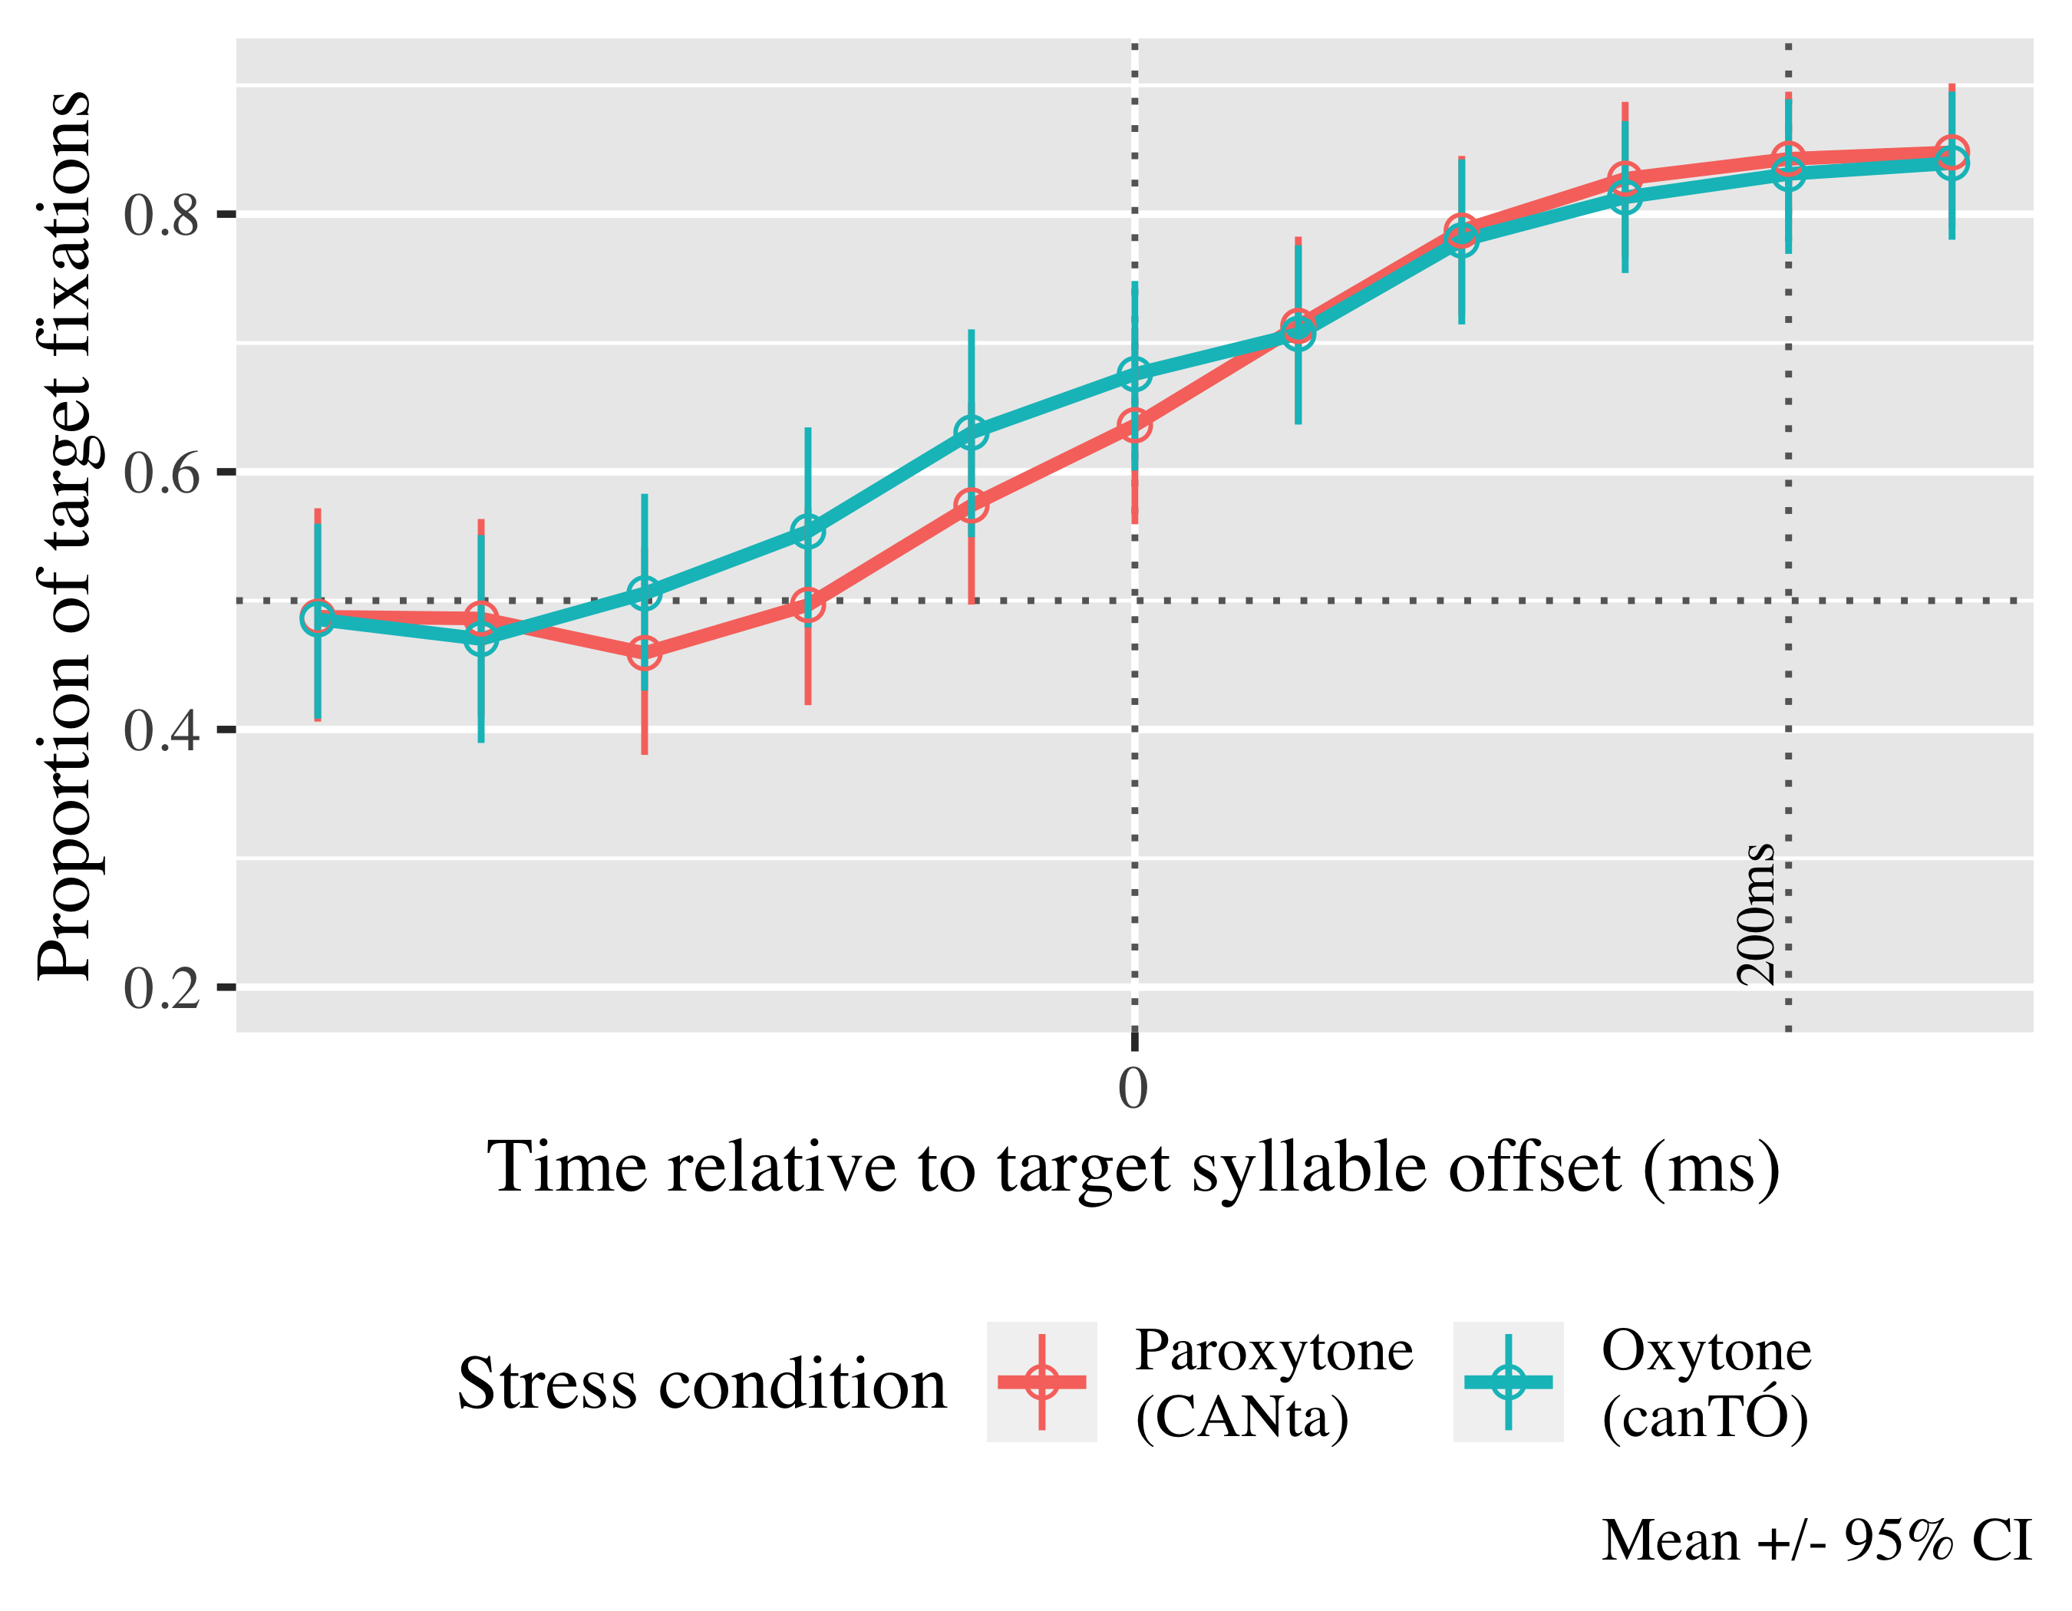

*Figure* *3*. Time course of fixations on the target verb.

For the full model summary see Appendices 2 (fixed effects) and 3 (random effects). The log odds of participants fixating on the target at 200 ms after the objective onset of the last syllable in the verb estimated by the processing speeds model is γ00 = 0.70; SE = 0.15; *t* = 4.66; *p* < .001 (proportion = .67). The exact probabilities for each condition can be found in Table 2.

| Lexical stress | Visuospatial prediction timing | Probability | Lower bound | Upper bound |
| --- | --- | --- | --- | --- |
| paroxytone | -1 | 0.65 | 0.49 | 0.78 |
|  | 0 | 0.89 | 0.87 | 0.91 |
|  | 1 | 0.97 | 0.95 | 0.99 |
| oxytone | -1 | 0.65 | 0.49 | 0.78 |
|  | 0 | 0.89 | 0.87 | 0.91 |
|  | 1 | 0.97 | 0.95 | 0.99 |

*Table 2.* Model estimates for probability of target fixations ±SE at 200 ms after the last syllable offset. Visuospatial processing values are given for our sample’s mean difference between key presses and reappearance millisecond (0), one standard deviation later (1) and one standard deviation before (-1).

We kept the linear (γ10 = 2.26; SE = 0.17; *t* = 12.93; *p* < .001) and quadratic (γ20 = 0.44; SE = 0.17; *t* = 2.60; *p* = .009) polynomial time terms a they improved the fit. There was a main effect of visuospatial prediction on the linear term ( chi2; (1) = 4.57, *p* = 0.033), indicating that the curve for those participants who tracked the trajectory more closely and pressed the button within the time window between when the car should have reappeared and when the press would have become a reaction pressed was steeper (see Figure 3), indicating they were increasing fixations on the target at a higher rate, therefore predicting language faster (γ11 = 1.85; SE = 0.87; *t* = 2.14; *p* = .032)

|  |  |  |  |  |
| --- | --- | --- | --- | --- |
| Parameter | Estimate | SE | *t* | *p* |
| Intercept (γ00) | 0.703 | 0.151 | 4.659 | < .001 |
| Time1 (γ10) | 2.256 | 0.174 | 12.935 | < .001 |
| Time2 (γ20) | 0.440 | 0.169 | 2.598 | .009 |
| car_dev (γ01) | 0.517 | 0.442 | 1.170 | .242 |
| Time1 × car_dev (γ11) | 1.852 | 0.866 | 2.140 | .032 |

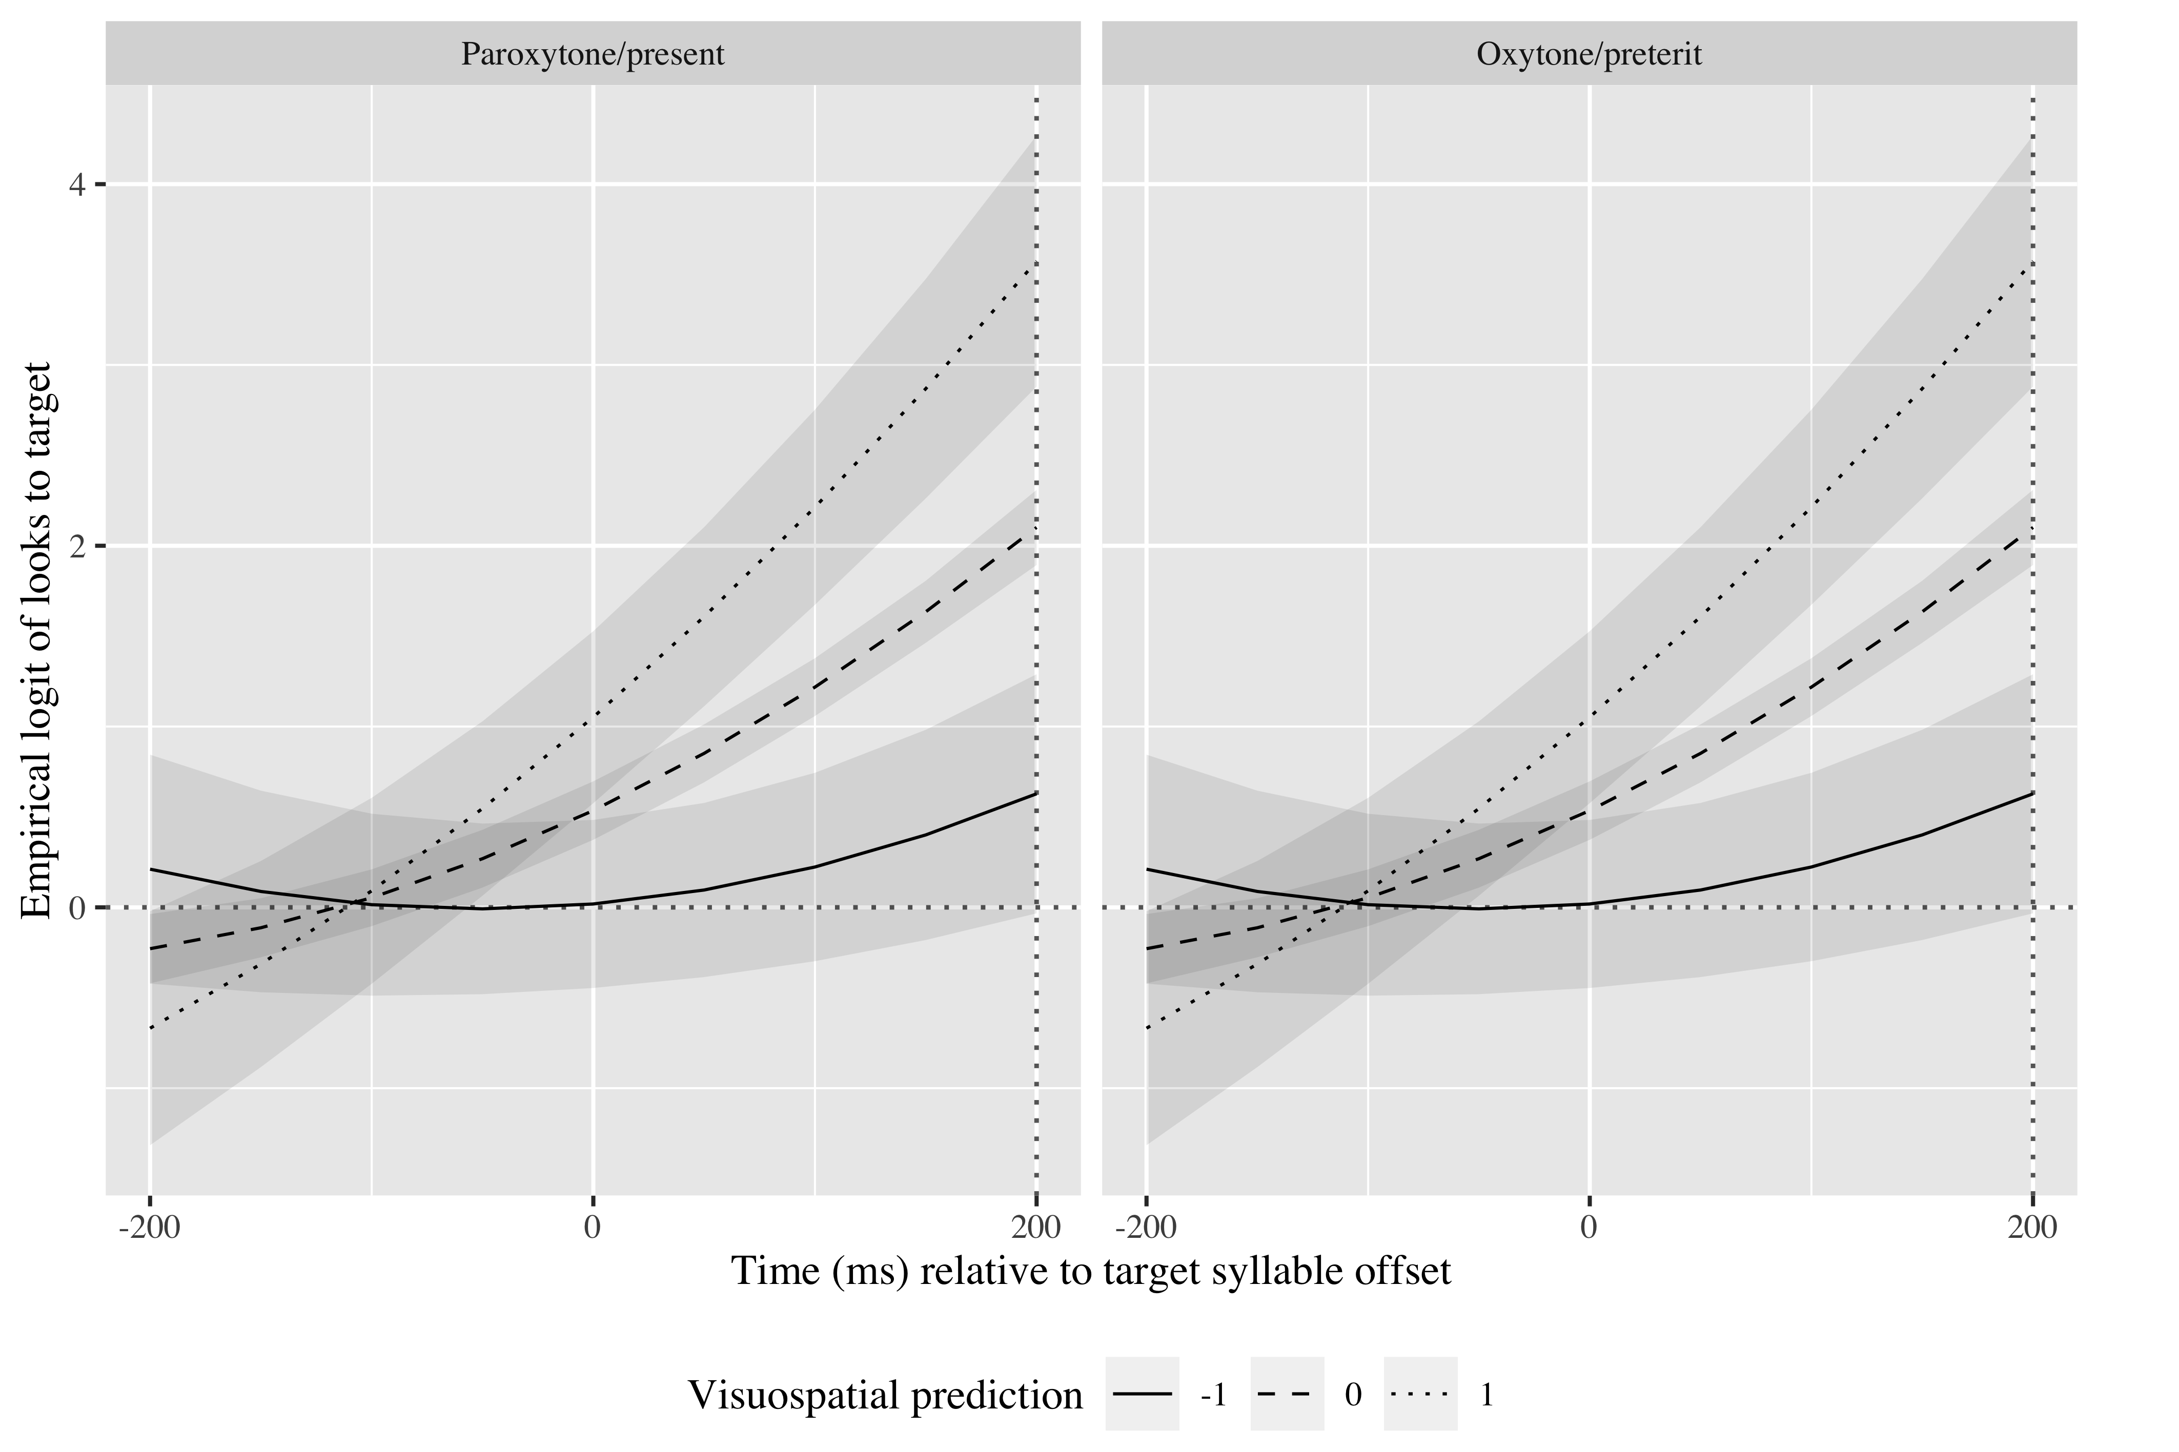

*Figure* *3*. Growth curve estimates of target fixations as a function of visuospatial prediction abilities and stress pattern during the analysis window. Symbols and lines represent model estimates, and transparent ribbons ±SE. Empirical logit values on y-axis correspond to proportions of 0.50, 0.88, and 0.98 of fixations on the target.

A CORRELATION TEST

# Tables

## Random effects

|  |  |  |  |  |
| --- | --- | --- | --- | --- |
| Group | Parameter | Variance | SD | Correlations |
| Participant | Intercept | 0.080 | 0.283 | 1.00 |
| Item | Intercept | 0.485 | 0.696 | 1.00 |
| Residual |  | 9.123 | 3.020 |  |

Appendix 2: Growth curve model random effects