Introduction
To examine whether a mindfulness intervention leads to differences in parental stress, I examine data from 320 parents from a quasi-experimental design in which some parents (n = 168) participated in the intervention, and some parents (n = 152) did not. Parental stress was measured at pretest and posttest. Parents’ employment status varied. Table 1 provides more information on the descriptive statistics and can be found in the Appendix.

- Model comparisons
I conducted a 2 x 3 factorial ANOVA in which I set the alpha level to 5% (α = .05) to examine differences in parental stress between parents with different employment status who participated in the mindfulness intervention and those who did not. Therefore, I compared an additive model that included stress at pretest, parents’ employment status and participation in the intervention with a model that included an interaction between parents’ employment status and participation in the intervention. The latter model also included stress at pretest, and the lower-order relatives from the previous model. The additive model explained a significant amount of variance, F(4, 315) = 952.20, p < .001, R² = 92.36%, compared to an intercept-only model, while the model with the interaction explained, F(6, 313) = 783.40, p < .001, R² = 93.76% of variance compared to an intercept-only model.
The ANOVA comparing these two models showed a significant interaction effect between parents’ employment status and the interaction, F(2, 313) = 34.98, p < .001, ∆R² = 1.40%. Therefore, I rejected the null hypothesis that the interaction has no effect above and beyond the main effects. Further, the assumption of homogeneity is not violated. This suggests that the differences in parental stress at posttest between parents who participated in the intervention and those who did not depend on parents’ employment status.

- Post-hoc tests
I conducted post-hoc tests, using the Bonferroni-adjusted p-value to investigate how the effect of the intervention resulted in differences in parental stress at posttest for different levels of employment status. The results suggest that parental stress was significantly higher at posttest regardless of parents’ employment status. Parents who worked full-time and participated in the intervention (n = 67, M = 86.16, SD = 7.78) showed the greatest increase in parental stress compared to parents with the same employment status who did not participate in the intervention (n = 57, M = 67.60, SD = 7.46), M_{Diff} = 18.74, t(313) = 22.23, p <. 001, 95% CI [16.71, 20.80], the standardized effect (1.01) was large. Parents who worked part-time and participated in the intervention (n = 39, M = 43.97, SD = 6.98) also had significantly higher values of parental stress at posttest, than those who worked part-time but did not participate in the intervention (n = 31, M = 30.61, SD = 6.78), M_{Diff} = 13.56, t(313) = 12.05, p <. 001, 95% CI [10.85, 16.30], the standardized effect (0.73) was medium. Parents who were unemployed and participated in the intervention (n = 62, M = 59.58, SD = 7.53) showed the smallest increase in parental stress compared to those who were unemployed and did not participate in the intervention (n = 64, M = 50.16, SD = 7.71), M_{Diff} = 8.82, t(313) = 10.58, p < .001, 95% CI [6.82, 10.80], the standardized effect (0.48) was small. To illustrate the differences in parental stress I have plotted the interaction in Figure 1, which can be found in the Appendix.

- Conclusion
The report aimed to test whether a mindfulness intervention resulted in differences in parental stress. Pairwise comparisons showed that the intervention had iatrogenic effects for all levels of employment status. Those who worked full-time showed the greatest increase in parental stress, followed by those who worked part-time. Unemployed parents showed the smallest increase in parental stress after the intervention.
Appendix
Table 1
Summary of descriptive statistics for the overall sample, and within the specific groups.
Intervention | Employment Status | Stress at Pretest |  |  | Stress at Posttest
 |  | n | M | SD | n | M | SD
Yes | Unemployed | 62 | 46.45 | 5.00 | 62 | 59.58 | 7.53
 | parttime | 39 | 29.64 | 4.57 | 39 | 43.97 | 6.98
 | fulltime | 67 | 60.82 | 5.20 | 67 | 86.16 | 7.78
No | Unemployed | 64 | 45.95 | 4.98 | 64 | 50.16 | 7.71
 | parttime | 31 | 29.81 | 4.72 | 31 | 30.61 | 6.78
 | fulltime | 57 | 60.96 | 4.27 | 57 | 67.60 | 7.46
Overall: |  | 320 | 48.28 | 12.74 | 320 | 59.98 | 18.54
Note: Participants are divided by employment status and whether they received the intervention or not.

Figure 1
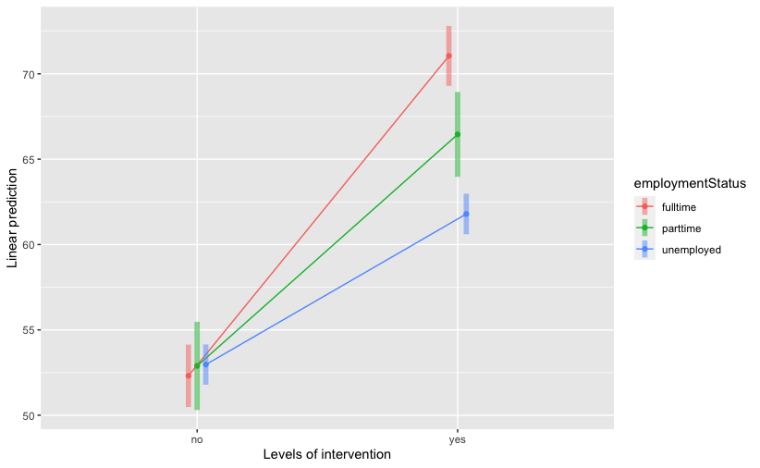
Differences in parental stress at posttest for different levels of employment status
Note: The linear prediction refers to parental stress measured at posttest.

