# YOIN – A Teaching Philosophy

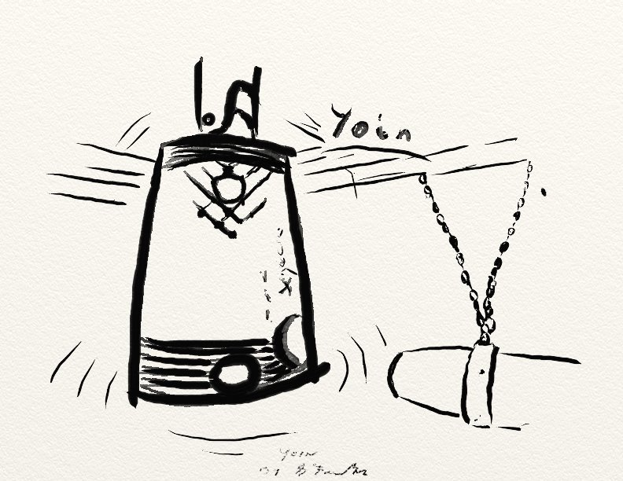

Yoin (The Bell is Struck)

Ignorance Flees

Life Changes

The word “Yoin” (yoh-EEN) is a Japanese word for which there is no direct English translation. In his book “They Have A Word for it: A Lighthearted Lexicon of Untranslatable Words & Phrases”, Rheingold (1988, p 142) describes it as “Experiential reverberation that continues to move you long after the initial external stimulus has ceased.” Rheingold then goes on to suggest that the “Bell” refers to human feeling. In her book “What Our Stories Teach Us: A Guide to Critical Reflection for College Faculty”, Linda K. Shadiow (2013), uses this word to express thanks to those that helped her with her book.

I would go further, tying the word directly to the act of teaching. We do not look to make short term changes in the lives of our students. We seek to enact Yoin upon our students.

Keeping with the Japanese aesthetic of the word “Yoin”, I have included in my teaching philosophy artifact, two items: one, a sketch of the Japanese ceremonial Goh Ohn bell that can be found at Ontario Place, designed by architect Raymond Moriyama, this bell and its creator well meet the term Yoin; two, a Haiku, written in a more classic Japanese style.

This Haiku, designed to express with the fewest syllables possible, (though that is harder in English, where our syllables tend to differ in length, then in Japanese, where an “on” is always the same length) meets the Haiku structure and style, by having two line separated by one that is juxtaposed, ([www.wikihow.com/Write-a-Haiku-Poem#Choose_a_Haiku_Subject](http://www.wikihow.com/Write-a-Haiku-Poem#Choose_a_Haiku_Subject)), and expresses my philosophy.

1. That we must teach knowing that we are changing lives.
2. That we must construct curriculum that aims at the long term goals of the learner.
3. That, knowing that we affect our students lives, we must (and therefore are empowered to) sometimes make hard decisions, like failing a student if it is in his/her best interest.
4. That we are here to guide and direct. The students have the ability to grow, we just have to show them the way.
5. That, following Prats’ perspective, our students are our apprentices. “An Apprenticeship Perspective: modeling ways of being” (Prat 1998)

This final point, that our students are our apprentices, is one that I can truly see, being once myself an apprentice mechanic, and the apprentice Ferrier (blacksmith). I understood well my role as apprentice, as this was necessary for me, to not only learn, but to fit into the community for which I was preparing. It took me many years however, having my bell rung many time so to speak, to come to understand the role of Master.

Master, not a cool word these days, fallen out of favor, and one that is open to misinterpretation or misuse. In my mind, it was never Master over the Apprentice, but Master of the craft, one to look up to, to emulate.

Taking the TPI (Teaching Perspective Inventory) I can see, examining my answers to Prats’ questions, I do indeed fall under the “Apprenticeship” perspective, though like everyone, I exhibit parts of all perspectives.

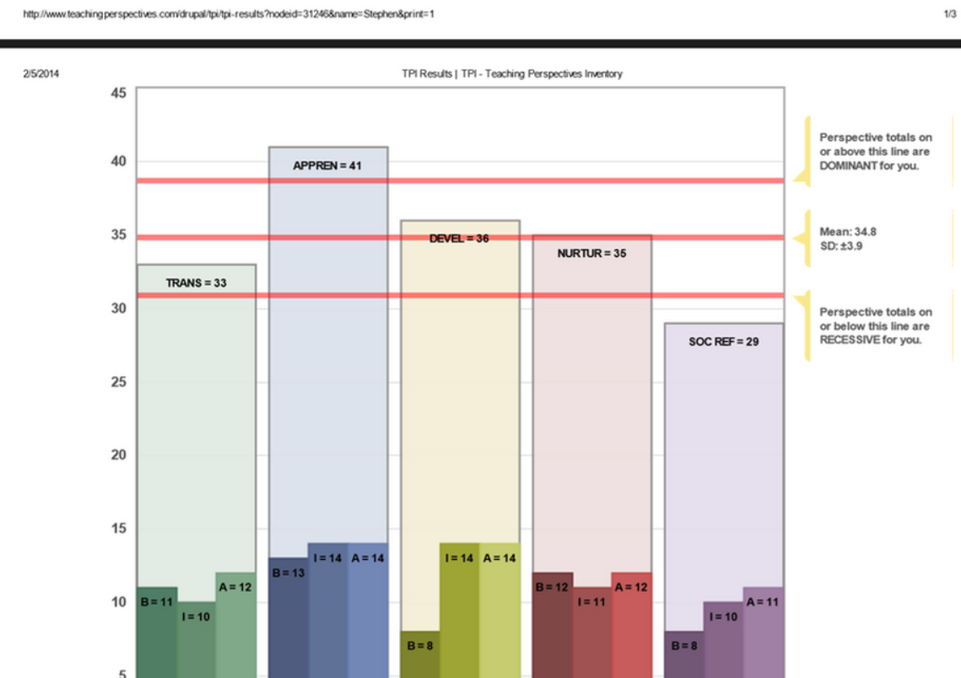

This descriptive narrative from Prat, which summarizes the Apprenticeship perspective,

“Good teachers are highly skilled practitioners of what they teach. Whether in classrooms or at work sites, they are recognized for their expertise. Teachers must reveal the inner workings of skilled performance and must translate it into accessible language and an ordered set of tasks which usually proceed from simple to complex, allowing for different points of entry depending upon the learner's capability. Good teachers know what their learners can do on their own and where they need guidance and direction; they engage learners within their 'zone of development'. As learners mature and become more competent, the teacher's role changes; they offer less direction and give more responsibility as students progress from dependent learners to independent workers.”

resonates with me as being true, and as something I have always tried to follow, even though I had never read this perspective until now.

In context then, I can see that my role as a teacher is to guide, to exemplify the professional in the field, to ensure that content is delivered in a way that allows the learner to discover and grow, and to give guidance in that growth.

To evidence this in my own teaching style, I only have at look to where my office is.

When I first started at Durham College, I was offered an office in a new build out on the third floor, sharing an office with another Professor in the School of Business. Instead I fought to have a smaller, older office, shared with 4 others from different schools, that happens to be directly in sight of, and in fact has windows into, both my main labs. When asked why I wanted a smaller, older office with old furniture, instead of a nice new office with new furniture, I simply stated “I want to be there for my students.” I do not believe we can guide or be a model in absentia.

“Teachers must reveal the inner workings of skilled performance and must translate it into accessible language…”

This fall, a 3rd year student received a failing mark in one of my classes, 47%. The student contacted me, knowing, I think, that he would have to face me in a class this winter, and asked me if there was anything he could do. I went over his marks with him, and summarized for him why he failed. “Aside from your marks, I am concerned that you are missing some of the skills you will need to be successful. This is not a matter of doing an extra lab, or re-writing a test, but of learning what you need, and being able to express it” The student will be doing a makeup class this spring.

“As learners mature and become more competent, the teacher's role changes; they offer less direction and give more responsibility as students progress from dependent learners to independent workers.”

Back a number of years ago at another college I had a student that was failing in a number of classes. When talking to the student, I happen to use car parts as an example (it was a data base class). The student just lit up. Talking about cars, he was more animated than I had ever seen him. When asked “Why did you get into computers when you love cars?” he replied that “everyone said you could get a better job in computers.”

I took the student to the Coordinator for the automotive school, and helped him transfer. He had been in 2nd year of a 3 year program, and had to basically start over. When asked by my chair, “couldn’t you keep him in our school?” My response was, “I did what was best for the student”. He graduated one of the top of his class a few years later.

“Good teachers know what their learners can do on their own and where they need guidance and direction; they engage learners within their 'zone of development'.”

In development of curriculum, I have often been the lead in pushing to advance the material to keep it current, and to push the students, to get more out of them, and stretch them. On more than one occasion this has pushed the material out of the comfort zones of both myself and my colleagues. When this happens, I remind my colleagues, and myself, that we are in an industry that demands change (computer science) and that we must grow to meet the needs of our students. It was with this in mind that a few years ago I started and finished my Masters in computer science, after not being a student for over 15 years.

” Good teachers are highly skilled practitioners of what they teach…”

I believe, that with proper introspection, one can have a one word philosophy in teaching. That it matches well with Prats’ Apprenticeship Perspective (and aligns well with many of his other perspectives) and can help guide me to be a better teaching practitioner.

Yoin

Ignorance Flees

Life Changes



References

Pratt, Daniel D. and Associates (1998). Five Perspectives on Teaching in Adult & Higher Education , Malabar, FL: Krieger Publishing. ISBN: 0-89464-937-X (Online) At: https://www.academia.edu/317235/Five_Perspectives_on_Teaching

Rheingold, H., (1988) They Have A Word for it: A Lighthearted Lexicon of Untranslatable Words & Phrases, Louisville, KY, Sarabande Books Inc.

Shadiow, Linda K.(2013) What Our Stories Teach Us: A Guide to Critical Reflection for College Faculty, San Francisco, CA, John Wiley & Sons, Inc.