MSc Bioinformatics for Health Science 3rd Term
Computational Sistems Biology

June 2019

Laura González Antiga

Netwrok analysis report

In this report, a python script was generated in order to create two different types of netwok models, both in pajek format. Both scripts (ER_generator.py and BA_generator.py) are attached in this folder, and the instruction to use them are:

pyhon generator.py N p name_output

Where generator would be the complete name of the script, N the number of nodes wanted, p would be E in the BA script, and the name of the output desired, which will be writen in text (.txt) format by the script.

In each model summary the parameters will be explained in more detail. For both models, the following points will be shown and discussed:
- Representation of the network
- Distribution of components sizes
- Distance distributions
- Degree and centralities distributions

The graphs in all the cases are undirected and unweigthed, which has to be taken into account, because otherwise the results would change.

Erdős-Rényi network

Erdős-Rényi graphs are defined by a fixed number of vertex and a probability of conecting each pair of them independently with a fixed probability p. This means that a ER network with p = 1 will be completely connected and one with p = 0 will be empied of edges. N and p arguments are passed to the ER_generator.py script to generate each network.

ER with N=1400 and p=0.001

As the first example, the R code is going to be shown for this network, and each point result, but given that all the networks are visualized the same way, in the other 3 cases the code isn’t going to be writen.

First, we load necessary libraries, and then read the input, in pajek format. Then we represent the network.

> library(igraph)
> ER1 <- read.graph("ER_1b.net", format= "pajek")
## Representation
> plot(ER1)
> is.connected(ER1)
[1] FALSE

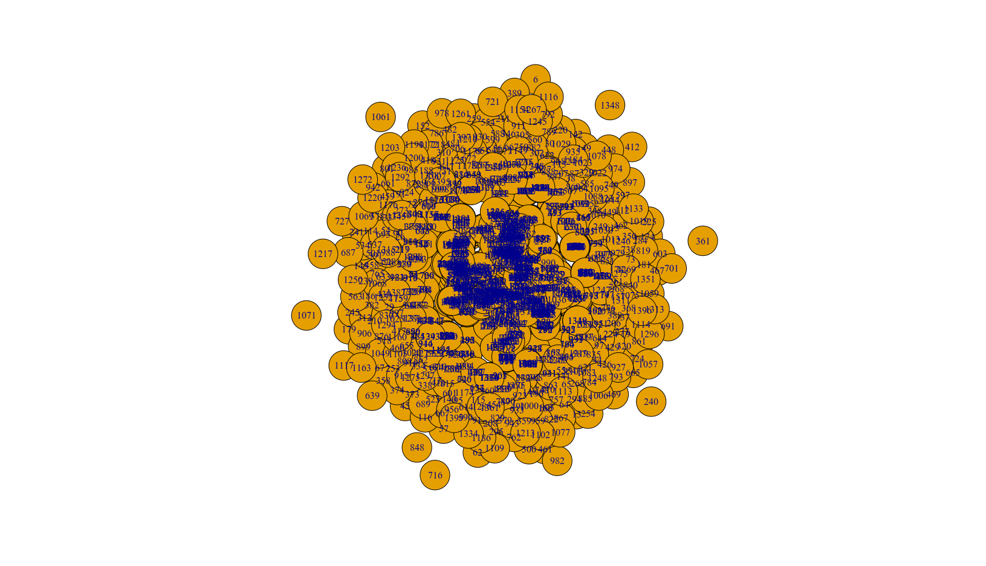

There are so many nodes that it’s difficult to visualize. But with this and some summary commands of igraph, what we can know is that the netwrok is formed by basically one big cluster (and lots of little ones, mostly of 1 node). And they are not connected (is.connected returns false).

##Size distribution
> y <- as.data.frame(table(clusters(ER1)$csize))
> library(ggplot2)
> My_Theme = theme(
+ axis.text = element_text(size = 14),
+ axis.title = element_text(size = 18, face = "bold"),
+ plot.title = element_text(size= 20, face ="bold", colour = "cornflowerblue" ))
> ggplot(y, aes(Var1, Freq)) + geom_point(color="cornflowerblue") + ggtitle("Size distribution") + xlab("Number of nodes per components") + ylab("Frequency") + My_Theme

Here, we did two things: first, generate a data frame that the library ggplot can read, with the corresponding clusters function, and then we personalize the labels of the plots (so that in all the following ones we don’t have to write the same thing).
Then we plot the cluster sizes and frequencies.

This piece of code is only used here, because in all the other cases, and we will see later, the is.connected returns TRUE, which means that all the network is connected, forming a unique, united cluster of N nodes (1400 in this case, so the plot will be a single point at x=1400 and y=1).
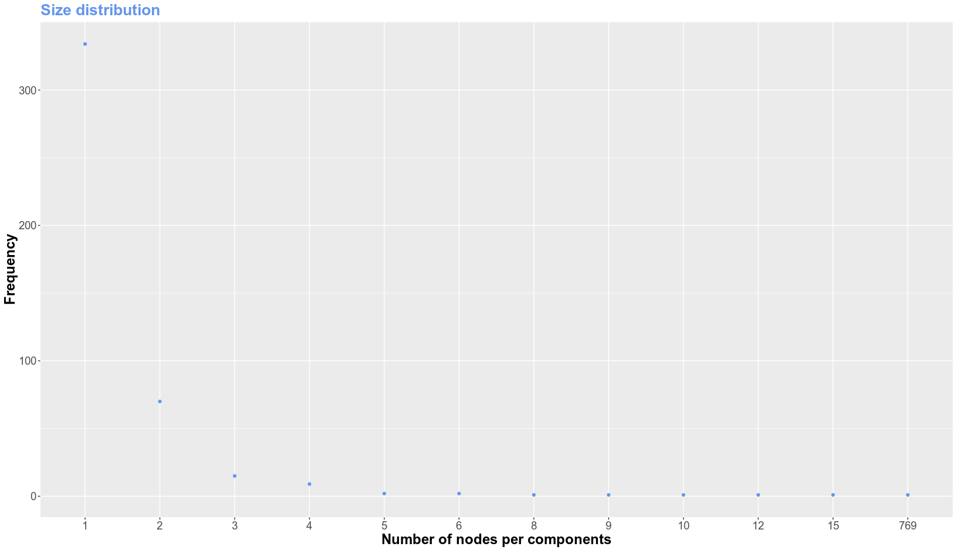
But, in this case, we can see that there is a huge cluster of over 700 nodes, but more than 300 of just one node, or unconnected. This is because the low p.

## Distance distribution
> s <- distance_table(ER1)$res
> a <- data.frame("x" = c(1:45), "y" = s)
> ggplot(a, aes(x, y)) + geom_point(color="cornflowerblue") + ggtitle("Distance distribution") + xlab("Path distance") + ylab("Frequency") + My_Theme
> average.path.length(ER1)
[1] 15.97806

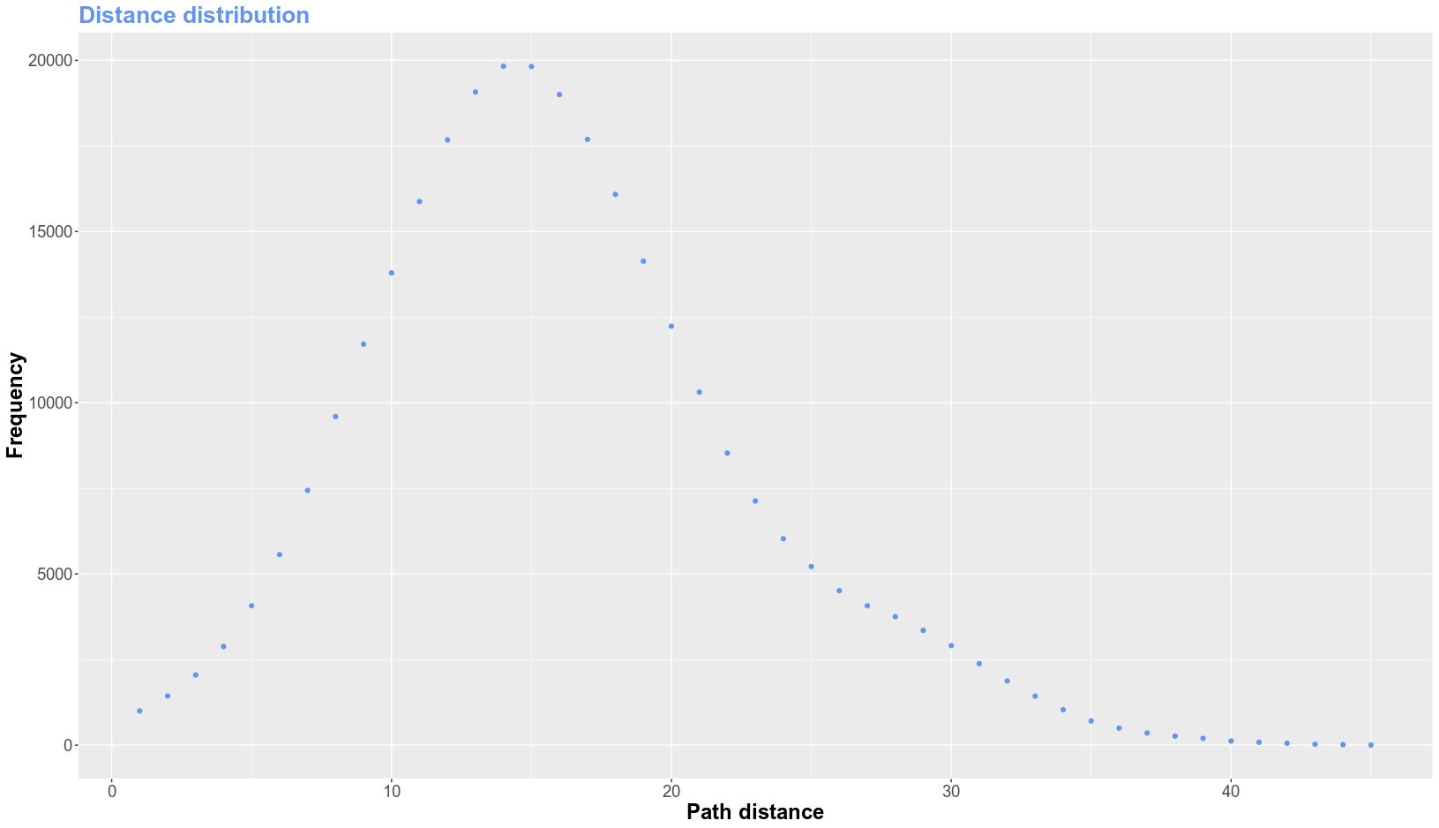
In the previous figure we can see that the path distance follows a normal distribution, with the mean arounf the average that the last command revealed. Also, we had to filter out the connected nodes (using the res array of the distance_table object) to avoid infinite values, which is the one returned for unconnected nodes.

## Degree distribution
> ab <- degree.distribution(ER1)
> b <- data.frame ("x" = c(1:8), "y" = a)
> ggplot(b, aes(x, y)) + geom_point(color="cornflowerblue") + ggtitle("Degree distribution") + xlab("Index") + ylab("Value") + My_Theme

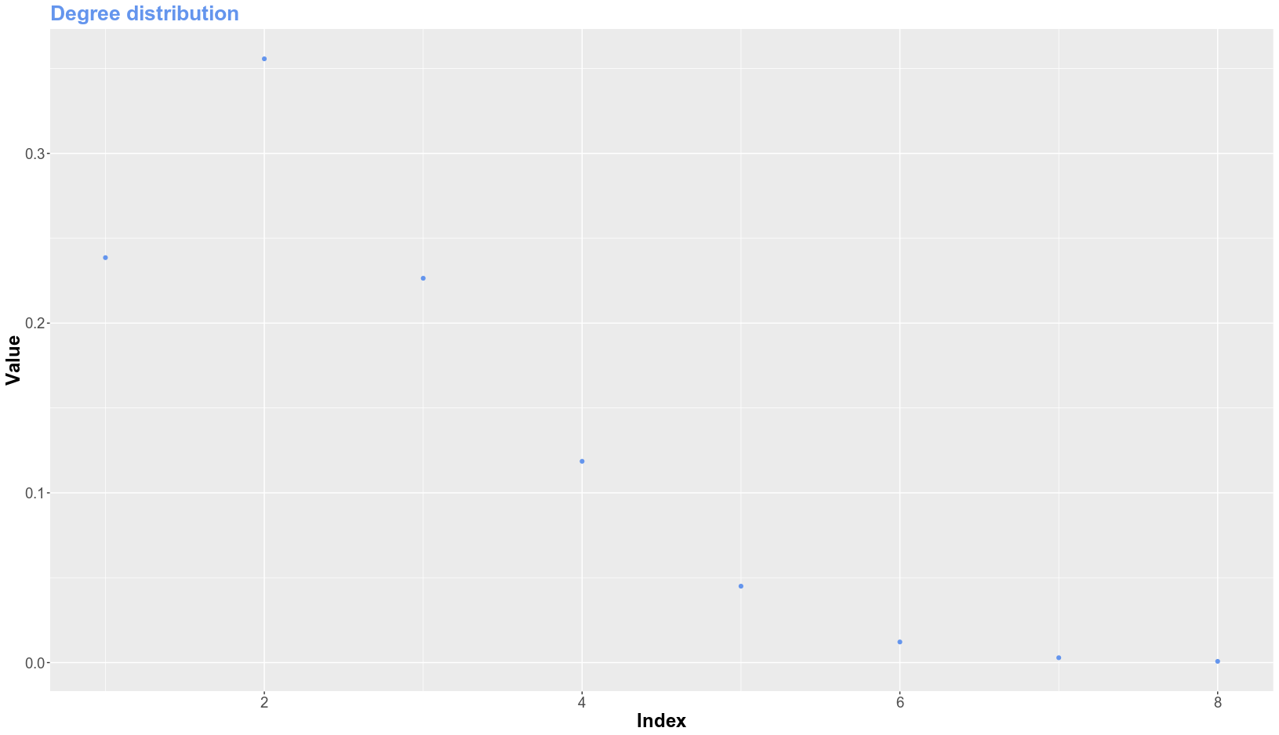
Here we expected a binomial distribution, but, as expected with such a low p, and that there are many unconnected nodes, it doesn’t look like one.

## Betweenness distribution
> norm <- as.data.frame(table(betweenness(ER1, normalized = TRUE )))
> norm$Var1=as.numeric(levels(norm$Var1))[norm$Var1]
> ggplot(norm, aes(Var1, Freq)) + geom_point(color="cornflowerblue") + ggtitle("Betweenness distribution") + xlab("Normalized Betweenness") + ylab("Frequency") + scale_x_continuous(limits= c(0,1), breaks = c(0,1)) + My_Theme

Here we calculated the betwenness, normalised with the formula Bnorm=2*B/(n*n-3*n+2), where Bnorm is the normalized, B the raw betweenness, and n is the number of vertices in the graph. This is because it’s simpler to identify the centrality of a network with values between 1 and 0, where 1 would mean a completely connected and centralise network and 0 the total opposite.
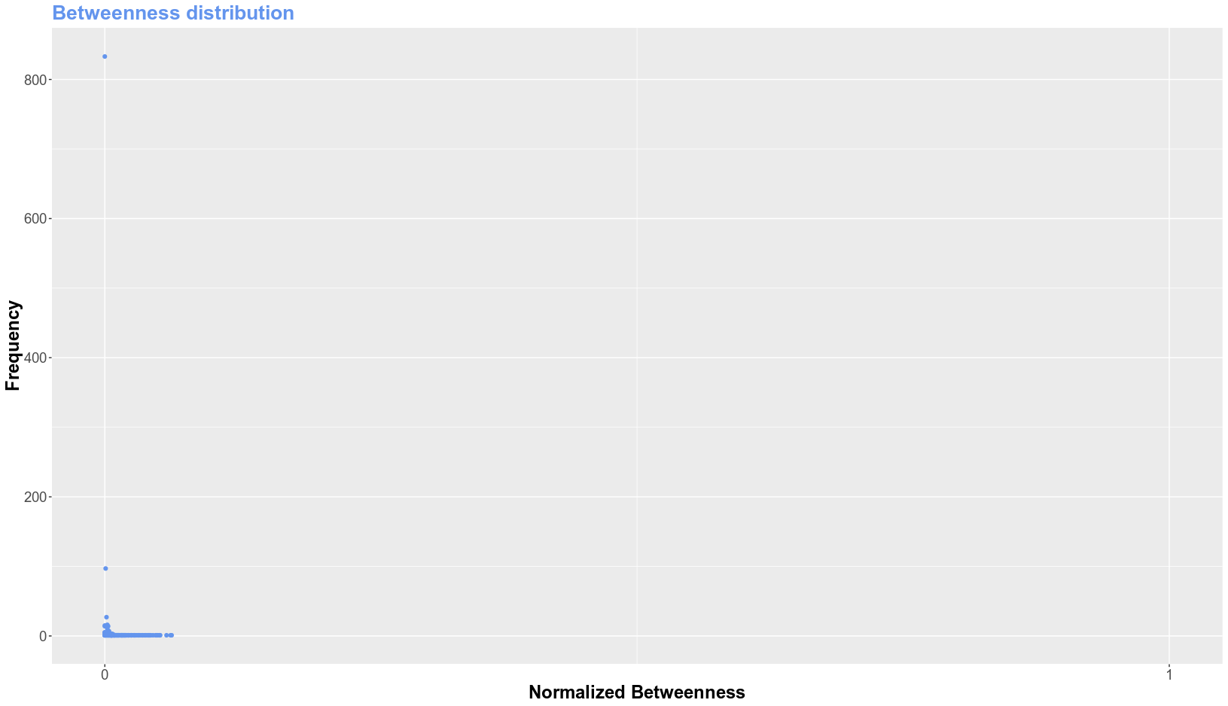
The betweenness expresses how good the nodes are connected. Being a value of 1 completely connected, and a value of 0 completely unconnected.

ER with N=1400 and p=0.02

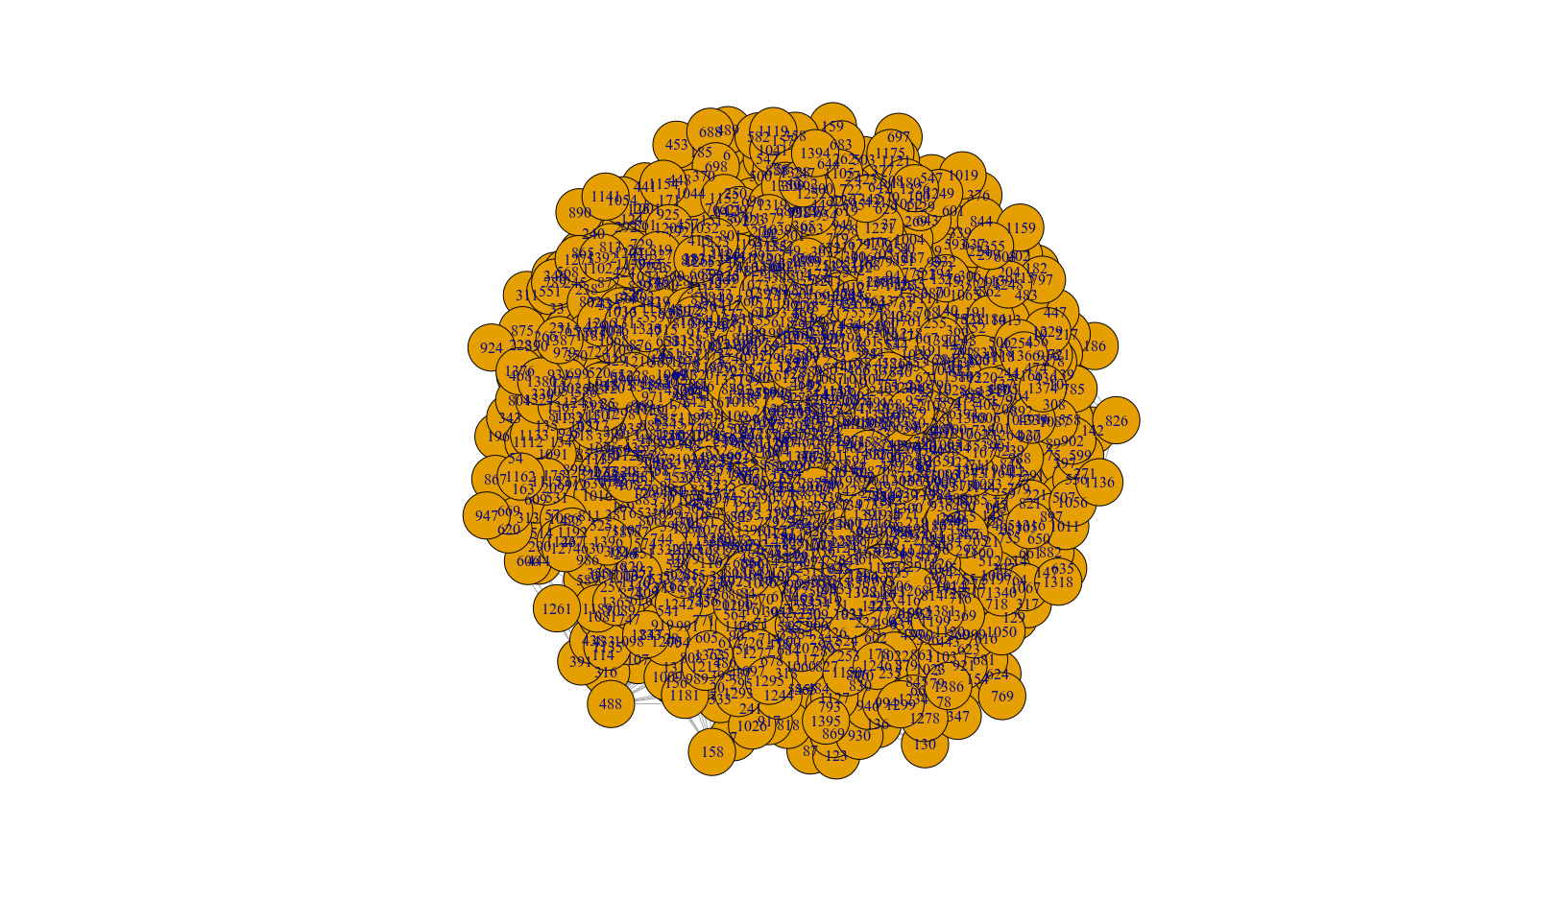
is.connected returns true, and although it’s not visualizable with this figure, we then know that there is a single N=1400 cluster, so no cluster distribution plot is required.

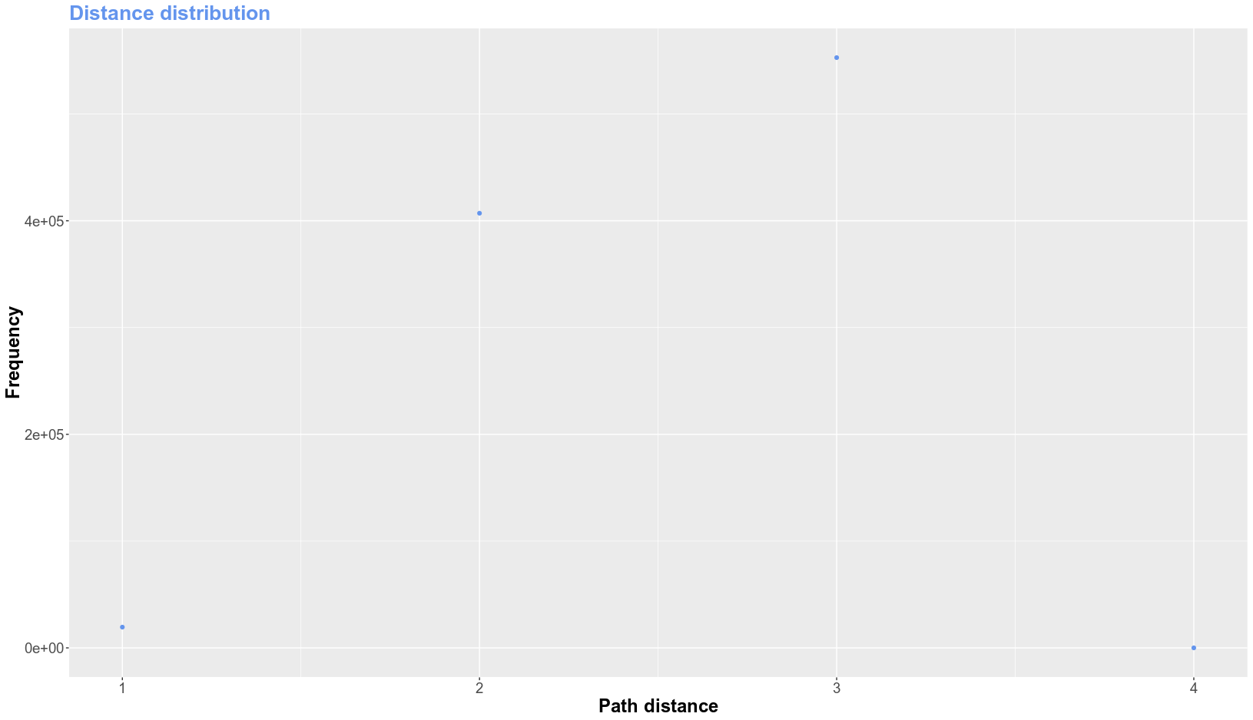
The average path length is 2.54466. It’s much lower than before because the network is more connected, being 4 the maximum steps required to go from one node to another.

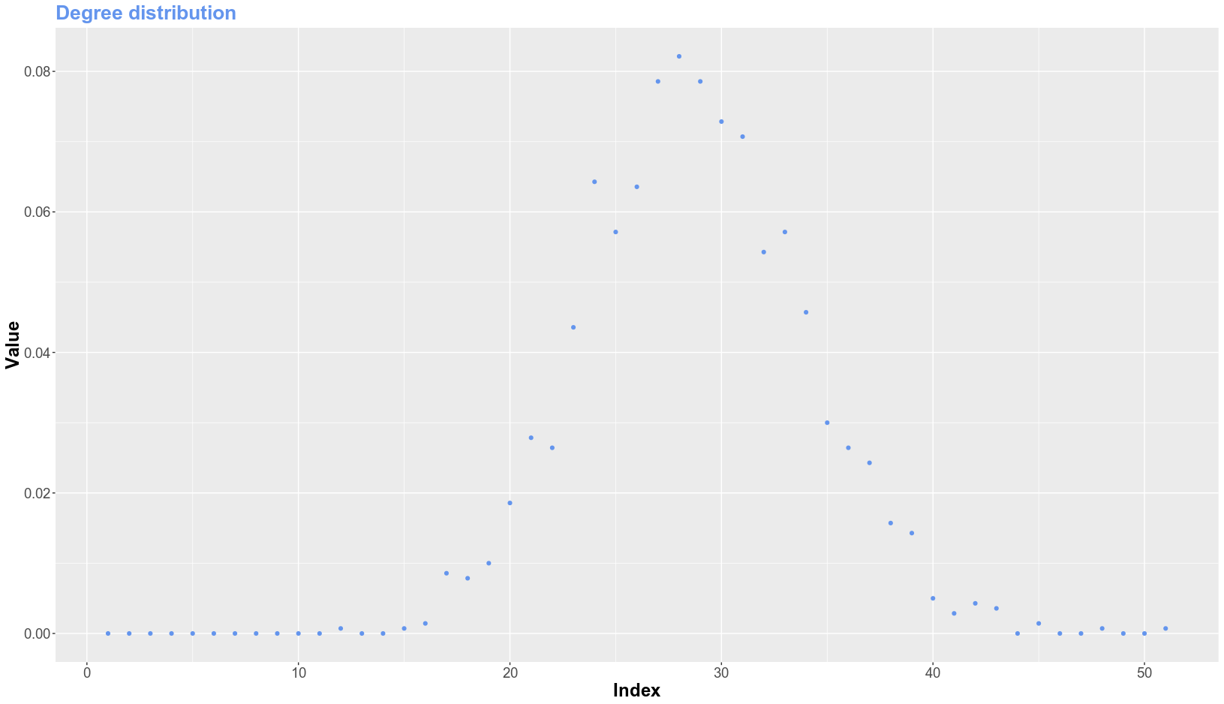
In this case we can really see a binomial distribution, because of the independent probability of connecting two nodes.
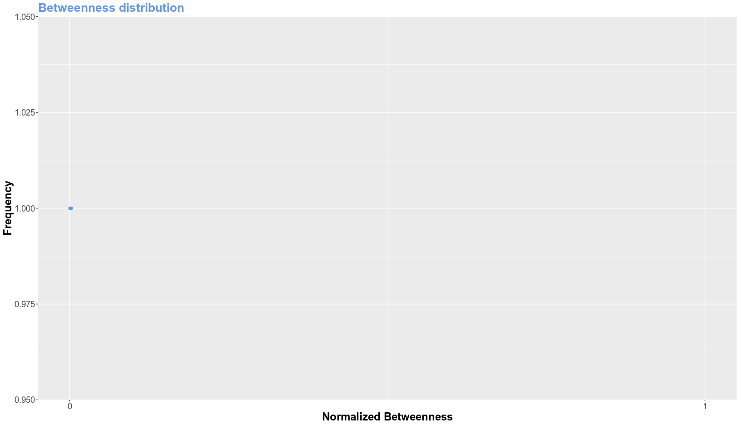
As the network is so connected, the centrality is very disperse, an so, the betwenness is really small in this case.

Barabási-Albert networks

Barabási–Albert are a scale-free networks that try to explain many networks observed in reality. It is thought that Social networks, internet, protein-protein interaction, Airline networks, etc. have a scale free topology, thus, making them a really good model to study an model them.
Barabási–Albert(BA) graph were the first scale free networks proposed and they require two inputs: N = number of nodes and E = number of edges of the new nodes. The general idea is that the network begins with an initial fully connected nodes (in our case it will be E+1, with E connections on each node). Subsequently, on each node addition it is connected to other E different nodes. The probability of each new node to connect other node is proportional to the degree of that node in a given moment, being the most connected also the most likely to connect with the new node.

BA with N = 1400 and E = 1

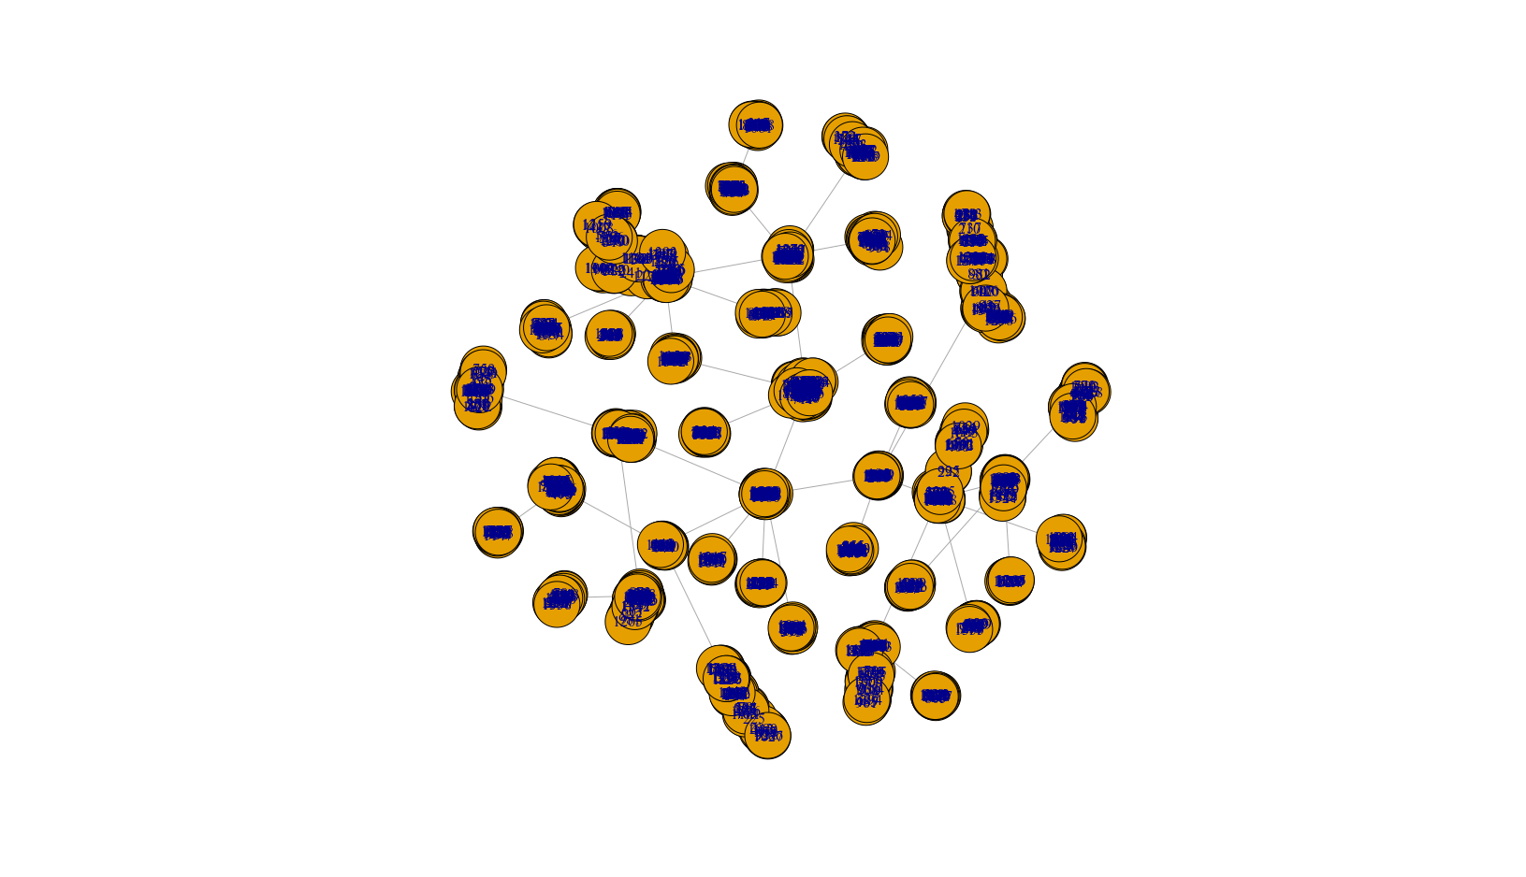
is.connected is true, so, we know this network has 1399 edges, because E=1, so each node (1400) has one edge, and the initial graph for the construction of this network consisted on 2 nodes connected by one edge.

In this case, is by definition of the BA models that all the nodes are connected by edges, so we know there is only one component of N=1400 nodes.

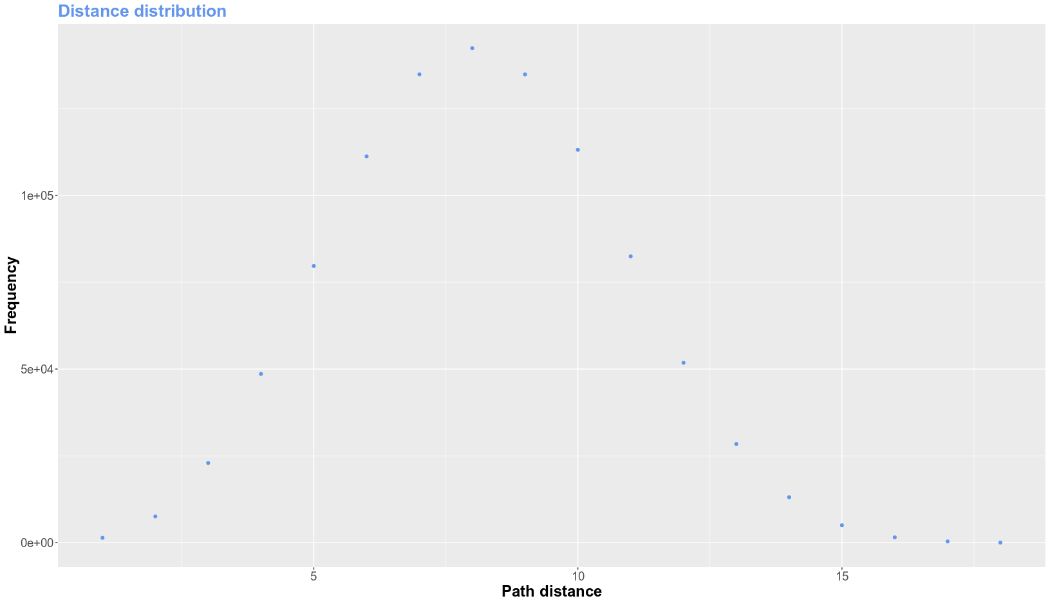

The average path length is 8.129412. We can see the same than in the previous models. The distances between paths follow a normal distribution. If we compare it with the previous figures of distances, we can notice that the value is in between of a ER connected and non-connected network, and this is because some paths go through the same edge more than once unless it is said contraryly, and it affects the mean.

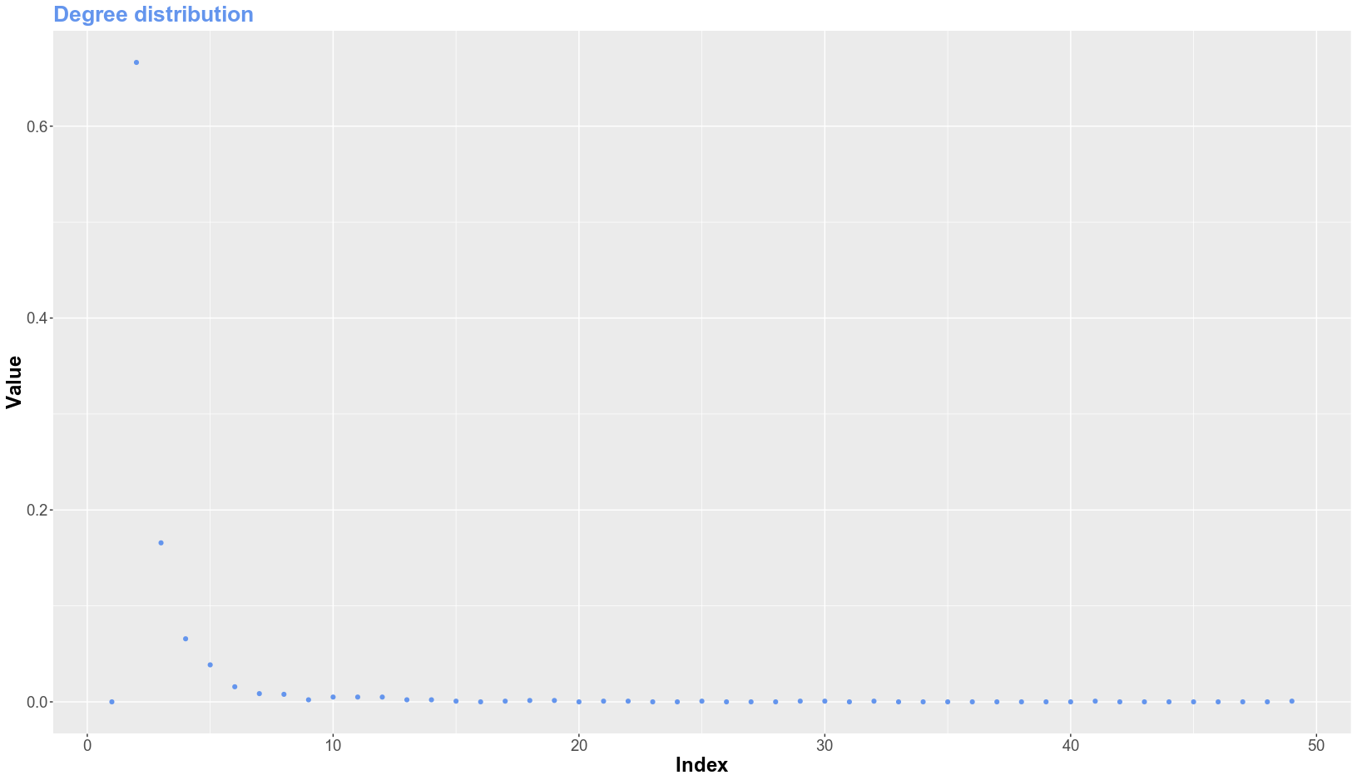
The degree distirbution of all scale free networks is a power law and it is corroborated in this plot. Very few nodes (usually the ones that were on the first steps of the graph) accumulate all the connections, thus, the high degree. Meanwhile, the majority of other nodes are lowly connected, and usually to the ‘big degree’ ones.

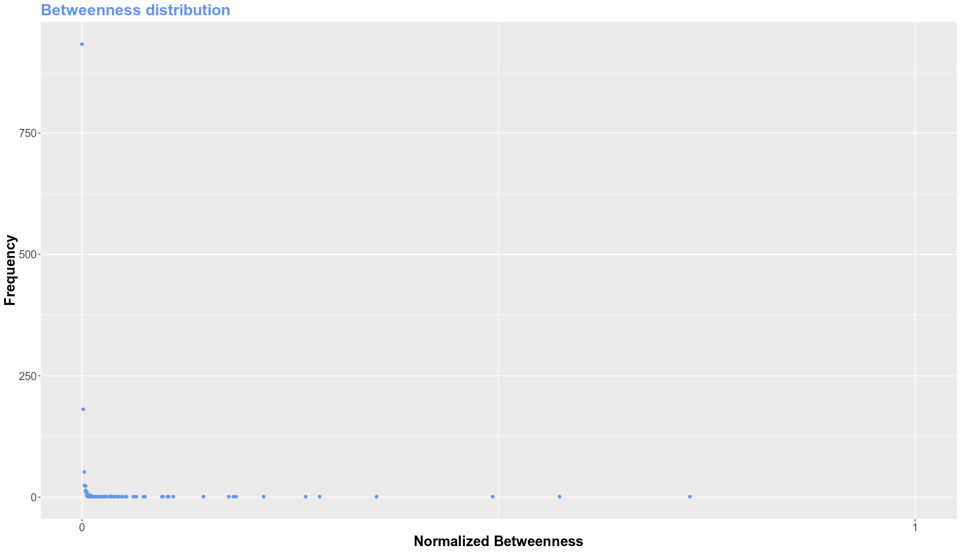
Following the same distribution as the degree, the betweenness has a long tail shape where some few nodes have high betweenness while the majority has very little. This make free scale networks very robust to random perturbations but if the highly connected node fails, the whole network can colapse.

BA with N = 1400 and E = 2

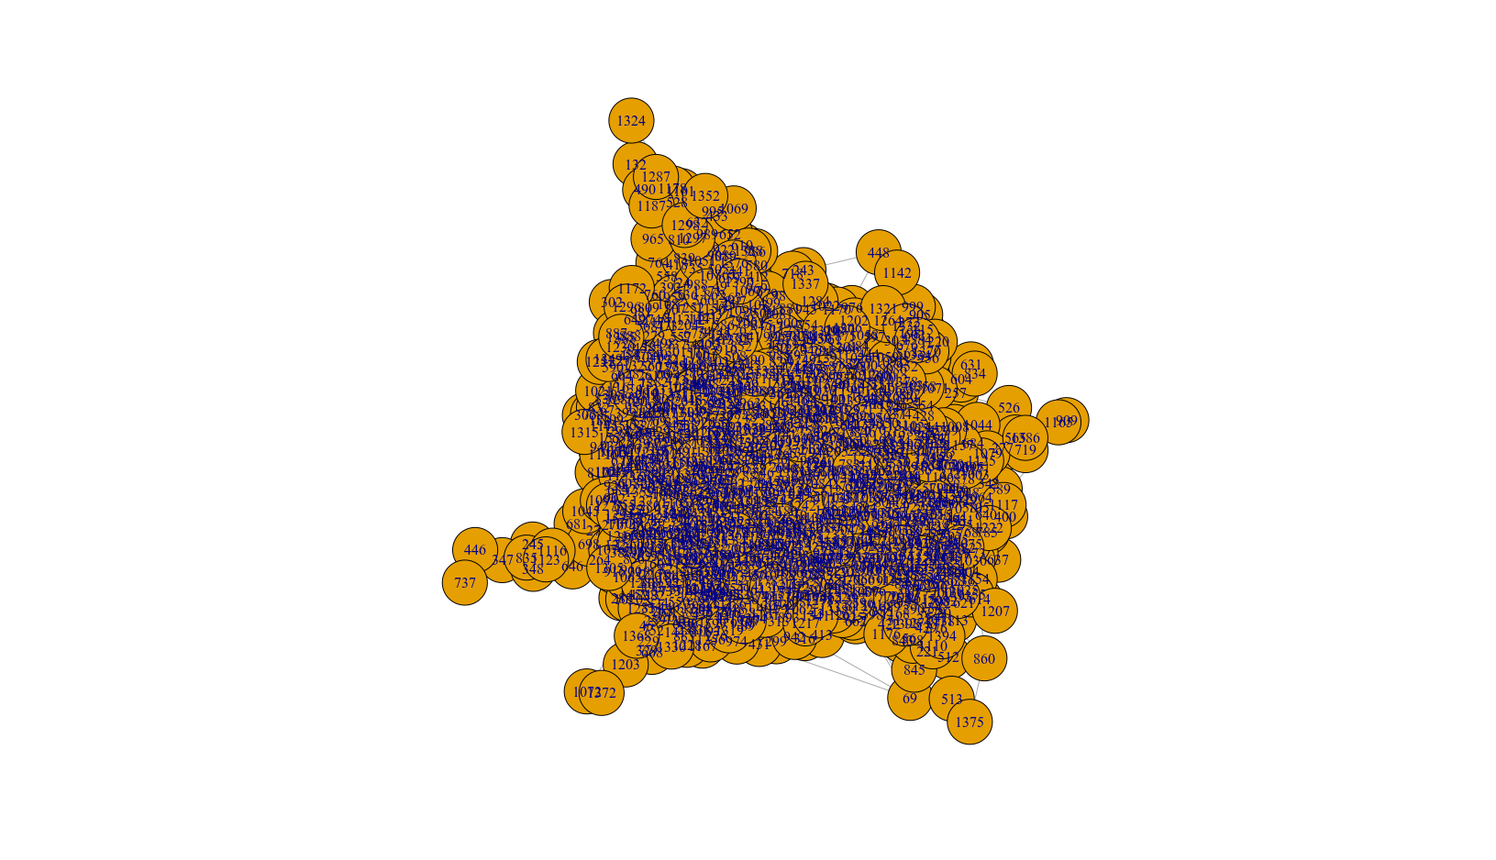
is.connected returns true. Again, we can not really see the edges on the previous plot, but we can ask R to tell us how many there are. If we run edges (BA2), we can see a summary, and that it has 2797. It should be 1400x2 edges each nodes (2800), but we see it misses 3. That is because the initial graph is made with 3 nodes and one edge between each of them.

Again, we expect, by definition, a single component of size 1400.

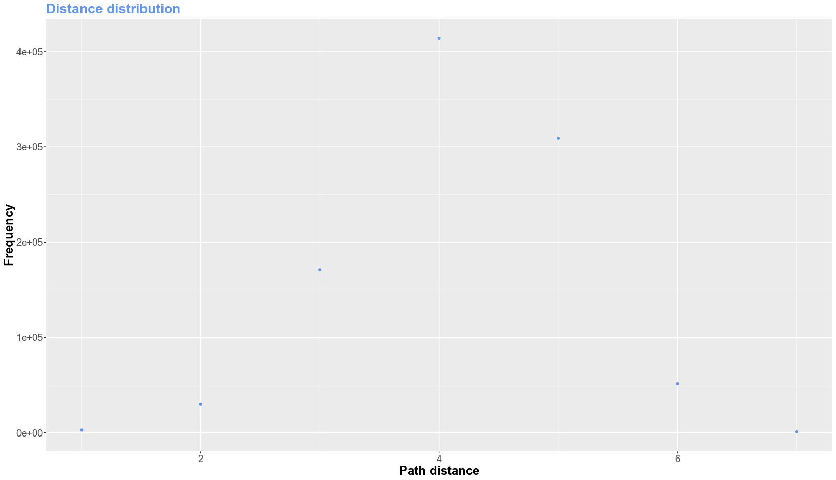
The average path length is 4.178982. it is half of the previous BA network, with half the edges between nodes, so we can see that increasing the edges also increasis the efficiency of the netwrok.

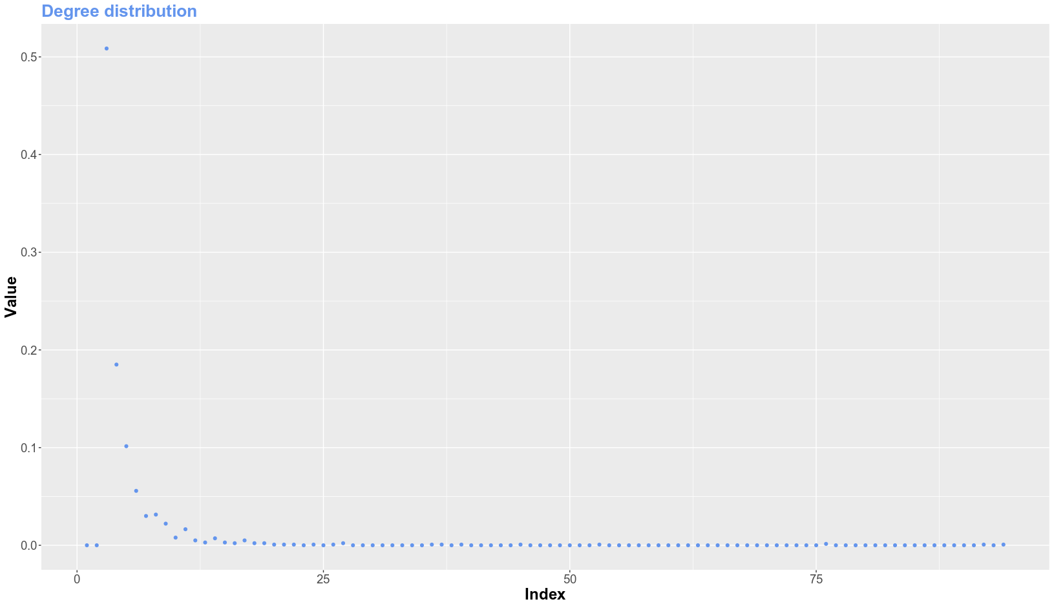
Same as before, few nodes accumulate all the connections and the rest are lowly connected.
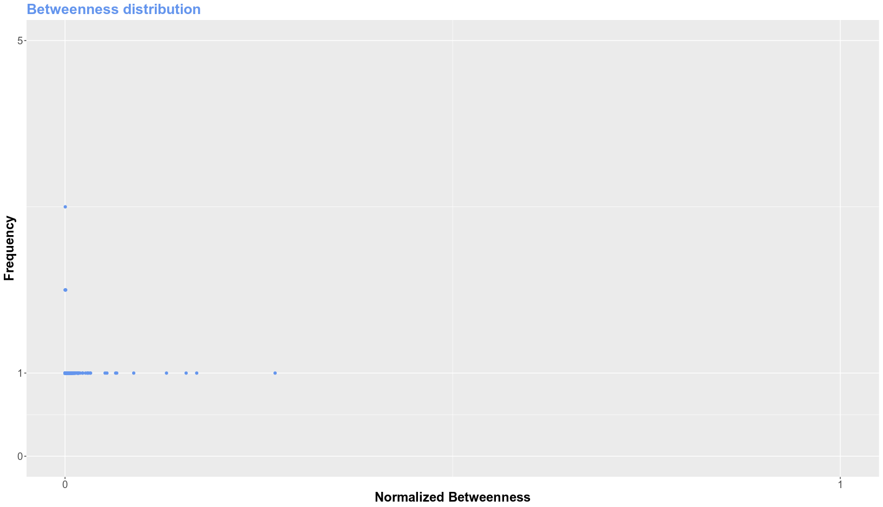
This result was not expected. Some few nodes have higher centrality values, but the rest are dispersed differently than in the previous BA netwrok. This may be because adding edges between nodes helps to connect paths, but we couldn’t identify this in the graph.

Discussion

In this report, two different kind of netwroks have been shown through different significant statistics, and a comparison between them has also been done.

