Physics 411 – Time Series Analysis

Project: Victoria Temperature Analysis

**Introduction**

**Hypotheses**

* Daily Frequency
* Yearly Frequency
* Lowest temperatures in the winter
* Highest temperatures in the summer
* Smallest variance in the winter
* Largest variance in the summer
* Smaller variance near the water

**Minute Data**

Plot the time series

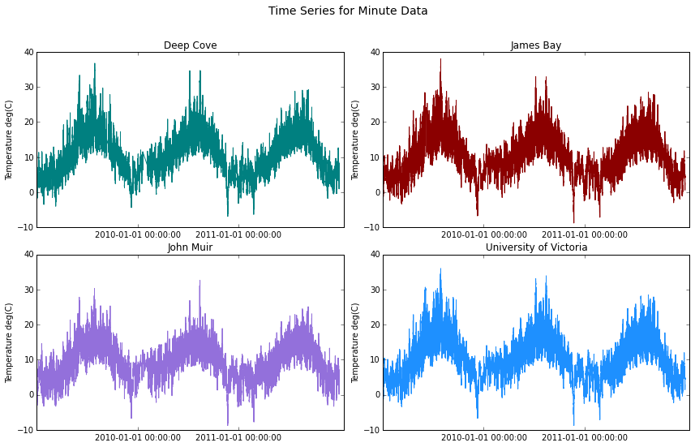

Find the means

|  |  |  |
| --- | --- | --- |
|  | Mean | Standard Deviation |
| Deep Cove | 10.30 | 5.98 |
| James Bay | 10.24 | 5.74 |
| John Muir | 9.12 | 4.84 |
| University of Victoria | 10.23 | 5.70 |

Plot PDFs

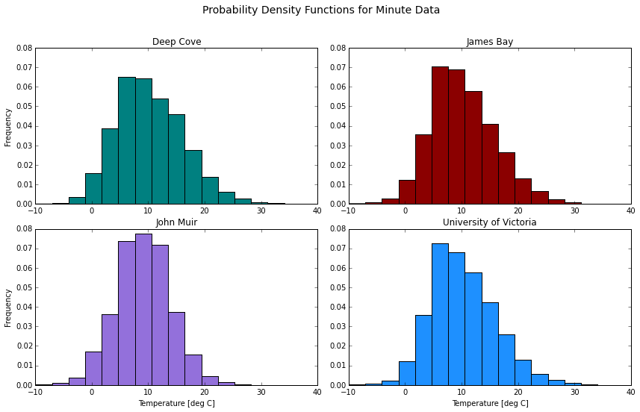

Plot power spectra

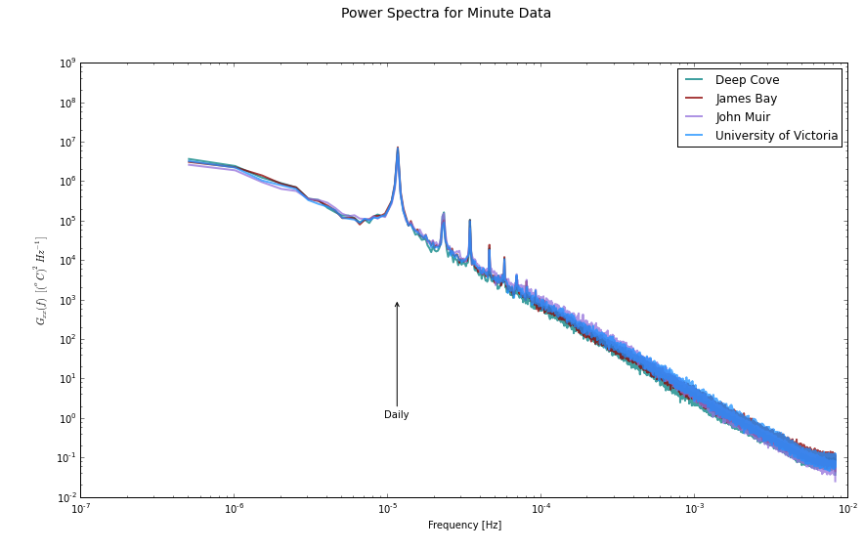

Plot correlations between the four stations

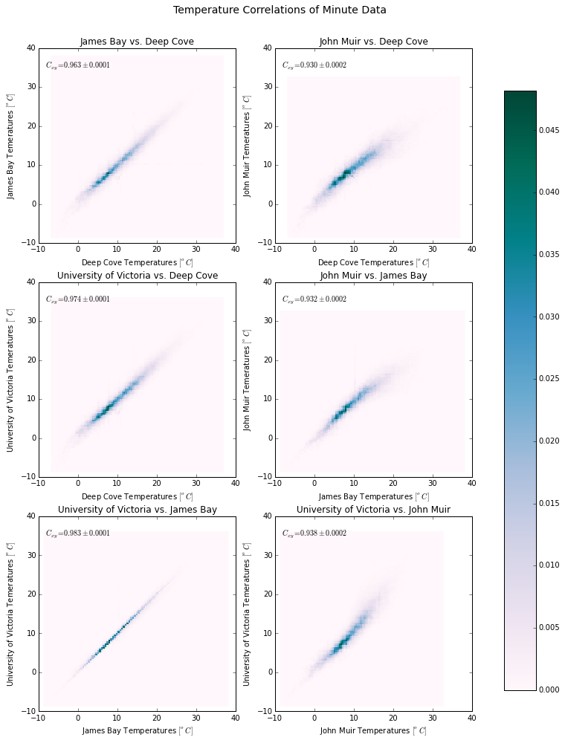

**Hour Data**

Plot the time series

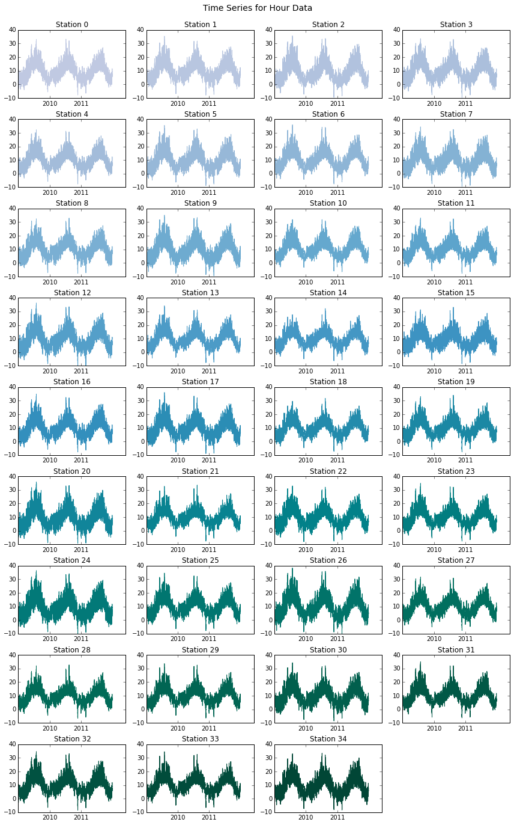

Plot the Power Spectra

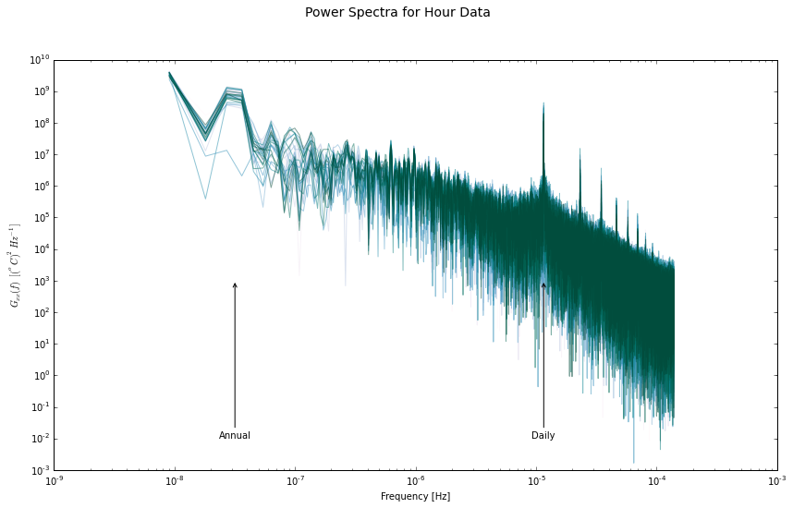

Replicate the weather station map

Look for spatial patterns by calculating Emperical Orthonormal Eigenfunctions or Principal Components

Plot the strongest modes of variability

Plot the time series of the modal amplitudes, check for physical meaning