Appointment Manager

with Time Zone API integrated

Documentation v2.0



Haraba Laura-Gabriela

Group 1078

1. General information

The online scheduling software - Appointment Manager – is simple, functional, powerful and without compromises!

Appointment Manager web application has everything you need when it comes to being more organized and simply manage yourself and your daily tasks.

****Being an online scheduler, it allows you to self schedule 24x7, any time, any where. No more classic heavy agendas that it is hard to carry with you everywhere and which is always forgotten at home or office.

1. Design User Interface

* 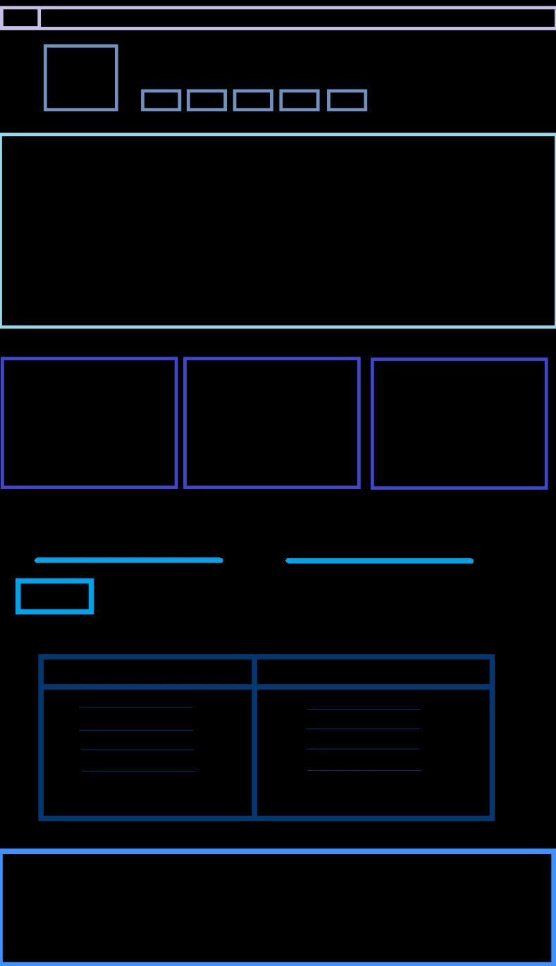Appointment Manager app comes with a very intuitive and consistent design which is very CLEARLY in order to help the user to understand its way around the interface.
* Appointment Manager provides high responsivity for user to enjoy using the interface.
* Appointment manager has a fast-running interface and gives the impression of a good software.
* Appointment manager is attractive!
* Appointment manager has a simple menu bar with only five buttons: ‘Home’, ‘About us’, ‘Features’, ‘Help’ and ‘Log in’.
* Appointment manager offers then an attractive way to inform the user about it, right before the meeting scheduler.
* It ends with a very impressive and attractive contact bar.

1. Identify Components
   1. Drop down (hamburger) menu
   2. Attractive images and logo
   3. Less text, more fun
   4. Form for adding meetings and their description
   5. Table to show the meetings inserted
   6. Cool icons
2. Identify API Calls
   1. timeZoneName/Id
   2. ADD/ CHANGE/ DELETE/ CANCEL
   3. GET/ POST/ DELETE
3. Define User Actions
   1. View scheduled meetings
   2. View their description
   3. Search bar
   4. Add meetings
   5. Add descriptions
4. Future updates:
   1. A more complex calendar view which would include: free national days, events nearby based on user’s location
   2. Notifications (e.g. reminders for tasks or meetings)
   3. Address Book
   4. Option for sharing the calendar
   5. Setting priority to the events or tasks
   6. Categorize option
   7. End month report