***Carry-over effects of temperature and pCO2 in multiple Olympia oyster populations***

Laura H Spencer1, Yaamini R Venkataraman1, Ryan Crim2, Stuart Ryan2, Micah J Horwith3, Steven B Roberts1

1University of Washington, School of Aquatic and Fishery Sciences, 1122 NE Boat St, Seattle, WA 98105, United States

2Puget Sound Restoration Fund, 8001 NE Day Road W, Bainbridge Island, WA 98110, United States

3Washington State Department of Natural Resources, 1111 Washington St SE, MS 47027, Olympia, WA 98504, United States

**Abstract**

Impacts of adult exposure to elevated temperature and altered carbonate chemistry on reproduction and offspring viability were examined in the Olympia oyster (*Ostrea lurida*). Three distinct populations of adult, hatchery-reared *O. lurida,* plus an additional cohort spawned from one of the populations, were sequentially exposed to elevated temperature (+4°C, at 10°C) and elevated pCO2 (+2204 µatm, at 3045 µatm) during winter months. Oysters were then induced to spawn volitionally in common conditions at ambient pCO2. Elevated winter temperature and pCO2 impacted male gonad development separately, and the two treatments acted antagonistically such that gonad stage and sex did not differ from control oysters. Male gametes were more developed after elevated temperature exposure, and less developed after high pCO2 exposure, but there was no impact on female gametes or sex ratios. Larval release occurred earlier in warm-exposed oysters, and tended to be later in high pCO2-exposed oysters. Fecundity over a 60 day collection period (in ambient conditions) was unaffected by pCO2 exposure, but winter warming conditions increased larval production. No effects on larval survival were detected in this study, but juveniles of parents exposed to elevated pCO2 had higher survival rates in the natural environment in two of the four deployment bays. These results indicate that despite impacts on gametogenesis and larval release timing, Olympia oyster fecundity in hatchery conditions is unaffected by winter warming and high pCO2, there are no significant negative effects on the offspring, and in certain environmental conditions carryover effects can be beneficial. Furthermore, persistent population-specific traits emphasize the importance of using multiple sources of test organisms in stress-response studies.

**Introduction**

One of the primary environmental impacts associated with global climate change is ocean warming. Sea surface temperature is predicted to increase by 0.6°C to 2.0°C by year 2100 (IPCC, 2013). Temperature is one of the most influential environmental drivers of marine invertebrate physiology, affecting many processes including metabolism, growth, development, stress response, and gametogenesis. The potential repercussions of warming on ectothermic marine species are therefore inumerable, but how warming will impact reproduction is a key question, as successful procreation is critical to a species’ performance under future climate scenarios. Temperature is a primary driver of reproductive processes in many marine invertebrates, as temperature increase initiates and accelerates gametogenesis [(Joyce et al. 2013; Maneiro et al. 2016; Oates 2013)](https://paperpile.com/c/DMAOJn/FBle+SkIL+YOvJ), influences sex determination [(Santerre et al. 2013)](https://paperpile.com/c/DMAOJn/kQaC) and in some species triggers spawning [(Fabioux et al. 2005)](https://paperpile.com/c/DMAOJn/tYkk) (alongside other factors such as photoperiod, nutrition, lunar/tidal phases). Many species are believed to have a thermal threshold for gametogenesis, below which they enter reproductive quiescence, typically during the winter [(Hopkins 1937)](https://paperpile.com/c/DMAOJn/gqlK). Warmer winters and earlier springs may therefore shift species’ reproductive cycle to begin earlier, or eliminate seasonality altogether. In oysters, which are economically and ecologically important taxa and the focus of this study, researchers have examined how gametogenesis and spawning is impacted by elevated temperature during reproductive conditioning. For example, warming during conditioning and spawning accelerates gametogenesis and alters sex ratios in the Sydney rock oyster (*Saccostrea glomerata,* [Parker et al. 2018](https://paperpile.com/c/DMAOJn/CFE1)). Unknown is how a previous exposure to elevated temperature (e.g. a warmer winter) impacts subsequent larval production.

In addition to warming, ocean carbonate chemistry is shifting, which is commonly referred to as ocean acidification. Ocean acidification is caused by diffusion of carbon dioxide from the atmosphere into the ocean where it reacts with water to form carbonic acid, which both reduces the ocean pH and removes carbonate ions from solution. Carbonate ions are components of calcite and aragonite, the two primary forms of calcium carbonate that marine organisms use to build shells [(Weiss et al. 2002)](https://paperpile.com/c/DMAOJn/xST4). Calcareous marine organisms are likely vulnerable to these chemical shifts, particular those with sensitive larval stages that build natal shells. In the recent decades, significant advances have been made in our understanding of how high pCO2 impacts oyster physiology, particularly in the early life stages, but few have examined impacts on reproduction. To our knowledge, three studies have examined how ocean acidification impacts oyster reproduction prior to fertilization [(Boulais et al. 2017; Parker et al. 2018; Venkataraman et al. 2019)](https://paperpile.com/c/DMAOJn/5aok+CFE1+yRoJ), but none have examined how an adult-only high pCO2 exposure impacts later volitional spawning under ambient conditions. Furthermore, there are no studies on the impacts of ocean acidification on adult oysters in the *Ostrea* genus, which have unique reproductive strategies as larviparous, simultaneous hermaphrodites.

Here, we investigate the effects of high pCO2 and warming on the Olympia oyster (*Ostrea lurida*), and whether adult exposure impacts reproduction and offspring viability. *O. lurida* is the only oyster species native to the Pacific coast of North America, inhabiting estuaries where shifts in ocean carbonate chemistry are occurring more rapidly than in other regions of the world [(Barton et al. 2012; Feely et al. 2008, 2012)](https://paperpile.com/c/DMAOJn/Bgwc+MDe1+CiIB). Overharvest and pollution devastated populations in the early 1900’s, and recent estimates indicate total *O. lurida* acreage is 2% of the historic level [(McGraw 2009; Polson & Zacherl 2009)](https://paperpile.com/c/DMAOJn/1tRB+ZoUg). *O. lurida* is being actively restored, but there are concerns that shifting ocean conditions will impede successful restoration. Larval *O. lurida* exposed to high pCO2 display slower growth into the juvenile stage, and are more vulnerable to predation by invasive snails [(Hettinger et al. 2012, 2013; Hettinger et al. 2013)](https://paperpile.com/c/DMAOJn/CCKm+m4VW+4nXg). In contrast, a separate group found no effect of ocean acidification on *O. lurida* larval survival or calcification [(Waldbusser et al. 2016)](https://paperpile.com/c/DMAOJn/yDyH). Two possible explanations for these conflicting findings include intergenerational carryover effects of a parental exposure, and genetic differences among test organisms, both of which are explored in this study.

An organism’s environmental history, and that of its parent, may influence how it responds to environmental change. There is growing evidence that exposure to warming and high pCO2 can be transferred between generations [(Diaz et al. 2018; Kong et al. 2019; Massamba-N’Siala et al. 2014; Putnam & Gates 2015)](https://paperpile.com/c/DMAOJn/bwO9+98DX+LNlq+BKMB). A series of studies on the Sydney rock oyster (*Saccostrea glomerata*) provide strong evidence for positive, or beneficial, carryover effects in oysters. Adult high pCO2 exposure during reproductive conditioning resulted in larvae that were larger and grew faster under a similarly high pCO2 environment [(Parker](https://paperpile.com/c/DMAOJn/msiO+S9dp) [et al.](https://paperpile.com/c/DMAOJn/bwO9+98DX+LNlq+BKMB) [2012, 2015)](https://paperpile.com/c/DMAOJn/msiO+S9dp), and expression of key stress-response genes differed depending on parental exposure [(Goncalves et al. 2016)](https://paperpile.com/c/DMAOJn/TNKm). Negative carryover effects are also documented [(Griffith & Gobler 2017)](https://paperpile.com/c/DMAOJn/UPY3). For example, female Pacific oysters (*Crassostrea gigas*) exposed to high pCO2 prior to reproductive conditioning produce fewer surviving larvae [(Venkataraman et al. 2019)](https://paperpile.com/c/DMAOJn/yRoJ). The complex interactions between an organism’s genotype, complete environmental history, timing and magnitude of climate exposures, and how and when reproduction occurs may determine if carryover effects are beneficial, or detrimental. To date, no studies have explored intergenerational carryover effects in an *Ostrea* species.

The source population used for experimental studies, which inevitably test a subsample of a species, may be a critical factor influencing climate-related findings. If the physiological response in question is conserved in the species, the results should be consistent across populations. Oysters, however, display physiological plasticity among genetically distinct groups. Oyster breeding programs are already leveraging variable resiliency to select for lines that are less vulnerable to ocean-acidification [(Parker](https://paperpile.com/c/DMAOJn/Ezx6+mI8K) [et al.](https://paperpile.com/c/DMAOJn/bwO9+98DX+LNlq+BKMB) [2011; Thompson](https://paperpile.com/c/DMAOJn/Ezx6+mI8K) [et al.](https://paperpile.com/c/DMAOJn/bwO9+98DX+LNlq+BKMB) [2015)](https://paperpile.com/c/DMAOJn/Ezx6+mI8K). In *Ostrea lurida*, phenotypic variability and genetic divergence has been observed in the wild. A recent coast-wide survey of *O. lurida* using Single Nucleotide Polymorphisms (SNPs) to estimate relatedness indicates that there is population structure and adaptive differentiation [(Silliman 2019)](https://paperpile.com/c/DMAOJn/oVxq). Indeed, larval *O. lurida* response to salinity stress (mortality, gene expression) varies among locally-adapted populations in California [(Bible & Sanford 2016; Maynard](https://paperpile.com/c/DMAOJn/h3IR+kcRL) [et al.](https://paperpile.com/c/DMAOJn/bwO9+98DX+LNlq+BKMB) [2018)](https://paperpile.com/c/DMAOJn/h3IR+kcRL). A series of studies on *O. lurida* in Puget Sound, Washington also show that growth, reproduction, and response to stress vary among oysters from three locations, concluding that fine-scale structure and adaptive divergence has occurred [(Heare](https://paperpile.com/c/DMAOJn/4QuA+OwPR+Xma3) [et al.](https://paperpile.com/c/DMAOJn/bwO9+98DX+LNlq+BKMB) [2017, 2018)](https://paperpile.com/c/DMAOJn/4QuA+OwPR+Xma3). These three Puget Sound populations are leveraged in the current study.

Here, we examine how exposure to elevated temperature and altered carbonate chemistry prior to reproduction influences gonad development, fecundity, and offspring performance. Adult oysters were sequentially exposed to elevated winter temperature (+4C), then elevated pCO2 (+2204 µatm, -0.51 pH). Elevated winter temperature was expected to impede gametogenic quiescence, presumably a critical annual event, and this subsequently would reduce larval production and larval viability. Similarly, we predicted that high pCO2 exposure would result in negative impacts due increased energy requirements for calcification and cellular maintenance, and that a synergistic impact would be realized upon exposure to both conditions.

**Methods**

**Adult oyster temperature and pCO2 exposures**

Four cohorts of adult *Ostrea lurida* were used in this study. Three of the cohorts were first-generation hatchery-produced (F1) oysters (32.1 ± 5.0 mm), all hatched in central Puget Sound (Port Gamble Bay) in 2013 as described in [(J. Emerson Heare et al., 2018)](https://paperpile.com/c/DMAOJn/OwPR). The broodstock used to produce these F1 oysters were wild, harvested from Fidalgo Bay in North Puget Sound (F), Dabob Bay in Hood Canal (D), and Oyster Bay in South Puget Sound (O-1) (O in Figure 1), which are considered genetically distinct subpopulations [(Heare et al. 2017; White et al. 2017)](https://paperpile.com/c/DMAOJn/4QuA+Xma3). The fourth cohort (O-2, 21.9 ± 3.3 mm) was second-generation, hatchery-produced from the aforementioned Oyster Bay F1 cohort in 2015, as described in Silliman et al. 2018, from a single larval release pulse and thus likely one family. The O-2 cohort was included to examine whether reproductive and offspring traits were consistent across generations of a population, with the O-2 cohort being siblings and 2 years younger. Prior to the experiment, all oysters were maintained in pearl nets in Clam Bay (C) for a minimum of 500 days.

**Temperature treatment**

Oysters were moved to the Kenneth K. Chew Center for Shellfish Research and Restoration adjacent to Clam Bay (C) and held in two temperature regimes (6.1±0.2°C and 10.2±0.5°C) for 60 days beginning December 6, 2016. The two temperatures correspond approximately to historic local winter temperature (6°C) in Clam Bay, and anomalously warm winter temperature (10°C) as experienced during 2014-2016 [(Gentemann](https://paperpile.com/c/DMAOJn/qEYN) [et al.](https://paperpile.com/c/DMAOJn/bwO9+98DX+LNlq+BKMB) [2017)](https://paperpile.com/c/DMAOJn/qEYN). For the temperature exposure, oysters from each cohort (100 for O-1 and F cohorts, 60 for D, and 300 for O-2) were divided into 4 bags, 2 bags per temperature, in two flow-through experimental tanks (50L - 1.2-L/min). Temperature in the 6°C treatment was maintained using a Teco Aquarium Chiller (TK-500), and hatchery-wide heated seawater was used for the 10°C treatment. Temperatures were recorded continuously with Onset HOBO Water Temperature Data Loggers (U22-001).

**Figure 1**: Locations where *O. lurida* populations’ progenitors were collected (F, D, O), where oysters were housed prior to and during the experiment (C), and where offspring were deployed (F, P, S, I): Fidalgo Bay (F), Port Gamble Bay (P), Dabob Bay (D), Clam Bay (C), Skokomish River Delta (S), Case Inlet (I), Oyster Bay (O).

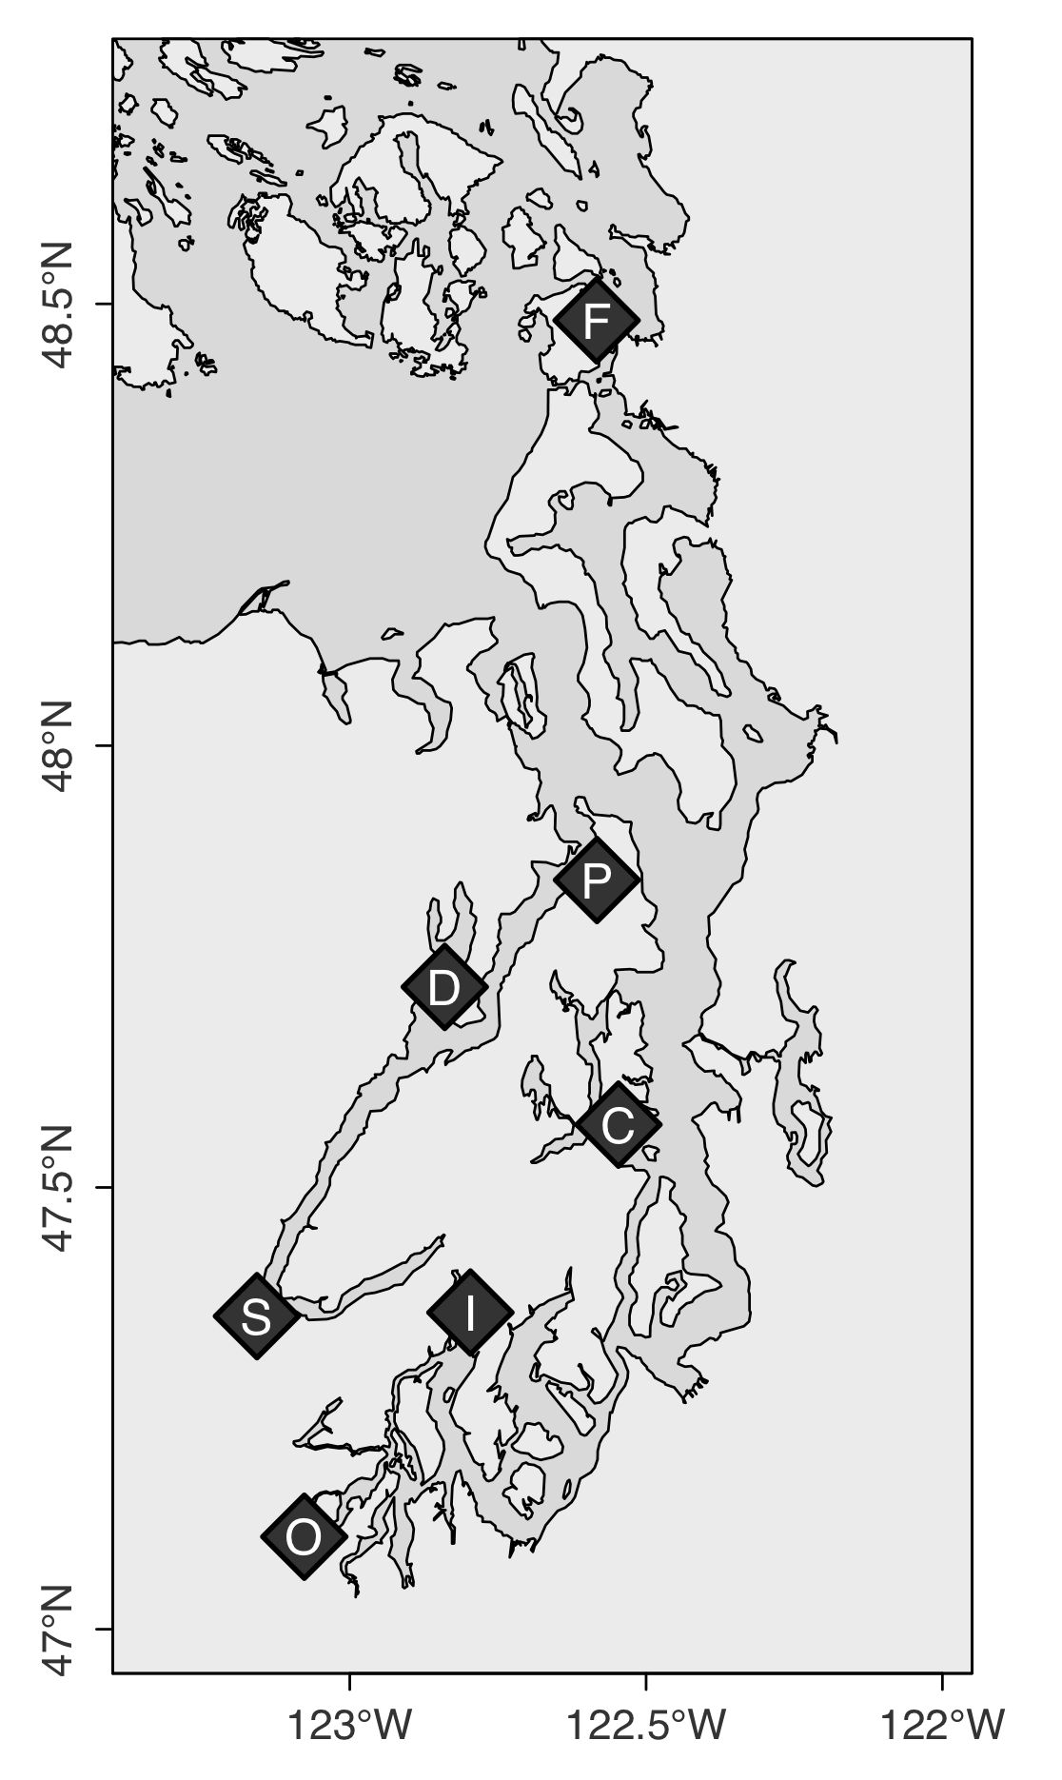**High pCO2 treatment**

A differential pCO2 exposure was carried out after the temperature treatment ended. Following a 10-day gradual temperature increase for the 6°C treatment to 10°C, oysters were further divided and held at ambient pCO2 (841±85 µatm, pH 7.82±0.02) or high pCO2 (3045±488 µatm, pH 7.31 ± 0.02) for 52 days (February 15 to April 8, 2017). Animals were housed in six flow-through tanks (50-L - 1.2-L/min), 3 replicate tanks per pCO2 treatment and oyster cohort. High pCO2 treated water was prepared using CO2 injection. Filtered seawater (1µm) first recirculated through a reservoir (1,610-L) with off-gas chimney to equilibrate with the atmosphere, then flowed into treatment reservoirs (757-L) recirculating through venturi injectors. Durafet pH probes (Honeywell Model 51453503-505) and a Dual Input Analytical Analyzer (Honeywell Model 50003691-501) monitored pH in treatment reservoirs with readings every 180 seconds. Using solenoid valves, CO2 gas was injected through lines at 15 psi in 0.4 second pulses if pH exceeded the 7.22 set point. Water pH was continuously monitored in experimental tanks using Durafet pH sensors, and temperature (10.4 ± 0.4°C) was measured using HOBO Pendant Temperature Data Loggers (UA-002-64). Twice weekly, water samples (1-L) were collected from experimental tanks and temperature (°C), salinity (PSU), and pH (mV, converted to pHT) were measured immediately using Traceable Digital Thermometer (Model 15-077, Fisher), Bench/Portable Conductivity Meter (Model 23226-505, VWR), and a Combination pH Electrode (Model 11278-220, Mettler Toledo), respectively. Simultaneously, discrete water samples (120-mL) were collected in duplicate from experimental tanks and preserved with HgCl (50-µL) for later total alkalinity measurements using a T5 Excellence titrator (Mettler Toledo). Standard pH curves were generated on each sampling day prior to pH measurements using TRIS buffer prepared in-house (Supplementary Materials) at 5 temperatures. Using the seacarb library in R, pCO2, dissolved organic carbon (DIC), calcite saturation (Ωcalcite), and aragonite saturation (Ωaragonite) were calculated for days 5, 33, and 48 (Table 1, Supplementary Materials).

During both temperature and pCO2 treatments, all oysters were fed from a shared algae header tank daily with Shellfish Diet 1800® (300-500-mL, Reed Mariculture) diluted in ambient pCO2 seawater (200-L, [Helm 2004](https://paperpile.com/c/DMAOJn/zxgm)), dosed continuously with Iwaki Metering Pumps. Twice weekly, experimental, reservoir, and algae tanks were drained and cleaned, and oysters were monitored for mortality and rotated within experimental system.

**Adult reproductive development**

A subset of oysters from each treatment were sampled for gonad stage and sex immediately before and after pCO2 treatments. Prior to pCO2 exposure 15 oysters were sampled from O-1, O-2, and F cohorts, and 9 from D cohort. Post pCO2 exposure, 9, 6, and 15 oysters were sampled from each treatment for O-1/F, D, and O-2 cohorts, respectively (distributed equally among replicates tanks). Whole visceral mass was excised and preserved in histology cassettes using the PAXgene Tissue FIX System, and processed for gonad analysis by Diagnostic Pathology Medical Group, Inc. (Sacramento, CA).

Adult gonad samples were assigned sex and stage using designations adapted from [da Silva et al. (2009)](https://paperpile.com/c/DMAOJn/PKKi). As per da Silva, sex was assigned as indeterminate (I), male (M), hermaphroditic primarily-male (HPM), hermaphroditic (H), hermaphroditic primarily-female (HPF), and female (F). For stage assignment, male and female gametes were assigned stages separately due to the high frequency of hermaphroditism (50.8%), then a dominant gonad stage was assigned based on the sex assignment. The da Silva gonad stages were applied for early gametogenesis (stage 1), advanced (stage 2), and ripe (stage 3). Departures from da Silva’s stage 0, stage 4 (partially spawned), and stage 5 (fully spawned/resorbing) were as follows: stage 0 in this study represented empty follicles, or no presence of male or female gonad tissue. Stage 4 represented both spawned and resorbing gonad. This method did not include a separate stage 5, due to the very high frequency of residual gametes, and no distinct partially spawned oysters (see Figure 5 and Supplementary Materials for gonad tissue images).

Gonad differences were assessed for all cohorts combined (Chi-square test of independence) for gonad sex, gonad stage of dominant sex, male gonad tissue when present, and female gonad tissue when present. Gonad sex was collapsed into simplified male and female designations for statistical analyses (Hermaphroditic-primarily male = Male, Hermaphroditic-primarily female = Male). Four comparisons were made: 1) between 6°C and 10°C treatments prior to pCO2 treatment; 2) between ambient and high pCO2 after 52 days in pCO2 treatments to determine whether pCO2 affected gonad sex ratios and development; and 3) before and after ambient pCO2 treatments to estimate whether gonad changed in ambient pCO2 treatment, and 4) before and after high pCO2 treatments. P-values were estimated using Monte-Carlo simulations with 1,000 permutations, and corrected using the Benjamini & Hochberg method [(Benjamini & Hochberg, 1995)](https://paperpile.com/c/DMAOJn/BxXn) (𝛼=0.05).

**Shell length**

Oysters sampled for histology were also measured for maximum shell length from the umbo using digital calipers (mm). Shell length was compared between temperature treatments (prior to pCO2 exposure) and after pCO2 exposures using 2-factor ANOVA for each cohort. Shell length was also compared among cohort using 1-factor ANOVA, excluding the younger O-2 cohort.

**Larval production and rearing**

**Production**

Following pCO2 exposure, adult oysters were induced to spawn to assess larval production timing and magnitude. Beginning on April 11th, oysters were reproductively conditioned by raising temperatures gradually to 14.9 ± 1.1°C until May 1st, with spawning induced at 18.1 ± 0.1°C. Oysters were allowed to spawn volitionally for 70 days and fed live algae cocktail at 66,000 ± 12,000 cells/mL. Six spawning tanks were used for each of the 4 temperature x pCO2 treatments (6°C-high pCO2, 6°C-ambient pCO2, 10°C-high pCO2, and 10°C-ambient pCO2): two spawning tanks each with F and O cohorts (14-17 oysters), and one each with D and O-2 cohorts (9-16 and 111-126 oysters, respectively)(Table 5). The large number of O-2 oysters were used due to their small size. *O. lurida* are viviparous spermcasters, brooding larvae to the veliger stage, so larvae were captured upon maternal release. Spawning tank outflow was collected in 7.5-L buckets using 100 µm screens made from 15.25 cm polyvinyl chloride rings and 100 µm nylon mesh. Larvae, first observed on May 11th, were collected and estimated based on counting subsamples (in triplicate) every one or two days for 60 days.

Larval collection was assessed for differences in spawn timing and fecundity. Larvae were collected daily from each spawning tank and counted by homogenizing larvae in seawater, then counting and averaging triplicate subsamples. For each spawning tank, the following summary statistics were compared between cohort, temperature and pCO2 treatments: average daily larvae released, total larvae released, cumulative larvae released (running total), maximum larvae released in one day, date of first release, date of maximum release, and number of substantial release days (greater than 10,000 larvae, an estimate for number of families). Total, cumulative (running total) and daily release values were also normalized by the number of broodstock * average broodstock length (cm) and compared between treatments. Distributions were assessed using qqp in the car package for {R} [(Fox & Weisberg 2011)](https://paperpile.com/c/DMAOJn/sTHB), and log-transformed if necessary to meet normal distribution assumptions. Differences between cohorts x treatments were assessed using linear regression and Three-Way ANOVA (aov) with backwards deletion to determine the most parsimonious model, and Tukey Honest Significant Differences with TukeyHSD [(R Core Team 2016)](https://paperpile.com/c/DMAOJn/F9gB) to assess pairwise comparisons.

**Larval rearing**

A subset of larvae collected between May 19 and July 6 were reared continuously within treatment x cohort. To maximize genetic diversity of offspring, no slow-growing or small larvae were discarded, and newly spawned larvae were added to culture tanks continuously to a maximum stocking density of 200,000 larvae (~1 larva/mL)(PSRF pers. communication & Helm 2004). No more than 50,000 newly collected larvae were added to their respective treatment x cohort larval rearing tank in one day. Larvae were grown in two connected 19-L flow-through tanks (8-L/hr) with aerated, filtered seawater (1 µm) at 18°C. The two-tank larval system was used to cull dead larvae: water flowed from one 19-L tank (where larvae were added but non-swimming larvae would remain, “mortality tank”) to the next (“live tank”), carrying live, swimming larvae which were then contained on a 100 µm screen. Twice weekly, live larval tanks were screened into three size classes: 100 μm < X < 180 μm (“100 μm”), 180 μm < X 224 μm (“180 um”), >224 μm (“224 μm”, which is when *O. lurida* larvae are near metamorphosis). Each size class was subsampled and counted, then the 100 µm and 180 µm classes returned to larval tanks, and the 224 µm class moved to downwelling tanks for settlement. The number of live larvae returned to culture tanks informed stocking of newly released larvae. The contents in the mortality buckets were collected during biweekly screenings on a 100 µm screen to count live and dead oysters, but live were not kept. For all culture tanks, seawater was heated to 18°C in a common 1,610-L recirculating reservoir using Aqua Logic digital temperature controllers (TR115SN), dosed with live algae cocktail via an Iwaki metering pump to achieve 100,000 cells/mL, and distributed to culture tanks. Larval rearing occurred over 67 days from May 19 to July 25.

During the twice weekly screening days, larvae that were larger than 224 µm were moved to downwelling setting silos, separated by cohort, temperature and pCO2 treatment. Setting tanks were 180 µm silos with 18°C filtered seawater (1 µm) dosed with live algae, which then flowed into each silo from 8-L/hr irrigation drippers. Microculch (Pacific oyster shell fragments, 224 µm) was sprinkled into each silo to cover the surface. Silos were cleaned and oysters submerged in fresh water at 18°C for one minute several times per week. Live, metamorphosed oysters were counted on August 12 for survival rate to post-set, then transferred to 450 µm silos with ~17°C upwelling filtered seawater (5 µm), fed live algae using a gravity algae header tank, and rinsed 1-2 times per week with fresh water. On October 4 oysters were moved to screen pouches, affixed to the inside of shellfish cages and hung in Clam Bay.

During larval rearing, culture tank stocking densities were capped at 200,000 larvae (appr. 1 larvae/mL), but ranged during the 67 day larval rearing period due to varying mortality and timing of larval released. Daily tank densities were estimated from twice-weekly larval counts and number of new larvae added, then compared between pCO2 treatments using Kruskal-Wallis Test. Percent survival between biweekly larval counts was calculated by summing the number of live larvae in all size classes (100 µm, 180 µm, 224 µm), divided by the number of live larvae restocked after the previous count, plus all new larvae added since. Cumulative percent survival from newly released larvae (“new-larvae”) to the near-metamorphosis stage (“eyed-larvae”) and to post-metamorphosis (“post-set”), were compared between treatments based on total number of new larvae and eyed larvae stocked in culture and setting tanks, respectively, over the larval rearing period. Survival differences were tested on square-root arcsin transformed percent survival, using ANCOVA on fitted linear regression models. Pearson’s correlation amongst candidate covariates and survival data were assessed using pairs and cor. Covariates that correlated significantly with survival were considered in a full regression model alongside cohort, temperature and pCO2 factors, then the best fit model was optimized using stepwise deletion and selected based on AIC value, adjusted R-squared, and F-statistic. Covariates examined for both new- and eyed-larvae survival included cumulative larvae released, number of days larvae were stocked, mean stocking density, and cumulative larvae stocked in culture tanks. Cumulative eyed-larvae stocked in setting tanks and percent survival to eyed-larvae stage were included for post-set survival data only. The average larval tank density was retained in the post-set survival model alongside cohort, temperature and pCO2. No continuous covariates were retained in the eyed larvae survival model.

**Offspring survival in a natural setting**

Juvenile oysters (approximately 1 year old) corresponding to the 6°C parental temperature treatment (both ambient pCO2 and high pCO2) were deployed for 3 months in summer 2018 to assess survival and growth in the natural environment. Juveniles were deployed in 4 bays in Puget Sound (Fidalgo Bay, Port Gamble Bay, Skokomish River Delta, and Case Inlet, Supplementary Material), two sites per bay, for a total of 8 locations. Autonomous sensors collected continuous water quality data at each location for pH (Honeywell Durafet II Electrode, in custom-built housing), salinity (via conductivity, Dataflow Systems Ltd. Odyssey Conductivity and Temperature Logger), dissolved oxygen (Precision Measurement Engineering MiniDOT Logger), temperature (via dissolved oxygen probes), and chlorophyll (Turner Designs Cyclops-7F Submersible Sensor with PME Cyclops-7 Data Loggers). For F/D and O-1/O-2 cohorts, respectively, 30 and 10 oysters were deployed at each location, enclosed in mesh bags that were affixed inside shellfish bags to exclude predators. Prior to deployment, shell length and group weight were recorded. At the end of three months, survival, shell length and group weight were measured for live oysters.

Juvenile oyster survival was compared among bays, cohort, and parental pCO2 exposure with a binomial generalized linear mixed model (glmm) using glmer from the lme4 package (vs. 1.1-19). Chi-square tests compared survival differences among factors using the car package Anova function [(Fox & Weisberg 2011)](https://paperpile.com/c/DMAOJn/sTHB). Mean shell growth was determined by subtracting pre-deployment mean length from post-deployment mean length (not including dead oysters), and compared among factors using ANOVA and F-statistics to test differences by bay, cohort, and parental pCO2. Similarly, mean mass change for each bag was compared among factors.

|  |  |  |  |  |
| --- | --- | --- | --- | --- |
| All data analysis was performed in R version 3.3.1 using RStudio interface [(R Core Team, 2016)](https://paperpile.com/c/DMAOJn/F9gB).  **Table 1:** Mean±SD of continuously monitored environmental data, assessed for periods of tidal submergence only (tidal height >0.3m), collected at two deployment locations within each bay. | | | | |
|  | *Fidalgo Bay* | *Port Gamble Bay* | *Skokomish River Delta* | *Case Inlet* |
| Temperature (°C) | 15.4±1.5 | 15.0±1.0 | 16.2±2.7 | 16.8±1.7 |
| Dissolved Oxygen (mg/L) | 10.6±2.4 | 10.5±1.9 | 10.2±3.9 | 11.2±2.8 |
| Salinity (PSU) | 28.5±3.9 | 31.9±2.0 | 29.6±1.3 | 24.6±1.7 |
| pH | 8.07±0.15 | 7.86±0.17 | 8.01±0.20 | 8.01.±0.16 |
| chlorophyll | 227±409 | 225±145 | 572±1536 | 331±613 |

**Results**

**Shell length**

Prior to pCO2 treatments, shell length did not vary between temperatures treatments, but did among F1 cohorts, with D smaller than F (p=0.043). After pCO2 treatment, D was smaller than both F (p=0.7.2e-6) and O-1 (p=0.7.3e-6). The O-1 cohort grew significantly in ambient pCO2, but not in high pCO2 (p=0.019). The F cohort tended to be larger after ambient pCO2 treatment (p=0.047), but this was not significant after multiple comparison correction. No differences among pre-pCO2 and post-pCO2 treatments were observed in the D or O-2 cohorts. Shell length in the O-2 cohort was not compared against the other cohorts, as they were 2 years younger. 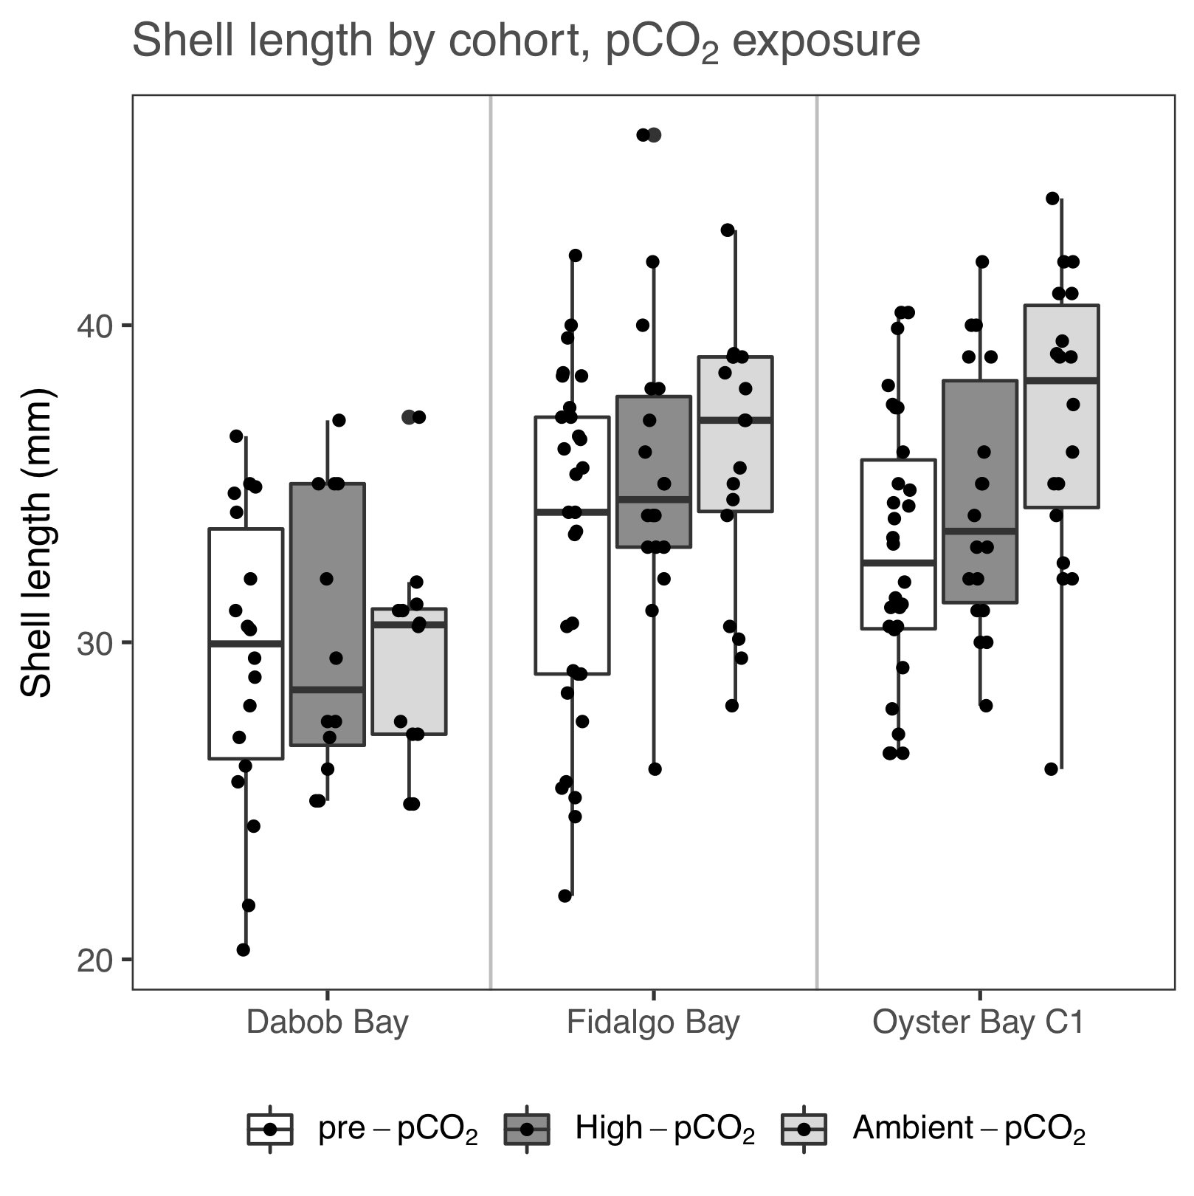

**Figure 2**: Adult shell length before (pre-pCO2) and after a 52-day exposure to high pCO2 (3045±488 µatm, pH 7.31±0.02) and ambient pCO2 (841±85 µatm, pH 7.82±0.02) for 3 populations of *Ostrea lurida*, all hatched and held for 4 years in common conditions prior to the experiment.

**Adult reproductive development**

After 60 days in 6.1±0.2°C and 10.2±0.5°C, dominant gonad stage differed significantly between temperatures (𝝌2=15.8, p-adj=0.016). The 10°C oysters had more instances of advanced gametogenesis (stage 2), and fewer resorbing/spawned (stage 4)(Figures 3 & 4, Supplementary Table 3). This difference was influenced strongly by male gametes, which were more advanced in the 10°C oyster when present (𝝌2=31.1, p-adj=0.0011), but there were no differences in female gamete stages (𝝌2=2.2, p-adj=0.73). No differences in dominant sex were observed between temperature treatments (𝝌2=8.0, p-adj=0.25).

After 52 days in pCO2 treatments, gonad stage of the dominant sex differed significantly between pCO2 exposure in 10°C-treated oysters (𝝌2=12.5, p-adj=0.026). There was no significant effect of pCO2 on gonad stage in the 6°C-treated oysters (𝝌2=9.7, p-adj=0.090). Male gamete stage tended to differ between pCO2 exposure in both temperatures (6°C: 𝝌2=9.0, p-adj=0.078, 10°C: 𝝌2=9.5, p-adj=0.054). Mature spermatocytes (stage 3) were found in 18.0% of all high pCO2-treated oysters, and 30.8% of ambient-pCO2 oysters. No differences were observed in female gamete stage, when present (all p-adj > 0.13). Ripe oocytes (stage 3) were found in 14.1% of all oysters sampled from high pCO2 (n=78), and 16.7% of all ambient pCO2 oysters (n=78).

Dominant gonad stage significantly changed while in ambient pCO2 for both temperature treatments (6°C: 𝝌2=16.5, p-adj=0.014; 10°C: 𝝌2=12.7, p-adj=0.031), influenced strongly by changes in male gamete stage (6°C: 𝝌2=24.2, p=0011; 10°C: 𝝌2=11.2 p-adj=0.036). Male gametes in the 6°C treated oysters changed while in the high pCO2 exposure (𝝌2=15.2, p-adj=0.0072), but not in 10°C treated oysters (𝝌2=0.6, p-adj=0.95). Gonad sex did not differ significantly among treatments, however, as shown in Figure 3, oysters tended to contain fewer male-only and more female-only gonad tissues in the riper, ambient pCO2-treated groups. No gonad stage or sex differences were detected among oysters from 10°C-high pCO2 (combined stressors) and 6°C-ambient pCO2 (no stressors) treatments.

Hermaphroditism was observed in 53.4% of all sampled oysters, 8.3% contained only female gametes, and 31.1% were male only (remaining were indeterminate). Across all treatments, gonad sex differed significantly among cohorts (𝝌2=55.8, p=1.0e-4). Fifty percent of all O-1 oysters sampled (across treatments) were female or hermaphroditic-primarily female (HPF), while 33%, 24% and 11% of D, F, and O-2 were female or HPF. Male or hermaphroditic-primarily male oysters comprised 29%, 48%, 59% and 69% of O-1, D, F, and O-2 cohorts, respectively. No sampled oysters contained brooded embryos or larvae.

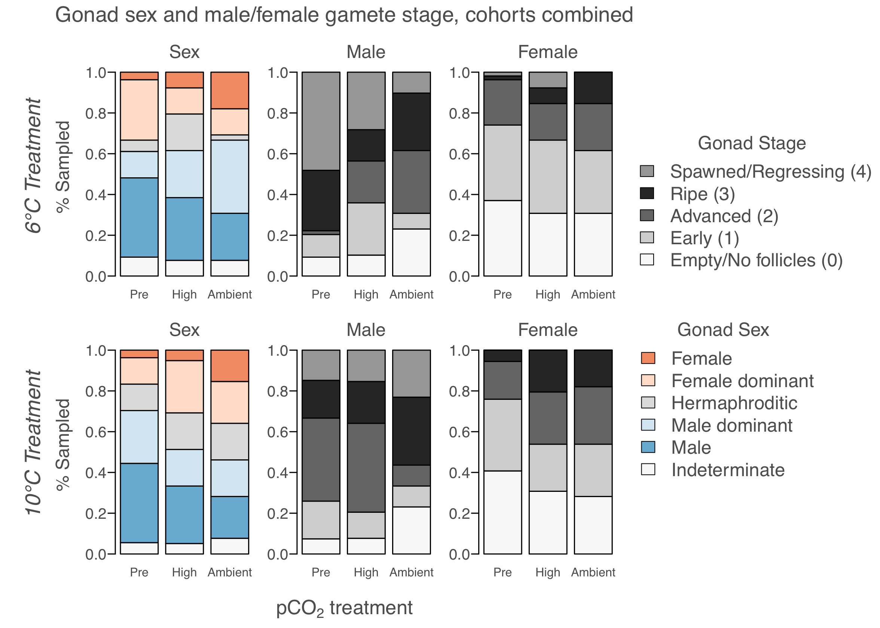

**Figure 3**: Gonad sex, and gonad developmental stages for female and male gametes, before pCO2 treatment and after 52 days in ambient pCO2 (841±85 µatm, n=39) and high pCO2 (3045±488 µatm, n=39). All oysters were assigned both male & female stages; if no oocytes were present, for example, that oyster was designated as female stage 0.

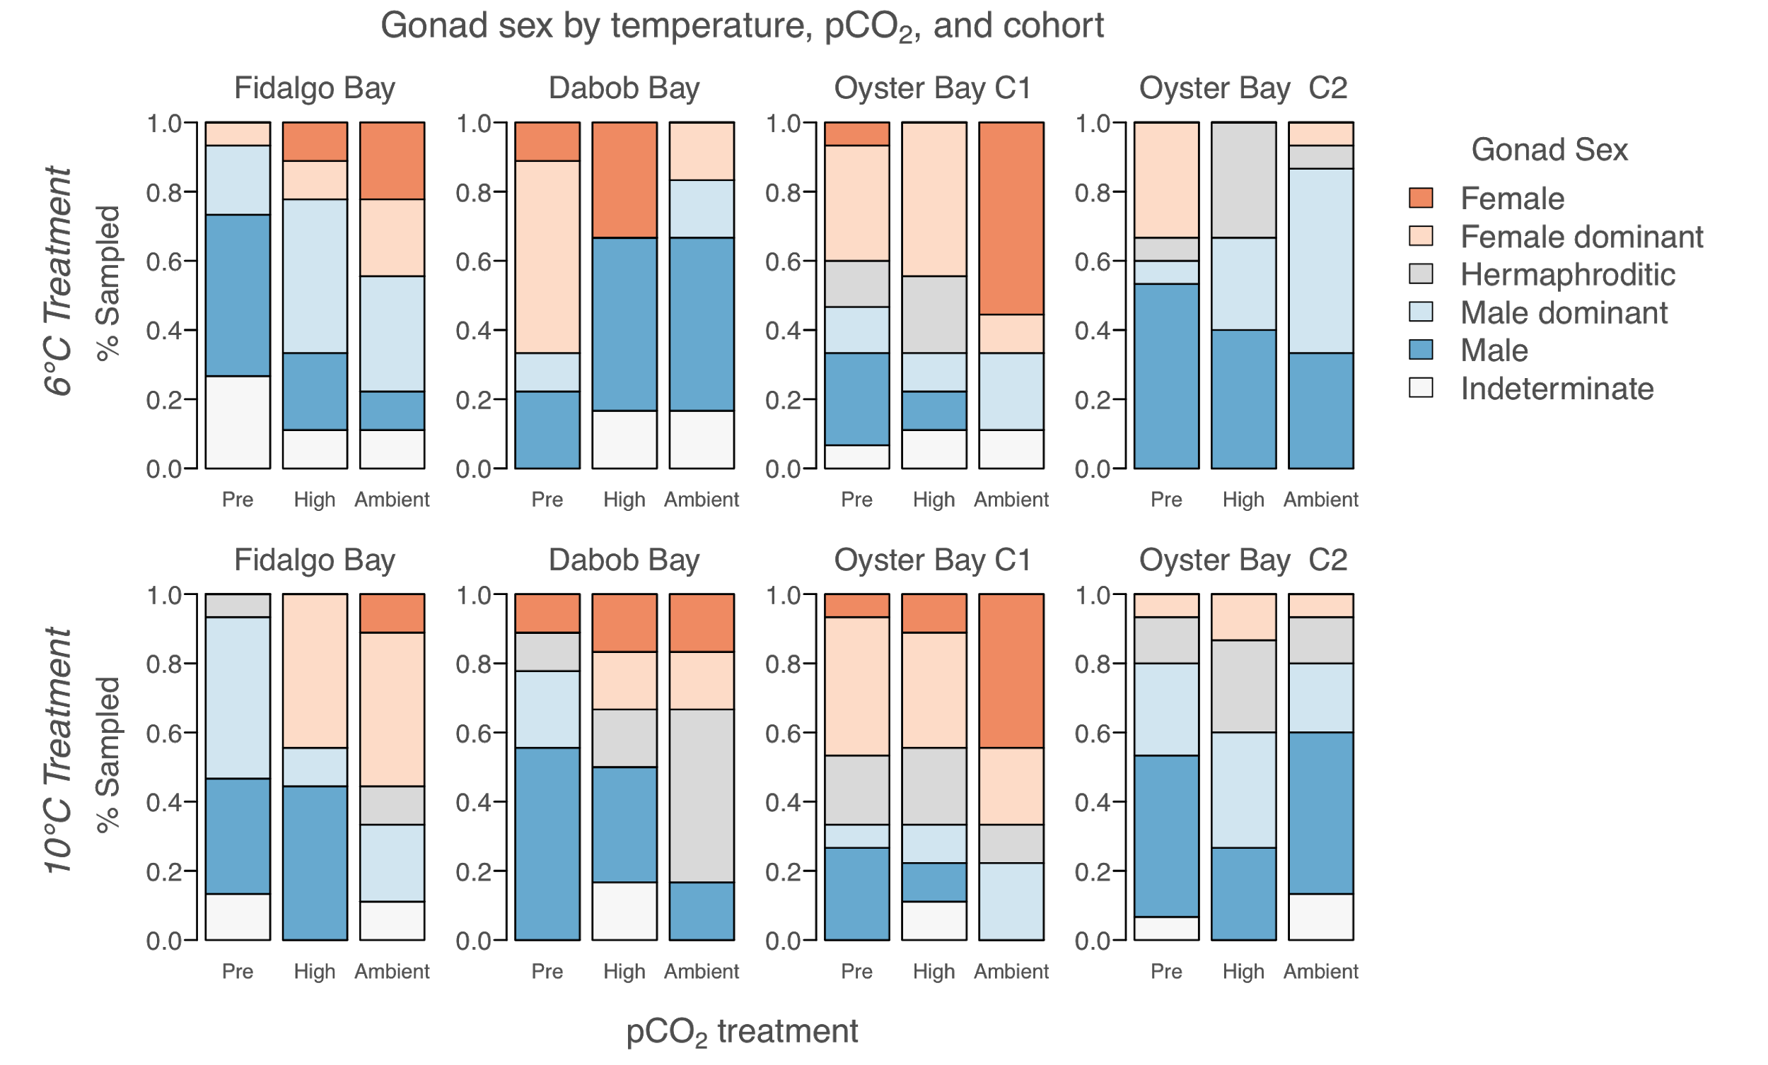

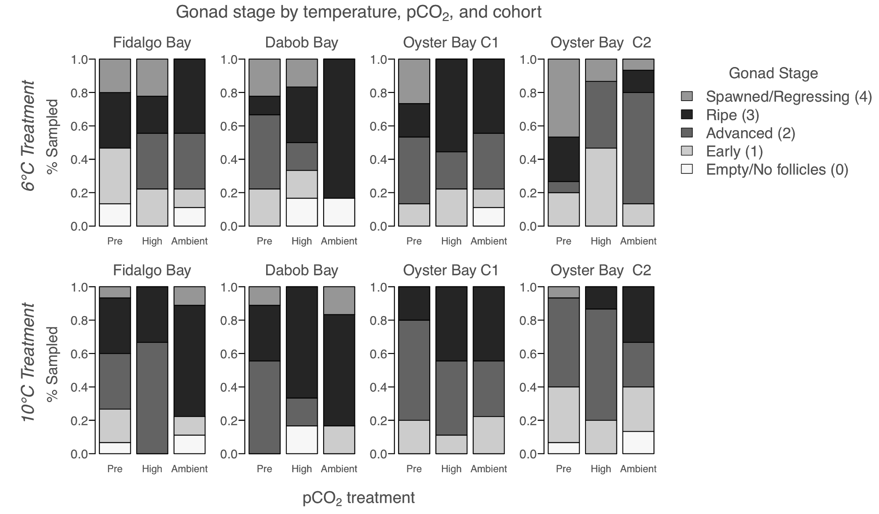

**Figure 4**: Top 2 panels: Gonad sex for each cohort, before pCO2 treatment (“PRE”), and after 52 days in high pCO2 (3045±488 µatm, n=39, “High”), and ambient pCO2 (7.82±0.02, n=39, “Ambient”), separated by temperature treatment (6°C and 10°C). Bottom 2 panels: gonad stage of dominant sex for each cohort.

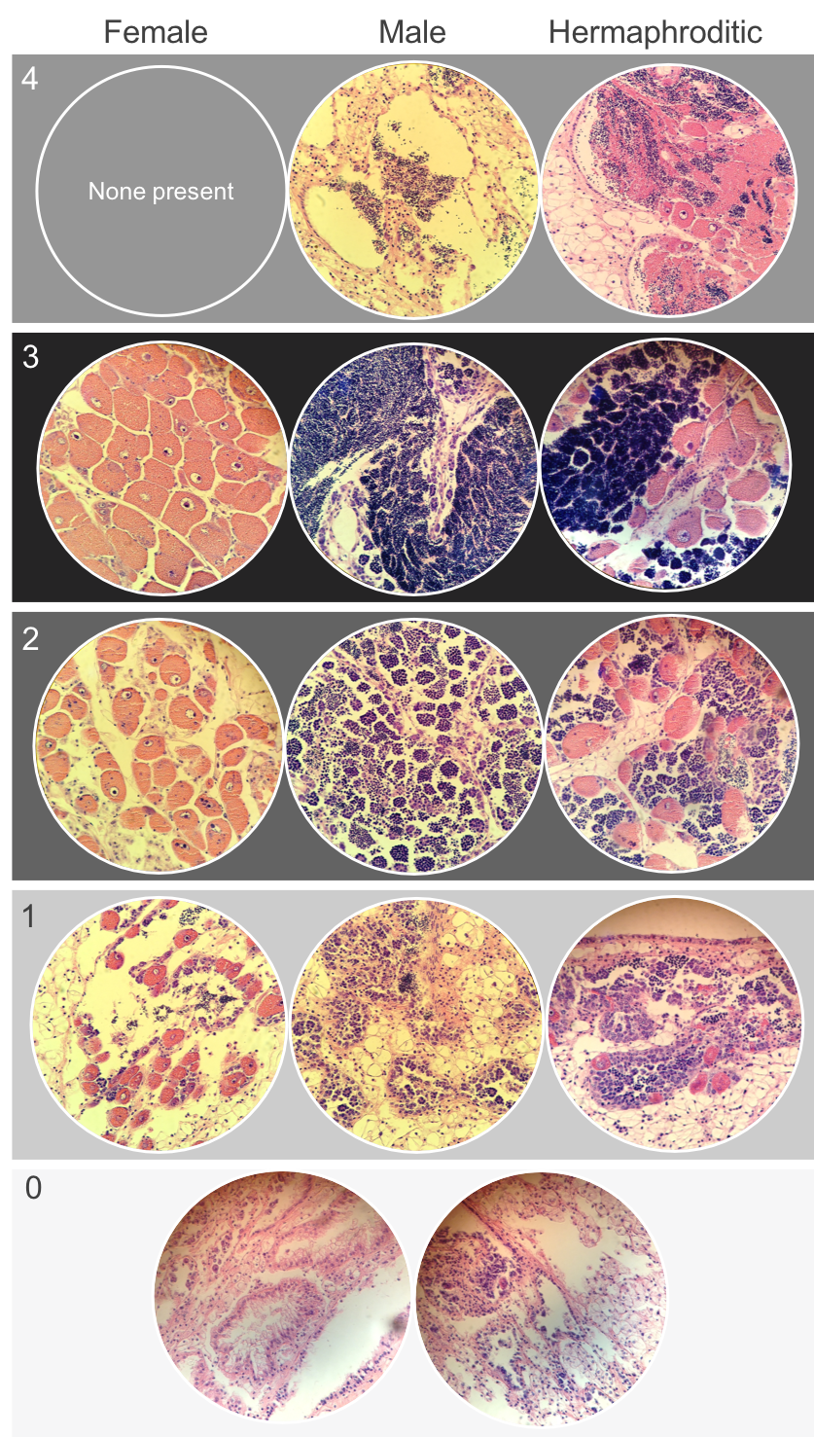

**Figure 5:** Examples of *Ostrea lurida* gonad stage designations. Stage 0 (no activity); Stage 1 (early gametogenesis); Stage 2 (advanced gametogenesis); Stage 3 (ripe / late gametogenesis); Stage 4 (spawned and/or resorbing).

**Larval production**

Over 60 days, 18.5 million larvae were collected from 767 oysters (122 daily collections of >10,000 larvae). Total larvae produced by O-1, F, D, and O-2 was 10.1M, 3.6M, 2.7M and 2.1M, respectively. Across all oyster cohort x treatment groups, average daily collection from a single tank was 96,200, with a maximum daily collection of 809,000. Broadly, fecundity differed significantly by cohort (most productive was O-1), and treatment temperature (10°C oysters produced earlier and more frequently than 6°C), and pCO2 tended to delay onset of larval release (Figures 6 & 7).

Total larvae collected (normalized by # broodstock*mean cohort length) differed by cohort (F(3,8)=15.3, p=0.001). O-1 produced significantly more total larvae than F and O-2 (p=0.0094, p=0.0014, respectively), and D produced more total larvae compared to O-2 (p=0.022). Adult pCO2 exposure did not affect larval production alone, but a pCO2:temperature interaction effect was detected (F(1,8)=8.0, p=0.022), where 10°C produced more larvae than 6°C in the ambient pCO2-exposed oysters (p=0.033), but not in high pCO2-exposed oysters (p=0.96). The same differences were observed in average daily larvae released by cohort (F(3,20)=8.9, p=0.0009) and by temperature within ambient pCO2 exposure (F(1,8)=10.3, p=0.012). Pairwise tests indicate that both O-1 and D were more productive than F on a daily basis (p=0.04 for both), and O-2 was significantly less productive than the other 3 cohorts. The maximum larvae collected in one day differed by cohort, O-1 produced more larvae in a single day (465,000±154,232) than FB and O-1 (222,928±71,044, 153,210±59,650, respectively), but not more than D (291,573±142,137).

The date of first larval release (onset) differed by temperature (F(1,8)=11.9, p=0.0087) and cohort (F(3,8)=15.1, p=0.0012), and an interaction was detected between cohort and pCO2 (F(3,8)=4.6, p=0.038). Onset was on average 5.2 days earlier in the 10°C treatment, and on average Oyster Bay cohorts (O-1 and O-2) released larvae 9.9 days earlier than F and D cohorts. Pairwise comparisons indicate that release onset did not differ by cohort within high pCO2 treatment, but did within ambient pCO2 treatment (O-1 and O-2 earlier than D). Timing of peak larval release differed by temperature treatment (F(1,22)=5.73, p=0.026), occurring on average 8.3 days earlier in 10°C oysters.

The 10°C treated oysters produced larvae more frequently, on average 2 additional days, than 6°C (F(1,8=7.25, p=0.027). Release frequency also differed by cohort (F(3,8)=9.8, p=0.0046). On average, O-1, O-2, F, and D released larvae 6.4±2.3, 8.0±2.9, 3.8±1.9, and 2.8±1.0 days, respectively. The O-1 cohort released larvae more frequently than F (p=0.017), and O-2 more frequently than both F and D (p=0.0066, p=0.043, respectively).

While not significant, the overall timing of larval release tended to be later in high pCO2 treated oysters. Across all cohorts and temperatures, the first larval release peak occurred on May 17th in ambient pCO2 oysters, and May 22nd in high pCO2 oysters. A second peak occurred on June 1st, and June 12th, for ambient and high pCO2 groups, respectively. A third small release peak occurred only in the ambient pCO2 oysters, on June 12th.

Cohort and temperature-specific pCO2 trends were also observed. The high pCO2-treated O-1 cohort began releasing larvae 5±1 days later than the ambient pCO2 O-1 oysters. Oysters that were 10°C-treated produced larvae at a nearly equivalent frequency irregardless of pCO2 treatment (36 and 35 release days in ambient and high pCO2 groups, respectively), while 6°C groups released less frequently after being held in ambient pCO2 (21 and 27 release days in ambient and high pCO2, respectively). However, the 6°C-treated F and D cohorts held in high pCO2 produced larvae more frequently (4 large releases) compared to ambient pCO2 oysters from the same cohorts (1-2 large releases).

**Table 2**: Timing and magnitude of larval production in 4 *Ostrea lurida* cohorts previously exposed to different winter temperatures (6°C and 10°C), then pCO2 treatments (“Amb.” is Ambient=841±85 µatm, pH 7.82±0.02, High=3045±488 µatm). Fidalgo Bay, Dabob Bay, and Oyster Bay are previously identified as genetically distinct populations [(Jake E. Heare et al., 2017; J. Emerson Heare et al., 2018)](https://paperpile.com/c/DMAOJn/4QuA+OwPR). Two Oyster Bay cohorts were used (O-1, O-2), with O-2 being the offspring of O-1 and likely all siblings. For each metric, total (“Tot.”) or mean (“Ave.”) of all cohorts combined for each treatment is shown.

|  |  |  |  |  |  |  |  |  |  |  |  |
| --- | --- | --- | --- | --- | --- | --- | --- | --- | --- | --- | --- |
| *Larval release by cohorts, winter temperature & pCO2 treatment* | | | | | | | | | | | |
| Cohort |  | *Fidalgo Bay*  *(2 reps)* | | *Dabob Bay* | | *Oyster Bay - F1*  *(2 reps)* | | *Oyster Bay - F2* | | *All cohorts combined* | |
| pCO2 treatment |  | Amb. pCO2 | High pCO2 | Amb. pCO2 | High pCO2 | Amb. pCO2 | High pCO2 | Amb. pCO2 | High pCO2 | Amb. pCO2 | High pCO2 |
| No. of broodstock | 6°C | 15/14 | 14/15 | 14 | 15 | 15/16 | 17/17 | 117 | 126 | Tot: 191 | Tot: 204 |
| 10°C | 15/14 | 14/14 | 9 | 16 | 17/17 | 15/15 | 115 | 111 | Tot: 177 | Tot: 185 |
| Date of first release | 6°C | 142/139 | 156/145 | 163 | 133 | 134/137 | 140/141 | 139 | 137 | Ave: 142 | Ave: 142 |
| 10°C | 145/137 | 144/141 | 144 | 146 | 135/134 | 134/137 | 131 | 131 | Ave: 138 | Ave: 139 |
| Date of max release | 6°C | 149/146 | 161/145 | 163 | 168 | 135/156 | 141/165 | 154 | 143 | Ave: 151 | Ave: 154 |
| 10°C | 145/137 | 144/144 | 151 | 147 | 135/152 | 151/137 | 140 | 143 | Ave: 143 | Ave: 144 |
| Date of last release | 6°C | 173/149 | 173/191 | 187 | 173 | 170/170 | 168/168 | 173 | 161 | Ave: 170 | Ave: 172 |
| 10°C | 158/168 | 184/191 | 182 | 175 | 191/187 | 175/173 | 166 | 170 | Ave: 175 | Ave: 178 |
| Ave. daily larvae released  (x103) | 6°C | 21/38 | 99/127 | 53 | 107 | 139/114 | 103/175 | 58 | 43 | Ave: 79 | Ave: 110 |
| 10°C | 139/84 | 58/56 | 117 | 101 | 192/107 | 133/111 | 36 | 57 | Ave: 108 | Ave: 88 |
| Total larvae released (x103) | 6°C | 127/150 | 591/892 | 105 | 959 | 697/  1,482 | 719/  1,397 | 518 | 389 | Tot: 3.08M | Tot: 4.95M |
| 10°C | 695/421 | 345/393 | 939 | 705 | 1,918/  1,502 | 933/  1,441 | 466 | 689 | Tot: 5.9M | Tot: 4.5M |
| Total larvae released per broodstock  (x103) | 6°C | 2.4/3.0 | 11.7/16.5 | 2.5 | 21.3 | 12.9/25.7 | 11.7/22.8 | 2.0 | 1.4 | Ave: 6.6 | Ave:13.5 |
| 10°C | 1.3/8.4 | 6.8/7.8 | 34.8 | 14.7 | 31.3/24.6 | 17.3/26.7 | 1.8 | 2.8 | Ave:18.8 | Ave: 11.7 |
| Maximum release (x103) | 6°C | 111/140 | 247/308 | 105 | 356 | 462/484 | 250/809 | 133 | 131 | Ave: 239 | Ave: 350 |
| 10°C | 248/246 | 298/186 | 437 | 268 | 555/407 | 378/379 | 108 | 241 | Ave: 333 | Ave: 292 |
| No. big release days (>10k) | 6°C | 2/1 | 4/4 | 1 | 4 | 3/8 | 5/5 | 6 | 5 | Tot: 21 | Tot: 27 |
| 10°C | 3/3 | 2/3 | 5 | 5 | 7/7 | 5/10 | 11 | 10 | Tot: 36 | Tot: 35 |



**Figure 6:** Larval collection over 60 days of continuous volitional spawning. Stacked bars are daily larvae collected, separated into four panels by cohort, and color coded by prior temperature and pCO2 exposures where ambient pCO2 = 841 µatm (7.8 pH), and high pCO2 = 3045 µatm (7.31). Spawning was induced by holding adults at 18°C (in ambient pCO2) and feeding with live algae at a density of 66,000 ± 12,000 cells/mL.

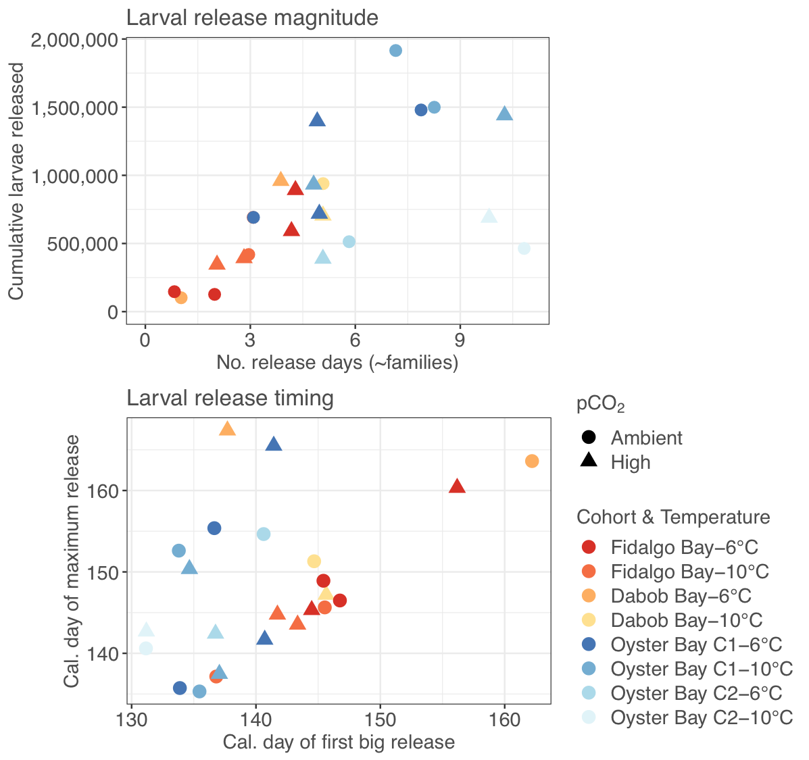

**Figure 7:** Top: cumulative larvae released against number of days >10k larvae were released (approximation for number of families). Bottom: date of maximum release against date of larval release onset. Both plots show reproductive similarities among Fidalgo and Dabob Bays, and among both Oyster Bay groups

**Larval survival and densities**

Larval survival between bi-weekly counts did not differ by pCO2 or temperature, but did differ by cohort (F(3,230)=5.73, p=8.5e-4) and pairwise tests indicate that O-1 survival was significantly lower than D (p=3.8e-4), O-2 (p=5.4e-4), and F (p=0.019). Mean biweekly survival of D, F, O-2, and O-1 cohorts was 62±22%, 59±24%, 55±24%, and 49±28%, respectively. Cumulative survival from new- to eyed-larvae was low across all treatments, did not differ by cohort, and did not significantly differ by parental pCO2 (F(1,7)= 4.7, p=0.067), or temperature treatment (F(1,7)=4.0, p=0.087)(Table 3). Cumulative survival in setting tanks through metamorphosis (from eyed larvae to postset) ranged from 0.2% to 26.5%, and differed by cohort (F(3,11)=3.8, p=0.04). Pairwise tests revealed that this was influenced by low survival in the O-1 group and significance was not strong after removing O-1 (F(2,9)=4.1, p=0.06). No survival differences through metamorphosis were detected between pCO2 or temperature treatments.

Although not significant, the number of days between first and last larval collection, and first and last eyed larvae varied by cohort. Across treatments, eyed larvae were present soonest in F (14.5±2.5 days), followed by O-1 (16.5±1.75 days), O-2 (17.25±1.25 days), and lastly D (18.25±3 days) (F(3,12)=2.0, p=0.16). The number of days between stocking the last batch of newly released larvae, and collecting the last eyed larvae were 22±5.8, 23.25±7.4, 29.5±4.7, and 32±4.8 for O-1, F, D, and K, respectively.

Average larval tank density did not influence cumulative survival from new- to eyed-larvae to across the 67 day rearing period (F(1,14)=0.57, p=0.46), but density was a significant factor influencing survival between bi-weekly counts (F(1,230)=10.4, p=0.0015). As a result, tank density prior to each biweekly screening was included as a covariate in ANCOVA testing biweekly survival among groups. Mean stocking densities in O-1, D, O-2, and F were 76,500±71,100, 54,400±424000, 47,000±46,200, and 43,500±42,700, respectively. While survival from eyed-larvae to post-set (i.e. through metamorphosis) was not affected by setting tank density, it was related to the average density in the larval tanks (F(1,11)=14.2, p=0.0002).

**Table 3:** Offspring survival through the larval stage and upon field deployment: survival of larvae between biweekly counts; cumulative survival from newly-released to eyed-larvae; cumulative survival from eyed larvae to post-set (through metamorphosis). Survival through metamorphosis was affected by larval tank density (*), which differed by cohort and temperature (but not by pCO2). 12-month old juveniles were deployed for 3 months in four bays in Puget Sound, Washington. Only the 6°C juveniles were deployed in the field trial (**). Juvenile shell length prior to deployment is also shown.

|  |  |  |  |  |  |  |  |  |  |  |  |
| --- | --- | --- | --- | --- | --- | --- | --- | --- | --- | --- | --- |
| *Larval and juvenile survival, by treatment and cohort* | | | | | | | | | | | |
|  |  | *Fidalgo Bay* | | *Dabob Bay* | | *Oyster Bay - F1* | | *Oyster Bay - F2* | | *All cohorts* | |
|  |  | Amb pCO2 | High pCO2 | Amb pCO2 | High pCO2 | Amb pCO2 | High pCO2 | Amb pCO2 | High pCO2 | Amb pCO2 | High pCO2 |
| Average biweekly larval survival | 6°C | 56±25% | 62±26% | 69±18% | 49±21% | 44±23% | 52±27% | 60±24% | 59±28% | 56±24% | 56±26% |
| 10°C | 50±18% | 51±26% | 58±25% | 70±18% | 49±30% | 46±29% | 63±25% | 55±21% | 55± | 56± |
| Cumulative survival to eyed larvae | 6°C | 8.5% | 3.0% | 5.1% | 4.7% | 2.7% | 1.2% | 6.7% | 5.7% | 5.7±2% | 3.6±2% |
| 10°C | 1.3% | 1.4% | 5.2% | 6.6% | 4.2% | 0.7% | 4.4% | 1.0% | 3.8±1% | 2.4±3% |
| *Cumulative survival, eyed larvae to post set | 6°C | 13.8% | 5.9% | 26.5% | 9.3% | 1.1% | 3.6% | 1.7% | 3.5% | 10.8  ±10% | 5.6  ±2.7% |
| 10°C | 18.5% | 2.7% | 9.7% | 6.0% | 0.2% | 0.7% | 1.9% | 5.8% | 7.6±8% | 3.8±3% |
| Juvenile shell length (12 months old) | 6°C | 9.0  ±2.7 | 8.4  ±3.5 | 6.5  ±1.9 | 4.9  ±2.3 | 11.2  ±3.5 | 11.0  ±3.4 | 11.0  ±3.7 | 7.5  ±3.0 | 8.7±3.4 | 7.1±3.6 |
| 10°C | 9.7  ±3.0 | 12.3  ±5.4 | 7.0  ±2.3 | 6.6  ±2.9 | 11.0  ±3.8 | 12.2  ±4.2 | 10.7  ±3.7 | 13.4  ±4.4 | 8.6±3.3 | 9.2±4.9 |
| **Juvenile survival, 3 month field deployment | 6°C | 27  ±22% | 62  ±29% | 30  ±22% | 34±  28% | 38  ±37% | 58  ±41% | 20  ±16% | 4  ±13% | 29  ±27% | 44  ±37% |

**Offspring survival in a natural setting**

Across all cohorts, survival differed significantly between oysters with different parental pCO2 histories (𝝌2=11.1, p=8.7e-4), and across all pCO2 treatments, survival differed by cohort (𝝌2=45.8, P=6.3e-10), and bay (𝝌2=18.5, p=3.4e-4), but no interaction was detected between cohorts and bay (𝝌2=9.8, p=0.37) (Figure 8, Table 3).

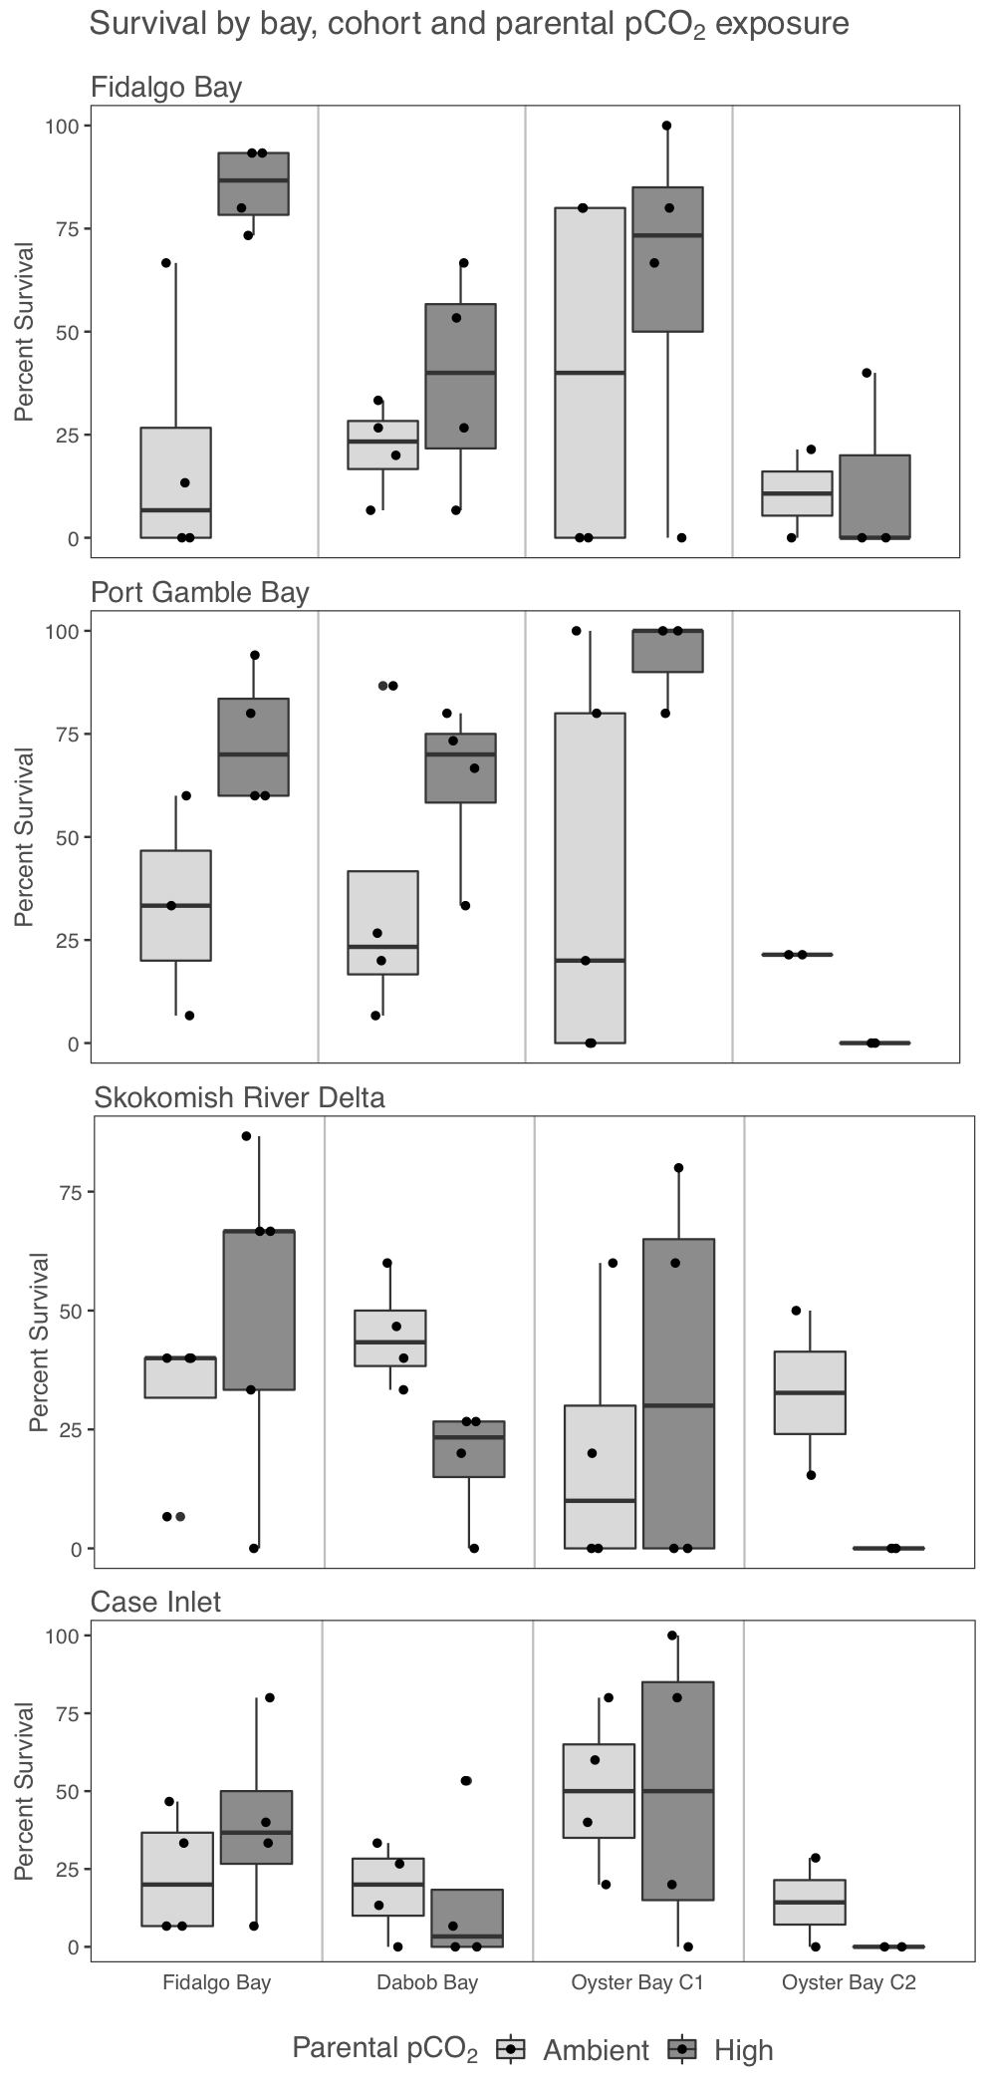Mean survival of all juvenile groups from high pCO2-exposed parents was 44±37%, and 29±27% from ambient pCO2 parents. The pCO2 differences varied by cohort. In the Fidalgo Bay cohort, survival was significantly higher in oysters from high pCO2 parents across all bays (𝝌2=28.1, p=4.6e-7); within-bay pCO2 differences were detected in the Fidalgo Bay location only, after correcting for multiple comparisons (𝝌2=17.6, p=0.0001). Survival in the Dabob Bay and Oyster Bay Cohort 1 cohorts did not differ between parental pCO2 across all bays (𝝌2=0.4, p=1, 𝝌2=2.5, p=0.44), or within bays. The Oyster Bay Cohort 2 survival was higher across all bays in the ambient parental pCO2 (𝝌2=9.1, p=0.010), but only significantly different within the Skokomish River Delta (𝝌2=8.9, p=0.011) after multiple comparison correction.

The pCO2 survival differences also varied by bay. In Fidalgo and Port Gamble Bays, survival in offspring from high pCO2 parents was higher (𝝌2=17.7, p= 2.6e-5; 𝝌2=10.0, p=1.6e-3, respectively), but this was not the case in Skokomish River Delta or Case Inlet. Highest survival was observed in oysters deployed in Port Gamble Bay (mean 49±36%), then Fidalgo Bay (39±36%), which both differed significantly from survival in Case Inlet (mean 29±29%, p=0.012 & p=0.037, respectively). Survival at Skokomish River Delta did not differ significantly from other locations (32±27%).

No differences in shell growth or mass per oyster were detected across factors, however these metrics were also confounded by the varying mortality during deployment, so comparisons between mean initial and mean final were not likely accurate. Correlation analysis revealed that the percent survival during deployment negatively correlated with percent survival from newly released larvae to eyed-larvae (rs= -0.83, p=0.015). Neither setting tank density or juvenile bag density correlated with deployment survival.

**Figure 8:** Percent survival during field deployment in all bag for each cohort x treatment x bay (n=4). The 4 panels each represent survival data in one bay: Fidalgo Bay, Port Gamble Bay, Skokomish River Delta, Case Inlet). Within each panel, boxplots are separated by cohort (Fidalgo Bay, Dabob Bay, Oyster Bay Cohort 1, and Oyster Bay Cohort 2), and parental pCO2 exposure (Ambient=841 µatm, High=3045 µatm). Boxes contain replicates deployment groups with percent survival lying within the interquartile range (IQR), with median survival indicated by line in middle of boxes. Whiskers extend to the largest value no greater than 1.5*IQR, and dots indicate outliers beyond 1.5*IQR.

**Discussion**

The impact of ocean acidification and ocean warming on reproduction and offspring viability was investigated in the Olympia oyster, using 4 oyster cohorts spawned from 3 genetically distinct Puget Sound populations. Oysters were sequentially exposed to elevated winter temperature (+4.1°C), then high pCO2 (+2204 µatm) prior to reproductive conditioning and spawning. Winter warming resulted in substantially more advanced gonad, which corresponded with earlier and more frequent larval release (on average 5.2 days earlier, 2 additional days). High pCO2 exposure resulted in substantially less advanced gonad and delayed larval release (first larval peak 5 days later), but there was no pCO2 effect on fecundity. In offspring, no significant carry-over effects were detected in larval survival, and 1-year old juveniles from high pCO2 parents tended to have higher survival upon deployment in the natural environment. Reproduction and survival data clearly support prior reports of population-specific fitness traits within Puget Sound *O. lurida* assemblages.

**Reproduction**

Based on prior observations of low fecundity in a *O. lurida* hatchery following the winter 2016 marine heat wave, elevated winter temperature was expected to reduce fecundity, due to oysters not entering reproductive quiescence, not resorbing residual gametes, and storing less glycogen reserves. Counter to this prediction warm winter temperature positively affected fecundity, as the warm-treated oysters released larvae earlier and more frequently than cold-treated oysters. One explanation of this observation could be that gametogenesis was uninterrupted, as there was a higher incidence of advanced and ripe gametes in oysters at elevated winter temperature. The more developed gametes were only detected in male gonad tissues, as oocyte maturity did not differ between temperatures, although temperature did not affect sex ratios. These results are analogous to what was seen in the Sydney rock oyster, where warming accelerates gametogenesis, increases fecundity, and does not alter sex determination [(Parker et al. 2018)](https://paperpile.com/c/DMAOJn/CFE1). It should be noted that both this and the Parker et al. (2018) studies were conducted under controlled hatchery settings, with ample phytoplankton, and in the wild numerous additional abiotic and biotic factors will contribute to fitness. For example, warmer winters may result in earlier and longer reproductive seasons only if nutritional requirements are met. Whether larvae released earlier in the spring can survive to recruitment will also greatly depend on food availability, predation, and environmental conditions.

We predicted high pCO2 exposure to redirect energy to maintenance processes and away from storage and reproduction, resulting in delayed gametogenesis and poor fecundity. After a 52 day exposure to high pCO2, fewer oysters contained ripe or advanced male gonad tissue, signaling delayed gametogenic activity, but sex ratios and female gonad were not affected. In support of the altered resource allocation hypothesis, adults in high pCO2 treatment grew less than those in the ambient pCO2 treatment (there was significant growth only in ambient pCO2-exposed F and O-1 cohorts). Onset of larval release tended to be delayed in high pCO2 treated oysters (appr. 5 days), however this delay was influenced significantly by the Oyster Bay cohort 1, and fecundity was not ultimately affected. These results suggest that high pCO2 negatively affects gametogenesis during exposure and subsequently impacts spawn timing, but if the high pCO2 stressor subsides, *O. lurida* can compensate and fecundity is unaffected. Furthermore, molecular triggers that induce spawning and successful fertilization are not likely impacted by a recent, severe high pCO2 exposure, although this would require additional research to assess.

In both the Sydney rock (*Saccostrea glomerata*) and Eastern (*Crassostrea virginica*) oysters, high pCO2 slows the rate of gametogenesis and results in fewer gravid individuals, however it also affects sex determination, as the Eastern oyster skews male [(Boulais et al. 2017)](https://paperpile.com/c/DMAOJn/5aok), while the Sydney rock oyster skews female [(Parker et al. 2018)](https://paperpile.com/c/DMAOJn/CFE1). Differences in pCO2 levels and exposure timing preclude generalities resulting from Parker, Boulais, and the present study. While Parker et al. (2018) found gametogenesis to slow in 856 µatm (pH 7.91, 8 weeks), Boulais et al. (2017) found normal rates at 2260 µatm (pH 7.5), delay at 5584 µatm (pH 7.1), and full inhibition at 18480 µatm (pH 6.9, 5 weeks). In this study, gametogenesis was slowed but not inhibited by 3045 µatm (pH 7.3), as there was a 13% increase in gravid oysters over 7 weeks of high pCO2 treatment. Had pCO2 treatment continued through reproductive conditioning and spawning, results could be more directly compared. Furthermore, there was very low incidence of total reproductive quiescence in these *O. lurida* cohorts - only 4 out of the 108 oysters that were sampled prior to pCO2 treatment contained empty follicles - and thus sex ratios may be different if pCO2 exposure occurs earlier in life during initial sex differentiation. There is also the possibility that there are in fact species-specific differences that are associated with variation on physiological mechanisms and respective life history attributes. Future research should examine *O. lurida* reproductive activity in a range of pCO2 above and below 3045 µatm, and in first-year juveniles, to determine conditions in which gametogenesis is unaffected, fully inhibited, and if initial sex determination is altered.

The combined effects of high pCO2 and warm winter treatments did not act synergistically to delay gonad development, but instead resulted in oysters with gonad sex and stage no different from the untreated oysters. Similarly, combined temperature and high pCO2 stressors did not affect Sydney rock oyster fecundity [(Parker et al. 2018)](https://paperpile.com/c/DMAOJn/CFE1). Together, these results indicate that high pCO2 slows gametogenesis, and elevated temperature accelerates it, and these two environmental drivers act antagonistically on gonad development if occurring during the same reproductive season. However, a long-term study of persistent pCO2 effects on reproduction would be a useful line of inquiry.

**Offspring**

We predicted that elevated winter temperature and high pCO2 would negatively impact offspring performance, a result of poorly provisioned gametes. Counter to these predictions, no significant larval survival differences were observed in offspring from high pCO2 or warm-treated parents. Similarly, upon deployment in the natural environment no negative pCO2 effects were detected. On the contrary, survival trended higher in oysters from high pCO2 parents (offspring from warm-treated adults were not deployed). These results suggest that parental exposure to high pCO2 prior to spawning does not negatively affect *O. lurida* offspring survival, despite impacts on gametogenesis. In contrast, a similar study that exposed Pacific oysters (*Crassostrea gigas*) to high pCO2 for 7 weeks, 3 months prior to reproductive conditioning, found that exposed females produced fewer hatched larvae [(Venkataraman et al. 2019)](https://paperpile.com/c/DMAOJn/yRoJ). Paternal pCO2 exposure did not influence survival, which was measured as hatch rate 18 hrs post fertilization, indicating a negative maternal effect, such as reduced egg quality [(Venkataraman et al., 2019)](https://paperpile.com/c/DMAOJn/yRoJ). Hatch rate was not directly measured in this study due to the Olympia oyster’s brooding behavior, however no difference in daily and total larvae released suggest that hatch rate was unaffected. Larval brooding may, in fact, be a mechanism by which sensitive larvae are either protected from environmental stressors, or acclimatized to stressors (brood chamber pH and dissolved oxygen can be significantly lower than the environment). The Olympia oyster is also native to the Pacific coast of North America, a region with frequent upwelling events, and may have evolved to tolerate periods of high pCO2.

Lack of discernible larval response may be linked to the male-specific gonad effects, and the conditions in which the oysters were held. During treatments, male gonad stage advanced significantly, but there was little change to female development and no difference between pCO2 treatments, an indication that little oogenesis occurred. Carryover effects of adult exposures to offspring are commonly linked to the maternal environment, and variation in oocyte quality [(Utting & Millican 1997)](https://paperpile.com/c/DMAOJn/cjEU). For example in the Chilean flat oyster (*Ostrea chilensis*), egg size and lipid content are positively correlated with juvenile growth and survival [(Wilson](https://paperpile.com/c/DMAOJn/N11W) [et al.](https://paperpile.com/c/DMAOJn/bwO9+98DX+LNlq+BKMB) [1996)](https://paperpile.com/c/DMAOJn/N11W). If high pCO2 were to coincide with rapid proliferation of oocytes and final maturation, *O. lurida* egg quality and larval viability could be compromised, but this certainly requires further investigation.

No negative effects of parental pCO2 treatment were detected in offspring in the field deployment, and in some instances survival was higher. Offspring with high pCO2 histories performed better in the northern bays, particularly in Port Gamble Bay, which signals a physiological difference that better equips them for conditions to the north. Port Gamble Bay and Fidalgo Bay were both cooler (-1.5°C), are more influenced by oceanic water, and typically less stratified than Skokomish River Delta which is in the Hood Canal fjord, and Case Inlet which has a longer residence time and is a finger-like basin in the southern reaches of Puget Sound. In Port Gamble Bay, where pCO2 parental history most significantly correlated with offspring survival, mean pH was considerably lower than the other deployment locations (-0.17 pH units, pCO2 was not recorded, Table 1), and mean salinity was higher (+3.8 PSU). Regardless of why survival was higher in juveniles with high pCO2 histories in the north, the consistent difference among cohorts suggests a positive carryover effect of parental pCO2 exposure, which is exhibited in particular conditions. Further investigation is necessary, for example stress-testing the offspring in a controlled environment could identify which parameters (pH, salinity, temperature) may have resulted in survival differences.

Oysters deployed in Port Gamble Bay also had the highest survival over the other 3 deployment bays. Port Gamble is the same bay in which the adult F1 cohorts (F, D, O-1, but not O-2) were hatched and reared during their larval stage in 2013 [(](https://paperpile.com/c/DMAOJn/4QuA)in a hatchery, [Heare et al. 2017)](https://paperpile.com/c/DMAOJn/4QuA). This suggests that, perhaps, a “memory” of the larval environment in Port Gamble Bay was retained for 4 years, then transferred to offspring, resulting in higher deployment survival in Port Gamble Bay. Alternatively, genetic selection in F1 larvae reared in 2013 may have occurred, preferring genotypes suited to Port Gamble Bay.

A few limitations in the offspring results must be noted. Firstly, this experiment was designed to maximize genetic diversity within treatments by collecting reared larvae continuously over 48 days, and not discarding slow-growing or small larvae, therefore larval growth was not directly measured for individual families (No. of families per treatment/cohort ranged from 1 to 11, Table 2), nor were families and pre-metamorphosis stages kept separate. For finer resolution, larvae should be reared, and growth and survival monitored, separately by “family” (one daily pulse of larvae). The multi-stage growing method also resulted in varying densities in setting tanks during metamorphosis, such that recruitment data could not be analyzed. Similarly, in the juvenile field deployment, due to correlation between deployment survival and larval survival by cohort, inter-stage carryover effects may have occurred, such as stress during the larval stage (see [Hettinger et al. 2013, 2012)](https://paperpile.com/c/DMAOJn/CCKm+m4VW). For this reason, there are no conclusions drawn regarding cohort-specific juvenile survival. There were no differences in larval survival or stocking density between pCO2 treatments, and thus we are confident in the findings regarding parental pCO2-specific juvenile survival.

**Population specific traits**

While there were no consistent effects of high pCO2 on fecundity, there did appear to be population-specific effects on larval production, depending on the temperature treatment. In both cold-treated Fidalgo Bay (F) and Dabob Bay (D) oysters, the high pCO2 exposed groups reproduced more frequently compared to ambient pCO2 (high: 4 larval releases, ambient: 1-2 larval releases). While these results are not significant, the similarities between Fidalgo and Dabob Bay cohorts are consistent with other reproductive traits exhibited in this and prior studies, particularly in comparison to the Oyster Bay cohort. In a reciprocal transplant study, Heare et al. [(2017)](https://paperpile.com/c/DMAOJn/4QuA) found no differences in reproductive timing between Dabob Bay and Fidalgo Bay, however Oyster Bay had considerably higher incidents of brooding, and maximum percent brooding was reached 20-30 days earlier than Dabob and Fidalgo Bays (145-159 degree days). Silliman et al. [(Silliman et al. 2018)](https://paperpile.com/c/DMAOJn/pNym) also found Oyster Bay to be the most reproductively active, followed by Dabob Bay, both producing significantly more larvae than Fidalgo Bay. In this study, the Oyster Bay cohorts (O-1, O-2) began to release larvae on average 9.9 days earlier than Fidalgo and Dabob Bays (99 degree days), and O-1 released significantly more larvae than Fidalgo Bay. A population’s unique reproductive traits may influence how it responds to environmental exposures (e.g. high fecundity in Oyster Bay), and if only one population is studied, the broader conclusions of temperature x pCO2 effects on larval production.

Variability in gonad sex ratios among cohorts may reveal why Oyster Bay is so fecund. Oyster Bay Cohort 1 had substantially more females compared to the same-age cohorts (Figure 4). In spermcasting species such as *O. lurida*, gravid females are often the limiting factors that determine the number of families produced in the hatchery, and the effective sex ratio in the wild. Populations with high proportions of females are therefore of interest to breeding programs, and may be more reproductively successful in the wild. Sex determination is still not fully understood in oysters, and likely a combination of genetic and environmental factors [(Hedrick & Hedgecock 2010)](https://paperpile.com/c/DMAOJn/c4Jy). Oyster Bay’s preponderance for females is likely genetic, as all F1 cohorts (F, D, and O-1, 4 years old) were produced and held in common conditions since they were in the larval stage. Larval release timing was also similar for both Oyster Bay cohorts (Figure 7), despite O-2 being a 2nd-generation hatchery cohort and 2 years younger, further support for genetically linked reproductive traits. However, germ-cell and transgenerational environmental sex determination cannot be ruled out at this time.

Combined, the Heare, Silliman and present study indicate that reproductive timing and investment is a heritable trait in Olympia oysters, and fine-scale selection has occurred within Puget Sound. Furthermore, heritable factors may contribute to higher rates of females within populations. Future studies should leverage recently published single-nucleotide polymorphism (SNP) data from these Puget Sound populations [(White et al. 2017)](https://paperpile.com/c/DMAOJn/Xma3) and the *Ostrea lurida* genome (*unpublished*), to explore genetic underpinnings of these reproductive traits.

Also consistent with prior studies on these populations, larval survival and growth varied by cohort. Highest percent survival during the larval stage was in Dabob Bay, which was also the slowest cohort to reach the eyed larval stage, and smallest overall at 12 months prior to deployment. Similarly, growth differences were observed in the F1 adults, as Fidalgo Bay and Oyster Bay Cohort 1 grew during ambient pCO2 treatment, but Dabob Bay adults did not. A unique phenotype was also visually observed in all Dabob Bay larvae, as they were significantly darker in color until the early post set stage (black) compared to the other cohorts (brown), a trait which has been genetically linked in adults of other oyster species [(Evans et al. 2009)](https://paperpile.com/c/DMAOJn/FxPg). These population-specific larval trends corroborate findings by Heare et al. (2017), and Silliman et al. (2018). Both observed fastest growth in the Fidalgo Bay population, and slowest growth in Dabob Bay. Heare et al. also observed highest deployment survival in Dabob Bay (although this was not the case during field deployment in this study). As suggested by these authors, the bay of origins’ distinct environments may explain varying phenotypes: resources are allocated to high reproductive output in Oyster Bay, which is a highly productive finger basin with long residence time; to growth in Fidalgo Bay, which is a cooler, more stable environment and influenced by oceanic water; and to larval survival in Dabob Bay, where environmental conditions can be highly variable and at times stressful (e.g. periods of hypoxia).

To begin investigating mechanisms behind differences in these *O. lurida* populations, Heare et al. (2018) used qPCR to measure key stress- and immune-response genes 24 hours after thermal and mechanical stress. They found no significant expression differences in Dabob Bay or Fidalgo Bay oysters. Only Oyster Bay exhibited differential expression after stress-treatments, which were related to transcription (H2AV), growth inhibition (BMP2 and GRB2), and stress (HSP70). Given the consistent characteristics between these oyster populations, future studies should leverage untargeted “omics” methods such as proteomics, transcriptomics, or metabolomics, to understand system-wide differences between oysters with such varying physiological priorities. Importantly, this future work should test multiple cohorts of first-generation (F1) hatchery-produced oysters to confirm that the population-specific traits are representative of the source population, and not influenced by hatchery selection.

A priority in ocean acidification research should address how population-specific traits, such as growth rates, correlate with performance under direct exposure to ocean acidification. This is important, as slow growth may be beneficial in high pCO2 environments. Waldbusser et al. suggest that slow shell secretion (a measure of growth rate) in *O. lurida* is a beneficial trait, contributing to their resilience to more acidic conditions compared with the faster growing Pacific oyster [(Waldbusser et al. 2016)](https://paperpile.com/c/DMAOJn/yDyH). Oyster hatcheries routinely cull slow-growing larvae to maximize survival through metamorphosis, a practice that could remove stress-resilient genotypes. Production-oriented commercial hatcheries which select for fast growth are certainly incentivized to continue these processes. Restoration hatcheries, which are governed by other principles such as genetic diversity, long-term population resilience, and maximizing survival rate in natural conditions, may wish to retain slow-growing larvae. Additional research with the Olympia oyster is needed, however, to confirm growth-related resilience to stress, particularly because faster growth is linked to ocean acidification resilience in selectively bred Sydney rock oysters (*Saccostrea glomerata*) [(Parker et al. 2011; Stapp et al. 2018; Thompson et al. 2015)](https://paperpile.com/c/DMAOJn/mI8K+Ezx6+bIjI).

**Conclusion**

Ocean acidification and ocean warming potentially threaten marine calcifiers and ectotherms, particularly those which are struggling to rebound after population crashes, such as the Olympia oyster (*Ostrea lurida*). Here, we report that both high pCO2 and warming affect *O. lurida* reproduction but in opposing directions, as high pCO2 seems to slow gametogenesis, but warming accelerates it, and the two stressors may counteract if they occur in the same season. These results support bioenergetic models of marine invertebrates under future ocean conditions, which predict that higher pCO2 will shift an organism’s resources to somatic maintenance, and away from reproductive investment [(Sokolova et al. 2012)](https://paperpile.com/c/DMAOJn/OZuM). Results are specific to low-temperature spermatogenesis (below 12.5°C) in *O. lurida* populations from Puget Sound, Washington, and as indicated by the consistent population-specific reproductive traits, should not necessarily be applied to all *O. lurida* assemblages coast wide.

Encouragingly, offspring survival in the natural environment support the hypothesis that adult exposure to high pCO2 does not negatively impact offspring, but instead may impart beneficial environmental memory [(Parker et al. 2012, 2015)](https://paperpile.com/c/DMAOJn/msiO+S9dp). There are several possible mechanisms linking parental exposure to offspring, including altered maternal RNA’s in oocytes, and changes to the epigenome. Comprehensive, multi-generational studies are needed, which should investigate transcriptional and epigenomic differences in somatic adult tissue, unfertilized gametes, and offspring from high pCO2 exposed parents in tandem with growth and survival in a repeat stressor. Critically, to truly decipher whether carryover effects of parental exposures are transgenerational, researchers must follow three generations at minimum (e.g. [Jeremias et al. 2018](https://paperpile.com/c/DMAOJn/HEbQ)), since the germ cells that ultimately produce the 3rd generation are present within gametes. Moreover, the population-specific growth and survival traits observed in this and previous studies highlight the need to include test organisms from multiple locations, to best represent a species-wide response to environmental perturbations.

**Acknowledgements**

Our gratitude to the following people who assisted with this project: Grace Crandall, Kaitlyn Mitchell, Olivia Smith, Megan Hintz, Rhonda Elliott, Lindsay Alma, Duncan Greeley, Beyer and Jackson Roberts, and my family helped with oyster husbandry and sampling; Alice Helker advised on husbandry and larval rearing system engineering; Emily Kunselman helped manage the field deployment; Sam White and Hollie Putnam contributed to the carbonate chemistry analysis; Katherine Silliman and Jake Heare produced (and saved) the experimental oysters; the NOAA Manchester Research Center and Puget Sound Restoration Fund provided facilities and materials; committee members Jackie Padilla-Gamñio, Rick Goetz (and Steven Roberts) advised and supported this extended project!

This work was supported in part by the National Science Foundation Graduate Research Fellowship Program, the National Shellfisheries Association Melbourne R. Carriker Student Research Grant, and the Washington Department of Natural Resources.

**References**

1. [Barton, A., Hales, B., Waldbusser, G. G., Langdon, C., & Feely, R. A. (2012). The Pacific oyster, Crassostrea gigas, shows negative correlation to naturally elevated carbon dioxide levels: Implications for near-term ocean acidification effects. *Limnology and Oceanography*, *57*(3), 698–710. Retrieved from](http://paperpile.com/b/DMAOJn/Bgwc) <https://onlinelibrary.wiley.com/doi/abs/10.4319/lo.2012.57.3.0698>
2. [Benjamini, Y., & Hochberg, Y. (1995). Controlling the False Discovery Rate: A Practical and Powerful Approach to Multiple Testing. *Journal of the Royal Statistical Society. Series B, Statistical Methodology*, *57*(1), 289–300. Retrieved from](http://paperpile.com/b/DMAOJn/BxXn) <http://www.jstor.org/stable/2346101>
3. [Bible, J. M., & Sanford, E. (2016). Local adaptation in an estuarine foundation species: Implications for restoration. *Biological Conservation*, *193*, 95–102. https://doi.org/](http://paperpile.com/b/DMAOJn/h3IR)[10.1016/j.biocon.2015.11.015](http://dx.doi.org/10.1016/j.biocon.2015.11.015)
4. [Boulais, M., Chenevert, K. J., Demey, A. T., Darrow, E. S., Robison, M. R., Roberts, J. P., & Volety, A. (2017). Oyster reproduction is compromised by acidification experienced seasonally in coastal regions. *Scientific Reports*, *7*(1), 13276. https://doi.org/](http://paperpile.com/b/DMAOJn/5aok)[10.1038/s41598-017-13480-3](http://dx.doi.org/10.1038/s41598-017-13480-3)
5. [da Silva, P. M., Fuentes, J., & Villalba, A. (2009). Differences in gametogenic cycle among strains of the European flat oyster Ostrea edulis and relationship between gametogenesis and bonamiosis. *Aquaculture* , *287*(3–4), 253–265. Retrieved from](http://paperpile.com/b/DMAOJn/PKKi) <http://www.sciencedirect.com/science/article/pii/S0044848608008156>
6. [Diaz, R., Lardies, M. A., Tapia, F. J., Tarifeño, E., & Vargas, C. A. (2018). Transgenerational Effects of pCO2-Driven Ocean Acidification on Adult Mussels Mytilus chilensis Modulate Physiological Response to Multiple Stressors in Larvae. *Frontiers in Physiology*, *9*, 1349. https://doi.org/](http://paperpile.com/b/DMAOJn/BKMB)[10.3389/fphys.2018.01349](http://dx.doi.org/10.3389/fphys.2018.01349)
7. [Evans, S., Camara, M. D., & Langdon, C. J. (2009). Heritability of shell pigmentation in the Pacific oyster, Crassostrea gigas. *Aquaculture* , *286*(3), 211–216. https://doi.org/](http://paperpile.com/b/DMAOJn/FxPg)[10.1016/j.aquaculture.2008.09.022](http://dx.doi.org/10.1016/j.aquaculture.2008.09.022)
8. [Fabioux, C., Huvet, A., Le Souchu, P., Le Pennec, M., & Pouvreau, S. (2005). Temperature and photoperiod drive Crassostrea gigas reproductive internal clock. *Aquaculture* , *250*(1–2), 458–470. https://doi.org/](http://paperpile.com/b/DMAOJn/tYkk)[10.1016/j.aquaculture.2005.02.038](http://dx.doi.org/10.1016/j.aquaculture.2005.02.038)
9. [Feely, R. A., Klinger, T., Newton, J. A., & Chadsey, M. (2012). *Scientific summary of ocean acidification in Washington State marine waters*. US Department of Commerce, National Oceanic and Atmospheric Administration, Office of Oceanic and Atmospheric Research. Retrieved from](http://paperpile.com/b/DMAOJn/CiIB) <https://pdfs.semanticscholar.org/5964/ffc14ae680fc855864a55b10351ed86e5935.pdf>
10. [Feely, R. A., Sabine, C. L., Hernandez-Ayon, J. M., Ianson, D., & Hales, B. (2008). Evidence for upwelling of corrosive “acidified” water onto the continental shelf. *Science*, *320*(5882), 1490–1492. https://doi.org/](http://paperpile.com/b/DMAOJn/MDe1)[10.1126/science.1155676](http://dx.doi.org/10.1126/science.1155676)
11. [Fox, J., & Weisberg, S. (2011). *An R Companion to Applied Regression* (Vol. Second Edition). Thousand Oaks CA: Sage. Retrieved from](http://paperpile.com/b/DMAOJn/sTHB) <http://socserv.socsci.mcmaster.ca/jfox/Books/Companion>
12. [Gentemann, C. L., Fewings, M. R., & García-Reyes, M. (2017). Satellite sea surface temperatures along the West Coast of the United States during the 2014-2016 northeast Pacific marine heat wave: Coastal SSTs During “the Blob.” *Geophysical Research Letters*, *44*(1), 312–319. https://doi.org/](http://paperpile.com/b/DMAOJn/qEYN)[10.1002/2016GL071039](http://dx.doi.org/10.1002/2016GL071039)
13. [Goncalves, P., Anderson, K., Thompson, E. L., Melwani, A., Parker, L. M., Ross, P. M., & Raftos, D. A. (2016). Rapid transcriptional acclimation following transgenerational exposure of oysters to ocean acidification. *Molecular Ecology*, *25*(19), 4836–4849. https://doi.org/](http://paperpile.com/b/DMAOJn/TNKm)[10.1111/mec.13808](http://dx.doi.org/10.1111/mec.13808)
14. [Griffith, A. W., & Gobler, C. J. (2017). Transgenerational exposure of North Atlantic bivalves to ocean acidification renders offspring more vulnerable to low pH and additional stressors. *Scientific Reports*, *7*(1), 11394. https://doi.org/](http://paperpile.com/b/DMAOJn/UPY3)[10.1038/s41598-017-11442-3](http://dx.doi.org/10.1038/s41598-017-11442-3)
15. [Heare, J. E., Blake, B., Davis, J. P., Vadopalas, B., & Roberts, S. B. (2017). Evidence of Ostrea lurida Carpenter, 1864, population structure in Puget Sound, WA, USA. *Marine Ecology* , *38*(5). https://doi.org/](http://paperpile.com/b/DMAOJn/4QuA)[10.1111/maec.12458](http://dx.doi.org/10.1111/maec.12458)
16. [Heare, J. E., White, S. J., Vadopalas, B., & Roberts, S. B. (2018). Differential response to stress in Ostrea lurida as measured by gene expression. *PeerJ*, *6*, e4261. https://doi.org/](http://paperpile.com/b/DMAOJn/OwPR)[10.7717/peerj.4261](http://dx.doi.org/10.7717/peerj.4261)
17. [Hedrick, P. W., & Hedgecock, D. (2010). Sex determination: genetic models for oysters. *The Journal of Heredity*, *101*(5), 602–611. https://doi.org/](http://paperpile.com/b/DMAOJn/c4Jy)[10.1093/jhered/esq065](http://dx.doi.org/10.1093/jhered/esq065)
18. [Helm, M. M. (2004). *Hatchery culture of bivalves: a practical manual*. FAO. Retrieved from](http://paperpile.com/b/DMAOJn/zxgm) <http://www.sidalc.net/cgi-bin/wxis.exe/?IsisScript=UACHBC.xis&method=post&formato=2&cantidad=1&expresion=mfn=102646>
19. [Hettinger, A., Sanford, E., Hill, T. M., Hosfelt, J. D., Russell, A. D., & Gaylord, B. (2013). The influence of food supply on the response of Olympia oyster larvae to ocean acidification. *Biogeosciences* , *10*(10), 6629–6638. https://doi.org/](http://paperpile.com/b/DMAOJn/4nXg)[10.5194/bg-10-6629-2013](http://dx.doi.org/10.5194/bg-10-6629-2013)
20. [Hettinger, A., Sanford, E., Hill, T. M., Lenz, E. A., Russell, A. D., & Gaylord, B. (2013). Larval carry-over effects from ocean acidification persist in the natural environment. *Global Change Biology*, *19*(11), 3317–3326. Retrieved from](http://paperpile.com/b/DMAOJn/m4VW) <https://onlinelibrary.wiley.com/doi/abs/10.1111/gcb.12307>
21. [Hettinger, A., Sanford, E., Hill, T. M., Russell, A. D., Sato, K. N. S., Hoey, J., … Gaylord, B. (2012). Persistent carry-over effects of planktonic exposure to ocean acidification in the Olympia oyster. *Ecology*, *93*(12), 2758–2768. https://doi.org/](http://paperpile.com/b/DMAOJn/CCKm)[10.1890/12-0567.1](http://dx.doi.org/10.1890/12-0567.1)
22. [Hopkins, A. E. (1937). Experimental observations on spawning, larval development, and setting in the olympia oyster. *Bureau of Fisheries Bulletin*.](http://paperpile.com/b/DMAOJn/gqlK)
23. IPCC, 2013: Summary for Policymakers. In: Climate Change 2013: The Physical Science Basis. Contribution of Working Group I to the Fifth Assessment Report of the Intergovernmental Panel on Climate Change [Stocker, T.F., D. Qin, G.-K. Plattner, M. Tignor, S.K. Allen, J. Boschung, A. Nauels, Y. Xia, V. Bex and P.M. Midgley (eds.)]. Cambridge University Press, Cambridge, United Kingdom and New York, NY, USA.
24. [Jeremias, G., Barbosa, J., Marques, S. M., De Schamphelaere, K. A. C., Van Nieuwerburgh, F., Deforce, D., … Asselman, J. (2018). Transgenerational Inheritance of DNA Hypomethylation in Daphnia magna in Response to Salinity Stress. *Environmental Science & Technology*, *52*(17), 10114–10123. https://doi.org/](http://paperpile.com/b/DMAOJn/HEbQ)[10.1021/acs.est.8b03225](http://dx.doi.org/10.1021/acs.est.8b03225)
25. [Joyce, A., Holthuis, T. D., Charrier, G., & Lindegarth, S. (2013). Experimental Effects of Temperature and Photoperiod on Synchrony of Gametogenesis and Sex Ratio in the European Oyster Ostrea edulis ( Linnaeus ). *Journal of Shellfish Research*, *32*(2), 447–458. https://doi.org/](http://paperpile.com/b/DMAOJn/FBle)[10.2983/035.032.0225](http://dx.doi.org/10.2983/035.032.0225)
26. [Kong, H., Jiang, X., Clements, J. C., Wang, T., Huang, X., Shang, Y., … Wang, Y. (2019). Transgenerational effects of short-term exposure to acidification and hypoxia on early developmental traits of the mussel Mytilus edulis. *Marine Environmental Research*, *145*, 73–80. https://doi.org/](http://paperpile.com/b/DMAOJn/bwO9)[10.1016/j.marenvres.2019.02.011](http://dx.doi.org/10.1016/j.marenvres.2019.02.011)
27. [Maneiro, V., Pérez-Parallé, M. L., Pazos, A. J., Silva, A., & Sánchez, J. L. (2016). Combined Effects of Temperature and Photoperiod on the Conditioning of the Flat Oyster ( Ostrea edulis [Linnaeus, 1758]) in Winter. *Journal of Shellfish Research*, *35*(1), 137–141. https://doi.org/](http://paperpile.com/b/DMAOJn/SkIL)[10.2983/035.035.0115](http://dx.doi.org/10.2983/035.035.0115)
28. [Massamba-N’Siala, G., Prevedelli, D., & Simonini, R. (2014). Trans-generational plasticity in physiological thermal tolerance is modulated by maternal pre-reproductive environment in the polychaete Ophryotrocha labronica. *The Journal of Experimental Biology*, *217*(Pt 11), 2004–2012. https://doi.org/](http://paperpile.com/b/DMAOJn/98DX)[10.1242/jeb.094474](http://dx.doi.org/10.1242/jeb.094474)
29. [Maynard, A., Bible, J. M., Pespeni, M. H., Sanford, E., & Evans, T. G. (2018). Transcriptomic responses to extreme low salinity among locally adapted populations of Olympia oyster (Ostrea lurida). *Molecular Ecology*, *27*(21), 4225–4240. https://doi.org/](http://paperpile.com/b/DMAOJn/kcRL)[10.1111/mec.14863](http://dx.doi.org/10.1111/mec.14863)
30. [McGraw, K. A. (2009). The Olympia Oyster, Ostrea lurida Carpenter 1864 Along the West Coast of North America. *Journal of Shellfish Research*, *28*(1), 5–10. https://doi.org/](http://paperpile.com/b/DMAOJn/ZoUg)[10.2983/035.028.0110](http://dx.doi.org/10.2983/035.028.0110)
31. [Oates, M. (2013). *Observations of gonad structure and gametogenic timing in a recovering population of Ostrea lurida (Carpenter 1864)* (Master of Science ). University of Oregon.](http://paperpile.com/b/DMAOJn/YOvJ)
32. [Parker, L. M., O’Connor, W. A., Byrne, M., Dove, M., Coleman, R. A., Pörtner, H.-O., … Ross, P. M. (2018). Ocean acidification but not warming alters sex determination in the Sydney rock oyster, Saccostrea glomerata. *Proc. R. Soc. B*, *285*(1872), 20172869. https://doi.org/](http://paperpile.com/b/DMAOJn/CFE1)[10.1098/rspb.2017.2869](http://dx.doi.org/10.1098/rspb.2017.2869)
33. [Parker, L. M., O’Connor, W. A., Raftos, D. A., Pörtner, H.-O., & Ross, P. M. (2015). Persistence of Positive Carryover Effects in the Oyster, Saccostrea glomerata, following Transgenerational Exposure to Ocean Acidification. *PloS One*, *10*(7), e0132276. https://doi.org/](http://paperpile.com/b/DMAOJn/S9dp)[10.1371/journal.pone.0132276](http://dx.doi.org/10.1371/journal.pone.0132276)
34. [Parker, L. M., Ross, P. M., & O’Connor, W. A. (2011). Populations of the Sydney rock oyster, Saccostrea glomerata, vary in response to ocean acidification. *Marine Biology*, *158*(3), 689–697. https://doi.org/](http://paperpile.com/b/DMAOJn/mI8K)[10.1007/s00227-010-1592-4](http://dx.doi.org/10.1007/s00227-010-1592-4)
35. [Parker, L. M., Ross, P. M., O’Connor, W. A., Borysko, L., Raftos, D. A., & Pörtner, H.-O. (2012). Adult exposure influences offspring response to ocean acidification in oysters. *Global Change Biology*, *18*(1), 82–92. https://doi.org/](http://paperpile.com/b/DMAOJn/msiO)[10.1111/j.1365-2486.2011.02520.x](http://dx.doi.org/10.1111/j.1365-2486.2011.02520.x)
36. [Polson, M. P., & Zacherl, D. C. (2009). Geographic Distribution and Intertidal Population Status for the Olympia Oyster, Ostrea lurida Carpenter 1864, from Alaska to Baja. *Journal of Shellfish Research*, *28*(1), 69–77. https://doi.org/](http://paperpile.com/b/DMAOJn/1tRB)[10.2983/035.028.0113](http://dx.doi.org/10.2983/035.028.0113)
37. [Putnam, H. M., & Gates, R. D. (2015). Preconditioning in the reef-building coral Pocillopora damicornis and the potential for trans-generational acclimatization in coral larvae under future climate change conditions. *The Journal of Experimental Biology*, *218*(15), 2365–2372. https://doi.org/](http://paperpile.com/b/DMAOJn/LNlq)[10.1242/jeb.123018](http://dx.doi.org/10.1242/jeb.123018)
38. [R Core Team. (2016). R: A language and environment for statistical computing (Version 1.1.383). Retrieved from](http://paperpile.com/b/DMAOJn/F9gB) [https://www.R-project.org/](https://www.r-project.org/)
39. [Santerre, C., Sourdaine, P., Marc, N., Mingant, C., Robert, R., & Martinez, A.-S. (2013). Oyster sex determination is influenced by temperature - first clues in spat during first gonadic differentiation and gametogenesis. *Comparative Biochemistry and Physiology. Part A, Molecular & Integrative Physiology*, *165*(1), 61–69. https://doi.org/](http://paperpile.com/b/DMAOJn/kQaC)[10.1016/j.cbpa.2013.02.007](http://dx.doi.org/10.1016/j.cbpa.2013.02.007)
40. [Silliman, K. (2019). Population structure, genetic connectivity, and adaptation in the Olympia oyster ( Ostrea lurida ) along the west coast of North America. *Evolutionary Applications*, *11*, 697. https://doi.org/](http://paperpile.com/b/DMAOJn/oVxq)[10.1111/eva.12766](http://dx.doi.org/10.1111/eva.12766)
41. [Silliman, K. E., Bowyer, T. K., & Roberts, S. B. (2018). Consistent differences in fitness traits across multiple generations of Olympia oysters. *Scientific Reports*, *8*(1), 6080. https://doi.org/](http://paperpile.com/b/DMAOJn/pNym)[10.1038/s41598-018-24455-3](http://dx.doi.org/10.1038/s41598-018-24455-3)
42. [Sokolova, I. M., Frederich, M., Bagwe, R., Lannig, G., & Sukhotin, A. A. (2012). Energy homeostasis as an integrative tool for assessing limits of environmental stress tolerance in aquatic invertebrates. *Marine Environmental Research*, *79*, 1–15. https://doi.org/](http://paperpile.com/b/DMAOJn/OZuM)[10.1016/j.marenvres.2012.04.003](http://dx.doi.org/10.1016/j.marenvres.2012.04.003)
43. [Stapp, L. S., Parker, L. M., O’Connor, W. A., Bock, C., Ross, P. M., Pörtner, H. O., & Lannig, G. (2018). Sensitivity to ocean acidification differs between populations of the Sydney rock oyster: Role of filtration and ion-regulatory capacities. *Marine Environmental Research*, *135*, 103–113. https://doi.org/](http://paperpile.com/b/DMAOJn/bIjI)[10.1016/j.marenvres.2017.12.017](http://dx.doi.org/10.1016/j.marenvres.2017.12.017)
44. [Thompson, E. L., O’Connor, W., Parker, L., Ross, P., & Raftos, D. A. (2015). Differential proteomic responses of selectively bred and wild-type Sydney rock oyster populations exposed to elevated CO2. *Molecular Ecology*, *24*(6), 1248–1262. https://doi.org/](http://paperpile.com/b/DMAOJn/Ezx6)[10.1111/mec.13111](http://dx.doi.org/10.1111/mec.13111)
45. [Utting, S. D., & Millican, P. F. (1997). Techniques for the hatchery conditioning of bivalve broodstocks and the subsequent effect on egg quality and larval viability. *Aquaculture* , *155*(1), 45–54. https://doi.org/](http://paperpile.com/b/DMAOJn/cjEU)[10.1016/S0044-8486(97)00108-7](http://dx.doi.org/10.1016/S0044-8486(97)00108-7)
46. [Venkataraman, Y. R., Spencer, L. H., & Roberts, S. B. (2019). Adult low pH exposure influences larval abundance in Pacific oysters (Crassostrea gigas). *Journal of Shellfish Research*. Retrieved from](http://paperpile.com/b/DMAOJn/yRoJ) <https://par.nsf.gov/biblio/10082500>
47. [Waldbusser, G. G., Gray, M. W., Hales, B., Langdon, C. J., Haley, B. A., Gimenez, I., … Hutchinson, G. (2016). Slow shell building, a possible trait for resistance to the effects of acute ocean acidification. *Limnology and Oceanography*, *61*(6), 1969–1983. https://doi.org/](http://paperpile.com/b/DMAOJn/yDyH)[10.1002/lno.10348](http://dx.doi.org/10.1002/lno.10348)
48. [Weiss, I. M., Tuross, N., Addadi, L., & Weiner, S. (2002). Mollusc larval shell formation: amorphous calcium carbonate is a precursor phase for aragonite. *The Journal of Experimental Zoology*, *293*(5), 478–491. https://doi.org/](http://paperpile.com/b/DMAOJn/xST4)[10.1002/jez.90004](http://dx.doi.org/10.1002/jez.90004)
49. [White, S. J., Vadopalas, B., Silliman, K., & Roberts, S. B. (2017). Genotoype-by-sequencing of three geographically distinct populations of Olympia oysters, Ostrea lurida. *Scientific Data*, *4*, 170130. https://doi.org/](http://paperpile.com/b/DMAOJn/Xma3)[10.1038/sdata.2017.130](http://dx.doi.org/10.1038/sdata.2017.130)
50. [Wilson, J. A., Chaparro, O. R., & Thompson, R. J. (1996). The importance of broodstock nutrition on the viability of larvae and spat in the Chilean oyster Ostrea chilensis. *Aquaculture* , *139*(1), 63–75. https://doi.org/](http://paperpile.com/b/DMAOJn/N11W)[10.1016/0044-8486(95)01159-5](http://dx.doi.org/10.1016/0044-8486(95)01159-5)