**Title: *Carry-over effects of temperature and pCO2 across multiple Olympia oyster populations***

**Running Title: *Carry-over effects in the Olympia oyster***

Laura H Spencer1, Yaamini R Venkataraman1, Ryan Crim2, Stuart Ryan2, Micah J Horwith3, Steven B Roberts1

1University of Washington, School of Aquatic and Fishery Sciences, 1122 NE Boat St, Seattle, WA 98105, United States

2Puget Sound Restoration Fund, 8001 NE Day Rd W, Bainbridge Island, WA 98110, United States

3Washington State Department of Natural Resources, 1111 Washington St SE, MS 47027, Olympia, WA 98504, United States

**Corresponding author:** Laura H Spencer, [lhs3@uw.edu](mailto:lhs3@uw.edu), +1 (206) 919-0736

**Abstract**

Impacts of adult exposure to elevated winter temperature and altered carbonate chemistry on reproduction and offspring viability were examined in the Olympia oyster (*Ostrea lurida*). Three distinct populations of adult, hatchery-reared *O. lurida,* plus an additional cohort spawned from one of the populations, were sequentially exposed to elevated temperature (+4°C, at 10°C), followed by elevated pCO2 (+2204 µatm, at 3045 µatm) during winter months. Male gametes were more developed after elevated temperature exposure and less developed after high pCO2 exposure, but there was no impact on female gametes or sex ratios. Oysters previously exposed to elevated winter temperature released larvae earlier, regardless of pCO2 exposure. Those exposed to elevated winter temperature as a sole treatment produced more larvae per day, but when oysters were also exposed to high pCO2 there was no effect. These combined results indicate that elevated winter temperature accelerates *O. lurida* spermatogenesis, resulting in earlier larval release and increased production, with elevated pCO2 exposure negating effects of elevated temperature. Offspring were reared in common conditions for one year, then deployed in four bays for three months. Offspring of parents exposed to elevated pCO2 had higher survival rates in two of the four bays, which had distinct environmental conditions. This carryover effect demonstrates that parental conditions can have substantial ecologically relevant impacts that should be considered when predicting impacts of environmental change.

**Keywords:** Ostrea, acidification, pH, reproduction, winter, phenology, intergenerational, transgenerational, climate change

**Introduction**

The repercussions of ocean warming and acidification on marine invertebrate physiology are complex, but significant recent advances indicate that early life stages of calcifying taxa are particularly vulnerable [(Byrne & Przeslawski, 2013; Kurihara, 2008; Przeslawski, Byrne, & Mellin, 2015)](https://paperpile.com/c/DMAOJn/ICk6+3hTC+7J6m). More recently, the focus has shifted to whether early stages benefit from ancestral exposures, based on evidence that memory of environmental stressors can be transferred between generations [(Diaz, Lardies, Tapia, Tarifeño, & Vargas, 2018; Kong *et al*., 2019; Massamba-N’Siala, Prevedelli, & Simonini, 2014; Putnam & Gates, 2015; Ross, Parker, & Byrne, 2016)](https://paperpile.com/c/DMAOJn/bwO9+98DX+LNlq+BKMB+jI23). Beneficial, or positive, carryover effects may be important acclimatory mechanisms for marine invertebrates, particularly those that evolved in dynamic environments, such as estuaries and the intertidal [(Donelson, Salinas, Munday, & Shama, 2018; Gavery & Roberts, 2014)](https://paperpile.com/c/DMAOJn/c3Qd+utId). These carryover effects are defined as transgenerational when they persist in generations that were never directly exposed. Intergenerational, or parental, effects may be due to direct exposure as germ cells [(Perez & Lehner, 2019)](https://paperpile.com/c/DMAOJn/pj0M). A foundational series of studies on the Sydney rock oyster (*Saccostrea glomerata*) provide strong evidence for intergenerational carryover effects in estuarine bivalves. Adult *S. glomerata* exposed to high pCO2 produced larger larvae that were less sensitive to high pCO2, and the effect persisted in the successive generation [(Parker *et al.*, 2012, 2015)](https://paperpile.com/c/DMAOJn/msiO+S9dp). In the presence of secondary stressors, however, parental high pCO2 exposure rendered larvae more sensitive [(Parker *et al.*, 2017)](https://paperpile.com/c/DMAOJn/E8iE). Intergenerational carryover effects are increasingly documented in larvae across other bivalve species, and are beneficial in the mussels *Mytilus chilensis* [(Diaz *et al*., 2018)](https://paperpile.com/c/DMAOJn/BKMB) and *Mytilus edulis* (but not juveniles) [(Kong *et al*., 2019; Thomsen *et al*., 2017)](https://paperpile.com/c/DMAOJn/epIz+bwO9), and detrimental in the clam *Mercenaria mercenaria*, the scallop *Argopecten irradians* [(Griffith & Gobler, 2017)](https://paperpile.com/c/DMAOJn/UPY3), and the oyster *Crassostrea gigas* [(Venkataraman, Spencer, & Roberts, 2019)](https://paperpile.com/c/DMAOJn/yRoJ).

Preliminary intergenerational studies in bivalves are promising, but the body of work is still narrow in scope. Nearly all studies have exposed parents to stressors during denovo gamete formation (gametogenesis). For many temperate bivalve species, this occurs seasonally in the spring [(Bayne, 1976)](https://paperpile.com/c/DMAOJn/Am9b). Yet, challenging periods of acidification and warming can occur during other times of the year [(Evans, Hales, & Strutton, 2013; Joesoef, Huang, Gao, & Cai, 2015; McGrath, McGovern, Gregory, & Cave, 2019)](https://paperpile.com/c/DMAOJn/8fVU+T3jC+YSh9). The most corrosive carbonate environment in the Puget Sound estuary in Washington State, for example, commonly occurs in the winter when many species are reproductively inactive, while favorable conditions are in the spring when gametogenesis coincides with phytoplankton blooms [(Pelletier, Roberts, Keyzers, & Alin, 2018)](https://paperpile.com/c/DMAOJn/8N99). Thus, adult exposure to severely corrosive conditions during gametogenesis may not represent the natural estuarine system. To our knowledge, one study has assessed carryover effects of pre-gametogenic acidification in a bivalve, the oyster *C. gigas*, and found negative maternal carryover effects on larval survival [(Venkataraman *et al*., 2019)](https://paperpile.com/c/DMAOJn/yRoJ), indicating that pre-gametogenic exposure also matters. No studies have yet attempted to examine intergenerational carryover effects of combined winter acidification and warming in bivalves.

To best predict whether intergenerational carryover effects will be beneficial or detrimental, it is also crucial to understand how warming and acidification will impact fertility and reproductive phenology. Temperature is a major driver of bivalve reproduction, and modulates gametogenesis [(Joyce, Holthuis, Charrier, & Lindegarth, 2013; Maneiro, Pérez-Parallé, Pazos, Silva, & Sánchez, 2016; Oates, 2013)](https://paperpile.com/c/DMAOJn/FBle+SkIL+YOvJ), influences sex determination [(Santerre *et al.*, 2013)](https://paperpile.com/c/DMAOJn/kQaC) and, in many species, triggers spawning [(Fabioux, Huvet, Le Souchu, Le Pennec, & Pouvreau, 2005)](https://paperpile.com/c/DMAOJn/tYkk) (alongside other factors such as photoperiod, nutrition, lunar/tidal phases). Year-round warming may result in unexpected impacts to larval competency resulting from changes to reproduction. For instance, some temperate bivalve species have a thermal threshold for gametogenesis and enter a period of reproductive inactivity, or “quiescence”, which is believed necessary for successive spawning [(Giese, 1959; Hopkins, 1937; Loosanoff, 1942)](https://paperpile.com/c/DMAOJn/gqlK+gTlm+hTGc). Warmer winters brought on by global climate change (IPCC, 2013) may therefore shift species’ reproductive cycles to begin earlier, or eliminate seasonality altogether, resulting in poorly provisioned or ill-timed larvae [(Chevillot *et al.*, 2017)](https://paperpile.com/c/DMAOJn/Qv70). Such impacts were clearly demonstrated using a long-term dataset (1973-2001) of estuarine clam *Macoma balthica* reproduction and temperature. Mild winters and earlier springs resulted in low fecundity, earlier spawning, and poor recruitment, which was largely explained by a phenological mismatch between spawning and peak phytoplankton blooms [(Philippart *et al*., 2003)](https://paperpile.com/c/DMAOJn/y5yL). The impacts of winter acidification on estuarine bivalve reproduction are less predictable. The few studies to date show that high pCO2 delays gametogenesis in the oysters *S. glomerata* and *Crassostrea virginica* [(Boulais *et al*., 2017; Parker *et al*., 2018)](https://paperpile.com/c/DMAOJn/CFE1+5aok), but both studies exposed oysters during gametogenesis. Acidification during the winter months could increase energetic requirements [(Sokolova, Frederich, Bagwe, Lannig, & Sukhotin, 2012)](https://paperpile.com/c/DMAOJn/OZuM), and deplete glycogen reserves that are later utilized for gametogenesis in the spring [(Mathieu & Lubet, 1993)](https://paperpile.com/c/DMAOJn/FalP), but this hypothesis has yet to be tested.

The purpose of this study was to assess whether warmer, more acidic winters will affect fecundity and offspring viability in the Olympia oyster, *Ostrea lurida*. The Olympia is the only oyster species native to the Pacific coast of North America [(McGraw, 2009)](https://paperpile.com/c/DMAOJn/ZoUg). Overharvest and pollution devastated populations in the early 1900’s, and today 2-5% of historic beds remain [(Blake & Bradbury, 2012; Polson & Zacherl, 2009)](https://paperpile.com/c/DMAOJn/acfL+1tRB). Restoration efforts are afoot, but *O. lurida* may be further challenged by changing conditions, which are amplified along the Pacific coast [(Barton, Hales, Waldbusser, Langdon, & Feely, 2012; Feely, Klinger, Newton, & Chadsey, 2012; Feely, Sabine, Hernandez-Ayon, Ianson, & Hales, 2008)](https://paperpile.com/c/DMAOJn/Bgwc+MDe1+CiIB). Like other invertebrate species [(Kelly, Padilla-Gamiño, & Hofmann, 2013; Parker, Ross, & O’Connor, 2011; Sanford & Kelly, 2011; Sunday *et al.*, 2014; Thompson, O’Connor, Parker, Ross, & Raftos, 2015)](https://paperpile.com/c/DMAOJn/Ezx6+mI8K+6kYq+k4I9+NkLU), *O. lurida* exhibits varying phenotypes among genetically distinct groups [(Silliman, 2019)](https://paperpile.com/c/DMAOJn/oVxq), which can influence their sensitivity to environmental stressors [(Bible & Sanford, 2016; Heare, Blake, Davis, Vadopalas, & Roberts, 2017; Heare, White, Vadopalas, & Roberts, 2018; Maynard, Bible, Pespeni, Sanford, & Evans, 2018; Silliman, Bowyer, & Roberts, 2018)](https://paperpile.com/c/DMAOJn/kcRL+h3IR+4QuA+OwPR+pNym). Indeed, the two groups to measure the response of *O. lurida* larvae to ocean acidification found contrasting results ⎼ no effect [(Waldbusser *et al.*, 2016)](https://paperpile.com/c/DMAOJn/yDyH), and slower growth [(Hettinger *et al.*, 2012, 2013)](https://paperpile.com/c/DMAOJn/CCKm+m4VW) ⎼ possibly a result of local adaptation. The source population used for experimental studies may therefore be a critical factor influencing climate-related findings. Therefore, this study leveraged oysters from three phenotypically distinct Puget Sound populations, which were hatchery-reared in common conditions to adulthood (Heare *et al*. 2017, 2018).

Here, we investigate carryover effects of winter exposure to elevated temperature and high pCO2 on reproduction and offspring viability across multiple *O. lurida* populations. This is the first study to assess the combined effects of elevated winter temperature and pCO2 on reproduction, and the first to explore intergenerational carryover in an *Ostrea* spp. We exposed adult *O. lurida* to elevated temperature (+4°C), followed by elevated pCO2 (+2204 µatm, -0.51 pH, Figure 2). Gonad development, reproductive timing, and fecundity were assessed for the adults, and offspring performance was assessed in the field. Elevated winter temperature was expected to impede gametogenic quiescence, presumably a critical annual event, subsequently reducing larval production. This prediction was in part based on observations of low larval yields in an *O. lurida* restoration hatchery (*unpublished*) following the winter 2016 marine heat wave in the Northeast Pacific Ocean [(Gentemann, Fewings, & García-Reyes, 2017)](https://paperpile.com/c/DMAOJn/qEYN). Similarly, we predicted that high pCO2 exposure would result in negative impacts due to increased energy requirements for calcification and cellular maintenance. Finally, we predicted that negative impacts would be amplified upon exposure to both conditions. By assessing the effects of winter warming and acidification on reproduction and offspring viability in multiple Olympia oyster populations, we provide an ecologically relevant picture of how the species will respond to ocean change.

**Methods**

**Adult oyster temperature and pCO2 exposures**

Four cohorts of adult *Ostrea lurida* were used in this study. Three of the cohorts were first-generation hatchery-produced (F1) oysters (32.1 ± 5.0 mm), all hatched in Puget Sound (Port Gamble Bay) in 2013 [(Heare *et al*., 2017)](https://paperpile.com/c/DMAOJn/OwPR). The broodstock used to produce these F1 oysters were wild, harvested from Fidalgo Bay in North Puget Sound (F), Dabob Bay in Hood Canal (D), and Oyster Bay in South Puget Sound (O-1) (O in Figure 1). These populations are considered genetically distinct subpopulations [(Heare *et al.*, 2017; White, Vadopalas, Silliman, & Roberts, 2017)](https://paperpile.com/c/DMAOJn/4QuA+Xma3). The fourth cohort (O-2, 21.9 ± 3.3 mm) was second-generation, hatchery-produced in 2015 from the aforementioned Oyster Bay F1 cohort, from a single larval release pulse and thus likely one family (Silliman *et al.* 2018). The O-2 cohort was included to examine whether reproductive and offspring traits were consistent across generations of a population, with the O-2 cohort being closely related to each other (siblings) and 2 years younger than the other cohorts. Prior to the experiment, all oysters were maintained in pearl nets in Clam Bay (C) for a minimum of 500 days.

**Temperature treatment**

Oysters were moved from Clam Bay (C) to the Kenneth K. Chew Center for Shellfish Research and Restoration for the temperature and pCO2 experiments. Oysters were held in one of two temperature regimes (6.1±0.2°C and 10.2±0.5°C) for 60 days beginning December 6, 2016 (Figure 2). The temperatures correspond to historic local winter temperature (6°C) in Clam Bay, and anomalously warm winter temperature (10°C) as experienced during 2014-2016 [(Gentemann *et al.*, 2017)](https://paperpile.com/c/DMAOJn/qEYN). For the temperature exposure, oysters from each cohort (100 for O-1 and F cohorts, 60 for D, and 300 for O-2) were divided into four bags, two bags per temperature, in two flow-through experimental tanks (50L - 1.2-L/min). Temperature in the 6°C treatment was maintained using a Teco Aquarium Chiller (TK-500), and unchilled water was used for the 10°C treatment. Temperatures were recorded continuously with Onset HOBO Water Temperature Data Loggers (U22-001).

**High pCO2 treatment**

A differential pCO2 exposure was carried out after the temperature treatment ended. Following a 10-day gradual temperature increase for the 6°C treatment to 10°C, oysters were further divided and held at ambient pCO2 (841±85 µatm, pH 7.82±0.02) or high pCO2 (3045±488 µatm, pH 7.31 ± 0.02) for 52 days (February 16 to April 8, 2017, Figure 2). Animals were housed in six flow-through tanks (50-L - 1.2-L/min), with three replicate tanks per pCO2 treatment and oyster cohort. High pCO2 treated water was prepared using CO2 injection. Filtered seawater (1µm) first recirculated through a reservoir (1,610-L) with degassing column to equilibrate with the atmosphere, then flowed into treatment reservoirs (757-L) recirculating through venturi injectors. Durafet pH probes (Honeywell Model 51453503-505) and a Dual Input Analytical Analyzer (Honeywell Model 50003691-501) monitored pH in treatment reservoirs with readings every 180 seconds. Using solenoid valves, CO2 gas was injected through lines at 15 psi in 0.4 second pulses if pH exceeded the 7.22 set point. Water pH was continuously monitored in experimental tanks using Durafet pH sensors, and temperature (10.4 ± 0.4°C) was measured using HOBO Pendant Temperature Data Loggers (UA-002-64). Twice weekly, water samples (1-L) were collected from experimental tanks, and temperature (°C), salinity (PSU), and pH (mV, converted to pHT) were measured immediately using Traceable Digital Thermometer (Model 15-077, Fisher), Bench/Portable Conductivity Meter (Model 23226-505, VWR), and a Combination pH Electrode (Model 11278-220, Mettler Toledo), respectively. Simultaneously, discrete water samples (120-mL) were collected in duplicate from experimental tanks and preserved with HgCl (50-µL) for later total alkalinity measurements using a T5 Excellence titrator (Mettler Toledo). Standard pH curves were generated on each sampling day prior to pH measurements using TRIS buffer prepared in-house at five temperatures (Supplementary Materials). Using the seacarb library in R, pCO2, dissolved organic carbon (DIC), calcite saturation (Ωcalcite), and aragonite saturation (Ωaragonite) were calculated for days 5, 33, and 48 (Table 3, Supplementary Materials).

During both temperature and pCO2 treatments, all oysters were fed from a shared algae header tank daily with Shellfish Diet 1800® (300-500-mL, Reed Mariculture) diluted in ambient pCO2 seawater (200-L, [Helm & Bourne, 2004](https://paperpile.com/c/DMAOJn/zxgm)), dosed continuously with Iwaki Metering Pumps. Twice weekly, experimental, reservoir, and algae tanks were drained and cleaned, and oysters were monitored for mortality and rotated within experimental system.

**Adult reproductive development**

A subset of oysters from each treatment were sampled for gonad stage and sex immediately before and after pCO2 treatments (Figure 2). Prior to pCO2 exposure, 15 oysters were sampled from O-1, O-2, and F cohorts, and 9 from D cohort. After pCO2 exposure, 9, 6, and 15 oysters were sampled from each treatment for O-1/F, D, and O-2 cohorts, respectively (distributed equally among replicates tanks). Whole visceral mass was excised and preserved in histology cassettes using the PAXgene Tissue FIX System, then processed for gonad analysis by Diagnostic Pathology Medical Group, Inc. (Sacramento, CA).

Adult gonad samples were assigned sex and stage using designations adapted from [(da Silva, Fuentes, & Villalba, 2009)](https://paperpile.com/c/DMAOJn/PKKi) (Supplementary Materials). Sex was assigned as indeterminate (I), male (M), hermaphroditic primarily-male (HPM), hermaphroditic (H), hermaphroditic primarily-female (HPF), and female (F). Gonad sex was collapsed into simplified male and female designations for statistical analyses (hermaphroditic-primarily male = male, hermaphroditic-primarily female = female). For stage assignment, male and female gametes were assigned stages separately due to the high frequency of hermaphroditism (50.8%). Dominant gonad stage was then assigned based on the sex assignment. The da Silva gonad stages were applied for early gametogenesis (stage 1), advanced (stage 2), and ripe (stage 3). Departures from da Silva’s stage 0, stage 4 (partially spawned), and stage 5 (fully spawned/resorbing) were as follows: stage 0 in this study represented empty follicles, or no presence of male or female gonad tissue; stage 4 represented both spawned and resorbing gonad; this method did not include a separate stage 5, due to the very high frequency of residual gametes, and no distinct partially spawned oysters (see Figure 3, and gonad images in Supplementary Materials).

Treatment effects on gonad tissue were assessed for all cohorts combined in 4 gonad metrics: 1) gonad stage of dominant sex, 2) male gonad tissue when present, 3) female gonad tissue when present, and 4) gonad sex-collapsed (Chi-square test of independence). To assess the effects of elevated winter temperature alone, gonad metrics were compared between 6°C and 10°C treatments prior to pCO2 treatment. To determine the effect of pCO2 exposure, gonad metrics were compared between ambient and high pCO2 after 52 days in pCO2 treatments, including temperature interaction effects. To estimate whether gonad changed during pCO2 treatment, metrics were compared before and after ambient and high pCO2 treatments, including temperature interaction effects. P-values were estimated using Monte-Carlo simulations with 1,000 permutations, and corrected using the Benjamini & Hochberg method and 𝛼=0.05 [(Benjamini & Hochberg, 1995)](https://paperpile.com/c/DMAOJn/BxXn).

**Larval production**

Following pCO2 exposure, adult oysters were spawned to assess larval production timing and magnitude in a hatchery setting. Beginning on April 11th (Figure 2), oysters were reproductively conditioned by raising temperatures gradually (~1°C/day) to 18.1 ± 0.1°C and fed live algae cocktail at 66,000 ± 12,000 cells/mL. Oysters were allowed to spawn volitionally in the hatchery for 90 days. Six spawning tanks were used for each temperature x pCO2 treatment: 6°C-high pCO2, 6°C-ambient pCO2, 10°C-high pCO2, and 10°C-ambient pCO2. Within the six tanks per treatment, two spawning tanks contained the F cohort (14-17 oysters), two tanks the O-1 cohort (14-17 oysters), one tank the D cohort (9-16 oysters), and one tank the O-2 cohort (111-126 oysters. More O-2 oysters were used due to their small size. Olympia oysters are viviparous spermcasters and brood larvae to the veliger stage, so larvae were captured upon maternal release. Spawning tank outflow was collected in 7.5-L buckets using 100 µm screens made from 15.25 cm polyvinyl chloride rings and 100 µm nylon mesh.

Larval collection was assessed for differences in spawn timing and fecundity. Larvae, first observed on May 11th (Figure 2), were collected from each spawning tank every one or two days for 60 days. Daily larval release was estimated by counting and averaging triplicate subsamples of larvae homogenized in seawater. The following summary statistics were compared between temperature x pCO2 treatments: average daily larvae released, total larvae released, maximum larvae released in one day, date of first release, date of maximum release, and number of substantial release days (greater than 10,000 larvae). The total and daily release values were normalized by the number of broodstock * average broodstock height (cm), which can impact fecundity. Distributions were assessed using qqp in the car package for R [(Fox & Weisberg, 2011)](https://paperpile.com/c/DMAOJn/sTHB), and log-transformed if necessary to meet normal distribution assumptions. Differences between treatments were assessed using linear regression and Three-Way ANOVA (cohort was included as a covariate) with backwards deletion to determine the most parsimonious models. Tukey Honest Significant Differences were obtained using TukeyHSD to assess pairwise comparisons [(R Core Team, 2016)](https://paperpile.com/c/DMAOJn/F9gB). Dates of peak larval release were also estimated for each pCO2 x temperature treatment by smoothing using locally weighted regression, with geom_smooth in the ggplot package [(Wickham, 2017)](https://paperpile.com/c/DMAOJn/RDtQ), with span=0.3 and degree=1.

**Offspring survival in a natural setting**

To assess potential carryover effects of parental pCO2 exposure, offspring from parents in 6ºC-ambient pCO2 and 6ºC-high pCO2 treatments were reared then deployed in the natural environment. Larvae were collected between May 19 and June 22, 2017, separated by parental pCO2 exposure and cohort, and reared in common conditions for approximately 1 year (Figure 2; for rearing methods see Supplementary Materials). On June 12, 2018 the juveniles were placed in four bays in Puget Sound —Fidalgo Bay, Port Gamble Bay, Skokomish River Delta, and Case Inlet — with two sites per bay, for a total of eight locations (Figure 1). Autonomous sensors collected continuous water quality data at each location for pH (Honeywell Durafet II Electrode, in custom-built housing), salinity (via conductivity, Dataflow Systems Ltd. Odyssey Conductivity and Temperature Logger), dissolved oxygen (Precision Measurement Engineering MiniDOT Logger), temperature (via dissolved oxygen probes), and chlorophyll (Turner Designs Cyclops-7F Submersible Sensor with PME Cyclops-7 Data Loggers). For F/D and O-1/O-2 cohorts, respectively, 30 and 10 oysters were placed at each location. Initial shell height and group weight were measured, then oysters were enclosed in mesh pouches and affixed inside shellfish bags to exclude predators. At the end of three months, survival, shell height and group weight were measured for live oysters.

Juvenile oyster survival was compared among bays and parental pCO2 exposure with a binomial generalized linear mixed model (glmm) using glmer from the lme4 package (vs. 1.1-19). Chi-square tests compared survival differences among factors using the car package Anova function [(Fox & Weisberg, 2011)](https://paperpile.com/c/DMAOJn/sTHB). Mean shell growth was determined by subtracting pre-deployment mean height from post-deployment mean height (not including dead oysters), and compared among factors using ANOVA and F-statistics to test differences by bay and parental pCO2. Similarly, mean mass change for each pouch was compared among factors.

All data analysis was performed in R version 3.3.1 using RStudio interface [(R Core Team, 2016)](https://paperpile.com/c/DMAOJn/F9gB). Code for statistical analyses can be found in the associated Github repository (Spencer *et al.,* 2019).

**Results**

**Adult reproductive development**

After 60 days in temperature treatments (6.1±0.2°C and 10.2±0.5°C), gonad stage of the dominant sex differed significantly between temperatures (Table 2). The 10°C oysters had more instances of advanced gametogenesis (stage 2), and fewer resorbing/spawned (stage 4) (Figure 4, Supplementary Materials). This difference was influenced strongly by more advanced male gametes in 10ºC oysters, but there were no differences in female gamete stages. No differences in sex were observed between temperature treatments (Figure 5).

After 52 days in pCO2 treatments, gonad stage of the dominant sex differed significantly between ambient and high pCO2 in the oysters previously held in 10°C (Table 2). More mature gametes (stage 3) were found in 10°C-ambient pCO2 (49%) compared to 10°C-high pCO2 (33%). This difference was strongly influenced by oysters that were predominantly male, as male gamete stage tended to differ between pCO2 treatment, but female gamete stage did not (Table 2, Figure 4). In 6°C-treated oysters, there were no pCO2 effects on gonad stage of the dominant sex, male gamete stage, or female gamete stage. No gonad stage or sex differences were detected among oysters from 10°C-high pCO2 (combined stressors) and 6°C-ambient pCO2 (no stressors). Gonad sex did not differ significantly among treatments, however oysters tended to contain fewer male-only and more female-only gonad tissues in the riper, ambient pCO2-treated groups than male-only tissues (Figure 5).

Compared to oysters before pCO2 exposure, those exposed to high pCO2 did not differ in gonad sex, stage of the dominant sex, or female gamete stage. Male gametes in the 6°C treated oysters changed while in the high pCO2 exposure, but not in 10°C treated oysters. Oysters held in ambient pCO2 had significantly more advanced gonad compared to before CO2 exposure regardless of temperature, again influenced strongly by changes in male gamete stage (Table 2).

No sampled oysters contained brooded embryos or larvae. Gonad data and patterns within cohorts is reported in Supplementary Materials.

**Larval production**

Adults exposed to 10°C produced more larvae per day than 6°C in ambient pCO2-exposed oysters (p=0.040), but not in high pCO2-exposed oysters (p=0.66) (Figure 7, pCO2:temperature interaction: (F(2,8)=5.1, p=0.037). Total larvae released over the 90-day spawning period did not differ by treatment (temperature:pCO2 interaction (F(2,8)=4.0, p=0.063). Temperature and pCO2 as single factors did not affect total or average larval release.

The date of first larval release differed by temperature regardless of pCO2 (Figure 6, F(1,8)=11.9, p=0.0087), and pCO2 had no effect on timing (not retained in model). Onset was on average 5.2 days earlier in the 10°C treatment. Timing of peak larval release differed by temperature treatment regardless of pCO2 (Figure 7, F(3,19)=6.7, p=0.018), occurring on average 8.3 days earlier in 10°C oysters. The 10°C treated oysters produced more large pulses of larvae, on average 2 additional days, than 6°C (F(1,8=7.25, p=0.027).

In total, 18.5 million larvae were collected from 767 oysters. Total larvae produced by each treatment was 3.1M, 4.8M, 5.9M, and 4.5M for 6°C-ambient pCO2, 6°C-high pCO2, 10°C-ambient pCO2, and 10°C-high pCO2, respectively. Based on reports of approximately 215,000 larvae produced per adult *O. lurida* of shell height 35 mm [(Hopkins, 1936)](https://paperpile.com/c/DMAOJn/XjgL), the number of oysters that spawned as female in this study was approximately 14.3, 22.5, 27.6, and 21.0 in the 6°C-ambient pCO2, 6°C-high pCO2, 10°C-ambient pCO2, and 10°C-high pCO2 treatments, respectively. This estimate is likely low across all treatments, due to the smaller D and O-2 cohorts (mean length in F, D, O-1 and O-2 was 35.7 mm, 29.8 mm, 35.7 mm, and 20.0 mm, respectively).

Larval production and timing data, including differences among cohorts, are included in the Supplementary Materials.

**Offspring survival in a natural setting**

Juvenile survival after three months in the field was on average 15% higher in cohorts from high pCO2 exposed parents than from ambient pCO2 parents (44±37%, and 29±27%, respectively, 𝝌2=10.6, p=0.0011). The influence of parental pCO2 on survival varied by bay (bay:parental pCO2 interaction 𝝌2=15.3, p=1.6e-3), and by cohort (cohort:parental pCO2 interaction 𝝌2=23.5, p=3.2e-5) (Table 3).

Survival in offspring from high pCO2 parents was higher in the Fidalgo Bay and Port Gamble Bay locations (𝝌2=17.7, p= 2.6e-5; 𝝌2=10.0, p=1.6e-3, respectively), but this was not the case in Skokomish River Delta or Case Inlet. Survival in the F cohort was 38% higher in oyster from pCO2 parents than those from ambient pCO2 parents across all deployment bays (𝝌2=28.1, p=4.6e-7), and within the Fidalgo Bay location (𝝌2=17.6, p-adj=0.0001). Survival in the D and O-1 cohorts did not differ significantly between parental pCO2 across all bays (D: 𝝌2=0.4, p=1, O-1: 𝝌2=2.5, p=0.44), or within individual bays. More O-2 juveniles with ambient pCO2 parents survived across all bays (𝝌2=9.1, p=0.010), and within the Skokomish River Delta (𝝌2=8.9, p=0.011).

Without considering parental pCO2, more oysters survived in Port Gamble Bay (mean 49±36%) and Fidalgo Bay (39±36%) than in Case Inlet (mean 29±29%, p=0.012 & p=0.037, respectively) (bay factor, 𝝌2=18.5, p=3.4e-4). Survival at Skokomish River Delta did not differ significantly from other locations (32±27%). No interaction between cohort and bay was detected (𝝌2=9.8, p=0.37) (Figure 8, Table 3).

Shell growth and mass per oyster were not affected by bay, cohort or parental pCO2. However, due to varying mortality during deployment, comparisons between initial and final means were not likely accurate.

**Discussion**

Ocean acidification and ocean warming potentially threaten marine calcifiers and ectotherms, particularly those which are struggling to rebound after population crashes, such as the Olympia oyster. An organism’s genotype, complete environmental history, and the timing and magnitude of environmental perturbations may all determine its fitness in future ocean conditions. To begin teasing apart these complex factors, this study leveraged four adult Olympia oyster cohorts with distinct genetic structure but known, shared histories. Elevated winter temperature resulted in increased gonad development, which corresponded with earlier and more frequent larval release (on average 5.2 days earlier, 2 additional days). High pCO2 exposure negatively influenced gonad maturation state, but did not affect subsequent fecundity. Offspring from parents exposed to elevated pCO2 had higher overall survival upon deployment. Differences in juvenile survival bays and cohorts indicate that carryover effects are dependent upon the environment and genotype, and reinforce the importance of using multiple sources of test organisms in stress-response studies.

**Reproduction**

We expected elevated winter temperature to reduce fecundity, based on predictions that changes to reproductive quiescence and metabolism would be deleterious to spring reproduction. Counter to this prediction, warm winter temperature positively affected larval production, possibly due to uninterrupted spermatogenesis. Oysters in elevated temperature contained more developed male gametes after treatment, and subsequently began releasing larvae earlier and produced more larvae per day, compared to cold-treated oysters. We find no evidence that cold winters are critical for spring reproduction, but rather elevated winter temperature may elongate the *O. lurida* spawning season. In comparison, a 29-year dataset of *M. balthica* reproduction showed that as winter temperature increased, spring spawning began earlier and fecundity declined [(Philippart *et al.*, 2003)](https://paperpile.com/c/DMAOJn/y5yL). This study was conducted in a hatchery setting, with ample phytoplankton, and did result in a temperature shift during spawning, which should be considered. In the wild numerous additional abiotic and biotic factors will contribute to *O. lurida* fitness, and warmer winters may result in earlier and longer reproductive seasons only if nutritional requirements are met. Whether larvae released earlier in the spring can survive to recruitment will greatly depend on many things including food availability and predation.

We predicted that high pCO2 exposure would redirect energy away from storage to maintenance processes, resulting in delayed gametogenesis and poor fecundity in the spring. After exposure to 3045 µatm pCO2 (pH 7.31), fewer oysters contained ripe or advanced male gonad tissue than in ambient pCO2, signaling reduced spermatogenic activity. Female gonad, sex ratios, and subsequent fecundity were not affected by sole exposure to high pCO2. Similar impacts on gametogenesis during exposure were observed in the Sydney rock (*S. glomerata*) and Eastern (*C. virginica*) oysters, but with varying pCO2 thresholds. Parker *et al.* (2018) found *S. glomerata* gametogenesis to slow in 856 µatm (pH 7.91), and Boulais *et al.* (2017) found normal rates at 2260 µatm (pH 7.5), delay at 5584 µatm (pH 7.1), and full inhibition at 18480 µatm (pH 6.9) in *C. virginica*. Together, these studies indicate that high pCO2 slows the rate of gametogenesis, but the level at which pCO2 affects gametogenesis appears species-specific, and likely reflective of variable physiological mechanisms and reproductive strategies.

The combined effects of sequential elevated temperature and pCO2 treatments did not act synergistically to delay gonad development, but instead resulted in oysters with gonad stage and fecundity no different from the untreated oysters. Similarly, combined simultaneous temperature and high pCO2 exposures did not affect *S. glomerata* fecundity [(Parker *et al.*, 2018)](https://paperpile.com/c/DMAOJn/CFE1). We did detect a pCO2 dependent effect of temperature on the average number of larvae released per day. Oysters that had previously been exposed to 10°C produced more larvae than 6°C, but only after ambient pCO2 exposure, which may reflect a general reproductive arrest that occurs when exposed to high pCO2. These preliminary dual-stressor studies indicate that high pCO2 slows gametogenesis, elevated temperature accelerates it, and these two environmental drivers act antagonistically on gonad development if occurring in the same reproductive season.

In contrast to prior studies, temperature and pCO2 did not impact *O. lurida* sex ratios, whereas in high pCO2 *C. virginica* skewed male [(Boulais *et al.,* 2017)](https://paperpile.com/c/DMAOJn/5aok), and *S. glomerata* skewed female [(Parker *et al.*, 2018)](https://paperpile.com/c/DMAOJn/CFE1). This observation may be explained by very low incidence of total reproductive inactivity in our *O. lurida* cohorts — only four out of the 108 oysters that were sampled prior to pCO2 treatment contained empty follicles — and thus sex ratios may be different if pCO2 exposure occurs earlier in life during initial sex differentiation. Furthermore, high pCO2 exposure only occurred in winter, prior to spawning. If high pCO2 persists during oocyte maturation and spawning, *O. lurida* fecundity may be reduced similar to *C. virginica* and *S. glomerata.* Future research should examine *O. lurida* spawning and fertilization in first-year juveniles across a range of pCO2 to determine conditions in which gametogenesis and sex determination are affected.

**Offspring**

Abiotic parental stressors can be beneficial, neutral, or detrimental to offspring viability [(Donelson *et al.,* 2018)](https://paperpile.com/c/DMAOJn/utId). We explored carryover effects of adult exposure to winter pCO2 on offspring by testing survival in the field. Offspring with high pCO2 parental histories performed better in two of four locations, Fidalgo Bay and Port Gamble Bay. Carryover effects of parental high pCO2 exposure may therefore be neutral, or beneficial, to offspring depending on the environmental conditions. Port Gamble Bay and Fidalgo Bay are more influenced by oceanic waters, which could explain cooler observed temperatures. These locations are also typically less stratified than the Skokomish River Delta and Case Inlet. In Port Gamble Bay, where pCO2 parental history most significantly correlated with offspring survival across cohorts, mean pH was considerably lower than the other deployment locations (-0.17 pH units), and mean salinity was higher (+3.8 PSU). Given the experimental design we are able to clearly demonstrate that manifestation of carry-over effects in Olympia oysters is dependent on environmental conditions. Specifically, there is a greater likelihood of beneficial carryover effects when parents are exposed to stressful conditions. Overall, carryover effects of parental pCO2 treatment were positive, however negative effects were observed in the O-2 cohort. This discrepancy could relate to unique O-2 juvenile characteristics, as they were bred from siblings, were 3rd-generation hatchery produced, and varied in size. The complex interactions among parental exposure, bay, and cohort indicate that offspring viability is influenced by ancestral environment history, environmental conditions, and genotype.

Our results contrast a similar study that exposed *C. gigas* oysters to high pCO2 during the winter, three months prior to reproductive conditioning. They found that exposed females produced fewer hatched larvae 18 hours post-fertilization, with no discernable paternal effect [(Venkataraman *et al.,* 2019)](https://paperpile.com/c/DMAOJn/yRoJ). Hatch rate was not directly measured in this study due to the *O. lurida* brooding behavior; however, no difference in daily and total larvae released suggest that hatch rate was unaffected. The different responses may reflect variability among species and spawning method. Venkataraman *et al.* (2019) artificially collected gametes by stripping gonad, whereas *O*. *lurida* late-stage veliger larvae were collected upon release from the brood chamber. Volitionally-spawned gametes could be higher quality than those strip-spawned. Larval brooding may also be a mechanism by which sensitive larvae are acclimatized to stressors, as the *O. lurida* brood chamber pH and dissolved oxygen can be significantly lower than the environment (Gray *et al*., *in press*).

Beneficial parental carryover may also be linked to the male-specific gonad effects, and the conditions in which the adult oysters were held. During pCO2 treatments, there was little change in female development and no difference in female gamete stage between pCO2 treatments. Negative intergenerational carryover effects are commonly linked to variation in oocyte quality, which can be affected by the maternal environment [(Utting & Millican, 1997)](https://paperpile.com/c/DMAOJn/cjEU). In the Chilean flat oyster (*Ostrea chilensis*), egg size and lipid content positively correlate with juvenile growth and survival [(Wilson, Chaparro, & Thompson, 1996](https://paperpile.com/c/DMAOJn/N11W)[)](https://paperpile.com/c/DMAOJn/bwO9+98DX+LNlq+BKMB). If high pCO2 were to coincide with rapid proliferation of oocytes and final maturation, *O. lurida* egg quality and larval viability could be compromised. In contrast, male gonad stage advanced significantly during pCO2 exposure. Intergenerational and transgenerational carryover effects are increasingly linked to the paternal environment in other taxa, such as inheritance of epigenetic changes to the male germ line [(Rodgers, Morgan, Bronson, Revello, & Bale, 2013; Skinner, 2007; Soubry, Hoyo, Jirtle, & Murphy, 2014)](https://paperpile.com/c/DMAOJn/4S67+OeTo+BuWo). Positive carryover effects of environmental stressors observed in this and other marine invertebrate taxa may be due to paternal epigenetic effects, but this link has not yet been observed.

This study clearly demonstrates exposure to elevated winter temperature and altered carbonate chemistry impacts reproduction and offspring viability in the Olympia oyster. Furthermore, we report the first observations of intergenerational plasticity in an *Ostrea* species, that is dependent on offspring environmental conditions and population. This characteristic could have a substantial impact on species resilience. With these considerations, future biological response studies need to be aware of three possible factors influencing results: 1) source population; 2) the source population’s environmental history (within its lifetime); and 3) the source population’s ancestral environmental history (inter and transgenerational carryover effects). Controlling for, or at minimum recognizing and recording these factors, will provide important context for those predicting ecosystem response to environmental change.

**Acknowledgements**

Our gratitude to the following people who assisted with this project: Grace Crandall, Kaitlyn Mitchell, Olivia Smith, Megan Hintz, Rhonda Elliott, Lindsay Alma, Duncan Greeley, Beyer and Jackson Roberts, and my family helped with oyster husbandry and sampling; Alice Helker advised on husbandry and larval rearing system engineering; Emily Kunselman helped manage the field deployment; Sam White and Hollie Putnam contributed to the carbonate chemistry analysis; Katherine Silliman and Jake Heare produced (and saved) the experimental oysters; the NOAA Manchester Research Center and Puget Sound Restoration Fund provided facilities and materials; committee members Jackie Padilla-Gamñio, Rick Goetz advised and supported this extended project!

This work was supported in part by the National Science Foundation Graduate Research Fellowship Program, the National Shellfisheries Association Melbourne R. Carriker Student Research Grant, Washington State Department of Natural Resources, and a grant from Washington Sea Grant, University of Washington, pursuant to the National Oceanic and Atmospheric Administration Award No. NA14OAR4170078; Project R/SFA-8. The views expressed herein are those of the author(s) and do not necessarily reflect the views of any funding agency.

**References**

[Barton, A., Hales, B., Waldbusser, G. G., Langdon, C., & Feely, R. A. (2012). The Pacific oyster, Crassostrea gigas, shows negative correlation to naturally elevated carbon dioxide levels: Implications for near-term ocean acidification effects. *Limnology and Oceanography*, **57**(3), 698–710. Retrieved from](http://paperpile.com/b/DMAOJn/Bgwc) <https://onlinelibrary.wiley.com/doi/abs/10.4319/lo.2012.57.3.0698>

[Bayne, B. L. (1976). Aspects of Reproduction in Bivalve Molluscs. In: M. Wiley (Ed.), Estuarine Processes (pp. 432–448). Academic Press. https://doi.org/](http://paperpile.com/b/DMAOJn/Am9b)[10.1016/B978-0-12-751801-5.50043-5](http://dx.doi.org/10.1016/B978-0-12-751801-5.50043-5)

[Benjamini, Y., & Hochberg, Y. (1995). Controlling the False Discovery Rate: A Practical and Powerful Approach to Multiple Testing. *Journal of the Royal Statistical Society. Series B, Statistical Methodology*, **57**(1), 289–300. Retrieved from](http://paperpile.com/b/DMAOJn/BxXn) <http://www.jstor.org/stable/2346101>

[Bible, J. M., & Sanford, E. (2016). Local adaptation in an estuarine foundation species: Implications for restoration. *Biological Conservation*, **193**, 95–102. https://doi.org/](http://paperpile.com/b/DMAOJn/h3IR)[10.1016/j.biocon.2015.11.015](http://dx.doi.org/10.1016/j.biocon.2015.11.015)

[Blake, B., & Bradbury, A. (2012). Washington Department of Fish and Wildlife plan for rebuilding Olympia oyster (Ostrea lurida) populations in Puget Sound with a historical and contemporary overview. Brinnon, WA: Washington Department of Fish and Wildlife. Retrieved from](http://paperpile.com/b/DMAOJn/acfL) <https://www.westcoast.fisheries.noaa.gov/publications/aquaculture/olympia_oyster_restoration_plan_final.pdf>

[Boulais, M., Chenevert, K. J., Demey, A. T., Darrow, E. S., Robison, M. R., Roberts, J. P., & Volety, A. (2017). Oyster reproduction is compromised by acidification experienced seasonally in coastal regions. *Scientific Reports*, **7**(1), 13276. https://doi.org/](http://paperpile.com/b/DMAOJn/5aok)[10.1038/s41598-017-13480-3](http://dx.doi.org/10.1038/s41598-017-13480-3)

[Byrne, M., & Przeslawski, R. (2013). Multistressor impacts of warming and acidification of the ocean on marine invertebrates’ life histories. *Integrative and Comparative Biology*, **53**(4), 582–596. https://doi.org/](http://paperpile.com/b/DMAOJn/3hTC)[10.1093/icb/ict049](http://dx.doi.org/10.1093/icb/ict049)

[Chevillot, X., Drouineau, H., Lambert, P., Carassou, L., Sautour, B., & Lobry, J. (2017). Toward a phenological mismatch in estuarine pelagic food web? *PloS One*, **12**(3), e0173752. https://doi.org/](http://paperpile.com/b/DMAOJn/Qv70)[10.1371/journal.pone.0173752](http://dx.doi.org/10.1371/journal.pone.0173752)

[da Silva, P. M., Fuentes, J., & Villalba, A. (2009). Differences in gametogenic cycle among strains of the European flat oyster Ostrea edulis and relationship between gametogenesis and bonamiosis. *Aquaculture*, **287**(3–4), 253–265.](http://paperpile.com/b/DMAOJn/PKKi) https://doi.org/10.1016/j.aquaculture.2008.10.055

[Diaz, R., Lardies, M. A., Tapia, F. J., Tarifeño, E., & Vargas, C. A. (2018). Transgenerational effects of pCO2-driven ocean acidification on adult mussels Mytilus chilensis modulate physiological response to multiple stressors in larvae. *Frontiers in Physiology*, **9**, 1349. https://doi.org/](http://paperpile.com/b/DMAOJn/BKMB)[10.3389/fphys.2018.01349](http://dx.doi.org/10.3389/fphys.2018.01349)

[Donelson, J. M., Salinas, S., Munday, P. L., & Shama, L. N. S. (2018). Transgenerational plasticity and climate change experiments: Where do we go from here? *Global Change Biology*, **24**(1), 13–34. https://doi.org/](http://paperpile.com/b/DMAOJn/utId)[10.1111/gcb.13903](http://dx.doi.org/10.1111/gcb.13903)

[Evans, W., Hales, B., & Strutton, P. G. (2013). pCO2 distributions and air–water CO2 fluxes in the Columbia River estuary. *Estuarine, Coastal and Shelf Science*, **117**, 260–272. https://doi.org/](http://paperpile.com/b/DMAOJn/8fVU)[10.1016/j.ecss.2012.12.003](http://dx.doi.org/10.1016/j.ecss.2012.12.003)

[Fabioux, C., Huvet, A., Le Souchu, P., Le Pennec, M., & Pouvreau, S. (2005). Temperature and photoperiod drive Crassostrea gigas reproductive internal clock. *Aquaculture*, **250**(1–2), 458–470. https://doi.org/](http://paperpile.com/b/DMAOJn/tYkk)[10.1016/j.aquaculture.2005.02.038](http://dx.doi.org/10.1016/j.aquaculture.2005.02.038)

[Feely, R. A., Sabine, C. L., Hernandez-Ayon, J. M., Ianson, D., & Hales, B. (2008). Evidence for upwelling of corrosive “acidified” water onto the continental shelf. *Science*, **320**(5882)**,** 1490–1492. https://doi.org/](http://paperpile.com/b/DMAOJn/MDe1)[10.1126/science.1155676](http://dx.doi.org/10.1126/science.1155676)

[Feely, R. A., Klinger, T., Newton, J. A., & Chadsey, M. (2012). Scientific summary of ocean acidification in Washington State marine waters. NOAA OAR Special Report. Retrieved from](http://paperpile.com/b/DMAOJn/CiIB) https://fortress.wa.gov/ecy/publications/documents/1201016.pdf

[Fox, J., & Weisberg, S. (2011). *An R Companion to Applied Regression*. SAGE Publications, Inc. Retrieved from](http://paperpile.com/b/DMAOJn/sTHB) <http://socserv.socsci.mcmaster.ca/jfox/Books/Companion>

[Gavery, M. R., & Roberts, S. B. (2014). A context dependent role for DNA methylation in bivalves. *Briefings in Functional Genomics*, **13**(3), 217–222. https://doi.org/](http://paperpile.com/b/DMAOJn/c3Qd)[10.1093/bfgp/elt054](http://dx.doi.org/10.1093/bfgp/elt054)

[Gentemann, C. L., Fewings, M. R., & García-Reyes, M. (2017). Satellite sea surface temperatures along the West Coast of the United States during the 2014-2016 northeast Pacific marine heat wave: Coastal SSTs During “the Blob.” *Geophysical Research Letters*, **44**(1), 312–319. https://doi.org/](http://paperpile.com/b/DMAOJn/qEYN)[10.1002/2016GL071039](http://dx.doi.org/10.1002/2016GL071039)

[Giese, A. C. (1959). Comparative physiology: annual reproductive cycles of marine invertebrates. *Annual Review of Physiology*, **21**, 547–576. https://doi.org/](http://paperpile.com/b/DMAOJn/hTGc)[10.1146/annurev.ph.21.030159.002555](http://dx.doi.org/10.1146/annurev.ph.21.030159.002555)

Gray, M. W., Chaparro O., Huebert K. B., O’Neill, S. P., Couture, T., Moreira A., Brady, D. C. (*in press*). Does brooding prepare young for tomorrow's acidic oceans and estuaries? *Journal of Shellfish Research.*

[Griffith, A. W., & Gobler, C. J. (2017). Transgenerational exposure of North Atlantic bivalves to ocean acidification renders offspring more vulnerable to low pH and additional stressors. *Scientific Reports*, **7**(1), 11394. https://doi.org/](http://paperpile.com/b/DMAOJn/UPY3)[10.1038/s41598-017-11442-3](http://dx.doi.org/10.1038/s41598-017-11442-3)

[Heare, J. E., Blake, B., Davis, J. P., Vadopalas, B., & Roberts, S. B. (2017). Evidence of Ostrea lurida Carpenter, 1864, population structure in Puget Sound, WA, USA. *Marine Ecology* , **38**(5). https://doi.org/](http://paperpile.com/b/DMAOJn/4QuA)[10.1111/maec.12458](http://dx.doi.org/10.1111/maec.12458)

[Heare, J. E., White, S. J., Vadopalas, B., & Roberts, S. B. (2018). Differential response to stress in Ostrea lurida as measured by gene expression. *PeerJ*, **6**, e4261. https://doi.org/](http://paperpile.com/b/DMAOJn/OwPR)[10.7717/peerj.4261](http://dx.doi.org/10.7717/peerj.4261)

[Helm, M. M. & Bourne, N. (2004). Hatchery culture of bivalves: a practical manual. Food and agriculture organization of the United Nations. Retrieved from](http://paperpile.com/b/DMAOJn/zxgm) <http://www.sidalc.net/cgi-bin/wxis.exe/?IsisScript=UACHBC.xis&method=post&formato=2&cantidad=1&expresion=mfn=102646>

[Hettinger, A., Sanford, E., Hill, T. M., Lenz, E. A., Russell, A. D., & Gaylord, B. (2013). Larval carry-over effects from ocean acidification persist in the natural environment. *Global Change Biology*, *19*(11), 3317–3326. Retrieved from](http://paperpile.com/b/DMAOJn/m4VW) http://www.fao.org/3/a-y5720e.pdf

[Hettinger, A., Sanford, E., Hill, T. M., Russell, A. D., Sato, K. N., Hoey, J., Forsch, M., Page, H. N., Gaylord, B. (2012). Persistent carry-over effects of planktonic exposure to ocean acidification in the Olympia oyster. *Ecology*, **93**(12), 2758–2768. https://doi.org/](http://paperpile.com/b/DMAOJn/CCKm)[10.1890/12-0567.1](http://dx.doi.org/10.1890/12-0567.1)

[Hopkins, A. E. (1936). Ecological Observations on Spawning and Early Larval Development in the Olympia Oyster (Ostrea Lurida). *Ecology*, **17**(4), 551–566. https://doi.org/](http://paperpile.com/b/DMAOJn/XjgL)[10.2307/1932760](http://dx.doi.org/10.2307/1932760)

[Hopkins, A. E. (1937). Experimental observations on spawning, larval development, and setting in the olympia oyster. *United States Bureau of Fisheries Bulletin*.](http://paperpile.com/b/DMAOJn/gqlK) 48:438–503.

IPCC, 2013: Climate Change 2013: The Physical Science Basis. Contribution of Working Group I to the Fifth Assessment Report of the Intergovernmental Panel on Climate Change [Stocker, T.F., D. Qin, G.-K. Plattner, M. Tignor, S.K. Allen, J. Boschung, A. Nauels, Y. Xia, V. Bex and P.M. Midgley (eds.)]. Cambridge University Press, Cambridge, United Kingdom and New York, NY, USA, 1535 pp, doi:10.1017/CBO9781107415324.

[Joesoef, A., Huang, W.-J., Gao, Y., & Cai, W.-J. (2015). Air–water fluxes and sources of carbon dioxide in the Delaware Estuary: spatial and seasonal variability. *Biogeosciences*, **12**(20), 6085–6101. https://doi.org/](http://paperpile.com/b/DMAOJn/T3jC)[10.5194/bg-12-6085-2015](http://dx.doi.org/10.5194/bg-12-6085-2015)

[Joyce, A., Holthuis, T. D., Charrier, G., & Lindegarth, S. (2013). Experimental Effects of Temperature and Photoperiod on Synchrony of Gametogenesis and Sex Ratio in the European Oyster Ostrea edulis ( Linnaeus ). *Journal of Shellfish Research*, **32**(2), 447–458. https://doi.org/](http://paperpile.com/b/DMAOJn/FBle)[10.2983/035.032.0225](http://dx.doi.org/10.2983/035.032.0225)

[Kelly, M. W., Padilla-Gamiño, J. L., & Hofmann, G. E. (2013). Natural variation and the capacity to adapt to ocean acidification in the keystone sea urchin Strongylocentrotus purpuratus. *Global Change Biology*, **19**(8), 2536–2546. https://doi.org/](http://paperpile.com/b/DMAOJn/k4I9)[10.1111/gcb.12251](http://dx.doi.org/10.1111/gcb.12251)

[Kong, H., Jiang, X., Clements, J. C., Wang, T., Huang, X., Shang, Y., Chen, J., Hu, M., Wang, Y. (2019). Transgenerational effects of short-term exposure to acidification and hypoxia on early developmental traits of the mussel Mytilus edulis. *Marine Environmental Research*, **145**, 73–80. https://doi.org/](http://paperpile.com/b/DMAOJn/bwO9)[10.1016/j.marenvres.2019.02.011](http://dx.doi.org/10.1016/j.marenvres.2019.02.011)

[Kurihara, H. (2008). Effects of CO2-driven ocean acidification on the early developmental stages of invertebrates. *Marine Ecology Progress Series*, **373**, 275–284. https://doi.org/](http://paperpile.com/b/DMAOJn/7J6m)[10.3354/meps07802](http://dx.doi.org/10.3354/meps07802)

[Loosanoff, V. L. (1942). Seasonal gonadal changes in the adult oysters, Ostrea virginica, of Long Island Sound. *The Biological Bulletin*, **82**(2), 195–206. https://doi.org/](http://paperpile.com/b/DMAOJn/gTlm)[10.2307/1538070](http://dx.doi.org/10.2307/1538070)

[Maneiro, V., Pérez-Parallé, M. L., Pazos, A. J., Silva, A., & Sánchez, J. L. (2016). Combined Effects of Temperature and Photoperiod on the Conditioning of the Flat Oyster (Ostrea edulis [Linnaeus, 1758]) in Winter. *Journal of Shellfish Research*, **35**(1), 137–141. https://doi.org/](http://paperpile.com/b/DMAOJn/SkIL)[10.2983/035.035.0115](http://dx.doi.org/10.2983/035.035.0115)

[Massamba-N’Siala, G., Prevedelli, D., & Simonini, R. (2014). Trans-generational plasticity in physiological thermal tolerance is modulated by maternal pre-reproductive environment in the polychaete Ophryotrocha labronica. *The Journal of Experimental Biology*, **217**(Pt 11), 2004–2012. https://doi.org/](http://paperpile.com/b/DMAOJn/98DX)[10.1242/jeb.094474](http://dx.doi.org/10.1242/jeb.094474)

[Mathieu, M., & Lubet, P. (1993). Storage tissue metabolism and reproduction in marine bivalves—a brief review. *Invertebrate Reproduction & Development*, **23**(2-3), 123–129. https://doi.org/](http://paperpile.com/b/DMAOJn/FalP)[10.1080/07924259.1993.9672303](http://dx.doi.org/10.1080/07924259.1993.9672303)

[Maynard, A., Bible, J. M., Pespeni, M. H., Sanford, E., & Evans, T. G. (2018). Transcriptomic responses to extreme low salinity among locally adapted populations of Olympia oyster (Ostrea lurida). *Molecular Ecology*, **27**(21), 4225–4240. https://doi.org/](http://paperpile.com/b/DMAOJn/kcRL)[10.1111/mec.14863](http://dx.doi.org/10.1111/mec.14863)

[McGrath, T., McGovern, E., Gregory, C., & Cave, R. R. (2019). Local drivers of the seasonal carbonate cycle across four contrasting coastal systems. *Regional Studies in Marine Science*, **30**, 100733. https://doi.org/](http://paperpile.com/b/DMAOJn/YSh9)[10.1016/j.rsma.2019.100733](http://dx.doi.org/10.1016/j.rsma.2019.100733)

[McGraw, K. A. (2009). The Olympia Oyster, Ostrea lurida Carpenter 1864 Along the West Coast of North America. *Journal of Shellfish Research*, **28**(1), 5–10. https://doi.org/](http://paperpile.com/b/DMAOJn/ZoUg)[10.2983/035.028.0110](http://dx.doi.org/10.2983/035.028.0110)

[Oates, M. (2013). *Observations of gonad structure and gametogenic timing in a recovering population of Ostrea lurida (Carpenter 1864)* (MS thesis). University of Oregon, Eugene, OR 66 pp.](http://paperpile.com/b/DMAOJn/YOvJ)

[Parker, L. M., Ross, P. M., & O’Connor, W. A. (2011). Populations of the Sydney rock oyster, Saccostrea glomerata, vary in response to ocean acidification. *Marine Biology*, **158**(3), 689–697. https://doi.org/](http://paperpile.com/b/DMAOJn/mI8K)[10.1007/s00227-010-1592-4](http://dx.doi.org/10.1007/s00227-010-1592-4)

[Parker, L. M., Ross, P. M., O’Connor, W. A., Borysko, L., Raftos, D. A., & Pörtner, H.O. (2012). Adult exposure influences offspring response to ocean acidification in oysters. *Global Change Biology*, **18**(1), 82–92. https://doi.org/](http://paperpile.com/b/DMAOJn/msiO)[10.1111/j.1365-2486.2011.02520.x](http://dx.doi.org/10.1111/j.1365-2486.2011.02520.x)

[Parker, L. M., O’Connor, W. A., Raftos, D. A., Pörtner, H.O., & Ross, & P. M. (2015). Persistence of Positive Carryover Effects in the Oyster, Saccostrea glomerata, following Transgenerational Exposure to Ocean Acidification. *PloS One*, **10**(7), e0132276. https://doi.org/](http://paperpile.com/b/DMAOJn/S9dp)[10.1371/journal.pone.0132276](http://dx.doi.org/10.1371/journal.pone.0132276)

[Parker, L. M., O’Connor, W. A., Byrne, M., Coleman, R. A., Virtue, P., Dove, M., Gibbs, M., Spohr, L., Scanes, E., & Ross, P. M. (2017). Adult exposure to ocean acidification is maladaptive for larvae of the Sydney rock oyster Saccostrea glomerata in the presence of multiple stressors. *Biology Letters*, **13**(2). https://doi.org/](http://paperpile.com/b/DMAOJn/E8iE)[10.1098/rsbl.2016.0798](http://dx.doi.org/10.1098/rsbl.2016.0798)

[Parker, L. M., O’Connor, W. A., Byrne, M., Dove, M., Coleman, R. A., Pörtner, H.O., Scanes, E., Virtue, P., Gibbs, M., & Ross, P. M. (2018). Ocean acidification but not warming alters sex determination in the Sydney rock oyster, Saccostrea glomerata. *Proc. R. Soc. B*, **285**(1872), 20172869. https://doi.org/](http://paperpile.com/b/DMAOJn/CFE1)[10.1098/rspb.2017.2869](http://dx.doi.org/10.1098/rspb.2017.2869)

[Pelletier, G., Roberts, M., Keyzers, M., & Alin, S. R. (2018). Seasonal variation in aragonite saturation in surface waters of Puget Sound – a pilot study](http://paperpile.com/b/DMAOJn/8N99). *Elementa: Science of the Anthropocene*, **6**(1), p.5. http://doi.org/10.1525/elementa.270

[Perez, M. F., & Lehner, B. (2019). Intergenerational and transgenerational epigenetic inheritance in animals. *Nature Cell Biology*, **21**(2), 143–151. https://doi.org/](http://paperpile.com/b/DMAOJn/pj0M)[10.1038/s41556-018-0242-9](http://dx.doi.org/10.1038/s41556-018-0242-9)

[Philippart, C. J. M., van Aken, H. M., Beukema, J. J., Bos, O. G., Cadée, G. C., & Dekker, R. (2003). Climate-related changes in recruitment of the bivalve Macoma balthica. *Limnology and Oceanography*, **48**(6), 2171–2185.](http://paperpile.com/b/DMAOJn/y5yL) https://doi.org/10.4319/lo.2003.48.6.2171

[Polson, M. P., & Zacherl, D. C. (2009). Geographic Distribution and Intertidal Population Status for the Olympia Oyster, Ostrea lurida Carpenter 1864, from Alaska to Baja. *Journal of Shellfish Research*, **28**(1), 69–77. https://doi.org/](http://paperpile.com/b/DMAOJn/1tRB)[10.2983/035.028.0113](http://dx.doi.org/10.2983/035.028.0113)

[Przeslawski, R., Byrne, M., & Mellin, C. (2015). A review and meta-analysis of the effects of multiple abiotic stressors on marine embryos and larvae. *Global Change Biology*, **21**(6), 2122–2140. https://doi.org/](http://paperpile.com/b/DMAOJn/ICk6)[10.1111/gcb.12833](http://dx.doi.org/10.1111/gcb.12833)

[Putnam, H. M., & Gates, R. D. (2015). Preconditioning in the reef-building coral Pocillopora damicornis and the potential for trans-generational acclimatization in coral larvae under future climate change conditions. *The Journal of Experimental Biology*, **218**(15), 2365–2372. https://doi.org/](http://paperpile.com/b/DMAOJn/LNlq)[10.1242/jeb.123018](http://dx.doi.org/10.1242/jeb.123018)

[R Core Team. (2016). R: A language and environment for statistical computing (Version 1.1.383). Retrieved from](http://paperpile.com/b/DMAOJn/F9gB) [https://www.R-project.org/](https://www.r-project.org/)

[Rodgers, A. B., Morgan, C. P., Bronson, S. L., Revello, S., & Bale, T. L. (2013). Paternal stress exposure alters sperm microRNA content and reprograms offspring HPA stress axis regulation. *The Journal of Neuroscience: The Official Journal of the Society for Neuroscience*, **33**(21), 9003–9012. https://doi.org/](http://paperpile.com/b/DMAOJn/BuWo)[10.1523/JNEUROSCI.0914-13.2013](http://dx.doi.org/10.1523/JNEUROSCI.0914-13.2013)

[Ross, P. M., Parker, L., & Byrne, M. (2016). Transgenerational responses of molluscs and echinoderms to changing ocean conditions. *ICES Journal of Marine Science: Journal Du Conseil*, **73**(3), 537–549. https://doi.org/](http://paperpile.com/b/DMAOJn/jI23)[10.1093/icesjms/fsv254](http://dx.doi.org/10.1093/icesjms/fsv254)

[Sanford, E., & Kelly, M. W. (2011). Local adaptation in marine invertebrates. *Annual Review of Marine Science*, **3**, 509–535. https://doi.org/](http://paperpile.com/b/DMAOJn/6kYq)[10.1146/annurev-marine-120709-142756](http://dx.doi.org/10.1146/annurev-marine-120709-142756)

[Santerre, C., Sourdaine, P., Marc, N., Mingant, C., Robert, R., & Martinez, A.-S. (2013). Oyster sex determination is influenced by temperature - first clues in spat during first gonadic differentiation and gametogenesis. *Comparative Biochemistry and Physiology. Part A, Molecular & Integrative Physiology*, **165**(1), 61–69. https://doi.org/](http://paperpile.com/b/DMAOJn/kQaC)[10.1016/j.cbpa.2013.02.007](http://dx.doi.org/10.1016/j.cbpa.2013.02.007)

[Silliman, K. (2019). Population structure, genetic connectivity, and adaptation in the Olympia oyster ( Ostrea lurida ) along the west coast of North America. *Evolutionary Applications*, **11**, 697. https://doi.org/](http://paperpile.com/b/DMAOJn/oVxq)[10.1111/eva.12766](http://dx.doi.org/10.1111/eva.12766)

[Silliman, K. E., Bowyer, T. K., & Roberts, S. B. (2018). Consistent differences in fitness traits across multiple generations of Olympia oysters. *Scientific Reports*, **8**(1), 6080. https://doi.org/](http://paperpile.com/b/DMAOJn/pNym)[10.1038/s41598-018-24455-3](http://dx.doi.org/10.1038/s41598-018-24455-3)

[Skinner, M. K. (2007). Epigenetic Transgenerational Actions of Endocrine Disruptors through the Male Germ-Line. *Male-Mediated Developmental Toxicity*, **2**(1).](http://paperpile.com/b/DMAOJn/OeTo) [https://doi.org/](http://paperpile.com/b/DMAOJn/pNym)10.1126/science.1108190

[Sokolova, I. M., Frederich, M., Bagwe, R., Lannig, G., & Sukhotin, A. A. (2012). Energy homeostasis as an integrative tool for assessing limits of environmental stress tolerance in aquatic invertebrates. *Marine Environmental Research*, **79**, 1–15. https://doi.org/](http://paperpile.com/b/DMAOJn/OZuM)[10.1016/j.marenvres.2012.04.003](http://dx.doi.org/10.1016/j.marenvres.2012.04.003)

[Soubry, A., Hoyo, C., Jirtle, R. L., & Murphy, S. K. (2014). A paternal environmental legacy: evidence for epigenetic inheritance through the male germ line. *BioEssays: News and Reviews in Molecular, Cellular and Developmental Biology*, **36**(4), 359–371. https://doi.org/](http://paperpile.com/b/DMAOJn/4S67)[10.1002/bies.201300113](http://dx.doi.org/10.1002/bies.201300113)

Spencer, L. H., Y. R. Venkataraman, R. Crim, S. Ryan, M. J. Horwith, & S. B. Roberts. Carry-over effects of temperature and pCO2 across multiple Olympia oyster populations. GitHub repository. https://doi.org/10.6084/m9.figshare.8872646.

[Sunday, J. M., Calosi, P., Dupont, S., Munday, P. L., Stillman, J. H., & Reusch, T. B. H. (2014). Evolution in an acidifying ocean. *Trends in Ecology & Evolution*, **29**(2), 117–125. https://doi.org/](http://paperpile.com/b/DMAOJn/NkLU)[10.1016/j.tree.2013.11.001](http://dx.doi.org/10.1016/j.tree.2013.11.001)

[Thompson, E. L., O’Connor, W., Parker, L., Ross, P., & Raftos, D. A. (2015). Differential proteomic responses of selectively bred and wild-type Sydney rock oyster populations exposed to elevated CO2. *Molecular Ecology*, **24**(6), 1248–1262. https://doi.org/](http://paperpile.com/b/DMAOJn/Ezx6)[10.1111/mec.13111](http://dx.doi.org/10.1111/mec.13111)

[Thomsen, J., Stapp, L. S., Haynert, K., Schade, H., Danelli, M., Lannig, G., Wegner, K. M., & Melzner, F. (2017). Naturally acidified habitat selects for ocean acidification–tolerant mussels. *Science Advances*, **3**(4), e1602411. https://doi.org/](http://paperpile.com/b/DMAOJn/epIz)[10.1126/sciadv.1602411](http://dx.doi.org/10.1126/sciadv.1602411)

[Utting, S. D., & Millican, P. F. (1997). Techniques for the hatchery conditioning of bivalve broodstocks and the subsequent effect on egg quality and larval viability. *Aquaculture* , **155**(1), 45–54. https://doi.org/](http://paperpile.com/b/DMAOJn/cjEU)[10.1016/S0044-8486(97)00108-7](http://dx.doi.org/10.1016/S0044-8486(97)00108-7)

[Venkataraman, Y. R., Spencer, L. H., & Roberts, S. B. (2019). Adult low pH exposure influences larval abundance in Pacific oysters (Crassostrea gigas). *Journal of Shellfish Research*. Retrieved from](http://paperpile.com/b/DMAOJn/yRoJ) http://hdl.handle.net/1773/43182

[Waldbusser, G. G., Gray, M. W., Hales, B., Langdon, C. J., Haley, B. A., Gimenez, I., Smith, S. R., Brunner, E. L., & Hutchinson, G. (2016). Slow shell building, a possible trait for resistance to the effects of acute ocean acidification. *Limnology and Oceanography*, **61**(6), 1969–1983. https://doi.org/](http://paperpile.com/b/DMAOJn/yDyH)[10.1002/lno.10348](http://dx.doi.org/10.1002/lno.10348)

[White, S. J., Vadopalas, B., Silliman, K., & Roberts, S. B. (2017). Genotoype-by-sequencing of three geographically distinct populations of Olympia oysters, Ostrea lurida. *Scientific Data*, **4**, 170130. https://doi.org/](http://paperpile.com/b/DMAOJn/Xma3)[10.1038/sdata.2017.130](http://dx.doi.org/10.1038/sdata.2017.130)

[Wickham, H. (2017). ggplot2 - Elegant Graphics for Data Analysis (2nd Edition). *Journal of Statistical Software, Book Reviews*, **77**(2), 1–3. https://doi.org/](http://paperpile.com/b/DMAOJn/RDtQ)[10.18637/jss.v077.b02](http://dx.doi.org/10.18637/jss.v077.b02)

[Wilson, J. A., Chaparro, O. R., & Thompson, R. J. (1996). The importance of broodstock nutrition on the viability of larvae and spat in the Chilean oyster Ostrea chilensis. *Aquaculture*, **139**(1), 63–75. https://doi.org/](http://paperpile.com/b/DMAOJn/N11W)[10.1016/0044-8486(95)01159-5](http://dx.doi.org/10.1016/0044-8486(95)01159-5)

|  |  |  |  |  |
| --- | --- | --- | --- | --- |
| **Table 1:** Environmental data from locations where offspring were deployed for 3 months. Mean±SD of continuously monitored environmental data are shown for periods of tidal submergence only (tidal height >0.3m), collected at two deployment locations within each bay. | | | | |
|  | **Fidalgo Bay** | **Port Gamble Bay** | **Skokomish River Delta** | **Case Inlet** |
| **Temperature (°C)** | 15.4±1.5 | 15.0±1.0 | 16.2±2.7 | 16.8±1.7 |
| **DO (mg/L)** | 10.6±2.4 | 10.5±1.9 | 10.2±3.9 | 11.2±2.8 |
| **Salinity (PSU)** | 28.5±3.9 | 31.9±2.0 | 29.6±1.3 | 24.6±1.7 |
| **pH** | 8.07±0.15 | 7.86±0.17 | 8.01±0.20 | 8.01±0.16 |
| **chlorophyll** | 227±409 | 225±145 | 572±1536 | 331±613 |

|  |  |  |  |  |  |  |  |  |  |  |  |  |  |
| --- | --- | --- | --- | --- | --- | --- | --- | --- | --- | --- | --- | --- | --- |
| **Table 2:** Pearson’s chi-square test results comparing gonad sex and stage among treatments. Gonad was sampled after temperature treatment but before pCO2 (6°C Pre and 10°C Pre, n=54), and after pCO2 treatment (Amb=841±85 µatm, n=39; High= 3045±488 µatm, n=39). Chi-square results are shown for gonad sex, stage of the dominant sex, male gametes when present, and female gametes when present. Bottom triangle =Pearson’s chi-square value, top triangle=p-adjusted. Values in bold indicate significant differences between comparison; x=not tested; % of mature = % of sampled oysters that contained stage 3 male or female gametes, per treatment. | | | | | | | | | | | | | |
|  | **6°C Pre** | **10°C Pre** | **6°C**  **Amb** | **6°C**  **High** | **10°C**  **Amb** | **10°C**  **High** |  | **6°C Pre** | **10°C Pre** | **6°C**  **Amb** | **6°C**  **High** | **10°C**  **Amb** | **10°C**  **High** |
|  | ***Sex*** | | | | | |  | ***Stage of the dominant sex*** | | | | | |
| **6°C**  **Pre** | - | 0.26 | 0.93 | 0.34 | x | x |  | - | **0.017** | **0.013** | 0.48 | x | x |
| **10°C**  **Pre** | 5.9 | - | x | x | 0.18 | 0.46 |  | **15.8** | - | x | x | **0.038** | 0.44 |
| **6°C**  **Amb** | 0.8 | x | - | 0.29 | x | 0.29 |  | **16.5** | x | - | 0.090 | x | 0.78 |
| **6°C**  **High** | 4.6 | x | 5.4 | - | x | x |  | 4.6 | x | 9.7 | - | x | x |
| **10°C Amb** | x | 6.8 | x | x | - | 0.94 |  | x | **12.7** | x | x | - | **0.038** |
| **10°C High** | x | 3.8 | 5.3 | x | 0.6 | - |  | x | 5.2 | 2.8 | x | **12.5** | - |
|  |  |  |  |  |  |  |  |  |  |  |  |  |  |
|  | ***Male gametes*** | | | | | |  | ***Female gametes*** | | | | | |
| **6°C**  **Pre** | - | **1.6e-3** | **1.6e-3** | **0.013** | x | x |  | - | 0.78 | 0.18 | 0.47 | x | x |
| **10°C**  **Pre** | **31.1** | - | x | x | **0.038** | 0.95 |  | 2.1 | - | x | x | 0.26 | 0.17 |
| **6°C**  **Amb** | **24.2** | x | - | 0.071 | x | 0.78 |  | 6.3 | x | - | 0.36 | x | 0.9 |
| **6°C**  **High** | **15.2** | x | 9.0 | - | x | x |  | 3.6 | x | 4.4 | - | x | x |
| **10°C Amb** | x | **11.2** | x | x | - | 0.084 |  | x | 4.2 | x | x | - | 1 |
| **10°C High** | x | 0.6 | 1.7 | x | 9.5 | - |  | x | 5.5 | 0.8 | x | 0.15 | - |
| **% mature** | 30% | 19% | 28% | 15% | 33% | 21% |  | 2% | 6% | 15% | 8% | 18% | 21% |

|  |  |  |  |  |  |  |  |  |  |  |
| --- | --- | --- | --- | --- | --- | --- | --- | --- | --- | --- |
| **Table 3:** Offspring survival in the field. 1-year old juveniles were deployed for 3 months in four bays in Puget Sound, Washington, in 2 sites per bay. Percent survival ± SD is shown by cohort x bay x parental pCO2 treatment (Amb=841±85 µatm, High= 3045±488 µatm). Only offspring from 6°C-treated adults were deployed. Values in bold indicate significant survival difference by parental pCO2 treatment. Mean shell height ± SD before and after deployment is shown. | | | | | | | | | | |
| Cohort → | Fidalgo Bay (F) | | Dabob Bay (D) | | Oyster Bay F1 (O-1) | | Oyster Bay F2 (O-2) | | All cohorts | |
| pCO2 →  Bay ↓ | Amb | High | Amb | High | Amb | High | Amb | High | Amb | High |
| All Bays | **27**  **±22%** | **62**  **±29%** | 30  ±22% | 34  ±28% | 38  ±37% | 58  ±41% | **20**  **±16%** | **4**  **±13%** | **29**  **±27%** | **44**  **±37%** |
| Fidalgo | **20**  **±32%** | **85**  **±10%** | 22  ±12% | 38  ±25% | 40  ±46% | 62  ±43% | 11  ±15% | 13  ±23% | **25**  **±30%** | **51**  **±37%** |
| Port Gamble | **33**  **±27%** | **74**  **±17%** | 35±35% | 63  ±21% | 40  ±47% | 93  ±12% | 21  ±0% | 0% | **34**  **±33%** | **64**  **±34%** |
| Skokomish | 32  ±17% | 51  ±23% | 45  ±11% | 18  ±13% | 20  ±28% | 35  ±41% | **33**  **±24%** | **0%** | 32  ±21% | 31  ±33% |
| Case Inlet | 20  ±19% | 40  ±30% | 18  ±15% | 15  ±26% | 50  ±26% | 50  ±48% | 14  ±20% | 0% | 27  ±23% | 30  ±35% |
| initial shell height (mm) | 9.1  ±2.3 | 8.4  ±2.9 | 7.0  ±1.4 | 6.3  ±1.4 | 11.2  ±3.0 | 11.0  ±3.4 | 11.0  ±3.3 | 7.5  ±2.9 | 9.6  ±3.1 | 8.6  ±3.2 |
| final shell height (mm) | 20.6  ±5.9 | 20.5  ±5.2 | 17.9  ±3.5 | 16.1  ±4.1 | 21.8  ±5.9 | 21.8  ±4.7 | 23.7  ±3.1 | 9.3  ±0.2 | 20.2  ±5.2 | 19.4  ±5.3 |

**Figure 1**: Locations where *O. lurida* populations’ progenitors were collected (F, D, O), where oysters were housed prior to and during the experiment (C), and where offspring were deployed (F, P, S, I): Fidalgo Bay (F), Port Gamble Bay (P), Dabob Bay (D), Clam Bay (C), Skokomish River Delta (S), Case Inlet (I), Oyster Bay (O).

**Figure 2**: Experimental timeline. Four cohorts of adult *O. lurida* (F, D, O-1, O-2) were sequentially exposed to two winter temperatures (6.1±0.2°C, 10.2±0.5°C) then two pCO2 levels (841±85 µatm, 3045±488 µatm). They were returned to ambient pCO2 conditions to volitionally spawn. Larvae were collected and reared by cohort x temperature x pCO2. Juveniles (~1 year) from 6°C-Ambient pCO2 and 6°C-Low pCO2 adults were deployed in 4 bays in Puget Sound.

**Figure 3:** Examples of *Ostrea lurida* gonad stage designations. Stage 0 (no activity/sex differentiation); Stage 1 (early gametogenesis); Stage 2 (advanced gametogenesis); Stage 3 (late gametogenesis / ripe); Stage 4 (spawned and/or resorbing).

**Figure 4**: Gonad developmental stages for male and female gametes, after 60-days in temperature treatments but before pCO2 treatments (“Pre”, n=54) and after 52 days in high pCO2 (3045±488 µatm, n=39) and ambient pCO2 (841±85 µatm, n=39). All oysters were assigned both male & female stages; if no oocytes were present, for example, that oyster was designated as female stage 0.

**Figure 5**: Gonad sex, after 60-days in temperature treatments but before pCO2 treatments (“Pre”, n=54) and after 52 days in high pCO2 (3045±488 µatm, n=39) and ambient pCO2 (841±85 µatm, n=39).

**Figure 6:** Cumulative larvae released over 90 days of continuous volitional spawning under hatchery conditions. Each of the four panels represent a cohort, and lines are color coded by winter temperature and pCO2 treatments, where ambient pCO2 = 841 µatm (7.8 pH), and high pCO2 = 3045 µatm (7.31). Reproductive conditioning and spawning occurred at 18°C, in ambient pCO2, and with live algae at a density of 66,000 ± 12,000 cells/mL.

**Figure 7:** Left: mean larvae released per day, normalized by number of oysters * average oyster height (cm). Daily production was higher in 10°C than 6°C, but only in oysters exposed to ambient pCO2. Right: number of spawning days until larval release peaked; peak release occurred earlier in 10°C treated oysters. Letters (a, ab, b) indicate differences among treatments. Boxes contain values lying within the interquartile range (IQR), with medians indicated by lines in the middle of boxes. Whiskers extend to the largest value no greater than 1.5*IQR.

**Figure 8:** Percent survival of juvenile offspring in the field. The four panels each represent survival in one bay (Fidalgo Bay, Port Gamble Bay, Skokomish River Delta, Case Inlet). Within each panel, boxplots are separated by parental pCO2 exposure (Ambient=841 µatm, High=3045 µatm). Points indicate % survival in each deployment pouch, and symbols indicate cohort (Fidalgo Bay, Dabob Bay, Oyster Bay Cohort 1, and Oyster Bay Cohort 2). Letters (a, b) indicate survival differences among parental pCO2 exposure within each bay. Boxes contain values lying within the interquartile range (IQR), with median survival indicated by lines in the middle of boxes. Whiskers extend to the largest value no greater than 1.5*IQR.

**Figure 1**

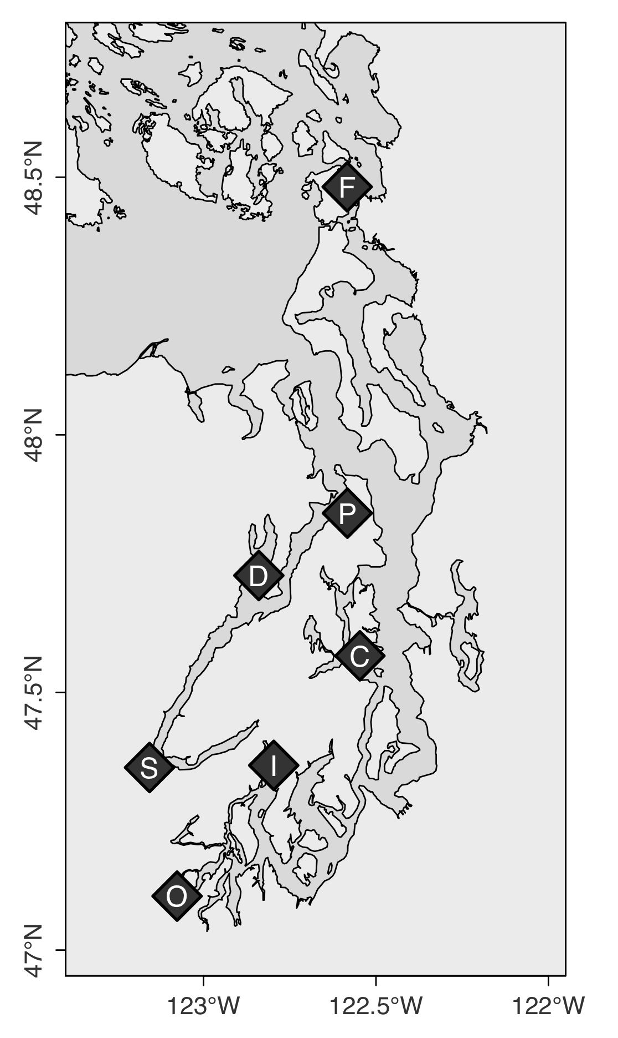

**Figure 2**

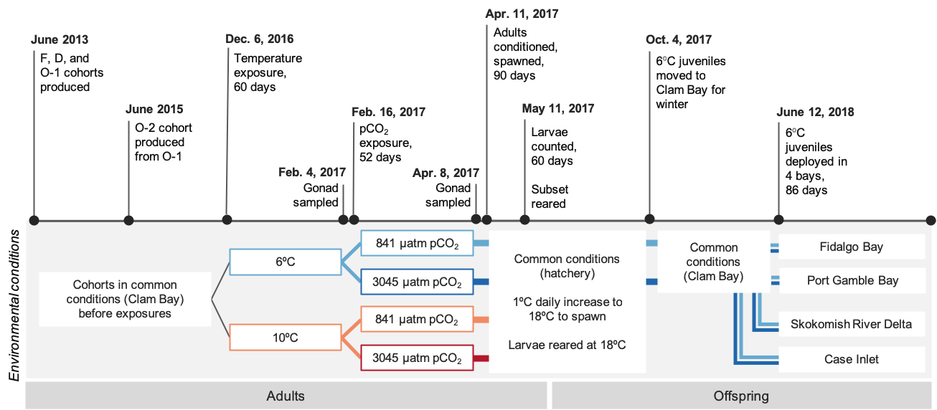

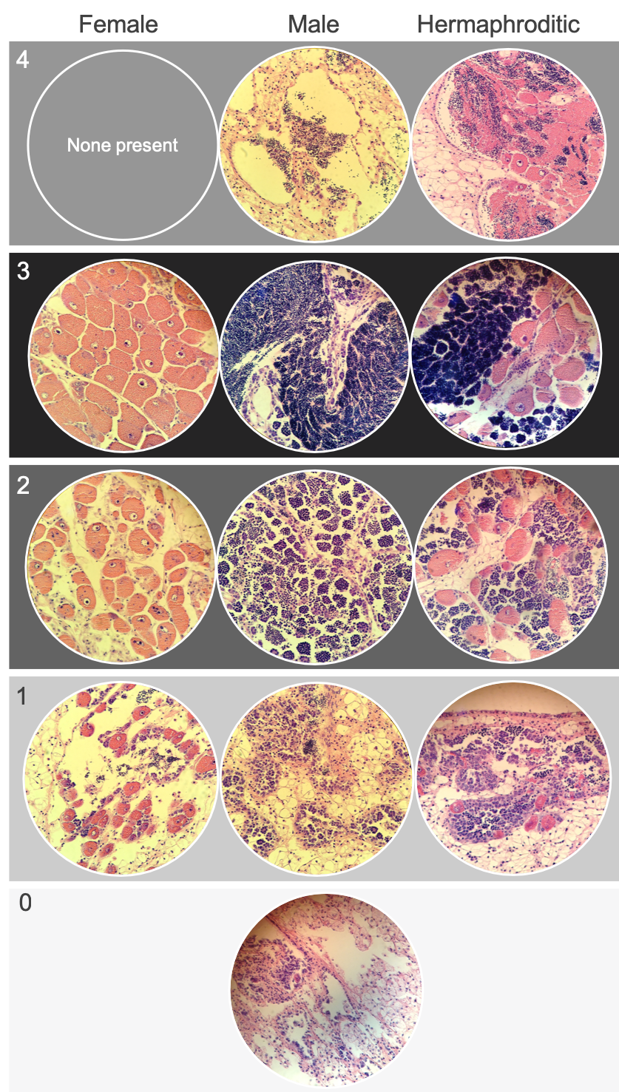**Figure 3**

**Figure 4**

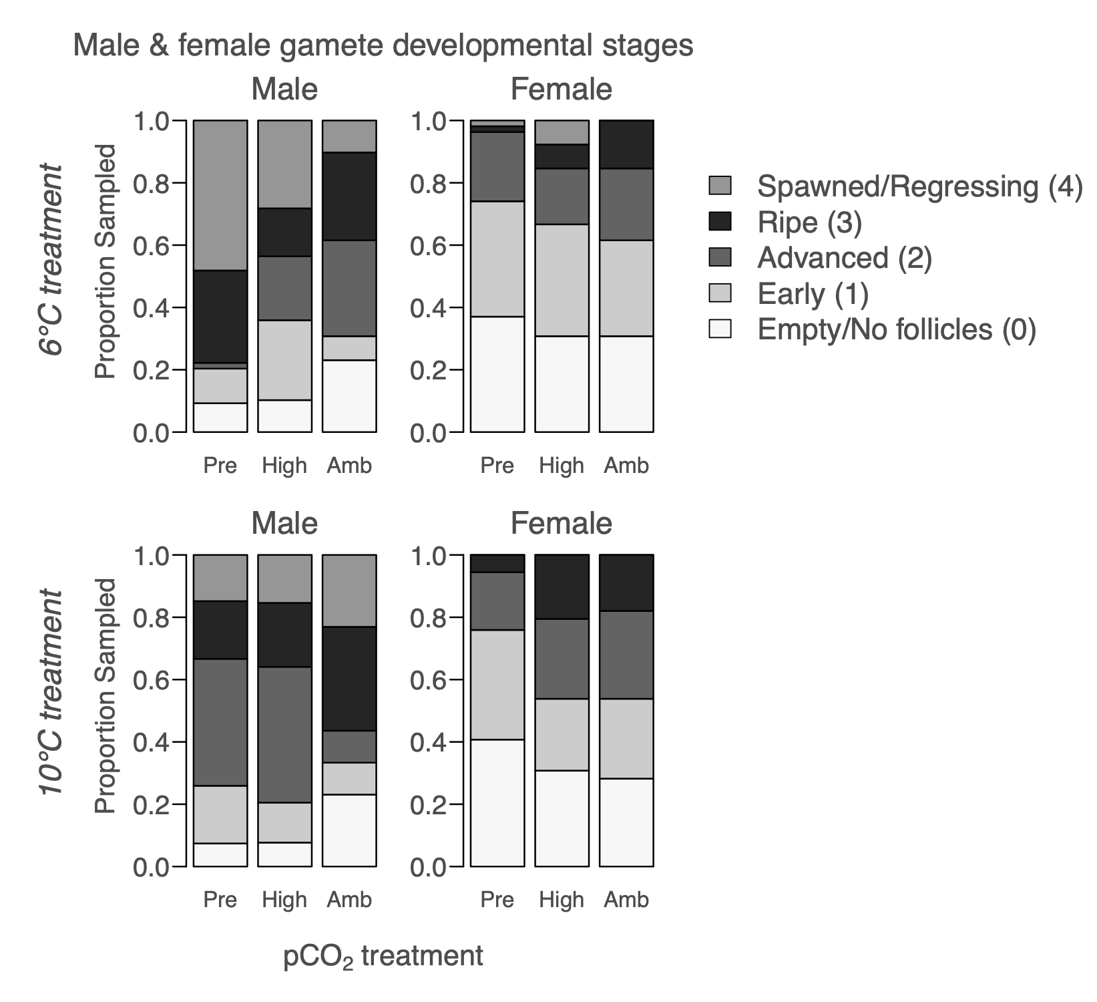

**Figure 5**

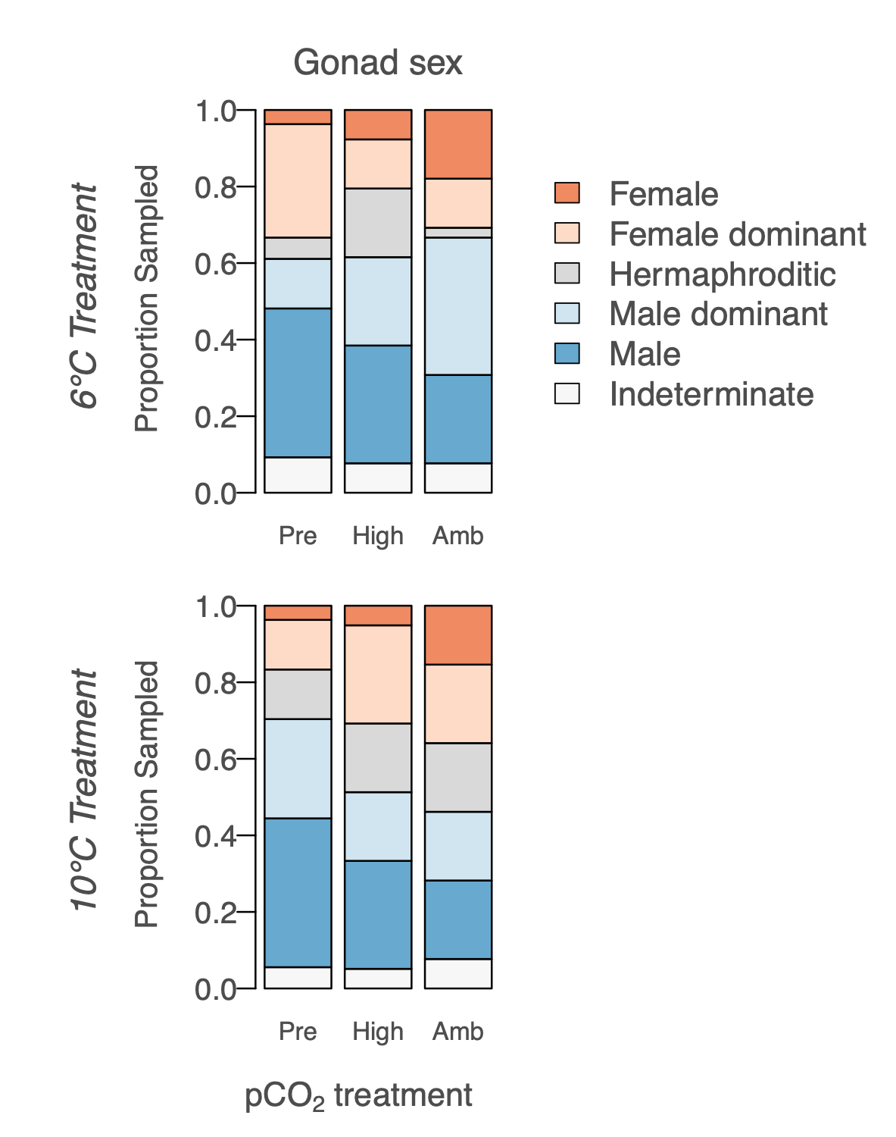

**Figure 6**

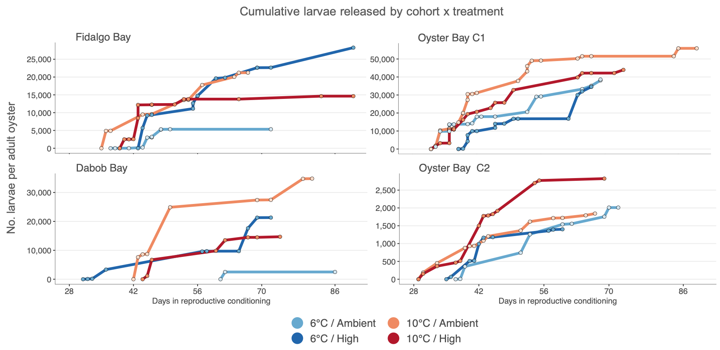

**Figure 7**

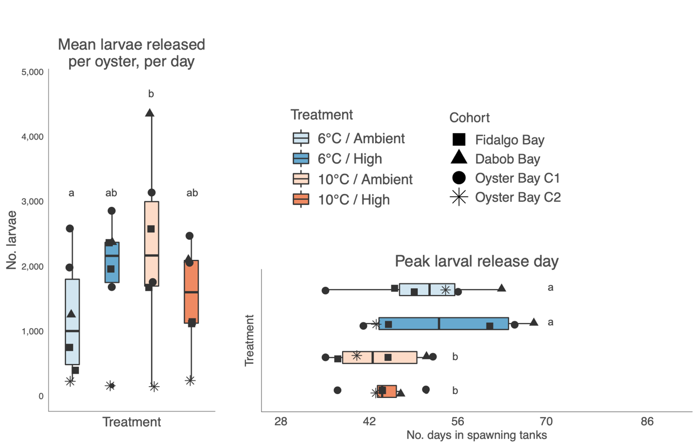

**Figure 8**

