Narrowed gene functions and enhanced transposon activity are associated with high tolerance to ocean acidification in a subarctic crustacean

Laura H Spencer1, William Christopher Long1, Ingrid B Spies1, Krista M Nichols2, Robert J Foy1

1 Alaska Fisheries Science Center

2 Northwest Fisheries Science Center

## Abstract

Ocean acidification (OA) threatens marine crustaceans, particularly those at high latitudes where conditions are changing more rapidly. Red king crab supports important fisheries in Alaskan waters. Early life stages of red king crab are sensitive to OA when exposure occurs during the embryonic and juvenile stages. However in a supporting study, red king crab were surprisingly tolerant of varying OA conditions when reared long-term (~3 months) from larval hatching to the first crab stage (C1) at pH 8.0 (ambient), pH 7.8 (moderate OA), and pH 7.5 (severe OA) by increasing pCO2. Here, we examined gene expression in the C1 juveniles to characterize transcriptional activity of these OA-tolerant crabs. Expression of nearly half of all genes (44%) correlated with pCO2, suggesting a strong molecular response to OA conditions, contrary to the phenotypic results. There was a general reduction in transcriptional activity and inter-individual variability in OA-reared crab. Downregulated functions were numerous in response to OA, and included less activity related to energy production, biosynthesis, immune function, and notably lipid and carbohydrate metabolic processes, which suggest a shift in metabolic strategy to protein catabolism, possibly to reduce CO2 production and facilitate acid/base regulation. Only a handful of functions were enriched in OA-induced genes, which were related to transcription regulation, control of growth and cell death, and signaling activity. We also found that transposon activity was high in OA-reared crab, many of which were upregulated at consistent levels among OA-reared individuals, suggesting that transposon mobilization may be a component of the red king crab OA-response system. Genetic analysis of single nucleotide polymorphisms extracted from RNA-Seq data indicates that genetic composition and family representation did not differ among OA treatments, and that the transcriptional differences in OA-reared crab are more likely attributed to phenotypic plasticity that applies broadly to the 10+ families. Our results suggest that OA-reared red king crabs have a narrowed, possibly optimized, set of gene functions that enables OA-tolerance through the early juvenile stage. OA-exposure from hatch may therefore benefit red king crab and related species by “hardening” them against OA through physiological reprogramming. Future studies should test OA-hardened crabs in additional abiotic and biotic challenges, as metabolic and immune limitations, revealed here by gene expression analysis, may ultimately make them more vulnerable to infection or secondary stressors and limit growth.

**Keywords**: red king crab; transcriptomics; functional genomics;

**Target Journal**: Frontiers in marine science or Molecular Ecology

## Introduction

Global oceans are rapidly changing due to increased concentrations of atmospheric greenhouse gasses. In addition to warming, deoxygenation, and sea level rise, oceans are acidifying (Cooley et al. 2022). This is occurring due to the increased partial pressure of carbon dioxide (CO2) in the ocean, which has absorbed ~30% of added atmospheric CO2 emitted since the industrial revolution [(Gruber et al., 2019)](https://paperpile.com/c/5QXdlO/6SlU). As a result, the concentration of aqueous CO2, hydrogen ions, and bicarbonate ions are increasing, and ocean pH, carbonate ion concentrations, and calcium carbonate saturation states are decreasing. This shift is referred to as ocean acidification (OA) [(Feely et al., 2004)](https://paperpile.com/c/5QXdlO/FJYv), and, in addition to the effects of lower pH, is particularly concerning for calcifying species including crustaceans, molluscs, and corals due to their reliance on calcium carbonate (aragonite, calcite) to form shells and exoskeletons [(Melzner et al., 2019; Figuerola et al., 2021)](https://paperpile.com/c/5QXdlO/qhGX+9AdX).

While OA is a global phenomenon, changes in high latitude coastal zones are likely to have outsized biological effects. Carbon dioxide is more soluble at high latitudes due to colder water, resulting in lower pH levels and carbonate saturation states [(Fabry et al., 2009; Mathis et al., 2015a)](https://paperpile.com/c/5QXdlO/RNJm+8wRx). Increased freshwater inputs from sea ice melt and river runoff, and enhanced upwelling and respiration are likely to augment acidification in high latitude coastal zones [(Mathis et al., 2015a)](https://paperpile.com/c/5QXdlO/RNJm). Conditions in those regions are therefore more likely to become undersaturated with carbonate ions and reach severely low pH levels [(Fabry et al., 2009; Terhaar et al., 2020)](https://paperpile.com/c/5QXdlO/8wRx+cFGk). The Bering Sea shelf, a coastal area off Alaska which supports highly productive commercial, subsistence, and sport fisheries [(Wiese et al., 2012)](https://paperpile.com/c/5QXdlO/ZATI), already experiences seasonal levels of aragonite saturation (Ω) below one, which is the biological threshold for calcium carbonate dissolution [(Mathis et al., 2011a, 2011b, 2014; Cross et al., 2013)](https://paperpile.com/c/5QXdlO/pE1Q+sERz+NOOc+Cc7G). Model projections for the Bering Sea through year 2100 predict longer seasonal periods of Ω<1(up to five and two months in the winter for aragonite and calcite, respectively)([Pilcher et al., 2022](https://paperpile.com/c/5QXdlO/F3aB+pjHI); Darren Pilcher[, *pers. comm.*](https://paperpile.com/c/5QXdlO/F3aB+pjHI)), and that pH will decrease 0.07 - 0.35 pH units in surface waters and 0.05 - 0.30 in bottom waters depending on greenhouse gas emissions [(Mathis et al., 2015b; Pilcher et al., 2022)](https://paperpile.com/c/5QXdlO/F3aB+pjHI). These carbonate changes have significant socio-economic implications for Alaskan crustaceans, given their importance to fisheries as both prey species (krill, copepods) [(Smetacek and Nicol, 2005; Mueter et al., 2021)](https://paperpile.com/c/5QXdlO/ElOf+Ntmz) and fishery stocks (e.g. king, tanner, and snow crabs) [(Punt et al., 2014, 2015)](https://paperpile.com/c/5QXdlO/TllO+M3qX).

OA has broad but variable physiological effects on crustaceans [(Bednaršek et al., 2021)](https://paperpile.com/c/5QXdlO/61zQ). Many are capable of maintaining hemolymph pH homeostasis by acid-base regulation [(Pane and Barry, 2007; Meseck et al., 2016)](https://paperpile.com/c/5QXdlO/JDBO+lBTy), and have exoskeletons composed of both calcium carbonate and chitin, which may protect against direct dissolution [(Pörtner, 2008; Ries et al., 2009)](https://paperpile.com/c/5QXdlO/EMPI+OGKL), although see Dickenson et al (2021). Still, tissue and shell growth [(Long et al., 2017)](https://paperpile.com/c/5QXdlO/CjsE), molt cycle [(Whiteley, 2011; Long et al., 2021)](https://paperpile.com/c/5QXdlO/shHY+obTI), exoskeleton properties [(Siegel et al., 2022)](https://paperpile.com/c/5QXdlO/3zDF), metabolic activity [(Dissanayake and Ishimatsu, 2011; Thor et al., 2018)](https://paperpile.com/c/5QXdlO/7tq7+J0m1), reproduction [(Swiney et al., 2015; Meseck et al., 2016)](https://paperpile.com/c/5QXdlO/oSXy+lBTy), behavior [(Dodd et al., 2015; Clements and Comeau, 2019)](https://paperpile.com/c/5QXdlO/Gp0a+Hphx), and immune function [(Meseck et al., 2016; Shields, 2019)](https://paperpile.com/c/5QXdlO/lBTy+ubNj) can all be altered by OA. Effects are most acutely observed in early life stages (larvae, juveniles), and vary greatly by species, severity of OA, life stage, and duration of exposure [(Bednaršek et al., 2021; McElhany et al., 2022; Siegel et al., 2022)](https://paperpile.com/c/5QXdlO/3zDF+61zQ+gwtI). The diversity of responses in crustaceans, and all marine invertebrates for that matter, has highlighted the need for a more mechanistic understanding of how organisms function in OA conditions.

In this study, we use functional genomics to examine the molecular response of OA-exposed red king crab, *Paralithodes camtschaticus*, one of several crab species that are highly valued fisheries in Alaskan waters but that is threatened by ocean acidification [(Punt et al., 2014)](https://paperpile.com/c/5QXdlO/TllO). Laboratory studies on embryonic, early zoeal, and juvenile red king crab indicate that OA affects their physiology such that development is altered, and growth and survival typically decreases [(Long et al., 2013a, 2013b, 2019)](https://paperpile.com/c/5QXdlO/xGsg+Tgcd+q7i2). OA also interacts with warming by increasing intermolt duration and decreasing survival in juveniles (Swiney et al. 2017). Long et al. (in prep) recently examined effects of long-term OA exposure in early life stages of red king crab, rearing them from hatch for ~3 months through the early juvenile stage, and found them to be surprisingly tolerant of moderate (pH 7.8) and severe (pH 7.5) acidification. Little is known about the mechanisms underlying these impacts to red king crab, particularly those that might enable tolerance after long-term exposure. Here, we leverage RNA-Seq and crab from Long et al. (in prep) to identify genes and functions that are potentially critical to survival in an acidified environment. RNA-Seq is a high-throughput sequencing approach that measures gene-activity, which provides a snap-shot of system-wide changes in energy allocation due to acidification exposure [(Sokolova et al., 2012)](https://paperpile.com/c/5QXdlO/vdd6). Functional genomics studies are intended to complement more traditional physiological assays by identifying mechanisms that are responsible for a species tolerance or sensitivity to environmental stressors [(Connon et al., 2018)](https://paperpile.com/c/5QXdlO/PwTZ).

To date, one previous study has examined gene expression patterns in red king crab after short-term OA exposure (3 weeks, Stillman et al. 2020), and found that cuticular processes were affected in juveniles, while there were no pronounced changes to larval gene expression. Our study examines expression in juveniles that were reared from hatching to the first crab stage (C1) over three months, and increases the resolution at which we can detect molecular responses by constructing libraries from at least 13 individuals per treatment, rather than pools of individuals which can obscure genotype-dependent variation. We also leverage a recently published draft *P. camtschaticus* genome which is large (7.29 Gbp) and highly repetitive [(Veldsman et al., 2021b)](https://paperpile.com/c/5QXdlO/6T5E). Crab were exposed to three carbonate chemistry treatments, thus capturing transcriptional differences among crab that are reared in historically ambient conditions along the Bering Sea shelf (pH 8.0), and those acclimated to a moderately (pH 7.8) and severely (pH 7.5) acidified environments that are projected to occur in surface and bottom waters by the end of this century [(Pilcher et al., 2022)](https://paperpile.com/c/5QXdlO/pjHI).

## Methods

#### Animal collection

Ovigerous females for this study were collected in Bristol Bay in October 2016 in crab pots during the commercial fishery. Animals were transported to Kodiak in the live hold of a fishing vessel. Females were held communally in tanks at the NOAA Kodiak Laboratory in the Kodiak Fisheries Research Center supplied with flow through sand-filtered seawater pumped from Trident Basin, Kodiak, at local ambient temperature and salinity, and were fed to excess on chopped frozen fish and squid. Embryos were monitored and, as they approached hatching, 48 females were moved to individual 48L tubs with flow-through seawater. Tanks were monitored for larvae. Larvae for this experiment were collected during peak hatch from as many females as possible over a period of three days (April 10-12, 2017), pooled, and immediately moved to experimental tanks. Larvae used to stock experimental tanks were from the same 21 females on the first 2 days of larval stocking, and from 20 of those 21 on the third (one female completed hatching after the second day of stocking).

#### Experimental Design

Experiments were performed in 180L conical bottomed tanks. Each tank was randomly assigned to one of three pH treatments: 1) Local ambient (pH ~ 8.1), 2) pH 7.8, and 3) pH 7.5, with five replicate tanks per treatment. Tanks were stocked in a random order with larvae on the same day they hatched. Flowthrough water for this experiment was passed through a 5 μm filter and UV sterilized and flow into each tank was 2 L/min. The temperature and salinity of all tanks were allowed to vary with seasonal change of the intake water. The pH in each tank was adjusted via direct bubbling of CO2 controlled by feedback from Honeywell controllers connected to an in-tank Durafet III pH probe. Discrete temperature and pH measurements were collected daily in each tank using a Durafet III pH probe calibrated with TRIS buffer (Millero, 1986). Water samples were taken once a week from each tank, poisoned with mercuric chloride to saturation and analyzed for dissolved inorganic carbon (DIC) and total alkalinity (TA). DIC and TA were measured using a VINDTA 3C (Marianda, Kiel, Germany) and a 5012 Coulometer (UIC Inc.) according to DOE (1994) using Certified Reference Material from the Dickson Laboratory (Scripps Institute, San Diego, CA, USA; Dickson et al. 2007). The seacarb package (Lavigne and Gattuse 2012) in R (V3.6.1, Vienna, Austria) was used to calculate the other parameters of the carbonate system.

Experimental pHs were well controlled to within 0.01 pH units in experimental treatments (Table 1). Water temperatures increased from about 5°C at the beginning of the experiment to about 10°C by the end and averaged about 7.2°C throughout (Table 1). Incorporating this seasonal shift in temperature provided ecologically relevant variability in conditions, including slight shifts in pCO2 and saturation state conditions over time [(Reum et al., 2014, 2015)](https://paperpile.com/c/5QXdlO/H9DE+5smF) (Supplemental Figure 1).

**Table 1.** Water parameters during the experiment. Temperature and pH were measured daily; salinity, dissolved inorganic carbon (DIC) and alkalinity were measured weekly; all other parameters were calculated. Values are mean ± standard deviation. See Supplemental Figure 1 for water parameter time-series.

|  |  |  |  |
| --- | --- | --- | --- |
| **Treatment** | **Ambient** | **Moderate OA** | **Severe OA** |
| Temperature (C) | 7.24 ± 1.40 | 7.25 ± 1.40 | 7.23 ± 1.44 |
| Salinity | 31.267 ± 0.142 | 31.277 ± 0.149 | 31.288 ± 0.163 |
| pHT | 8.05 ± 0.03 | 7.79 ± 0.05 | 7.50 ± 0.06 |
| pCO2  (µatm) | 370.74 ± 26.92 | 703.89 ± 90.45 | 1414.71 ± 287.82 |
| HCO3- (mmol/kg) | 1.89 ± 0.08 | 1.96 ± 0.05 | 2.00 ± 0.04 |
| CO3-2 (mmol/kg) | 0.11 ± 0.01 | 0.06 ± 0.01 | 0.03 ± 0.01 |
| DIC (mmol/kg) | 2.01 ± 0.08 | 2.06 ± 0.05 | 2.10 ± 0.05 |
| Alkalinity (mmol/kg) | 2.16 ± 0.08 | 2.12 ± 0.05 | 2.09 ± 0.06 |
| ΩAragonite | 1.66 ± 0.09 | 0.96 ± 0.13 | 0.52 ± 0.19 |
| ΩCalcite | 2.65 ± 0.15 | 1.53 ± 0.21 | 0.83 ± 0.31 |

#### Larval rearing

Larvae were stocked at 50 larvae/L, or approximately 9,000 larvae per tank, and reared according to Swingle et al. (2013), except that in this experiment we used ambient incoming seawater rather than elevated temperature to avoid potential interactive effects between pH and temperature. In brief, larvae were fed daily to excess on a diet of *Artemia* *sp.* enriched with DC DHA Selco (Inve Aquaculture) except during the non-feeding glaucothoe stage. Once the larvae molted to the glaucothoe stage, artificial seaweed was provided as a settling substrate. Glaucothoe continued to be monitored until they molted to the first crab stage. Survival, growth, and development metrics were captured at each of the four zoea, glaucothoe, and C1 stages (for details, see Long et al. *in prep*)

#### RNA Extraction & Sequencing

For each OA treatment 13-15 juvenile crabs at the first juvenile instar (C1) stage were sampled for RNA-seq (2-4 crab from each replicate tank, Table 2), placing whole crabs in RNAlater per manufacturer’s instructions (Thermofisher Scientific, Waltham, MA). To standardize among tanks/treatments and ensure that all crabs were at the same point in their molt cycle, sampling date varied by tank to target the C1-stage, and occurred five days after 100% of crabs in a tank reached the C1-stage. RNA isolation, library construction, and sequencing were performed by the University of Oregon. Briefly, RNAlater-preserved crabs were homogenized with silica beads using a Spex Geno/Grinder®, then RNA was isolated following TRIzol™ Reagent protocol for total RNA (Invitrogen Inc., Carlsbad, CA). The purity and quality of RNA were assessed with a NanoDrop™ Spectrophotometer (ThermoFisher Scientific) and a *Fragment Analyzer*™ (Agilent Technologies, Boulder, CO). Stranded mRNA-Seq libraries were constructed with the NuGen Universal Plus mRNA kit (Tecan Genomics, Inc, Männedorf, Switzerland). Libraries were prepared for sequencing using TruSeq RNA sample prep kits (Illumina). Paired-end sequencing was conducted on two lanes of a Hi-Seq 4000 with 100-bp read length.

**Table 2** RNA-Seq sampling scheme.

|  |  |  |  |
| --- | --- | --- | --- |
| **Treatment** | **Individuals / Libraries** | **Replicate Tanks** | **Replicates per Tank** |
| Ambient (pH 8.0) | 14 | 5 | 2 or 3 |
| Moderate OA (pH 7.8) | 13 | 4 | 3 or 4 |
| Severe OA (pH 7.5) | 15 | 5 | 3 |

#### Bioinformatics

Raw sequence data from each of the two lanes was demultiplexed, concatenated by library, then trimmed using Cutadapt v3.5 [(Martin, 2011)](https://paperpile.com/c/5QXdlO/R8rh) to remove Illumina adapters, poly-A tails, flanking N bases, reads less than 50bp, and low-quality ends from reads using minimum quality scores of 20 and 15 for the 5’ and 3’ ends, respectively. Raw and trimmed data were inspected using FastQC [(Andrews, 2010)](https://paperpile.com/c/5QXdlO/GppG) and MultiQC [(Ewels et al., 2016)](https://paperpile.com/c/5QXdlO/E5X7). Reads were aligned to the draft Red king crab (*Paralithodes camtschaticus*) genome (Genbank accession GCA_018397895.1) [(Veldsman et al., 2021a, 2021b)](https://paperpile.com/c/5QXdlO/6T5E+4qkK) using Bowtie2 v2.4.2 with the preset option --sensitive [(Langmead and Salzberg, 2012; Tong et al., 2020)](https://paperpile.com/c/5QXdlO/eTqC+CynD). The number of fragments aligning to gene coding regions of the *P. camtschaticus* genome was quantified using featureCounts v2.0.3 [(Liao et al., 2014)](https://paperpile.com/c/5QXdlO/kqn3) with settings -p --countReadPairs to count paired-end fragments and -C and -B to exclude chimeras and singletons, respectively. Gene functions were identified by querying coding sequences of the *P. camtschaticus* genome, derived from gene annotations published along with the *P. camtschaticus* genome [(Veldsman et al., 2021a)](https://paperpile.com/c/5QXdlO/4qkK), against the Uniprot/Swissprot database [(UniProt Consortium, 2021)](https://paperpile.com/c/5QXdlO/7WO8) using blastx from blast v2.11.0 (e-value < 1–10) [(Camacho et al., 2009)](https://paperpile.com/c/5QXdlO/P1rP).

#### Genetic analysis

As with many rearing experiments, there was high larval mortality rate. While survival rates did not differ among treatments in this experiment (Long et al. *in prep*), there could have been treatment-specific survival rates among the ~20 families, possibly resulting in genotype-specific expression patterns. We therefore assessed whether there were genetic differences among treatments. Single nucleotide polymorphisms (SNPs) were extracted from RNA-Seq reads to examine the genetic composition of sampled crabs. Variants were identified using the GATK toolkit [(McKenna et al., 2010)](https://paperpile.com/c/5QXdlO/pQhx). Briefly, RNA-Seq reads were aligned to the draft red king crab genome [(Veldsman et al., 2021b)](https://paperpile.com/c/5QXdlO/6T5E). The genome was first concatenated into 50 larger contigs, with 1000N separating each original contig, which was necessary to reduce the processing time in GATK. Alignment files were deduplicated using MarkDuplicates, reads spanning splicing events and CigarN reads were split, variants were called using HaplotypeCaller, then joint-genotyped using GenotypeGVCFs. SNPs were filtered using VariantFiltration to hard-filter loci with any of the characteristics FS>60, QD<2, QUAL<30, SOR>3, DP<15, DP>150, or AF<0.30. SNPs were then pruned with snpgdsLDpruning from the R package *SNPRelate* v1.30.1to remove those in linkage-disequilibrium and with >15% missing rate or <5% minor allele frequency. One sample from the ambient treatment was removed from the genetic analysis due to high missingness. From 227,781 candidate SNPs, 331 markers resulted from the above filtering and were retained for genetic analysis.

#### Differences in genetic composition among treatments was examined using multivariate analysis, estimates of diversity, and parentage analysis. Using *SNPRelate*, allele frequencies (major and minor) and per-SNP missing rate were calculated with *snpgdsSNPRateFreq()*, and PCA biplots of the first four principal components (PCs) were constructed with snpgdsPCA(). The first four PCs were selected as they explained over 25% of the total variance, and each additional PC explained less than 4% of the total variance. Pairwise Fst values [(Weir and Cockerham, 1984)](https://paperpile.com/c/5QXdlO/yHby) among treatments were calculated with stamppFst() from *STaMPP* v1.6.3 using 1000 bootstraps to generate 95% confidence intervals and *p*-values. Parentage analysis was performed using the 331 SNPs with *Colony* v2.0.6.6 for R [(Jones and Wang, 2010)](https://paperpile.com/c/5QXdlO/4BQf), specifying polygamous males and females with three replicate medium-length runs using the full likelihood method with high precision. The parentage of samples with cluster probability < 0.5 were considered invalid (three samples from each treatment). The relationship between global expression patterns and genetic structure was assessed by regressing genotype PCA sample scores against the expression-derived PCA sample scores along the first two principal components, using OA treatment as a covariate.

#### Gene expression analysis

Analyses were performed in R v4.1.2 using RStudio interface v2021.09.1 (R Core Team, 2021; RStudio Team, 2020). Unless otherwise specified, significance thresholds were alpha = 0.05 and representations of spread in data are 1 standard deviation.

##### RNA-Seq pre-processing for gene expression analysis

Gene counts were filtered to remove outlier samples and low-frequency genes. Outlier samples were identified using principal component analysis (PCA), which was performed on variance-stabilizing transformed counts of the top 500 genes using vsd and plotPCA from *DESeq2* v1.34.0 (Love et al., 2014). Genes with mean count <10 across all samples or those with counts <30 across at minimum 10% of the samples were discarded, and differences in the number of remaining fragments per sample among treatments was tested using ANOVA. This filtered gene count dataset was used in comparative gene expression analyses as raw counts, or transformed counts via variance-stabilization transformation in *DESeq2*.

##### Global patterns

Global gene expression differences among OA treatments were explored with PCA, using prcomp from the R package *vegan* v.2.5-7 on all gene counts that were transformed via variance-stabilization. Principal components that explained a significant amount of variance were identified using the scree test [(Cattell, 1966)](https://paperpile.com/c/5QXdlO/eiAC). Global differences among treatments was assessed by permutational pairwise permANOVA with pairwise.adonis from the *pairwiseAdonis* package, which is a wrapper for adonis from the *vegan* package.

##### Variation in gene expression

Global differences in the variation of gene expression among OA treatments was assessed with a test of multivariate homogeneity of group dispersions. To do so, we used betadisper from the *vegan* package to calculate per-sample distances to group medians in multivariate space, then analysis of variance to compare per-sample distances among treatments for all genes, and for differentially expressed genes. Pairwise comparisons and associated permuted *p*-values identified which treatments differed. We then examined gene-wise variation in expression by treatment for genes that were upregulated, downregulated, or not differentially expressed for each treatment. The within-treatment coefficient of variation (CV=SD/mean) was calculated for each gene, providing a method of comparing variation in gene expression relative to the mean for each treatment [(Reed et al., 2003)](https://paperpile.com/c/5QXdlO/zHWn). CV was summarized by calculating the mean CV of genes that were upregulated, downregulated, and were not differentially expressed for each treatment.

##### Differential gene expression analysis

Differentially expressed genes among pH treatments were identified using *DESeq2* with default settings [(Love et al., 2014; Costa-Silva et al., 2017)](https://paperpile.com/c/5QXdlO/0LPj+vJDR). *DESeq2* uses raw count data to generate generalized linear models and internally corrects for library size, therefore counts were not transformed prior to differential expression analysis. In addition to examining the transcriptional responses of crabs to OA treatments, differentially expressed genes were used to characterize the gene modules with expression that correlated with pCO2.

##### Gene co-expression network analysis

We identified groups of co-expressed genes (i.e. gene modules) with expression profiles that correlated with OA treatment using weighted gene co-expression network analysis (WGCNA v1.70-3, [Langfelder and Horvath, 2008](https://paperpile.com/c/5QXdlO/FkVP)). Briefly, a weighted gene network was constructed from transformed gene counts with a signed adjacency matrix using the soft thresholding power 15, and minimum module size 75. Modules were merged if their eigengene expression correlated at R > 0.75, and those with eigengenes that correlated with pCO2 concentration at alpha=0.05 were determined to be associated with OA treatment. Modules with positive and negative correlations were designated as those with upregulated and downregulated expression profiles, respectively.

##### Functional Analyses

Gene sets of interest were characterized by Gene Ontology (GO) enrichment analyses. To characterize functions that respond to pCO2 in a dose-dependent manner, enrichment analyses were performed on co-expressed gene modules (from WGCNA analysis) for which eigengenes correlated with pCO2 concentration, filtered to retain genes that either correlated individually with pCO2 (Gene Significance *p*-value < 0.05) or were differentially expressed. Two enrichment analyses were performed for each of the three pairwise treatment contrasts to determine the functions of differentially expressed genes that were upregulated (L2FC > 0.5) and downregulated (L2FC < -0.5) in response to the more severe OA treatment. To identify processes that are likely critical to the function of OA-reared crab, enrichment analysis was performed on a subset of differentially expressed genes that were upregulated in OA compared to ambient: those that had very consistent expression levels (genes with within-treatment CV < 3%). For all gene sets, genes were filtered for those that map to the Uniprot/Swissprot database [(UniProt Consortium, 2021)](https://paperpile.com/c/5QXdlO/7WO8), and enriched GO terms were identified by entering UniprotID’s into the Gene-Enrichment and Functional Annotation Tool from DAVID v2021 [(Sherman et al., 2022)](https://paperpile.com/c/5QXdlO/6hTa) to identify enriched biological processes, which were defined as those with modified Fisher Exact *p*-values (EASE Scores) <0.05.

Given that not all transposable elements are assigned to transposition-related GO terms and may be overlooked by traditional enrichment analyses, gene sets were also interrogated for transposable element composition. The proportion of genes that were transposable elements was estimated for each gene set described above by searching within the protein names of annotated genes for the words “transposon”, “transposable”, “LINE” (representing long interspersed nuclear elements), “retrotransposable element”, “transposable element”, “mobile element jockey” (a LINE), and “pol polyprotein”. Pol polyprotein was included as it is core to the replication of retrotransposons, but may also be associated with retroviral activity [(Havecker et al., 2004)](https://paperpile.com/c/5QXdlO/Nk7c). These terms were determined to represent the majority of TEs by manual review of annotated genes.

## Results

##### Survival, growth, and development

Survival, growth, and development results are reported in Long et al. (*in prep*). Briefly, survival, developmental time, calcification, and mass did not differ among treatments at any stage, nor did survival or developmental time cumulatively from hatch to the C1 juvenile stage differ.

##### Genetic relatedness analysis

Principal component analysis (PCA) constructed from SNPs (n=331) indicated genetic homogeneity among treatments (Figure 1, Supplemental Figure 2). Individuals loosely aggregated into two or three clusters, primarily along PC1 and PC2 which explained 8.71% and 7.23% of variation, respectively, but no treatments were overrepresented in any of the clusters. Pairwise *F*ST values among samples from the three treatments did not differ from zero for any contrast (Table 3). Parentage analysis using Colony estimated the same number of mothers (n=9) and fathers (n=10) represented by surviving offspring in each treatment. No correlation was found among SNP-derived PCA scores and gene expression-derived PCA scores along the first two principal components (Supplemental Figure 3).

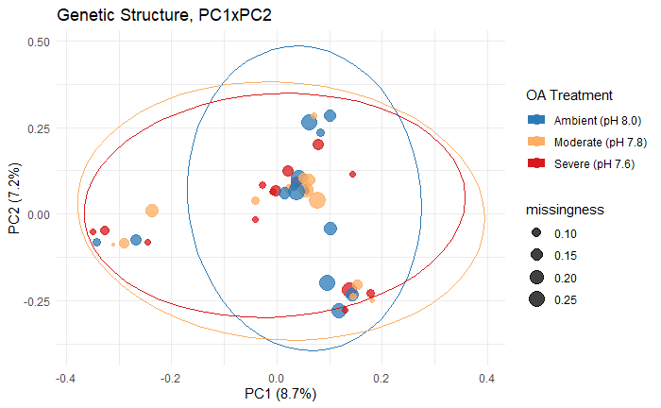

**Figure 1**: PCA biplot of the first two principal components, constructed from RNA-Seq derived SNPs (n=331). Points represent individual crabs that are color-coded by OA treatment, which do not indicate clustering by treatment, and sizes represent the percent of SNPs that are missing in each individual. The PCA and other genetic analyses (parentage, pairwise *F*ST) does not indicate that genetic composition of individuals surviving the three-month exposure differed among treatments.

**Table 3: Pairwise *F*ST values**

|  |  |  |  |  |  |
| --- | --- | --- | --- | --- | --- |
| *Treatment 1* | *Treatment 2* | *F*ST | *CI Lower Bound* | *CI Upper Bound* | *p-value* |
| Ambient | Severe | -0.0015 | -0.0107 | 0.0073 | 0.67 |
| Ambient | Moderate | -0.0123 | -0.0207 | -0.0035 | 1.00 |
| Moderate | Severe | -0.0033 | -0.0125 | 0.0061 | 0.78 |

##### RNA-Seq pre-processing for gene expression analysis

A total of ~2.65B paired-end reads (henceforth “fragments”) remained after discarding ~4.55M (0.17%) during initial quality-filtering, with a per-sample mean of 61.7M +/- 10.7M fragments. Across all samples ~2.14B reads were aligned to the *P. camtschaticus* draft genome [(Veldsman et al., 2021a, 2021b)](https://paperpile.com/c/5QXdlO/6T5E+4qkK), for a total alignment rate of 80.47%. The average per-sample alignment rate was 80.43%±2.15%, which included 43.19%±1.50% and 24.52%±0.89% of concordantly mapped fragments that mapped uniquely and multiple times, respectively. The multi-mapped fragments were assigned by Bowtie2 to the “best” location, and therefore counted once in the downstream analysis. Of the ~2.14B aligned fragments, ~1.27B were assigned to gene-coding regions of the *P. camtschaticus* draft genome (59.6%). The remainder were not included in the downstream analyses as they mapped to non-coding regions (22.3%), were assigned ambiguously (6.7%), were singletons (8.3%) or chimeras (3.1%). Initial examination of the gene counts using PCA identified one sample from the ambient pH treatment as an outlier, which was removed from the dataset and resulted in 14, 13, and 15 samples for the ambient, moderate OA, and severe OA treatments, respectively (Table 2). In total, we detected all 162,611 gene features that are in the draft *P. camtschaticus* genome [(Veldsman et al., 2021a)](https://paperpile.com/c/5QXdlO/4qkK), but after removing low frequency genes (totalling 0.75% of fragments), 74,778 genes remained for analysis, 32,435 of which mapped to genes in the Uniprot/Swissprot database. The high number of genes reflects the large *P. camtschaticus* draft genome, which includes a high degree of repeat elements [(Veldsman et al., 2021b)](https://paperpile.com/c/5QXdlO/6T5E). A one-way ANOVA indicated that the number of fragments retained for analyses did not differ among OA treatments (F(2,39)=0.22, *p*-value=0.80), and ranged from 15.4M to 38.2M per sample and averaged 29.4M±5.1M, mapped to on average 75K±80 genes.

**Figure 2**. PCA biplot of first the two principal components, constructed from all expressed genes. 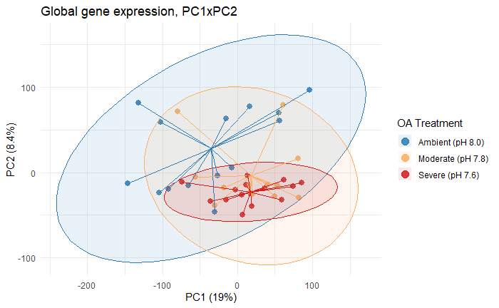

##### Global expression patterns

Global expression profiles of red king crabs reared in ambient conditions differed from those reared in either moderate or severe OA. Pairwise permANOVA tests detected significant differences in multivariate space among ambient conditions and OA treatments (moderate OA: F(1)=1.84, *p*-adj=0.042; severe OA: F(1)=2.70, *p*-adj=3.0e-3), but not between the two OA treatments (F(1)=1.20, *p*-adj=0.50), which is evident from the biplot of the first two principal components (PC1 & PC2) (Figure 2). Ambient-reared crabs were separated from those reared in OA treatments along PC1 (19.0%) and PC2 (8.4%), which combined explained 27.4% of variation in global expression. While the scree test indicated that PC3 and PC4 also explained a significant amount of variation (7.0% and 6.2%, respectively), there was no separation among treatments along those axes (Supplemental Figure 4).

Global gene expression was less variable among crabs reared in OA treatments compared to those reared in ambient conditions. Using a test of multivariate homogeneity of group dispersions, we found that variation in global gene expression differed by treatment (F(2,39)=4.9, p=0.012). Pairwise comparisons indicated that variation differed between ambient and severe OA (*p*-valuepermuted=8.3e-3)(Figure 1), but did not differ between ambient and moderate OA (*p*-valuepermuted=0.32) or moderate and severe OA (*p*-valuepermuted=0.25).

##### Co-expression network analysis

We performed a weighted gene co-expression network analysis (WGCNA) to identify groups of genes that were co-expressed (i.e. gene modules), and for which expression correlated with pCO2 concentration. The 74,778 examined genes were assigned to 41 modules, 14 of which had eigengenes that correlated significantly with pCO2 (Supplemental Table 1). For eight of the modules, which contained in total 22,537 genes, the eigengenes correlated negatively with pCO2 indicating that expression decreased as OA treatment became more severe (panels a-h in Figure 5). Six modules, containing 19,248 genes in total, correlated positively with pCO2,

indicating higher expression in OA treatments (panels i-m in Figure 5).

**Table 4**: Coefficient of variation mean ± SD for genes that were upregulated or downregulated relative to other treatments, or not differentially expressed (Non-DEG). To focus on differences among OA and ambient treatments, the 16 genes that were only differentially expressed among moderate and severe OA were not included in these calculations.

|  |  |  |  |
| --- | --- | --- | --- |
|  | Ambient | Moderate OA | Severe OA |
| Up-regulated | 11.0%±10.3% | 6.8%±4.7% | 4.0%±4.2% |
| Down-regulated | 5.5%±4.1% | 11.2%±9.5% | 8.5%±7.2% |
| Non-DEG | 8.3%±5.6% | 8.0%±5.3% | 7.2%±5.2% |

##### Differential gene expression

Analysis in DESeq2 identified 6,806 genes that were differentially expressed among treatments (9.1% of all examined genes). The number of differentially expressed genes increased with OA severity: 1,459 genes differed between ambient and moderate OA (526 upregulated in moderate OA, 933 downregulated), and 6,257 genes differed between ambient and severe OA (2,350 upregulated in severe OA, 3,907 downregulated). Only 47 genes differed between moderate and severe OA treatments (22 upregulated in severe OA, 25 downregulated), indicating that the two OA treatments induced a similar transcriptional response (Figure 3, Supplemental Table 2). There was high overlap between the differentially expressed genes and the co-expression network analysis (WGCNA), with 92.8% of DEG’s assigned to one of the 14 pCO2-correlated co-expression modules.

Within-treatment mean coefficient of variation (CV), which was calculated separately from genes that were upregulated, downregulated, or not differentially expressed, ranged from 4.0%-11.2% (Table 4). Genes upregulated in the severe OA treatment relative to ambient had the lowest mean CV (Table 4).

**Figure 3**. Venn diagram showing the number of differentially expressed genes among each pairwise OA treatment contrast, and the number that are shared among contrasts.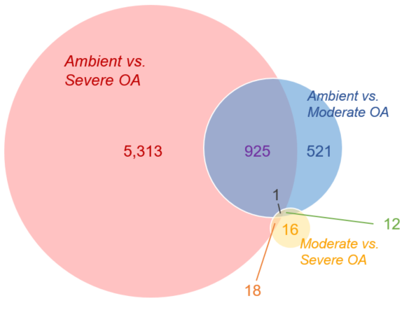

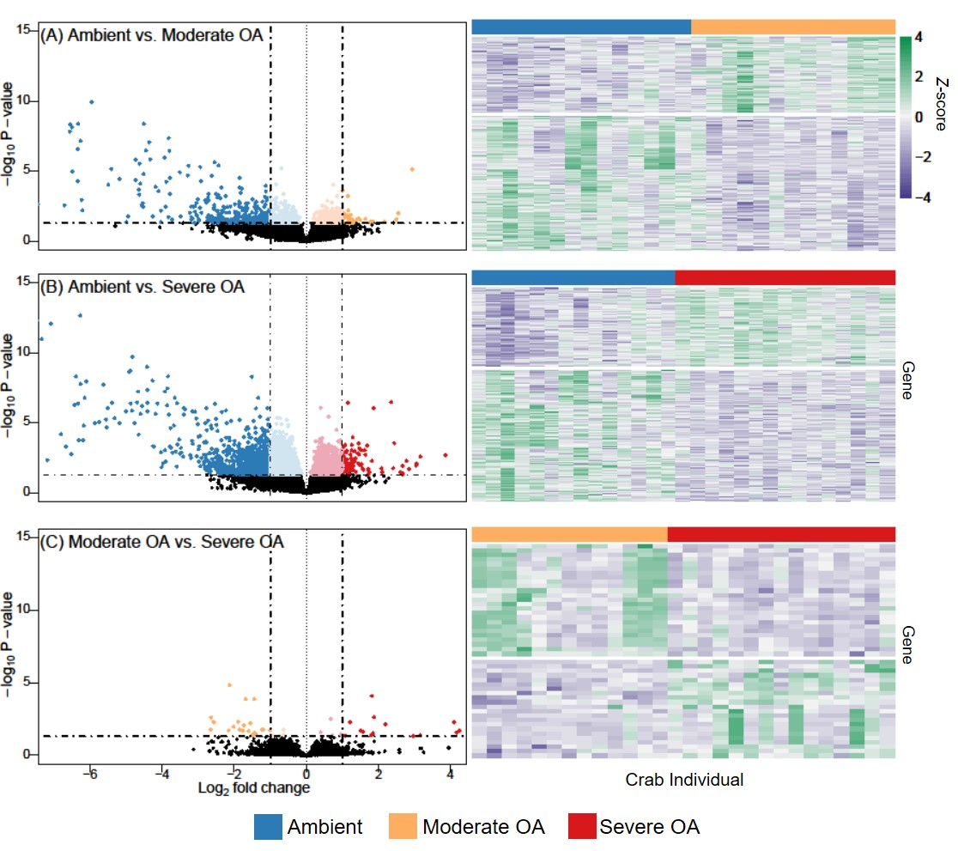

**Figure 4**. Pairwise differential expression among OA treatments for (A) ambient (pH 8.0) vs. moderate OA (pH 7.8), (B) ambient vs. severe OA (pH 7.5), and (C) moderate OA vs. severe OA. Volcano plots (left panels) show Log2 fold change along the x-axes, with higher absolute values indicating larger differences among treatments, and -log10 *p*-values along the y-axes, with higher numbers indicating higher significance. Each point represents a unique gene, with differentially expressed genes (*p*-adj < 0.05) color coded to indicate those that are expressed at higher levels in ambient treatment (blue), moderate OA (orange), or severe OA (red). Points with darker colors indicate those that have |Log2FC| >0.5. Heatmaps (right panels) show expression of differentially expressed genes only (rows=genes) at per-sample resolution (columns=samples), with the purple-green gradient indicating the *z*-score of expression values standardized across samples for each gene, where green and purple indicate higher and lower expression, respectively.

#### Functional Analyses

##### Enrichment analysis of co-expressed genes that correlate with pCO2

Genes that decreased significantly with pCO2 (eight modules) were enriched for 193 biological processes (65 at FDR<10%), which were predominantly related to protein production, energy production, metabolic activity, tissue development, muscle activity, cell cycle, immune function, chaperone mediated protein folding, and telomere maintenance (Figure 5, Supplemental Table 3). Genes that increased significantly with pCO2 (six modules) were enriched for 48 processes (10 at FDR<10%), focused on transcription regulation and signaling (Figure 5, Supplemental Table 3). We also found that transposition and the related process DNA integration were enriched in both downregulated and upregulated modules (5 modules each). 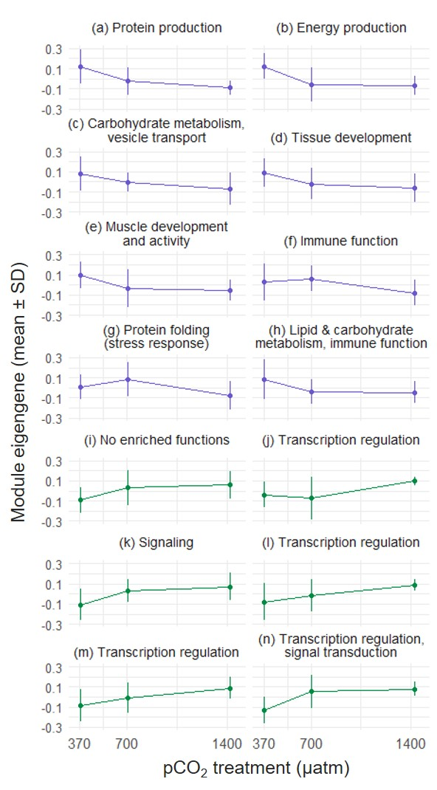

**Figure 5:** Expression profiles of co-expressed gene modules that correlated with pCO2 treatment negatively (purple, a-h) and positively (green, i-n), indicating those genes that decreased and increased with OA severity, respectively, where 370 µatm is ambient (pH 8.0), 700 µatm is moderate OA (pH 7.8), and 1400 µatm is severe OA (pH 7.5). Points indicate the mean eigengenes (i.e. first principal component) for each treatment within each module, with standard deviation among individuals within treatments indicated by error bars. Figure titles indicate the predominant biological functions that were enriched in each module. Detailed enrichment analysis results, number of genes in each module, and correlation statistics are Supplemental Table 3. Transposition was omitted from figure titles as it was enriched in many modules.

##### Enrichment analysis of differentially expressed genes

GO enrichment analysis revealed 26 and 104 biological processes that were enriched in genes that were differentially upregulated and downregulated in an OA treatment compared to ambient, respectively (Supplemental Table 4). In genes upregulated in moderate-OA compared to ambient reared crab, 11 enriched processes were involved in negatively regulating (i.e. decreasing) cell growth and proliferation, transcription regulation, chaperone-mediated protein folding, chromatin organization, neurotransmitter exocytosis and signal transduction, and DNA integration via transposons (Figure 6A). In severe-OA reared crab, 15 enriched processes in upregulated genes were involved in transposable element activity, regulation of transcription, nervous system development, signal transduction, and tissue development (Figure 6A).

A variety of biological processes were downregulated in OA-reared crab compared to ambient-reared crab (Figure 6B). Of the 23 processes that were enriched in genes down-regulated in moderate-OA reared crab, many were involved in the metabolism of various compounds (e.g. carbohydrates, lipids, fatty acids, estrogen), energy production (e.g. tricarboxylic acid cycle), and ceramide activity (biosynthesis, translocation, and metabolism), but also were involved in protein folding and N-linked glycosylation, toxin transport, and telomerase activity (see Supplemental Table 4 for full list). There were 81 enriched processes in genes down-regulated in severe-OA reared crab. Many processes that were enriched in moderate-OA reared crab were also enriched in genes downregulated in severe-OA reared crab (Figure 6B). Enriched processes that were uniquely downregulated in severe-OA reared crab included translation (the most significantly enriched down regulated process, *p*-value=8.6e-14), and those related to DNA replication, microtubules, immune function, and aerobic respiration (Figure 6B, see Supplemental Table 4 for full list).

Five biological processes were enriched in genes that were differentially expressed among crab reared in moderate vs. severe OA. Two processes involved in molecular chaperone activity via the heat shock complex were more active in the moderate OA-reared crab, and three processes involved in transposition were more active in the severe OA-reared crab (Supplemental Table 4).

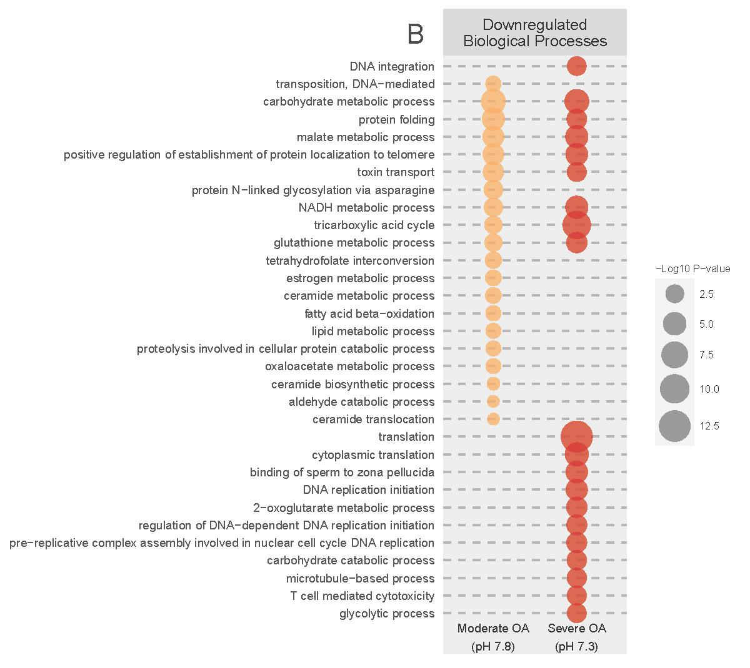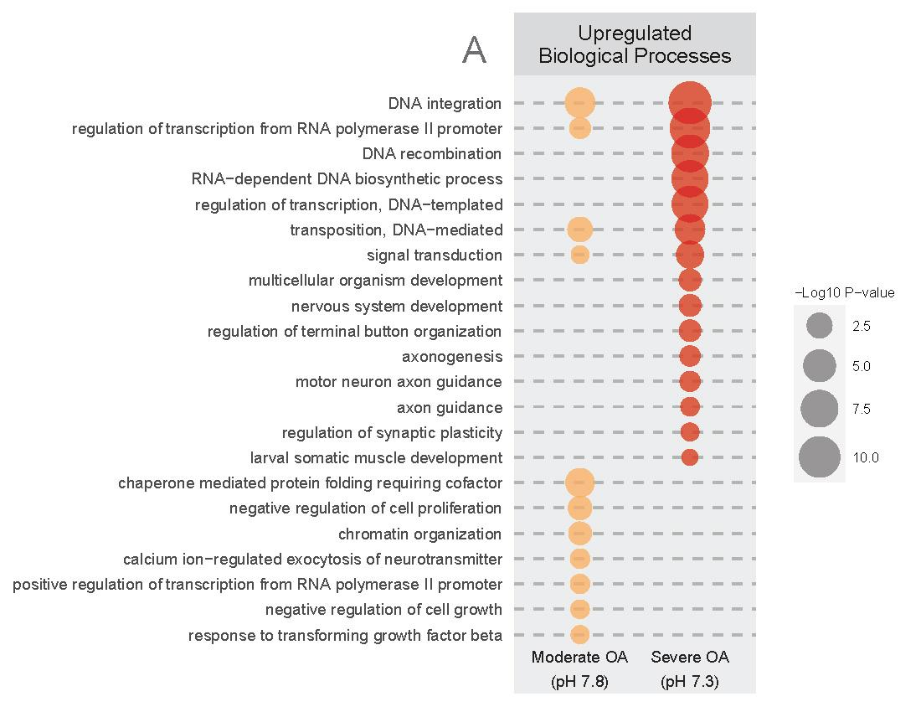

**Figure 6**: Enriched Gene Ontology biological processes in genes that were A) upregulated or B) downregulated in moderate OA (pH 7.8, left column) and severe OA (pH 7.3, right column) compared to ambient conditions (pH 8.0). Point size indicates the -Log10 transformed *p*-value (all *p*-values < 0.05), such that larger points are more significantly enriched. For downregulated processes (B) only the top 20 processes by *p*-value per OA treatment were included in this figure.

##### Enrichment analysis of genes potentially critical in an OA environment

Of the 526 and 2,350 genes that were upregulated in moderate and severe OA relative to ambient treatment, respectively, 66 (13%) and 1,319 (56%) were expressed at consistent levels across individuals within treatments (CV < 3%, hereafter referred to as low-variance genes). These upregulated low-variance genes are of interest as they may provide critical functions in the OA environment. Low-variance genes upregulated in severe OA treatment were enriched for biological processes involved in transcription regulation, DNA integration (transposon activity), nervous system processes (neurogenesis, signal transduction, calcium ion-regulated exocytosis of neurotransmitter), developmental processes (multicellular organism development, keratinocyte differentiation, glycosaminoglycan biosynthesis), regulation of cardiac muscle cell contraction, and potassium ion transport (Supplemental Table 5). Low-variance genes upregulated in moderate OA treatment were enriched for chromatin organization and transposition (Supplemental Table 5). In contrast, low-variance genes that were upregulated in ambient treatment relative to either OA treatment were primarily enriched for processes involved in protein biosynthesis, glycolysis, and ion transport (including hydrogen ion transport) (Supplemental Table 5).

##### Transposable element composition

A large portion of the red king crab transcriptome mapped to transposable elements (20,860 TEs), comprising 28% of the 74,778 analyzed genes, and 64% of the 32,435 annotated genes. These TEs mapped to 67 distinct Uniprot Species IDs, all of which were retroelements (Supplemental Table 6). Transposable element activity was high in all treatments, but activity increased with OA severity. Of the annotated genes that were upregulated in severe OA compared to ambient and moderate OA treatments, 65% and 86% mapped to TE’s, respectively, while 51% of genes upregulated in moderate OA compared to ambient were TE’s (Figure 7, Supplemental Table 7). In contrast, 31% and 28% of genes that were more abundant in ambient treatment compared to moderate and severe OA mapped to TEs (Figure 7, Supplemental Table 7). A large percentage of upregulated low-variance genes were also transposable elements, comprising 50% and 60% of those genes in moderate and severe OA-treated crab, respectively. In contrast, 16% of the low-variance upregulated genes in ambient-pH-reared crab were transposable elements (Supplemental Table 7). The TE composition of co-expressed gene modules was similar- on average the percent of genes that increased and decreased with pCO2 was 73% and 51%, respectively (Figure 7).

## 

**Figure 7**: The percent of genes in each co-expressed gene module and differentially expressed gene set (DEGs) that were transposable elements (TEs), categorized by whether genes were downregulated or upregulated in OA relative to ambient treatment. The proportion of all genes examined that were TEs (64%) is indicated by the dotted line. TEs were identified by searching within the protein names for the words transposon, transposable, LINE, retrotransposable element, transposable element, mobile element jockey, and pol polyprotein. Lines in the middle of each boxplot indicate the median percent TEs in downregulated and upregulated gene sets.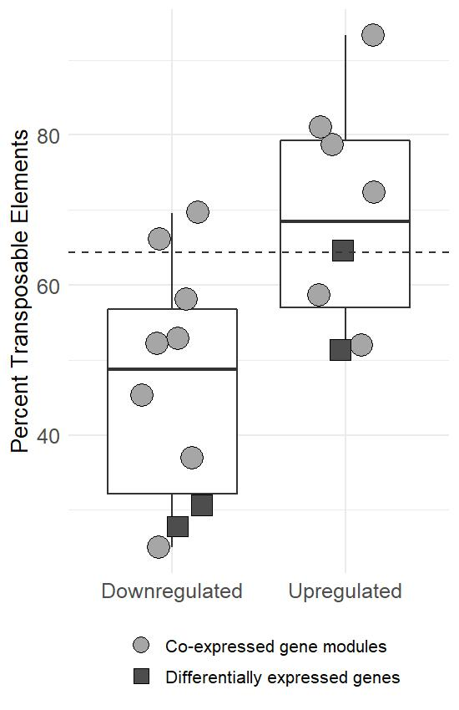

## 

## Discussion

Calcifying marine species living at high latitudes may be particularly vulnerable to the impacts of OA due to more extreme changes projected to occur in those regions [(](https://paperpile.com/c/5QXdlO/pjHI)Cooley et al. 2022, [Pilcher et al., 2022)](https://paperpile.com/c/5QXdlO/pjHI). Crustaceans in some high latitude regions are likely already experiencing acidified conditions seasonally; at present the Bering Sea shelf drops to seasonal lows of around pH 7.5 (Mathis et al. 2014) and mean bottom pH is projected to drop by a further 0.3 units by 2100 (Pilcher et al. 2022). Red king crab, which is one of several valuable commercial fisheries in Alaskan waters, are sensitive to changes in ocean chemistry at the juvenile stage, resulting in high mortality and decreased growth [(Long et al., 2013a; Coffey et al., 2017)](https://paperpile.com/c/5QXdlO/mYSS+Tgcd). However, our supporting study (Long et al. *in prep*) found that red king crab are surprisingly resilient to OA when exposure begins early in life – at hatch – with no impact to survival, growth, or development through the early juvenile (C1) stage. Here, we explore aspects of red king crab molecular physiology that are altered by long term exposure to acidification, and which may be critical to their survival, to understand their adaptive potential and improve population predictions. We provide the first study to describe the molecular signatures of juvenile red king crab that were reared from the larval stage in acidified conditions.

Expression of nearly half of all genes (44%) correlated significantly with pCO2, suggesting a strong molecular response to OA conditions, contrary to the phenotypic results. There was a general reduction in transcriptional activity and inter-individual variability in OA-reared crab, suggesting that OA reduces the breadth of physiological functions compared to crabs reared in ambient seawater. Functional analysis of downregulated genes indicates that energy production is depressed in OA conditions, which is likely associated with decreases in biosynthesis, the immune system, and myriad metabolic processes. Downregulated lipid and carbohydrate metabolic processes suggest a shift in metabolic strategy to protein catabolism, possibly to reduce CO2 production and facilitate acid/base regulation. The limited energy is shunted towards transcriptional regulation mechanisms, signaling systems, and control of growth. Transposable elements (TEs) in OA-reared crab were highly active, particularly in the most severe OA treatment, and were expressed at consistent levels, suggesting that TEs play a role in the OA-response. In the remainder of this section we describe processes that are suppressed and triggered by OA exposure during development in red king crab, and expand on effects to TE activity. Finally, we discuss differences in gene expression variation observed among treatments, and consider whether there were significant genetic differences among treatment groups that may have contributed to the observed gene expression profiles.

##### Processes that are suppressed in OA-reared crab

OA resulted in a widespread downregulation of metabolic processes involved in multiple respiratory pathways, metabolism of a variety of compounds, and protein synthesis machinery (Figure 6B). Reduced metabolic activity may be one way that red king crabs mitigate acidosis [(Michaelidis et al., 2005; Small et al., 2010)](https://paperpile.com/c/5QXdlO/xUjq+vbFK). Carbon dioxide is produced during respiration, therefore a decrease in metabolic activity reduces internal CO2 production. Decreased mitochondrial activity can also reduce oxidative cellular stress by reducing mitochondrial production of reactive oxygen species, which might otherwise increase due to environmental stressors [(Pörtner, 2010; Rato et al., 2017; Rivera-Ingraham and Lignot, 2017)](https://paperpile.com/c/5QXdlO/xNeC+topR+LTz1).

Another outcome of changes in metabolic activity could be a shift in metabolic strategy away from carbohydrate and lipid substrates and towards proteins to improve acid/base regulation [(Mayzaud and Conover, 1988; Pousse et al., 2020)](https://paperpile.com/c/5QXdlO/LAZT+s6O9). Protein catabolism is less energy efficient, but instead of CO2 it produces ammonia and bicarbonate, which can be used to buffer intracellular pH [(Langenbuch and Pörtner, 2002)](https://paperpile.com/c/5QXdlO/nTmG). While we did detect downregulation of carbohydrate & lipid metabolism that suggests a metabolic shift (Figure 6B), and increased transmembrane signaling, we did not detect increased ion regulation processes in response to OA. It is possible that ion transport was indeed higher, but was uncoupled from mRNA levels in our fully OA-acclimated crab [(Pan et al., 2015)](https://paperpile.com/c/5QXdlO/TX8C). Pairing gene expression with more direct physiological assays (e.g. excreted O:N ratio, in vivo Na+,K+-ATPase activity) would improve interpretation of how red king crab metabolic and ion regulation strategies respond to OA.

Metabolic changes are quite common in response to OA [(Kelley and Lunden; Strader et al., 2020)](https://paperpile.com/c/5QXdlO/N51P+XVzb). OA can cause metabolic depression (and more generally, reduction in gene activity) in crustaceans and other marine invertebrates [(Kaniewska et al., 2012; Evans and Watson-Wynn, 2014; Johnson and Hofmann, 2017; Kriefall et al., 2018; Bogan et al., 2020)](https://paperpile.com/c/5QXdlO/3ts9+HAzU+NQXe+dNSo+hjN0). In the present study, metabolic processes were downregulated in both the moderate and severe OA treatments, which likely reflects the sensitivity of red king crab to changes in ocean chemistry. Given these findings, we might expect metabolic rate to decrease in response to OA in red king crab. In previous respiration trials [(Long et al., 2019)](https://paperpile.com/c/5QXdlO/xGsg) there was no change to metabolic rate measured by oxygen consumption in juvenile red king crab exposed to the same OA conditions after three weeks. The decreased metabolic gene activity in the present study could reflect an acclimatory response that is only induce by long-term and/or multi-stage exposure – in our case three months from hatching - which may influence the physiology of crabs in a way that short term- or single life stage- exposure does not [(Strader et al., 2020)](https://paperpile.com/c/5QXdlO/XVzb). Decreased expression of metabolic functions may also reflect an interactive effect between OA treatment and seasonal temperature increase, which was not a factor in Long et al. (2019) (they held crab at 5°C). Future studies should pair gene expression analysis with more direct measurements of metabolic rate (and other traditional physiological measurements) at varying temperatures to untangle the effects of OA and temperature on red king crab metabolic functioning.

OA affected the red king crab immune system. Genes involved in neuroinflammation (microglial cell activation), viral response, and the innate immune system decreased with pCO2, although effects were less pronounced compared to metabolic changes. OA can negatively impact the immune system in crustaceans [(Hernroth et al., 2012, 2015; Meseck et al., 2016; McLean et al., 2018; Shields, 2019)](https://paperpile.com/c/5QXdlO/lBTy+4cZH+9pn4+cCJv+ubNj) and other marine invertebrates [(Bibby et al., 2008; Hernroth et al., 2011; Liu et al., 2016)](https://paperpile.com/c/5QXdlO/VJds+fGz8+ejA9). The mechanisms by which OA alters immune function are not fully understood, and could relate to energy constraints and malfunction of immune-related enzymes and signaling/recognition pathways (among other mechanisms) [(Bibby et al., 2008; Liu et al., 2016)](https://paperpile.com/c/5QXdlO/VJds+ejA9). We find evidence that immunosuppression may in part be due to activation of the stress response [(Adamo, 2012)](https://paperpile.com/c/5QXdlO/2kpO). Genes coding for the octopamine receptors and a receptor for tyramine, the direct precursor of octopamine, were upregulated in OA. Octopamine is the invertebrate orthologue to norepinephrine, and is one of the key neurotransmitters that regulates the acute stress-response [(Adamo, 2008)](https://paperpile.com/c/5QXdlO/QRBY). Interestingly, molecular chaperones (HSP70 and DNAJA1), which respond to a variety of stressors by refolding or facilitating the destruction of damaged proteins ([Feder and Hofmann, 1999](https://paperpile.com/c/5QXdlO/CMJC+GzaW)), increased in moderate OA but decreased substantially in severe OA, which suggests that those processes become ineffective as OA severity worsens. Further, it suggests that at moderate OA levels increased oxidative stress damages proteins, or that altered intracellular or extracellular pH affects folding patterns of proteins. While these changes did not ultimately result in mortality in the present study, our findings indicate that red king crab may be more vulnerable to co-occurring secondary stressors, such as thermal stress [(Swiney et al., 2017; Stillman et al., 2020)](https://paperpile.com/c/5QXdlO/BSB0+Zcud), due to immunosuppression and changes in cellular stress-response mechanisms. Additional multi-stressor studies are needed that expose red king crab to a range of pH levels alongside other stressors, particularly pathogen challenges.

##### Transposable elements are highly active in OA-reared crab

Many of the genes upregulated under OA conditions were transposable elements (TEs, or transposons). While TEs were present in all gene sets, including those that were more active in ambient conditions, they comprised a much larger percentage of genes upregulated in OA-reared crab (Figure 7, Supplemental Table 7). TEs, or “jumping genes”, are DNA elements that move to new locations in the genome when activated, resulting in insertional mutations [(Bourque et al., 2018)](https://paperpile.com/c/5QXdlO/I2W1). Retrotransposons, the class of TEs detected in our study, are mobilized by a copy-and-paste mechanism where the DNA sequence is transcribed and an RNA intermediary is then reverse-transcribed into a cDNA copy before being integrated into the genome [(Casacuberta and González, 2013)](https://paperpile.com/c/5QXdlO/CfP5). Increased transposable element activity in response to environmental stress is well documented in a variety of eukaryotes [(Horváth et al., 2017)](https://paperpile.com/c/5QXdlO/fCb4). There have been, however, only a few studies to detect stress-activated TEs in marine crustaceans [(de la Vega et al., 2007)](https://paperpile.com/c/5QXdlO/MhGi), and to our knowledge this is the first to do so in response to OA. While TEs comprise large portions of the genomes of arthropods [(Wu and Lu, 2019)](https://paperpile.com/c/5QXdlO/qilI), including crustaceans [(Tang et al., 2021; Veldsman et al., 2021b)](https://paperpile.com/c/5QXdlO/hgjc+6T5E), previous transcriptional characterization of stress-responses in crustaceans may have overlooked TE’s due to the common practice of masking repeat elements from genomes during analysis [(Lanciano and Cristofari, 2020)](https://paperpile.com/c/5QXdlO/G4XJ). Recent reports from a wide range of other taxa have also implicated TEs in the OA-response, including anemones [(Urbarova et al., 2019)](https://paperpile.com/c/5QXdlO/vYgr), clams [(Lesser et al., 2019)](https://paperpile.com/c/5QXdlO/bT4R), and diatoms [(Huang et al., 2018)](https://paperpile.com/c/5QXdlO/Zgfn). This breadth of taxa, which now includes crustaceans, suggests that TEs are a common response to acidification exposure.

Why TEs can become activated under stress is still under debate, as is whether they are detrimental or beneficial to an organism’s survival [(Casacuberta and González, 2013)](https://paperpile.com/c/5QXdlO/CfP5). TEs may become more active because the mechanisms that suppress them are no longer functioning, which could negatively affect fitness due to pathological mutations. Alternatively, stress-activated TE’s could act as regulatory elements and/or increase diversity of proteins available to the organism or its descendents, which may cause beneficial phenotypic variation. TEs may also be a component of the antiviral defense system, as they can stimulate the antiviral inflammatory response [(Macchietto et al., 2020; Hale, 2022)](https://paperpile.com/c/5QXdlO/cTQb+cYAA). Deciphering why TE were more active in OA-reared crab is beyond the scope of this study. However, given that red king crab early life stages tolerated OA in this study, and that many genes that were upregulated at consistent levels among OA-exposed individuals were TEs, TE mobilization may be an effective component of the red king crab stress-response system, rather than simply the result of genomic instability. TEs are also strong facilitators of adaptive evolution [(Oliver and Greene, 2009; Schrader and Schmitz, 2019)](https://paperpile.com/c/5QXdlO/aFzz+c4OX), thus OA-induced TE activity may benefit red king crab at an evolutionary scale, given that it could provide a mechanism for rapidly increasing genetic diversity [(Horváth et al., 2017; Pimpinelli and Piacentini, 2020)](https://paperpile.com/c/5QXdlO/XDbs+fCb4). It would be informative to examine whether the stress-induced mobilization of TE’s increases mutation rates by re-integration into the germline, resulting in heritable changes to the genome, which can occur in other species [(Ito et al., 2016)](https://paperpile.com/c/5QXdlO/wupt). If so, this could provide a mechanism by which OA exposure increases phenotypic diversity across generations.

##### Other processes that are more active in OA-reared crab

OA triggered a heavy investment in transcriptional regulation at multiple levels of transcriptional control. DNA methylation and histone demethylase activity was upregulated in OA-reared crab, which are epigenetic mechanisms that control transcription through changes to chromatin structure and DNA accessibility [(Gibney and Nolan, 2010)](https://paperpile.com/c/5QXdlO/zY4Q). A large percentage of upregulated genes (18%) were associated with the regulation of transcription from RNA polymerase II promoters. Increased expression was also detected in genes that code for post-translational gene control, such as Exportin-5, which is involved in mRNA silencing by microRNAs [(Yi et al., 2003)](https://paperpile.com/c/5QXdlO/wiFs). Increased transcription regulation activity in OA-reared crab explains the widespread changes in gene expression (44% of all genes correlated with pCO2). Given that OA resulted in widespread downregulation of a variety of biological functions (Figure 6B, Supplemental Tables 3 & 4), one purpose of the transcriptional regulatory response of OA-reared crab may be to shut down (or dampen) less critical processes. Additionally, since physiological metrics were unaffected by OA (Long et al. *in prep*), changes in transcription regulation may reflect physiological reprogramming that optimizes gene activity for the OA-environment, for instance by shifting metabolic pathways to improve acid/base regulation, and decreasing activity of less-critical processes to conserve energy. In addition to the broad transcriptional effects, these regulatory elements may be responsible for the unleashing of transposable element activity in response to OA [(Horváth et al., 2017)](https://paperpile.com/c/5QXdlO/fCb4).

Cell signaling and nervous system development was substantially more active in OA-reared crab. Many upregulated genes were associated with signal transduction, and interacted with or spanned cell membranes (e.g. Teneurin-m, Semaphorin-1A, Ankyrin-2). Increased expression of these genes suggest that OA increases the need to transfer information between the external and internal environments, particularly across the plasma membrane, to regulate activity inside the cell. Investment in signaling molecules may also reflect negative effects of OA on transmembrane signaling, perhaps by damaging the membrane or cytoskeleton (e.g. due to oxidative stress, [Pörtner, 2010](https://paperpile.com/c/5QXdlO/LTz1)), or by decreasing signaling molecule binding affinity [(Roggatz et al., 2016; Porteus et al., 2021)](https://paperpile.com/c/5QXdlO/DOX8+IKEP). Investment in the nervous system may be necessary to fortify systems that monitor conditions in the environment. A gene coding for the protein “pinocchio”, which was upregulated in severe OA, is expressed in the antenna of some arthropods (e.g. fruit fly, [Rollmann et al., 2005](https://paperpile.com/c/5QXdlO/hlfG)), and acts as a chemosensory receptor [(Rollmann et al., 2005; Vizueta et al., 2020)](https://paperpile.com/c/5QXdlO/fkLM+hlfG). OA-associated carapace dissolution around neuritic canals is correlated with damaged setae in larval Dungeness crab or their underdevelopment [(Bednaršek et al., 2020)](https://paperpile.com/c/5QXdlO/B0cf). Setae are important sensory structures which are innervated with chemo- and mechano-receptors [(Smolowitz, 2021)](https://paperpile.com/c/5QXdlO/7QKZ). Further, OA can alter the response of crabs to chemosensory cues suggesting a reduction in their ability to detect such cues [(Draper and Weissburg, 2022)](https://paperpile.com/c/5QXdlO/NWUN). The heavy investment in neurogenesis found here may be one way that OA-reared crab counteract the negative effects of OA to external sensory structures.

Genes involved in negative regulation of growth and cell proliferation were also upregulated in OA conditions (Figure 4A). Differentially upregulated genes included negative growth regulators Menin, Brain tumor protein, and Forkhead box protein O (FOXO). FOXO is a transcription factor that specifically inhibits growth in response to cellular stressors, including oxidative stress and nutrient deprivation [(Furukawa-Hibi et al., 2005)](https://paperpile.com/c/5QXdlO/IwSm), and may therefore be one regulatory mechanism connecting oxidative stress with OA exposure [(Melzner et al., 2019)](https://paperpile.com/c/5QXdlO/9AdX) and decreased growth rate previously seen in juvenile red king crab and related species [(Long et al., 2013a, 2017, 2019)](https://paperpile.com/c/5QXdlO/Tgcd+xGsg+CjsE). Interestingly, our supporting study did not find any effects of OA on growth measured throughout the larval stages and into the early juvenile stage. Had treatments continued it is possible that growth through the juvenile stage could have been impacted. Alternatively, negative growth regulators could reflect increased cellular response to DNA damage caused by OA. For example, FOXO negatively regulates growth by promoting cell cycle arrest, DNA repair and detoxification, and apoptosis [(Greer and Brunet 2005)](https://paperpile.com/c/5QXdlO/2wf2), which may be needed in OA conditions due to damage from oxidative stress [(Melzner et al. 2019)](https://paperpile.com/c/5QXdlO/9AdX). While this experiment’s three-month exposure is long relative to much of the other research, it would be informative for future studies to extend OA treatments through the full juvenile stage, and where possible sexual maturity, to fully capture effects of OA on growth across life stages.

A previous study reported that OA-exposed juvenile red king crab predominantly upregulated genes related to the cuticle [(Stillman et al., 2020)](https://paperpile.com/c/5QXdlO/BSB0), which we did not see. On the contrary, five genes coding for cuticle proteins (CP1158 & CPAM119) were downregulated in severe OA-reared crab (but cuticle processes were not enriched). The Stillman et al. (2020) experimental design was similar to the present study in many ways (similar laboratory & OA conditions), but the treatments were shorter in duration (three weeks) and occurred only during the juvenile stage. The transcriptional response of juvenile red king crab may therefore depend on whether they are OA-naive, or if they were previously exposed to OA conditions as larvae. Exposure to OA during early life stages may be particularly impactful, as it can alter an organism’s physiological trajectory [(Pechenik, 2006; Block et al., 2008)](https://paperpile.com/c/5QXdlO/tNKq+jfzo). For instance, exposure to OA during oogenesis and embryogenesis positively impacts larval performance in snow crab (Long et al. 2022), and larval exposure to OA carries over to affect growth and shell strength later in life in the Olympia oyster [(Hettinger et al., 2012, 2013; Sanford et al., 2014)](https://paperpile.com/c/5QXdlO/uCiU+Ct6x+ue7x). Another possible factor influencing the transcriptional response to OA is when red king crab are exposed relative to their molt cycle, which greatly influences gene expression [(Chang and Mykles, 2011; Mykles and Chang, 2020)](https://paperpile.com/c/5QXdlO/Kbjf+o3T2). We sampled juveniles early in the intermolt stage and, because of the design, know that all crabs were sampled at the same stage in the molt cycle (at ~5 days post molt). The crabs sampled by Stillman et al. (2020) were not standardized by where they were in the molt cycle, thus possibly capturing some effects of OA on crabs in the early pre-molt stage when the new exoskeleton is being synthesized. A time-series analysis of the transcriptome in varying OA environments, particularly across multiple stages of the molt-cycle, would provide a more integrated view of the crustacean OA response.

##### OA decreases gene expression variability, which is not explained by genetic differences

The variability in gene expression was much lower among individuals reared in OA treatments than those reared in ambient pH. This is evident in the PCA constructed from genome-wide expression data (Figure 1), which reveals tighter clustering as OA treatment severity increases. Genes upregulated in OA-reared crabs were also expressed at more consistent levels, particularly in the severe OA-reared crab (Figure 2b, Table 3), suggesting the need for highly controlled levels of transcripts that perform critical functions. This tight transcriptional control may reduce the scope for potential responses to other stressors (e.g. warming, pathogens), which could explain synergistic effects of OA and warming on survival reported for red king crab [(Swiney et al., 2017)](https://paperpile.com/c/5QXdlO/Zcud). Given the possibility for genotype-specific gene expression influencing our transcriptional results, we investigated whether genetic composition differed among OA treatments (i.e. did larvae from only a few families survive in OA treatments). We found no evidence of genetic differences among treatments - samples did not cluster by treatment in the PCA (Figure 1, Supplemental Figure 2), and no families were over- or under-represented in any treatment. The constricted gene expression pattern observed in juveniles reared in OA treatments therefore is not likely attributed to genotype-specific expression, but is a plastic response to OA conditions that is consistent across many families. This may reflect a lack of standing genetic variability that is needed to fuel rapid adaptation to OA [(Bitter et al., 2019)](https://paperpile.com/c/5QXdlO/FAz8), as transcriptional variability and other measures of phenotypic plasticity in response to OA may be associated with the tolerance of a species or population [(Kenkel and Matz, 2017)](https://paperpile.com/c/5QXdlO/RZFB), or their potential for adaptive selection [(Crispo, 2008)](https://paperpile.com/c/5QXdlO/GE9c). It must be noted that our genetic analysis is limited to variants within transcribed genes, and therefore may not fully capture variation across the genome. As the OA literature continues to mature, closer attention should be paid to transcriptional variability among OA-exposed organisms, and how it relates to the species’ tolerance.

## Conclusion

Red king crab juveniles are quite sensitive to short-term OA exposure, even when compared to closely related species [(Coffey et al., 2017; Long et al., 2019)](https://paperpile.com/c/5QXdlO/mYSS+xGsg). When reared in OA from hatching through the early juvenile stage, however, typical response metrics (growth, development, survival) are unaffected (Long et al. *in prep*), suggesting a shift in molecular mechanisms that enable OA tolerance. Our findings reveal that red king crab reared in OA conditions have a narrowed, possibly optimized, set of gene functions that may reflect physiological reprogramming for the OA environment (Gurr et al. 2020). Still unknown is whether OA tolerance in OA-reared crab persists through all juvenile stages, as metabolic limitations and depressed immune function, revealed here by gene expression analysis, may ultimately make them more vulnerable to infection or secondary stressors and limit growth. Only a handful of processes are upregulated in OA, indicating a critical need for a more active and developed nervous system, and tight regulation of transcription and control of growth. Given the universal and invariable upregulation of transposable elements in OA-exposed crab, TE activity may serve as an effective OA response by producing novel or cryptic transcripts, but these effects may only be fully realized in future generations. Multistressor studies are needed, with a focus on the immunological effects of OA, the role (and vulnerability) of the nervous system in an acidified world, and the potential role of TE’s in fueling adaptation.

## Acknowledgements

Thank you to Jennifer Gardner and Allie Batemen for helping to rear the larvae in the lab, Darren Pilcher for providing calcite projections for the Bering Sea, Brian Garber-Yonts and Michael Smith for providing fishery valuation information, Giles Goetz for computing assistance, Shannon Meseck & Shallin Busch for their thorough manuscript reviews, and the NOAA Ocean Acidification Program for financial support (Grants OAP1530-1213 and 21404).

## Ethics statement

All pertinent laws and regulations were followed.

## References

[Adamo, S. A. (2008). Norepinephrine and octopamine: linking stress and immune function across phyla. *Invertebrate Surviv. J.* Available at:](http://paperpile.com/b/5QXdlO/QRBY) <https://www.isj.unimore.it/index.php/ISJ/article/download/154/70>[.](http://paperpile.com/b/5QXdlO/QRBY)

[Adamo, S. A. (2012). The effects of the stress response on immune function in invertebrates: an evolutionary perspective on an ancient connection. *Horm. Behav.* 62, 324–330. doi:](http://paperpile.com/b/5QXdlO/2kpO) [10.1016/j.yhbeh.2012.02.012](http://dx.doi.org/10.1016/j.yhbeh.2012.02.012)[.](http://paperpile.com/b/5QXdlO/2kpO)

[Andrews, S. (2010). *A Quality Control Tool for High Throughput Sequence Data [Online]*. Available at:](http://paperpile.com/b/5QXdlO/GppG) <http://www.bioinformatics.babraham.ac.uk/projects/fastqc/>[.](http://paperpile.com/b/5QXdlO/GppG)

[Bednaršek, N., Ambrose, R., Calosi, P., Childers, R. K., Feely, R. A., Litvin, S. Y., et al. (2021). Synthesis of Thresholds of Ocean Acidification Impacts on Decapods. *Frontiers in Marine Science* 8. doi:](http://paperpile.com/b/5QXdlO/61zQ) [10.3389/fmars.2021.651102](http://dx.doi.org/10.3389/fmars.2021.651102)[.](http://paperpile.com/b/5QXdlO/61zQ)

[Bednaršek, N., Feely, R. A., Beck, M. W., Alin, S. R., Siedlecki, S. A., Calosi, P., et al. (2020). Exoskeleton dissolution with mechanoreceptor damage in larval Dungeness crab related to severity of present-day ocean acidification vertical gradients. *Sci. Total Environ.* 716, 136610. doi:](http://paperpile.com/b/5QXdlO/B0cf) [10.1016/j.scitotenv.2020.136610](http://dx.doi.org/10.1016/j.scitotenv.2020.136610)[.](http://paperpile.com/b/5QXdlO/B0cf)

[Bibby, R., Widdicombe, S., Parry, H., Spicer, J., and Pipe, R. (2008). Effects of ocean acidification on the immune response of the blue mussel Mytilus edulis. *Aquat. Biol.* 2, 67–74. doi:](http://paperpile.com/b/5QXdlO/VJds) [10.3354/ab00037](http://dx.doi.org/10.3354/ab00037)[.](http://paperpile.com/b/5QXdlO/VJds)

[Bitter, M. C., Kapsenberg, L., Gattuso, J.-P., and Pfister, C. A. (2019). Standing genetic variation fuels rapid adaptation to ocean acidification. *Nat. Commun.* 10, 5821. doi:](http://paperpile.com/b/5QXdlO/FAz8) [10.1038/s41467-019-13767-1](http://dx.doi.org/10.1038/s41467-019-13767-1)[.](http://paperpile.com/b/5QXdlO/FAz8)

[Block, M. D. E., de Block, M., and Stoks, R. (2008). Short-term larval food stress and associated compensatory growth reduce adult immune function in a damselfly. *Ecological Entomology*. doi:](http://paperpile.com/b/5QXdlO/tNKq) [10.1111/j.1365-2311.2008.01024.x](http://dx.doi.org/10.1111/j.1365-2311.2008.01024.x)[.](http://paperpile.com/b/5QXdlO/tNKq)

[Bogan, S. N., Johnson, K. M., and Hofmann, G. E. (2020). Changes in genome-wide methylation and gene expression in response to future pCO2 extremes in the antarctic pteropod Limacina helicina antarctica. *Front. Mar. Sci.* 6. doi:](http://paperpile.com/b/5QXdlO/3ts9) [10.3389/fmars.2019.00788](http://dx.doi.org/10.3389/fmars.2019.00788)[.](http://paperpile.com/b/5QXdlO/3ts9)

[Bourque, G., Burns, K. H., Gehring, M., Gorbunova, V., Seluanov, A., Hammell, M., et al. (2018). Ten things you should know about transposable elements. *Genome Biol.* 19, 199. doi:](http://paperpile.com/b/5QXdlO/I2W1) [10.1186/s13059-018-1577-z](http://dx.doi.org/10.1186/s13059-018-1577-z)[.](http://paperpile.com/b/5QXdlO/I2W1)

[Buchberger, A. R., DeLaney, K., Liu, Y., Vu, N. Q., Helfenbein, K., and Li, L. (2020). Mass Spectrometric Profiling of Neuropeptides in Callinectes sapidus during Hypoxia Stress. *ACS Chem. Neurosci.* 11, 3097–3106. doi:](http://paperpile.com/b/5QXdlO/e7nQ) [10.1021/acschemneuro.0c00439](http://dx.doi.org/10.1021/acschemneuro.0c00439)[.](http://paperpile.com/b/5QXdlO/e7nQ)

[Camacho, C., Coulouris, G., Avagyan, V., Ma, N., Papadopoulos, J., Bealer, K., et al. (2009). BLAST+: architecture and applications. *BMC Bioinformatics* 10, 421. doi:](http://paperpile.com/b/5QXdlO/P1rP) [10.1186/1471-2105-10-421](http://dx.doi.org/10.1186/1471-2105-10-421)[.](http://paperpile.com/b/5QXdlO/P1rP)

[Casacuberta, E., and González, J. (2013). The impact of transposable elements in environmental adaptation. *Mol. Ecol.* 22, 1503–1517. doi:](http://paperpile.com/b/5QXdlO/CfP5) [10.1111/mec.12170](http://dx.doi.org/10.1111/mec.12170)[.](http://paperpile.com/b/5QXdlO/CfP5)

[Cattell, R. B. (1966). The Scree Test For The Number Of Factors. *Multivariate Behav. Res.* 1, 245–276. doi:](http://paperpile.com/b/5QXdlO/eiAC) [10.1207/s15327906mbr0102_10](http://dx.doi.org/10.1207/s15327906mbr0102_10)[.](http://paperpile.com/b/5QXdlO/eiAC)

[Chang, E. S., and Mykles, D. L. (2011). Regulation of crustacean molting: A review and our perspectives. *Gen. Comp. Endocrinol.* 172, 323–330. doi:](http://paperpile.com/b/5QXdlO/Kbjf) [10.1016/j.ygcen.2011.04.003](http://dx.doi.org/10.1016/j.ygcen.2011.04.003)[.](http://paperpile.com/b/5QXdlO/Kbjf)

[Clements, J. C., and Comeau, L. A. (2019). Behavioral Defenses of Shellfish Prey under Ocean Acidification. *shre* 38, 725–742. doi:](http://paperpile.com/b/5QXdlO/Gp0a) [10.2983/035.038.0324](http://dx.doi.org/10.2983/035.038.0324)[.](http://paperpile.com/b/5QXdlO/Gp0a)

[Coffey, W. D., Nardone, J. A., Yarram, A., Long, W. C., Swiney, K. M., Foy, R. J., et al. (2017). Ocean acidification leads to altered micromechanical properties of the mineralized cuticle in juvenile red and blue king crabs. *J. Exp. Mar. Bio. Ecol.* 495, 1–12. doi:](http://paperpile.com/b/5QXdlO/mYSS) [10.1016/j.jembe.2017.05.011](http://dx.doi.org/10.1016/j.jembe.2017.05.011)[.](http://paperpile.com/b/5QXdlO/mYSS)

[Connon, R. E., Jeffries, K. M., Komoroske, L. M., Todgham, A. E., and Fangue, N. A. (2018). The utility of transcriptomics in fish conservation. *J. Exp. Biol.* 221. doi:](http://paperpile.com/b/5QXdlO/PwTZ) [10.1242/jeb.148833](http://dx.doi.org/10.1242/jeb.148833)[.](http://paperpile.com/b/5QXdlO/PwTZ)

Cooley, S., D. Schoeman, L. Bopp, P. Boyd, S. Donner, D.Y. Ghebrehiwet, S.-I. Ito, W. Kiessling, P. Martinetto, E. Ojea, M.-F. Racault, B. Rost, and M. Skern-Mauritzen, 2022: Oceans and Coastal Ecosystems and Their Services. In: Climate Change 2022: Impacts, Adaptation and Vulnerability. Contribution of Working Group II to the Sixth Assessment Report of the Intergovernmental Panel on Climate Change [H.-O. Pörtner, D.C. Roberts, M. Tignor, E.S. Poloczanska, K. Mintenbeck, A. Alegría, M. Craig, S. Langsdorf, S. Löschke, V. Möller, A. Okem, B. Rama (eds.)]. Cambridge University Press, Cambridge, UK and New York, NY, USA, pp. 379–550, doi:10.1017/9781009325844.005.

[Costa-Silva, J., Domingues, D., and Lopes, F. M. (2017). RNA-Seq differential expression analysis: An extended review and a software tool. *PLoS One* 12, e0190152. doi:](http://paperpile.com/b/5QXdlO/vJDR) [10.1371/journal.pone.0190152](http://dx.doi.org/10.1371/journal.pone.0190152)[.](http://paperpile.com/b/5QXdlO/vJDR)

[Crispo, E. (2008). Modifying effects of phenotypic plasticity on interactions among natural selection, adaptation and gene flow. *J. Evol. Biol.* 21, 1460–1469. doi:](http://paperpile.com/b/5QXdlO/GE9c) [10.1111/j.1420-9101.2008.01592.x](http://dx.doi.org/10.1111/j.1420-9101.2008.01592.x)[.](http://paperpile.com/b/5QXdlO/GE9c)

[Cross, J. N., Mathis, J. T., Bates, N. R., and Byrne, R. H. (2013). Conservative and non-conservative variations of total alkalinity on the southeastern Bering Sea shelf. *Mar. Chem.* 154, 100–112. doi:](http://paperpile.com/b/5QXdlO/NOOc) [10.1016/j.marchem.2013.05.012](http://dx.doi.org/10.1016/j.marchem.2013.05.012)[.](http://paperpile.com/b/5QXdlO/NOOc)

[de la Vega, E., Degnan, B. M., Hall, M. R., and Wilson, K. J. (2007). Differential expression of immune-related genes and transposable elements in black tiger shrimp (*Penaeus monodon*) exposed to a range of environmental stressors. *Fish Shellfish Immunol.* 23, 1072–1088. doi:](http://paperpile.com/b/5QXdlO/MhGi) [10.1016/j.fsi.2007.05.001](http://dx.doi.org/10.1016/j.fsi.2007.05.001)[.](http://paperpile.com/b/5QXdlO/MhGi)

DOE (1994) Handbook of methods for the analysis of the various parameters of the carbon dioxide system in sea water. Version 2. U.S. Department of Energy. 197 p.

Dickson AG, Sabine CL, Christian JR (2007) Guide to best practices for ocean CO2 measurements. 191 p.

Dickenson GH, Bejerano S, Salvador T, Makdisi C, Patel S, Long WC, Swiney KM, Foy RJ, Steffel BV, Smith KE, Aaronson RB (2021) Ocean acidification alters exoskeleton properties in adult Tanner crabs, *Chionoecetes baridi*. J Exp Biol 224:jeb232819

[Dissanayake, A., and Ishimatsu, A. (2011). Synergistic effects of elevated CO2 and temperature on the metabolic scope and activity in a shallow-water coastal decapod (*Metapenaeus joyneri*; Crustacea: Penaeidae). *ICES J. Mar. Sci.* 68, 1147–1154. doi:](http://paperpile.com/b/5QXdlO/7tq7) [10.1093/icesjms/fsq188](http://dx.doi.org/10.1093/icesjms/fsq188)[.](http://paperpile.com/b/5QXdlO/7tq7)

[Dodd, L. F., Grabowski, J. H., Piehler, M. F., Westfield, I., and Ries, J. B. (2015). Ocean acidification impairs crab foraging behaviour. *Proc. Biol. Sci.* 282. doi:](http://paperpile.com/b/5QXdlO/Hphx) [10.1098/rspb.2015.0333](http://dx.doi.org/10.1098/rspb.2015.0333)[.](http://paperpile.com/b/5QXdlO/Hphx)

[Draper, A. M., and Weissburg, M. J. (2022). Differential effects of warming and acidification on chemosensory transmission and detection may strengthen non-consumptive effects of blue crab predators (*Callinectes sapidus*) on mud crab prey (*Panopeus herbstii*). *Front. Mar. Sci.* 9. doi:](http://paperpile.com/b/5QXdlO/NWUN) [10.3389/fmars.2022.944237](http://dx.doi.org/10.3389/fmars.2022.944237)[.](http://paperpile.com/b/5QXdlO/NWUN)

[Evans, T. G., and Watson-Wynn, P. (2014). Effects of seawater acidification on gene expression: resolving broader-scale trends in sea urchins. *Biol. Bull.* 226, 237–254. doi:](http://paperpile.com/b/5QXdlO/dNSo) [10.1086/BBLv226n3p237](http://dx.doi.org/10.1086/BBLv226n3p237)[.](http://paperpile.com/b/5QXdlO/dNSo)

[Ewels, P., Magnusson, M., Lundin, S., and Käller, M. (2016). MultiQC: summarize analysis results for multiple tools and samples in a single report. *Bioinformatics* 32, 3047–3048. doi:](http://paperpile.com/b/5QXdlO/E5X7) [10.1093/bioinformatics/btw354](http://dx.doi.org/10.1093/bioinformatics/btw354)[.](http://paperpile.com/b/5QXdlO/E5X7)

[Fabry, V., McClintock, J., Mathis, J., and Grebmeier, J. (2009). Ocean Acidification at High Latitudes: The Bellwether. *Oceanography* 22, 160–171. doi:](http://paperpile.com/b/5QXdlO/8wRx) [10.5670/oceanog.2009.105](http://dx.doi.org/10.5670/oceanog.2009.105)[.](http://paperpile.com/b/5QXdlO/8wRx)

[Feder, M. E., and Hofmann, G. E. (1999). Heat-shock proteins, molecular chaperones, and the stress response: evolutionary and ecological physiology. *Annu. Rev. Physiol.* 61, 243–282. doi:](http://paperpile.com/b/5QXdlO/GzaW) [10.1146/annurev.physiol.61.1.243](http://dx.doi.org/10.1146/annurev.physiol.61.1.243)[.](http://paperpile.com/b/5QXdlO/GzaW)

[Feely, R. A., Sabine, C. L., Lee, K., Berelson, W., Kleypas, J., Fabry, V. J., et al. (2004). Impact of anthropogenic CO2 on the CaCO3 system in the oceans. *Science* 305, 362–366. doi:](http://paperpile.com/b/5QXdlO/FJYv) [10.1126/science.1097329](http://dx.doi.org/10.1126/science.1097329)[.](http://paperpile.com/b/5QXdlO/FJYv)

[Figuerola, B., Hancock, A. M., Bax, N., Cummings, V. J., Downey, R., Griffiths, H. J., et al. (2021). A Review and Meta-Analysis of Potential Impacts of Ocean Acidification on Marine Calcifiers From the Southern Ocean. *Frontiers in Marine Science* 8. doi:](http://paperpile.com/b/5QXdlO/qhGX) [10.3389/fmars.2021.584445](http://dx.doi.org/10.3389/fmars.2021.584445)[.](http://paperpile.com/b/5QXdlO/qhGX)

[Furukawa-Hibi, Y., Kobayashi, Y., Chen, C., and Motoyama, N. (2005). FOXO transcription factors in cell-cycle regulation and the response to oxidative stress. *Antioxid. Redox Signal.* 7, 752–760. doi:](http://paperpile.com/b/5QXdlO/IwSm) [10.1089/ars.2005.7.752](http://dx.doi.org/10.1089/ars.2005.7.752)[.](http://paperpile.com/b/5QXdlO/IwSm)

[Gibney, E. R., and Nolan, C. M. (2010). Epigenetics and gene expression. *Heredity*  105, 4–13. doi:](http://paperpile.com/b/5QXdlO/zY4Q) [10.1038/hdy.2010.54](http://dx.doi.org/10.1038/hdy.2010.54)[.](http://paperpile.com/b/5QXdlO/zY4Q)

[Gruber, N., Clement, D., Carter, B. R., Feely, R. A., van Heuven, S., Hoppema, M., et al. (2019). The oceanic sink for anthropogenic CO2 from 1994 to 2007. *Science* 363, 1193–1199. doi:](http://paperpile.com/b/5QXdlO/6SlU) [10.1126/science.aau5153](http://dx.doi.org/10.1126/science.aau5153)[.](http://paperpile.com/b/5QXdlO/6SlU)

Gurr, S. J., Vadopalas, B., Roberts, S. B., and Putnam, H. M. (2020). Metabolic recovery and compensatory shell growth of juvenile Pacific geoduck *Panopea generosa* following short-term exposure to acidified seawater. *Conserv Physiol* 8, coaa024.

[Hale, B. G. (2022). Antiviral immunity triggered by infection-induced host transposable elements. *Curr. Opin. Virol.* 52, 211–216. doi:](http://paperpile.com/b/5QXdlO/cYAA) [10.1016/j.coviro.2021.12.006](http://dx.doi.org/10.1016/j.coviro.2021.12.006)[.](http://paperpile.com/b/5QXdlO/cYAA)

[Havecker, E. R., Gao, X., and Voytas, D. F. (2004). The diversity of LTR retrotransposons. *Genome Biol.* 5, 225. doi:](http://paperpile.com/b/5QXdlO/Nk7c) [10.1186/gb-2004-5-6-225](http://dx.doi.org/10.1186/gb-2004-5-6-225)[.](http://paperpile.com/b/5QXdlO/Nk7c)

[Hernroth, B., Baden, S., Thorndyke, M., and Dupont, S. (2011). Immune suppression of the echinoderm *Asterias rubens* (L.) following long-term ocean acidification. *Aquat. Toxicol.* 103, 222–224. doi:](http://paperpile.com/b/5QXdlO/fGz8) [10.1016/j.aquatox.2011.03.001](http://dx.doi.org/10.1016/j.aquatox.2011.03.001)[.](http://paperpile.com/b/5QXdlO/fGz8)

[Hernroth, B., Krång, A.-S., and Baden, S. (2015). Bacteriostatic suppression in Norway lobster (*Nephrops norvegicus*) exposed to manganese or hypoxia under pressure of ocean acidification. *Aquat. Toxicol.* 159, 217–224. doi:](http://paperpile.com/b/5QXdlO/cCJv) [10.1016/j.aquatox.2014.11.025](http://dx.doi.org/10.1016/j.aquatox.2014.11.025)[.](http://paperpile.com/b/5QXdlO/cCJv)

[Hernroth, B., Sköld, H. N., Wiklander, K., Jutfelt, F., and Baden, S. (2012). Simulated climate change causes immune suppression and protein damage in the crustacean *Nephrops norvegicus*. *Fish Shellfish Immunol.* 33, 1095–1101. doi:](http://paperpile.com/b/5QXdlO/4cZH) [10.1016/j.fsi.2012.08.011](http://dx.doi.org/10.1016/j.fsi.2012.08.011)[.](http://paperpile.com/b/5QXdlO/4cZH)

[Hettinger, A., Sanford, E., Hill, T. M., Lenz, E. A., Russell, A. D., and Gaylord, B. (2013). Larval carry-over effects from ocean acidification persist in the natural environment. *Glob. Chang. Biol.* 19, 3317–3326. doi:](http://paperpile.com/b/5QXdlO/ue7x) [10.1111/gcb.12307](http://dx.doi.org/10.1111/gcb.12307)[.](http://paperpile.com/b/5QXdlO/ue7x)

[Hettinger, A., Sanford, E., Hill, T. M., Russell, A. D., Sato, K. N. S., Hoey, J., et al. (2012). Persistent carry-over effects of planktonic exposure to ocean acidification in the Olympia oyster. *Ecology* 93, 2758–2768. doi:](http://paperpile.com/b/5QXdlO/uCiU) [10.1890/12-0567.1](http://dx.doi.org/10.1890/12-0567.1)[.](http://paperpile.com/b/5QXdlO/uCiU)

[Horváth, V., Merenciano, M., and González, J. (2017). Revisiting the Relationship between Transposable Elements and the Eukaryotic Stress Response. *Trends Genet.* 33, 832–841. doi:](http://paperpile.com/b/5QXdlO/fCb4) [10.1016/j.tig.2017.08.007](http://dx.doi.org/10.1016/j.tig.2017.08.007)[.](http://paperpile.com/b/5QXdlO/fCb4)

[Huang, R., Ding, J., Gao, K., Cruz de Carvalho, M. H., Tirichine, L., Bowler, C., et al. (2018). A Potential Role for Epigenetic Processes in the Acclimation Response to Elevated pCO2 in the Model Diatom *Phaeodactylum tricornutum*. *Front. Microbiol.* 9, 3342. doi:](http://paperpile.com/b/5QXdlO/Zgfn) [10.3389/fmicb.2018.03342](http://dx.doi.org/10.3389/fmicb.2018.03342)[.](http://paperpile.com/b/5QXdlO/Zgfn)

[Ito, H., Kim, J.-M., Matsunaga, W., Saze, H., Matsui, A., Endo, T. A., et al. (2016). A Stress-Activated Transposon in *Arabidopsis* Induces Transgenerational Abscisic Acid Insensitivity. *Sci. Rep.* 6, 23181. doi:](http://paperpile.com/b/5QXdlO/wupt) [10.1038/srep23181](http://dx.doi.org/10.1038/srep23181)[.](http://paperpile.com/b/5QXdlO/wupt)

[Johnson, K. M., and Hofmann, G. E. (2017). Transcriptomic response of the Antarctic pteropod *Limacina helicina antarctica* to ocean acidification. *BMC Genomics* 18, 812. doi:](http://paperpile.com/b/5QXdlO/HAzU) [10.1186/s12864-017-4161-0](http://dx.doi.org/10.1186/s12864-017-4161-0)[.](http://paperpile.com/b/5QXdlO/HAzU)

[Jones, O. R., and Wang, J. (2010). COLONY: a program for parentage and sibship inference from multilocus genotype data. *Mol. Ecol. Resour.* 10, 551–555. doi:](http://paperpile.com/b/5QXdlO/4BQf) [10.1111/j.1755-0998.2009.02787.x](http://dx.doi.org/10.1111/j.1755-0998.2009.02787.x)[.](http://paperpile.com/b/5QXdlO/4BQf)

[Kaniewska, P., Campbell, P. R., Kline, D. I., Rodriguez-Lanetty, M., Miller, D. J., Dove, S., et al. (2012). Major cellular and physiological impacts of ocean acidification on a reef building coral. *PLoS One* 7, e34659. doi:](http://paperpile.com/b/5QXdlO/hjN0) [10.1371/journal.pone.0034659](http://dx.doi.org/10.1371/journal.pone.0034659)[.](http://paperpile.com/b/5QXdlO/hjN0)

[Kelley, and Lunden Meta-analysis identifies metabolic sensitivities to ocean acidification running title: ocean acidification impacts metabolic function. *AIMS Environ. Sci.* Available at:](http://paperpile.com/b/5QXdlO/N51P) <https://www.researchgate.net/profile/Amanda-Kelley-3/publication/321220000_Meta-analysis_identifies_metabolic_sensitivities_to_ocean_acidificationRunning_title_Ocean_acidification_impacts_metabolic_function/links/5a42acf4a6fdcce19715b6ac/Meta-analysis-identifies-metabolic-sensitivities-to-ocean-acidificationRunning-title-Ocean-acidification-impacts-metabolic-function.pdf>[.](http://paperpile.com/b/5QXdlO/N51P)

[Kenkel, C. D., and Matz, M. V. (2017). Gene expression plasticity as a mechanism of coral adaptation to a variable environment. *Nature Ecology & Evolution* 1. doi:](http://paperpile.com/b/5QXdlO/RZFB) [10.1038/s41559-016-0014](http://dx.doi.org/10.1038/s41559-016-0014)[.](http://paperpile.com/b/5QXdlO/RZFB)

[Kriefall, N. G., Pechenik, J. A., Pires, A., and Davies, S. W. (2018). Resilience of Atlantic slippersnail *Crepidula fornicata* larvae in the face of severe coastal acidification. *Front. Mar. Sci.* 5. doi:](http://paperpile.com/b/5QXdlO/NQXe) [10.3389/fmars.2018.00312](http://dx.doi.org/10.3389/fmars.2018.00312)[.](http://paperpile.com/b/5QXdlO/NQXe)

[Kültz, D. (2020). Evolution of cellular stress response mechanisms. *J Exp Zool A Ecol Integr Physiol* 333, 359–378. doi:](http://paperpile.com/b/5QXdlO/CMJC) [10.1002/jez.2347](http://dx.doi.org/10.1002/jez.2347)[.](http://paperpile.com/b/5QXdlO/CMJC)

[Lanciano, S., and Cristofari, G. (2020). Measuring and interpreting transposable element expression. *Nat. Rev. Genet.* 21, 721–736. doi:](http://paperpile.com/b/5QXdlO/G4XJ) [10.1038/s41576-020-0251-y](http://dx.doi.org/10.1038/s41576-020-0251-y)[.](http://paperpile.com/b/5QXdlO/G4XJ)

[Langenbuch, M., and Pörtner, H. O. (2002). Changes in metabolic rate and N excretion in the marine invertebrate *Sipunculus nudus* under conditions of environmental hypercapnia: identifying effective acid-base variables. *J. Exp. Biol.* 205, 1153–1160. doi:](http://paperpile.com/b/5QXdlO/nTmG) [10.1242/jeb.205.8.1153](http://dx.doi.org/10.1242/jeb.205.8.1153)[.](http://paperpile.com/b/5QXdlO/nTmG)

[Langfelder, P., and Horvath, S. (2008). WGCNA: an R package for weighted correlation network analysis. *BMC Bioinformatics* 9, 559. doi:](http://paperpile.com/b/5QXdlO/FkVP) [10.1186/1471-2105-9-559](http://dx.doi.org/10.1186/1471-2105-9-559)[.](http://paperpile.com/b/5QXdlO/FkVP)

[Langmead, B., and Salzberg, S. L. (2012). Fast gapped-read alignment with Bowtie 2. *Nat. Methods* 9, 357–359. doi:](http://paperpile.com/b/5QXdlO/eTqC) [10.1038/nmeth.1923](http://dx.doi.org/10.1038/nmeth.1923)[.](http://paperpile.com/b/5QXdlO/eTqC)

Lavigne H, Gattuse J (2012) seacarb: Seawater carbonate chemistry with R. http://CRAN.R-project.org/package=seacarb. R package version 2.4.6 ed.

[Lesser, M. P., Thompson, M. M., and Walker, C. W. (2019). Effects of Thermal Stress and Ocean Acidification on the Expression of the Retrotransposon Steamer in the Softshell *Mya arenaria*. *shre* 38, 535–541. doi:](http://paperpile.com/b/5QXdlO/bT4R) [10.2983/035.038.0304](http://dx.doi.org/10.2983/035.038.0304)[.](http://paperpile.com/b/5QXdlO/bT4R)

[Liao, Y., Smyth, G. K., and Shi, W. (2014). featureCounts: an efficient general purpose program for assigning sequence reads to genomic features. *Bioinformatics* 30, 923–930. doi:](http://paperpile.com/b/5QXdlO/kqn3) [10.1093/bioinformatics/btt656](http://dx.doi.org/10.1093/bioinformatics/btt656)[.](http://paperpile.com/b/5QXdlO/kqn3)

[Liu, S., Shi, W., Guo, C., Zhao, X., Han, Y., Peng, C., et al. (2016). Ocean acidification weakens the immune response of blood clam through hampering the NF-kappa β and toll-like receptor pathways. *Fish Shellfish Immunol.* 54, 322–327. doi:](http://paperpile.com/b/5QXdlO/ejA9) [10.1016/j.fsi.2016.04.030](http://dx.doi.org/10.1016/j.fsi.2016.04.030)[.](http://paperpile.com/b/5QXdlO/ejA9)

[Long, W. C., Swiney, K. M., Harris, C., Page, H. N., and Foy, R. J. (2013a). Effects of ocean acidification on juvenile red king crab (*Paralithodes camtschaticus*) and Tanner crab (*Chionoecetes bairdi*) growth, condition, calcification, and survival. *PLoS One* 8, e60959. doi:](http://paperpile.com/b/5QXdlO/Tgcd) [10.1371/journal.pone.0060959](http://dx.doi.org/10.1371/journal.pone.0060959)[.](http://paperpile.com/b/5QXdlO/Tgcd)

[Long, W., Swiney, K. M., and Foy, R. J. (2013b). Effects of ocean acidification on the embryos and larvae of red king crab, *Paralithodes camtschaticus*. *Mar. Pollut. Bull.* 69, 38–47. doi:](http://paperpile.com/b/5QXdlO/q7i2) [10.1016/j.marpolbul.2013.01.011](http://dx.doi.org/10.1016/j.marpolbul.2013.01.011)[.](http://paperpile.com/b/5QXdlO/q7i2)

[Long, W. C., Van Sant, S. B., Swiney, K. M., and Foy, R. J. (2017). Survival, growth, and morphology of blue king crabs: effect of ocean acidification decreases with exposure time. *ICES J. Mar. Sci.* 74, 1033–1041. doi:](http://paperpile.com/b/5QXdlO/CjsE) [10.1093/icesjms/fsw197](http://dx.doi.org/10.1093/icesjms/fsw197)[.](http://paperpile.com/b/5QXdlO/CjsE)

[Long, W. C., Pruisner, P., Swiney, K. M., and Foy, R. J. (2019). Effects of ocean acidification on the respiration and feeding of juvenile red and blue king crabs (*Paralithodes camtschaticus* and *P. platypus*). *ICES J. Mar. Sci.* 76, 1335–1343. doi:](http://paperpile.com/b/5QXdlO/xGsg) [10.1093/icesjms/fsz090](http://dx.doi.org/10.1093/icesjms/fsz090)[.](http://paperpile.com/b/5QXdlO/xGsg)

[Long, W. C., Swiney, K. M., and Foy, R. J. (2021). Effects of ocean acidification on young-of-the-year golden king crab (*Lithodes aequispinus*) survival and growth. *Mar. Biol.* 168. doi:](http://paperpile.com/b/5QXdlO/obTI) [10.1007/s00227-021-03930-y](http://dx.doi.org/10.1007/s00227-021-03930-y)[.](http://paperpile.com/b/5QXdlO/obTI)

Christopher Long, W., Swiney, K. M., and Foy, R. J. (2022). Effects of high pCO2 on snow crab larvae: Carryover effects from embryogenesis and oogenesis reduce direct effects on larval survival. *bioRxiv*, 2022.10.06.511100. doi: 10.1101/2022.10.06.511100.

[Love, M. I., Huber, W., and Anders, S. (2014). Moderated estimation of fold change and dispersion for RNA-seq data with DESeq2. *Genome Biol.* 15, 550. doi:](http://paperpile.com/b/5QXdlO/0LPj) [10.1186/s13059-014-0550-8](http://dx.doi.org/10.1186/s13059-014-0550-8)[.](http://paperpile.com/b/5QXdlO/0LPj)

[Macchietto, M. G., Langlois, R. A., and Shen, S. S. (2020). Virus-induced transposable element expression up-regulation in human and mouse host cells. *Life Sci Alliance* 3. doi:](http://paperpile.com/b/5QXdlO/cTQb) [10.26508/lsa.201900536](http://dx.doi.org/10.26508/lsa.201900536)[.](http://paperpile.com/b/5QXdlO/cTQb)

[Martin, M. (2011). Cutadapt removes adapter sequences from high-throughput sequencing reads. *EMBnet.journal* 17, 10–12. doi:](http://paperpile.com/b/5QXdlO/R8rh) [10.14806/ej.17.1.200](http://dx.doi.org/10.14806/ej.17.1.200)[.](http://paperpile.com/b/5QXdlO/R8rh)

[Mathis, J., NOAA, Cross, J., Evans, W., and Doney, S. (2015a). Ocean Acidification in the Surface Waters of the Pacific-Arctic Boundary Regions. *Oceanography* 25, 122–135. doi:](http://paperpile.com/b/5QXdlO/RNJm) [10.5670/oceanog.2015.36](http://dx.doi.org/10.5670/oceanog.2015.36)[.](http://paperpile.com/b/5QXdlO/RNJm)

[Mathis, J. T., Cooley, S. R., Lucey, N., Colt, S., Ekstrom, J., Hurst, T., et al. (2015b). Ocean acidification risk assessment for Alaska’s fishery sector. *Progress in Oceanography* 136, 71–91. doi:](http://paperpile.com/b/5QXdlO/F3aB) [10.1016/j.pocean.2014.07.001](http://dx.doi.org/10.1016/j.pocean.2014.07.001)[.](http://paperpile.com/b/5QXdlO/F3aB)

[Mathis, J. T., Cross, J. N., and Bates, N. R. (2011a). Coupling primary production and terrestrial runoff to ocean acidification and carbonate mineral suppression in the eastern Bering Sea. *J. Geophys. Res.* 116. doi:](http://paperpile.com/b/5QXdlO/pE1Q) [10.1029/2010jc006453](http://dx.doi.org/10.1029/2010jc006453)[.](http://paperpile.com/b/5QXdlO/pE1Q)

[Mathis, J. T., Cross, J. N., and Bates, N. R. (2011b). The role of ocean acidification in systemic carbonate mineral suppression in the Bering Sea. *Geophys. Res. Lett.* 38. doi:](http://paperpile.com/b/5QXdlO/sERz) [10.1029/2011GL048884](http://dx.doi.org/10.1029/2011GL048884)[.](http://paperpile.com/b/5QXdlO/sERz)

[Mathis, J. T., Cross, J. N., Monacci, N., Feely, R. A., and Stabeno, P. (2014). Evidence of prolonged aragonite undersaturations in the bottom waters of the southern Bering Sea shelf from autonomous sensors. *Deep Sea Res. Part 2 Top. Stud. Oceanogr.* 109, 125–133. doi:](http://paperpile.com/b/5QXdlO/Cc7G) [10.1016/j.dsr2.2013.07.019](http://dx.doi.org/10.1016/j.dsr2.2013.07.019)[.](http://paperpile.com/b/5QXdlO/Cc7G)

[Mayzaud, P., and Conover, R. J. (1988). O: N atomic ratio as a tool to describe zooplankton metabolism. *Marine ecology progress series. Oldendorf* 45, 289–302. Available at:](http://paperpile.com/b/5QXdlO/LAZT) <https://www.int-res.com/articles/meps/45/m045p289.pdf>[.](http://paperpile.com/b/5QXdlO/LAZT)

[McElhany, P., Busch, D. S., Lawrence, A., Maher, M., Perez, D., Reinhardt, E. M., et al. (2022). Higher survival but smaller size of juvenile Dungeness crab (*Metacarcinus magister*) in high CO2. *J. Exp. Mar. Bio. Ecol.* 555, 151781. doi:](http://paperpile.com/b/5QXdlO/gwtI) [10.1016/j.jembe.2022.151781](http://dx.doi.org/10.1016/j.jembe.2022.151781)[.](http://paperpile.com/b/5QXdlO/gwtI)

[McKenna, A., Hanna, M., Banks, E., Sivachenko, A., Cibulskis, K., Kernytsky, A., et al. (2010). The Genome Analysis Toolkit: a MapReduce framework for analyzing next-generation DNA sequencing data. *Genome Res.* 20, 1297–1303. doi:](http://paperpile.com/b/5QXdlO/pQhx) [10.1101/gr.107524.110](http://dx.doi.org/10.1101/gr.107524.110)[.](http://paperpile.com/b/5QXdlO/pQhx)

[McLean, E. L., Katenka, N. V., and Seibel, B. A. (2018). Decreased growth and increased shell disease in early benthic phase Homarus americanus in response to elevated CO2. *Mar. Ecol. Prog. Ser.* 596, 113–126. doi:](http://paperpile.com/b/5QXdlO/9pn4) [10.3354/meps12586](http://dx.doi.org/10.3354/meps12586)[.](http://paperpile.com/b/5QXdlO/9pn4)

[Melzner, F., Mark, F. C., Seibel, B. A., and Tomanek, L. (2019). Ocean Acidification and Coastal Marine Invertebrates: Tracking CO2 Effects from Seawater to the Cell. *Ann. Rev. Mar. Sci.* doi:](http://paperpile.com/b/5QXdlO/9AdX) [10.1146/annurev-marine-010419-010658](http://dx.doi.org/10.1146/annurev-marine-010419-010658)[.](http://paperpile.com/b/5QXdlO/9AdX)

[Meseck, S. L., Alix, J. H., Swiney, K. M., Long, W. C., Wikfors, G. H., and Foy, R. J. (2016). Ocean Acidification Affects Hemocyte Physiology in the Tanner Crab (*Chionoecetes bairdi*). *PLoS One* 11, e0148477. doi:](http://paperpile.com/b/5QXdlO/lBTy) [10.1371/journal.pone.0148477](http://dx.doi.org/10.1371/journal.pone.0148477)[.](http://paperpile.com/b/5QXdlO/lBTy)

[Michaelidis, B., Ouzounis, C., Paleras, A., and Pörtner, H. O. (2005). Effects of long-term moderate hypercapnia on acid–base balance and growth rate in marine mussels *Mytilus galloprovincialis*. *Mar. Ecol. Prog. Ser.* 293, 109–118. Available at:](http://paperpile.com/b/5QXdlO/xUjq) <http://www.jstor.org/stable/24868542>[.](http://paperpile.com/b/5QXdlO/xUjq)

Millero FJ (1986) The pH of estuarine waters. Limnology and Oceanography: 839-847.

[Mueter, F. J., Planque, B., Hunt, G. L., Alabia, I. D., Hirawake, T., Eisner, L., et al. (2021). Possible future scenarios in the gateways to the Arctic for Subarctic and Arctic marine systems: II. prey resources, food webs, fish, and fisheries. *ICES J. Mar. Sci.* 78, 3017–3045. doi:](http://paperpile.com/b/5QXdlO/ElOf) [10.1093/icesjms/fsab122](http://dx.doi.org/10.1093/icesjms/fsab122)[.](http://paperpile.com/b/5QXdlO/ElOf)

[Mykles, D. L., and Chang, E. S. (2020). Hormonal control of the crustacean molting gland: Insights from transcriptomics and proteomics. *Gen. Comp. Endocrinol.* 294, 113493. doi:](http://paperpile.com/b/5QXdlO/o3T2) [10.1016/j.ygcen.2020.113493](http://dx.doi.org/10.1016/j.ygcen.2020.113493)[.](http://paperpile.com/b/5QXdlO/o3T2)

[Oliver, K. R., and Greene, W. K. (2009). Transposable elements: powerful facilitators of evolution. *Bioessays* 31, 703–714. doi:](http://paperpile.com/b/5QXdlO/aFzz) [10.1002/bies.200800219](http://dx.doi.org/10.1002/bies.200800219)[.](http://paperpile.com/b/5QXdlO/aFzz)

[Pane, and Barry (2007). Extracellular acid–base regulation during short-term hypercapnia is effective in a shallow-water crab, but ineffective in a deep-sea crab. *Mar. Ecol. Prog. Ser.* 334. Available at:](http://paperpile.com/b/5QXdlO/JDBO) <https://www.int-res.com/abstracts/meps/v334/p1-9/>[.](http://paperpile.com/b/5QXdlO/JDBO)

[Pan, T.-C. F., Applebaum, S. L., and Manahan, D. T. (2015). Experimental ocean acidification alters the allocation of metabolic energy. *Proc. Natl. Acad. Sci. U. S. A.* 112, 4696–4701. doi:](http://paperpile.com/b/5QXdlO/TX8C) [10.1073/pnas.1416967112](http://dx.doi.org/10.1073/pnas.1416967112)[.](http://paperpile.com/b/5QXdlO/TX8C)

[Pechenik, J. A. (2006). Larval experience and latent effects—metamorphosis is not a new beginning. *Integr. Comp. Biol.* 46, 323–333. doi:](http://paperpile.com/b/5QXdlO/jfzo) [10.1093/icb/icj028](http://dx.doi.org/10.1093/icb/icj028)[.](http://paperpile.com/b/5QXdlO/jfzo)

[Pilcher, D. J., Cross, J. N., Hermann, A. J., Kearney, K. A., Cheng, W., and Mathis, J. T. (2022). Dynamically downscaled projections of ocean acidification for the Bering Sea. *Deep Sea Res. Part 2 Top. Stud. Oceanogr.* 198, 105055. doi:](http://paperpile.com/b/5QXdlO/pjHI) [10.1016/j.dsr2.2022.105055](http://dx.doi.org/10.1016/j.dsr2.2022.105055)[.](http://paperpile.com/b/5QXdlO/pjHI)

[Pimpinelli, S., and Piacentini, L. (2020). Environmental change and the evolution of genomes: Transposable elements as translators of phenotypic plasticity into genotypic variability. *Funct. Ecol.* 34, 428–441. doi:](http://paperpile.com/b/5QXdlO/XDbs) [10.1111/1365-2435.13497](http://dx.doi.org/10.1111/1365-2435.13497)[.](http://paperpile.com/b/5QXdlO/XDbs)

[Porteus, C. S., Roggatz, C. C., Velez, Z., Hardege, J. D., and Hubbard, P. C. (2021). Acidification can directly affect olfaction in marine organisms. *J. Exp. Biol.* 224. doi:](http://paperpile.com/b/5QXdlO/IKEP) [10.1242/jeb.237941](http://dx.doi.org/10.1242/jeb.237941)[.](http://paperpile.com/b/5QXdlO/IKEP)

[Pörtner, H.-O. (2008). Ecosystem effects of ocean acidification in times of ocean warming: a physiologist’s view. *Mar. Ecol. Prog. Ser.* 373, 203–217. Available at:](http://paperpile.com/b/5QXdlO/EMPI) <https://www.int-res.com/abstracts/meps/v373/p203-217/>[.](http://paperpile.com/b/5QXdlO/EMPI)

[Pörtner, H.-O. (2010). Oxygen- and capacity-limitation of thermal tolerance: a matrix for integrating climate-related stressor effects in marine ecosystems. *J. Exp. Biol.* 213, 881–893. doi:](http://paperpile.com/b/5QXdlO/LTz1) [10.1242/jeb.037523](http://dx.doi.org/10.1242/jeb.037523)[.](http://paperpile.com/b/5QXdlO/LTz1)

[Pousse, E., Poach, M. E., Redman, D. H., Sennefelder, G., White, L. E., Lindsay, J. M., et al. (2020). Energetic response of Atlantic surfclam *Spisula solidissima* to ocean acidification. *Mar. Pollut. Bull.* 161, 111740. doi:](http://paperpile.com/b/5QXdlO/s6O9) [10.1016/j.marpolbul.2020.111740](http://dx.doi.org/10.1016/j.marpolbul.2020.111740)[.](http://paperpile.com/b/5QXdlO/s6O9)

[Punt, A. E., Foy, R. J., Dalton, M. G., Long, W. C., and Swiney, K. M. (2015). Effects of long-term exposure to ocean acidification conditions on future southern Tanner crab (*Chionoecetes bairdi*) fisheries management. *ICES J. Mar. Sci.* 73, 849–864. doi:](http://paperpile.com/b/5QXdlO/M3qX) [10.1093/icesjms/fsv205](http://dx.doi.org/10.1093/icesjms/fsv205)[.](http://paperpile.com/b/5QXdlO/M3qX)

[Punt, A. E., Poljak, D., Dalton, M. G., and Foy, R. J. (2014). Evaluating the impact of ocean acidification on fishery yields and profits: The example of red king crab in Bristol Bay. *Ecol. Modell.* 285, 39–53. doi:](http://paperpile.com/b/5QXdlO/TllO) [10.1016/j.ecolmodel.2014.04.017](http://dx.doi.org/10.1016/j.ecolmodel.2014.04.017)[.](http://paperpile.com/b/5QXdlO/TllO)

[Rato, L. D., Novais, S. C., Lemos, M. F. L., Alves, L. M. F., and Leandro, S. M. (2017). *Homarus gammarus* (Crustacea: Decapoda) larvae under an ocean acidification scenario: responses across different levels of biological organization. *Comp. Biochem. Physiol. C. Toxicol. Pharmacol.* 203, 29–38. doi:](http://paperpile.com/b/5QXdlO/topR) [10.1016/j.cbpc.2017.09.002](http://dx.doi.org/10.1016/j.cbpc.2017.09.002)[.](http://paperpile.com/b/5QXdlO/topR)

[Reed, G. F., Lynn Freyja, and Meade Bruce D. (2003). Use of Coefficient of Variation in Assessing Variability of Quantitative Assays. *Clin. Vaccine Immunol.* 10, 1162–1162. doi:](http://paperpile.com/b/5QXdlO/zHWn) [10.1128/CDLI.10.6.1162.2003](http://dx.doi.org/10.1128/CDLI.10.6.1162.2003)[.](http://paperpile.com/b/5QXdlO/zHWn)

[Reum, J. C. P., Alin, S. R., Feely, R. A., Newton, J., Warner, M., and McElhany, P. (2014). Seasonal carbonate chemistry covariation with temperature, oxygen, and salinity in a fjord estuary: implications for the design of ocean acidification experiments. *PLoS One* 9, e89619. doi:](http://paperpile.com/b/5QXdlO/H9DE) [10.1371/journal.pone.0089619](http://dx.doi.org/10.1371/journal.pone.0089619)[.](http://paperpile.com/b/5QXdlO/H9DE)

[Reum, J. C. P., Alin, S. R., Harvey, C. J., Bednaršek, N., Evans, W., Feely, R. A., et al. (2015). Interpretation and design of ocean acidification experiments in upwelling systems in the context of carbonate chemistry co-variation with temperature and oxygen. *ICES J. Mar. Sci.* 73, 582–595. doi:](http://paperpile.com/b/5QXdlO/5smF) [10.1093/icesjms/fsu231](http://dx.doi.org/10.1093/icesjms/fsu231)[.](http://paperpile.com/b/5QXdlO/5smF)

[Ries, J. B., Cohen, A. L., and McCorkle, D. C. (2009). Marine calcifiers exhibit mixed responses to CO2-induced ocean acidification. *Geology* 37, 1131–1134. doi:](http://paperpile.com/b/5QXdlO/OGKL) [10.1130/G30210A.1](http://dx.doi.org/10.1130/G30210A.1)[.](http://paperpile.com/b/5QXdlO/OGKL)

[Rivera-Ingraham, G. A., and Lignot, J.-H. (2017). Osmoregulation, bioenergetics and oxidative stress in coastal marine invertebrates: raising the questions for future research. *J. Exp. Biol.* 220, 1749–1760. doi:](http://paperpile.com/b/5QXdlO/xNeC) [10.1242/jeb.135624](http://dx.doi.org/10.1242/jeb.135624)[.](http://paperpile.com/b/5QXdlO/xNeC)

[Roggatz, C. C., Lorch, M., Hardege, J. D., and Benoit, D. M. (2016). Ocean acidification affects marine chemical communication by changing structure and function of peptide signalling molecules. *Glob. Chang. Biol.* 22, 3914–3926. doi:](http://paperpile.com/b/5QXdlO/DOX8) [10.1111/gcb.13354](http://dx.doi.org/10.1111/gcb.13354)[.](http://paperpile.com/b/5QXdlO/DOX8)

[Rollmann, S. M., Mackay, T. F. C., and Anholt, R. R. H. (2005). Pinocchio, a novel protein expressed in the antenna, contributes to olfactory behavior in *Drosophila melanogaster*. *J. Neurobiol.* 63, 146–158. doi:](http://paperpile.com/b/5QXdlO/hlfG) [10.1002/neu.20123](http://dx.doi.org/10.1002/neu.20123)[.](http://paperpile.com/b/5QXdlO/hlfG)

[Sanford, E., Gaylord, B., Hettinger, A., Lenz, E. A., Meyer, K., and Hill, T. M. (2014). Ocean acidification increases the vulnerability of native oysters to predation by invasive snails. *Proc. Biol. Sci.* 281, 20132681. doi:](http://paperpile.com/b/5QXdlO/Ct6x) [10.1098/rspb.2013.2681](http://dx.doi.org/10.1098/rspb.2013.2681)[.](http://paperpile.com/b/5QXdlO/Ct6x)

[Schrader, L., and Schmitz, J. (2019). The impact of transposable elements in adaptive evolution. *Mol. Ecol.* 28, 1537–1549. doi:](http://paperpile.com/b/5QXdlO/c4OX) [10.1111/mec.14794](http://dx.doi.org/10.1111/mec.14794)[.](http://paperpile.com/b/5QXdlO/c4OX)

[Sherman, B. T., Hao, M., Qiu, J., Jiao, X., Baseler, M. W., Lane, H. C., et al. (2022). DAVID: a web server for functional enrichment analysis and functional annotation of gene lists (2021 update). *Nucleic Acids Res.* doi:](http://paperpile.com/b/5QXdlO/6hTa) [10.1093/nar/gkac194](http://dx.doi.org/10.1093/nar/gkac194)[.](http://paperpile.com/b/5QXdlO/6hTa)

[Shields, J. D. (2019). Climate change enhances disease processes in crustaceans: case studies in lobsters, crabs, and shrimps. *J. Crustacean Biol.* 39, 673–683. doi:](http://paperpile.com/b/5QXdlO/ubNj) [10.1093/jcbiol/ruz072](http://dx.doi.org/10.1093/jcbiol/ruz072)[.](http://paperpile.com/b/5QXdlO/ubNj)

[Siegel, K. R., Kaur, M., Grigal, A. C., Metzler, R. A., and Dickinson, G. H. (2022). Meta-analysis suggests negative, but pCO2-specific, effects of ocean acidification on the structural and functional properties of crustacean biomaterials. *Ecol. Evol.* 12, e8922. doi:](http://paperpile.com/b/5QXdlO/3zDF) [10.1002/ece3.8922](http://dx.doi.org/10.1002/ece3.8922)[.](http://paperpile.com/b/5QXdlO/3zDF)

[Small, D., Calosi, P., White, D., Spicer, J. I., and Widdicombe, S. (2010). Impact of medium-term exposure to CO2 enriched seawater on the physiological functions of the velvet swimming crab Necora puber. *Aquat. Biol.* 10, 11–21. doi:](http://paperpile.com/b/5QXdlO/vbFK) [10.3354/ab00266](http://dx.doi.org/10.3354/ab00266)[.](http://paperpile.com/b/5QXdlO/vbFK)

[Smetacek, V., and Nicol, S. (2005). Polar ocean ecosystems in a changing world. *Nature* 437, 362–368. doi:](http://paperpile.com/b/5QXdlO/Ntmz) [10.1038/nature04161](http://dx.doi.org/10.1038/nature04161)[.](http://paperpile.com/b/5QXdlO/Ntmz)

[Smolowitz, R. (2021). Arthropoda. *Invertebrate Histology*, 277–299. doi:](http://paperpile.com/b/5QXdlO/7QKZ) [10.1002/9781119507697.ch11](http://dx.doi.org/10.1002/9781119507697.ch11)[.](http://paperpile.com/b/5QXdlO/7QKZ)

[Sokolova, I. M., Frederich, M., Bagwe, R., Lannig, G., and Sukhotin, A. A. (2012). Energy homeostasis as an integrative tool for assessing limits of environmental stress tolerance in aquatic invertebrates. *Mar. Environ. Res.* 79, 1–15. doi:](http://paperpile.com/b/5QXdlO/vdd6) [10.1016/j.marenvres.2012.04.003](http://dx.doi.org/10.1016/j.marenvres.2012.04.003)[.](http://paperpile.com/b/5QXdlO/vdd6)

[Stillman, J. H., Fay, S. A., Ahmad, S. M., Swiney, K. M., and Foy, R. J. (2020). Transcriptomic response to decreased pH in adult, larval and juvenile red king crab, *Paralithodes camtschaticus*, and interactive effects of pH and temperature on juveniles. *J. Mar. Biol. Assoc. U. K.* 100, 251–265.](http://paperpile.com/b/5QXdlO/BSB0) doi: 10.1017/S002531541900119X

[Strader, M. E., Wong, J. M., and Hofmann, G. E. (2020). Ocean acidification promotes broad transcriptomic responses in marine metazoans: a literature survey. *Front. Zool.* 17, 7. doi:](http://paperpile.com/b/5QXdlO/XVzb) [10.1186/s12983-020-0350-9](http://dx.doi.org/10.1186/s12983-020-0350-9)[.](http://paperpile.com/b/5QXdlO/XVzb)

[Swiney, K. M., Long, W. C., and Foy, R. J. (2015). Effects of high pCO2 on Tanner crab reproduction and early life history—Part I: long-term exposure reduces hatching success and female calcification, and alters embryonic development. *ICES J. Mar. Sci.* 73, 825–835. doi:](http://paperpile.com/b/5QXdlO/oSXy) [10.1093/icesjms/fsv201](http://dx.doi.org/10.1093/icesjms/fsv201)[.](http://paperpile.com/b/5QXdlO/oSXy)

[Swiney, K. M., Long, W. C., and Foy, R. J. (2017). Decreased pH and increased temperatures affect young-of-the-year red king crab (*Paralithodes camtschaticus*). *ICES J. Mar. Sci.* 74, 1191–1200. doi:](http://paperpile.com/b/5QXdlO/Zcud) [10.1093/icesjms/fsw251](http://dx.doi.org/10.1093/icesjms/fsw251)[.](http://paperpile.com/b/5QXdlO/Zcud)

[Tang, B., Wang, Z., Liu, Q., Wang, Z., Ren, Y., Guo, H., et al. (2021). Chromosome-level genome assembly of Paralithodes platypus provides insights into evolution and adaptation of king crabs. *Mol. Ecol. Resour.* 21, 511–525. doi:](http://paperpile.com/b/5QXdlO/hgjc) [10.1111/1755-0998.13266](http://dx.doi.org/10.1111/1755-0998.13266)[.](http://paperpile.com/b/5QXdlO/hgjc)

[Terhaar, J., Kwiatkowski, L., and Bopp, L. (2020). Emergent constraint on Arctic Ocean acidification in the twenty-first century. *Nature* 582, 379–383. doi:](http://paperpile.com/b/5QXdlO/cFGk) [10.1038/s41586-020-2360-3](http://dx.doi.org/10.1038/s41586-020-2360-3)[.](http://paperpile.com/b/5QXdlO/cFGk)

[Thor, P., Bailey, A., Dupont, S., Calosi, P., Søreide, J. E., De Wit, P., et al. (2018). Contrasting physiological responses to future ocean acidification among Arctic copepod populations. *Glob. Chang. Biol.* 24, e365–e377. doi:](http://paperpile.com/b/5QXdlO/J0m1) [10.1111/gcb.13870](http://dx.doi.org/10.1111/gcb.13870)[.](http://paperpile.com/b/5QXdlO/J0m1)

[Tong, L., Wu, P.-Y., Phan, J. H., Hassazadeh, H. R., SEQC Consortium, Tong, W., et al. (2020). Impact of RNA-seq data analysis algorithms on gene expression estimation and downstream prediction. *Sci. Rep.* 10, 17925. doi:](http://paperpile.com/b/5QXdlO/CynD) [10.1038/s41598-020-74567-y](http://dx.doi.org/10.1038/s41598-020-74567-y)[.](http://paperpile.com/b/5QXdlO/CynD)

[UniProt Consortium (2021). UniProt: the universal protein knowledgebase in 2021. *Nucleic Acids Res.* 49, D480–D489. doi:](http://paperpile.com/b/5QXdlO/7WO8) [10.1093/nar/gkaa1100](http://dx.doi.org/10.1093/nar/gkaa1100)[.](http://paperpile.com/b/5QXdlO/7WO8)

[Urbarova, I., Forêt, S., Dahl, M., Emblem, Å., Milazzo, M., Hall-Spencer, J. M., et al. (2019). Ocean acidification at a coastal CO2 vent induces expression of stress-related transcripts and transposable elements in the sea anemone *Anemonia viridis*. *PLoS One* 14, e0210358. doi:](http://paperpile.com/b/5QXdlO/vYgr) [10.1371/journal.pone.0210358](http://dx.doi.org/10.1371/journal.pone.0210358)[.](http://paperpile.com/b/5QXdlO/vYgr)

[Veldsman, W. P., Ma, K. Y., Hui, J. H. L., Chan, T. F., Baeza, A. J., Qin, J., et al. (2021a). *Nuclear genomes of Birgus latro, Paralithodes camtschaticus, and Panulirus ornatus*. doi:](http://paperpile.com/b/5QXdlO/4qkK) [10.5281/zenodo.4589425](http://dx.doi.org/10.5281/zenodo.4589425)[.](http://paperpile.com/b/5QXdlO/4qkK)

[Veldsman, W. P., Ma, K. Y., Hui, J. H. L., Chan, T. F., Baeza, J. A., Qin, J., et al. (2021b). Comparative genomics of the coconut crab and other decapod crustaceans: exploring the molecular basis of terrestrial adaptation. *BMC Genomics* 22, 313. doi:](http://paperpile.com/b/5QXdlO/6T5E) [10.1186/s12864-021-07636-9](http://dx.doi.org/10.1186/s12864-021-07636-9)[.](http://paperpile.com/b/5QXdlO/6T5E)

[Vizueta, J., Escuer, P., Frías-López, C., Guirao-Rico, S., Hering, L., Mayer, G., et al. (2020). Evolutionary History of Major Chemosensory Gene Families across Panarthropoda. *Mol. Biol. Evol.* 37, 3601–3615. doi:](http://paperpile.com/b/5QXdlO/fkLM) [10.1093/molbev/msaa197](http://dx.doi.org/10.1093/molbev/msaa197)[.](http://paperpile.com/b/5QXdlO/fkLM)

[Weir, B. S., and Cockerham, C. C. (1984). ESTIMATING F-STATISTICS FOR THE ANALYSIS OF POPULATION STRUCTURE. *Evolution* 38, 1358–1370. doi:](http://paperpile.com/b/5QXdlO/yHby) [10.1111/j.1558-5646.1984.tb05657.x](http://dx.doi.org/10.1111/j.1558-5646.1984.tb05657.x)[.](http://paperpile.com/b/5QXdlO/yHby)

[Whiteley, N. M. (2011). Physiological and ecological responses of crustaceans to ocean acidification. *Mar. Ecol. Prog. Ser.* 430, 257–271. doi:](http://paperpile.com/b/5QXdlO/shHY) [10.3354/meps09185](http://dx.doi.org/10.3354/meps09185)[.](http://paperpile.com/b/5QXdlO/shHY)

[Wiese, F. K., Wiseman, W. J., and Van Pelt, T. I. (2012). Bering Sea linkages. *Deep Sea Res. Part 2 Top. Stud. Oceanogr.* 65-70, 2–5. doi:](http://paperpile.com/b/5QXdlO/ZATI) [10.1016/j.dsr2.2012.03.001](http://dx.doi.org/10.1016/j.dsr2.2012.03.001)[.](http://paperpile.com/b/5QXdlO/ZATI)

[Wu, C., and Lu, J. (2019). Diversification of Transposable Elements in Arthropods and Its Impact on Genome Evolution. *Genes*  10. doi:](http://paperpile.com/b/5QXdlO/qilI) [10.3390/genes10050338](http://dx.doi.org/10.3390/genes10050338)[.](http://paperpile.com/b/5QXdlO/qilI)

[Yi, R., Qin, Y., Macara, I. G., and Cullen, B. R. (2003). Exportin-5 mediates the nuclear export of pre-microRNAs and short hairpin RNAs. *Genes Dev.* 17, 3011–3016. doi:](http://paperpile.com/b/5QXdlO/wiFs) [10.1101/gad.1158803](http://dx.doi.org/10.1101/gad.1158803)[.](http://paperpile.com/b/5QXdlO/wiFs)

[Zhang, Y., Buchberger, A., Muthuvel, G., and Li, L. (2015). Expression and distribution of neuropeptides in the nervous system of the crab *Carcinus maenas* and their roles in environmental stress. *Proteomics* 15, 3969–3979. doi:](http://paperpile.com/b/5QXdlO/cKzQ) [10.1002/pmic.201500256](http://dx.doi.org/10.1002/pmic.201500256)[.](http://paperpile.com/b/5QXdlO/cKzQ)

## Supplemental Materials

*Narrowed gene function and enhanced transposon activity is associated with high early-life tolerance to ocean acidification in a subarctic crustacean*

Laura H Spencer, William Christopher Long, Ingrid B Spies, Krista M Nichols, Robert J Foy

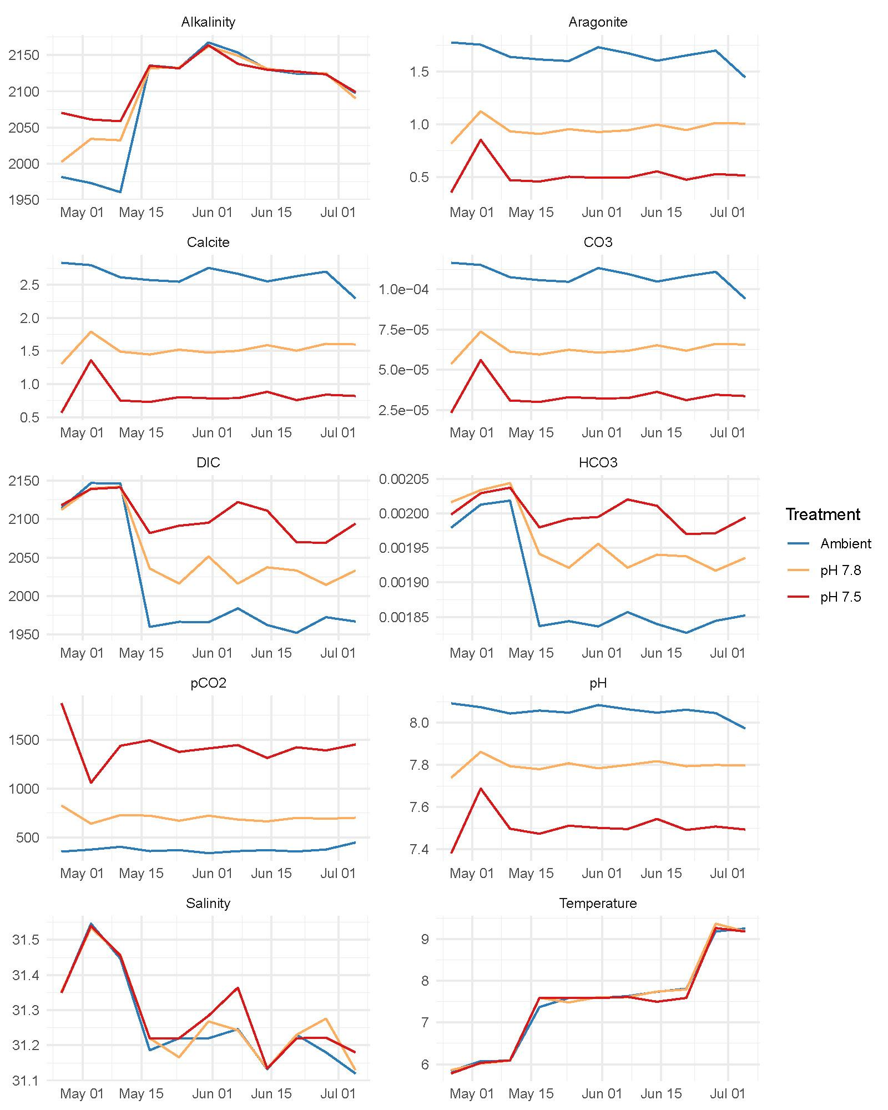

**Supplemental Figure 1:** Water parameters during the experiment. Temperature and pH were measured daily; salinity, dissolved inorganic carbon (DIC) and alkalinity were measured weekly; all other parameters were calculated. Lines are mean values across tanks for each treatment.

**Supplemental Figure 2:** PCA biplot of principal components 3 and 4, constructed from RNA-Seq derived SNPs (n=331). Points represent individual crabs that are color-coded by OA treatment, which do not indicate clustering by treatment, and sizes represent the percent of SNPs that are missing in each individual.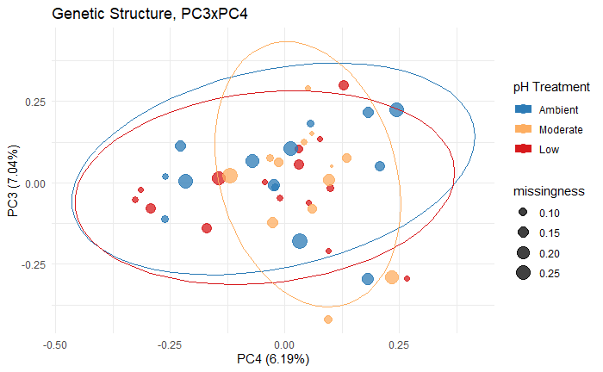

## 

**Supplemental Figure 3**: Correlation plots among SNP-derived PCA scores and gene expression-derived PCA scores along the first two principal components, with Pearson correlation coefficients and p-values calculated for each treatment.

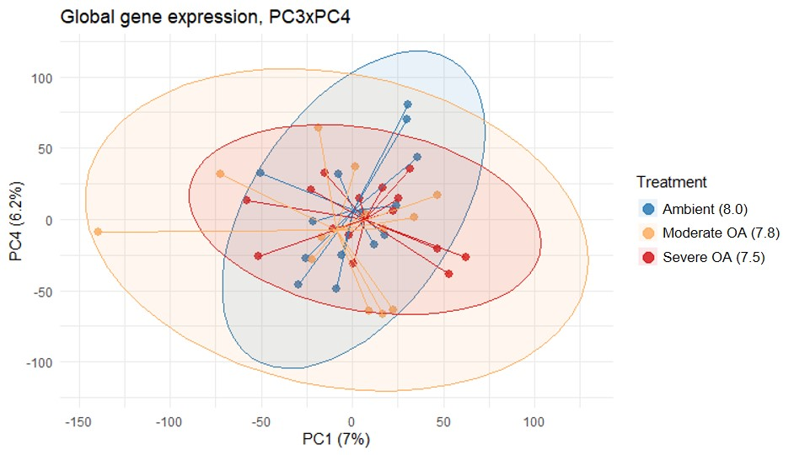

**Supplemental Figure 4.** PCA biplot of principal components 3 and 4 constructed from all expressed genes.

## 

**Supplemental Table 1:** Statistics for modules with eigengenes that correlated significantly with pCO2 concentration. Modules in purple (⬇) and green (⬆) indicate modules for which gene expression decreased and increased with pCO2, respectively. The percent of genes that were transposable elements are also included for each module. Modules are randomly assigned color names, and the letters correspond to Figure 5 panels in the main text.

|  |  |  |  |  |  |
| --- | --- | --- | --- | --- | --- |
| **Module** | **No. of genes in module** | **No. of genes in module that are also differentially expressed** | **Weighted Pearson correlation with pCO2 (P-value)** | **% Transposable Elements** | **No. of enriched biological process GO terms at EASE<0.05**  **(FDR 10%)** |
| a (magenta) ⬇ | 6,602 | 1,280 | -0.52 (4.5e-4) | 45% | 43 (11) |
| b (lightcyan) ⬇ | 4,169 | 1,171 | -0.45 (2.9e-3) | 39% | 60 (31) |
| c (firebrick4) ⬇ | 1,573 | 191 | -0.39 (9.7e-3) | 60% | 4 (0) |
| d (darkviolet) ⬇ | 92 | 17 | -0.37 (0.016) | 23% | 6 (4) |
| e (royalblue) ⬇ | 1,245 | 197 | -0.36 (0.019) | 32% | 19 (3) |
| f (coral1) ⬇ | 162 | 21 | -0.34 (0.028) | 40% | 5 (0) |
| g (plum1) ⬇ | 449 | 40 | -0.31 (0.042) | 53% | 6 (1) |
| h (pink) ⬇ | 8,245 | 980 | -0.30 (0.049) | 63% | 50 (15) |
| i (blue2) ⬆ | 96 | 16 | 0.36 (0.018) | 92% | 0 |
| j (lightsteelblue1) ⬆ | 306 | 20 | 0.42 (5.4e-3) | 53% | 2 (0) |
| k (ivory) ⬆ | 301 | 84 | 0.44 (3.4e-3) | 43% | 13 (0) |
| l (lightgreen) ⬆ | 7,080 | 515 | 0.45 (2.7e-3) | 76% | 13 (4) |
| m (purple) ⬆ | 2,862 | 328 | 0.46 (2.1e-3) | 77% | 7 (4) |
| n (green) ⬆ | 8,603 | 1,453 | 0.50 (6.6e-4) | 68% | 13 (2) |

**Supplemental Table 2:** Number of differentially expressed genes and enriched GO terms by pairwise treatment contrast. Colors and arrows indicate the number of DEGs and GO terms that were upregulated (⬆) and downregulated (⬇) in the more severe OA treatment, where ambient = pH 8.0, moderate = pH 7.8, and severe = pH 7.5.

|  |  |  |  |  |  |
| --- | --- | --- | --- | --- | --- |
| **OA treatment contrast** | No. of DEGs | No. of enriched Biological Processes | No. of enriched Molecular Functions | No. of enriched Cellular Components | % Transposable Elements |
| Ambient vs Moderate | 526 ⬆  933 ⬇ | 9 ⬆  23 ⬇ | 7 ⬆  18 ⬇ | 2 ⬆  16 ⬇ | 51.4% ⬆  30.6% ⬇ |
| Ambient vs Severe | 2,350 ⬆  3,907 ⬇ | 5 ⬆  81 ⬇ | 10 ⬆  47 ⬇ | 1 ⬆  29 ⬇ | 64.5% ⬆  27.7% ⬇ |
| Moderate vs Severe | 22 ⬆  25 ⬇ | 3 ⬆  2 ⬇ | 5 ⬆  0 ⬇ | 0 ⬆  0 ⬇ | 85.7% ⬆  12.5% ⬇ |

**Supplemental Table 3**: [Enrichment results from WGCNA modules](https://github.com/laurahspencer/red-king_RNASeq-2022/blob/main/results/Supplemental-Table-3_WGCNA-Enrichment-Results.csv)

**Supplemental Table 4**: [Enrichment results from DEG analysis](https://github.com/laurahspencer/red-king_RNASeq-2022/blob/main/results/Supplemental-Table-4_DEG-Enrichment-Results.csv)

**Supplemental Table 5**: [Enrichment results from upregulated low-variance genes](https://github.com/laurahspencer/red-king_RNASeq-2022/blob/main/results/Supplemental-Table-5_Upregulated-Low-CV-Enrichment-Results.csv)

**Supplemental Table 6:** [Transposable elements detected, list of 68 unique Uniprot IDs](https://github.com/laurahspencer/red-king_RNASeq-2022/blob/main/results/Supplemental-Table-6_Transposons.csv)

**Supplemental Table 7**: Percent of genes differentially expressed among pairwise contrasts that map to transposable elements. Colors indicate genes that were more active in ambient (blue), moderate OA (orange), and severe OA (red) treatments in each pairwise comparison. Values below the dotted line indicate the % of upregulated genes with low within-treatment variation (CV < 3%) that were TEs.

|  |  |  |  |
| --- | --- | --- | --- |
|  | Ambient | Moderate | Severe |
| Ambient |  | 51% | 65% |
| Moderate OA | 31% |  | 86% |
| Severe OA | 28% | 13% |  |
| Upregulated with low variance (CV< 3%) | 16% | 50% | 60% |

##### 