Supplemental Materials for Short-term mechanisms, long-term consequences: molecular effects of ocean acidification on juvenile snow crab
Laura H Spencer^{1,3}, Ingrid Spies³, Jennifer L. Gardner², Steven Roberts¹, W. Christopher Long²
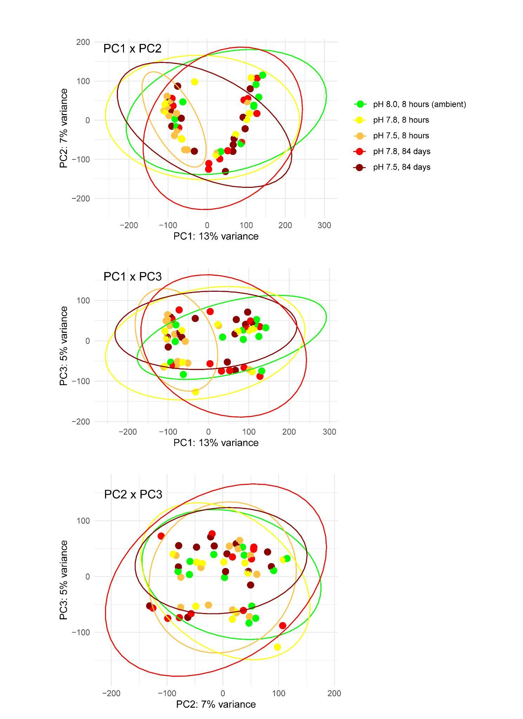
Figure S1: Principal component analysis biplots (PC1-PC3) without including surrogate variable analysis to control for unknown latent effects. The horseshoe pattern in PC1xPC2 and clustering by factors not related to treatment in biplots along PC1 and PC3 demonstrate the expression heterogeneity of technical or biological variables that obfuscates acclimatory response to acidification.
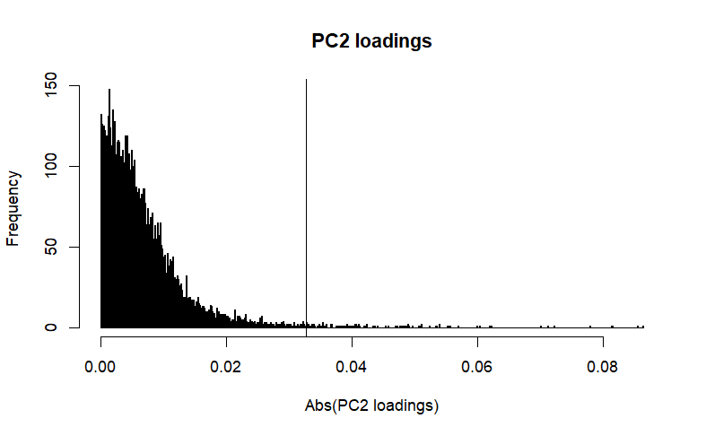
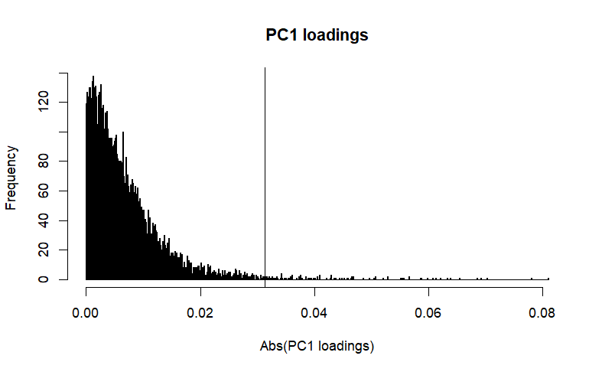
Figure S2: Histograms of PC1 & PC2 loadings (absolute values) from the VST- and SVA-controlled count matrix, the top 1% of which were >0.032 (to the right of vertical lines).

Table S1: Highlighted list of annotated genes that were differentially expressed in both moderate (pH 7.8) and severe (pH 7.5) OA after 8-hr exposure. Log₂ Fold Change (L₂FC) and -Log(P-adjusted) are compared to control crab held in ambient conditions (pH 8.0) at time-0. For all genes, the relative expression compared to control (higher, lower) was consistent in both OA treatments. **Indicates genes that were also differentially expressed after 88-days in both treatments.
Gene Name | Gene ID | Mod. OA  Δ% | Mod. OA -Log(P) | Sev. OA  Δ% | Sev. OA -Log(P) | Protein | Biological Processes
Higher Expression in both OA treatments at 8 h
Ndufs2 | GWK47_042301 | 22% | 1.45 | 25% | 2.34 | NADH dehydrogenase [ubiquinone] iron-sulfur protein 2, mitochondrial | Mitochondrial respiration, energy metabolism
Ndufs3 | GWK47_035555 | 19% | 1.42 | 28% | 3.15 | NADH dehydrogenase [ubiquinone] iron-sulfur protein 3, mitochondrial | Mitochondrial respiration, energy metabolism, redox
NDUBA | GWK47_048997 | 20% | 1.36 | 27% | 2.61 | NADH dehydrogenase [ubiquinone] 1 beta subcomplex subunit 10 | Mitochondrial respiration, energy metabolism
MRPS22 | GWK47_024976 | 24% | 1.98 | 21% | 2.32 | 28S ribosomal protein S22, mitochondrial | Mitochondrial translation, energy metabolism
mRpL35 | GWK47_003027 | 20% | 1.43 | 20% | 1.96 | 39S ribosomal protein L35, mitochondrial | Mitochondrial translation, energy metabolism
MRPL30 | GWK47_027395 | 18% | 1.36 | 27% | 2.97 | 39S ribosomal protein L30, mitochondrial | Mitochondrial translation, energy metabolism
UGT2B15_3 | GWK47_007253 | 117% | 1.52 | 7% | 1.31 | UDP-glucuronosyltransferase 2B15 | Detoxification, xenobiotic metabolism
4CL_0 | GWK47_015047 | 110% | 1.87 | 52% | 1.36 | 4-coumarate--CoA ligase | Energy metabolism
Echs1 | GWK47_021840 | 21% | 1.60 | 17% | 1.65 | Enoyl-CoA hydratase, mitochondrial | Lipid metabolism, β-oxidation
miox | GWK47_050003 | 40% | 1.31 | 44% | 2.07 | Inositol oxygenase | Carbohydrate metabolism
emc2-b | GWK47_005824 | 23% | 1.93 | 13% | 1.32 | ER membrane protein complex subunit 2-B | Protein processing, ER membrane insertion
Xpnpep1_2 | GWK47_044723 | 11% | 1.41 | 9% | 1.38 | Xaa-Pro aminopeptidase 1 | Protein turnover, stress response
MED27 | GWK47_029699 | 17% | 1.36 | 16% | 1.79 | Mediator of RNA polymerase II transcription subunit 27 | Transcriptional regulation (RNA polymerase II)
prmt6 | GWK47_007501 | 24% | 1.87 | 26% | 2.79 | Protein arginine N-methyltransferase 6 | Epigenetic and transcriptional regulation
Srsf7 | GWK47_020456 | 16% | 1.36 | 16% | 2.06 | Serine/arginine-rich splicing factor 7 | RNA splicing, mRNA processing
U2af50 | GWK47_001080 | 15% | 1.49 | 13% | 1.56 | Splicing factor U2AF subunit | RNA splicing, mRNA processing
Tsnax | GWK47_041448 | 14% | 1.41 | 16% | 2.22 | Translin-associated protein X | RNA silencing, reproductive process
Myo5a_0 | GWK47_011520 | 61% | 2.46 | 27% | 1.44 | Unconventional myosin-Va | Cytoskeletal transport, vesicle trafficking
**NUP43 | GWK47_010369 | 27% | 1.41 | 21% | 1.45 | Nucleoporin Nup43 | Nucleocytoplasmic transport, cell cycle regulation
Lower Expression in both OA treatments at 8 h
oct-1_1 | GWK47_003819 | -71% | 1.93 | -61% | 1.90 | Organic cation transporter 1 | Ion transport, acid–base homeostasis
Gstt4 | GWK47_034834 | -41% | 2.38 | -23% | 1.32 | Glutathione S-transferase theta-4 | Detoxification, oxidative stress response
RSPRY1_1 | GWK47_007365 | -17% | 1.34 | -16% | 1.62 | RING finger and SPRY domain-containing protein 1 | Protein degradation, turnover
USP19 | GWK47_030223 | -15% | 1.38 | -14% | 1.55 | Ubiquitin carboxyl-terminal hydrolase 19 | Protein quality control, stress response
Phm | GWK47_018134 | -46% | 1.84 | -34% | 1.63 | Peptidylglycine alpha-hydroxylating monooxygenase | Peptide processing, reproduction
PCE_0 | GWK47_027739 | -43% | 1.63 | -41% | 2.17 | Proclotting enzyme | Immune, coagulation response
PCE_2 | GWK47_051844 | -35% | 1.37 | -43% | 2.64 | Proclotting enzyme | Immune, coagulation response
VPS13C_1 | GWK47_005657 | -27% | 1.31 | -30% | 2.10 | Vacuolar protein sorting-associated protein 13C | Lipid transport, organelle organization (mitochondrial)
PDXK | GWK47_032265 | -38% | 1.86 | -24% | 1.33 | Pyridoxal kinase | Cofactor metabolism, cellular metabolism
TGFBI | GWK47_026454 | -37% | 1.60 | -31% | 1.68 | Transforming growth factor-beta-induced protein ig-h3 | Cell adhesion, structural organization
**Cad87A | GWK47_018958 | -23% | 1.86 | -19% | 2.02 | Cadherin-87A | Cell adhesion, signaling
sas_3 | GWK47_043552 | -30% | 1.31 | -36% | 2.34 | putative epidermal cell surface receptor | Cell signaling, membrane receptor activity
rhpn2 | GWK47_028156 | -22% | 1.58 | -17% | 1.44 | Rhophilin-2 | Cytoskeletal signaling
MYO18A | GWK47_044957 | -18% | 1.52 | -15% | 1.45 | Unconventional myosin-XVIIIa | Cytoskeletal transport, cell organization
CycG | GWK47_003032 | -23% | 1.41 | -24% | 2.11 | Cyclin G | Cell cycle regulation, growth control
A1CF | GWK47_037491 | -21% | 1.36 | -20% | 1.78 | APOBEC1 complementation factor | Reproduction, RNA editing
DOP1A | GWK47_009521 | -15% | 1.61 | -15% | 2.27 | Protein dopey-1 | Vesicle trafficking, protein transport

Descriptions of Tables S2-S6
Please also see Google Spreadsheet for Tables S2-S6 (in addition to .csv files).

Table S2: Genes with top loadings along PC1 and PC2.
Table S3: Full list of DEGs after 8 hr OA exposure.
Table S4: Persistent DEGs, those from 8 hr that were also DEGs at 88 days.
Table S5: Lists of DEGs among OA treatments at 88 days.
Table S6: Enriched biological processes.

Short term acclimation mechanisms that persisted at day 88
We did not generate expression data for the ambient treatment at day 88, so cannot fully separate OA effects from other potential influences of long-term laboratory exposure (e.g., diet, tank environment). To focus on genes most consistently associated with OA, we identified differentially expressed genes (DEGs) at 8 h that remained differentially expressed at 88 days (Figure S3, Table S4).
In moderate OA, 18 DEGs identified at 8-hr persisted at 88 d (Table S4), which were enriched for RNA binding (GO:0003723) and included several involved in transcription and splicing, proteolysis, retinol metabolism, cell adhesion/structure, and possibly circadian rhythm (Mandibular organ-inhibiting hormone, see Fig 3).
In the severe OA treatment, 59 DEGs identified at 8-hr persisted at 88 d (Table S4), which were not significant enriched for any processes, but broadly reflect genes involved in mitochondrial energy metabolism, detoxification, and defense against oxidative or hypoxic stress (HSP22, CYP2L1, SIRT4, CBS, Gstt4), cell division and transcriptional control (e.g. cdk1, Mafg, Usp21), cell adhesion and cytoskeleton dynamics (TTN, Actr3, Cad87), and hormone and growth factor signaling (FLT4, LHCGR, Tdrd9). These “persistent” DEGs suggest that severe OA induces long-lasting shifts in stress response, signaling, and cellular regulation (Table X).
Two genes were found to persist in both moderate and severe OA treatments: cad87A which codes for a cadherin, and nup43 which codes for a nucleoporin, and which were expressed at lower and higher levels, respectively, in OA treatments compared to control (Figure S4).

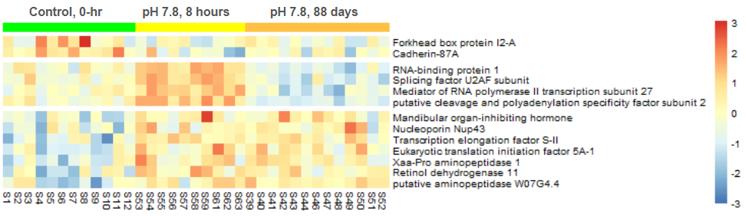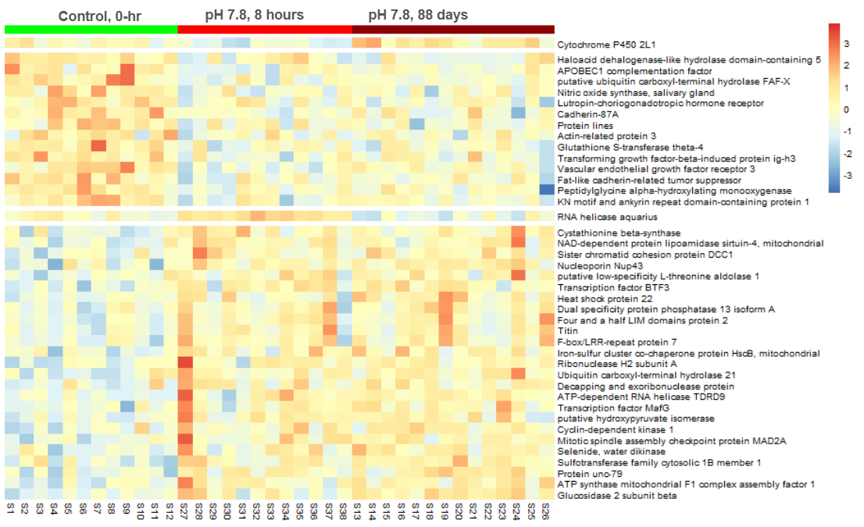Figure S3: Heatmaps of persistent DEGs, defined as genes differentially expressed at both 8 h and 88 d. Results are shown for moderate OA (pH 7.8, top) and severe OA (pH 7.5, bottom) relative to control conditions measured at time 0. Colors indicate relative expression (z-scores), with red = higher and blue = lower expression, columns represent individual crabs, and rows represent individual genes, which are grouped by their expression pattern. Two genes were persistent DEGs in both OA treatments: cadherin-87A (cad87a) and nucleoporin (nup43), which were expressed at lower and higher levels, respectively, in OA compared to control.

