Short-term mechanisms, long-term consequences: molecular effects of ocean acidification on juvenile snow crab

Abstract
Understanding how marine species tolerate acidified conditions is critical for predicting biological responses to ocean change. A recent one-year experiment (Long 2025) found that juvenile snow crab (Chionoecetes opilio) maintain growth and molting under acidification (pH 7.8, 7.5), and survival begins to decline only after ~250 days under severe acidification (pH 7.5). In this companion study, we characterized whole-transcriptome responses after 8 hours and 88 days of exposure to identify molecular mechanisms underlying short-term tolerance and chronic effects of ocean acidification. The immediate transcriptional response involved strong activation of genes associated with mitochondrial metabolism, protein homeostasis, cuticle maintenance, and immune modulation, processes shared between moderate and severe treatments but of greater magnitude under severe acidification. After 88 days, expression patterns diverged, revealing sustained upregulation of stress- and damage-mitigation pathways in the severe treatment. These findings indicate that crabs in the severe treatment likely experienced chronic OA stress that preceded outward physiological effects, and provide a mechanistic basis for their delayed mortality. We further highlight potential early indicators of chronic acidification stress in snow crab, among which a gene likely coding for carbonic anhydrase 7 (CA7, GWK47_031192) appears to be the most promising biomarker.

Target Journal options:
- Molecular Ecology

Keywords:
Transcriptomics, ocean acidification, tolerance, crustacean

1. Introduction
Atmospheric and ocean conditions are changing at an unprecedented rate compared to the geologic record. Since monitoring of atmospheric carbon dioxide began at Mauna Loa Research Station (Keeling et al., 1976), concentrations have risen by ~33%, from 316 ppm in 1959 to 425 ppm in 2024 (based on annual means, https://gml.noaa.gov/ccgg/trends/data.html). Roughly 25% of this additional CO₂ has been absorbed by the ocean (DeVries, 2022), driving a decrease in ocean pH of 0.1 units over the past 50 years (DeVries, 2022). Because pH is on a logarithmic scale, this represents a ~25% increase in proton concentration ([H⁺]), accompanied by reductions in the saturation states of dissolved calcium carbonates (Doney et al., 2009). Reduced carbonate availability can impair shell and skeletal formation in calcareous marine organisms by impeding biomineralization (Figuerola et al., 2021). Some organisms cannot fully regulate internal acid-base balance (Auzoux-Bordenave et al., 2021), while others maintain internal pH levels through buffering (Fehsenfeld & Weihrauch, 2017), but at an energetic cost (Meseck et al., 2016). Consequently, the observed shifts in the ocean carbon cycle, collectively termed ocean acidification (Caldeira & Wickett, 2003), pose significant risks to marine communities by altering the physiology and productivity of calcareous species.

Large benthic decapod crabs are calcareous species that play critical ecological and economic roles as predators, prey, and major fisheries targets (Boudreau & Worm, 2012). Additionally many of these crabs may be especially vulnerable to ocean acidification, as they live in high-latitude regions that are acidifying (and warming) more rapidly than lower latitudes (Fabry et al., 2009). Decapod crabs, like other calcareous taxa, are typically most sensitive to changes in pH (commonly used as a proxy for acidification) during early life stages, as embryos, larvae, and juveniles (Long et al., 2013; Przeslawski et al., 2015). However, as with many marine taxa (Kroeker et al., 2010; Vargas et al., 2017), decapod responses to ocean acidification are notoriously diverse, differing among species, among populations within species, and even among individuals within populations (Bednaršek et al., 2021; McElhany & Busch, 2024; Siegel et al., 2022). Understanding the causes of this variation is now a central focus. After decades of field observations and laboratory experiments, research efforts are turning toward the development of mechanistic models to distinguish tolerant versus sensitive groups (Leung et al., 2022), with the goal of improving management and conservation strategies.
The diversity of crab species that co-occur in the North Pacific Ocean provides opportunities to identify factors that differentiate OA-tolerant crabs from those that are OA-sensitive (Knauber et al., 2023; Otto & Jamieson, 2001). Experimental work has examined the responses of king (red, blue, golden), snow, tanner, and dungeness crabs to acidification, all of which are found inAlaskan waters (Kruse et al., 2025). Across these species, early life stages often experience reduced survival, slower growth, or impaired calcification, although the severity of effects varies (Coffey et al., 2017; Long et al., 2013, 2016, 2019, 2021, 2024; Miller et al., 2016; Swiney et al., 2016; Trigg et al., 2019). Juvenile red king crab (Paralithodes camtschaticus) are among the most sensitive, with 100% mortality reported at pH 7.5 within 95 days (Long et al., 2013; Swiney et al., 2017), and this sensitivity is thought to contribute to recent declines in productivity in the southeastern Bering Sea (Litzow et al., 2025). Tanner crab (Chionoecetes bairdi) are similarly vulnerable, as adults exhibit impaired reproductive output when held at low pH (Swiney et al., 2016), larvae show significantly reduced survival under acidified conditions (Long et al., 2016), and long-term juvenile exposures result in reduced calcification, slower growth, and increased mortality at pH 7.5 (Long et al., 2013).
Snow crab (Chionoecetes opilio) stand out as a striking exception. Despite being closely related to Tanner crab and even capable of hybridizing with them, snow crab appear relatively tolerant to OA. Embryos and larvae consistently show little to no direct sensitivity to acidification, with embryo morphology, hatching success, and larval condition largely unaffected even at pH 7.5 (Long et al., 2023). Adult calcification is similarly unaffected (Algayer et al., 2023). Long (2025) recently demonstrated that this tolerance largely extends to the juvenile stage, as juvenile morphology and molting were unaffected after a full year of exposure to moderate (pH 7.8) and severe (pH 7.5) acidification. However, elevated mortality began after 250 days in the severe treatment and ultimately resulted in ~40% higher mortality by the end of the experiment. This long-term decline highlights that even apparently resilient stages can experience cumulative physiological costs over time, and that chronic exposures, more akin to real-world ocean conditions, may reveal impacts that short-term observations overlook.
This study advances understanding of both the short-term acclimation mechanisms and the long-term consequences of ocean acidification in snow crab. Using individuals from Long (2025), we applied transcriptomics to assess gene expression profiles after short-term (8 h) and intermediate (88 d) exposure in the moderate and severe OA treatments. Transcriptomics captures the complete set of expressed genes, providing a comprehensive view of active physiological pathways and their energetic demands (Page & Lawley, 2022). Long (2025) observed that mortality under severe OA began after ~250 days, while our data capture much earlier time points. These snapshots provide a unique opportunity to address three key questions: (1) How do snow crabs acclimate to acidification in the short term? (2) Do these acclimation mechanisms persist over longer exposures? and (3) Which molecular pathways differ between crabs exposed to severe (pH 7.5) versus moderate (pH 7.8) acidification, that is, which mechanisms ultimately drive mortality under chronic acidification? Finally, we identify candidate biomarkers that could be used to determine whether snow crabs and related species (e.g., Tanner crabs and hybrids) are experiencing chronic OA stress.

2. Methods

2.1 Experimental Design and Sampling
This work is part of a larger study on how ocean acidification affects snow crab (Chionoecetes opilio); full methodological details are available in Long (2025). Briefly, snow crab juveniles (wet weight: 0.24 ± 0.03 g; carapace width: 8.3 ± 0.3 mm) were collected by trawl from the Bering Sea in April 2021 and transported to the Kodiak Laboratory, where they were acclimated in flow-through seawater for X days (4°C, ambient salinity), then randomly assigned to one of three pH treatments: Control / ambient pH (~8.0), moderate acidification (pH 7.8), or severe acidification (pH 7.5). These levels are relevant in the Bering Sea with seasonal lows of pH around 7.5 (Mathis et al., 2014), and align with previous experiments (Long et al., 2013; Spencer et al., 2024). Thirty crabs per treatment were housed individually in mesh-bottom PVC inserts in 380 L tanks chilled to 4°C. Target pH was maintained by CO₂ bubbling with Durafet III probe feedback, and carbonate chemistry parameters verified regularly (Table 1). Crabs were held in treatments for 396 days beginning on April 23, 2021, monitored daily for molting and survival, and fed to excess three times weekly. Exuviae and mortalities were photographed under a stereomicroscope, and morphometric traits (carapace dimensions, rostrum, and orbital spine measurements) were quantified from calibrated images. Crabs were blotted and weighed at the start and following each molt. Survival was modeled as a constant mortality rate with treatment effects evaluated by likelihood methods and AIC model selection. Growth (carapace width, wet mass), intermolt duration, and morphometric variation were assessed by ANOVA and PERMANOVA.
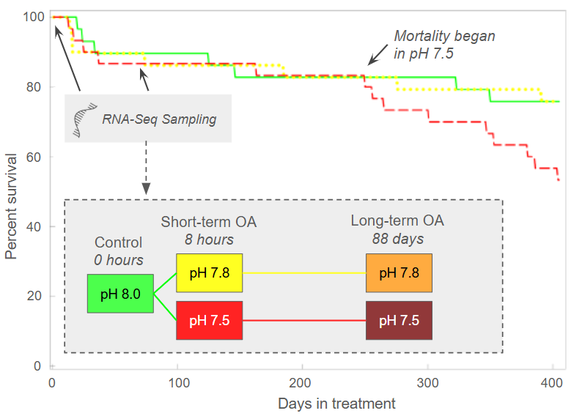
Tissue samples were collected for gene expression analysis on days 1 and 88 of treatments, and included four treatment: (1) a control treatment using crabs held at ambient conditions, after 8 hours of exposure to (2) pH 7.8 and (3) and pH 7.5, and after 88 days of exposure to (4) pH 7.8 and (5) pH 7.5 (Figure 1, Table 1). Prior to sampling, all crabs were starved for 24 hrs, then sacrificed by puncturing the carapace through the cardiac region, and preserved directly in RNA, which was then held overnight at 4°C prior to being transferred to -80°C.
Figure 1. Juvenile snow crab survival did not vary among treatments until day 250, when higher mortality began to occur in the lowest pH treatment (pH 7.5). Tissues were sampled for gene expression on Day 1 from control treatment (0 hrs) and two OA treatments (8 hrs) to examine short-term acclimation mechanisms, and on Day 88 to examine long-term consequences of OA treatments. Growth, intermolt duration, and morphology was unaffected by a 396-day exposure to varying pH treatments (Long 2025). Figure adapted from Long (2025).

2.2 RNASeq data generating and processing
Total RNA was isolated from RNAlater-preserved and homogenized whole-body crab tissue. Specimens were transferred from RNAlater into individual tubes containing cold TRIzol® reagent (500 µL) (Invitrogen, Carlsbad, CA, USA) and ~five scoops of silica beads, then homogenized using a SPEX SamplePrep Geno/Grinder®. RNA was extracted following the manufacturer’s TRIzol® protocol. RNA-seq libraries were prepared using the Universal Plus™ mRNA-Seq with NuQuant kit (Tecan Genomics, Redwood City, CA, USA) for Illumina sequencing. Paired-end sequencing (150 bp) was performed on two lanes of an Illumina NovaSeq 6000 Sequencing System (Illumina, Inc., San Diego, CA, USA), with each sample split across both lanes. Raw sequence data were demultiplexed, concatenated by sample, and trimmed using Cutadapt v4.5 (Martin 2011) to remove Illumina adapters, flanking Ns, reads <50 bp, and low-quality ends (minimum quality scores of 20 and 15 for the 5′ and 3′ ends, respectively). Raw and trimmed reads were assessed using FastQC (Andrews, 2010) and MultiQC (Ewels et al., 2016).
Trimmed paired-end RNA-seq reads from 5 treatments (Table 1) (6.13B) were aligned to the C. opilio genome assembly from NCBI (accession: GCA_016584305.1_ASM1658430v1) using STAR v2.7.10a in splice-aware single-pass mode, with the options --quantMode GeneCounts and --outFilterMultimapNmax 30. A total of 4.84B paired-end fragments aligned to the snow crab genome, with a rate of 78.9%. Genome indexing was performed with the corresponding GTF annotation file to incorporate known splice junctions, using sjdbOverhang=149 to match the 150 bp read length. Gene counts, i.e. the number of paired-end fragments mapping to each gene, were extracted from STAR’s ReadsPerGene.out.tab files. One low-depth outlier sample (“S45”, ~680K fragments) from the 88-day moderate OA treatment and another outlier from the 8-hr moderate OA treatment which influenced differential expression analysis (“S60”, 3.4M fragments) were excluded from analyses, leaving 10-14 samples per treatment (Table 1). Genes were filtered to remove low-expression features (fewer than 10 fragments in at least 10% of samples), resulting in counts for 11,097 unigenes which were analyzed for differential expression analysis.
Gene function was determined using a combination of available NCBI annotations and DIAMOND v2.1.8 blastx (Buchfink et al., 2015) searches against the UniProt/Swiss-Prot protein database (Release 2025_03)(UniProt Consortium, 2021), using an e-value cutoff of 1e-10 and retaining only the top hit. Header metadata from the snow crab coding sequence (cds) FASTA file was parsed to extract gene ids and functional tokens (e.g., GO terms, InterPro, Pfam). These were linked to external GO annotations using mapping files (interpro2go, pfam2go) from the Gene Ontology Consortium. For genes lacking functional labels, top DIAMOND matches were used to assign likely gene names and descriptions. Gene-to-GO mappings were compiled for downstream enrichment analyses.

2.3 Expression Analysis
Gene expression analyses were performed in R v4.3.2 using RStudio interface V2023.09.1+494 (R Core Team 2021; RStudio Team 2020). Unless otherwise specified, α = 0.05 and error bars represent ±1 SD.

2.3.1 Global exploration and latent heterogeneity
We first performed an exploratory PCA of all analyzed genes with DESeq2’s plotPCA() on variance-stabilized counts to assess global expression patterns. This revealed latent, unknown sources of variation not aligned with known library prep, alignment, or biological variables in PC1-PC3 (Figure S1). To control for this latent heterogeneity, we used surrogate variable analysis (SVA) with the sva package. Specifically, we preserved the pH treatment effect (~ treatment) when estimating SVs, computed the number of SVs with num.sv(), and estimated them with svaseq() on variance-stabilized counts. The SVs were regressed from the VST matrix using limma::removeBatchEffect, and we then performed PCA again with stats::prcomp on the SV-adjusted matrix.
Global differences among treatments were assessed with permutational MANOVA (PERMANOVA) on the SV-adjusted VST matrix using vegan::adonis2 (Bray-Curtis). Pairwise treatment differences were evaluated with pairwiseAdonis::pairwise.adonis. To identify genes contributing most strongly to the observed treatment differences we extracted the top 1% of genes with the largest positive and negative loadings on PC1 (0.5% per sign). PCA biplot (PC1xPC2) visualized global expression variability, alongside tile plots which visualized expression patterns of the top 1% of genes contributing to each positive (n=55) and negative (n=55) ends of PC axes.

2.3.2 Differential expression analysis
To identify genes that varied among treatments (differentially expressed genes, or DEGs), we analyzed raw counts with DESeq2 (default settings) (Costa-Silva et al., 2017; Love et al., 2014). As recommended (Jaffe et al., 2015), we did not use the SV-regressed matrix for hypothesis tests, and instead all automatically detected SVs (n=7) from svaseq() were included as covariates in the DESeq2 design together with treatment (~ SV1 + SV2 + … + SV7 + treatment). We then fit the model with DESeq(), and significant DEGs were defined by FDR-adjusted p-value (P_{adj} < 0.05) among treatment contrasts. We compared differentially expressed gene (DEG) lists to evaluate:

- Short-term acclimation to moderate OA: pH 7.8 at 8 h vs. control at 0 h
- Short-term acclimation to severe OA: pH 7.5 at 8 h vs. control at 0 h
- Long-term consequences of severe OA: pH 7.5 vs. pH 7.8 at 88 days.

To identify potential gene targets for biomarker development of ocean acidification (OA) tolerance and stress, we also examined expression patterns across short-term (8 h, 88 d) and long-term exposures relative to time-0 controls. Genes were prioritized if they showed (1) consistently elevated expression under both short-term OA treatments and long-term exposure compared to control, or (2) differential expression among chronic OA treatments that also differed from time-0 controls.
For all differential expression analyses, outliers were handled using DESeq2’s built-in replacement method, where Cook's Distance was used to identify influential outliers and then the original count values were replaced with trimmed means. To ensure that no outliers were influencing our DEG lists, we also used an iterative Leave-One-Out (iLOO) approach to identify and remove DEGs with outlier samples (n=114 genes) (George et al., 2015).

Table 1. Summary of water chemistry parameters and RNA-Seq sampling scheme. Parameter values represent means ± SD calculated from repeated measurements taken from the start of the experiment (Day 1; April 23, 2021) through each corresponding sampling date. Salinity and alkalinity values without associated error indicate parameters measured on Day 1 only. Temperature and pH were measured three times per week, salinity every two weeks, and all other parameters were calculated from these measurements.
 | Day 1 |  |  | Day 88
OA Treatment | Ambient  (pH ~8.0) | Moderate OA  (pH ~7.8) | Severe OA  (pH ~7.5) | Moderate OA  (pH ~7.8) | Severe OA  (pH ~7.5)
Tissue Sample Time | 0 hrs | 8 hrs | 8 hrs | 88 days | 88 days
Number of RNA-Seq libraries  each individual whole-body crabs | 12 | 10 | 12 | 13 | 14
Temperature | 3.2 ± 0.1 | 2.8 ± 0.0 | 2.8 ± 0.2 | 3.61 ± 0.4 | 3.69 ± 0.5
Salinity | 32.1 | 32.1 | 32.0 | 31.5 ± 0.4 | 31.6 ± 0.5
pH_{T} | 7.96 ± 0.01 | 7.76 ± 0.01 | 7.52 ± 0.01 | 7.79 ± 0.02 | 7.49 ± 0.04
Alkalinity (mmol/kg) | 2.17 | 2.17 | 2.17 | 2.14 ±.0.02 | 2.15 ± 0.02
pCO₂ (µatm) | 463 ± 7 | 764 ± 19 | 1,348 ± 19 | 711 ± 44 | 1,459 ± 132
HCO₃⁻ (mmol/kg) | 1.972 ± 0.002 | 2.045 ± 0.002 | 2.092 ± 0.001 | 2.005 ± 0.020 | 2.074 ± 0.021
CO₃⁻² (mmol/kg) | 0.079 ± 0.001 | 0.050 ± 0.001 | 0.030 ± 0.001 | 0.054 ± 0.003 | 0.028 ± 0.003
DIC (mmol/kg) | 2.08 ± 0.001 | 2.14 ± 0.002 | 2.20 ± 0.002 | 2.10 ± 0.02 | 2.18 ± 0.02
Ω_{Aragonite} | 1.20 ± 0.01 | 0.77 ± 0.01 | 0.45 ± 0.01 | 0.82 ± 0.05 | 0.43 ± 0.04
Ω_{Calcite} | 1.91 ± 0.02 | 1.23 ± 0.02 | 0.72 ± 0.01 | 1.3 ± 0.07 | 0.69 ± 0.06

2.4 Functional Analyses
Differentially expressed gene sets were characterized by identifying enriched biological processes based on Gene Ontology (GO) terms and Uniprot keywords. For each set of differentially expressed genes, two enrichment analyses were performed to determine the functions of genes with higher and lower expression in OA treatments compared to control, or in severe OA compared to moderate OA. Enrichment was performed using Uniprot species IDs and the DAVID Bioinformatics Resources (v2023). For each enrichment analysis, the full set of annotated expressed genes was used as the background, P-values were adjusted using the false discovery rate (“FDR”) method, and enriched terms were defined as those with P_{adj} < 0.1 and at least two contributing genes. In cases where enriched GO terms and Uniprot keywords were the same, we only report GO terms.

All bioinformatics analyses were conducted on the NOAA Fisheries high-performance computing (HPC) cluster “Sedna”, maintained by the Northwest Fisheries Science Center (NWFSC) in Seattle, Washington.

3. Results

3.1 Summary of morphometrics and survival
Full results are reported in Long (2025) and summarized here. Across treatments, crabs molted up to three times during the experiment, with most completing their first molt within one month and prior to the Day 88 sampling. Growth metrics (wet mass, carapace width, intermolt duration, and morphometric traits) did not differ among pH treatments. Survival rates through the 88-day gene expression sampling point did not differ by treatment; however, after continued monitoring through 396 days, survival diverged (Figure 1). Differential mortality began after day 250, resulting in >75% survival in ambient and moderate OA treatments but 50% survival under severe OA, where mortality was often associated with molting. The mortality rate in the pH 7.5 treatment was appr. 40% higher than in the other treatments.

3.2 Global expression variability
We analyzed 2.1B read pairs from 62 samples which mapped to a total of 11,097 putative genes (per-sample average of 34.9 ± 7.0M read pairs mapped to 11,000 ± 44 genes; overall mean mapping rate was 78.9 ± 3.5%). After controlling for unknown surrogate variables (see methods & Figure S1), principal component analysis using all genes differentiated individuals by treatment and time along PC1 (9.1% variability) and PC2 (5.7% variability) (Figure 2), and permANOVA detected significant differences in multivariate space among treatments (F_{4,56}=2.55, P=1.0e⁻³).
The genes with the strongest PC1 and PC2 loadings represent those most variable among the ~11,097 genes analyzed and shaped the overall PCA clustering. For each axis, we performed enrichment analysis on the top 1% of genes, defined as the 0.5% with the most positive loadings and the 0.5% with the most negative loadings.
Genes with the largest negative PC1 loadings were those most highly expressed in the two short-term OA treatments (red and yellow in Figure 2), were strongly enriched for the Uniprot keyword stress response (FDR=2e⁻⁹) and GO processes protein refolding (FDR=5e⁻¹¹), chaperone cofactor-dependent protein refolding (FDR=2e⁻⁸), and cellular response to unfolded protein (4.3e⁻²), due to high prevalence of molecular chaperones (e.g., HSP90). The ten genes with the largest negative PC1 loadings included two heat shock proteins (HSP90AA1, HSP71_1), two cuticle proteins (CUPA3_0, CUPA3_2), a detoxicant (UGT2B15), and five hypothetical proteins (Table S1). Genes with the largest positive PC1 loadings had higher expression in the long-term OA treatments (orange and dark red) and, were enriched for GO processes vitamin K metabolic process (FDR=0.0027), triglyceride catabolic process (FDR=0.0028), and lipid metabolic process (FDR=0.0028). The ten genes with the largest positive PC1 loadings included two pancreatic lipase-related proteins (PNLIPRP2_1, PNLIPRP1_0), three solute carrier transporters (SLC18B1_0, SLC15A1, MFSD12_1), an ankyrin structural protein (ANK1), a leukocyte receptor cluster member (LENG9), and three hypothetical proteins (Table S1).
Genes with the largest positive PC2 loadings had higher expression in many long-term severe OA individuals and some short-term OA individuals, were enriched for positive regulation of reactive oxygen species metabolic process (FDR=0.047) and vitamin K metabolic process (FDR=0.01), and the ten genes with highest PC2 loadings included an immune-related receptor (LENG9), a redox regulator (DOXA-1), a carboxylesterase (EST6_2), a carnitine biosynthesis enzyme (BBOX1_6), and six hypothetical proteins (Table S1). Genes with the largest negative PC2 loadings were those with highest expression in time-0 controls and some short-term OA individuals, were enriched for peptide metabolic process (FDR=0.038) and protolysis (FDR=0.070), and the top ten genes included a serine protease (PRSS55), an integumentary mucin (MUCB1), an antimicrobial peptide (ALF_2), a carboxypeptidase (CPB1), and six hypothetical proteins (Table S1). Finally, chitin binding proteins were prevalent in the top PC2 loadings, both positive and negative.
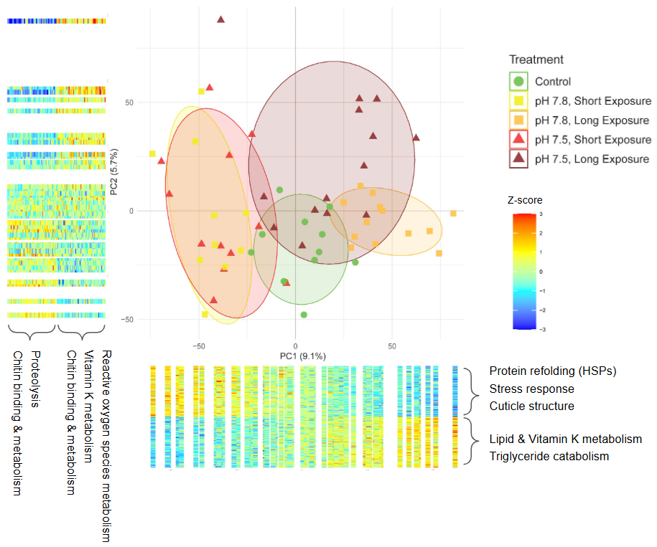
Figure 2. Principal component analysis biplot constructed from all analyzed transcripts, showing distinct clustering by pH treatment and exposure duration. PCA was performed on variance-stabilized gene expression data after regressing out latent variation with surrogate variable analysis (SVA). Adjacent heatmaps display z-transformed expression values for the top 1% of genes (n = 110, red = highest expression, blue = lowest expression) with the largest loadings on PC1 and PC2, with enriched processes shown for each gene set. For PC1, rows represent genes and columns represent individual crabs ordered by PC1 score; for PC2, columns represent genes and rows represent individual crabs ordered by PC2 score.

3.3 Short term acclimation mechanisms: differential expression at 8 hours
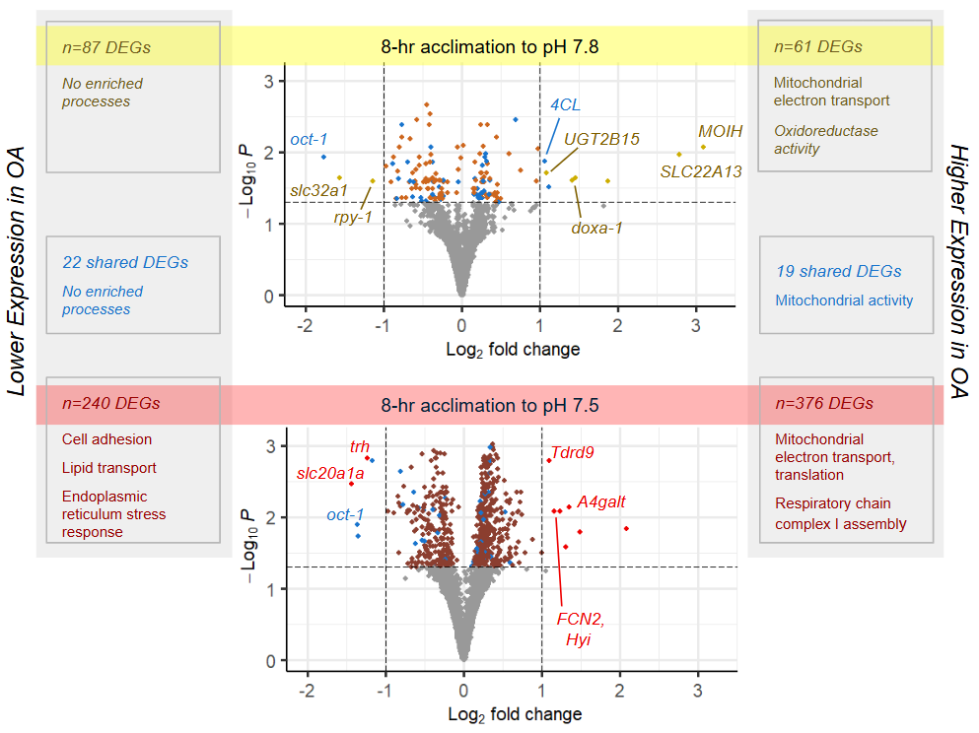
We compared gene expression of crab sampled from ambient pH at time-0 to those exposed to moderate (pH 7.8) and severe (pH 7.5) acidification for 8 h to identify short-term acclimation mechanisms.
Figure 3. Differential gene expression and enriched biological processes in juvenile snow crab after 8-hr exposure to two acidification levels (pH 7.8, pH 7.5). Volcano plots show differentially expressed genes (DEGs) among time-0 control (pH 8.0) and OA treatments, which reveal a more robust transcriptional response in the more severe OA treatment (pH 7.5), and highlight annotated genes with >50% fold difference (|L₂FC|>0.58). Panels show the number of DEGs in each 8-hr OA treatment by expression profile (lower, higher), those shared across both OA treatments (in blue, see Table 2), and associated biological processes (enriched Gene Ontology terms and Uniprot Keywords).

In crabs held for 8-hr in moderate acidification (pH 7.8), 148 genes were differentially expressed (DEGs). Genes with higher expression patterns (n=61) in moderate OA were enriched for the Uniprot keywords respiratory chain (FDR=0.022) and electron transport (FDR=0.088), and annotated genes with large effect size (Log₂FC>1) that were uniquely expressed in moderate OA included mandibular organ-inhibiting hormone (MOIH), solute carrier family 22 member 13 (SLC22A13), and dual oxidase maturation factor 1 (doxa-1) (Figure 3). Genes with lower expression in moderate OA (n=87) were not significantly enriched for any terms. Annotated genes that were uniquely expressed in moderate OA with large effect size (Log₂FC>1) included vesicular inhibitory amino acid transporter (slc32a1), and receptor-associated protein of the synapse (rpy-1) (Fig 3).
Severe acidification (pH 7.5) resulted in a larger transcriptional response, with 616 differentially expressed genes. Genes with higher expression in severe acidification (n=376) compared to control were highly enriched for the GO process mitochondrial translation (FDR=8.2e⁻⁸), and the Uniprot keywords respiratory chain (FDR=4.4e⁻⁴), electron transport (FDR=1.8e⁻³), and protein biosynthesis (FDR=0.023), and and the large effect-size genes (Log₂FC≥1) that were uniquely expressed in severe OA included the lactosylceramide 4-alpha-galactosyltransferase (A4galt), a putative hydroxypyruvate isomerase (Hyi), Ficolin-2 (FCN2), ATP-dependent RNA helicase (Tdrd9), and putative nuclease HARBI1 (harbi1) (Figure 3). Genes with lower expression in severe acidification (n=240) were enriched for the GO processes cell adhesion (FDR=0.022), lipid transport (FDR=0.022), and response to endoplasmic reticulum stress (FDR=0.053), and annotated, large effect size genes (Log₂FC>1) that were uniquely expressed at lower levels in severe OA included sodium-dependent phosphate transporter 1-A (slc20a1a), and protein trachealess (trh).
Forty-three genes were commonly differentially expressed in both OA treatments at 8-hr (blue points in Figure 3), 37 of which were annotated (Table 2). Genes that were expressed at higher levels in both OA treatments were enriched for the Uniprot keywords respiratory chain (FDR=0.038) and electron transport (FDR=0.079). No terms were enriched in genes with lower expression in both OA treatments.

Table 2: Annotated genes that were differentially expressed in both moderate (pH 7.8) and severe (pH 7.5) OA after 8-hr exposure. Log₂ Fold Change (L₂FC) and -Log(P-adjusted) are compared to control crab held in ambient conditions (pH 8.0) at time-0. For all genes, the relative expression compared to control (higher, lower) was consistent in both OA treatments. **Indicates genes that were also differentially expressed after 88-days in both treatments.
Gene Name | Gene ID | Mod. OA L2FC | Mod. OA -Log(P) | Sev. OA L2FC | Sev. OA -Log(P) | Protein | Biological Processes
Higher Expression in both OA treatments at 8 h
Ndufs2 | GWK47_042301 | 0.28 | 1.45 | 0.32 | 2.34 | NADH dehydrogenase [ubiquinone] iron-sulfur protein 2, mitochondrial | Mitochondrial respiration, energy metabolism
Ndufs3 | GWK47_035555 | 0.25 | 1.42 | 0.36 | 3.15 | NADH dehydrogenase [ubiquinone] iron-sulfur protein 3, mitochondrial | Mitochondrial respiration, energy metabolism, redox
NDUBA | GWK47_048997 | 0.26 | 1.36 | 0.34 | 2.61 | NADH dehydrogenase [ubiquinone] 1 beta subcomplex subunit 10 | Mitochondrial respiration, energy metabolism
MRPS22 | GWK47_024976 | 0.31 | 1.98 | 0.28 | 2.32 | 28S ribosomal protein S22, mitochondrial | Mitochondrial translation, energy metabolism
mRpL35 | GWK47_003027 | 0.26 | 1.43 | 0.26 | 1.96 | 39S ribosomal protein L35, mitochondrial | Mitochondrial translation, energy metabolism
MRPL30 | GWK47_027395 | 0.24 | 1.36 | 0.34 | 2.97 | 39S ribosomal protein L30, mitochondrial | Mitochondrial translation, energy metabolism
UGT2B15_3 | GWK47_007253 | 1.12 | 1.52 | 0.10 | 1.31 | UDP-glucuronosyltransferase 2B15 | Detoxification, xenobiotic metabolism
4CL_0 | GWK47_015047 | 1.07 | 1.87 | 0.60 | 1.36 | 4-coumarate--CoA ligase | Energy metabolism
Echs1 | GWK47_021840 | 0.27 | 1.60 | 0.23 | 1.65 | Enoyl-CoA hydratase, mitochondrial | Lipid metabolism, β-oxidation
miox | GWK47_050003 | 0.48 | 1.31 | 0.53 | 2.07 | Inositol oxygenase | Carbohydrate metabolism
emc2-b | GWK47_005824 | 0.29 | 1.93 | 0.18 | 1.32 | ER membrane protein complex subunit 2-B | Protein processing, ER membrane insertion
Xpnpep1_2 | GWK47_044723 | 0.15 | 1.41 | 0.13 | 1.38 | Xaa-Pro aminopeptidase 1 | Protein turnover, stress response
MED27 | GWK47_029699 | 0.23 | 1.36 | 0.22 | 1.79 | Mediator of RNA polymerase II transcription subunit 27 | Transcriptional regulation (RNA polymerase II)
prmt6 | GWK47_007501 | 0.31 | 1.87 | 0.34 | 2.79 | Protein arginine N-methyltransferase 6 | Epigenetic and transcriptional regulation
Srsf7 | GWK47_020456 | 0.21 | 1.36 | 0.22 | 2.06 | Serine/arginine-rich splicing factor 7 | RNA splicing, mRNA processing
U2af50 | GWK47_001080 | 0.20 | 1.49 | 0.17 | 1.56 | Splicing factor U2AF subunit | RNA splicing, mRNA processing
Tsnax | GWK47_041448 | 0.19 | 1.41 | 0.21 | 2.22 | Translin-associated protein X | RNA silencing, reproductive process
Myo5a_0 | GWK47_011520 | 0.69 | 2.46 | 0.35 | 1.44 | Unconventional myosin-Va | Cytoskeletal transport, vesicle trafficking
**NUP43 | GWK47_010369 | 0.35 | 1.41 | 0.28 | 1.45 | Nucleoporin Nup43 | Nucleocytoplasmic transport, cell cycle regulation
Lower Expression in both OA treatments at 8 h
oct-1_1 | GWK47_003819 | -1.76 | 1.93 | -1.36 | 1.90 | Organic cation transporter 1 | Ion transport, acid–base homeostasis
Gstt4 | GWK47_034834 | -0.76 | 2.38 | -0.37 | 1.32 | Glutathione S-transferase theta-4 | Detoxification, oxidative stress response
RSPRY1_1 | GWK47_007365 | -0.27 | 1.34 | -0.24 | 1.62 | RING finger and SPRY domain-containing protein 1 | Protein degradation, turnover
USP19 | GWK47_030223 | -0.23 | 1.38 | -0.21 | 1.55 | Ubiquitin carboxyl-terminal hydrolase 19 | Protein quality control, stress response
Phm | GWK47_018134 | -0.89 | 1.84 | -0.61 | 1.63 | Peptidylglycine alpha-hydroxylating monooxygenase | Peptide processing, reproduction
PCE_0 | GWK47_027739 | -0.81 | 1.63 | -0.77 | 2.17 | Proclotting enzyme | Immune, coagulation response
PCE_2 | GWK47_051844 | -0.62 | 1.37 | -0.81 | 2.64 | Proclotting enzyme | Immune, coagulation response
VPS13C_1 | GWK47_005657 | -0.46 | 1.31 | -0.51 | 2.10 | Vacuolar protein sorting-associated protein 13C | Lipid transport, organelle organization (mitochondrial)
PDXK | GWK47_032265 | -0.69 | 1.86 | -0.39 | 1.33 | Pyridoxal kinase | Cofactor metabolism, cellular metabolism
TGFBI | GWK47_026454 | -0.66 | 1.60 | -0.54 | 1.68 | Transforming growth factor-beta-induced protein ig-h3 | Cell adhesion, structural organization
**Cad87A | GWK47_018958 | -0.37 | 1.86 | -0.31 | 2.02 | Cadherin-87A | Cell adhesion, signaling
sas_3 | GWK47_043552 | -0.51 | 1.31 | -0.64 | 2.34 | putative epidermal cell surface receptor | Cell signaling, membrane receptor activity
rhpn2 | GWK47_028156 | -0.36 | 1.58 | -0.27 | 1.44 | Rhophilin-2 | Cytoskeletal signaling
MYO18A | GWK47_044957 | -0.29 | 1.52 | -0.23 | 1.45 | Unconventional myosin-XVIIIa | Cytoskeletal transport, cell organization
CycG | GWK47_003032 | -0.37 | 1.41 | -0.39 | 2.11 | Cyclin G | Cell cycle regulation, growth control
A1CF | GWK47_037491 | -0.34 | 1.36 | -0.33 | 1.78 | APOBEC1 complementation factor | Reproduction, RNA editing
DOP1A | GWK47_009521 | -0.23 | 1.61 | -0.24 | 2.27 | Protein dopey-1 | Vesicle trafficking, protein transport

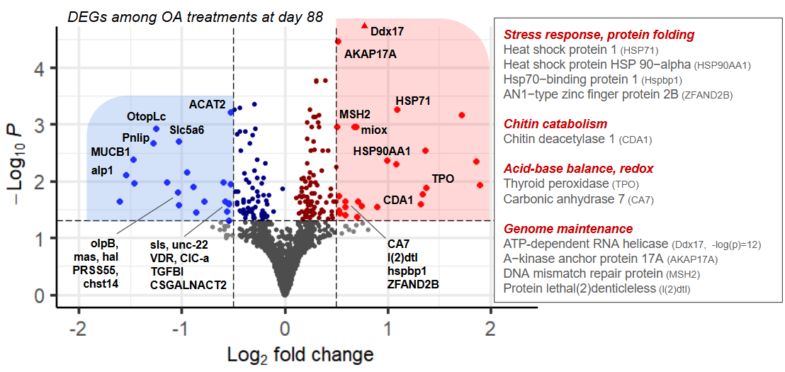
Figure 4. Volcano plot of differentially expressed genes (DEGs) between the moderate (pH 7.8) and severe (pH 7.5) ocean acidification (OA) treatments. Annotated genes meeting the significance thresholds of adjusted p < 0.05 and |log₂ fold change| > 0.5 are in bright blue and red for genes with higher expression in moderate and severe OA, respectively. Genes with higher expression in the severe OA treatment (red) broadly represent stress-response, chitin catabolism, acid-base balance, and genome maintenance, which may underlie the higher long-term mortality observed in that treatment.

3.4 Long term consequences: differential expression among OA treatments at Day 88
After 88 days of exposure, 186 genes were differentially expressed in severe OA (pH 7.5) compared to moderate OA (pH 7.8) (Table S4). A total of 80 genes expressed at higher levels in moderate OA compared to severe OA (blue points, Figure 4). While these genes were not significantly enriched for any biological processes, they represent possible mechanisms and markers of chronic OA tolerance in juvenile snow crab (see Table 3 for DEGs with L₂FC>0.5, and Table S4 for all DEGs).
A total of 106 genes were expressed at higher levels in severe OA compared to moderate OA (red points, Figure 4), which were highly enriched for GO process mRNA processing (FDR=5.7e⁻⁵) and RNA splicing (FDR=9.2e⁻⁵). Genes that were highly expressed in severe OA (L₂FC>0.5, or >1.4x) could be indicators of chronic OA stress (Table 3). Two annotated genes showed distinct expression patterns in long-term severe OA, and are therefore top candidates for OA stress biomarker development: carbonic anhydrase 7 (CA7) and protein lethal(2) denticleless (l(2)dtl) (Figure 5). Several additional genes were highly expressed in chronic severe OA exposure (e.g., HSP90AA1, HSP71, Cyp6a13, Ddx17, AKAP17A) compared to chronic moderate OA, however they were also highly expressed in time-0 controls, indicating that they are likely sensitive to other factors and stressors (Power et al., 2023), and may not be reliable indicators of OA stress if measured alone.
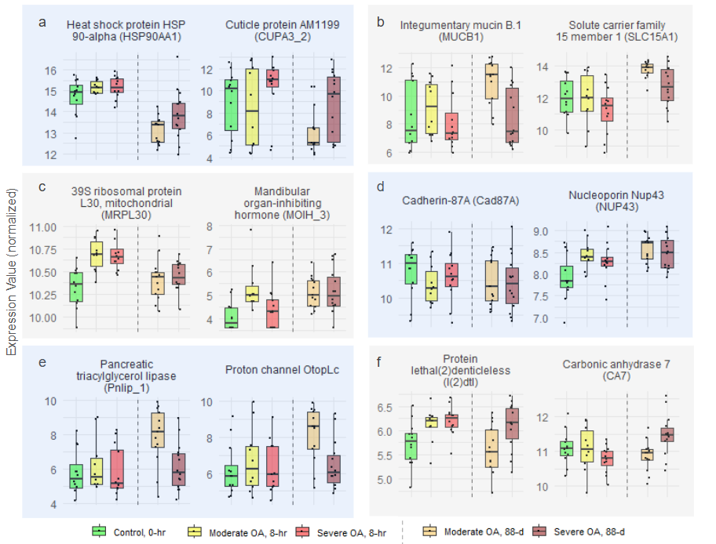
Figure 5. Expression patterns of select genes representing major axes of transcriptional variation and functional responses to ocean acidification (OA): (a) genes with high negative PC1 loadings, highly expressed in crabs likely experiencing OA stress; (b) genes with high positive PC1 loadings, highly expressed in crabs acclimated long-term to moderate OA; (c) genes differentially expressed in both OA treatments at 8 hr (MRPL30) or 88 days (MOIH); (d) genes that were differentially expressed in both OA treatments at 8 hr and 88 days; (e) genes uniquely or highly expressed in individuals acclimated to and tolerant of long-term moderate OA; and (f) genes highly expressed after 88 days of severe OA exposure, representing candidate biomarkers of chronic acidification stress. Boxplots show normalized gene counts without surrogate-variable (SV) correction. Dashed vertical lines separate sample days (Day 1 and Day 88).

Table 3. Top differentially expressed genes (|log₂ fold change| > 0.5) distinguishing moderate vs. severe OA treatments after 88 days of exposure.
Gene ID | Gene Name | L₂FC | -Log  (P_{adj}) | Protein | Biological Processes
Higher in Chronic Moderate OA, Lower in Severe OA
GWK47_039354 | OtopLc | 1.26 | 2.93 | Proton channel OtopLc | Ion transport
GWK47_004210 | ClC-a_1 | 0.56 | 1.46 | Chloride channel protein 2 | Ion transport
GWK47_012393 | mas | 1.14 | 1.98 | Protein masquerade | Immune response
GWK47_019251 | MUCB1 | 1.47 | 2.39 | Integumentary mucin B.1 | Mucosal barrier defense
GWK47_046958 | PRSS55 | 1.03 | 1.58 | Serine protease 55 (Vitamin K-dependent protein C) | Blood coagulation, barrier defense
GWK47_015214 | Slc5a6_0 | 1.03 | 2.71 | Sodium-dependent multivitamin transporter | Nutrient transport, barrier defense
GWK47_049593 | Pnlip_1 | 1.28 | 2.68 | Pancreatic triacylglycerol lipase | Lipid metabolism
GWK47_018438 | Hal | 0.79 | 1.64 | Histidine ammonia-lyase | Amino acid metabolism
GWK47_037894 | chst14 | 0.86 | 1.45 | Carbohydrate sulfotransferase 14 | Carbohydrate biosynthesis
GWK47_044097 |  | 1.55 | 2.11 | Protein ALP1-like | Transcription regulation (likely)
GWK47_027940 | VDR | 0.60 | 1.99 | Vitamin D3 receptor | Transcription regulation
GWK47_026454 | TGFBI | 0.54 | 1.60 | Transforming growth factor-beta-induced protein ig-h3 | Cell adhesion
GWK47_043346 | olpB_2 | 0.95 | 2.15 | Cell surface glycoprotein 1 | Cell adhesion
GWK47_020793 | CSGALNACT2 | 0.58 | 1.64 | Chondroitin sulfate N-acetylgalactosaminyltransferase 2 | Glycoprotein biosynthesis
GWK47_043379 | sls_5 | 0.54 | 1.61 | Titin | Muscle structure and contraction
GWK47_055061 | unc-22_9 | 0.53 | 1.94 | Twitchin | Muscle contraction, sarcomere organization
GWK47_002621 |  | 1.60 | 1.64 | hypothetical protein | Uncharacterized
GWK47_039428 |  | 1.46 | 1.96 | hypothetical protein | Uncharacterized
GWK47_044956 |  | 1.04 | 1.81 | hypothetical protein | Uncharacterized
GWK47_002357 |  | 0.89 | 1.91 | hypothetical protein | Uncharacterized
Higher Expression in Chronic Severe OA, Lower in Moderate OA
GWK47_031192 | CA7 | 0.59 | 1.65 | Carbonic anhydrase 7 | pH regulation
GWK47_027385 | l(2)dtl | 0.59 | 1.54 | Protein lethal(2)denticleless | DNA-damage checkpoint, protein ubiquitination
GWK47_000589 | MSH2 | 0.51 | 2.97 | DNA mismatch repair protein Msh2 | DNA repair
GWK47_046856 | ZFAND2B | 0.71 | 1.64 | AN1-type zinc finger protein 2B | Protein degradation
GWK47_033734 | HSP71_1 | 1.09 | 3.26 | Heat shock protein 1 | Protein refolding, stress response
GWK47_029205 | HSP90AA1 | 1.00 | 2.37 | Heat shock protein HSP 90-alpha | Protein refolding, stress response
GWK47_002223 | Hspbp1 | 0.52 | 1.74 | Hsp70-binding protein 1 | Chaperone cofactor, protein quality control
GWK47_036054 | ENTPD5_2 | 0.53 | 1.43 | Ectonucleoside triphosphate diphosphohydrolase 5 | Protein folding, glycosylation
GWK47_046427 | Smpd1_1 | 0.75 | 1.57 | Sphingomyelin phosphodiesterase | Lipid metabolism, cell stress response
GWK47_037129 | Cyp6a13 | 0.50 | 1.65 | putative cytochrome P450 6a13 | Detoxification, immune defense
GWK47_051181 | TPO | 1.38 | 1.89 | Thyroid peroxidase | Oxidative-stress defense, hormone synthesis
GWK47_024010 | *BmCDA1 | 0.90 | 1.55 | Putative chitin deacetylase 1 | Cuticle remodeling
GWK47_029842 | Ddx17 | 0.58 | 12.87 | putative ATP-dependent RNA helicase DDX17 | RNA processing, antiviral response
GWK47_042166 | AKAP17A | 0.52 | 4.47 | A-kinase anchor protein 17A | RNA processing, transcription regulation
GWK47_020967 |  | 1.89 | 1.94 | hypothetical protein | Uncharacterized
GWK47_039556 |  | 1.71 | 3.17 | hypothetical protein | Uncharacterized
GWK47_034150 |  | 1.37 | 2.54 | hypothetical protein | Uncharacterized
GWK47_035275 |  | 1.34 | 1.77 | hypothetical protein | Uncharacterized
GWK47_016794 |  | 1.32 | 1.60 | hypothetical protein | Uncharacterized
GWK47_050573 |  | 1.08 | 2.30 | hypothetical protein | Uncharacterized
GWK47_035560 |  | 0.70 | 1.37 | hypothetical protein | Uncharacterized
GWK47_029207 |  | 0.59 | 1.41 | hypothetical protein | Uncharacterized
Asterisks (*) denote genes annotated via DIAMOND BLAST searches against the UniProt/Swiss-Prot database.

4. Discussion
Snow crab appear remarkably tolerant to ocean acidification compared with many other decapod crustaceans (Algayer et al., 2023; Long et al., 2023), even during the juvenile stage when other species show high sensitivity (e.g., red king crab (Long et al., 2013; Swiney et al., 2017)). Long (2025) reported no detectable effect on juvenile growth or morphology during a full year of OA treatments. However, Long (2025) also revealed that snow crab tolerance has limits, with elevated molting-related mortality emerging after 250 days under severe acidification (pH 7.5), an effect that was not observed under moderate acidification (pH 7.8). In this discussion, we describe results from transcriptomic analyses conducted during the immediate acclimation period (8 h) and at an intermediate time point (88 d) that preceded mortality, to understand how snow crab tolerate OA, but why chronic exposure to severe acidification ultimately exceeds juveniles’ physiological capacity. Specifically, we describe (1) the major sources of gene expression variation across all treatments and time points, reflecting processes central to snow OA acclimation, (2) a more detailed description of the OA-responsive genes and processes that likely underpin short-term tolerance, and (3) transcriptional differences between moderate and severe OA at 88 days that reveal potential causes of mortality, and also identify candidate biomarkers distinguishing snow crab that are tolerating chronic OA and those that are experiencing chronic OA stress.

4.1 Largest signals of variation include cellular stress-response and cuticle maintenance genes
We conducted an unsupervised PCA of all 11,097 expressed genes (Figure 2), revealing strong variation among treatments. Heat shock proteins (HSPs) were a central component of the OA response. The main axis of variability (PC1; Figure 2), which separated samples by treatment and exposure duration, was strongly influenced by HSP expression (nine of the top 55 genes with the highest negative PC1 loadings were HSPs; Table S1). HSPs act as molecular chaperones that stabilize and refold misfolded proteins under stress (Roberts et al., 2010), and their induction is a hallmark of the cellular stress response in metazoans exposed to environmental stressors, including crustaceans under pH stress (Harms et al., 2014; Kumar et al., 2022; P. Li, 2017). During the initial acclimation period (8 h), expression of several HSPs was elevated in both OA treatments relative to the control, and the control group itself exhibited high HSP expression, likely reflecting transient handling, transport, or general laboratory acclimation stress that subsided by Day 88 (see also (Power et al., 2023)). After 88 days, HSP expression remained higher under severe OA than under moderate OA, suggesting that chronic exposure to pH 7.5 continues to impose cellular stress requiring ongoing protein repair. Together, these patterns indicate that HSP induction occurs both as an acute acclimation response and as a marker of sustained stress under long-term, severe acidification.
Unsupervised analyses also revealed clear treatment effects on genes involved in chitin metabolism and cuticle structure. Two genes coding for the cuticle protein AM1199 (CUPA3), a component of the chitin-based exoskeletal matrix (Liu et al., 2024), was highly and consistently expressed in severe OA crab during the short-term (8 h) exposure (Figure 5), suggesting an early protective response aimed at stabilizing or reinforcing the cuticle. During the long-term (88 d) exposure, AM1199 and other cuticle-related genes (putative CDA1, CU1A) remained elevated in severe OA relative to moderate OA. Consistent with sustained investment in cuticle maintenance or remodeling in OA, chitin-processing genes are associated with molting (Campli et al., 2024). For instance, expression of chitin deacetylase (CDA1), which modifies chitin structure by influencing Ca²⁺ and protein binding (Zhang et al., 2021), increases during molting and its disruption impairs molting in the Chinese mitten crab (X. Li, Chu, et al., 2021; X. Li, Diao, et al., 2021). Given the persistent upregulation of cuticle-associated genes in crabs held long-term in severe OA, it is possible that chronic exposure causes energetic or structural challenges during molting that contribute to elevated mortality, even if surviving crabs show no apparent differences in carapace condition or growth (Algayer et al., 2023)(Long et al., 2025). Alternatively, some observed expression signals in snow crab may reflect modifications to chitinous structures on the gill or gut as well as the exoskeleton (Novikov et al., 2023; Sarmiento et al., 2016; Zhang et al., 2021), an idea that warrants tissue-specific investigation.

4.2 Short-term OA tolerance: acclimation mechanisms (8-hr response)

4.2.1 Commonly affected processes & genes
Snow crab tolerance to ocean acidification may partly stem from their ability to activate key metabolic and protective pathways while minimizing unnecessary or costly ones. After short-term (8 h) exposure, snow crabs in both OA treatments highly expressed genes involved in aerobic respiration and mitochondrial metabolism, with the response being far more pronounced under severe OA (pH 7.5). Approximately 30% of all genes highly expressed in severe OA were mitochondrial, including numerous ribosomal subunits, translation factors, respiratory chain components, and assembly proteins, reflecting large-scale activation of mitochondrial biogenesis and turnover. These results demonstrate a robust, OA-driven metabolic activation. The capacity to upregulate energy metabolism likely underpins snow crab’s short-term tolerance to acidified conditions, and is likely necessary to sustain protein repair and other energy-intensive defense processes. Future studies could target metabolic genes (Table 2) across a wider range of pH levels to identify the threshold at which metabolic depression begins to occur in snow crab (Bednaršek et al., 2021; McElhany & Busch, 2024), as observed in the great spider crab (Hyas araneus; (Harms et al., 2014)).
About one third of the genes differentially expressed under moderate OA at 8 h were also upregulated under severe OA, indicating a shared core set essential for OA acclimation (Table 2). In addition to mitochondrial and metabolic genes, these included those involved in β-oxidation, carbohydrate metabolism, protein processing, transcriptional regulation, and intracellular transport. One such gene, NUP43, encoding a nucleoporin, was elevated in both treatments and remained upregulated after 88 days (Figure 5). A related nucleoporin (NUP54) was identified as a hub gene during prolonged high-pH stress in shrimp (Litopenaeus vannamei; (Huang et al., 2018)), where its interaction with HSPA4 likely promoted mRNA export through the nuclear pore complex. NUP43 may serve a similar function in snow crab, helping maintain mRNA trafficking and protein synthesis under acidified conditions.
Genes expressed at lower levels in both short-term OA treatments were associated with structural maintenance, immune function, and solute transport. Several genes linked to cell adhesion and cytoskeletal organization (TGFBI, Cad87A, sas, rhpn2, MYO18A, CycG) were less abundant, including a gene coding for Cadherin 87A, which remained low after 88 days in both OA treatments (Figure 5). Two proclotting enzymes (PCE) and solute transporters (oct-1/SLC22A1) were likewise reduced, consistent with short-term suppression of immune activity, and potential shifts in osmotic balance that reduce the need for active osmolyte transport. It is possible that, rather than simple transcriptional downregulation, these patterns may reflect high metabolic or protein demand outpacing transcription rate. Because RNA-seq measures steady-state mRNA abundance, apparent decreases can result from reduced transcription, increased mRNA decay, or rapid turnover (Schwanhäusser et al., 2011). Future studies sampling tissues at finer temporal scales during early acclimation could help resolve transient mRNA dynamics and distinguish fluctuations from true gene suppression.

4.2.2 Treatment-specific processes and genes: ion/osmotic regulation vs. damage mitigation
Differences between moderate and severe short-term OA responses indicate that snow crab tolerance operates along a continuum, where mild acidification elicits regulatory adjustments, and stronger acidification triggers defensive and repair mechanisms. Genes elevated in only moderate OA were primarily involved in solute transport and osmotic regulation, including SLC22A13, an organic ion transporter that may facilitate ion balance (Nigam, 2018), and SLC5A3, which imports osmolytes against a Na⁺ gradient to support cell volume and osmotic stability (Chauvin & Griswold, 2004). Their co-expression suggests tight coupling between acid-base and osmotic homeostasis during acclimation to mild acidification. Increased expression of doxa-1 (dual oxidase maturation factor 1) in moderate OA further points to enhanced redox signaling or oxidative stress response regulation during this compensatory phase (Hu et al., 2023). In contrast, genes elevated only under severe OA were linked to cellular protection and damage mitigation, such as TDRD9 and HARBI1 (transposon silencing and DNA repair)(Gan et al., 2019; Kapitonov & Jurka, 2004) and FCN2 (innate immune recognition, apoptosis)(Jensen et al., 2007).
A gene in the crustacean hyperglycemic hormone (CHH) superfamily (Fanjul-Moles, 2006) showed markedly higher expression under moderate OA at 8 h (MOIH), and at 88 days in both OA treatments (Fig. 3 & 5, Table 2). MOIH encodes the mandibular organ-inhibiting hormone, a neuropeptide that suppresses vitellogenesis (Ding et al., 2023). Similar transcripts were also elevated under transport stress in snow crab (Power et al., 2023), suggesting a broader stress-related role. Power et al. (2023) suggested that these transcripts may instead encode other CHH-family members regulating hemolymph glucose (Stoner, 2012; Webster et al., 2012), and their upregulation may reflect metabolic or ionoregulatory responses. Consistent with this hypothesis, CHH genes are known to influence ion and osmoregulation (Chen et al., 2020; Spanings-Pierrot et al., 2000). Given that long-term OA exposure does not affect female fecundity (Long et al., 2023), the snow crab genes annotated as MOIH are likely misidentified members of the CHH superfamily. The observed elevation of MOIH/CHH-like transcripts, initially under moderate OA and maintained across both long-term OA treatments, likely reflects a compensatory regulatory shift to sustain metabolic and osmotic homeostasis, rather than a signal of reproductive inhibition.
Notably absent from the OA response were canonical ion-transport genes that code for Na⁺/K⁺-ATPase and V-type H⁺-ATPase. Whether crustaceans regulate or conform to external pH varies by species, life stage, and ion, but snow crab larvae and juveniles are generally osmoconformers (juveniles were previously found to hyporegulate magnesium only, (Charmantier & Charmantier‐Daures, 1995)). This suggests that juveniles may partially conform to environmental pH/pCO₂ rather than actively regulate, and may explain why we did not detect differences in canonical ion pumps. However, other decapods do show OA-induced modulation of osmolyte transporters and CHH-family neuropeptides linked to ion and glucose balance (Luo et al., 2021; Shen et al., 2021), indicating that compensation in snow crab could occur through alternative molecular pathways. Furthermore, RNA data was derived from homogenized whole-body tissues, thus gill-specific ion transport responses may have been underrepresented. Focused gill expression studies could better resolve the molecular basis of acid-base regulation in snow crab.

4.3 Molecular signatures of chronic OA exposure
After 88 days, crabs showed no outward signs of stress in survival, growth, or molt timing. However, the two OA treatments likely represent distinct positions along the stress-performance continuum. Crabs under moderate OA (pH 7.8) were probably functioning within their tolerance range, near the physiological optimum or entering the pejus zone, whereas those under severe OA (pH 7.5) were operating under suboptimal conditions. This interpretation aligns with the delayed but substantial mortality observed after ~250 days in the severe treatment, which ultimately was appr. 40% higher than the moderate group (Long 2025). The transcriptional profiles captured at day 88 therefore provide an early glimpse into molecular processes distinguishing sustained tolerance from accumulating stress.

4.3.1 Signatures of a crab tolerant of chronic, moderate OA
We identified dozens of genes with elevated expression after 88 days under moderate OA, which may contribute to snow crab’s long-term resilience to acidified conditions (Table 3 & Table S4). Many encode secreted or membrane-associated proteins, including integumentary mucin B.1 (MUCB1, Figure 5), serine protease 55 (PRSS55, also annotated to PROC, a vitamin K-dependent protein C), and sodium-dependent multivitamin transporter (Slc5a6). MUCB1 forms protective mucin coatings on epithelial surfaces (Probst et al., 1990), while PROC/PRSS55likely regulates blood coagulation to protect endothelial cells, and Slc5a6 mediates Na⁺-coupled vitamin uptake and is essential for gut mucosa maintenance in mice (Sabui et al., 2016), suggesting reinforced epithelial and mucosal defenses through enhanced secretion, proteolysis, and nutrient uptake. High expression of metabolic enzymes such as pancreatic triacylglycerol lipase (Pnlip, Figure 5) further points to increased lipid turnover supporting energetic and membrane demands (Lowe, 2002). Elevated ion-transport genes, notably the proton channel OtopLc (Figure 5) and chloride channel ClC-a, imply active ion regulation (Cabrero et al., 2014; W. W. Chang et al., 2021; Wheatly & Henry, 1992). Several immune-regulatory genes were also upregulated, including masquerade (mas) which potentially moderate inflammation levels, cell adhesion, and epithelial integrity (Murugasu-Oei et al., 1995), and a gene similar to cybc1 (GWK47_039981), which promotes reactive oxygen species production for pathogen defense (Arnadottir et al., 2018). High expression of adhesion, and structural genes, including TGFBI, OLPB₂, Titin, and two Twitchin paralogs, suggest coordinated maintenance of muscle function (Ayme-Southgate et al., 1991; Murugasu-Oei et al., 1995). Collectively, the dominant transcriptional signals under long-term exposure to moderate OA indicate enhanced secretion of protective proteins and enzymes, strengthened epithelial barriers, stabilized ion gradients, and maintained immune and structural function compared to those in severe OA.

4.3.2 Signatures and candidate biomarkers of chronic OA stress
Genes highly expressed after 88 days under severe OA provide mechanistic insight into chronic acidification stress that, as shown by Long (2025), ultimately leads to elevated molt-associated mortality in juvenile snow crabs. Broadly, genes upregulated in severe OA relative to moderate OA were involved in protein folding, genome maintenance, transcriptional regulation, pH homeostasis, and immune and metabolic control (Table 3). Many of these same processes were elevated in severe OA during the initial acclimation phase, indicating that exposure to pH 7.5 constitutes a stressor despite long-term exposure.
Genes involved in chaperone-mediated refolding (e.g., HSP71, HSP90AA1, Hspbp1) and proteasomal degradation (e.g., ZFAND2B, l(2)dtl) were among the most highly expressed overall. HSP synthesis, and protein synthesis more broadly, is energetically costly (Feder & Hofmann, 1999). However, Long (2025) saw no differences in growth among treatments over a one-year exposure, implying that energetic demands were met when crabs were not molting. Instead, the molt-associated mortality observed in severe OA could reflect the combined physiological strain of molting and acidification exceeding the crab’s capacity for cellular repair. Indeed, HSP expression varies among molt stages in other decapods (Cesar & Yang, 2007; E. S. Chang, 2005; López-Cerón, 2019; Spees et al., 2003). Despite their strong responses, HSPs are not ideal standalone biomarkers of chronic OA exposure because they are broadly inducible by diverse stressors (e.g., as the name suggests, they were originally described in response to high temperature stress) (De Maio et al., 2012; Kumar et al., 2022). In our study, HSP expression was higher in control crabs sampled on Day 1 than in OA-exposed crabs at Day 88, potentially reflecting handling stress, or exposure to more variable environmental conditions prior to the experiment (among other possible stressors) (Power et al., 2023). We therefore do not recommend HSPs as standalone indicators of OA stress.
Carbonic anhydrase 7 (CA7 or CAH7; GWK47_031192) was the most distinctively upregulated gene in crabs exposed to long-term severe OA (Figure 5) and represents our top candidate for biomarker development. In crustaceans, carbonic anhydrases (CAs) are highly active in gill tissue, where they support acid-base regulation, CO₂ excretion, and provide bicarbonate for CaCO₃ formation during calcification (Henry, 1988; Le Roy et al., 2014; McMahon et al., 1984). Although CA7 has not been characterized in crustaceans, studies in vertebrates identify it as a cytosolic isoform that catalyzes the reversible hydration of CO₂ to bicarbonate and protons (Aspatwar et al., 2022). Because of their central roles in ion regulation and biomineralization, CAs have been widely proposed as biomarkers of environmental stress in calcifying animals (Zebral et al., 2019). Numerous studies in corals and molluscs have reported altered CA transcription and enzyme activity under acidified conditions, most commonly showing suppression (reviewed in (Zebral et al., 2019)). In contrast, CA7 expression in snow crab increased, and only after prolonged exposure to severe acidification rather than during the initial 8-h response. This delayed activation suggests that CA7 reflects a shift from an immediate OA response to chronic acclimation, making it a promising molecular indicator of sustained OA exposure. Future work should identify the tissue(s) in which CA7 expression is most responsive to OA, as the present analysis used whole-body homogenates.
A second notable gene, lethal (2) denticleless (l(2)dtl), was uniquely expressed in both short-term OA treatments and the long-term severe OA treatment (Figure 5). Conserved across taxa, l(2)dtl regulates DNA replication and repair via ubiquitin-mediated degradation pathways (Sloan et al., 2012). Its high expression under exposure to OA may reflect enhanced DNA damage surveillance or adaptation to replication stress, making it a potentially sensitive indicator of genotoxic stress.

5. Conclusion
Snow crabs show a remarkable ability to maintain growth under ocean acidification (Long 2025). This study described the flexible transcriptional responses that appear to buffer cellular stress. Even after months of exposure to low pH, juveniles sustained expression of genes involved in protein repair, cuticle maintenance, and ion regulation, with no detectable effects on growth or molting (Long 2025). These results suggest that snow crab tolerate acidified conditions through active molecular compensation. A similar pattern has been observed in postlarval American lobster, where strong activation of stress and immune pathways maintained performance under OA (Niemisto et al., 2021). In contrast, species such as the Antarctic pteropod (Limacina helicina antarctica, Johnson and Hofmann 2017) and the Chinese mitten crab (Eriocheir sinensis, Luo et al. 2021) exhibit transcriptional suppression or trade-offs between defense and reproduction, consistent with reduced plasticity and lower resilience to acidification.
The eventual molt-associated mortality observed under chronic severe acidification indicates that snow crabs’ tolerance has limits. Genes such as carbonic anhydrase 7 (CA7) and l(2)dtl have potential to be used to detect whether a snow crab (and related species) is experiencing OA stress, which could be a useful tool for monitoring Bering Sea populations (Litzow et al., 2025; Szuwalski et al., 2021). Future work should focus on tissue-specific expression with finer temporal resolution to better understandthe timing and location of OA-responsive genes. Comparative analyses with the closely related, OA-sensitive Tanner crab will be especially valuable for identifying the molecular mechanisms underlying differences in resilience among North Pacific crab species.

References
Algayer, T., Mahmoud, A., Saksena, S., Long, W. C., Swiney, K. M., Foy, R. J., Steffel, B. V., Smith, K. E., Aronson, R. B., & Dickinson, G. H. (2023). Adult snow crab, Chionoecetes opilio, display body-wide exoskeletal resistance to the effects of long-term ocean acidification. Marine Biology, 170(5). https://doi.org/10.1007/s00227-023-04209-0
Andrews, S. (2010). A Quality Control Tool for High Throughput Sequence Data [Online]. http://www.bioinformatics.babraham.ac.uk/projects/fastqc/
Arnadottir, G. A., Norddahl, G. L., Gudmundsdottir, S., Agustsdottir, A. B., Sigurdsson, S., Jensson, B. O., Bjarnadottir, K., Theodors, F., Benonisdottir, S., Ivarsdottir, E. V., Oddsson, A., Kristjansson, R. P., Sulem, G., Alexandersson, K. F., Juliusdottir, T., Gudmundsson, K. R., Saemundsdottir, J., Jonasdottir, A., Jonasdottir, A., … Stefansson, K. (2018). A homozygous loss-of-function mutation leading to CYBC1 deficiency causes chronic granulomatous disease. Nature Communications, 9(1), 4447. https://doi.org/10.1038/s41467-018-06964-x
Aspatwar, A., Tolvanen, M. E. E., Barker, H., Syrjänen, L., Valanne, S., Purmonen, S., Waheed, A., Sly, W. S., & Parkkila, S. (2022). Carbonic anhydrases in metazoan model organisms: molecules, mechanisms, and physiology. Physiological Reviews, 102(3), 1327–1383. https://doi.org/10.1152/physrev.00018.2021
Auzoux-Bordenave, S., Chevret, S., Badou, A., Martin, S., Di Giglio, S., & Dubois, P. (2021). Acid–base balance in the hæmolymph of European abalone (Haliotis tuberculata) exposed to CO2-induced ocean acidification. Comparative Biochemistry and Physiology. Part A, Molecular & Integrative Physiology, 259(110996), 110996. https://doi.org/10.1016/j.cbpa.2021.110996
Ayme-Southgate, A., Vigoreaux, J., Benian, G., & Pardue, M. L. (1991). Drosophila has a twitchin/titin-related gene that appears to encode projectin. Proceedings of the National Academy of Sciences of the United States of America, 88(18), 7973–7977. https://doi.org/10.1073/pnas.88.18.7973
Bednaršek, N., Ambrose, R., Calosi, P., Childers, R. K., Feely, R. A., Litvin, S. Y., Long, W. C., Spicer, J. I., Štrus, J., Taylor, J., Kessouri, F., Roethler, M., Sutula, M., & Weisberg, S. B. (2021). Synthesis of thresholds of ocean acidification impacts on decapods. Frontiers in Marine Science, 8. https://doi.org/10.3389/fmars.2021.651102
Boudreau, S. A., & Worm, B. (2012). Ecological role of large benthic decapods in marine ecosystems: a review. Marine Ecology Progress Series, 469, 195–213. https://doi.org/10.3354/meps09862
Buchfink, B., Xie, C., & Huson, D. H. (2015). Fast and sensitive protein alignment using DIAMOND. Nature Methods, 12(1), 59–60. https://doi.org/10.1038/nmeth.3176
Cabrero, P., Terhzaz, S., Romero, M. F., Davies, S. A., Blumenthal, E. M., & Dow, J. A. T. (2014). Chloride channels in stellate cells are essential for uniquely high secretion rates in neuropeptide-stimulated Drosophila diuresis. Proceedings of the National Academy of Sciences of the United States of America, 111(39), 14301–14306. https://doi.org/10.1073/pnas.1412706111
Caldeira, K., & Wickett, M. E. (2003). Oceanography: anthropogenic carbon and ocean pH. Nature, 425(6956), 365. https://doi.org/10.1038/425365a
Campli, G., Volovych, O., Kim, K., Veldsman, W. P., Drage, H. B., Sheizaf, I., Lynch, S., Chipman, A. D., Daley, A. C., Robinson-Rechavi, M., & Waterhouse, R. M. (2024). The moulting arthropod: a complete genetic toolkit review. Biological Reviews of the Cambridge Philosophical Society, 99(6), 2338–2375. https://doi.org/10.1111/brv.13123
Cesar, J. R. O., & Yang, J. (2007). Expression patterns of ubiquitin, heat shock protein 70, alpha-actin and beta-actin over the molt cycle in the abdominal muscle of marine shrimp Litopenaeus vannamei. Molecular Reproduction and Development, 74(5), 554–559. https://doi.org/10.1002/mrd.20605
Chang, E. S. (2005). Stressed-out lobsters: crustacean hyperglycemic hormone and stress proteins. Integrative and Comparative Biology, 45(1), 43–50. https://doi.org/10.1093/icb/45.1.43
Chang, W. W., Matt, A.-S., Schewe, M., Musinszki, M., Grüssel, S., Brandenburg, J., Garfield, D., Bleich, M., Baukrowitz, T., & Hu, M. Y. (2021). An otopetrin family proton channel promotes cellular acid efflux critical for biomineralization in a marine calcifier. Proceedings of the National Academy of Sciences of the United States of America, 118(30), e2101378118. https://doi.org/10.1073/pnas.2101378118
Charmantier, G., & Charmantier‐Daures, M. (1995). Osmoregulation and salinity tolerance in zoeae and juveniles of the snow crab Chionoecetes opilio. Aquatic Living Resources, 8, 171–179. https://doi.org/10.1051/ALR:1995014
Chauvin, T. R., & Griswold, M. D. (2004). Characterization of the expression and regulation of genes necessary for myo-inositol biosynthesis and transport in the seminiferous epithelium. Biology of Reproduction, 70(3), 744–751. https://doi.org/10.1095/biolreprod.103.022731
Chen, H.-Y., Toullec, J.-Y., & Lee, C.-Y. (2020). The crustacean hyperglycemic hormone superfamily: Progress made in the past decade. Frontiers in Endocrinology, 11, 578958. https://doi.org/10.3389/fendo.2020.578958
Coffey, W. D., Nardone, J. A., Yarram, A., Long, W. C., Swiney, K. M., Foy, R. J., & Dickinson, G. H. (2017). Ocean acidification leads to altered micromechanical properties of the mineralized cuticle in juvenile red and blue king crabs. Journal of Experimental Marine Biology and Ecology, 495, 1–12. https://doi.org/10.1016/j.jembe.2017.05.011
Costa-Silva, J., Domingues, D., & Lopes, F. M. (2017). RNA-Seq differential expression analysis: An extended review and a software tool. PloS One, 12(12), e0190152. https://doi.org/10.1371/journal.pone.0190152
De Maio, A., Santoro, M. G., Tanguay, R. M., & Hightower, L. E. (2012). Ferruccio Ritossa’s scientific legacy 50 years after his discovery of the heat shock response: a new view of biology, a new society, and a new journal. Cell Stress & Chaperones, 17(2), 139–143. https://doi.org/10.1007/s12192-012-0320-z
DeVries, T. (2022). The ocean carbon cycle. Annual Review of Environment and Resources, 47(1), 317–341. https://doi.org/10.1146/annurev-environ-120920-111307
Ding, S., Huang, M., Sheng, N., Chen, T., Xu, R., Luo, Z., Huang, X., Wan, Z., Su, S., & Li, X. (2023). RNAi-mediated knockdown of the mandibular organ-inhibiting hormone (MOIH) gene stimulates vitellogenesis in the Chinese mitten crab Eriocheir sinensis. Fisheries Science: FS, 89(3), 399–408. https://doi.org/10.1007/s12562-023-01680-y
Doney, S. C., Fabry, V. J., Feely, R. A., & Kleypas, J. A. (2009). Ocean acidification: the other CO2 problem. Annual Review of Marine Science, 1, 169–192. https://doi.org/10.1146/annurev.marine.010908.163834
Ewels, P., Magnusson, M., Lundin, S., & Käller, M. (2016). MultiQC: summarize analysis results for multiple tools and samples in a single report. Bioinformatics , 32(19), 3047–3048. https://doi.org/10.1093/bioinformatics/btw354
Fabry, V., McClintock, J., Mathis, J., & Grebmeier, J. (2009). Ocean Acidification at High Latitudes: The Bellwether. In Oceanography (Vol. 22, Issue 4, pp. 160–171). https://doi.org/10.5670/oceanog.2009.105
Fanjul-Moles, M. L. (2006). Biochemical and functional aspects of crustacean hyperglycemic hormone in decapod crustaceans: review and update. Comparative Biochemistry and Physiology. Toxicology & Pharmacology: CBP, 142(3-4), 390–400. https://doi.org/10.1016/j.cbpc.2005.11.021
Feder, M. E., & Hofmann, G. E. (1999). Heat-shock proteins, molecular chaperones, and the stress response: evolutionary and ecological physiology. Annual Review of Physiology, 61(1), 243–282. https://doi.org/10.1146/annurev.physiol.61.1.243
Fehsenfeld, S., & Weihrauch, D. (2017). Acid–base regulation in aquatic decapod crustaceans. In Acid-Base Balance and Nitrogen Excretion in Invertebrates (pp. 151–191). Springer International Publishing. https://doi.org/10.1007/978-3-319-39617-0_6
Figuerola, B., Hancock, A. M., Bax, N., Cummings, V. J., Downey, R., Griffiths, H. J., Smith, J., & Stark, J. S. (2021). A review and meta-analysis of potential impacts of ocean acidification on marine calcifiers from the Southern Ocean. Frontiers in Marine Science, 8. https://doi.org/10.3389/fmars.2021.584445
Gan, B., Chen, S., Liu, H., Min, J., & Liu, K. (2019). Structure and function of eTudor domain containing TDRD proteins. Critical Reviews in Biochemistry and Molecular Biology, 54(2), 119–132. https://doi.org/10.1080/10409238.2019.1603199
George, N. I., Bowyer, J. F., Crabtree, N. M., & Chang, C.-W. (2015). An Iterative Leave-One-Out Approach to Outlier Detection in RNA-Seq Data. PloS One, 10(6), e0125224. https://doi.org/10.1371/journal.pone.0125224
Harms, L., Frickenhaus, S., Schiffer, M., Mark, F. C., Storch, D., Held, C., Pörtner, H.-O., & Lucassen, M. (2014). Gene expression profiling in gills of the great spider crab Hyas araneus in response to ocean acidification and warming. BMC Genomics, 15, 789. https://doi.org/10.1186/1471-2164-15-789
Henry, R. P. (1988). Multiple functions of carbonic anhydrase in the crustacean gill. The Journal of Experimental Zoology, 248(1), 19–24. https://doi.org/10.1002/jez.1402480104
Huang, W., Li, H., Cheng, C., Ren, C., Chen, T., Jiang, X., Cheng, K., Luo, P., & Hu, C. (2018). Analysis of the transcriptome data in Litopenaeus vannamei reveals the immune basis and predicts the hub regulation-genes in response to high-pH stress. PloS One, 13(12), e0207771. https://doi.org/10.1371/journal.pone.0207771
Hu, Y., Xu, Z., Pan, Q., & Ma, L. (2023). Casein kinase 1 gamma regulates oxidative stress response via interacting with the NADPH dual oxidase complex. PLoS Genetics, 19(4), e1010740. https://doi.org/10.1371/journal.pgen.1010740
Jaffe, A. E., Hyde, T., Kleinman, J., Weinbergern, D. R., Chenoweth, J. G., McKay, R. D., Leek, J. T., & Colantuoni, C. (2015). Practical impacts of genomic data “cleaning” on biological discovery using surrogate variable analysis. BMC Bioinformatics, 16(1), 372. https://doi.org/10.1186/s12859-015-0808-5
Jensen, M. L., Honoré, C., Hummelshøj, T., Hansen, B. E., Madsen, H. O., & Garred, P. (2007). Ficolin-2 recognizes DNA and participates in the clearance of dying host cells. Molecular Immunology, 44(5), 856–865. https://doi.org/10.1016/j.molimm.2006.04.002
Kapitonov, V. V., & Jurka, J. (2004). Harbinger transposons and an ancient HARBI1 gene derived from a transposase. DNA and Cell Biology, 23(5), 311–324. https://doi.org/10.1089/104454904323090949
Keeling, C. D., Bacastow, R. B., Bainbridge, A. E., Ekdahl, C. A., Jr, Guenther, P. R., Waterman, L. S., & Chin, J. F. S. (1976). Atmospheric carbon dioxide variations at Mauna Loa Observatory, Hawaii. Tellus, 28(6), 538–551. https://doi.org/10.1111/j.2153-3490.1976.tb00701.x
Knauber, H., Kohlenbach, K., Brandt, A., & Saeedi, H. (2023). Crustaceans of the Northwest Pacific Ocean: Species richness and distribution patterns. Journal of Sea Research, 191(102332), 102332. https://doi.org/10.1016/j.seares.2022.102332
Kroeker, K. J., Kordas, R. L., Crim, R. N., & Singh, G. G. (2010). Meta-analysis reveals negative yet variable effects of ocean acidification on marine organisms. Ecology Letters, 13(11), 1419–1434. https://doi.org/10.1111/j.1461-0248.2010.01518.x
Kruse, G. H., Daly, B. J., Fedewa, E. J., Stram, D. L., & Szuwalski, C. S. (2025). Ecosystem-based fisheries management of crab fisheries in the Bering Sea and Aleutian Islands. Fisheries Research, 281(107236), 107236. https://doi.org/10.1016/j.fishres.2024.107236
Kumar, V., Roy, S., Behera, B. K., & Das, B. K. (2022). Heat shock proteins (Hsps) in cellular homeostasis: A promising tool for health management in crustacean aquaculture. Life (Basel, Switzerland), 12(11), 1777. https://doi.org/10.3390/life12111777
Le Roy, N., Jackson, D. J., Marie, B., Ramos-Silva, P., & Marin, F. (2014). The evolution of metazoan α-carbonic anhydrases and their roles in calcium carbonate biomineralization. Frontiers in Zoology, 11(1). https://doi.org/10.1186/s12983-014-0075-8
Leung, J. Y. S., Zhang, S., & Connell, S. D. (2022). Is ocean acidification really a threat to marine calcifiers? A systematic review and meta-analysis of 980+ studies spanning two decades. Small, 18(35), e2107407. https://doi.org/10.1002/smll.202107407
Li, P. (2017). Heat shock proteins in aquaculture disease immunology and stress response of crustaceans. In Heat Shock Proteins (pp. 275–320). Springer International Publishing. https://doi.org/10.1007/978-3-319-73377-7_10
Litzow, M. A., Long, W. C., Palof, K. J., & Pilcher, D. J. (2025). Ocean acidification may contribute to recruitment failure of Bering Sea red king crab. Canadian Journal of Fisheries and Aquatic Sciences, 82, 1–7. https://doi.org/10.1139/cjfas-2024-0173
Liu, C., Zhang, W., Dong, Q., & Liu, H. (2024). Exoskeleton protein repertoires in decapod crustaceans revealed distinct biomineralization evolution with molluscs. Journal of Proteomics, 291(105046), 105046. https://doi.org/10.1016/j.jprot.2023.105046
Li, X., Chu, J., Diao, P., Xu, Z., Xu, Y., Zhou, G., Zhou, J., & Bi, K. (2021). Identification and expression profiles of chitin deacetylase family genes in the Chinese mitten crab, Eriocheir sinensis. Aquaculture Research, 52(7), 3198–3211. https://doi.org/10.1111/are.15166
Li, X., Diao, P., Chu, J., Zhou, G., Zhou, J., Lin, H., Chen, J., & Zeng, Q. (2021). Molecular characterization and function of chitin deacetylase-like from the Chinese mitten crab, Eriocheir sinensis. Comparative Biochemistry and Physiology. Part B, Biochemistry & Molecular Biology, 256(110612), 110612. https://doi.org/10.1016/j.cbpb.2021.110612
Long, W. C., Conrad, A. L., Gardner, J. L., & Foy, R. J. (2024). Red king crab larval survival and development are resilient to ocean acidification. Journal of Experimental Marine Biology and Ecology, 577(152028), 152028. https://doi.org/10.1016/j.jembe.2024.152028
Long, W. C., Pruisner, P., Swiney, K. M., & Foy, R. J. (2019). Effects of ocean acidification on the respiration and feeding of juvenile red and blue king crabs (Paralithodes camtschaticus and P. platypus). ICES Journal of Marine Science: Journal Du Conseil, 76(5), 1335–1343. https://doi.org/10.1093/icesjms/fsz090
Long, W. C., Swiney, K. M., & Foy, R. J. (2016). Effects of high pCO2 on Tanner crab reproduction and early life history, Part II: carryover effects on larvae from oogenesis and embryogenesis are stronger than direct effects. ICES Journal of Marine Science: Journal Du Conseil, 73(3), 836–848. https://doi.org/10.1093/icesjms/fsv251
Long, W. C., Swiney, K. M., & Foy, R. J. (2021). Effects of ocean acidification on young-of-the-year golden king crab (Lithodes aequispinus) survival and growth. Marine Biology, 168(8). https://doi.org/10.1007/s00227-021-03930-y
Long, W. C., Swiney, K. M., & Foy, R. J. (2023). Direct, carryover, and maternal effects of ocean acidification on snow crab embryos and larvae. PloS One, 18(10), e0276360. https://doi.org/10.1371/journal.pone.0276360
Long, W. C., Swiney, K. M., Harris, C., Page, H. N., & Foy, R. J. (2013). Effects of ocean acidification on juvenile red king crab (Paralithodes camtschaticus) and Tanner crab (Chionoecetes bairdi) growth, condition, calcification, and survival. PloS One, 8(4), e60959. https://doi.org/10.1371/journal.pone.0060959
López-Cerón, D. A. (2019). Role of Stress-Responsive Genes in the Molt Cycle of Decapod Crustaceans. https://search.proquest.com/openview/652ac1d450e5918b4b38d634d78d25ea/1?pq-origsite=gscholar&cbl=18750&diss=y&casa_token=W_bQUrNt2YgAAAAA:CU4wA5uksg1y7rd5EmBSMf3K1b3edkSnheWX4YRGmZfrVhXI4_DzfjZM5Q9hrccmDW4RRv8cWsA
Love, M. I., Huber, W., & Anders, S. (2014). Moderated estimation of fold change and dispersion for RNA-seq data with DESeq2. Genome Biology, 15(12), 550. https://doi.org/10.1186/s13059-014-0550-8
Lowe, M. E. (2002). The triglyceride lipases of the pancreas. The Journal of Lipid Research, 43(12), 2007–2016. https://doi.org/10.1194/jlr.r200012-jlr200
Luo, B.-Y., Qian, H.-L., Jiang, H.-C., Xiong, X.-Y., Ye, B.-Q., Liu, X., Guo, Z.-Q., & Ma, K.-Y. (2021). Transcriptional changes revealed water acidification leads to the immune response and ovary maturation delay in the Chinese mitten crab Eriocheir sinensis. Comparative Biochemistry and Physiology. Part D, Genomics & Proteomics, 39, 100868. https://doi.org/10.1016/j.cbd.2021.100868
Mathis, J. T., Cross, J. N., Monacci, N., Feely, R. A., & Stabeno, P. (2014). Evidence of prolonged aragonite undersaturations in the bottom waters of the southern Bering Sea shelf from autonomous sensors. Deep-Sea Research. Part II, Topical Studies in Oceanography, 109, 125–133. https://doi.org/10.1016/j.dsr2.2013.07.019
McElhany, P., & Busch, D. S. (2024). Ocean acidification thresholds for decapods are unresolved. Frontiers in Marine Science, 11(1449345). https://doi.org/10.3389/fmars.2024.1449345
McMahon, B. R., Burnett, L. E., & de Fur, P. L. (1984). Carbon dioxide excretion and carbonic anhydrase function in the Red Rock CrabCancer productus. Journal of Comparative Physiology. B, Biochemical, Systemic, and Environmental Physiology, 154(4), 371–383. https://doi.org/10.1007/bf00684444
Meseck, S. L., Alix, J. H., Swiney, K. M., Long, W. C., Wikfors, G. H., & Foy, R. J. (2016). Ocean acidification affects hemocyte physiology in the Tanner crab (Chionoecetes bairdi). PloS One, 11(2), e0148477. https://doi.org/10.1371/journal.pone.0148477
Miller, J. J., Maher, M., Bohaboy, E., Friedman, C. S., & McElhany, P. (2016). Exposure to low pH reduces survival and delays development in early life stages of Dungeness crab (Cancer magister). Marine Biology, 163(5), 118. https://doi.org/10.1007/s00227-016-2883-1
Murugasu-Oei, B., Rodrigues, V., Yang, X., & Chia, W. (1995). Masquerade: a novel secreted serine protease-like molecule is required for somatic muscle attachment in the Drosophila embryo. Genes & Development, 9(2), 139–154. https://doi.org/10.1101/gad.9.2.139
Niemisto, M., Fields, D. M., Clark, K. F., Waller, J. D., Greenwood, S. J., & Wahle, R. A. (2021). American lobster postlarvae alter gene regulation in response to ocean warming and acidification. Ecology and Evolution, 11(2), 806–819. https://doi.org/10.1002/ece3.7083
Nigam, S. K. (2018). The SLC22 transporter family: A paradigm for the impact of drug transporters on metabolic pathways, signaling, and disease. Annual Review of Pharmacology and Toxicology, 58, 663–687. https://doi.org/10.1146/annurev-pharmtox-010617-052713
Novikov, V. Y., Rysakova, K. S., Shumskaya, N. V., Mukhortova, A. M., & Kesarev, K. A. (2023). King crab gills as a new source of chitin/chitosan and protein hydrolysates. International Journal of Biological Macromolecules, 232(123346), 123346. https://doi.org/10.1016/j.ijbiomac.2023.123346
Otto, R., & Jamieson, G. (2001). Commercially important crabs, shrimps and lobsters of the north pacific ocean. https://meetings.pices.int/publications/scientific-reports/Report19/Sci_Rep_19.pdf
Page, T. M., & Lawley, J. W. (2022). The next generation is here: A review of transcriptomic approaches in marine ecology. Frontiers in Marine Science, 9(757921). https://doi.org/10.3389/fmars.2022.757921
Power, C., Lamarre, S. G., & Dion-Côté, A.-M. (2023). Transcriptional and metabolomic investigation of the stress response in snow crab during simulated transport condition (Chionoecetes opilio). Comparative Biochemistry and Physiology. Part D, Genomics & Proteomics, 46(101079), 101079. https://doi.org/10.1016/j.cbd.2023.101079
Probst, J. C., Gertzen, E. M., & Hoffmann, W. (1990). An integumentary mucin (FIM-B.1) from Xenopus laevis homologous with von Willebrand factor. Biochemistry, 29(26), 6240–6244. https://doi.org/10.1021/bi00478a018
Przeslawski, R., Byrne, M., & Mellin, C. (2015). A review and meta-analysis of the effects of multiple abiotic stressors on marine embryos and larvae. Global Change Biology, 21(6), 2122–2140. https://doi.org/10.1111/gcb.12833
Roberts, R. J., Agius, C., Saliba, C., Bossier, P., & Sung, Y. Y. (2010). Heat shock proteins (chaperones) in fish and shellfish and their potential role in relation to fish health: a review: Heat shock proteins in fish and shellfish. Journal of Fish Diseases, 33(10), 789–801. https://doi.org/10.1111/j.1365-2761.2010.01183.x
Sabui, S., Bohl, J. A., Kapadia, R., Cogburn, K., Ghosal, A., Lambrecht, N. W., & Said, H. M. (2016). Role of the sodium-dependent multivitamin transporter (SMVT) in the maintenance of intestinal mucosal integrity. American Journal of Physiology. Gastrointestinal and Liver Physiology, 311(3), G561–G570. https://doi.org/10.1152/ajpgi.00240.2016
Sarmiento, K. P., Panes, V. A., & Santos, M. D. (2016). Molecular cloning and expression of chitin deacetylase 1 gene from the gills of Penaeus monodon (black tiger shrimp). Fish & Shellfish Immunology, 55, 484–489. https://doi.org/10.1016/j.fsi.2016.06.025
Schwanhäusser, B., Busse, D., Li, N., Dittmar, G., Schuchhardt, J., Wolf, J., Chen, W., & Selbach, M. (2011). Global quantification of mammalian gene expression control. Nature, 473(7347), 337–342. https://doi.org/10.1038/nature10098
Shen, Q., Wang, W. X., Chen, H. G., Zhu, H. G., Chen, J. H., & Gao, H. (2021). Transcriptome analysis of Exopalaemon carinicauda (Holthuis, 1950) (Caridea, Palaemonidae) in response to CO2-driven acidification. Crustaceana, 94(6), 661–677. https://doi.org/10.1163/15685403-bja10121
Siegel, K. R., Kaur, M., Grigal, A. C., Metzler, R. A., & Dickinson, G. H. (2022). Meta-analysis suggests negative, but pCO2-specific, effects of ocean acidification on the structural and functional properties of crustacean biomaterials. Ecology and Evolution, 12(6), e8922. https://doi.org/10.1002/ece3.8922
Sloan, R. S., Swanson, C. I., Gavilano, L., Smith, K. N., Malek, P. Y., Snow-Smith, M., Duronio, R. J., & Key, S. C. S. (2012). Characterization of null and hypomorphic alleles of the Drosophila l(2)dtl/cdt2 gene: Larval lethality and male fertility: Larval lethality and male fertility. Fly, 6(3), 173–183. https://doi.org/10.4161/fly.20247
Spanings-Pierrot, C., Soyez, D., Van Herp, F., Gompel, M., Skaret, G., Grousset, E., & Charmantier, G. (2000). Involvement of crustacean hyperglycemic hormone in the control of gill ion transport in the crab Pachygrapsus marmoratus. General and Comparative Endocrinology, 119(3), 340–350. https://doi.org/10.1006/gcen.2000.7527
Spees, J. L., Chang, S. A., Mykles, D. L., Snyder, M. J., & Chang, E. S. (2003). Molt cycle-dependent molecular chaperone and polyubiquitin gene expression in lobster. Cell Stress & Chaperones, 8(3), 258–264. https://doi.org/10.1379/1466-1268(2003)008<0258:mcmcap>2.0.co;2
Spencer, L. H., Long, W. C., Spies, I. B., Nichols, K. M., & Foy, R. J. (2024). Narrowed gene functions and enhanced transposon activity are associated with high tolerance to ocean acidification in a juvenile subarctic crustacean. PLOS Climate, 3(3), e0000319. https://doi.org/10.1371/journal.pclm.0000319
Stoner, A. W. (2012). Assessing stress and predicting mortality in economically significant crustaceans. Reviews in Fisheries Science, 20(3), 111–135. https://doi.org/10.1080/10641262.2012.689025
Swiney, K. M., Long, W. C., & Foy, R. J. (2016). Effects of high pCO2 on Tanner crab reproduction and early life history—Part I: long-term exposure reduces hatching success and female calcification, and alters embryonic development. ICES Journal of Marine Science: Journal Du Conseil, 73(3), 825–835. https://doi.org/10.1093/icesjms/fsv201
Swiney, K. M., Long, W. C., & Foy, R. J. (2017). Decreased pH and increased temperatures affect young-of-the-year red king crab (Paralithodes camtschaticus). ICES Journal of Marine Science: Journal Du Conseil, 74(4), 1191–1200. https://doi.org/10.1093/icesjms/fsw251
Szuwalski, C., Cheng, W., Foy, R., Hermann, A. J., Hollowed, A., Holsman, K., Lee, J., Stockhausen, W., & Zheng, J. (2021). Climate change and the future productivity and distribution of crab in the Bering Sea. ICES Journal of Marine Science: Journal Du Conseil, 78(2), 502–515. https://doi.org/10.1093/icesjms/fsaa140
Trigg, S. A., McElhany, P., Maher, M., Perez, D., Busch, D. S., & Nichols, K. M. (2019). Uncovering mechanisms of global ocean change effects on the Dungeness crab (Cancer magister) through metabolomics analysis. Scientific Reports, 9(1), 10717. https://doi.org/10.1038/s41598-019-46947-6
UniProt Consortium. (2021). UniProt: the universal protein knowledgebase in 2021. Nucleic Acids Research, 49(D1), D480–D489. https://doi.org/10.1093/nar/gkaa1100
Vargas, C. A., Lagos, N. A., Lardies, M. A., Duarte, C., Manríquez, P. H., Aguilera, V. M., Broitman, B., Widdicombe, S., & Dupont, S. (2017). Species-specific responses to ocean acidification should account for local adaptation and adaptive plasticity. Nature Ecology & Evolution, 1(4), 84. https://doi.org/10.1038/s41559-017-0084
Webster, S. G., Keller, R., & Dircksen, H. (2012). The CHH-superfamily of multifunctional peptide hormones controlling crustacean metabolism, osmoregulation, moulting, and reproduction. General and Comparative Endocrinology, 175(2), 217–233. https://doi.org/10.1016/j.ygcen.2011.11.035
Wheatly, M. G., & Henry, R. P. (1992). Extracellular and intracellular acid‐base regulation in crustaceans. The Journal of Experimental Zoology, 263(2), 127–142. https://doi.org/10.1002/jez.1402630204
Zebral, Y. D., da Silva Fonseca, J., Marques, J. A., & Bianchini, A. (2019). Carbonic anhydrase as a biomarker of global and local impacts: Insights from calcifying animals. International Journal of Molecular Sciences, 20(12), 3092. https://doi.org/10.3390/ijms20123092
Zhang, X., Yuan, J., Li, F., & Xiang, J. (2021). Chitin synthesis and degradation in crustaceans: A genomic view and application. Marine Drugs, 19(3), 153. https://doi.org/10.3390/md19030153

Supplementary
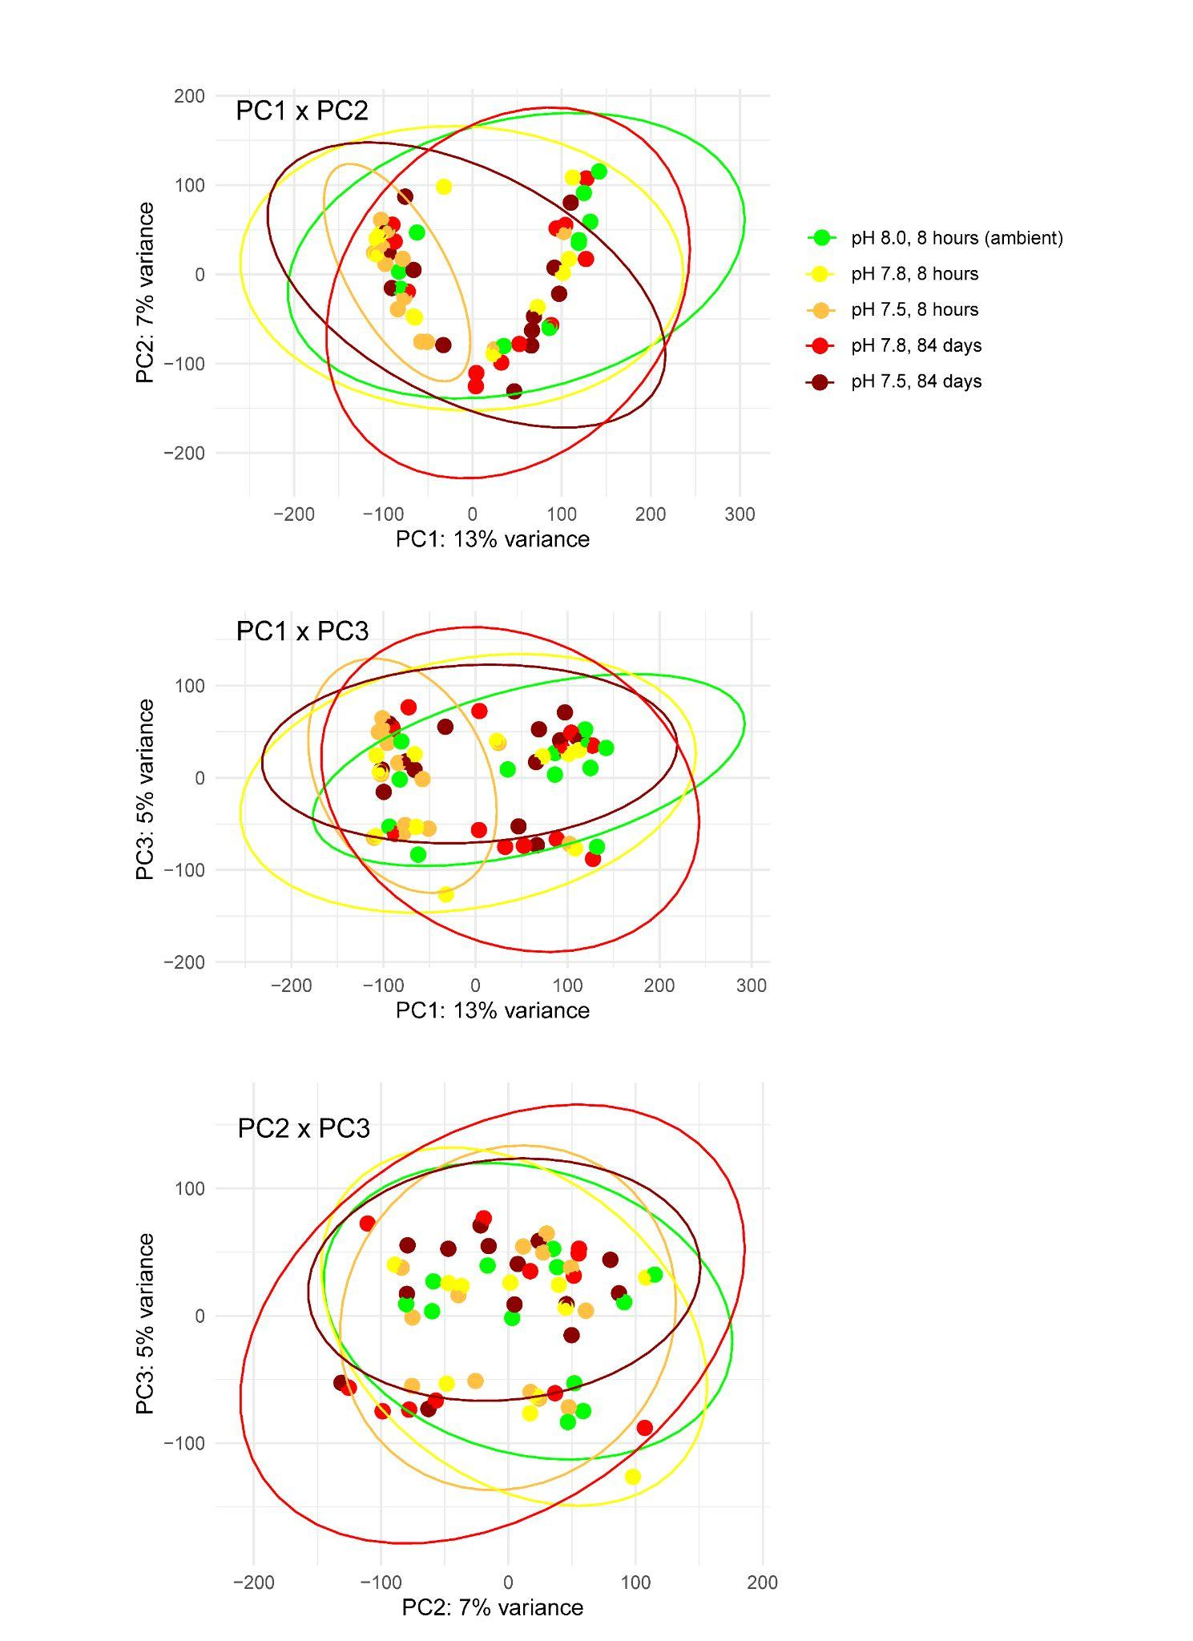
Figure S1: Principal component analysis biplots (PC1-PC3) without including surrogate variable analysis to control for unknown latent effects. The horseshoe pattern in PC1xPC2 and clustering by factors not related to treatment in biplots along PC1 and PC3 demonstrate the expression heterogeneity of unknown technical or biological variables that obfuscates acclimatory response to acidification.
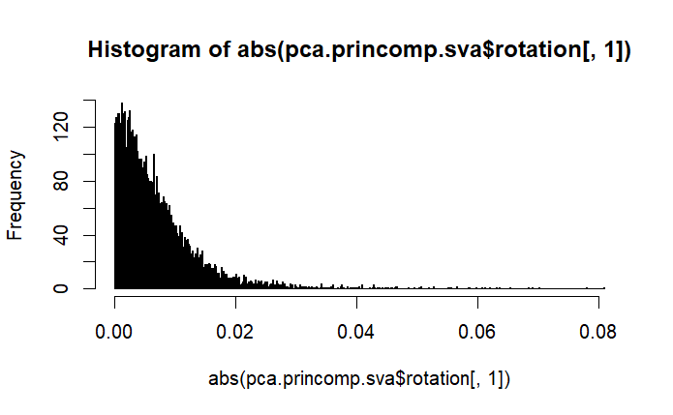
Figure S2: Histogram of PC1 loadings (absolute values) from the VST- and SVA-controlled count matrix, the top 1% of which were >0.03.

Table S1: Genes with top loadings along PC1 and PC2. Link to table for now.

Table S2: Lists of DEGs after 8 hr OA exposure. Link to table for now.

Table S3: Persistent DEGs, those from 8 hr that were also DEGs at 88 days . Link to table for now.

Table S4: Lists of DEGs among OA treatments at 88 days. Link to table for now.

Short term acclimation mechanisms that persisted at day 88
We did not generate expression data for the ambient treatment at day 88, so cannot fully separate OA effects from other potential influences of long-term laboratory exposure (e.g., diet, tank environment). To focus on genes most consistently associated with OA, we identified differentially expressed genes (DEGs) at 8 h that remained differentially expressed at 88 days (Figure S3, Table S2).
In moderate OA, 18 DEGs identified at 8-hr persisted at 88 d (Table S2), which were enriched for RNA binding (GO:0003723) and included several involved in transcription and splicing, proteolysis, retinol metabolism, cell adhesion/structure, and circadian rhythm (Mandibular organ-inhibiting hormone, see Fig 3).
In the severe OA treatment, 59 DEGs identified at 8-hr persisted at 88 d (Table S2), which were not significant enriched for any processes, but broadly reflect genes involved in mitochondrial energy metabolism, detoxification, and defense against oxidative or hypoxic stress (HSP22, CYP2L1, SIRT4, CBS, Gstt4), cell division and transcriptional control (e.g. cdk1, Mafg, Usp21), cell adhesion and cytoskeleton dynamics (TTN, Actr3, Cad87), and hormone and growth factor signaling (FLT4, LHCGR, Tdrd9). These “persistent” DEGs suggest that severe OA induces long-lasting shifts in stress response, signaling, and cellular regulation (Table X).
Two genes were found to persist in both moderate and severe OA treatments: cad87A which codes for a cadherin, and nup43 which codes for a nucleoporin, and which were expressed at lower and higher levels, respectively, in OA treatments compared to control (Figure S4).

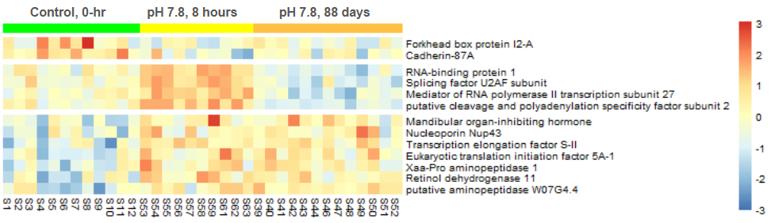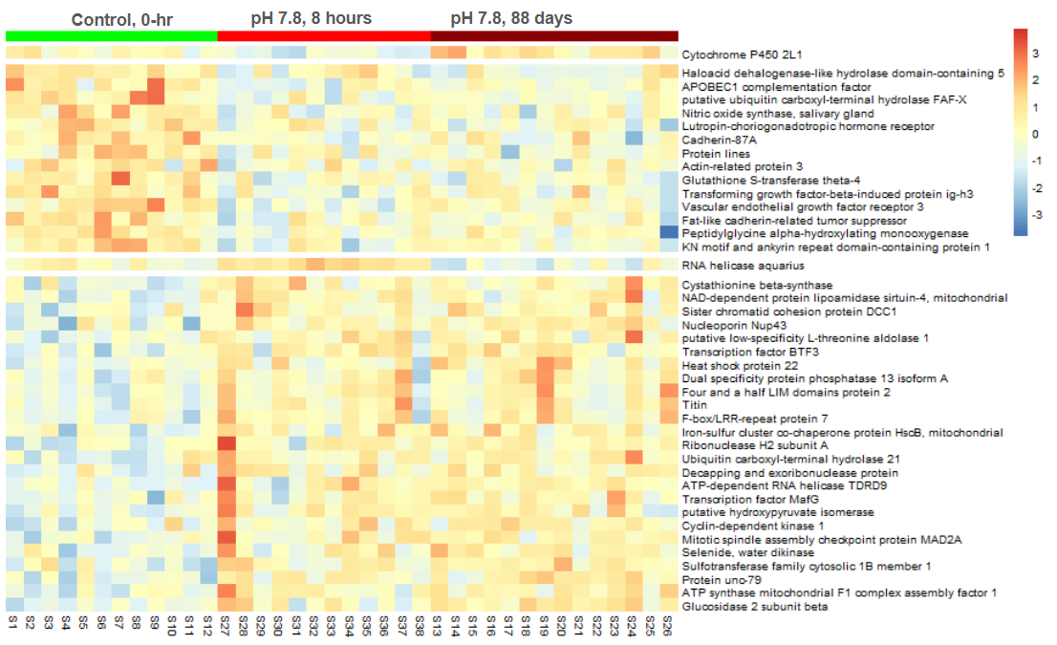Figure S3: Heatmaps of persistent DEGs, defined as genes differentially expressed at both 8 h and 88 d. Results are shown for moderate OA (pH 7.8, top) and severe OA (pH 7.5, bottom) relative to control conditions measured at time 0. Colors indicate relative expression (z-scores), with red = higher and blue = lower expression, columns represent individual crabs, and rows represent individual genes, which are grouped by their expression pattern. Two genes were persistent DEGs in both OA treatments: cadherin-87A (cad87a) and nucleoporin (nup43), which were expressed at lower and higher levels, respectively, in OA compared to control.

