ESM 260 - Problem Set 1

Laura Ingulsrud

1/29/2020

#### 1. Mean Density of Adult Fish

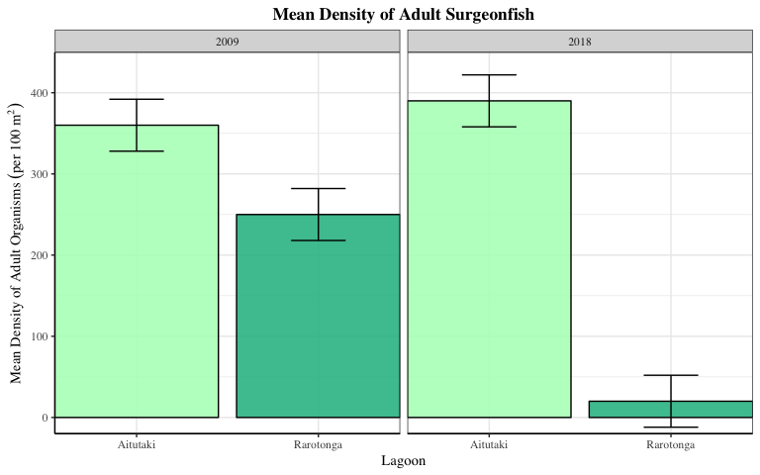

There were significantly less adult Surgeonfish in Rarotonga compared to Aitutaki in both 2009 and 2018, although this difference is more drastic in 2018. In Rarotonga, adult Surgeonfish significantly decreased from 2009 to 2018.

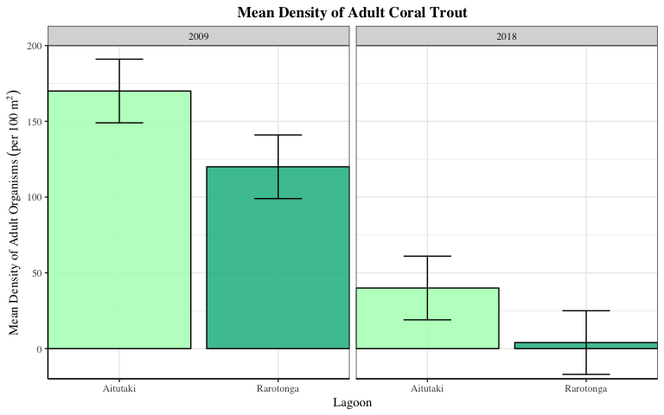

There were significantly less adult Coral Trout in Rarotonga compared to Aitutaki in 2009. In Aitutaki and Rarotonga, adult Coral Trout significantly decreased from 2009 to 2018.

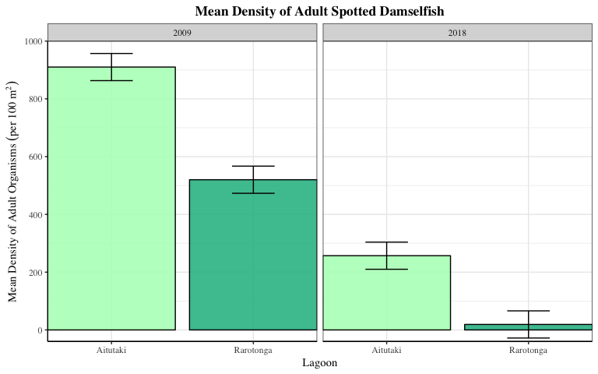

There were significantly less adult Spotted Damselfish in Rarotonga compared to Aitutaki in both 2009 and 2018. In Aitutaki and Rarotonga, adult Spotted Damselfish significantly decreased from 2009 to 2018.

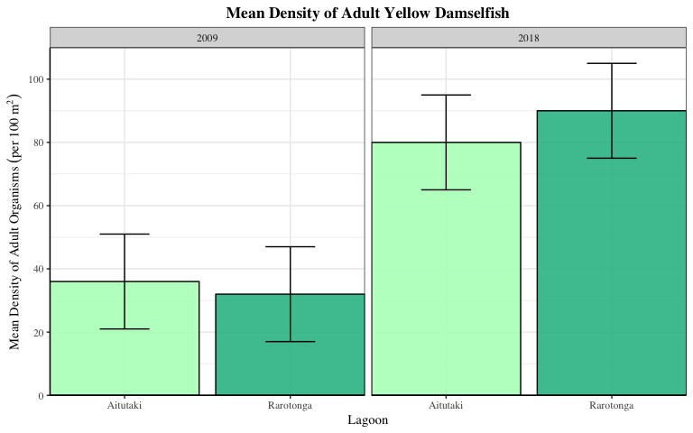

In Aitutaki and Rarotonga, adult Yellow Damselfish significantly increased from 2009 to 2018.

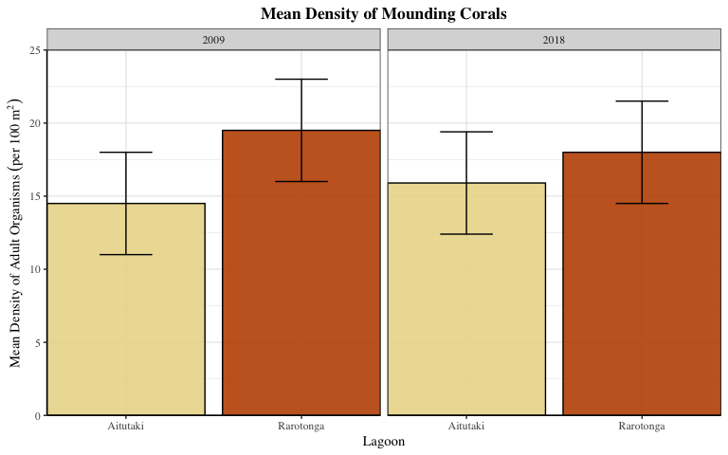

There are no statistically significant differences in mounding coral density across lagoons and years.

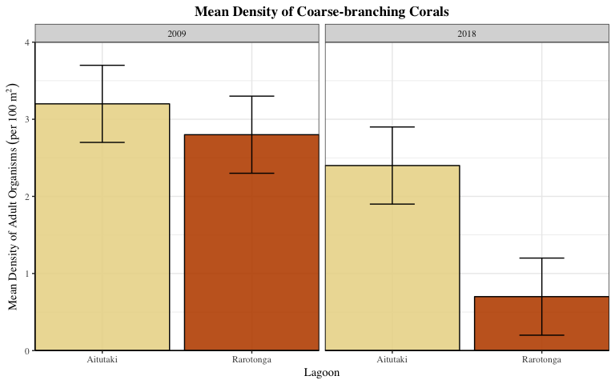

In Rarotonga, Coarse-branching Corals significantly decreased from 2009 to 2018. Coarse-branching Corals density in Rarotonga is significantly less than in Aitutaki in 2018.

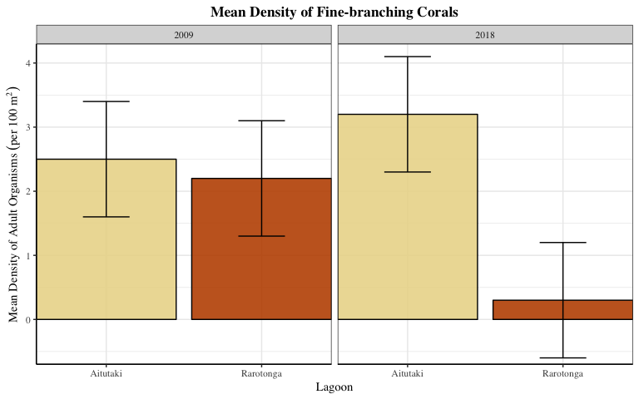

In Rarotonga, Fine-branching Corals significantly decreased from 2009 to 2018. Coarse-branching Corals density in Rarotonga is significantly less than in Aitutaki in 2018.

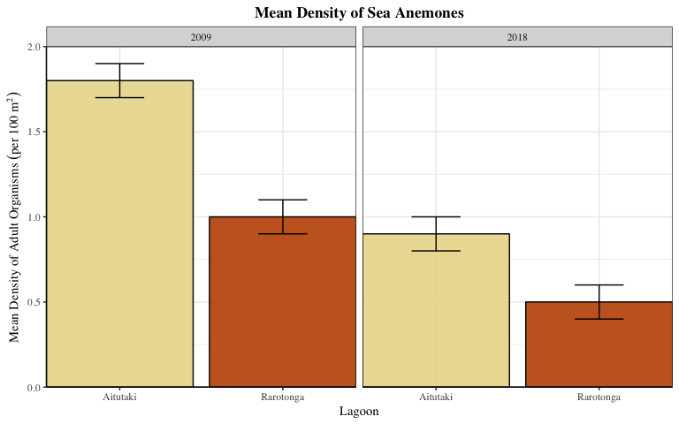

In Rarotonga and Aitutaki, Sea Anemones significantly decreased from 2009 to 2018. Sea Anemone densities in Rarotonga significantly less than in Aitutaki in both 2009 and 2018.

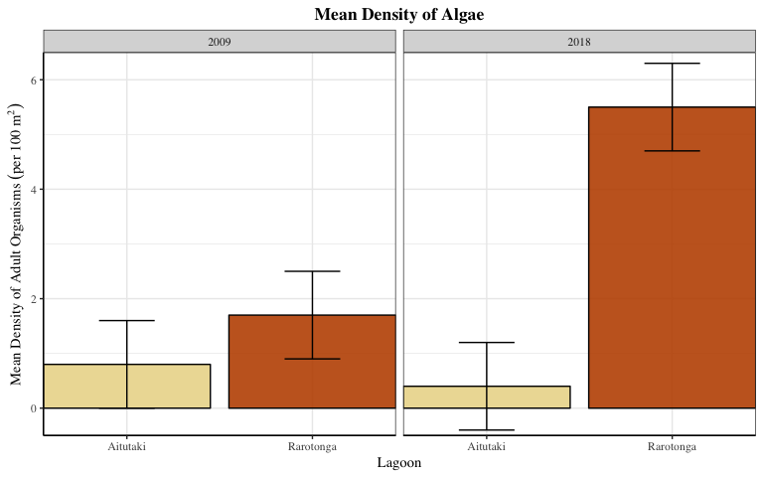

In Rarotonga, Algae significantly increased from 2009 to 2018. Algae density in Rarotonga is significantly greater than in Aitutaki in 2018.

#### 2. Mean Density of Recruited Young Fish

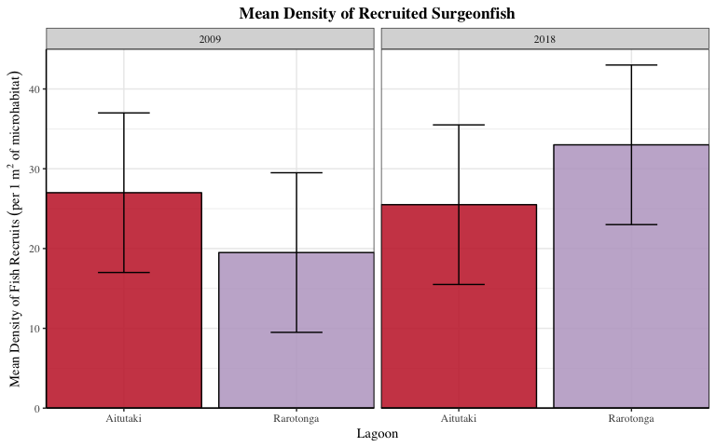

There are no statistically significant differences in mounding coral density across lagoons and years.

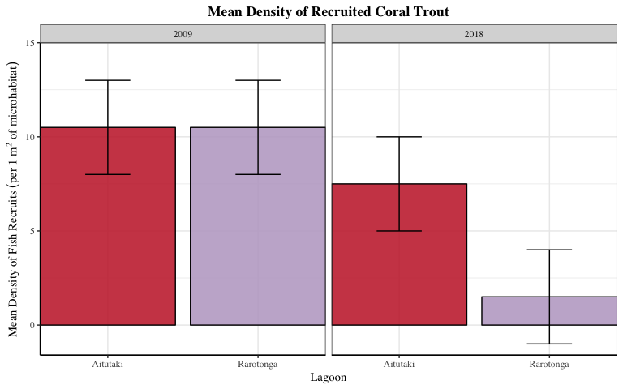

In Rarotonga, recruited Coral Trout significantly decreased from 2009 to 2018. There were significantly less recruited Coral Trout in Rarotonga compared to Aitutaki in 2018.

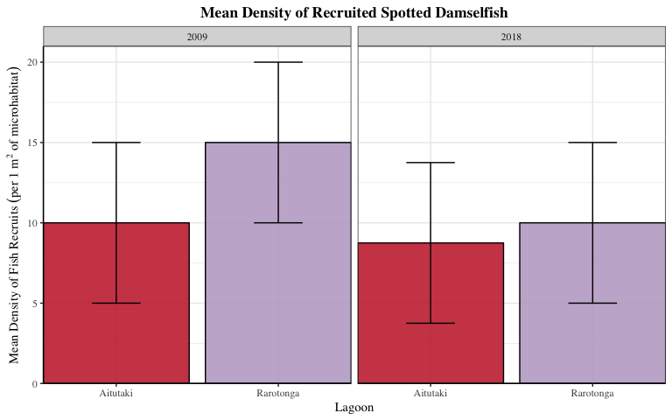

There are no statistically significant differences in mounding coral density across lagoons and years.

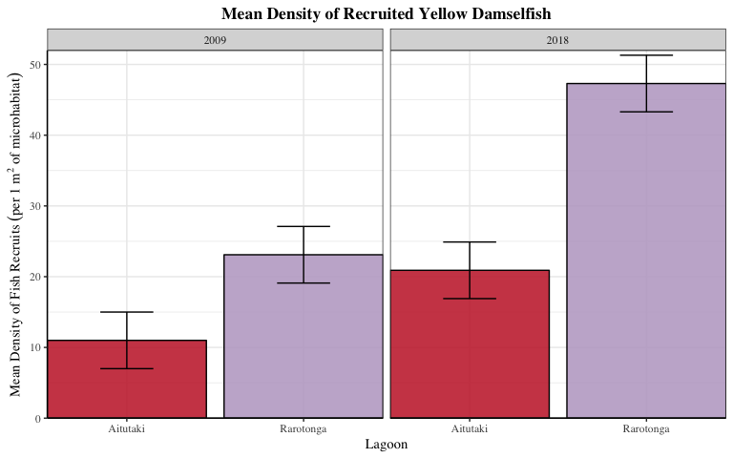

There were significantly more recruited Yellow Damselfish in Rarotonga compared to Aitutaki in both 2009 and 2018. In both Aitutaki and Rarotonga, recruited Yellow Damselfish significantly increased from 2009 to 2018.

#### 3. Density of Fish Recruits per 100 m2 Area of Reef

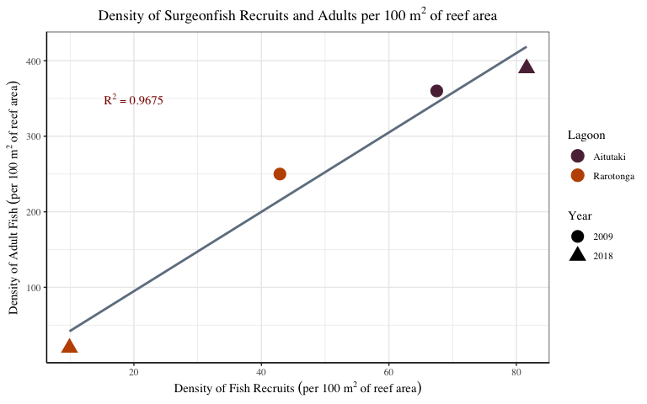

Surgeonfish shows a strong positive correlation in adult and recruit densities overall. In Aitutaki from 2009 to 2018, this relationship indicates a trend of both adult Surgeonfish and its recruits increasing over time. In Rarotonga from 2009 to 2018, this relationship indicates a trend of both adult Surgeonfish and its recruits decreasing over time.

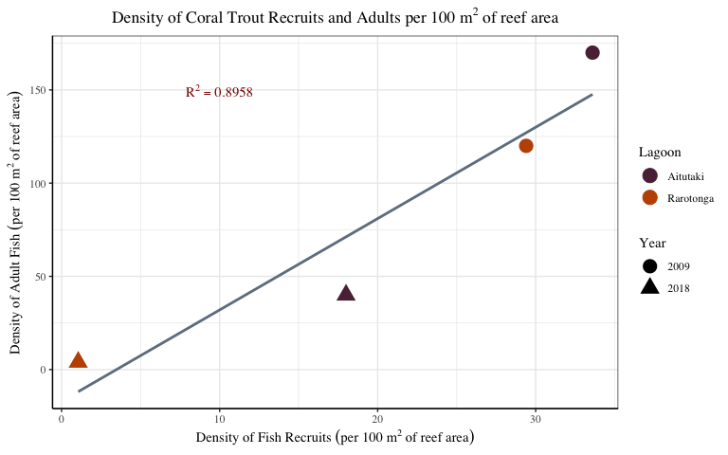

Coral Trout shows a strong positive correlation in adult and recruit densities overall. In both Aitutaki and Rarotonga from 2009 to 2018, this relationship indicates a trend of both adult Coral Trout and its recruits decreasing over time.

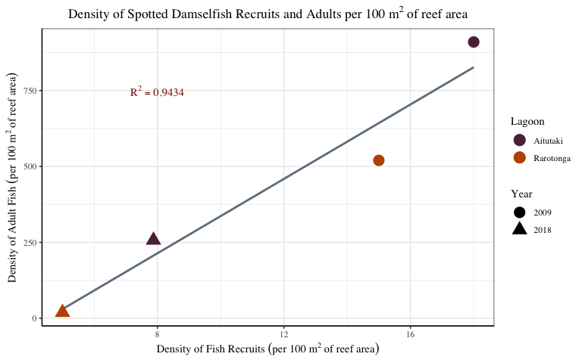

Spotted Damselfish shows a strong positive correlation in adult and recruit densities overall. In both Aitutaki and Rarotonga from 2009 to 2018, this relationship indicates a trend of both adult Spotted Damselfish and its recruits decreasing over time.

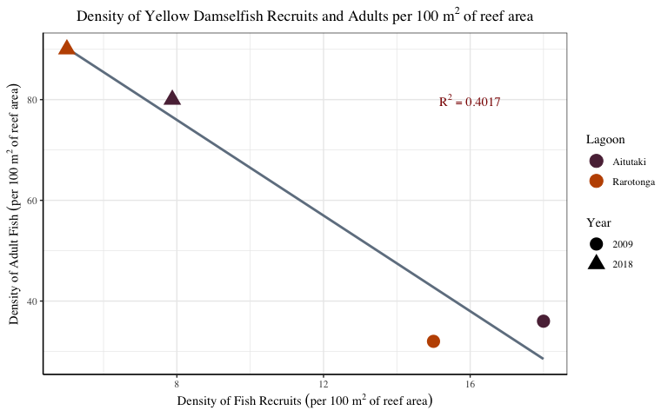

Yellow Damselfish shows a weak negative correlation in adult and recruit densities overall. In both Aitutaki and Rarotonga from 2009 to 2018, this relationship indicates a trend of adult Coral Trout increasing, but recruits decreasing over time.

#### 4. Relationship between density of adults and density of microhabitat used by young

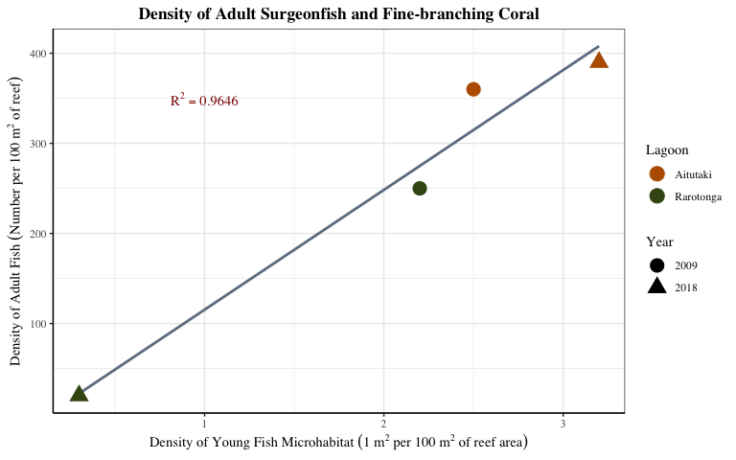

Adult Surgeonfish shows a strong positive correlation between its density and its young’s microhabitat (Fine-branching Coral) density overall. In Aitutaki from 2009 to 2018, this relationship indicates a trend of increasing young fish microhabitat leading to increasing adult fish associated with that microhabitat. In Rarotonga from 2009 to 2018 however, this trend reverses, with both Fine-branching Coral and adult Surgeonfish decreasing over time.

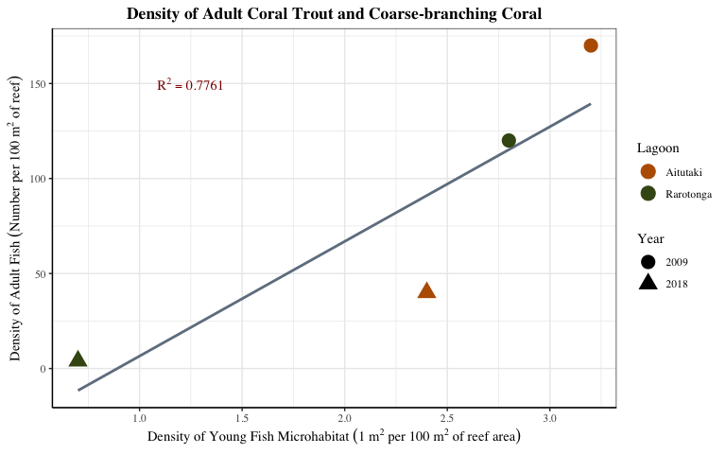

Adult Coral Trout shows a positive correlation between its density and its young’s microhabitat (Coarse-branching Coral) density overall. In both Aitutaki and Rarotonga from 2009 to 2018, this relationship indicates a trend of both Coarse-branching Coral and adult Coral Trout decreasing over time.

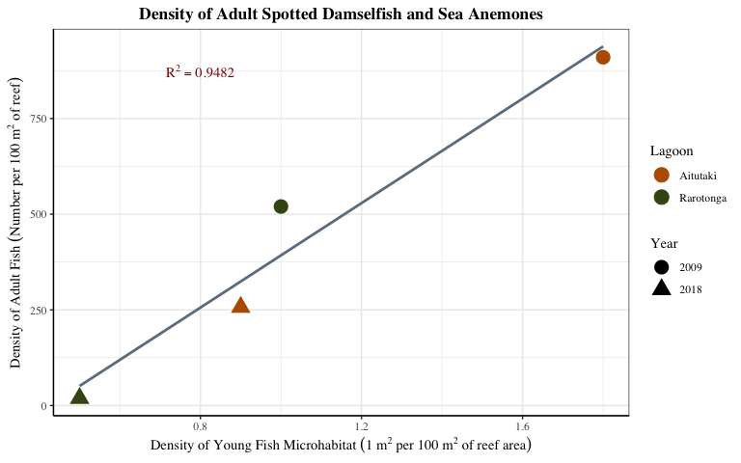

Adult Spotted Damselfish shows a strong positive correlation between its density and its young’s microhabitat (Sea Anemones) density overall. In both Aitutaki and Rarotonga from 2009 to 2018, this relationship indicates a trend of both Sea Anemones and adult Spotted Damselfish decreasing over time.

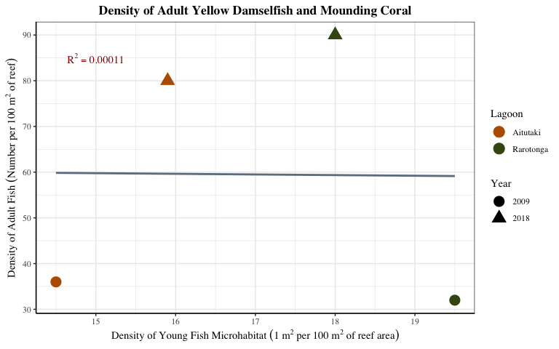

There is no significant correlation between adult Yellow Damselfish density and its young’s microhabitat (Mounding Coral) density overall. This relationship indicates there is no trend associated with Mounding Coral and adult Yellow Damselfish.

#### 5. Density of adults per area of microhabitat used by young

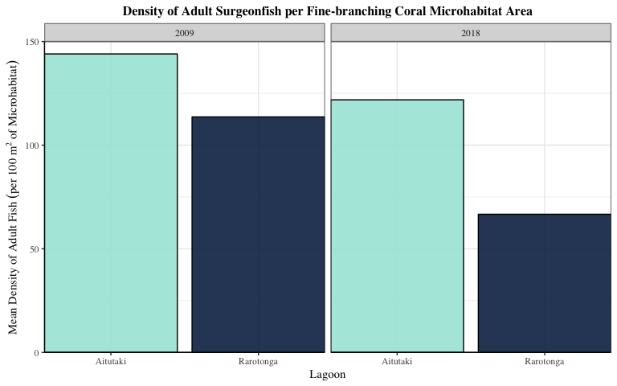

Between Rarotonga and Aitutaki, Surgeonfish show apparent differences in the density of adults per area of juvenile microhabitat in both 2009 and 2018, with densities being lower in Rarotonga compared to Aitutaki. Surgeonfish show an apparent decrease in the density of adults per area of juvenile habitat in both lagoons between 2009 and 2018.

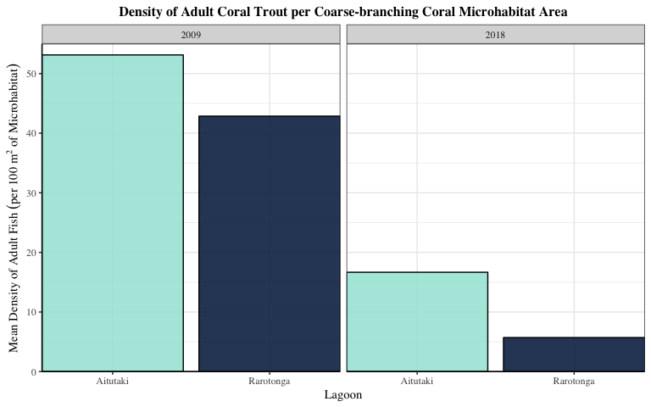

Between Rarotonga and Aitutaki, Coral Trout show apparent differences in the density of adults per area of juvenile microhabitat in both 2009 and 2018, with densities being lower in Rarotonga compared to Aitutaki. Coral Trout show an apparent decrease in the density of adults per area of juvenile habitat in both lagoons between 2009 and 2018, with a large decrease appearing in Rarotonga between 2009 and 2018.

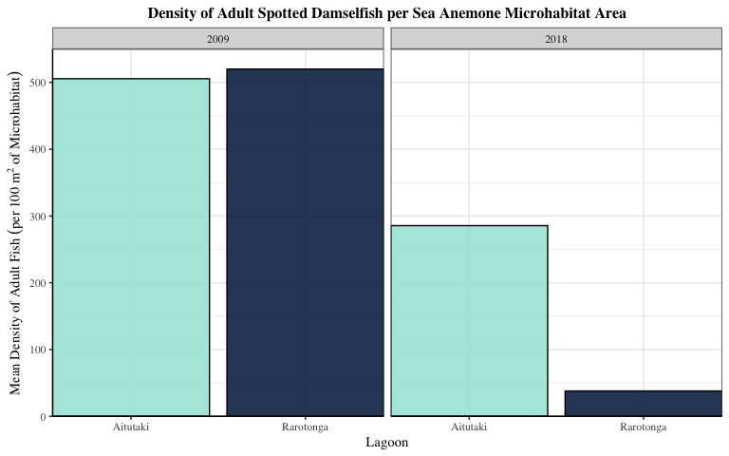

Spotted Damselfish show apparent differences in the density of adults per area of juvenile microhabitat in 2018, with densities being much lower in Rarotonga compared to Aitutaki, but densities are pretty similar between the two lagoons in 2009. Spotted Damselfish show an apparent decrease in the density of adults per area of juvenile habitat in both lagoons between 2009 and 2018, with a large decrease appearing in Rarotonga between 2009 and 2018.

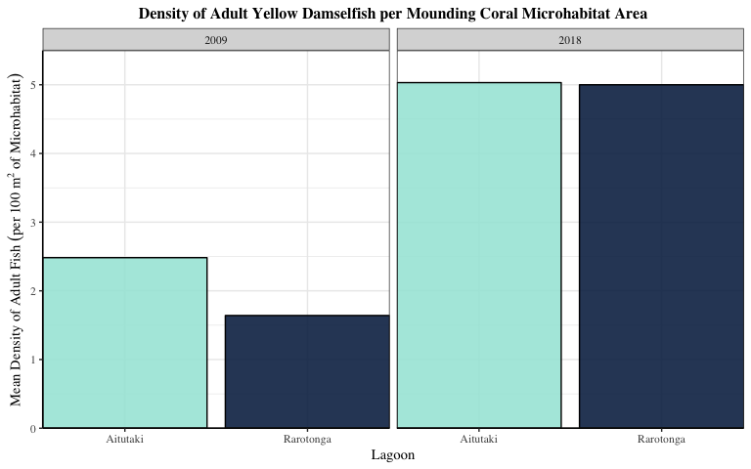

Yellow Damselfish show an apparent increase in the density of adults per area of juvenile habitat in both lagoons between 2009 and 2018, although there isn’t much difference between the two lagoons in both years.

#### 6. Compare densities of adults

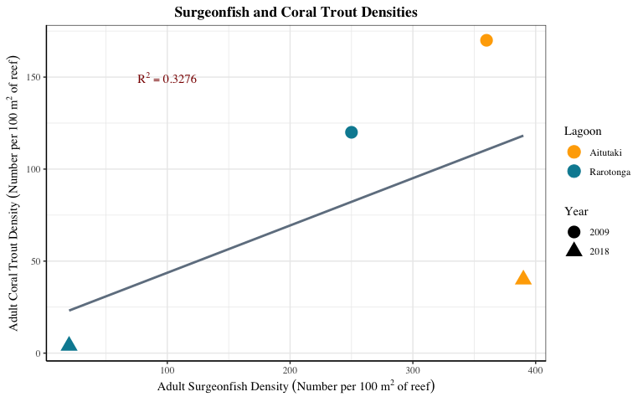

There is a weak positive correlation between adult Coral Trout and adult Surgeonfish densities overall. In Aitutaki from 2009 to 2018, this relationship indicates a trend of increasing Surgeonfish but decreasing Coral Trout. In Rarotonga from 2009 to 2018, this relationship indicates a negative trend, with both Coral Trout and Surgeonfish decreasing over time.

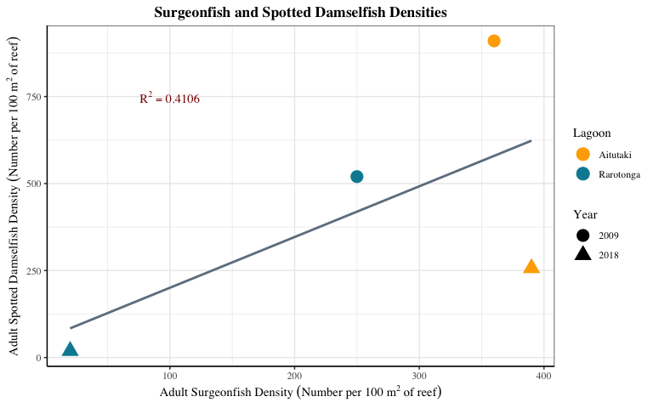

There is a weak positive correlation between adult Spotted Damselfish and adult Surgeonfish densities overall. In Aitutaki from 2009 to 2018, this relationship indicates a trend of increasing Surgeonfish but decreasing Spotted Damselfish. In Rarotonga from 2009 to 2018, this relationship indicates a negative trend, with both Spotted Damselfish and Surgeonfish decreasing over time.

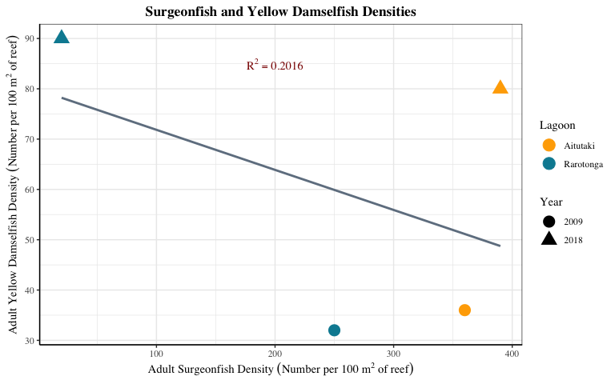

There is a weak negative correlation between adult Yellow Damselfish and adult Surgeonfish densities overall. In Aitutaki from 2009 to 2018, this relationship indicates a positive trend of increasing Surgeonfish and Yellow Damselfish. In Rarotonga from 2009 to 2018, this trend shows Yellow Damselfish increasing, while Surgeonfish is decreasing over time.

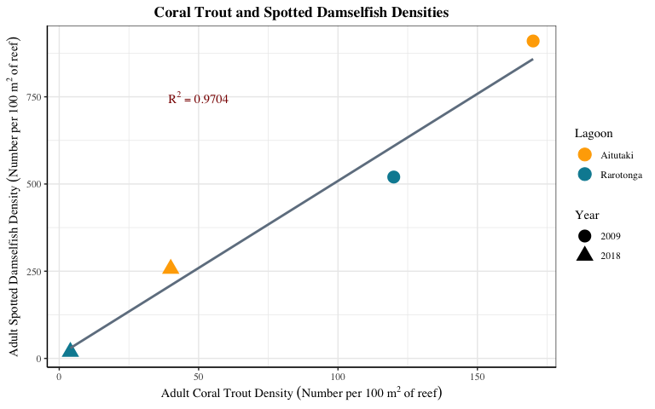

There is a strong positive correlation between adult Coral Trout and adult Spotted Damselfish densities overall. In both Aitutaki and Rarotonga from 2009 to 2018, this relationship indicates a trend of decreasing Coral Trout and Spotted Damselfish over time.

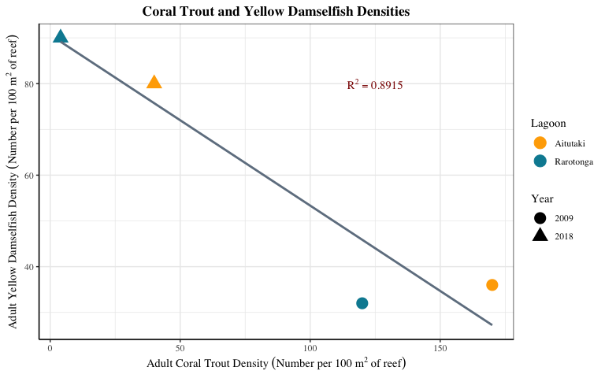

There is a strong negative correlation between adult Coral Trout and adult Yellow Damselfish densities overall. In both Aitutaki and Rarotonga from 2009 to 2018, this relationship indicates a trend of decreasing Coral Trout but increasing Yellow Damselfish over time.

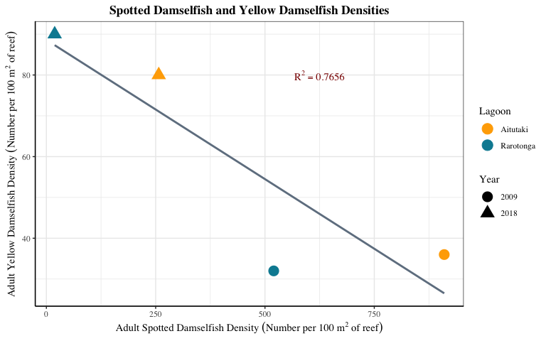

There is a negative correlation between adult Spotted Damselfish and adult Yellow Damselfish densities overall. In both Aitutaki and Rarotonga from 2009 to 2018, this relationship indicates a trend of decreasing Spotted Damselfish but increasing Yellow Damselfish over time.