Donor Compass Sensitivity Analysis Report
Cause-Area Cluster View
Generated May 06, 2026 · Rethink Priorities

Executive Summary
This report measures sensitivity at the cause-area level rather than the individual-fund level. Funds are grouped into three cause areas:
- GHD (Global Health & Dev.): givewell + leaf
- GCR (Global Catastrophic Risks): longview_ai + longview_nuclear + sentinel_bio
- AW (Animal Welfare): ea_awf + navigation_fund_cagefree + navigation_fund_general
The cause-area sensitivity index (SI) measures how much the total allocation to each cause area changes when an assumption is shifted. SI = Σ|Δ cause area| / 2 (half the total flow between causes) for all analyses. A test that reshuffles money between funds within the same cause area — for example shifting dollars from GiveWell to LEAF — will show SI = 0 here but nonzero SI in the companion fund-level report. Comparing the two reports reveals whether a sensitivity driver is a cross-cause or within-cause effect.

Baseline Cause-Area Allocation
Cause Area | Baseline Allocation (%)
GHD (Global Health & Dev.) | 17.9%
GCR (Global Catastrophic Risks) | 35.6%
AW (Animal Welfare) | 46.5%

Maximum Cause-Area SI by Dimension
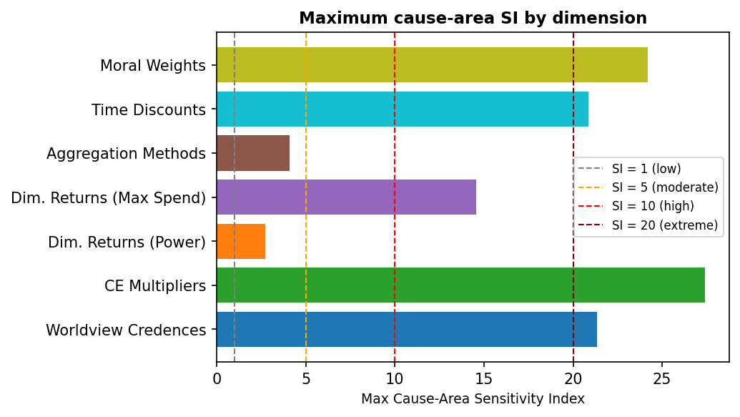

Distribution of Cause-Area SI Values — Main Analyses Only
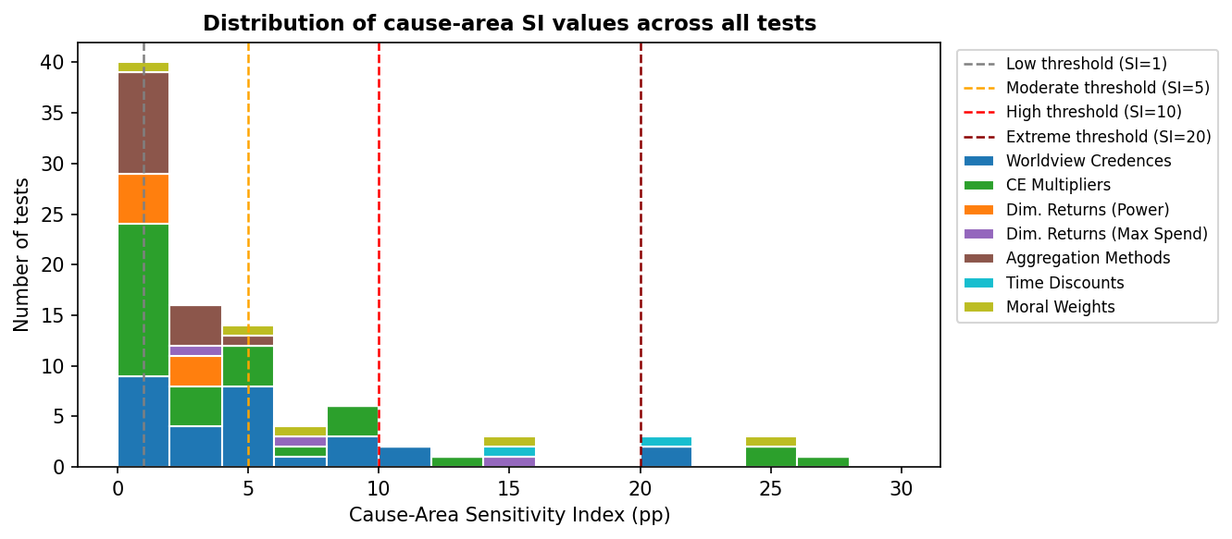

Note: risk-aversion scenario tests and analyses placing 100% credence in a single worldview or aggregation method are presented separately in Section 5 as illustrative scenarios; they are excluded from the chart above.

Distribution of Cause-Area SI Values — Including Illustrative Tests
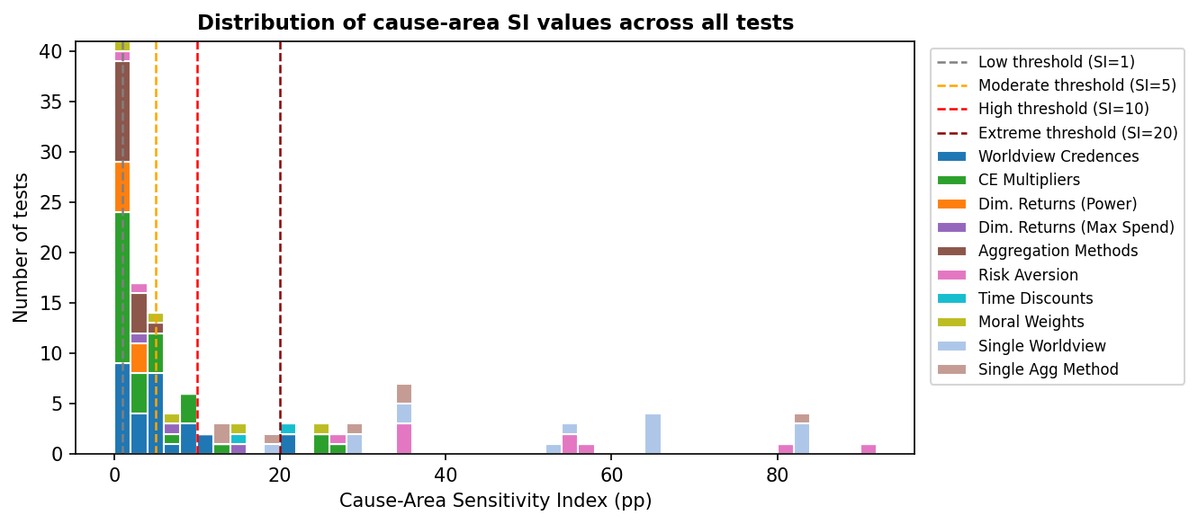

1. Worldview Credences
Each worldview's credence is shifted to its low-end or high-end uncertainty bound one at a time, with others renormalised. SI here measures the total flow between cause areas (GHD ↔ GCR ↔ AW). A test that moves money from GiveWell to LEAF (both GHD) will show SI = 0 in this report.

Cause-Area Sensitivity — Ranked by SI (top 20)
Worldview | Bound | Credence Range | SI | Scaled SI* | Most Affected Cause Area | Max Δ
Total Utilitarianism — Default | high | 10% → 25% | 21.33 | 1.42 | GCR (Global Catastrophic Risks) | +21.33 pp
Non-Utilitarian Consequentialism — Default | high | 5% → 20% | 21.15 | 1.41 | GCR (Global Catastrophic Risks) | +21.15 pp
Total Utilitarianism — Weighted Linear Utility | low | 10% → 5% | 11.89 | 2.38 | GCR (Global Catastrophic Risks) | +11.89 pp
Non-Utilitarian Consequentialism — Person-Affecting/Cluelessness | high | 5% → 20% | 10.49 | 0.70 | GCR (Global Catastrophic Risks) | +10.49 pp
Contractualism — Person-Affecting/Cluelessness and Animals Baseline | high | 10% → 25% | 9.16 | 0.61 | GCR (Global Catastrophic Risks) | +9.16 pp
Contractualism — Default + cluelessness | high | 5% → 15% | 8.99 | 0.90 | GHD (Global Health & Dev.) | +8.99 pp
Kantianism — Low animals | high | 5% → 20% | 8.38 | 0.56 | GHD (Global Health & Dev.) | +8.38 pp
Kantianism — Low animals / downside critical | high | 10% → 20% | 6.15 | 0.62 | GHD (Global Health & Dev.) | +6.15 pp
Contractualism — Person-Affecting/Cluelessness and Animals Baseline - Risk Neutral | high | 10% → 20% | 5.33 | 0.53 | GCR (Global Catastrophic Risks) | +5.33 pp
Non-Utilitarian Consequentialism — High Life Value / Cluelessness / Low animals | high | 5% → 15% | 5.29 | 0.53 | GCR (Global Catastrophic Risks) | +5.29 pp
Kantianism — Low animals / downside critical | low | 10% → 1% | 4.97 | 0.55 | GHD (Global Health & Dev.) | -4.97 pp
Total Utilitarianism — Weighted Linear Utility | high | 10% → 20% | 4.66 | 0.47 | AW (Animal Welfare) | +4.66 pp
Total Utilitarianism — Person-Affecting/Cluelessness, Sentience-only discounts, Empirical disbelief in upside scenarios | high | 10% → 20% | 4.65 | 0.46 | AW (Animal Welfare) | +4.65 pp
Total Utilitarianism — Suffering forward, clueless, and only sentience discount | high | 5% → 15% | 4.46 | 0.45 | AW (Animal Welfare) | +4.46 pp
Total Utilitarianism — High life value, risk averse, and skeptical of upside cases | high | 5% → 15% | 4.43 | 0.44 | AW (Animal Welfare) | +4.43 pp
Contractualism — Person-Affecting/Cluelessness and Animals Baseline - Risk Neutral | low | 10% → 1% | 4.09 | 0.45 | GCR (Global Catastrophic Risks) | -4.09 pp
Non-Utilitarian Consequentialism — Weighted Linear Utility | high | 5% → 15% | 3.59 | 0.36 | GCR (Global Catastrophic Risks) | -3.59 pp
Total Utilitarianism — Default | low | 10% → 5% | 2.50 | 0.50 | GCR (Global Catastrophic Risks) | -2.50 pp
Total Utilitarianism — Person-Affecting/Cluelessness, Sentience-only discounts, Empirical disbelief in upside scenarios | low | 10% → 5% | 2.19 | 0.44 | AW (Animal Welfare) | -2.19 pp
Kantianism — Low animals | low | 5% → 1% | 2.01 | 0.50 | GHD (Global Health & Dev.) | -2.01 pp
* Scaled SI = SI ÷ absolute credence change (pp).

Same Tests — Ranked by Scaled SI (top 20)
Rank | Worldview | Bound | Credence Range | SI | Scaled SI | Most Affected Cause Area | Max Δ
1 | Total Utilitarianism — Weighted Linear Utility | low | 10% → 5% | 11.89 | 2.38 | GCR (Global Catastrophic Risks) | +11.89 pp
2 | Total Utilitarianism — Default | high | 10% → 25% | 21.33 | 1.42 | GCR (Global Catastrophic Risks) | +21.33 pp
3 | Non-Utilitarian Consequentialism — Default | high | 5% → 20% | 21.15 | 1.41 | GCR (Global Catastrophic Risks) | +21.15 pp
4 | Contractualism — Default + cluelessness | high | 5% → 15% | 8.99 | 0.90 | GHD (Global Health & Dev.) | +8.99 pp
5 | Non-Utilitarian Consequentialism — Person-Affecting/Cluelessness | high | 5% → 20% | 10.49 | 0.70 | GCR (Global Catastrophic Risks) | +10.49 pp
6 | Kantianism — Low animals / downside critical | high | 10% → 20% | 6.15 | 0.62 | GHD (Global Health & Dev.) | +6.15 pp
7 | Contractualism — Person-Affecting/Cluelessness and Animals Baseline | high | 10% → 25% | 9.16 | 0.61 | GCR (Global Catastrophic Risks) | +9.16 pp
8 | Contractualism — Default + cluelessness | low | 5% → 2% | 1.77 | 0.59 | GHD (Global Health & Dev.) | -1.77 pp
9 | Kantianism — Low animals | high | 5% → 20% | 8.38 | 0.56 | GHD (Global Health & Dev.) | +8.38 pp
10 | Kantianism — Low animals / downside critical | low | 10% → 1% | 4.97 | 0.55 | GHD (Global Health & Dev.) | -4.97 pp
11 | Contractualism — Person-Affecting/Cluelessness and Animals Baseline - Risk Neutral | high | 10% → 20% | 5.33 | 0.53 | GCR (Global Catastrophic Risks) | +5.33 pp
12 | Non-Utilitarian Consequentialism — High Life Value / Cluelessness / Low animals | high | 5% → 15% | 5.29 | 0.53 | GCR (Global Catastrophic Risks) | +5.29 pp
13 | Kantianism — Low animals | low | 5% → 1% | 2.01 | 0.50 | GHD (Global Health & Dev.) | -2.01 pp
14 | Total Utilitarianism — Default | low | 10% → 5% | 2.50 | 0.50 | GCR (Global Catastrophic Risks) | -2.50 pp
15 | Total Utilitarianism — Weighted Linear Utility | high | 10% → 20% | 4.66 | 0.47 | AW (Animal Welfare) | +4.66 pp
16 | Total Utilitarianism — Person-Affecting/Cluelessness, Sentience-only discounts, Empirical disbelief in upside scenarios | high | 10% → 20% | 4.65 | 0.46 | AW (Animal Welfare) | +4.65 pp
17 | Contractualism — Person-Affecting/Cluelessness and Animals Baseline - Risk Neutral | low | 10% → 1% | 4.09 | 0.45 | GCR (Global Catastrophic Risks) | -4.09 pp
18 | Total Utilitarianism — Suffering forward, clueless, and only sentience discount | high | 5% → 15% | 4.46 | 0.45 | AW (Animal Welfare) | +4.46 pp
19 | Total Utilitarianism — Suffering forward, clueless, and only sentience discount | low | 5% → 2% | 1.33 | 0.44 | AW (Animal Welfare) | -1.33 pp
20 | Total Utilitarianism — High life value, risk averse, and skeptical of upside cases | high | 5% → 15% | 4.43 | 0.44 | AW (Animal Welfare) | +4.43 pp

Cause-Area Allocation Changes — Tests with SI ≥ 5 (moderate+)
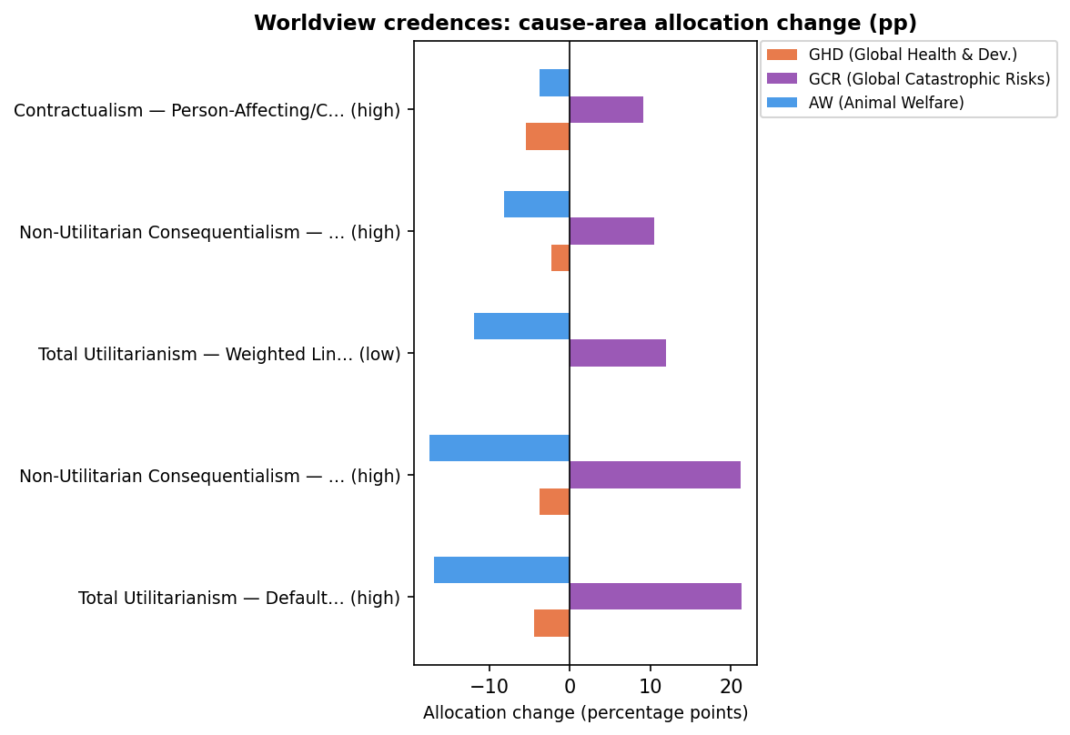

Cause-Area Allocation Changes — All Tests (Top 15 by Σ|Δ|)
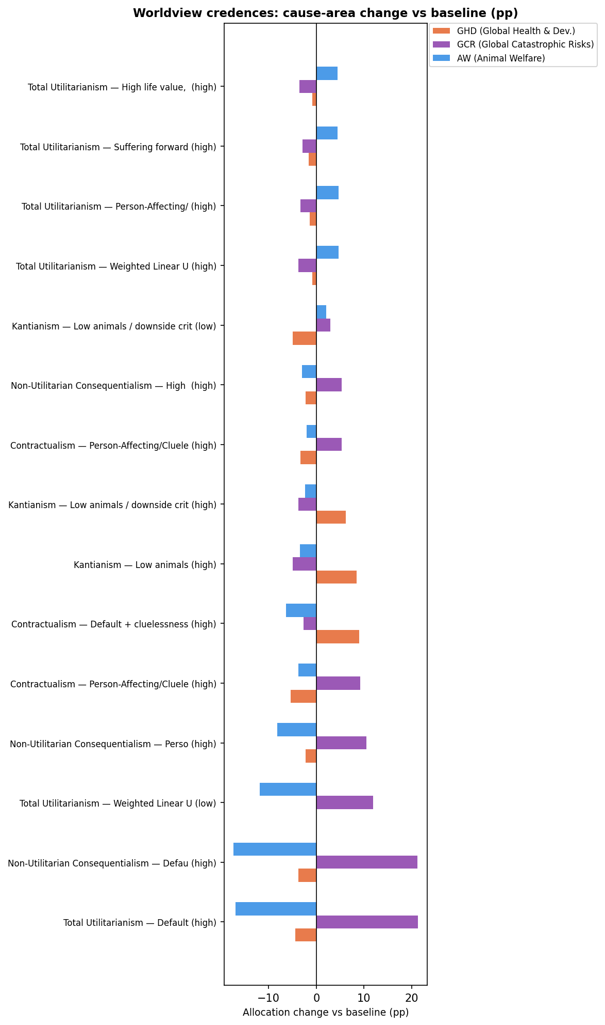

2. Cost-Effectiveness Multipliers
Each fund's CE was multiplied by a constant factor, one fund or group at a time. SI = Σ|Δ cause area| / 2 (the same convention as all other analyses). Multiplying the CE of a fund affects its cause area's total allocation; funds in other cause areas gain or lose what that cause area gains or loses.

Cause-Area Sensitivity — Ranked by SI (all tests)
Fund Varied | Multiplier | SI | Scaled SI* | Biggest Gainer | Biggest Loser
all_gcr | 100.0× | 27.40 | 13.70 | GCR (Global Catastrophic Risks) (+27.40 pp) | AW (Animal Welfare) (-19.45 pp)
all_gcr | 10000.0× | 25.96 | 6.49 | GCR (Global Catastrophic Risks) (+25.96 pp) | AW (Animal Welfare) (-18.09 pp)
all_gcr | 1000.0× | 25.89 | 8.63 | GCR (Global Catastrophic Risks) (+25.89 pp) | AW (Animal Welfare) (-18.03 pp)
all_aw | 0.25× | 12.20 | 20.27 | GHD (Global Health & Dev.) (+10.39 pp) | AW (Animal Welfare) (-12.20 pp)
all_gcr | 0.01× | 8.79 | 4.39 | GHD (Global Health & Dev.) (+8.79 pp) | GCR (Global Catastrophic Risks) (-7.77 pp)
all_gcr | 0.001× | 8.78 | 2.92 | GHD (Global Health & Dev.) (+8.78 pp) | GCR (Global Catastrophic Risks) (-7.77 pp)
all_gcr | 0.0001× | 8.78 | 2.19 | GHD (Global Health & Dev.) (+8.78 pp) | GCR (Global Catastrophic Risks) (-7.77 pp)
givewell | 2.0× | 6.32 | 20.98 | GHD (Global Health & Dev.) (+6.32 pp) | AW (Animal Welfare) (-5.82 pp)
longview_ai | 10.0× | 5.52 | 5.52 | GCR (Global Catastrophic Risks) (+5.52 pp) | GHD (Global Health & Dev.) (-3.26 pp)
longview_ai | 0.1× | 4.64 | 4.64 | GHD (Global Health & Dev.) (+4.64 pp) | AW (Animal Welfare) (-2.75 pp)
navigation_fund_general | 0.5× | 4.29 | 14.23 | GHD (Global Health & Dev.) (+4.29 pp) | AW (Animal Welfare) (-4.29 pp)
givewell | 1.5× | 4.25 | 24.12 | GHD (Global Health & Dev.) (+4.25 pp) | AW (Animal Welfare) (-3.75 pp)
all_aw | 4.0× | 3.97 | 6.59 | AW (Animal Welfare) (+3.97 pp) | GCR (Global Catastrophic Risks) (-2.74 pp)
sentinel_bio | 10.0× | 3.81 | 3.81 | GCR (Global Catastrophic Risks) (+3.81 pp) | GHD (Global Health & Dev.) (-3.78 pp)
leaf | 2.0× | 3.62 | 12.03 | GHD (Global Health & Dev.) (+3.62 pp) | AW (Animal Welfare) (-3.12 pp)
longview_nuclear | 10.0× | 2.77 | 2.77 | GCR (Global Catastrophic Risks) (+2.77 pp) | GHD (Global Health & Dev.) (-2.74 pp)
givewell | 0.5× | 1.77 | 5.90 | AW (Animal Welfare) (+1.01 pp) | GHD (Global Health & Dev.) (-1.77 pp)
leaf | 1.5× | 1.71 | 9.70 | GHD (Global Health & Dev.) (+1.71 pp) | AW (Animal Welfare) (-1.51 pp)
navigation_fund_cagefree | 0.5× | 1.33 | 4.40 | GCR (Global Catastrophic Risks) (+1.33 pp) | AW (Animal Welfare) (-1.00 pp)
givewell | 0.25× | 1.02 | 1.70 | AW (Animal Welfare) (+1.02 pp) | GCR (Global Catastrophic Risks) (-0.84 pp)
ea_awf | 2.0× | 1.01 | 3.35 | AW (Animal Welfare) (+1.01 pp) | GHD (Global Health & Dev.) (-0.97 pp)
navigation_fund_general | 2.0× | 0.98 | 3.26 | AW (Animal Welfare) (+0.98 pp) | GHD (Global Health & Dev.) (-0.98 pp)
navigation_fund_cagefree | 2.0× | 0.98 | 3.26 | GHD (Global Health & Dev.) (+0.63 pp) | GCR (Global Catastrophic Risks) (-0.98 pp)
navigation_fund_cagefree | 1.5× | 0.71 | 4.04 | GHD (Global Health & Dev.) (+0.48 pp) | GCR (Global Catastrophic Risks) (-0.71 pp)
longview_nuclear | 0.1× | 0.60 | 0.60 | GHD (Global Health & Dev.) (+0.59 pp) | GCR (Global Catastrophic Risks) (-0.60 pp)
sentinel_bio | 0.1× | 0.60 | 0.60 | GHD (Global Health & Dev.) (+0.59 pp) | GCR (Global Catastrophic Risks) (-0.60 pp)
navigation_fund_general | 1.5× | 0.59 | 3.35 | AW (Animal Welfare) (+0.59 pp) | GHD (Global Health & Dev.) (-0.59 pp)
ea_awf | 0.5× | 0.46 | 1.54 | GHD (Global Health & Dev.) (+0.46 pp) | AW (Animal Welfare) (-0.46 pp)
ea_awf | 1.5× | 0.46 | 2.58 | AW (Animal Welfare) (+0.46 pp) | GHD (Global Health & Dev.) (-0.46 pp)
leaf | 0.5× | 0.34 | 1.11 | GHD (Global Health & Dev.) (+0.34 pp) | AW (Animal Welfare) (-0.34 pp)
leaf | 0.25× | 0.12 | 0.19 | GHD (Global Health & Dev.) (+0.12 pp) | AW (Animal Welfare) (-0.12 pp)
* Scaled SI = SI ÷ orders-of-magnitude change in multiplier.

Same Tests — Ranked by Scaled SI
Rank | Fund Varied | Multiplier | SI | Scaled SI | Biggest Gainer | Biggest Loser
1 | givewell | 1.5× | 4.25 | 24.12 | GHD (Global Health & Dev.) (+4.25 pp) | AW (Animal Welfare) (-3.75 pp)
2 | givewell | 2.0× | 6.32 | 20.98 | GHD (Global Health & Dev.) (+6.32 pp) | AW (Animal Welfare) (-5.82 pp)
3 | all_aw | 0.25× | 12.20 | 20.27 | GHD (Global Health & Dev.) (+10.39 pp) | AW (Animal Welfare) (-12.20 pp)
4 | navigation_fund_general | 0.5× | 4.29 | 14.23 | GHD (Global Health & Dev.) (+4.29 pp) | AW (Animal Welfare) (-4.29 pp)
5 | all_gcr | 100.0× | 27.40 | 13.70 | GCR (Global Catastrophic Risks) (+27.40 pp) | AW (Animal Welfare) (-19.45 pp)
6 | leaf | 2.0× | 3.62 | 12.03 | GHD (Global Health & Dev.) (+3.62 pp) | AW (Animal Welfare) (-3.12 pp)
7 | leaf | 1.5× | 1.71 | 9.70 | GHD (Global Health & Dev.) (+1.71 pp) | AW (Animal Welfare) (-1.51 pp)
8 | all_gcr | 1000.0× | 25.89 | 8.63 | GCR (Global Catastrophic Risks) (+25.89 pp) | AW (Animal Welfare) (-18.03 pp)
9 | all_aw | 4.0× | 3.97 | 6.59 | AW (Animal Welfare) (+3.97 pp) | GCR (Global Catastrophic Risks) (-2.74 pp)
10 | all_gcr | 10000.0× | 25.96 | 6.49 | GCR (Global Catastrophic Risks) (+25.96 pp) | AW (Animal Welfare) (-18.09 pp)
11 | givewell | 0.5× | 1.77 | 5.90 | AW (Animal Welfare) (+1.01 pp) | GHD (Global Health & Dev.) (-1.77 pp)
12 | longview_ai | 10.0× | 5.52 | 5.52 | GCR (Global Catastrophic Risks) (+5.52 pp) | GHD (Global Health & Dev.) (-3.26 pp)
13 | longview_ai | 0.1× | 4.64 | 4.64 | GHD (Global Health & Dev.) (+4.64 pp) | AW (Animal Welfare) (-2.75 pp)
14 | navigation_fund_cagefree | 0.5× | 1.33 | 4.40 | GCR (Global Catastrophic Risks) (+1.33 pp) | AW (Animal Welfare) (-1.00 pp)
15 | all_gcr | 0.01× | 8.79 | 4.39 | GHD (Global Health & Dev.) (+8.79 pp) | GCR (Global Catastrophic Risks) (-7.77 pp)
16 | navigation_fund_cagefree | 1.5× | 0.71 | 4.04 | GHD (Global Health & Dev.) (+0.48 pp) | GCR (Global Catastrophic Risks) (-0.71 pp)
17 | sentinel_bio | 10.0× | 3.81 | 3.81 | GCR (Global Catastrophic Risks) (+3.81 pp) | GHD (Global Health & Dev.) (-3.78 pp)
18 | navigation_fund_general | 1.5× | 0.59 | 3.35 | AW (Animal Welfare) (+0.59 pp) | GHD (Global Health & Dev.) (-0.59 pp)
19 | ea_awf | 2.0× | 1.01 | 3.35 | AW (Animal Welfare) (+1.01 pp) | GHD (Global Health & Dev.) (-0.97 pp)
20 | navigation_fund_cagefree | 2.0× | 0.98 | 3.26 | GHD (Global Health & Dev.) (+0.63 pp) | GCR (Global Catastrophic Risks) (-0.98 pp)
21 | navigation_fund_general | 2.0× | 0.98 | 3.26 | AW (Animal Welfare) (+0.98 pp) | GHD (Global Health & Dev.) (-0.98 pp)
22 | all_gcr | 0.001× | 8.78 | 2.92 | GHD (Global Health & Dev.) (+8.78 pp) | GCR (Global Catastrophic Risks) (-7.77 pp)
23 | longview_nuclear | 10.0× | 2.77 | 2.77 | GCR (Global Catastrophic Risks) (+2.77 pp) | GHD (Global Health & Dev.) (-2.74 pp)
24 | ea_awf | 1.5× | 0.46 | 2.58 | AW (Animal Welfare) (+0.46 pp) | GHD (Global Health & Dev.) (-0.46 pp)
25 | all_gcr | 0.0001× | 8.78 | 2.19 | GHD (Global Health & Dev.) (+8.78 pp) | GCR (Global Catastrophic Risks) (-7.77 pp)
26 | givewell | 0.25× | 1.02 | 1.70 | AW (Animal Welfare) (+1.02 pp) | GCR (Global Catastrophic Risks) (-0.84 pp)
27 | ea_awf | 0.5× | 0.46 | 1.54 | GHD (Global Health & Dev.) (+0.46 pp) | AW (Animal Welfare) (-0.46 pp)
28 | leaf | 0.5× | 0.34 | 1.11 | GHD (Global Health & Dev.) (+0.34 pp) | AW (Animal Welfare) (-0.34 pp)
29 | longview_nuclear | 0.1× | 0.60 | 0.60 | GHD (Global Health & Dev.) (+0.59 pp) | GCR (Global Catastrophic Risks) (-0.60 pp)
30 | sentinel_bio | 0.1× | 0.60 | 0.60 | GHD (Global Health & Dev.) (+0.59 pp) | GCR (Global Catastrophic Risks) (-0.60 pp)
31 | leaf | 0.25× | 0.12 | 0.19 | GHD (Global Health & Dev.) (+0.12 pp) | AW (Animal Welfare) (-0.12 pp)

Tornado Chart — All CE Multiplier Tests
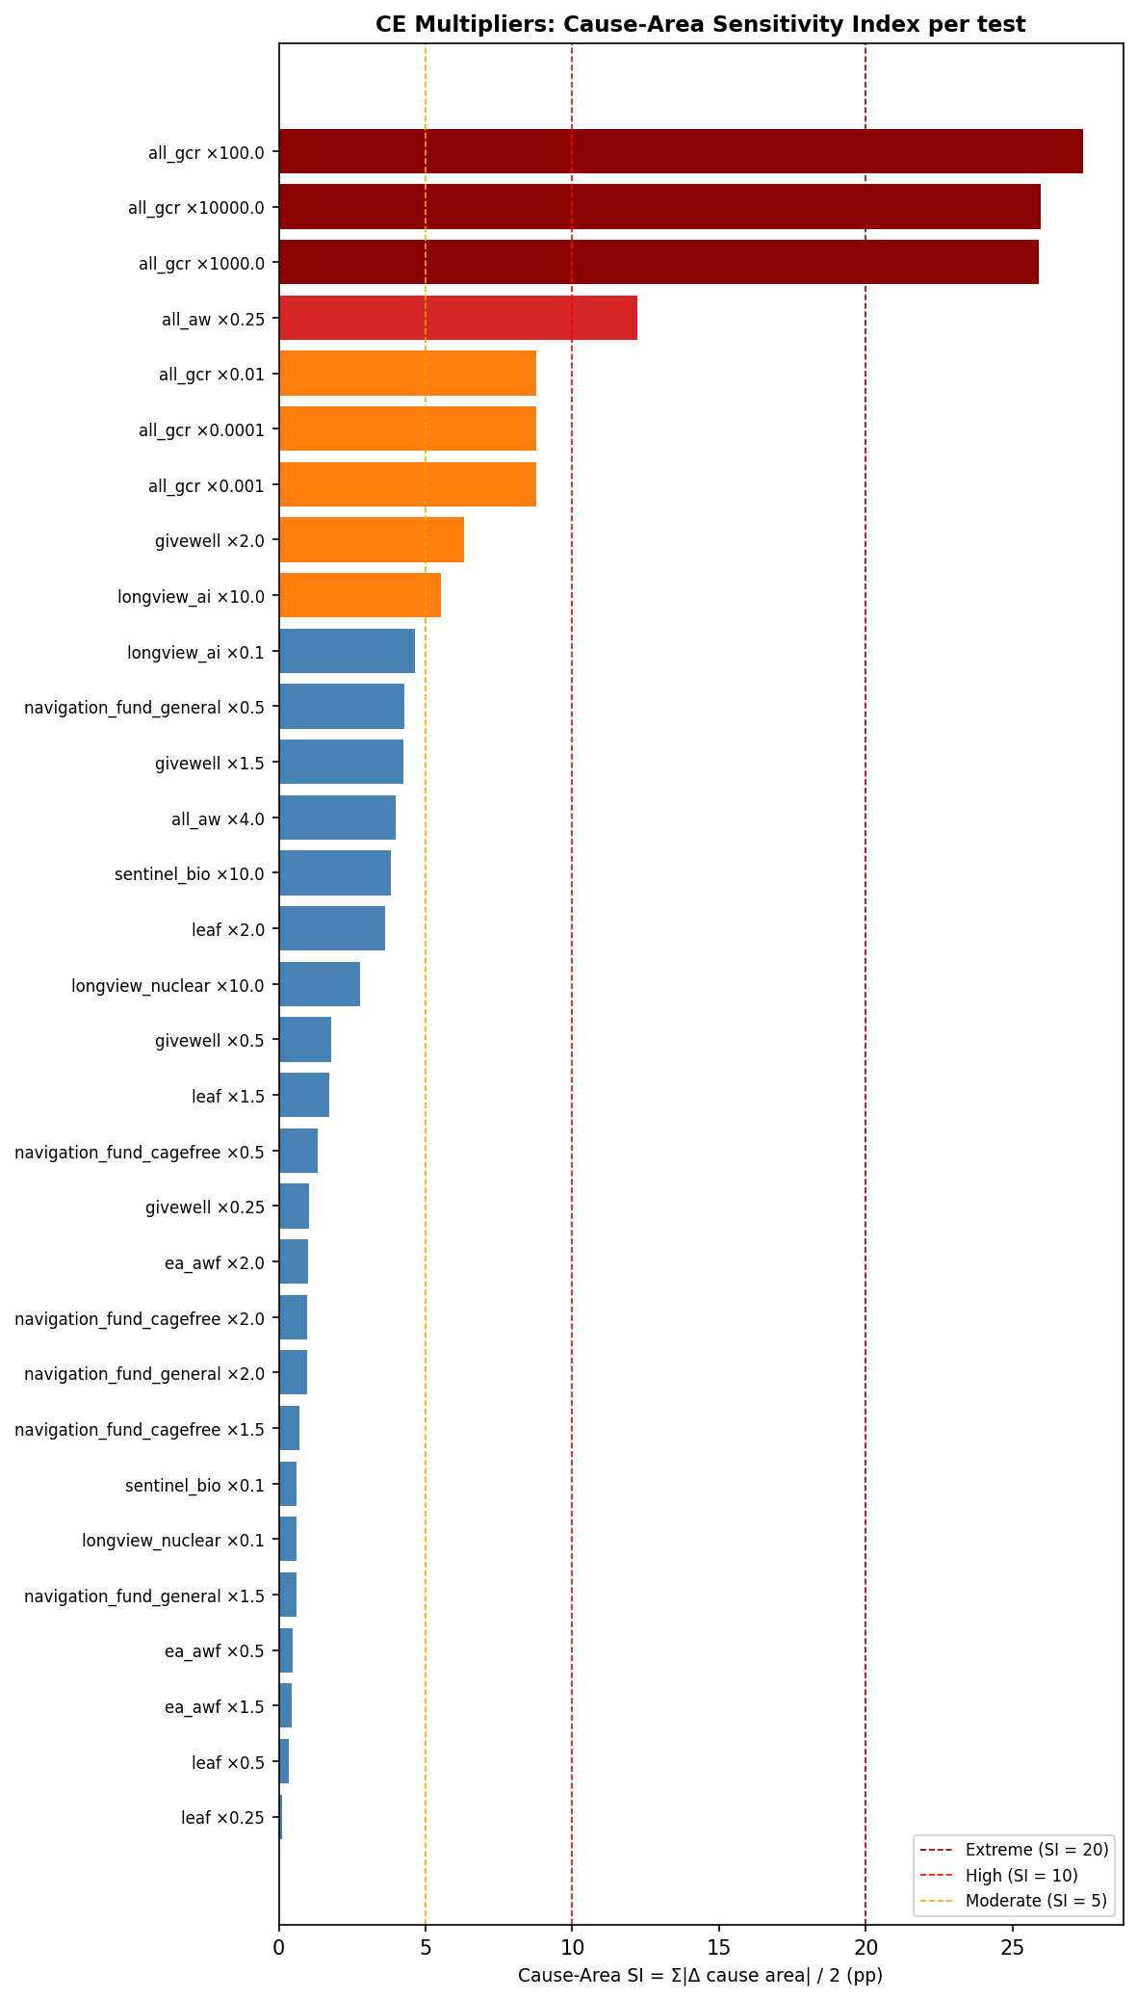

Cause-Area Allocation Changes — All CE Tests (Top 15 by Σ|Δ|)
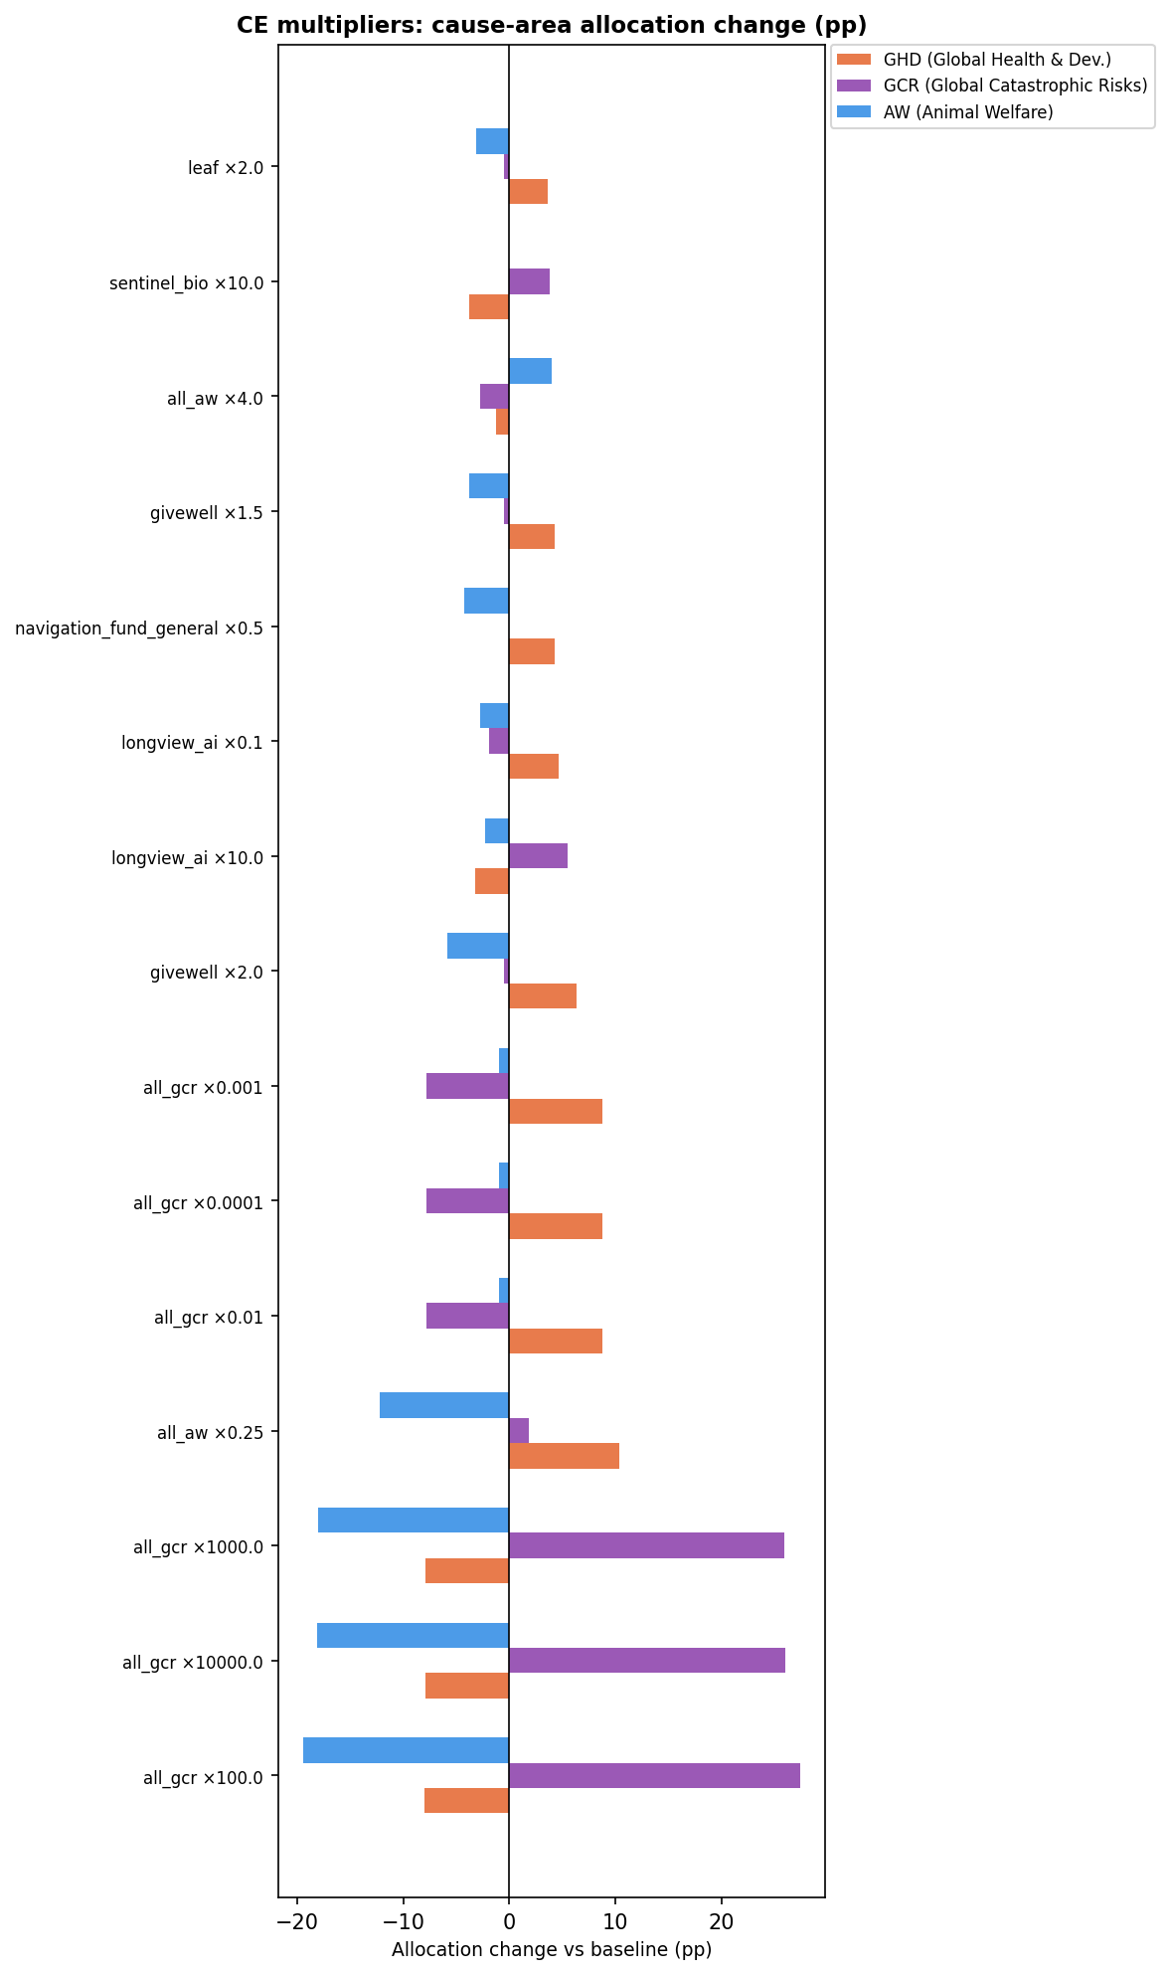

3. Diminishing Returns

3a. Power Parameters
Eight combinations of DR power parameters across GCR and AW clusters. Because both clusters are separate cause areas, changes in their DR curves may shift money between GCR and AW (cross-cause) or between GCR/AW and GHD.
Scenario | Cause-Area SI | Most Affected Cause Area | Max Δ
gcr_and_aw_low_power | 2.73 | GHD (Global Health & Dev.) | +2.73 pp
aw_low_power | 2.42 | AW (Animal Welfare) | -2.42 pp
gcr_high_aw_low_power | 2.42 | AW (Animal Welfare) | -2.42 pp
gcr_high_power | 1.20 | GHD (Global Health & Dev.) | -1.20 pp
gcr_and_aw_high_power | 0.96 | GHD (Global Health & Dev.) | -0.96 pp
gcr_low_aw_high_power | 0.73 | GCR (Global Catastrophic Risks) | -0.73 pp
gcr_low_power | 0.60 | GCR (Global Catastrophic Risks) | -0.60 pp
aw_high_power | 0.53 | GCR (Global Catastrophic Risks) | -0.53 pp
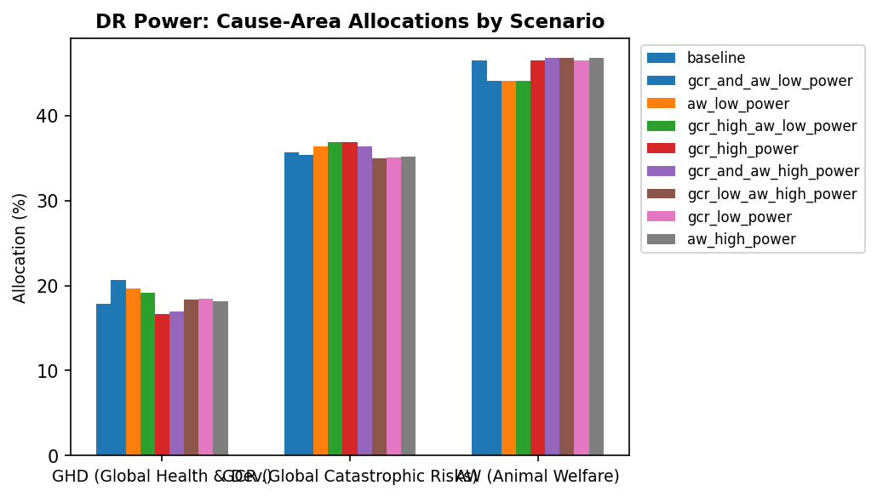

Cause-Area Allocation Changes by DR Power Scenario
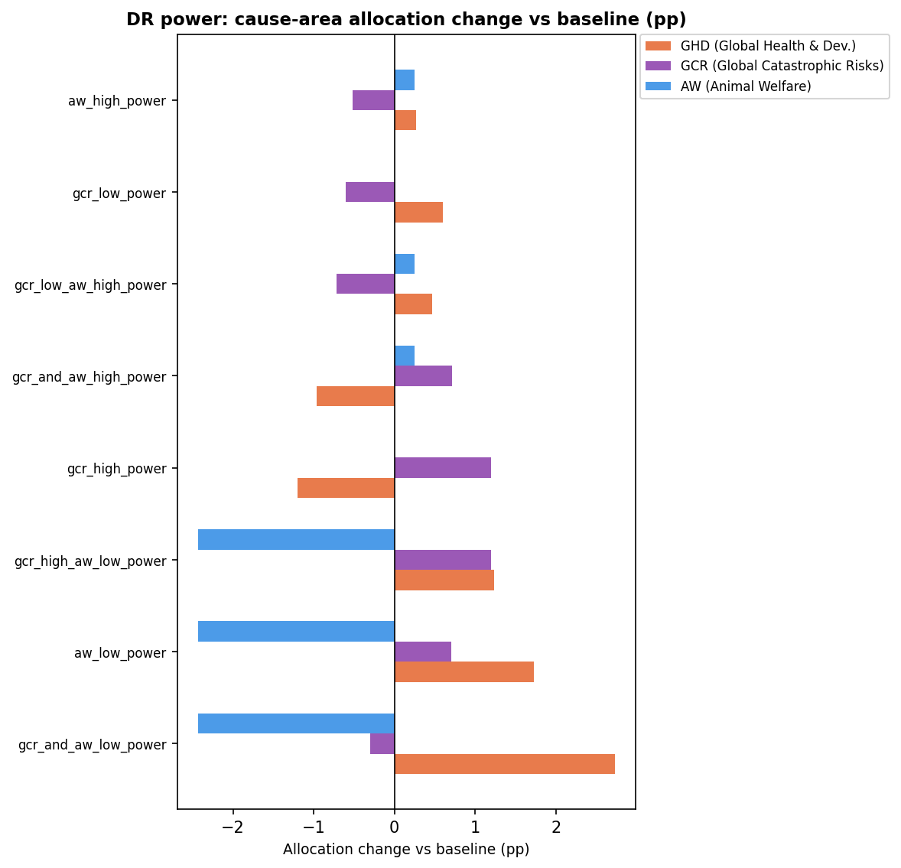

3b. Maximum Spending Cap
Three cap multipliers (2.5×, 7.5×, 10×) were tested. The cap limits total spending on any fund; tighter caps redistribute within and between cause areas.
Scenario | Cap Multiplier | Cause-Area SI | Most Affected Cause Area | Max Δ
max_spend_2_5x | 2.5× | 14.55 | GHD (Global Health & Dev.) | +14.55 pp
max_spend_10x | 10.0× | 6.83 | GCR (Global Catastrophic Risks) | +6.83 pp
max_spend_7_5x | 7.5× | 3.37 | GHD (Global Health & Dev.) | -3.37 pp
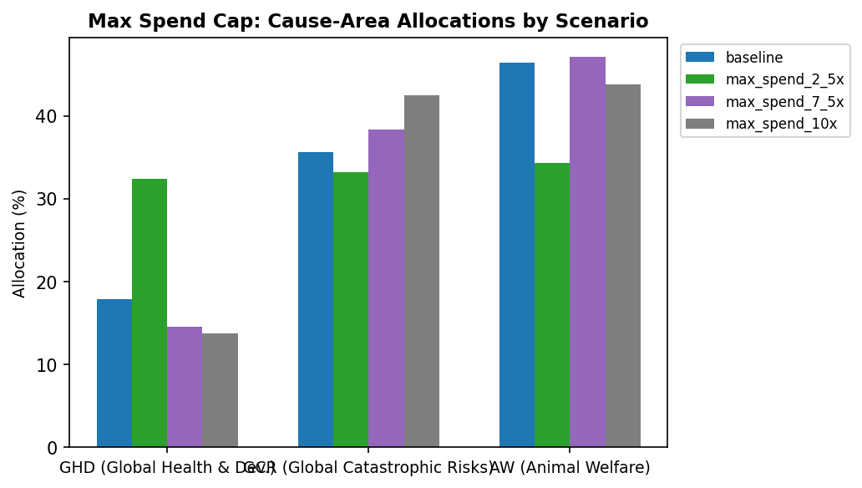

Cause-Area Allocation Changes by Max Spend Cap
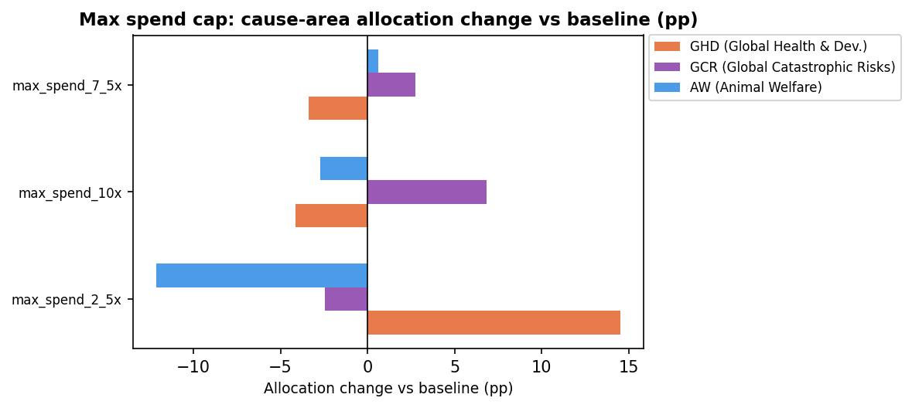

3c. Combined: DR Power × Maximum Spending Cap
24 joint tests crossing 8 DR power scenarios with 3 cap multipliers.

Cause-Area SI Heatmap: Power × Cap
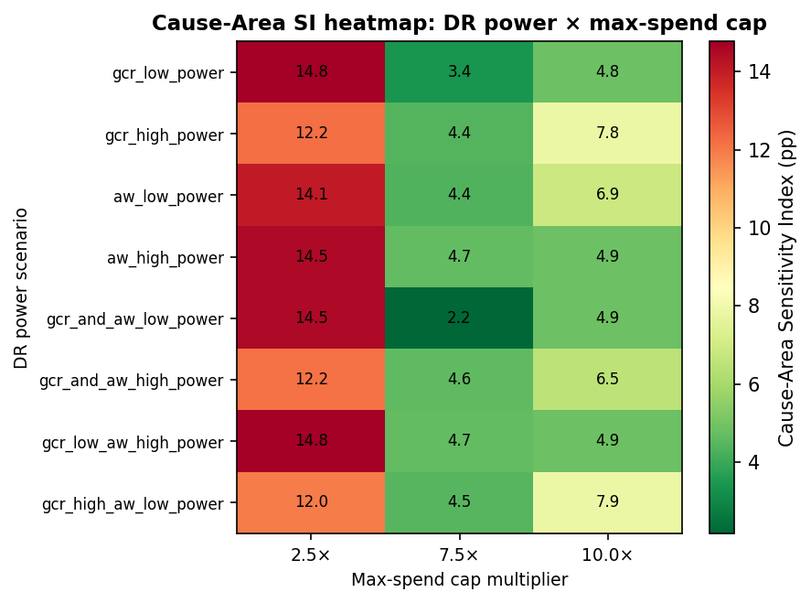

All 24 Tests — Ranked by Cause-Area SI
Power Scenario | Cap Multiplier | Cause-Area SI | Most Affected Cause Area | Max Δ
gcr_low_power | 2.5× | 14.77 | GHD (Global Health & Dev.) | +14.77 pp
gcr_low_aw_high_power | 2.5× | 14.76 | GHD (Global Health & Dev.) | +14.76 pp
gcr_and_aw_low_power | 2.5× | 14.52 | GHD (Global Health & Dev.) | +14.52 pp
aw_high_power | 2.5× | 14.50 | GHD (Global Health & Dev.) | +14.50 pp
aw_low_power | 2.5× | 14.06 | GHD (Global Health & Dev.) | +14.06 pp
gcr_high_power | 2.5× | 12.21 | GHD (Global Health & Dev.) | +12.21 pp
gcr_and_aw_high_power | 2.5× | 12.16 | GHD (Global Health & Dev.) | +12.16 pp
gcr_high_aw_low_power | 2.5× | 11.96 | AW (Animal Welfare) | -11.96 pp
gcr_high_aw_low_power | 10.0× | 7.86 | GCR (Global Catastrophic Risks) | +7.86 pp
gcr_high_power | 10.0× | 7.83 | GCR (Global Catastrophic Risks) | +7.83 pp
aw_low_power | 10.0× | 6.86 | GCR (Global Catastrophic Risks) | +6.86 pp
gcr_and_aw_high_power | 10.0× | 6.53 | GCR (Global Catastrophic Risks) | +6.53 pp
gcr_low_aw_high_power | 10.0× | 4.87 | GHD (Global Health & Dev.) | -4.87 pp
aw_high_power | 10.0× | 4.87 | GHD (Global Health & Dev.) | -4.87 pp
gcr_and_aw_low_power | 10.0× | 4.86 | GCR (Global Catastrophic Risks) | +4.86 pp
gcr_low_power | 10.0× | 4.83 | GCR (Global Catastrophic Risks) | +4.83 pp
gcr_low_aw_high_power | 7.5× | 4.66 | GHD (Global Health & Dev.) | -4.66 pp
aw_high_power | 7.5× | 4.66 | GHD (Global Health & Dev.) | -4.66 pp
gcr_and_aw_high_power | 7.5× | 4.63 | GHD (Global Health & Dev.) | -4.63 pp
gcr_high_aw_low_power | 7.5× | 4.47 | GCR (Global Catastrophic Risks) | +4.47 pp
gcr_high_power | 7.5× | 4.43 | GCR (Global Catastrophic Risks) | +4.43 pp
aw_low_power | 7.5× | 4.37 | GCR (Global Catastrophic Risks) | +4.37 pp
gcr_low_power | 7.5× | 3.37 | GHD (Global Health & Dev.) | -3.37 pp
gcr_and_aw_low_power | 7.5× | 2.17 | GCR (Global Catastrophic Risks) | +2.17 pp

Cause-Area Allocation Changes — Top 10 DR Combo Scenarios
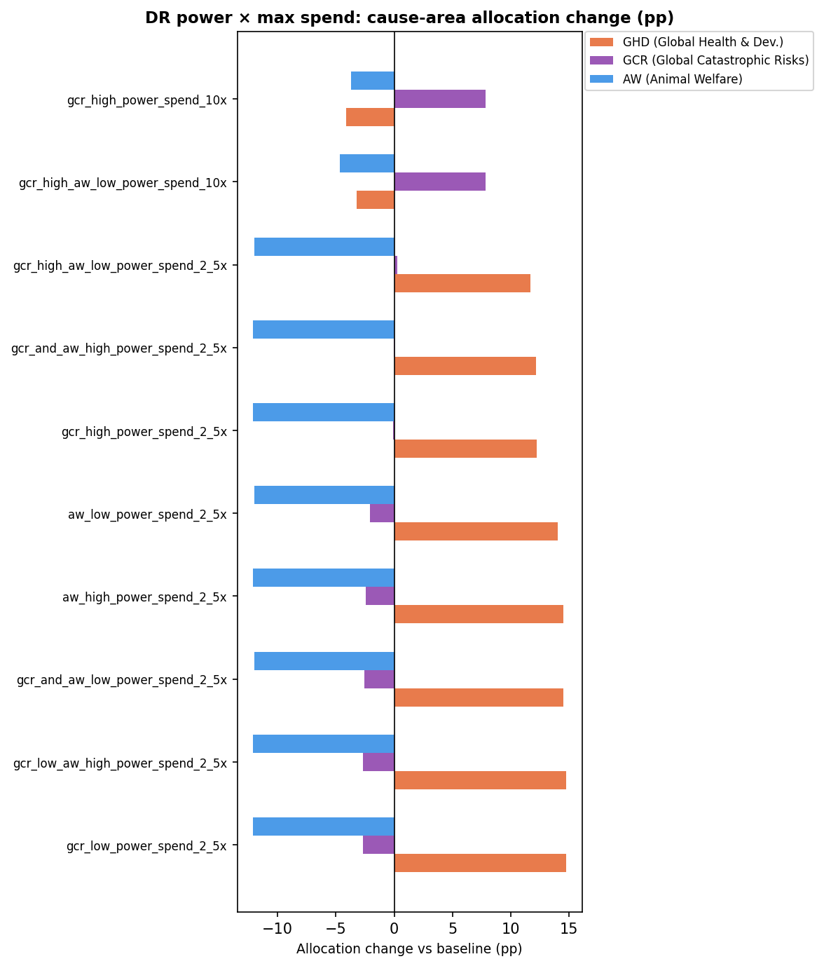

4. Aggregation Method Weights
Each aggregation method's credence is shifted to its low or high uncertainty bound, one at a time. SI measures cross-cause-area reallocation. Methods that primarily reshuffle within a cause area will appear low-sensitivity here.
Test | Bound | Credence Range | SI | Scaled SI* | Most Affected Cause Area | Max Δ
lexicographicMaximin_high | high | 0% → 5% | 4.11 | 0.82 | GHD (Global Health & Dev.) | +4.11 pp
nashBargaining_low | low | 35% → 15% | 3.98 | 0.20 | AW (Animal Welfare) | +3.98 pp
marketplace_high | high | 30% → 50% | 3.69 | 0.18 | AW (Animal Welfare) | -3.69 pp
nashBargaining_high | high | 35% → 50% | 2.98 | 0.20 | AW (Animal Welfare) | -2.98 pp
splitCycle_low | low | 8% → 2% | 2.31 | 0.39 | GCR (Global Catastrophic Risks) | +2.31 pp
marketplace_low | low | 30% → 20% | 1.85 | 0.18 | AW (Animal Welfare) | +1.85 pp
MET_low | low | 10% → 5% | 1.58 | 0.32 | AW (Animal Welfare) | -1.58 pp
MET_high | high | 10% → 15% | 1.58 | 0.32 | AW (Animal Welfare) | +1.58 pp
borda_high | high | 2% → 5% | 1.09 | 0.36 | GCR (Global Catastrophic Risks) | -1.09 pp
MEC_low | low | 15% → 10% | 1.09 | 0.22 | AW (Animal Welfare) | -1.09 pp
MEC_high | high | 15% → 20% | 1.09 | 0.22 | AW (Animal Welfare) | +1.09 pp
splitCycle_high | high | 8% → 10% | 0.77 | 0.39 | GCR (Global Catastrophic Risks) | -0.77 pp
borda_low | low | 2% → 0% | 0.73 | 0.36 | GCR (Global Catastrophic Risks) | +0.73 pp
lexicographicMaximin_low | low | 0% → 0% | 0.00 | — | AW (Animal Welfare) | -0.00 pp
baseline | baseline | nan% → nan% | 0.00 | — | nan | 0.00 pp
* Scaled SI = SI ÷ absolute credence change (pp).

Same Tests — Ranked by Scaled SI
Rank | Test | Bound | Credence Range | SI | Scaled SI | Most Affected Cause Area | Max Δ
1 | lexicographicMaximin_high | high | 0% → 5% | 4.11 | 0.82 | GHD (Global Health & Dev.) | +4.11 pp
2 | splitCycle_low | low | 8% → 2% | 2.31 | 0.39 | GCR (Global Catastrophic Risks) | +2.31 pp
3 | splitCycle_high | high | 8% → 10% | 0.77 | 0.39 | GCR (Global Catastrophic Risks) | -0.77 pp
4 | borda_high | high | 2% → 5% | 1.09 | 0.36 | GCR (Global Catastrophic Risks) | -1.09 pp
5 | borda_low | low | 2% → 0% | 0.73 | 0.36 | GCR (Global Catastrophic Risks) | +0.73 pp
6 | MET_high | high | 10% → 15% | 1.58 | 0.32 | AW (Animal Welfare) | +1.58 pp
7 | MET_low | low | 10% → 5% | 1.58 | 0.32 | AW (Animal Welfare) | -1.58 pp
8 | MEC_low | low | 15% → 10% | 1.09 | 0.22 | AW (Animal Welfare) | -1.09 pp
9 | MEC_high | high | 15% → 20% | 1.09 | 0.22 | AW (Animal Welfare) | +1.09 pp
10 | nashBargaining_low | low | 35% → 15% | 3.98 | 0.20 | AW (Animal Welfare) | +3.98 pp
11 | nashBargaining_high | high | 35% → 50% | 2.98 | 0.20 | AW (Animal Welfare) | -2.98 pp
12 | marketplace_high | high | 30% → 50% | 3.69 | 0.18 | AW (Animal Welfare) | -3.69 pp
13 | marketplace_low | low | 30% → 20% | 1.85 | 0.18 | AW (Animal Welfare) | +1.85 pp

Cause-Area Allocation Changes — All Aggregation Method Tests (Top 15)
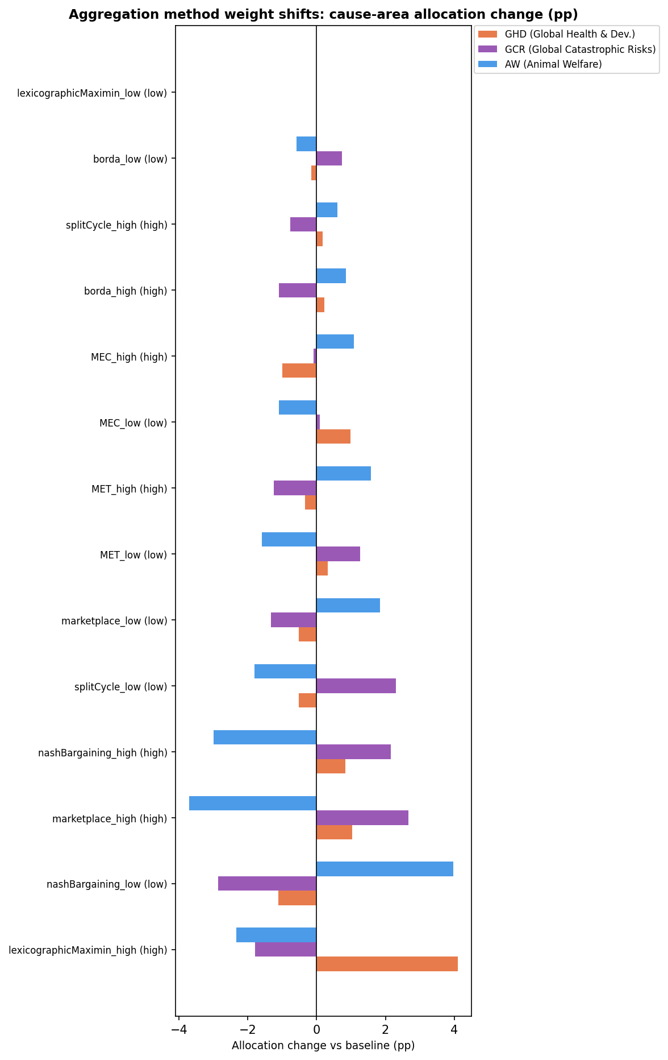

Least Sensitive Tests at Cause-Area Level (SI < 1)
The following tests produced less than 1 pp of cross-cause reallocation. Note that some of these may appear in the fund-level report as sensitive (they move money within a cause area but not between cause areas).
Aggregation Methods
- SI = 0.00 · Method weight shift: lexicographicMaximin_low (0%→0%)
- SI = 0.00 · Method weight shift: baseline (nan%→nan%)
- SI = 0.73 · Method weight shift: borda_low (2%→0%)
- SI = 0.77 · Method weight shift: splitCycle_high (8%→10%)
CE Multipliers
- SI = 0.12 · Multiply leaf CE by 0.25×
- SI = 0.34 · Multiply leaf CE by 0.5×
- SI = 0.46 · Multiply ea_awf CE by 1.5×
- SI = 0.46 · Multiply ea_awf CE by 0.5×
- SI = 0.59 · Multiply navigation_fund_general CE by 1.5×
- SI = 0.60 · Multiply longview_nuclear CE by 0.1×
- SI = 0.60 · Multiply sentinel_bio CE by 0.1×
- SI = 0.71 · Multiply navigation_fund_cagefree CE by 1.5×
- SI = 0.98 · Multiply navigation_fund_general CE by 2.0×
- SI = 0.98 · Multiply navigation_fund_cagefree CE by 2.0×
Dim. Returns (Power)
- SI = 0.53 · DR power combo: aw_high_power
- SI = 0.60 · DR power combo: gcr_low_power
- SI = 0.73 · DR power combo: gcr_low_aw_high_power
- SI = 0.96 · DR power combo: gcr_and_aw_high_power
Time Discounts
- SI = 0.00 · Scale discount factor(s) by 0.1× in group 'discount 500+'
- SI = 0.00 · Scale discount factor(s) by 0.01× in group 'discount 500+'
- SI = 0.00 · Scale discount factor(s) by 0.001× in group 'discount 500+'
- SI = 0.00 · Scale discount factor(s) by 0.1× in group 'discount 100-500 and 500+'
- SI = 0.00 · Scale discount factor(s) by 0.01× in group 'discount 100-500 and 500+'
- SI = 0.00 · Scale discount factor(s) by 0.001× in group 'discount 100-500 and 500+'
Worldview Credences
- SI = 0.00 · baseline (baseline bound: nan%→nan%)
- SI = 0.92 · Non-Utilitarian Consequentialism — Weighted Linear (low bound: 5%→2%)

5. Time Discounts
This analysis tests how the allocation shifts when far-future timeframe weights are reduced. 'Discount 500+' modifies the 500+ year weight only; 'Discount 100–500 and 500+' modifies both the 100–500 and 500+ year weights. Multipliers tested: 0.1×, 0.01×, 0.001×, and 0× (complete elimination).

Cause-Area Sensitivity — All Scenarios
Scenario Group | Multiplier | Cause-Area SI | Biggest Gainer | Biggest Loser
discount 500+ | 0.1× | 0.00 | — | —
discount 500+ | 0.01× | 0.00 | — | —
discount 500+ | 0.001× | 0.00 | — | —
discount 500+ | 0× | 15.38 | AW (Animal Welfare) (+12.39 pp) | GCR (Global Catastrophic Risks) (-15.38 pp)
discount 100-500 and 500+ | 0.1× | 0.00 | — | —
discount 100-500 and 500+ | 0.01× | 0.00 | — | —
discount 100-500 and 500+ | 0.001× | 0.00 | — | —
discount 100-500 and 500+ | 0× | 20.87 | AW (Animal Welfare) (+14.90 pp) | GCR (Global Catastrophic Risks) (-20.87 pp)

Cause-Area Allocation Changes — 0× Scenarios
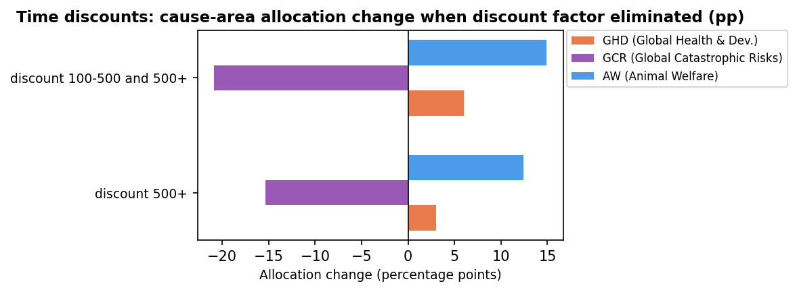

Key findings: Partial reductions (0.1× through 0.001×) produce SI = 0 pp at the cause-area level — the allocation is completely insensitive. Complete elimination (0×) of the 500+ year weight shifts 15.38 pp out of GCR (−15.38 pp) into AW (+12.39 pp) and GHD (+2.99 pp). Eliminating both the 100–500 and 500+ year weights (SI = 20.87 pp) amplifies the GCR loss to −20.87 pp, with AW gaining +14.90 pp and GHD +5.97 pp. This is a cross-cause effect: far-future weighting directly benefits GCR (which has long-horizon expected value) at the expense of near-term AW and GHD.

6. Animal Moral Weights
Animal moral weights are scaled across two levels: (1) the overall blend — all worldviews' weights scaled simultaneously; and (2) per-worldview — each worldview run at 100% credence. Multipliers: 0.1×, 2×, 5×, 10×, 100×. Weights are capped at species-level upper bounds.

6a. Overall Blend Sensitivity
Multiplier | Cause-Area SI | Scaled SI* | Biggest Gainer | Biggest Loser
0.1× | 24.18 | 24.18 | GHD (Global Health & Dev.) (+22.25 pp) | AW (Animal Welfare) (-24.18 pp)
100.0× | 14.01 | 7.01 | AW (Animal Welfare) (+14.01 pp) | GHD (Global Health & Dev.) (-8.19 pp)
10.0× | 6.31 | 6.31 | AW (Animal Welfare) (+6.31 pp) | GCR (Global Catastrophic Risks) (-3.53 pp)
5.0× | 4.91 | 7.02 | AW (Animal Welfare) (+4.91 pp) | GCR (Global Catastrophic Risks) (-3.48 pp)
2.0× | 1.62 | 5.38 | AW (Animal Welfare) (+1.62 pp) | GCR (Global Catastrophic Risks) (-0.85 pp)
* Scaled SI = SI ÷ orders-of-magnitude change in multiplier.

Cause-Area Allocation Changes — All Multipliers
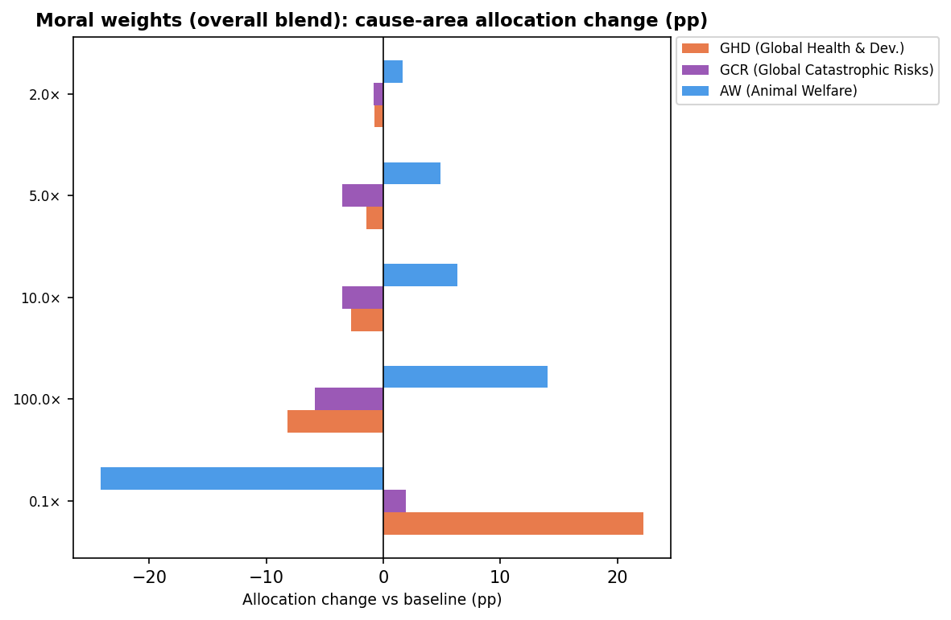

6b. Per-Worldview Sensitivity — Ranked Summary (Top 15)
Each worldview run in isolation with its animal weights scaled. Cause-area SI measured against that worldview's own unmodified baseline. Only non-zero scenarios shown.
Idx | Worldview | Risk | Mult. | CA SI | Scaled SI* | Biggest Gainer | Biggest Loser
11 | Contractualism | 2 | 100.0× | 75.00 | 37.50 | AW (Animal Welfare) (+75.00 pp) | GHD (Global Health & Dev.) (-75.00 pp)
2 | Total Utilitarian | 2 | 0.1× | 60.00 | 60.00 | GHD (Global Health & Dev.) (+60.00 pp) | AW (Animal Welfare) (-60.00 pp)
6 | Consequentialism (Non-Utilit | 0 | 100.0× | 53.00 | 26.50 | AW (Animal Welfare) (+53.00 pp) | GCR (Global Catastrophic Risks) (-53.00 pp)
3 | Total Utilitarian | 6 | 0.1× | 51.00 | 51.00 | GHD (Global Health & Dev.) (+51.00 pp) | AW (Animal Welfare) (-51.00 pp)
8 | Consequentialism (Non-Utilit | 2 | 100.0× | 47.00 | 23.50 | AW (Animal Welfare) (+47.00 pp) | GHD (Global Health & Dev.) (-47.00 pp)
8 | Consequentialism (Non-Utilit | 2 | 10.0× | 47.00 | 47.00 | AW (Animal Welfare) (+47.00 pp) | GHD (Global Health & Dev.) (-47.00 pp)
7 | Consequentialism (Non-Utilit | 0 | 100.0× | 44.00 | 22.00 | AW (Animal Welfare) (+44.00 pp) | GCR (Global Catastrophic Risks) (-44.00 pp)
7 | Consequentialism (Non-Utilit | 0 | 10.0× | 43.00 | 43.00 | AW (Animal Welfare) (+43.00 pp) | GCR (Global Catastrophic Risks) (-43.00 pp)
1 | Total Utilitarian | 7 | 0.1× | 42.00 | 42.00 | GHD (Global Health & Dev.) (+41.00 pp) | AW (Animal Welfare) (-42.00 pp)
8 | Consequentialism (Non-Utilit | 2 | 5.0× | 39.00 | 55.80 | AW (Animal Welfare) (+39.00 pp) | GHD (Global Health & Dev.) (-39.00 pp)
9 | Contractualism | 5 | 0.1× | 39.00 | 39.00 | GHD (Global Health & Dev.) (+39.00 pp) | AW (Animal Welfare) (-39.00 pp)
7 | Consequentialism (Non-Utilit | 0 | 5.0× | 35.00 | 50.07 | AW (Animal Welfare) (+35.00 pp) | GCR (Global Catastrophic Risks) (-35.00 pp)
12 | Kantianism | 3 | 100.0× | 33.00 | 16.50 | AW (Animal Welfare) (+33.00 pp) | GHD (Global Health & Dev.) (-33.00 pp)
13 | Custom | 6 | 100.0× | 32.00 | 16.00 | AW (Animal Welfare) (+32.00 pp) | GHD (Global Health & Dev.) (-32.00 pp)
8 | Consequentialism (Non-Utilit | 2 | 0.1× | 28.00 | 28.00 | GHD (Global Health & Dev.) (+28.00 pp) | AW (Animal Welfare) (-28.00 pp)
* Scaled SI = SI ÷ orders-of-magnitude change in multiplier.

Per-Worldview Cause-Area SI — Tornado Chart (Top 20 Scenarios)
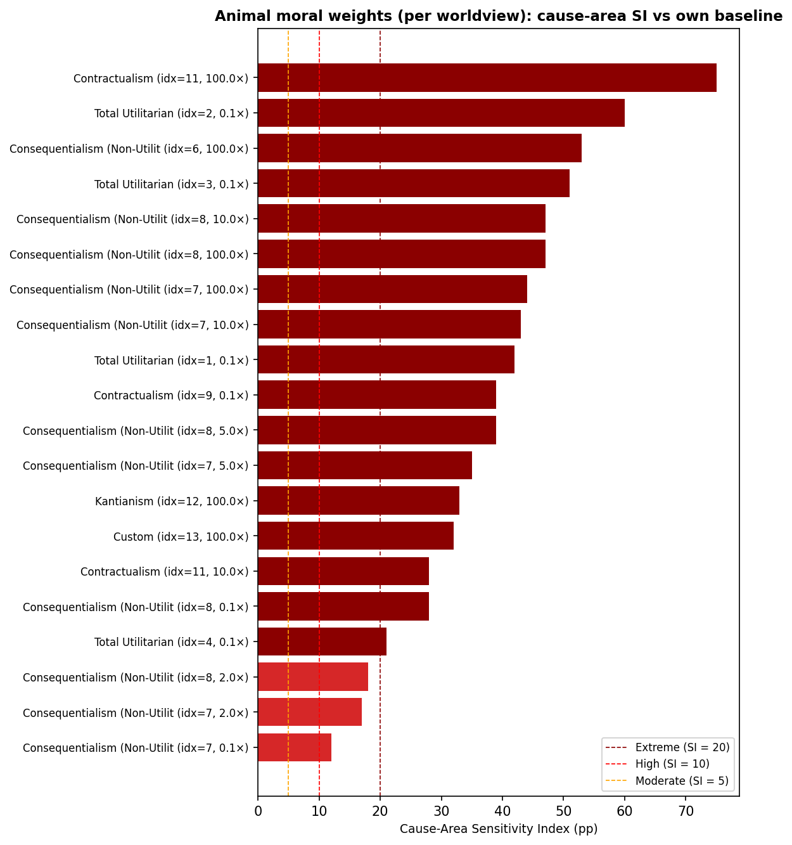

Key findings (overall blend): All moral weight changes — up or down — shift money between AW and GHD/GCR. Reducing weights (0.1×) causes the largest cross-cause shift (SI = 24.18 pp), with AW losing 24 pp primarily to GHD. Increasing weights drives the reverse: AW gains at the expense of GHD (100× gives SI = 14 pp at cause-area level). GCR is barely affected by moral weight changes at the overall blend level, as the GCR–AW tradeoff is driven predominantly by worldviews where one or the other is already dominant. Key findings (per worldview): The most sensitive worldviews for cross-cause shifts are Contractualism idx 11 (CA SI = 75 pp at 100×, full GHD→AW reversal) and Non-Utilitarian Consequentialism idx 7 and 8 (CA SI ≈ 43–47 pp at 10×, GCR→AW shift). TU worldviews are sensitive downward only and shift GHD↔AW, while the Non-Util Consequentialist worldviews primarily shift GCR↔AW.

7. Illustrative: Single-Perspective Analyses
These analyses place 100% credence in one perspective. Because credence shifts are extreme, cause-area SIs can be large. Sensitivity tiers: moderate ≥ 5 pp, high ≥ 10 pp, extreme ≥ 20 pp. Large cause-area SIs here mean the perspective concentrates the portfolio in one cause area rather than just reshuffling within it.

5a. Risk Aversion
Test | Cause-Area SI | Most Affected Cause Area | Max Δ
neutral_to_combined | 90.15 | GCR (Global Catastrophic Risks) | -90.15 pp
neutral_to_cont_upside_skep | 80.69 | GCR (Global Catastrophic Risks) | -80.69 pp
neutral_to_downside_critical | 56.15 | GCR (Global Catastrophic Risks) | -56.15 pp
specialblend_to_neutral | 54.52 | GCR (Global Catastrophic Risks) | +54.52 pp
specialblend_to_bilateral_skep | 54.39 | GCR (Global Catastrophic Risks) | +54.39 pp
specialblend_to_combined | 35.63 | GCR (Global Catastrophic Risks) | -35.63 pp
specialblend_to_wlu_5 | 35.63 | GCR (Global Catastrophic Risks) | -35.63 pp
specialblend_to_wlu_10 | 35.63 | GCR (Global Catastrophic Risks) | -35.63 pp
specialblend_to_cont_upside_skep | 26.18 | GCR (Global Catastrophic Risks) | -26.18 pp
specialblend_to_downside_critical | 3.10 | AW (Animal Welfare) | +3.10 pp
neutral_to_bilateral_skep | 0.13 | GCR (Global Catastrophic Risks) | -0.13 pp

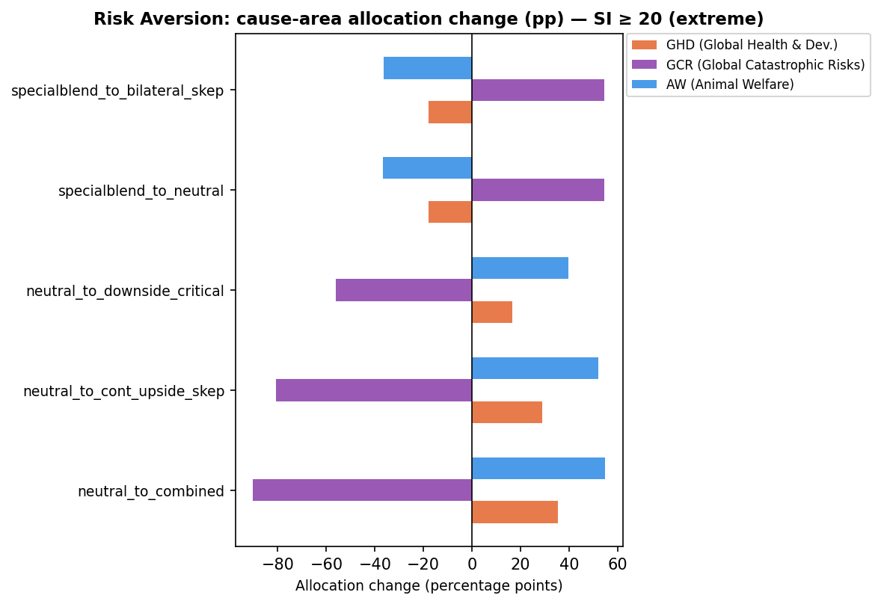

Cause-Area Allocation Changes — All Risk Aversion Tests
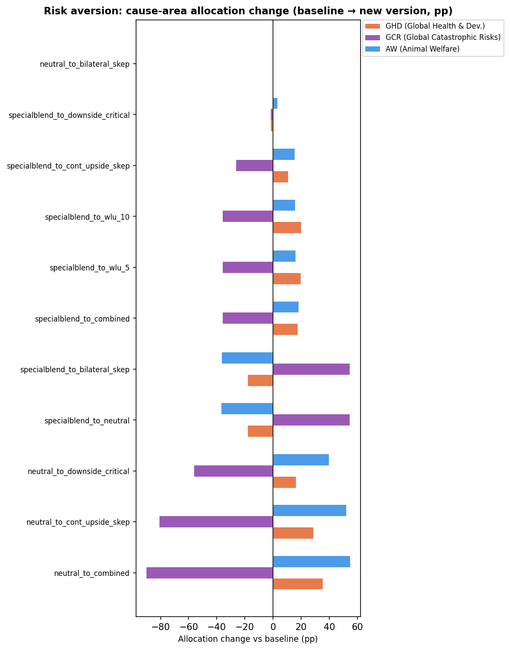

5b. 100% Credence in One Worldview
Each worldview run in isolation. Cause-area SI is computed against the baseline special-blend allocation. A worldview that directs 100% of the budget to a single cause area will show SI ≈ 50 pp here (the maximum when one cause area gains 50 pp and the others lose 50 pp combined).
Worldview | Cause-Area SI | Most Affected Cause Area | Max Δ
Kantianism — Low animals / downside critical | 82.11 | GHD (Global Health & Dev.) | +82.11 pp
Kantianism — Low animals | 82.11 | GHD (Global Health & Dev.) | +82.11 pp
Contractualism — Default + cluelessness | 82.11 | GHD (Global Health & Dev.) | +82.11 pp
Non-Utilitarian Consequentialism — High Life Value / Clueles | 64.37 | GCR (Global Catastrophic Risks) | +64.37 pp
Total Utilitarianism — Default | 64.37 | GCR (Global Catastrophic Risks) | +64.37 pp
Non-Utilitarian Consequentialism — Default | 64.37 | GCR (Global Catastrophic Risks) | +64.37 pp
Contractualism — Person-Affecting/Cluelessness and Animals B | 64.37 | GCR (Global Catastrophic Risks) | +64.37 pp
Non-Utilitarian Consequentialism — Weighted Linear Utility | 54.11 | GHD (Global Health & Dev.) | +54.11 pp
Non-Utilitarian Consequentialism — Person-Affecting/Clueless | 52.37 | GCR (Global Catastrophic Risks) | +52.37 pp
Total Utilitarianism — High life value, risk averse, and ske | 35.63 | GCR (Global Catastrophic Risks) | -35.63 pp
Total Utilitarianism — Weighted Linear Utility | 35.63 | GCR (Global Catastrophic Risks) | -35.63 pp
Total Utilitarianism — Person-Affecting/Cluelessness, Sentie | 29.63 | GCR (Global Catastrophic Risks) | -29.63 pp
Total Utilitarianism — Suffering forward, clueless, and only | 28.52 | AW (Animal Welfare) | +28.52 pp
Contractualism — Person-Affecting/Cluelessness and Animals B | 19.52 | AW (Animal Welfare) | +19.52 pp

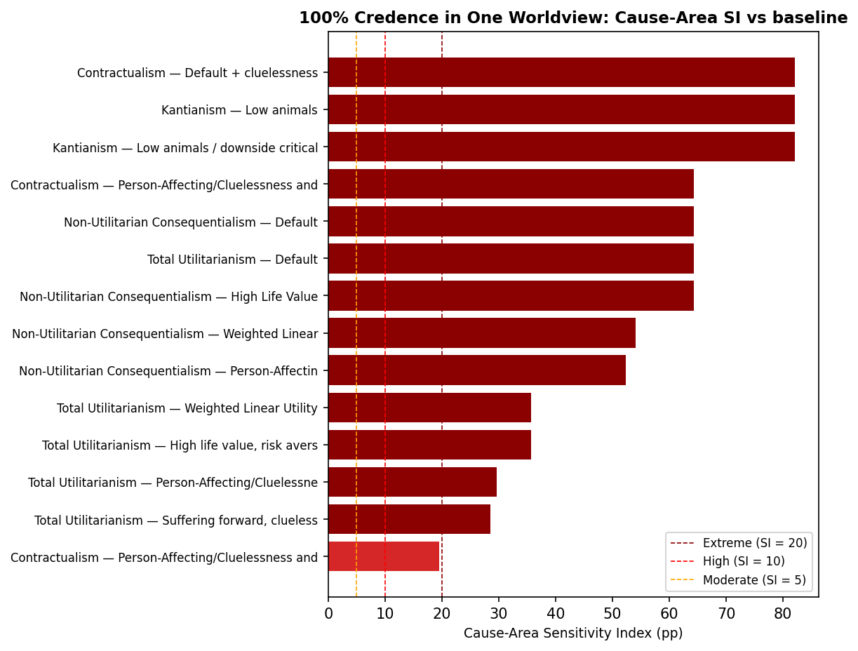

Cause-Area Allocation Changes — All Single Worldviews vs Baseline
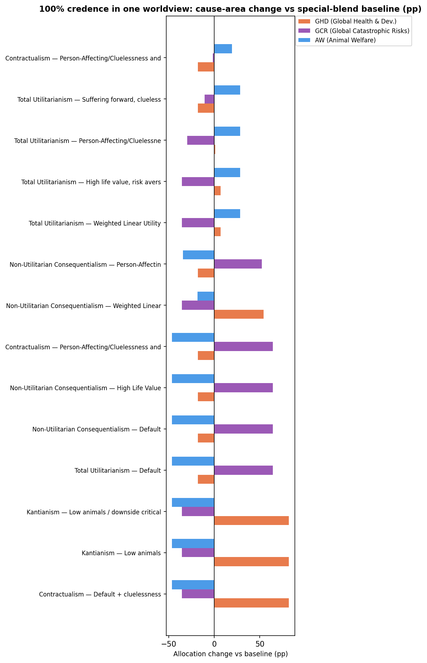

5c. 100% Credence in One Aggregation Method
Each method run on the full budget with all worldviews. Cause-area SI is computed against the baseline allocation.
Method | Cause-Area SI | Most Affected Cause Area | Max Δ
lexicographicMaximin | 82.11 | GHD (Global Health & Dev.) | +82.11 pp
borda | 35.63 | GCR (Global Catastrophic Risks) | -35.63 pp
splitCycle | 35.43 | GCR (Global Catastrophic Risks) | -35.43 pp
MET | 28.52 | AW (Animal Welfare) | +28.52 pp
MEC | 18.52 | AW (Animal Welfare) | +18.52 pp
marketplace | 12.93 | AW (Animal Welfare) | -12.93 pp
nashBargaining | 12.93 | AW (Animal Welfare) | -12.93 pp

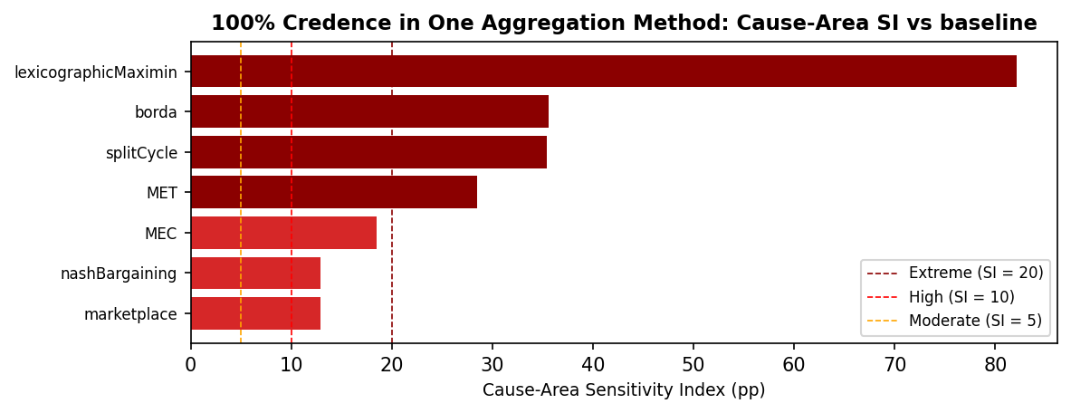

Cause-Area Allocation Changes — All Single Methods vs Baseline
