Donor Compass Sensitivity Analysis Report
Within-Cluster Reshuffling Analysis
Generated May 05, 2026 · Rethink Priorities

Executive Summary
This report compares cluster-level and fund-level sensitivity indices across all sensitivity dimensions. A test is flagged as a 'within-cluster shift' when the fund-level SI significantly exceeds the cluster-level SI — meaning money is moving between funds inside the same cause area, producing little net change at the cause-area level but large changes at the individual-fund level.
Metric used: Gap = Fund SI − Cluster SI. Tests with Gap ≥ 3.0 pp are flagged and detailed in each section.

Baseline Allocations
Fund | Cause Area | Baseline (%)
GiveWell | GHD (Global Health & Dev.) | 12.9%
LEAF | GHD (Global Health & Dev.) | 4.9%
Longview AI | GCR (Global Catastrophic Risks) | 23.2%
Longview Nuclear | GCR (Global Catastrophic Risks) | 3.8%
Sentinel Bio | GCR (Global Catastrophic Risks) | 8.6%
EA AWF | AW (Animal Welfare) | 12.8%
Nav. Cage-Free | AW (Animal Welfare) | 15.6%
Nav. General | AW (Animal Welfare) | 18.1%

Cluster SI vs Fund SI — All Main-Analysis Tests
Each point represents one test. Points above the diagonal (y = x) have higher fund-level SI than cluster-level SI, indicating within-cluster reshuffling. Labeled points have a gap ≥ 3.0 pp.
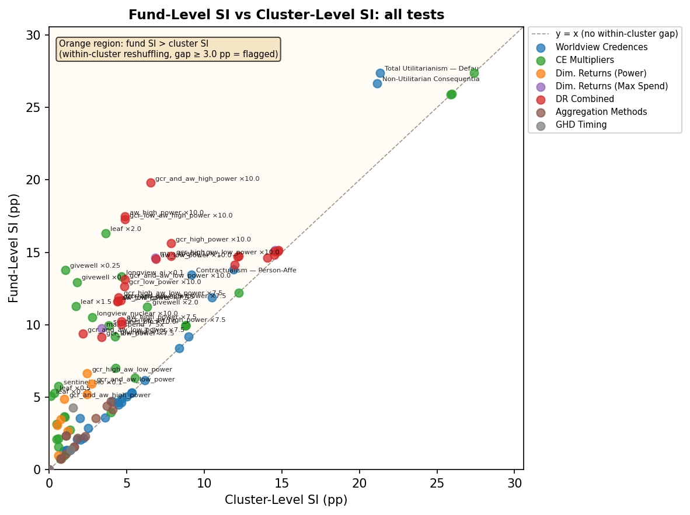

Top Tests by Gap (Fund SI − Cluster SI)
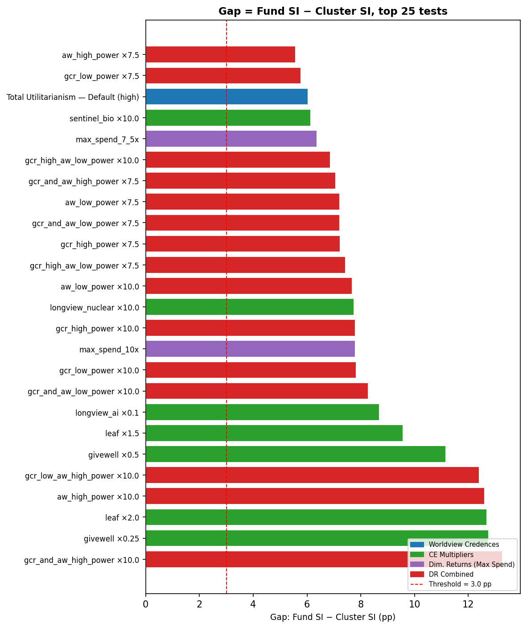

Summary: 36 Flagged Tests (Gap ≥ 3.0 pp)
Test | Dimension | Cluster SI | Fund SI | Gap
gcr_and_aw_high_power ×10.0 | DR Combined | 6.53 | 19.81 | 13.28
givewell ×0.25 | CE Multipliers | 1.02 | 13.79 | 12.76
leaf ×2.0 | CE Multipliers | 3.62 | 16.30 | 12.68
aw_high_power ×10.0 | DR Combined | 4.87 | 17.47 | 12.60
gcr_low_aw_high_power ×10.0 | DR Combined | 4.87 | 17.27 | 12.40
givewell ×0.5 | CE Multipliers | 1.77 | 12.95 | 11.17
leaf ×1.5 | CE Multipliers | 1.71 | 11.28 | 9.57
longview_ai ×0.1 | CE Multipliers | 4.64 | 13.33 | 8.69
gcr_and_aw_low_power ×10.0 | DR Combined | 4.86 | 13.14 | 8.27
gcr_low_power ×10.0 | DR Combined | 4.83 | 12.67 | 7.84
max_spend_10x | Dim. Returns (Max Spend) | 6.83 | 14.64 | 7.80
gcr_high_power ×10.0 | DR Combined | 7.83 | 15.64 | 7.80
longview_nuclear ×10.0 | CE Multipliers | 2.77 | 10.51 | 7.74
aw_low_power ×10.0 | DR Combined | 6.86 | 14.54 | 7.67
gcr_high_aw_low_power ×7.5 | DR Combined | 4.47 | 11.90 | 7.43
gcr_high_power ×7.5 | DR Combined | 4.43 | 11.66 | 7.23
gcr_and_aw_low_power ×7.5 | DR Combined | 2.17 | 9.40 | 7.23
aw_low_power ×7.5 | DR Combined | 4.37 | 11.60 | 7.23
gcr_and_aw_high_power ×7.5 | DR Combined | 4.63 | 11.70 | 7.07
gcr_high_aw_low_power ×10.0 | DR Combined | 7.86 | 14.74 | 6.87
max_spend_7_5x | Dim. Returns (Max Spend) | 3.37 | 9.74 | 6.37
sentinel_bio ×10.0 | CE Multipliers | 3.81 | 9.96 | 6.14
Total Utilitarianism — Default (high) | Worldview Credences | 21.33 | 27.38 | 6.05
gcr_low_power ×7.5 | DR Combined | 3.37 | 9.14 | 5.77
aw_high_power ×7.5 | DR Combined | 4.66 | 10.25 | 5.58
Non-Utilitarian Consequentialism — (high) | Worldview Credences | 21.15 | 26.67 | 5.51
gcr_low_aw_high_power ×7.5 | DR Combined | 4.66 | 10.05 | 5.38
sentinel_bio ×0.1 | CE Multipliers | 0.60 | 5.76 | 5.16
leaf ×0.5 | CE Multipliers | 0.34 | 5.30 | 4.96
leaf ×0.25 | CE Multipliers | 0.12 | 5.08 | 4.96
36 of 113 main-analysis tests (32%) show a within-cluster gap ≥ 3.0 pp.

1. Worldview Credences
Each worldview's credence is shifted one at a time to its low or high uncertainty bound. A within-cluster gap here means the credence shift primarily reallocates money between funds within the same cause area (e.g., GCR funds rearranging among Longview AI, Nuclear, Sentinel) rather than shifting money between GHD, GCR, and AW.

Cluster SI vs Fund SI — All Worldview Credence Tests
Worldview | Bound | Credence Range | Cluster SI | Fund SI | Gap
Total Utilitarianism — Default | high | 10%→25% | 21.33 | 27.38 | 6.05 | ⚠
Non-Utilitarian Consequentialism — Default | high | 5%→20% | 21.15 | 26.67 | 5.51 | ⚠
Contractualism — Person-Affecting/Clueless | high | 10%→25% | 9.16 | 13.45 | 4.29 | ⚠
Total Utilitarianism — Weighted Linear Uti | low | 10%→5% | 11.89 | 13.80 | 1.92
Contractualism — Person-Affecting/Clueless | low | 10%→5% | 1.98 | 3.57 | 1.58
Non-Utilitarian Consequentialism — Person- | high | 5%→20% | 10.49 | 11.90 | 1.41
Contractualism — Person-Affecting/Clueless | low | 10%→1% | 4.09 | 4.73 | 0.63
Non-Utilitarian Consequentialism — Weighte | low | 5%→2% | 0.92 | 1.28 | 0.36
Total Utilitarianism — Default | low | 10%→5% | 2.50 | 2.85 | 0.35
Contractualism — Default + cluelessness | low | 5%→2% | 1.77 | 2.10 | 0.33
Non-Utilitarian Consequentialism — High Li | low | 5%→2% | 1.11 | 1.34 | 0.22
Contractualism — Default + cluelessness | high | 5%→15% | 8.99 | 9.20 | 0.21
Total Utilitarianism — Weighted Linear Uti | high | 10%→20% | 4.66 | 4.86 | 0.21
Total Utilitarianism — High life value, ri | high | 5%→15% | 4.43 | 4.63 | 0.20
Non-Utilitarian Consequentialism — Person- | low | 5%→2% | 1.13 | 1.32 | 0.19
Non-Utilitarian Consequentialism — Default | low | 5%→2% | 1.15 | 1.34 | 0.19
Total Utilitarianism — High life value, ri | low | 5%→2% | 1.19 | 1.29 | 0.11
Kantianism — Low animals / downside critic | low | 10%→1% | 4.97 | 5.04 | 0.07
Kantianism — Low animals | low | 5%→1% | 2.01 | 2.05 | 0.04
Total Utilitarianism — Suffering forward, | low | 5%→2% | 1.33 | 1.34 | 0.01
Contractualism — Person-Affecting/Clueless | high | 10%→20% | 5.33 | 5.33 | 0.00
Non-Utilitarian Consequentialism — High Li | high | 5%→15% | 5.29 | 5.29 | 0.00
Kantianism — Low animals / downside critic | high | 10%→20% | 6.15 | 6.15 | 0.00
Kantianism — Low animals | high | 5%→20% | 8.38 | 8.38 | 0.00
Non-Utilitarian Consequentialism — Weighte | high | 5%→15% | 3.59 | 3.59 | 0.00
Total Utilitarianism — Person-Affecting/Cl | low | 10%→5% | 2.19 | 2.19 | 0.00
Total Utilitarianism — Person-Affecting/Cl | high | 10%→20% | 4.65 | 4.65 | 0.00
Total Utilitarianism — Suffering forward, | high | 5%→15% | 4.46 | 4.46 | 0.00
baseline | baseline | nan%→nan% | 0.00 | 0.00 | 0.00
Note: A '⚠' in the last column indicates Gap ≥ 3.0 pp (within-cluster shift). Cluster SI and Fund SI can differ even without within-cluster movement if a cause area's net flow is concentrated in one fund.

Within-Cluster Shifts — Tests with Gap ≥ 3.0 pp

Total Utilitarianism — Default
Cluster SI = 21.33 pp | Fund SI = 27.38 pp | Gap = 6.05 pp
Within-cluster movement in GCR (Global Catastrophic Risks): Longview AI +27.38 pp, Sentinel Bio -3.52 pp, Longview Nuclear -2.52 pp.
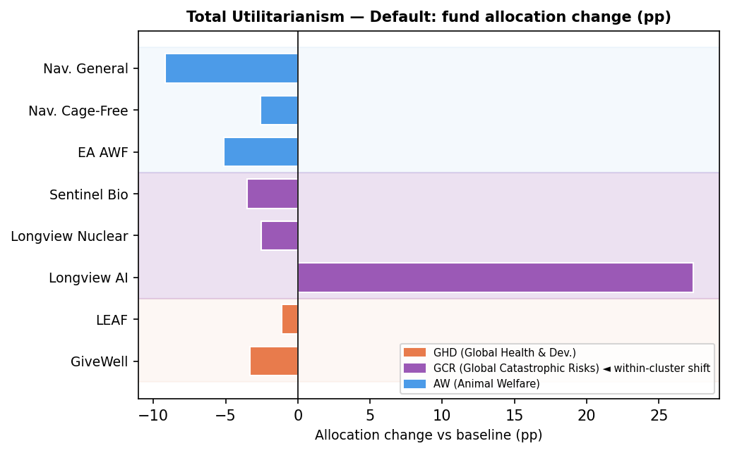

Non-Utilitarian Consequentialism — Default
Cluster SI = 21.15 pp | Fund SI = 26.67 pp | Gap = 5.51 pp
Within-cluster movement in GCR (Global Catastrophic Risks): Longview AI +26.67 pp, Sentinel Bio -3.20 pp, Longview Nuclear -2.31 pp.
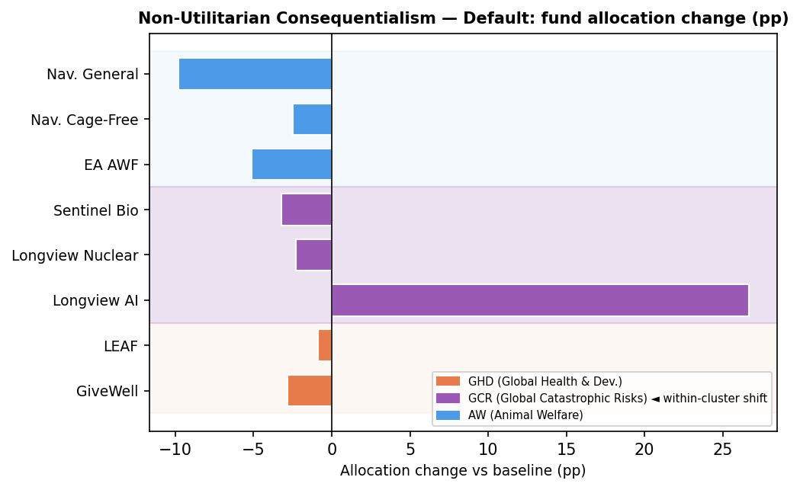

Contractualism — Person-Affecting/Cluelessness and Animals Baseli
Cluster SI = 9.16 pp | Fund SI = 13.45 pp | Gap = 4.29 pp
Within-cluster movement in GCR (Global Catastrophic Risks): Sentinel Bio +8.95 pp, Longview Nuclear +4.50 pp, Longview AI -4.29 pp.
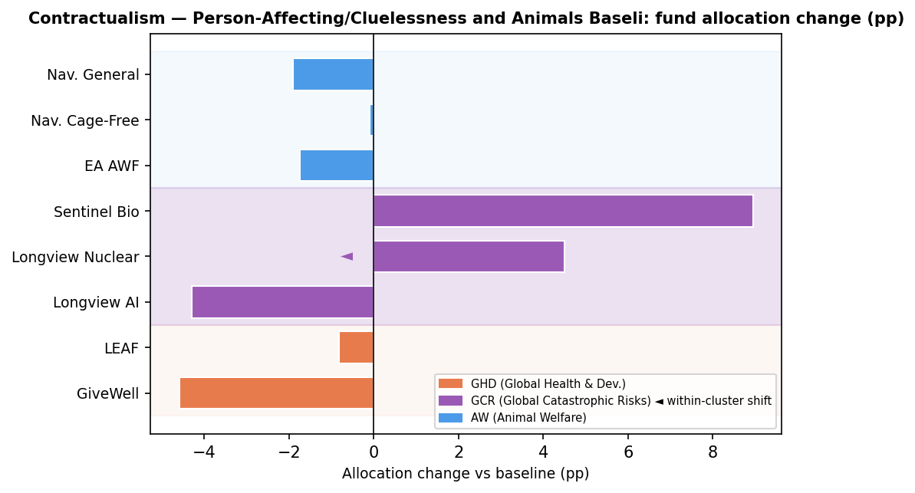

2. Cost-Effectiveness Multipliers
Each fund's cost-effectiveness score is multiplied by a constant factor. The key within-cluster effect: scaling a fund within GHD (e.g. LEAF) changes which GHD fund 'wins' but leaves GHD's total allocation largely unchanged. Cluster-level SI stays low while fund-level SI can be high.

Cluster SI vs Fund SI — All CE Multiplier Tests
Fund Varied | Multiplier | Cluster SI | Fund SI | Gap
givewell | 0.25× | 1.02 | 13.79 | 12.76 | ⚠
leaf | 2.0× | 3.62 | 16.30 | 12.68 | ⚠
givewell | 0.5× | 1.77 | 12.95 | 11.17 | ⚠
leaf | 1.5× | 1.71 | 11.28 | 9.57 | ⚠
longview_ai | 0.1× | 4.64 | 13.33 | 8.69 | ⚠
longview_nuclear | 10.0× | 2.77 | 10.51 | 7.74 | ⚠
sentinel_bio | 10.0× | 3.81 | 9.96 | 6.14 | ⚠
sentinel_bio | 0.1× | 0.60 | 5.76 | 5.16 | ⚠
leaf | 0.5× | 0.34 | 5.30 | 4.96 | ⚠
leaf | 0.25× | 0.12 | 5.08 | 4.96 | ⚠
givewell | 1.5× | 4.25 | 9.18 | 4.93 | ⚠
givewell | 2.0× | 6.32 | 11.24 | 4.93 | ⚠
navigation_fund_general | 0.5× | 4.29 | 7.01 | 2.73
navigation_fund_general | 2.0× | 0.98 | 3.68 | 2.70
ea_awf | 0.5× | 0.46 | 3.15 | 2.69
ea_awf | 2.0× | 1.01 | 3.64 | 2.63
ea_awf | 1.5× | 0.46 | 2.11 | 1.66
navigation_fund_general | 1.5× | 0.59 | 2.15 | 1.56
navigation_fund_cagefree | 0.5× | 1.33 | 2.75 | 1.42
all_gcr | 0.01× | 8.79 | 9.96 | 1.17
all_gcr | 0.0001× | 8.78 | 9.95 | 1.17
all_gcr | 0.001× | 8.78 | 9.95 | 1.17
longview_nuclear | 0.1× | 0.60 | 1.59 | 0.99
longview_ai | 10.0× | 5.52 | 6.33 | 0.81
navigation_fund_cagefree | 1.5× | 0.71 | 0.75 | 0.04
navigation_fund_cagefree | 2.0× | 0.98 | 0.98 | 0.00
all_gcr | 100.0× | 27.40 | 27.40 | 0.00
all_gcr | 1000.0× | 25.89 | 25.89 | 0.00
all_gcr | 10000.0× | 25.96 | 25.96 | 0.00
all_aw | 0.25× | 12.20 | 12.20 | 0.00
all_aw | 4.0× | 3.97 | 3.97 | 0.00

Within-Cluster Shifts — Tests with Gap ≥ 3.0 pp

givewell ×0.25
Cluster SI = 1.02 pp | Fund SI = 13.79 pp | Gap = 12.76 pp
Within-cluster movement in GHD (Global Health & Dev.): GiveWell -12.95 pp, LEAF +12.76 pp.
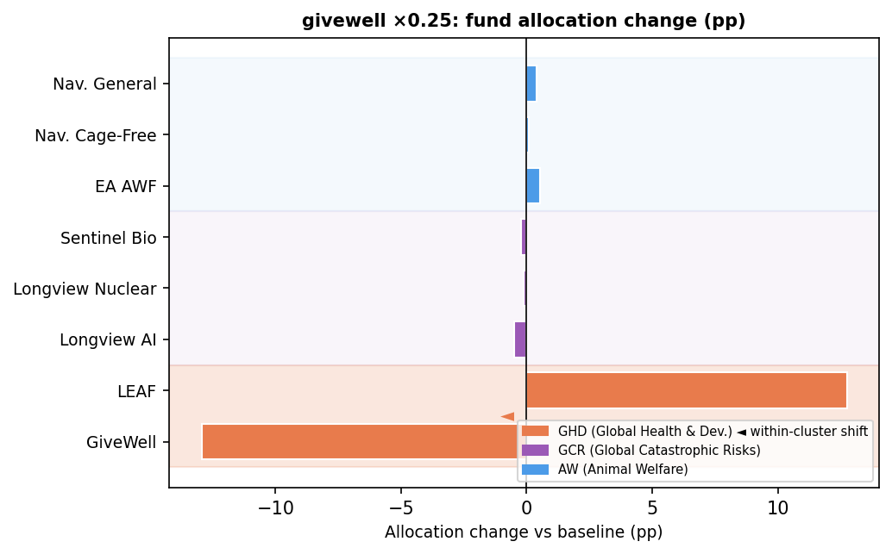

leaf ×2.0
Cluster SI = 3.62 pp | Fund SI = 16.30 pp | Gap = 12.68 pp
Within-cluster movement in GHD (Global Health & Dev.): LEAF +16.30 pp, GiveWell -12.69 pp.
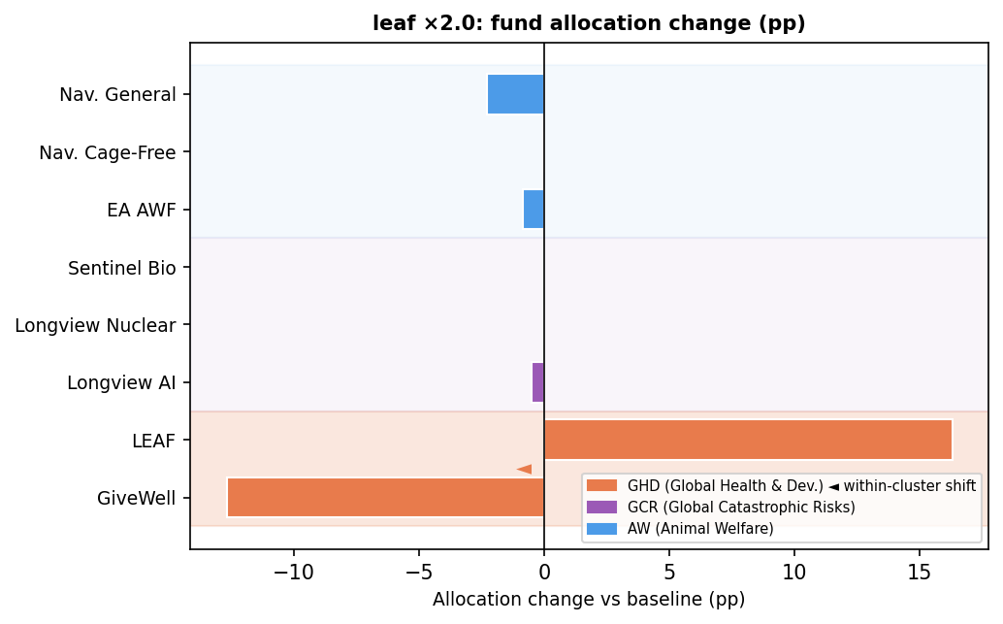

givewell ×0.5
Cluster SI = 1.77 pp | Fund SI = 12.95 pp | Gap = 11.17 pp
Within-cluster movement in GHD (Global Health & Dev.): GiveWell -12.95 pp, LEAF +11.17 pp.
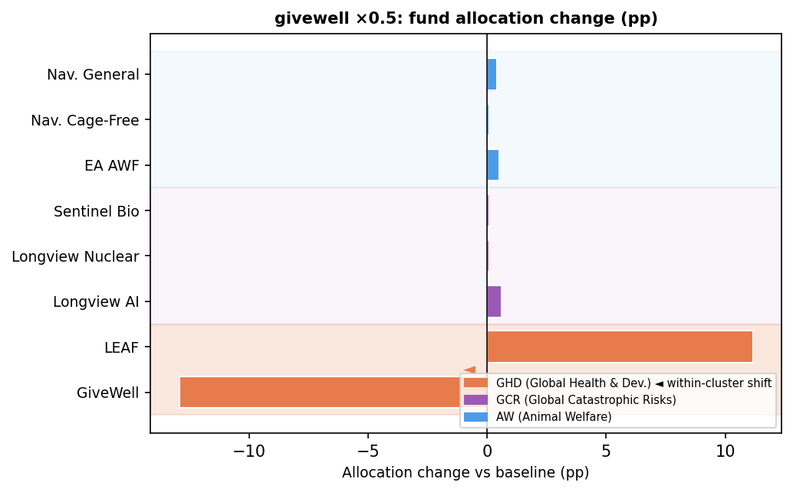

leaf ×1.5
Cluster SI = 1.71 pp | Fund SI = 11.28 pp | Gap = 9.57 pp
Within-cluster movement in GHD (Global Health & Dev.): LEAF +11.28 pp, GiveWell -9.57 pp.
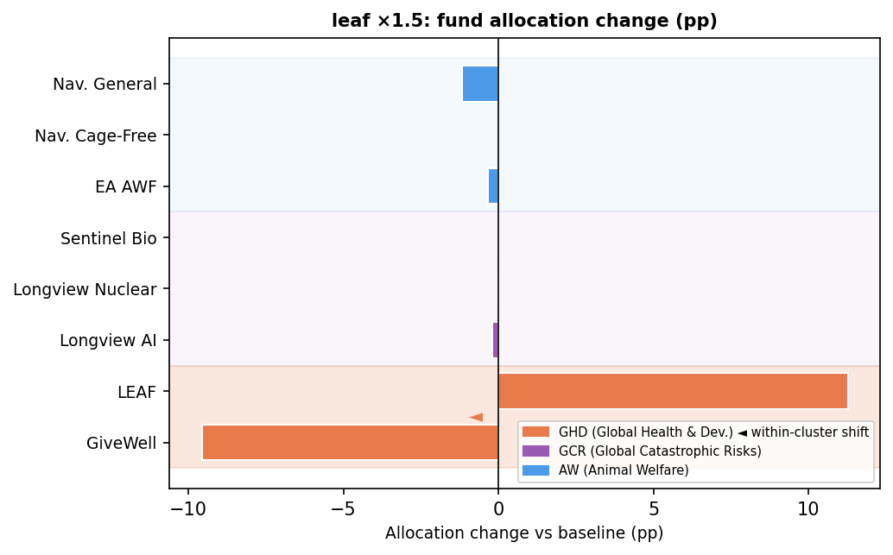

longview_ai ×0.1
Cluster SI = 4.64 pp | Fund SI = 13.33 pp | Gap = 8.69 pp
Within-cluster movement in GCR (Global Catastrophic Risks): Longview AI -10.38 pp, Sentinel Bio +4.54 pp, Longview Nuclear +3.94 pp.
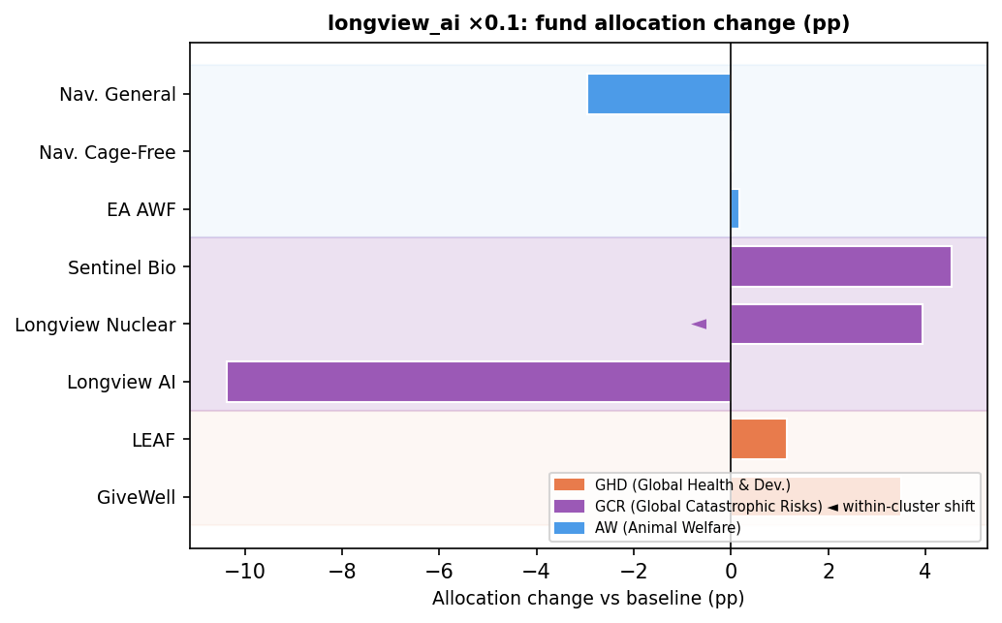

longview_nuclear ×10.0
Cluster SI = 2.77 pp | Fund SI = 10.51 pp | Gap = 7.74 pp
Within-cluster movement in GCR (Global Catastrophic Risks): Longview Nuclear +10.51 pp, Sentinel Bio -5.01 pp, Longview AI -2.73 pp.
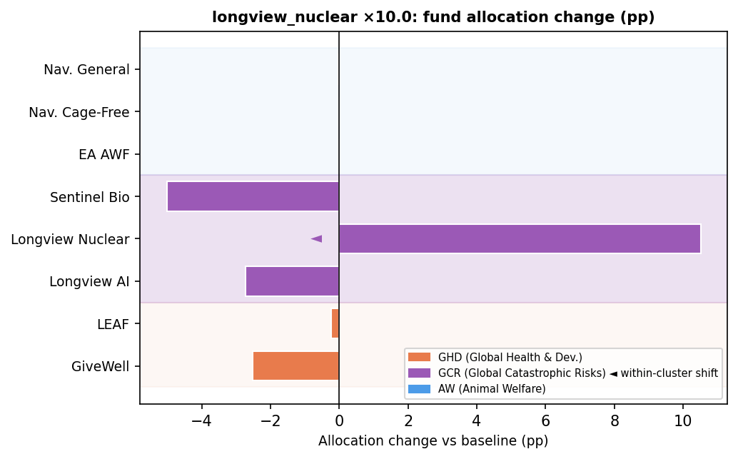

3. Diminishing Returns

3a. DR Power Parameters
DR power curves control how steeply returns diminish as spending increases. Altering curves for GCR or AW can reshape fund shares within those clusters without necessarily moving money between clusters.
DR Power Scenario | Cluster SI | Fund SI | Gap
gcr_high_aw_low_power | 2.42 | 6.66 | 4.23 | ⚠
gcr_and_aw_high_power | 0.96 | 4.87 | 3.91 | ⚠
gcr_and_aw_low_power | 2.73 | 5.94 | 3.21 | ⚠
aw_low_power | 2.42 | 5.19 | 2.76
gcr_low_aw_high_power | 0.73 | 3.46 | 2.74
aw_high_power | 0.53 | 3.08 | 2.55
gcr_high_power | 1.20 | 2.67 | 1.47
gcr_low_power | 0.60 | 0.95 | 0.35

Within-Cluster Shifts — Tests with Gap ≥ 3.0 pp

gcr_high_aw_low_power
Cluster SI = 2.42 pp | Fund SI = 6.66 pp | Gap = 4.23 pp
Within-cluster movement in AW (Animal Welfare): Nav. General -4.60 pp, EA AWF +2.76 pp, Nav. Cage-Free -0.58 pp.
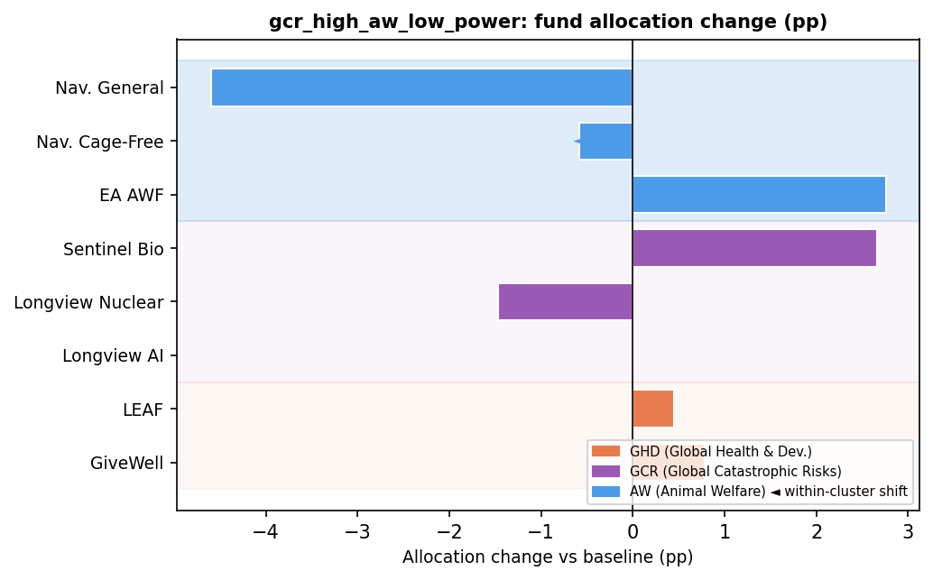

gcr_and_aw_high_power
Cluster SI = 0.96 pp | Fund SI = 4.87 pp | Gap = 3.91 pp
Within-cluster movement in AW (Animal Welfare): Nav. General +2.47 pp, EA AWF -2.35 pp.
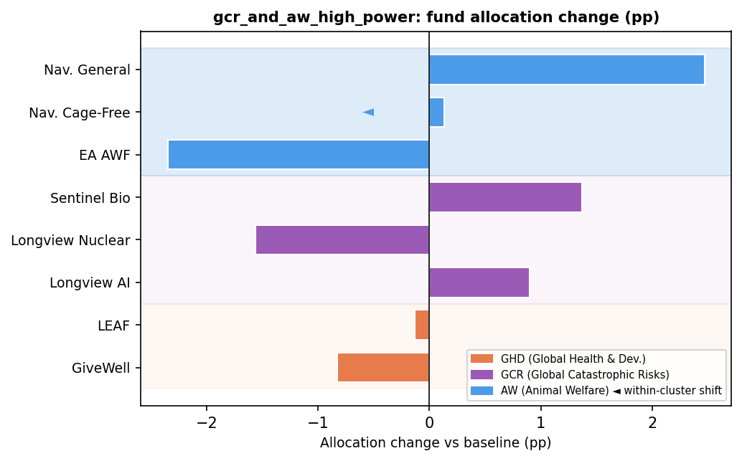

gcr_and_aw_low_power
Cluster SI = 2.73 pp | Fund SI = 5.94 pp | Gap = 3.21 pp
Within-cluster movement in AW (Animal Welfare): Nav. General -4.60 pp, EA AWF +2.76 pp, Nav. Cage-Free -0.58 pp.
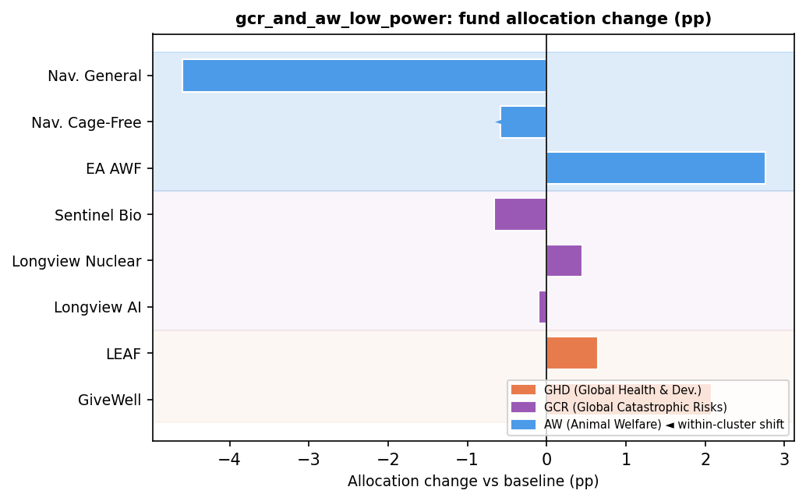

3b. Maximum Spending Cap
Three cap multipliers (2.5×, 7.5×, 10×) limit maximum fund-level spending. A tighter cap can cause large shifts between funds in the same cause area if one fund was the main beneficiary of uncapped spending.
Scenario | Cluster SI | Fund SI | Gap
max_spend_10x | 6.83 | 14.64 | 7.80 | ⚠
max_spend_7_5x | 3.37 | 9.74 | 6.37 | ⚠
max_spend_2_5x | 14.55 | 15.13 | 0.58

Within-Cluster Shifts — Tests with Gap ≥ 3.0 pp

max_spend_10x
Cluster SI = 6.83 pp | Fund SI = 14.64 pp | Gap = 7.80 pp
Within-cluster movement in AW (Animal Welfare): Nav. General -8.93 pp, Nav. Cage-Free +7.31 pp, EA AWF -1.08 pp.
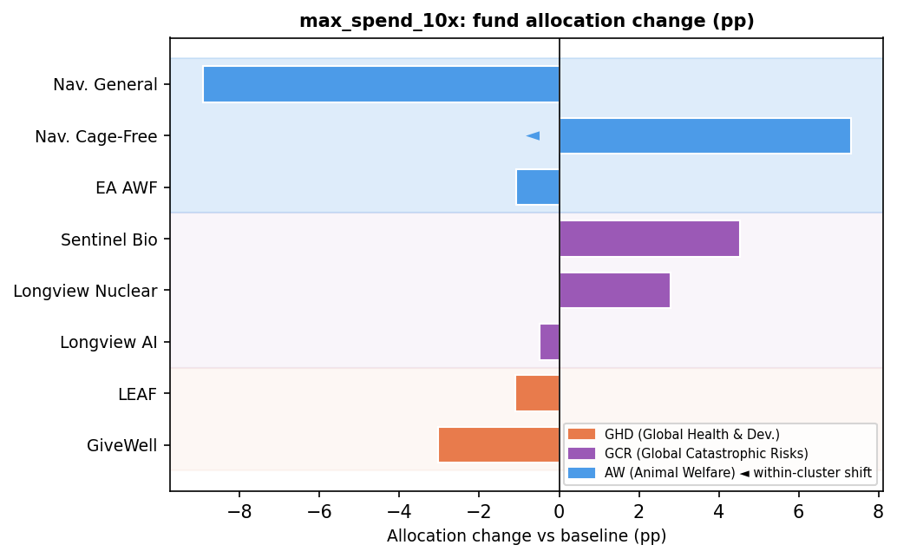

max_spend_7_5x
Cluster SI = 3.37 pp | Fund SI = 9.74 pp | Gap = 6.37 pp
Within-cluster movement in AW (Animal Welfare): Nav. Cage-Free +6.51 pp, Nav. General -5.35 pp, EA AWF -0.53 pp.
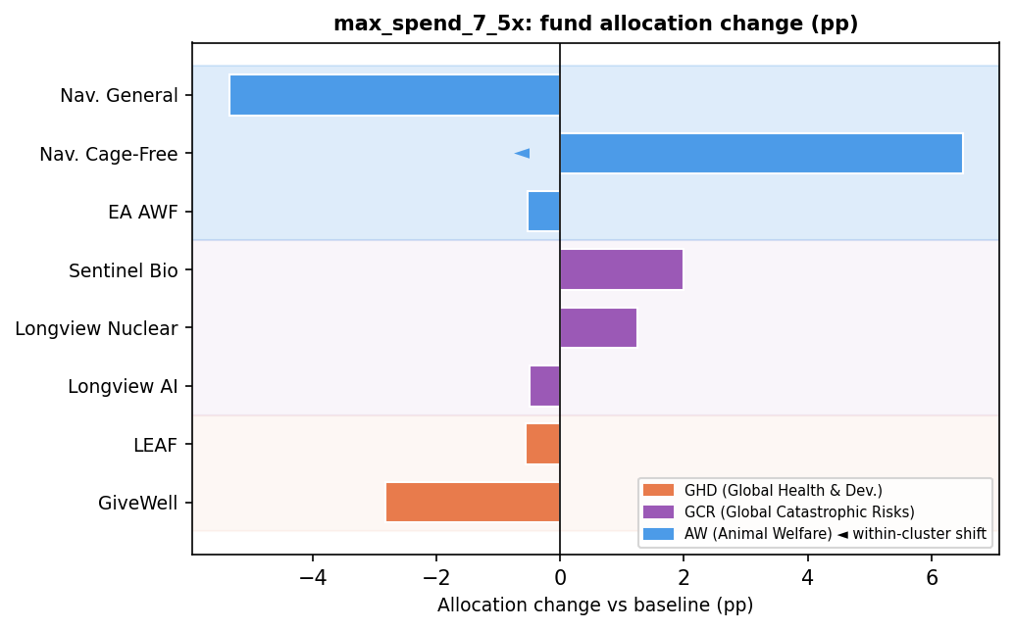

3c. Combined: DR Power × Maximum Spending Cap
24 joint tests. The interaction of power curves and spending caps can amplify within-cluster shifts beyond what either dimension alone produces.
Power Scenario | Cap Mult. | Cluster SI | Fund SI | Gap
gcr_and_aw_high_power | 10.0× | 6.53 | 19.81 | 13.28 | ⚠
aw_high_power | 10.0× | 4.87 | 17.47 | 12.60 | ⚠
gcr_low_aw_high_power | 10.0× | 4.87 | 17.27 | 12.40 | ⚠
gcr_and_aw_low_power | 10.0× | 4.86 | 13.14 | 8.27 | ⚠
gcr_low_power | 10.0× | 4.83 | 12.67 | 7.84 | ⚠
gcr_high_power | 10.0× | 7.83 | 15.64 | 7.80 | ⚠
aw_low_power | 10.0× | 6.86 | 14.54 | 7.67 | ⚠
gcr_high_aw_low_power | 7.5× | 4.47 | 11.90 | 7.43 | ⚠
gcr_high_power | 7.5× | 4.43 | 11.66 | 7.23 | ⚠
gcr_and_aw_low_power | 7.5× | 2.17 | 9.40 | 7.23 | ⚠
aw_low_power | 7.5× | 4.37 | 11.60 | 7.23 | ⚠
gcr_and_aw_high_power | 7.5× | 4.63 | 11.70 | 7.07 | ⚠
gcr_high_aw_low_power | 10.0× | 7.86 | 14.74 | 6.87 | ⚠
gcr_low_power | 7.5× | 3.37 | 9.14 | 5.77 | ⚠
aw_high_power | 7.5× | 4.66 | 10.25 | 5.58 | ⚠
gcr_low_aw_high_power | 7.5× | 4.66 | 10.05 | 5.38 | ⚠
gcr_and_aw_high_power | 2.5× | 12.16 | 14.68 | 2.52
gcr_high_power | 2.5× | 12.21 | 14.73 | 2.52
gcr_high_aw_low_power | 2.5× | 11.96 | 14.14 | 2.18
aw_low_power | 2.5× | 14.06 | 14.64 | 0.58
aw_high_power | 2.5× | 14.50 | 15.07 | 0.57
gcr_low_power | 2.5× | 14.77 | 15.13 | 0.36
gcr_and_aw_low_power | 2.5× | 14.52 | 14.84 | 0.32
gcr_low_aw_high_power | 2.5× | 14.76 | 15.07 | 0.31

Within-Cluster Shifts — Tests with Gap ≥ 3.0 pp

gcr_and_aw_high_power ×10.0
Cluster SI = 6.53 pp | Fund SI = 19.81 pp | Gap = 13.28 pp
Within-cluster movement in AW (Animal Welfare): Nav. Cage-Free +12.78 pp, Nav. General -8.02 pp, EA AWF -6.42 pp.
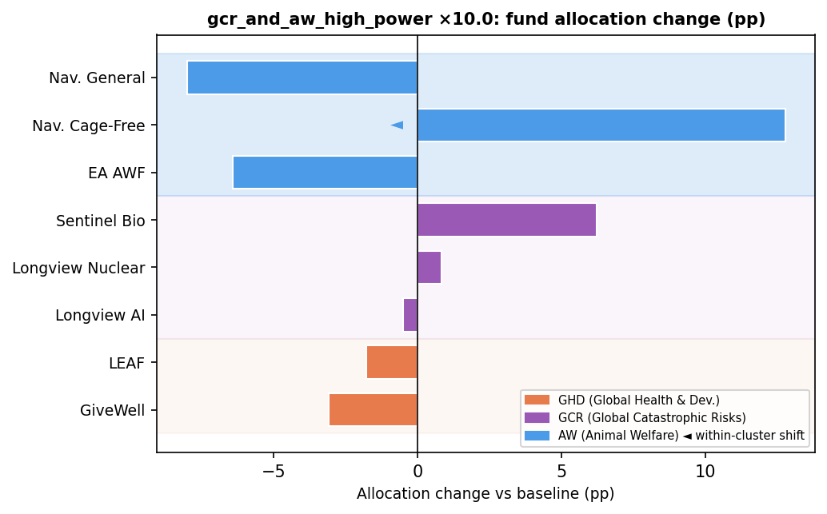

aw_high_power ×10.0
Cluster SI = 4.87 pp | Fund SI = 17.47 pp | Gap = 12.60 pp
Within-cluster movement in AW (Animal Welfare): Nav. Cage-Free +12.84 pp, Nav. General -6.29 pp, EA AWF -5.79 pp.
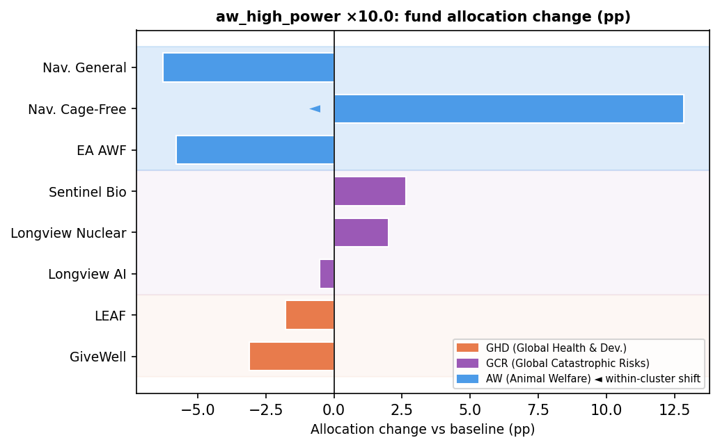

gcr_low_aw_high_power ×10.0
Cluster SI = 4.87 pp | Fund SI = 17.27 pp | Gap = 12.40 pp
Within-cluster movement in AW (Animal Welfare): Nav. Cage-Free +12.84 pp, Nav. General -6.19 pp, EA AWF -5.69 pp.
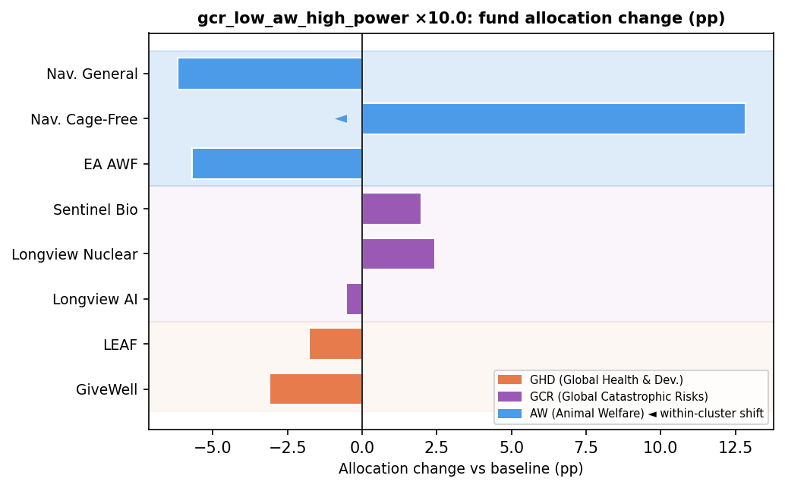

gcr_and_aw_low_power ×10.0
Cluster SI = 4.86 pp | Fund SI = 13.14 pp | Gap = 8.27 pp
Within-cluster movement in AW (Animal Welfare): Nav. General -9.45 pp, EA AWF +5.66 pp, Nav. Cage-Free +2.12 pp.
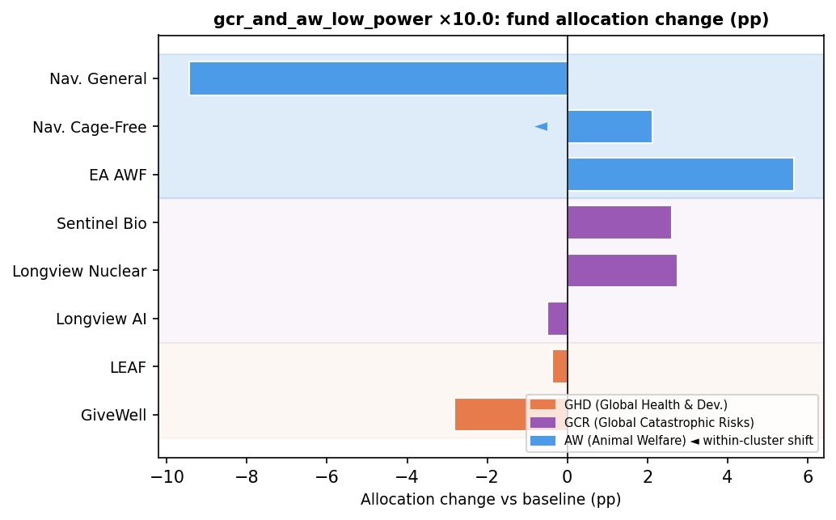

4. Aggregation Method Weights
Each aggregation method's credence is shifted to its low or high bound. Some methods favour particular funds within a cause area without substantially changing the cause area's total budget share.
Method | Bound | Credence Range | Cluster SI | Fund SI | Gap
MEC | low | 15%→10% | 1.09 | 2.36 | 1.27
MEC | high | 15%→20% | 1.09 | 2.36 | 1.27
nashBargaining | low | 35%→15% | 3.98 | 4.72 | 0.74
marketplace | high | 30%→50% | 3.69 | 4.38 | 0.69
nashBargaining | high | 35%→50% | 2.98 | 3.54 | 0.56
marketplace | low | 30%→20% | 1.85 | 2.19 | 0.35
lexicographicMaximin | high | 0%→5% | 4.11 | 4.15 | 0.05
splitCycle | low | 8%→2% | 2.31 | 2.31 | 0.00
MET | low | 10%→5% | 1.58 | 1.58 | 0.00
MET | high | 10%→15% | 1.58 | 1.58 | 0.00
borda | high | 2%→5% | 1.09 | 1.09 | 0.00
splitCycle | high | 8%→10% | 0.77 | 0.77 | 0.00
borda | low | 2%→0% | 0.73 | 0.73 | 0.00
lexicographicMaximin | low | 0%→0% | 0.00 | 0.00 | 0.00
baseline | baseline | nan%→nan% | 0.00 | 0.00 | 0.00

5. GHD Timing Sensitivity
Three scenarios shift when GHD program effects are realized. Because both GiveWell and LEAF belong to GHD, a shift from one to the other produces high fund-level SI but near-zero cluster-level SI — a pure within-GHD shift.
Scenario | Cluster SI | Fund SI | Gap
all effects far | 1.53 | 4.28 | 2.75
health effects near | 1.36 | 1.36 | 0.00
all effects near | 0.00 | 0.00 | 0.00

GHD Timing — Borderline Within-Cluster Cases (Gap ≥ 1.5 pp)

all effects far
Cluster SI = 1.53 pp | Fund SI = 4.28 pp | Gap = 2.75 pp
Within-cluster movement in GHD (Global Health & Dev.): LEAF -4.28 pp, GiveWell +2.75 pp.
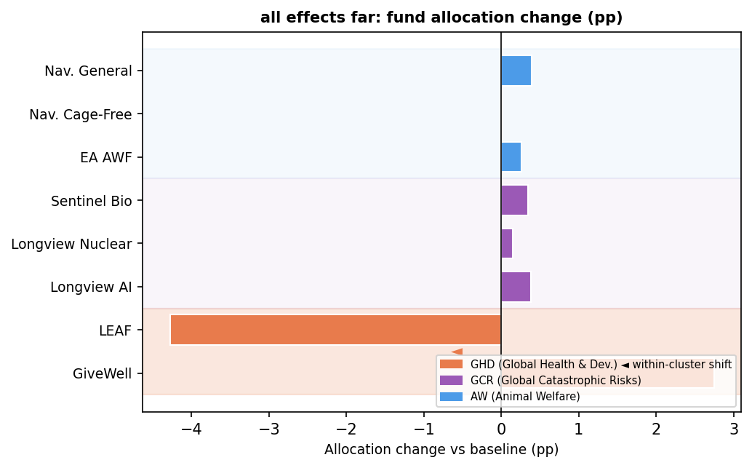

6. Illustrative: Risk Aversion
Risk-aversion scenarios place extreme credence in a single risk profile. These are presented separately as illustrative analyses. Because the shifts are often total reallocation toward one cause area, the gap here reflects whether individual funds within a favoured cause area also redistribute.
Test | Cluster SI | Fund SI | Gap
neutral_to_downside_critical | 56.15 | 89.14 | 32.99 | ⚠
specialblend_to_downside_critical | 3.10 | 26.68 | 23.58 | ⚠
specialblend_to_bilateral_skep | 54.39 | 66.81 | 12.42 | ⚠
specialblend_to_neutral | 54.52 | 65.93 | 11.41 | ⚠
neutral_to_bilateral_skep | 0.13 | 1.20 | 1.07
specialblend_to_cont_upside_skep | 26.18 | 27.12 | 0.95
specialblend_to_combined | 35.63 | 35.75 | 0.12
neutral_to_cont_upside_skep | 80.69 | 80.69 | 0.00
neutral_to_combined | 90.15 | 90.15 | 0.00
specialblend_to_wlu_5 | 35.63 | 35.63 | 0.00
specialblend_to_wlu_10 | 35.63 | 35.63 | 0.00

Within-Cluster Shifts — Tests with Gap ≥ 3.0 pp

neutral_to_downside_critical
Cluster SI = 56.15 pp | Fund SI = 89.14 pp | Gap = 32.99 pp
Within-cluster movement in GCR (Global Catastrophic Risks): Longview AI -89.14 pp, Sentinel Bio +18.41 pp, Longview Nuclear +14.58 pp.
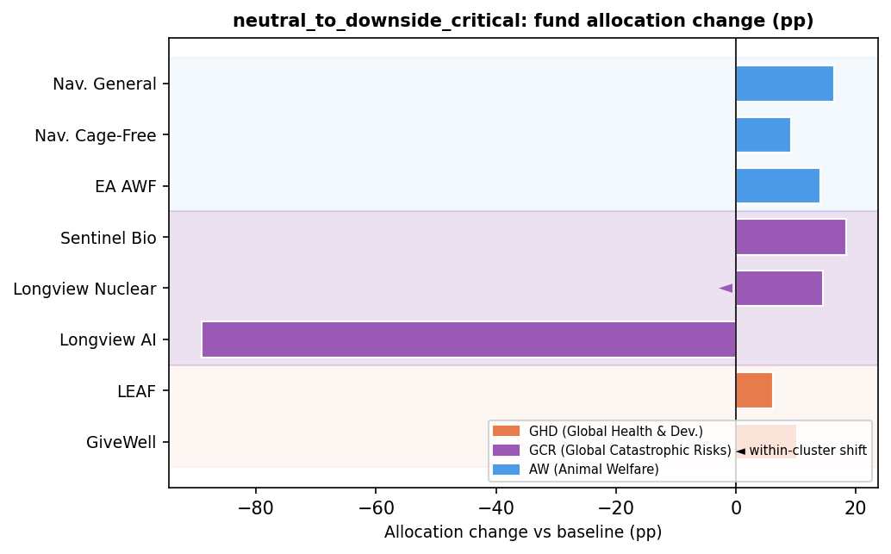

specialblend_to_downside_critical
Cluster SI = 3.10 pp | Fund SI = 26.68 pp | Gap = 23.58 pp
Within-cluster movement in GCR (Global Catastrophic Risks): Longview AI -23.22 pp, Longview Nuclear +11.18 pp, Sentinel Bio +10.41 pp.
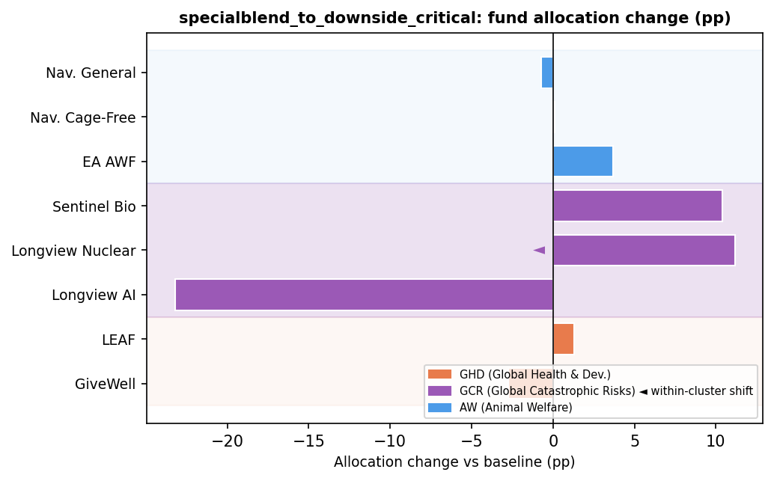

specialblend_to_bilateral_skep
Cluster SI = 54.39 pp | Fund SI = 66.81 pp | Gap = 12.42 pp
Within-cluster movement in GCR (Global Catastrophic Risks): Longview AI +66.80 pp, Sentinel Bio -8.59 pp, Longview Nuclear -3.82 pp.
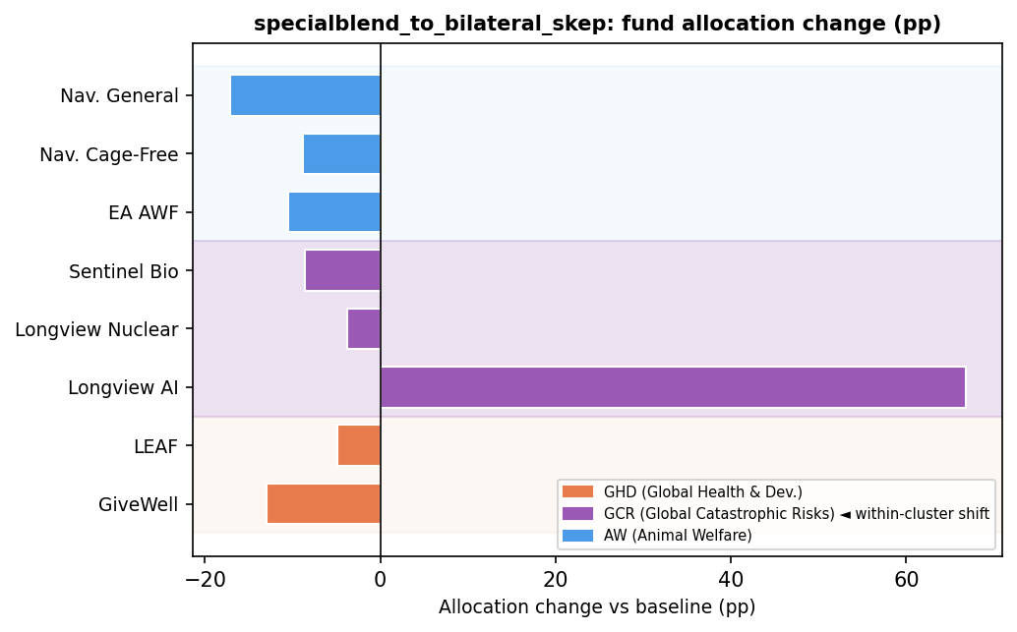

specialblend_to_neutral
Cluster SI = 54.52 pp | Fund SI = 65.93 pp | Gap = 11.41 pp
Within-cluster movement in GCR (Global Catastrophic Risks): Longview AI +65.93 pp, Sentinel Bio -8.01 pp, Longview Nuclear -3.40 pp.
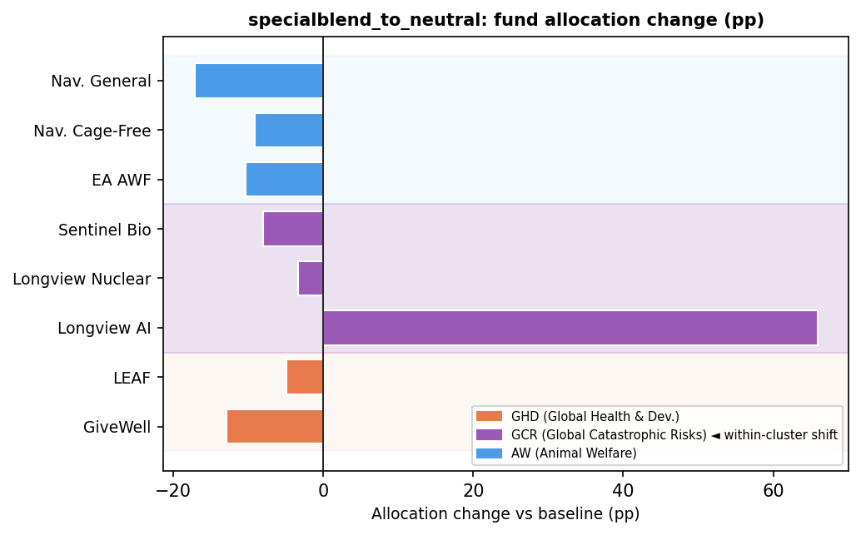

Robustly Insensitive Tests (Cluster SI < 1 and Fund SI < 2)
The following tests show low sensitivity at both the cluster and fund level — the allocation is genuinely robust to these parameter changes.
Aggregation Methods
- Cluster SI = 0.00 | Fund SI = 0.00 · lexicographicMaximin (low)
- Cluster SI = 0.00 | Fund SI = 0.00 · baseline (baseline)
- Cluster SI = 0.73 | Fund SI = 0.73 · borda (low)
- Cluster SI = 0.77 | Fund SI = 0.77 · splitCycle (high)
CE Multipliers
- Cluster SI = 0.71 | Fund SI = 0.75 · navigation_fund_cagefree ×1.5
- Cluster SI = 0.98 | Fund SI = 0.98 · navigation_fund_cagefree ×2.0
- Cluster SI = 0.60 | Fund SI = 1.59 · longview_nuclear ×0.1
Dim. Returns (Power)
- Cluster SI = 0.60 | Fund SI = 0.95 · gcr_low_power
GHD Timing
- Cluster SI = 0.00 | Fund SI = 0.00 · all effects near
Worldview Credences
- Cluster SI = 0.00 | Fund SI = 0.00 · baseline (baseline)
- Cluster SI = 0.92 | Fund SI = 1.28 · Non-Utilitarian Consequentialism — (low)

Within-Cluster Shifters with Low Cluster SI (SI < 2)
These tests appear nearly stable in a cluster-only view (cluster SI < 2) but produce meaningful fund-level reallocation (fund SI ≥ 2). Donors targeting specific funds should treat these as sensitive.
Aggregation Methods
- Cluster SI = 1.09 | Fund SI = 2.36 | Gap = 1.27 · MEC (low)
- Cluster SI = 1.09 | Fund SI = 2.36 | Gap = 1.27 · MEC (high)
- Cluster SI = 1.85 | Fund SI = 2.19 | Gap = 0.35 · marketplace (low)
CE Multipliers
- Cluster SI = 1.02 | Fund SI = 13.79 | Gap = 12.76 · givewell ×0.25
- Cluster SI = 1.77 | Fund SI = 12.95 | Gap = 11.17 · givewell ×0.5
- Cluster SI = 1.71 | Fund SI = 11.28 | Gap = 9.57 · leaf ×1.5
- Cluster SI = 0.60 | Fund SI = 5.76 | Gap = 5.16 · sentinel_bio ×0.1
- Cluster SI = 0.34 | Fund SI = 5.30 | Gap = 4.96 · leaf ×0.5
- Cluster SI = 0.12 | Fund SI = 5.08 | Gap = 4.96 · leaf ×0.25
- Cluster SI = 0.98 | Fund SI = 3.68 | Gap = 2.70 · navigation_fund_general ×2.0
- Cluster SI = 0.46 | Fund SI = 3.15 | Gap = 2.69 · ea_awf ×0.5
- Cluster SI = 1.01 | Fund SI = 3.64 | Gap = 2.63 · ea_awf ×2.0
- Cluster SI = 0.46 | Fund SI = 2.11 | Gap = 1.66 · ea_awf ×1.5
- Cluster SI = 0.59 | Fund SI = 2.15 | Gap = 1.56 · navigation_fund_general ×1.5
- Cluster SI = 1.33 | Fund SI = 2.75 | Gap = 1.42 · navigation_fund_cagefree ×0.5
Dim. Returns (Power)
- Cluster SI = 0.96 | Fund SI = 4.87 | Gap = 3.91 · gcr_and_aw_high_power
- Cluster SI = 0.73 | Fund SI = 3.46 | Gap = 2.74 · gcr_low_aw_high_power
- Cluster SI = 0.53 | Fund SI = 3.08 | Gap = 2.55 · aw_high_power
- Cluster SI = 1.20 | Fund SI = 2.67 | Gap = 1.47 · gcr_high_power
GHD Timing
- Cluster SI = 1.53 | Fund SI = 4.28 | Gap = 2.75 · all effects far
Worldview Credences
- Cluster SI = 1.98 | Fund SI = 3.57 | Gap = 1.58 · Contractualism — Person-Affecting/C (low)
- Cluster SI = 1.77 | Fund SI = 2.10 | Gap = 0.33 · Contractualism — Default + clueless (low)

