Donor Compass Sensitivity Analysis Report
Generated May 25, 2026 · Rethink Priorities

Executive Summary
The sensitivity index (SI) used throughout this report measures the total absolute change (in percentage points) summed across all funds, divided by two, when an assumption is shifted from its baseline to an alternative value. Because allocations sum to 100%, total gains always equal total losses; dividing by two gives the net amount redistributed. An SI of 10 means 10 pp was redistributed from losing funds to gaining funds.

Most Important Sensitivity Drivers
The table below ranks the most impactful parameter changes across all main analyses, sorted by SI. Risk-aversion scenarios (Section 7) are excluded because they represent extreme single-perspective cases rather than uncertainty about a shared parameter.
Rank | SI | Dimension | Test / Parameter | Most Affected Fund | Max Δ
1 | 27.40 | CE Multipliers | all_gcr ×100.0 | Longview AI Safety | +18.20 pp
2 | 27.38 | Worldview Credences | Total Utilitarianism — Default (high, 10%→25%) | Longview AI Safety | +27.38 pp
3 | 26.67 | Worldview Credences | Non-Utilitarian Consequentialism — Default (high, | Longview AI Safety | +26.67 pp
4 | 25.96 | CE Multipliers | all_gcr ×10000.0 | Longview AI Safety | +16.74 pp
5 | 25.89 | CE Multipliers | all_gcr ×1000.0 | Longview AI Safety | +16.67 pp
6 | 24.18 | Moral Weights | All animal weights ×0.1 | GiveWell | +20.94 pp
7 | 20.87 | Time Discounts | discount 100-500 and 500+ ×0.0 | Navigation Fund (General) | +10.74 pp
8 | 15.38 | Time Discounts | discount 500+ ×0.0 | Navigation Fund (General) | +8.36 pp
9 | 15.13 | Dim. Returns (Max Spend) | Max spend cap ×2.5 | GiveWell | +13.27 pp
10 | 14.64 | Dim. Returns (Max Spend) | Max spend cap ×10.0 | Navigation Fund (General) | -8.93 pp
11 | 14.15 | Moral Weights | All animal weights ×0.2 | GiveWell | +11.01 pp
12 | 13.80 | Worldview Credences | Total Utilitarianism — Weighted Linear Utilit (low | Longview AI Safety | +13.57 pp
13 | 9.74 | Dim. Returns (Max Spend) | Max spend cap ×7.5 | Navigation Fund (Cage-Free) | +6.50 pp
14 | 6.66 | Dim. Returns (Power) | gcr_high_aw_low_power | Navigation Fund (General) | -4.60 pp
15 | 5.94 | Dim. Returns (Power) | gcr_and_aw_low_power | Navigation Fund (General) | -4.60 pp
16 | 4.72 | Aggregation Methods | nashBargaining_low (low bound) | Longview AI Safety | -3.61 pp
17 | 4.38 | Aggregation Methods | marketplace_high (high bound) | Longview AI Safety | +3.35 pp
Worldview credences and CE multipliers dominate: both reach SI > 27 pp, driven by parameters that directly control how much weight the model places on GCR spending. Increasing credence on either Total Utilitarianism — Default or Non-Utilitarian Consequentialism — Default (both GCR-favouring worldviews) shifts up to ~27 pp to Longview AI Safety. Boosting the GCR group's CE by 100× similarly adds ~18 pp to Longview AI Safety. Within GHD, LEAF and GiveWell are highly sensitive to each other's CE: doubling LEAF's CE redistributes ~16 pp from GiveWell to LEAF. The max-spending cap is the most impactful DR parameter (SI up to 15 pp): a tight 2.5× cap prevents money from concentrating in Longview AI Safety, sending ~13 pp to GiveWell instead. Aggregation method weights and GHD timing are the least sensitive dimensions tested (SI ≤ 5 pp).

Baseline Allocation
Fund | Baseline Allocation (%)
EA Animal Welfare Fund | 12.8%
GiveWell | 12.9%
LEAF | 4.9%
Longview AI Safety | 23.2%
Longview Nuclear Security | 3.8%
Navigation Fund (Cage-Free) | 15.6%
Navigation Fund (General) | 18.1%
Sentinel Biosecurity | 8.6%

Maximum SI by Dimension
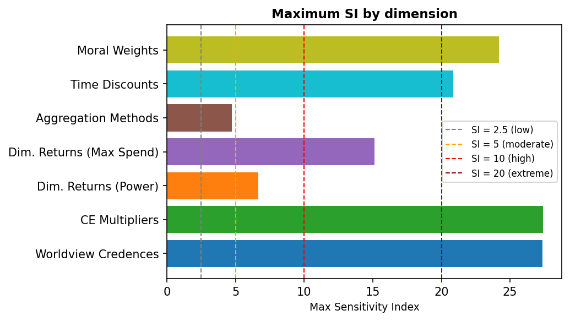

Distribution of SI Values — Main Analyses Only
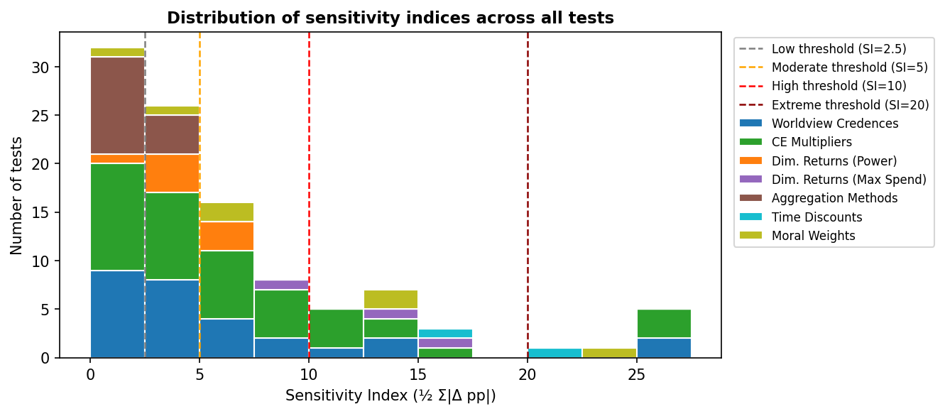

Note: risk-aversion scenario tests and analyses placing 100% credence in a single worldview or aggregation method are presented separately in Section 7 as illustrative scenarios; they are excluded from the chart above.

Distribution of SI Values — Including Illustrative Tests
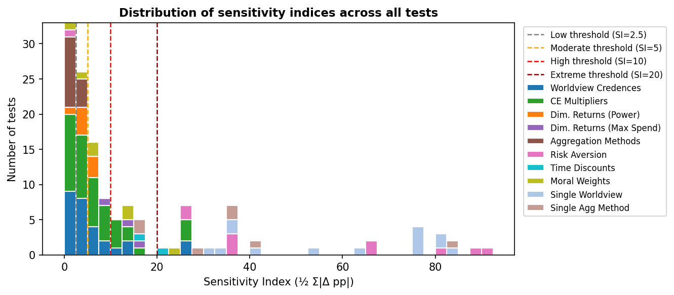

1. Worldview Credences
Each of the 14 worldviews carries a credence weight (best-guess estimate). Each worldview's credence is shifted to its low-end or high-end uncertainty bound, one worldview at a time, holding the rest at their best-guess values and re-normalising. For example, Total Utilitarianism — Default is shifted from 10% credence to 25% (high bound) or 5% (low bound). Single-worldview (100% credence) scenarios are presented in Section 7.

Sensitivity by Test — Ranked by SI (top 20 of 28)
Worldview | Bound | Credence Range | SI | Scaled SI* | Most Affected Fund | Max Δ
Total Utilitarianism — Default | high | 10% → 25% | 27.38 | 1.83 | Longview AI Safety | +27.38 pp
Non-Utilitarian Consequentialism — Default | high | 5% → 20% | 26.67 | 1.78 | Longview AI Safety | +26.67 pp
Total Utilitarianism — Weighted Linear Utility | low | 10% → 5% | 13.80 | 2.76 | Longview AI Safety | +13.57 pp
Contractualism — Person-Affecting/Cluelessness and Animals Baseline | high | 10% → 25% | 13.45 | 0.90 | Sentinel Biosecurity | +8.95 pp
Non-Utilitarian Consequentialism — Person-Affecting/Cluelessness | high | 5% → 20% | 11.90 | 0.79 | Longview AI Safety | +11.71 pp
Contractualism — Default + cluelessness | high | 5% → 15% | 9.20 | 0.92 | GiveWell | +8.60 pp
Kantianism — Low animals | high | 5% → 20% | 8.38 | 0.56 | GiveWell | +7.91 pp
Kantianism — Low animals / downside critical | high | 10% → 20% | 6.15 | 0.62 | GiveWell | +5.74 pp
Contractualism — Person-Affecting/Cluelessness and Animals Baseline - Risk Neutral | high | 10% → 20% | 5.33 | 0.53 | Longview AI Safety | +5.20 pp
Non-Utilitarian Consequentialism — High Life Value / Cluelessness / Low animals | high | 5% → 15% | 5.29 | 0.53 | Longview AI Safety | +4.45 pp
Kantianism — Low animals / downside critical | low | 10% → 1% | 5.04 | 0.56 | GiveWell | -5.04 pp
Total Utilitarianism — Weighted Linear Utility | high | 10% → 20% | 4.86 | 0.49 | Longview AI Safety | -3.02 pp
Contractualism — Person-Affecting/Cluelessness and Animals Baseline - Risk Neutral | low | 10% → 1% | 4.73 | 0.53 | Longview AI Safety | -4.73 pp
Total Utilitarianism — Person-Affecting/Cluelessness, Sentience-only discounts, Empirical disbelief in upside scenarios | high | 10% → 20% | 4.65 | 0.46 | EA Animal Welfare Fund | +2.56 pp
Total Utilitarianism — High life value, risk averse, and skeptical of upside cases | high | 5% → 15% | 4.63 | 0.46 | Longview AI Safety | -2.89 pp
Total Utilitarianism — Suffering forward, clueless, and only sentience discount | high | 5% → 15% | 4.46 | 0.45 | EA Animal Welfare Fund | +2.47 pp
Non-Utilitarian Consequentialism — Weighted Linear Utility | high | 5% → 15% | 3.59 | 0.36 | Longview AI Safety | -2.89 pp
Contractualism — Person-Affecting/Cluelessness and Animals Baseline | low | 10% → 5% | 3.57 | 0.71 | Sentinel Biosecurity | -2.52 pp
Total Utilitarianism — Default | low | 10% → 5% | 2.85 | 0.57 | Longview AI Safety | -2.85 pp
Total Utilitarianism — Person-Affecting/Cluelessness, Sentience-only discounts, Empirical disbelief in upside scenarios | low | 10% → 5% | 2.19 | 0.44 | Longview AI Safety | +1.26 pp
* Scaled SI = SI ÷ absolute credence change (pp). Higher values indicate greater sensitivity per unit shift in credence weight.

Same Tests — Ranked by Scaled SI (top 20)
Rank | Worldview | Bound | Credence Range | SI | Scaled SI | Most Affected Fund | Max Δ
1 | Total Utilitarianism — Weighted Linear Utility | low | 10% → 5% | 13.80 | 2.76 | Longview AI Safety | +13.57 pp
2 | Total Utilitarianism — Default | high | 10% → 25% | 27.38 | 1.83 | Longview AI Safety | +27.38 pp
3 | Non-Utilitarian Consequentialism — Default | high | 5% → 20% | 26.67 | 1.78 | Longview AI Safety | +26.67 pp
4 | Contractualism — Default + cluelessness | high | 5% → 15% | 9.20 | 0.92 | GiveWell | +8.60 pp
5 | Contractualism — Person-Affecting/Cluelessness and Animals Baseline | high | 10% → 25% | 13.45 | 0.90 | Sentinel Biosecurity | +8.95 pp
6 | Non-Utilitarian Consequentialism — Person-Affecting/Cluelessness | high | 5% → 20% | 11.90 | 0.79 | Longview AI Safety | +11.71 pp
7 | Contractualism — Person-Affecting/Cluelessness and Animals Baseline | low | 10% → 5% | 3.57 | 0.71 | Sentinel Biosecurity | -2.52 pp
8 | Contractualism — Default + cluelessness | low | 5% → 2% | 2.10 | 0.70 | Longview AI Safety | +1.30 pp
9 | Kantianism — Low animals / downside critical | high | 10% → 20% | 6.15 | 0.62 | GiveWell | +5.74 pp
10 | Total Utilitarianism — Default | low | 10% → 5% | 2.85 | 0.57 | Longview AI Safety | -2.85 pp
11 | Kantianism — Low animals / downside critical | low | 10% → 1% | 5.04 | 0.56 | GiveWell | -5.04 pp
12 | Kantianism — Low animals | high | 5% → 20% | 8.38 | 0.56 | GiveWell | +7.91 pp
13 | Contractualism — Person-Affecting/Cluelessness and Animals Baseline - Risk Neutral | high | 10% → 20% | 5.33 | 0.53 | Longview AI Safety | +5.20 pp
14 | Non-Utilitarian Consequentialism — High Life Value / Cluelessness / Low animals | high | 5% → 15% | 5.29 | 0.53 | Longview AI Safety | +4.45 pp
15 | Contractualism — Person-Affecting/Cluelessness and Animals Baseline - Risk Neutral | low | 10% → 1% | 4.73 | 0.53 | Longview AI Safety | -4.73 pp
16 | Kantianism — Low animals | low | 5% → 1% | 2.05 | 0.51 | GiveWell | -1.81 pp
17 | Total Utilitarianism — Weighted Linear Utility | high | 10% → 20% | 4.86 | 0.49 | Longview AI Safety | -3.02 pp
18 | Total Utilitarianism — Person-Affecting/Cluelessness, Sentience-only discounts, Empirical disbelief in upside scenarios | high | 10% → 20% | 4.65 | 0.46 | EA Animal Welfare Fund | +2.56 pp
19 | Total Utilitarianism — High life value, risk averse, and skeptical of upside cases | high | 5% → 15% | 4.63 | 0.46 | Longview AI Safety | -2.89 pp
20 | Total Utilitarianism — Suffering forward, clueless, and only sentience discount | low | 5% → 2% | 1.34 | 0.45 | Longview AI Safety | +0.72 pp

Fund Allocation Changes — Tests with SI ≥ 10
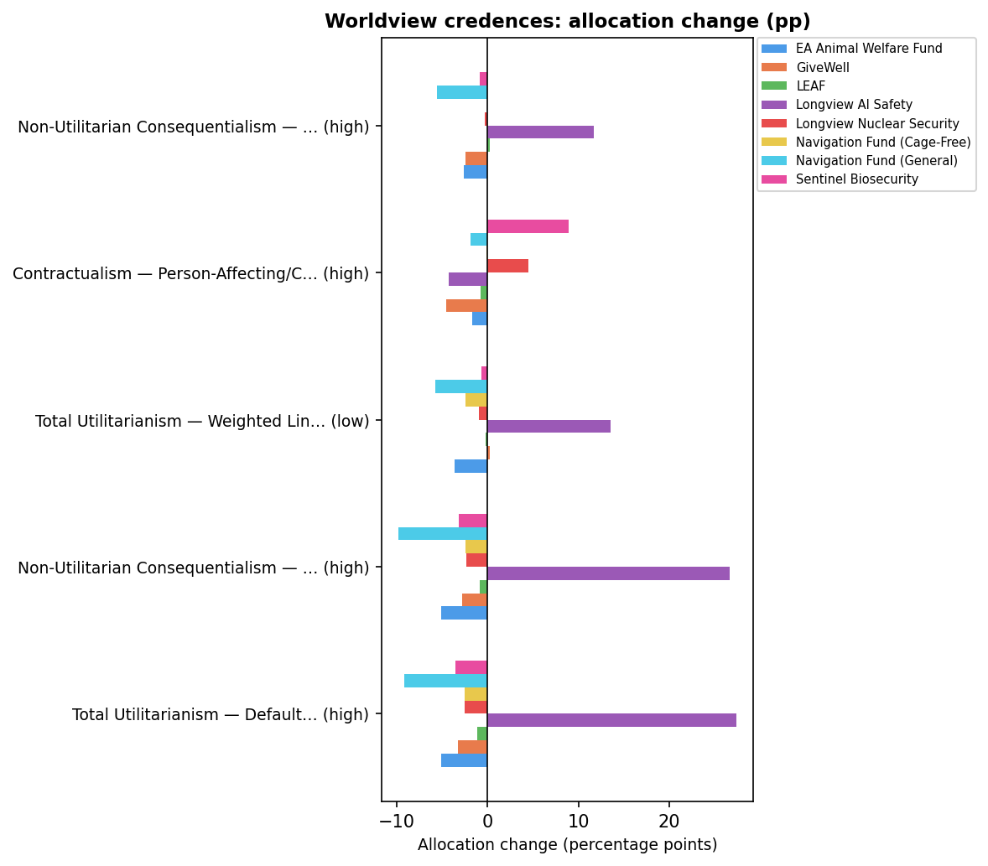

Key findings: Raising credence on Total Utilitarianism — Default or Non-Utilitarian Consequentialism — Default (both utilitarian-leaning worldviews that favour GCR spending) strongly increases Longview AI Safety's allocation (up to +27 pp). Raising credences on Contractualist or Kantian worldviews instead boosts GiveWell and Sentinel Biosecurity. Low-bound shifts are generally less impactful than high-bound shifts.

2. Cost-Effectiveness Multipliers
Each fund's cost-effectiveness (CE) was multiplied by a constant factor, one fund (or group) at a time. GCR individual funds (Longview AI, Longview Nuclear, Sentinel) were tested at 0.1× and 10×; GHD funds (GiveWell, LEAF) at 0.25×–2×; AW individual funds at 0.5×–2×. The GCR group (all three GCR funds jointly) was tested at 0.0001×–10,000× (∼8 orders of magnitude). The AW group (all three AW funds jointly) was tested at 0.25× and 4×.

Sensitivity by Test — Ranked by SI (all 31 tests)
Fund Varied | Multiplier | SI | Scaled SI* | Biggest Gainer | Biggest Loser
all_gcr | 100.0× | 27.40 | 13.70 | Longview AI Safety (+18.20 pp) | Navigation Fund (General) (-10.73 pp)
all_gcr | 10000.0× | 25.96 | 6.49 | Longview AI Safety (+16.74 pp) | Navigation Fund (General) (-10.62 pp)
all_gcr | 1000.0× | 25.89 | 8.63 | Longview AI Safety (+16.67 pp) | Navigation Fund (General) (-10.60 pp)
leaf | 2.0× | 16.30 | 54.16 | LEAF (+16.30 pp) | GiveWell (-12.69 pp)
longview_ai | 0.1× | 13.33 | 13.33 | Sentinel Biosecurity (+4.54 pp) | Longview AI Safety (-10.38 pp)
givewell | 0.5× | 12.95 | 43.00 | LEAF (+11.17 pp) | GiveWell (-12.95 pp)
all_aw | 0.25× | 12.05 | 20.02 | GiveWell (+9.08 pp) | Navigation Fund (General) (-9.69 pp)
leaf | 1.5× | 11.30 | 64.16 | LEAF (+11.30 pp) | GiveWell (-9.58 pp)
givewell | 2.0× | 11.24 | 37.36 | GiveWell (+11.24 pp) | LEAF (-4.93 pp)
longview_nuclear | 10.0× | 10.51 | 10.51 | Longview Nuclear Security (+10.51 pp) | Sentinel Biosecurity (-5.01 pp)
sentinel_bio | 10.0× | 9.92 | 9.92 | Sentinel Biosecurity (+9.92 pp) | Longview AI Safety (-4.52 pp)
all_gcr | 0.01× | 9.92 | 4.96 | GiveWell (+6.75 pp) | Longview AI Safety (-6.97 pp)
all_gcr | 0.001× | 9.91 | 3.30 | GiveWell (+6.74 pp) | Longview AI Safety (-6.97 pp)
all_gcr | 0.0001× | 9.91 | 2.48 | GiveWell (+6.74 pp) | Longview AI Safety (-6.97 pp)
givewell | 1.5× | 9.18 | 52.12 | GiveWell (+9.18 pp) | LEAF (-4.93 pp)
navigation_fund_general | 0.5× | 7.01 | 23.30 | GiveWell (+3.40 pp) | Navigation Fund (General) (-7.01 pp)
longview_ai | 10.0× | 6.33 | 6.33 | Longview AI Safety (+6.33 pp) | GiveWell (-2.63 pp)
all_ghd | 2.0× | 6.11 | 20.28 | GiveWell (+5.08 pp) | Navigation Fund (General) (-4.70 pp)
all_aw | 0.5× | 6.08 | 20.21 | GiveWell (+3.60 pp) | Navigation Fund (General) (-4.91 pp)
longview_nuclear | 4.0× | 5.95 | 9.88 | Longview Nuclear Security (+5.95 pp) | Sentinel Biosecurity (-3.87 pp)
sentinel_bio | 0.1× | 5.74 | 5.74 | Longview Nuclear Security (+5.13 pp) | Sentinel Biosecurity (-5.74 pp)
leaf | 0.5× | 5.30 | 17.60 | GiveWell (+5.23 pp) | LEAF (-4.93 pp)
all_aw | 4.0× | 3.97 | 6.59 | EA Animal Welfare Fund (+2.08 pp) | Longview AI Safety (-1.97 pp)
all_ghd | 1.5× | 3.90 | 22.14 | GiveWell (+2.99 pp) | Navigation Fund (General) (-2.78 pp)
sentinel_bio | 4.0× | 3.82 | 6.35 | Sentinel Biosecurity (+3.82 pp) | GiveWell (-1.89 pp)
navigation_fund_general | 2.0× | 3.68 | 12.22 | Navigation Fund (General) (+3.68 pp) | EA Animal Welfare Fund (-2.60 pp)
ea_awf | 2.0× | 3.64 | 12.09 | EA Animal Welfare Fund (+3.64 pp) | Navigation Fund (General) (-2.44 pp)
longview_ai | 4.0× | 3.37 | 5.60 | Longview AI Safety (+3.37 pp) | GiveWell (-2.42 pp)
ea_awf | 0.5× | 3.15 | 10.47 | Navigation Fund (General) (+2.56 pp) | EA Animal Welfare Fund (-3.15 pp)
navigation_fund_cagefree | 0.5× | 2.78 | 9.23 | Sentinel Biosecurity (+1.30 pp) | Navigation Fund (Cage-Free) (-1.89 pp)
sentinel_bio | 2.0× | 2.65 | 8.82 | Sentinel Biosecurity (+2.61 pp) | Longview Nuclear Security (-1.37 pp)
longview_nuclear | 2.0× | 2.40 | 7.98 | Longview Nuclear Security (+2.39 pp) | Sentinel Biosecurity (-1.99 pp)
navigation_fund_general | 1.5× | 2.15 | 12.21 | Navigation Fund (General) (+2.15 pp) | EA Animal Welfare Fund (-1.50 pp)
ea_awf | 1.5× | 2.11 | 12.00 | EA Animal Welfare Fund (+2.11 pp) | Navigation Fund (General) (-1.59 pp)
all_aw | 2.0× | 1.83 | 6.09 | EA Animal Welfare Fund (+0.81 pp) | LEAF (-0.99 pp)
longview_nuclear | 0.1× | 1.56 | 1.56 | Sentinel Biosecurity (+0.96 pp) | Longview Nuclear Security (-1.56 pp)
all_ghd | 0.5× | 1.38 | 4.57 | Navigation Fund (General) (+0.56 pp) | LEAF (-0.75 pp)
longview_nuclear | 1.5× | 1.30 | 7.41 | Longview Nuclear Security (+1.30 pp) | Sentinel Biosecurity (-1.10 pp)
longview_ai | 2.0× | 0.99 | 3.29 | GiveWell (+0.68 pp) | Longview AI Safety (-0.47 pp)
navigation_fund_cagefree | 2.0× | 0.88 | 2.92 | GiveWell (+0.48 pp) | Sentinel Biosecurity (-0.40 pp)
sentinel_bio | 0.8× | 0.79 | 8.10 | Longview Nuclear Security (+0.58 pp) | Sentinel Biosecurity (-0.79 pp)
navigation_fund_cagefree | 1.5× | 0.62 | 3.52 | GiveWell (+0.39 pp) | Sentinel Biosecurity (-0.31 pp)
* Scaled SI = SI ÷ orders-of-magnitude change in multiplier. Normalises for the size of the perturbation so tests at very different multiplier sizes can be compared on a like-for-like basis.

Same Tests — Ranked by Scaled SI
Rank | Fund Varied | Multiplier | SI | Scaled SI | Biggest Gainer | Biggest Loser
1 | leaf | 1.5× | 11.30 | 64.16 | LEAF (+11.30 pp) | GiveWell (-9.58 pp)
2 | leaf | 2.0× | 16.30 | 54.16 | LEAF (+16.30 pp) | GiveWell (-12.69 pp)
3 | givewell | 1.5× | 9.18 | 52.12 | GiveWell (+9.18 pp) | LEAF (-4.93 pp)
4 | givewell | 0.5× | 12.95 | 43.00 | LEAF (+11.17 pp) | GiveWell (-12.95 pp)
5 | givewell | 2.0× | 11.24 | 37.36 | GiveWell (+11.24 pp) | LEAF (-4.93 pp)
6 | navigation_fund_general | 0.5× | 7.01 | 23.30 | GiveWell (+3.40 pp) | Navigation Fund (General) (-7.01 pp)
7 | all_ghd | 1.5× | 3.90 | 22.14 | GiveWell (+2.99 pp) | Navigation Fund (General) (-2.78 pp)
8 | all_ghd | 2.0× | 6.11 | 20.28 | GiveWell (+5.08 pp) | Navigation Fund (General) (-4.70 pp)
9 | all_aw | 0.5× | 6.08 | 20.21 | GiveWell (+3.60 pp) | Navigation Fund (General) (-4.91 pp)
10 | all_aw | 0.25× | 12.05 | 20.02 | GiveWell (+9.08 pp) | Navigation Fund (General) (-9.69 pp)
11 | leaf | 0.5× | 5.30 | 17.60 | GiveWell (+5.23 pp) | LEAF (-4.93 pp)
12 | all_gcr | 100.0× | 27.40 | 13.70 | Longview AI Safety (+18.20 pp) | Navigation Fund (General) (-10.73 pp)
13 | longview_ai | 0.1× | 13.33 | 13.33 | Sentinel Biosecurity (+4.54 pp) | Longview AI Safety (-10.38 pp)
14 | navigation_fund_general | 2.0× | 3.68 | 12.22 | Navigation Fund (General) (+3.68 pp) | EA Animal Welfare Fund (-2.60 pp)
15 | navigation_fund_general | 1.5× | 2.15 | 12.21 | Navigation Fund (General) (+2.15 pp) | EA Animal Welfare Fund (-1.50 pp)
16 | ea_awf | 2.0× | 3.64 | 12.09 | EA Animal Welfare Fund (+3.64 pp) | Navigation Fund (General) (-2.44 pp)
17 | ea_awf | 1.5× | 2.11 | 12.00 | EA Animal Welfare Fund (+2.11 pp) | Navigation Fund (General) (-1.59 pp)
18 | longview_nuclear | 10.0× | 10.51 | 10.51 | Longview Nuclear Security (+10.51 pp) | Sentinel Biosecurity (-5.01 pp)
19 | ea_awf | 0.5× | 3.15 | 10.47 | Navigation Fund (General) (+2.56 pp) | EA Animal Welfare Fund (-3.15 pp)
20 | sentinel_bio | 10.0× | 9.92 | 9.92 | Sentinel Biosecurity (+9.92 pp) | Longview AI Safety (-4.52 pp)
21 | longview_nuclear | 4.0× | 5.95 | 9.88 | Longview Nuclear Security (+5.95 pp) | Sentinel Biosecurity (-3.87 pp)
22 | navigation_fund_cagefree | 0.5× | 2.78 | 9.23 | Sentinel Biosecurity (+1.30 pp) | Navigation Fund (Cage-Free) (-1.89 pp)
23 | sentinel_bio | 2.0× | 2.65 | 8.82 | Sentinel Biosecurity (+2.61 pp) | Longview Nuclear Security (-1.37 pp)
24 | all_gcr | 1000.0× | 25.89 | 8.63 | Longview AI Safety (+16.67 pp) | Navigation Fund (General) (-10.60 pp)
25 | sentinel_bio | 0.8× | 0.79 | 8.10 | Longview Nuclear Security (+0.58 pp) | Sentinel Biosecurity (-0.79 pp)
26 | longview_nuclear | 2.0× | 2.40 | 7.98 | Longview Nuclear Security (+2.39 pp) | Sentinel Biosecurity (-1.99 pp)
27 | longview_nuclear | 1.5× | 1.30 | 7.41 | Longview Nuclear Security (+1.30 pp) | Sentinel Biosecurity (-1.10 pp)
28 | all_aw | 4.0× | 3.97 | 6.59 | EA Animal Welfare Fund (+2.08 pp) | Longview AI Safety (-1.97 pp)
29 | all_gcr | 10000.0× | 25.96 | 6.49 | Longview AI Safety (+16.74 pp) | Navigation Fund (General) (-10.62 pp)
30 | sentinel_bio | 4.0× | 3.82 | 6.35 | Sentinel Biosecurity (+3.82 pp) | GiveWell (-1.89 pp)
31 | longview_ai | 10.0× | 6.33 | 6.33 | Longview AI Safety (+6.33 pp) | GiveWell (-2.63 pp)
32 | all_aw | 2.0× | 1.83 | 6.09 | EA Animal Welfare Fund (+0.81 pp) | LEAF (-0.99 pp)
33 | sentinel_bio | 0.1× | 5.74 | 5.74 | Longview Nuclear Security (+5.13 pp) | Sentinel Biosecurity (-5.74 pp)
34 | longview_ai | 4.0× | 3.37 | 5.60 | Longview AI Safety (+3.37 pp) | GiveWell (-2.42 pp)
35 | all_gcr | 0.01× | 9.92 | 4.96 | GiveWell (+6.75 pp) | Longview AI Safety (-6.97 pp)
36 | all_ghd | 0.5× | 1.38 | 4.57 | Navigation Fund (General) (+0.56 pp) | LEAF (-0.75 pp)
37 | navigation_fund_cagefree | 1.5× | 0.62 | 3.52 | GiveWell (+0.39 pp) | Sentinel Biosecurity (-0.31 pp)
38 | all_gcr | 0.001× | 9.91 | 3.30 | GiveWell (+6.74 pp) | Longview AI Safety (-6.97 pp)
39 | longview_ai | 2.0× | 0.99 | 3.29 | GiveWell (+0.68 pp) | Longview AI Safety (-0.47 pp)
40 | navigation_fund_cagefree | 2.0× | 0.88 | 2.92 | GiveWell (+0.48 pp) | Sentinel Biosecurity (-0.40 pp)
41 | all_gcr | 0.0001× | 9.91 | 2.48 | GiveWell (+6.74 pp) | Longview AI Safety (-6.97 pp)
42 | longview_nuclear | 0.1× | 1.56 | 1.56 | Sentinel Biosecurity (+0.96 pp) | Longview Nuclear Security (-1.56 pp)

Tornado Chart — All CE Multiplier Tests
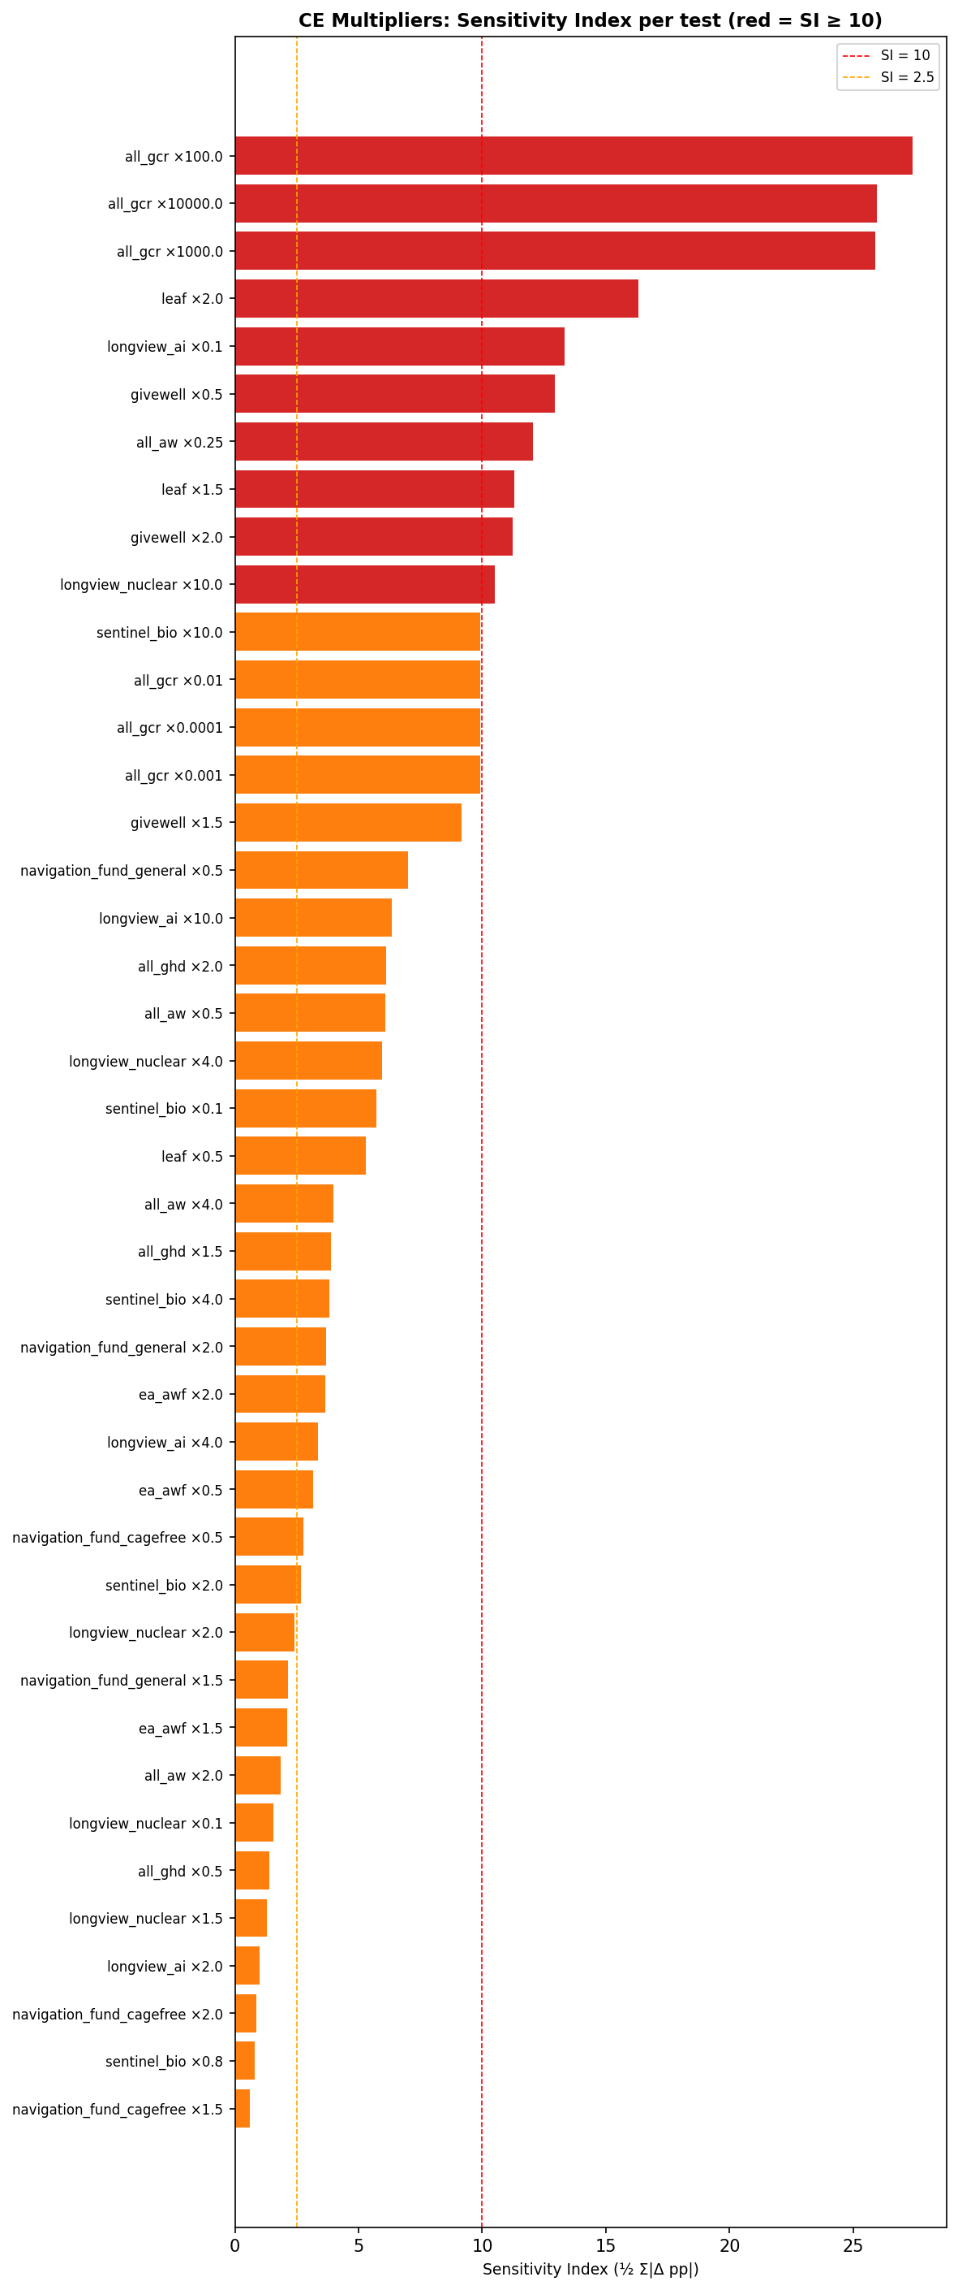

Fund Allocation Changes — Tests with SI ≥ 10
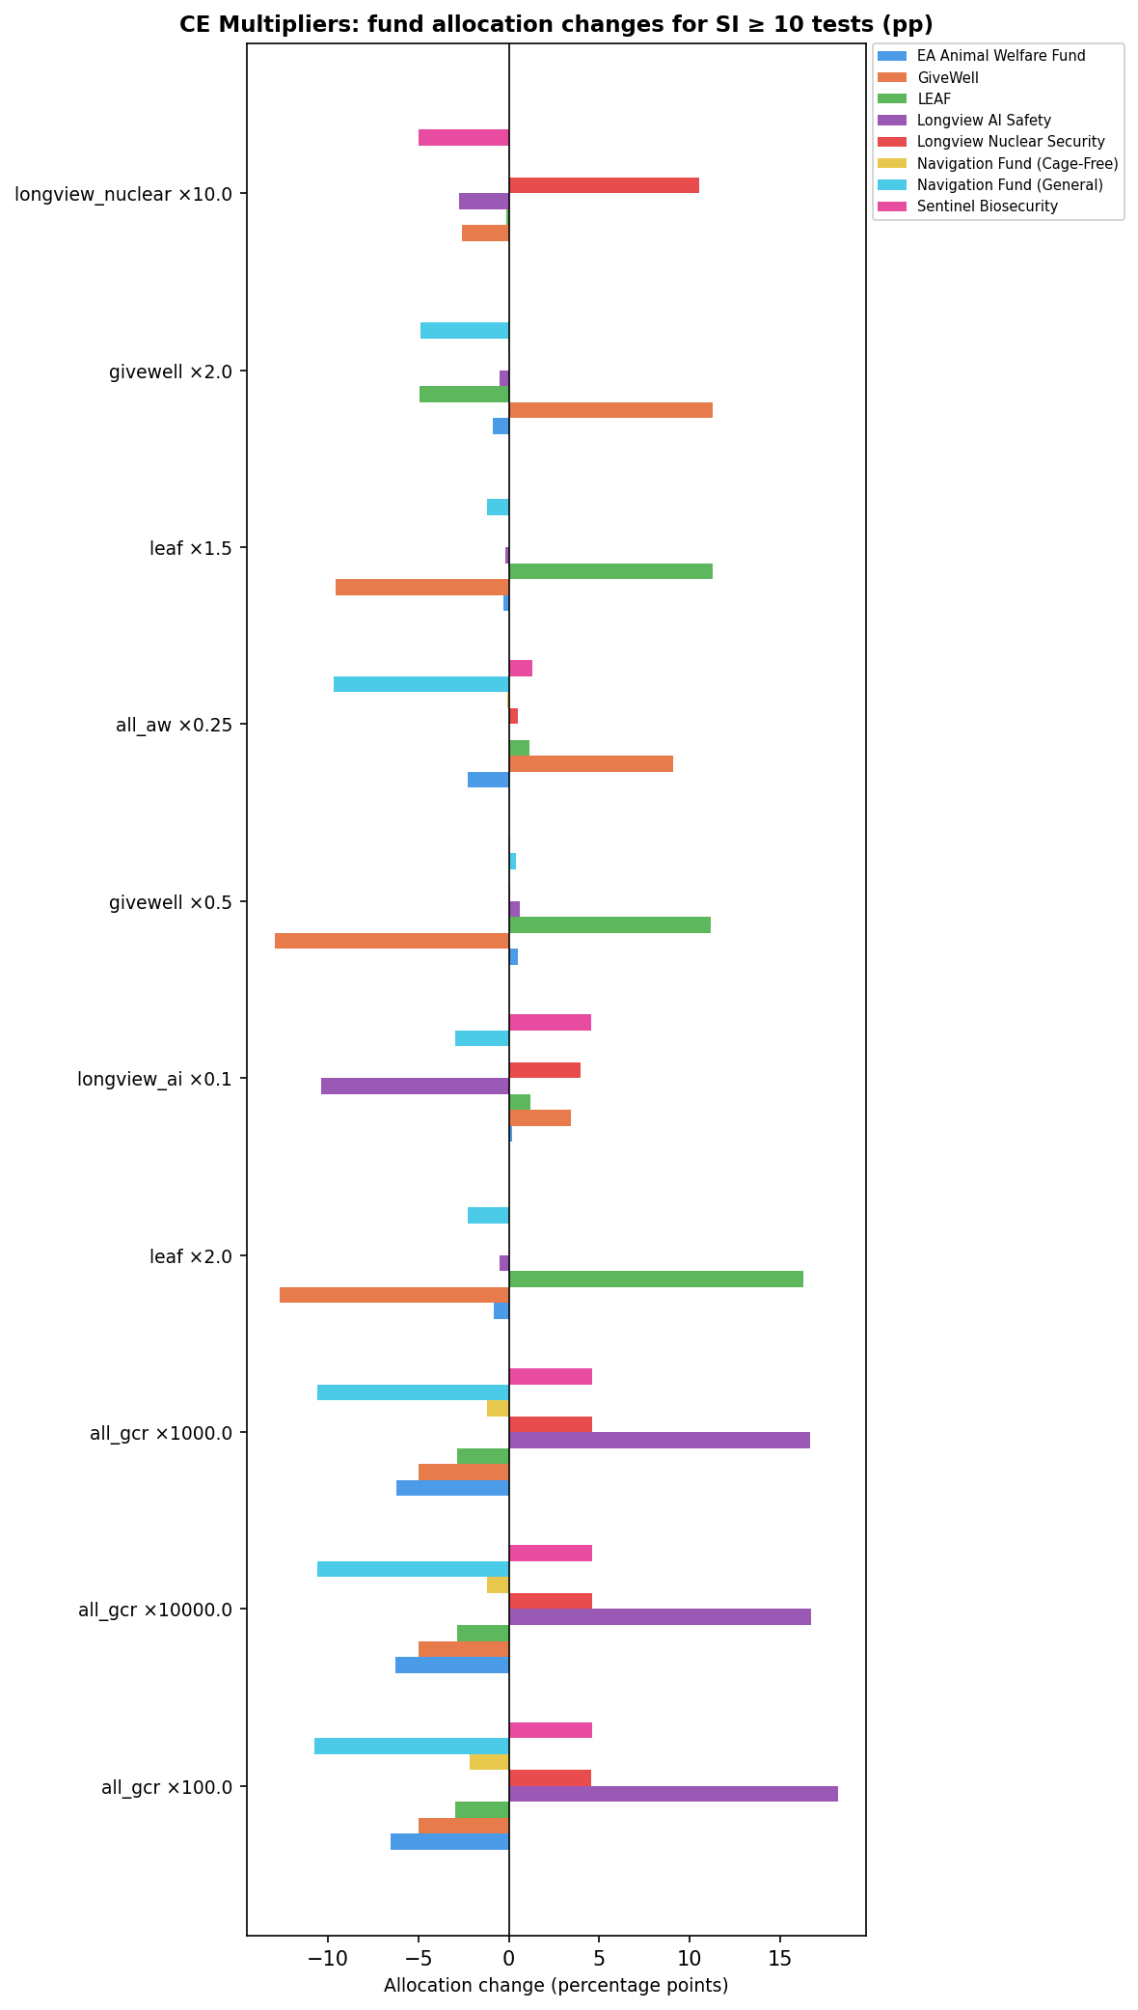

Key findings: The GCR group at 100× is the most impactful test, adding ~18 pp to Longview AI Safety while reducing Navigation General (~11 pp), EA AWF (~7 pp), and GiveWell (~5 pp). Reducing Longview AI Safety's CE to 10% (×0.1) redistributes ~13 pp, mainly to Sentinel Bio (+4.5 pp), Longview Nuclear (+3.9 pp), and GiveWell (+3.5 pp). GiveWell is also highly sensitive to LEAF's CE (×1.5 and ×2), as the two funds closely compete within GHD. Navigation Fund (Cage-Free) is the least sensitive individual fund — its allocation barely changes across any CE variation (max SI 2.75 pp).

3. Diminishing Returns
Two sub-analyses explore how the diminishing-returns curves affect allocations.

3a. Power Parameters (SI range: 0.96 – 6.66)
The power parameter controls how steeply returns diminish as more money flows into a fund cluster. 'Low power' means gradual diminishing returns; 'high power' means steep. Eight combinations were tested across the GCR and AW clusters.
Scenario | SI | Most Affected Fund | Max Δ
gcr_high_aw_low_power | 6.66 | Navigation Fund (General) | -4.60 pp
gcr_and_aw_low_power | 5.94 | Navigation Fund (General) | -4.60 pp
aw_low_power | 5.19 | Navigation Fund (General) | -4.60 pp
gcr_and_aw_high_power | 4.87 | Navigation Fund (General) | +2.47 pp
gcr_low_aw_high_power | 3.46 | Navigation Fund (General) | +2.51 pp
aw_high_power | 3.08 | Navigation Fund (General) | +2.51 pp
gcr_high_power | 2.67 | Sentinel Biosecurity | +2.66 pp
gcr_low_power | 0.95 | Sentinel Biosecurity | -0.86 pp

Fund Allocation Changes — All DR Power Scenarios
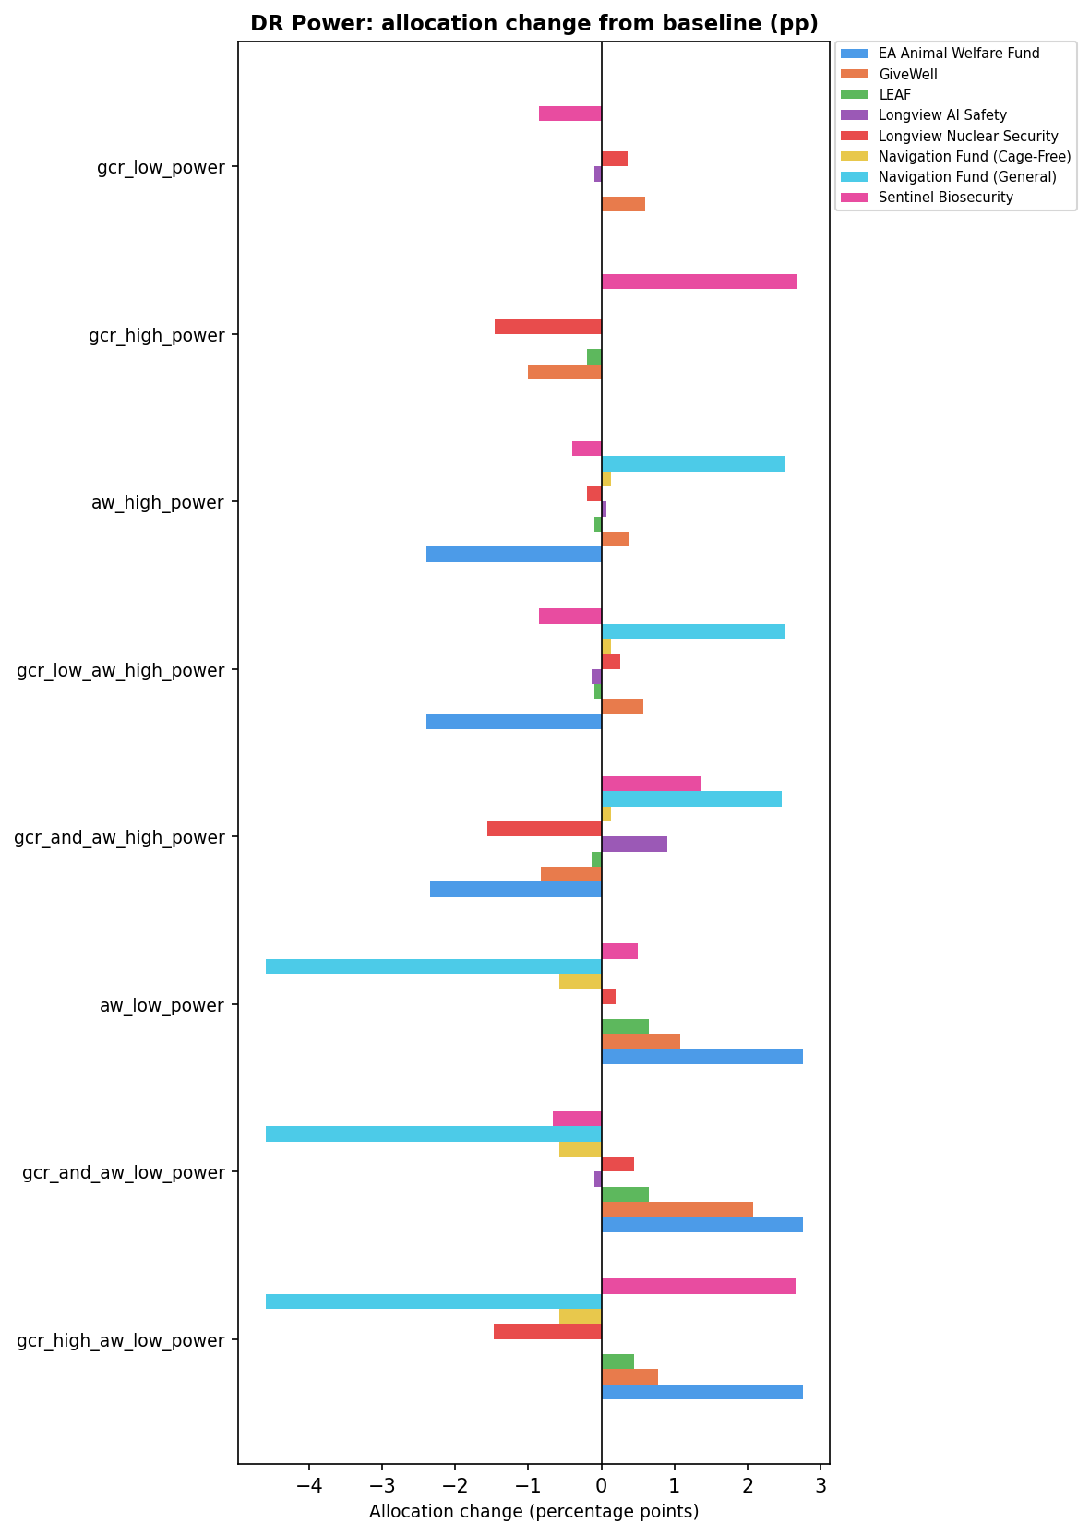

No tests exceed SI = 10. The most sensitive combination (gcr_high_aw_low_power, SI 6.66) reduces Navigation Fund (General) by 4.6 pp. GCR power parameters primarily affect Sentinel Biosecurity; AW power primarily affects Navigation General.

3b. Maximum Spending Cap (SI range: 9.74 – 15.13)
The maximum spending cap limits how much of the total budget can flow to any one fund cluster. Three cap multipliers were tested: 2.5×, 7.5×, and 10× the baseline per-fund spending ceiling. All three tests exceed the SI = 10 threshold.
Scenario | Cap Multiplier | SI | Most Affected Fund | Max Δ
max_spend_2_5x | 2.5× | 15.13 | GiveWell | +13.27 pp
max_spend_10x | 10.0× | 14.64 | Navigation Fund (General) | -8.93 pp
max_spend_7_5x | 7.5× | 9.74 | Navigation Fund (Cage-Free) | +6.50 pp

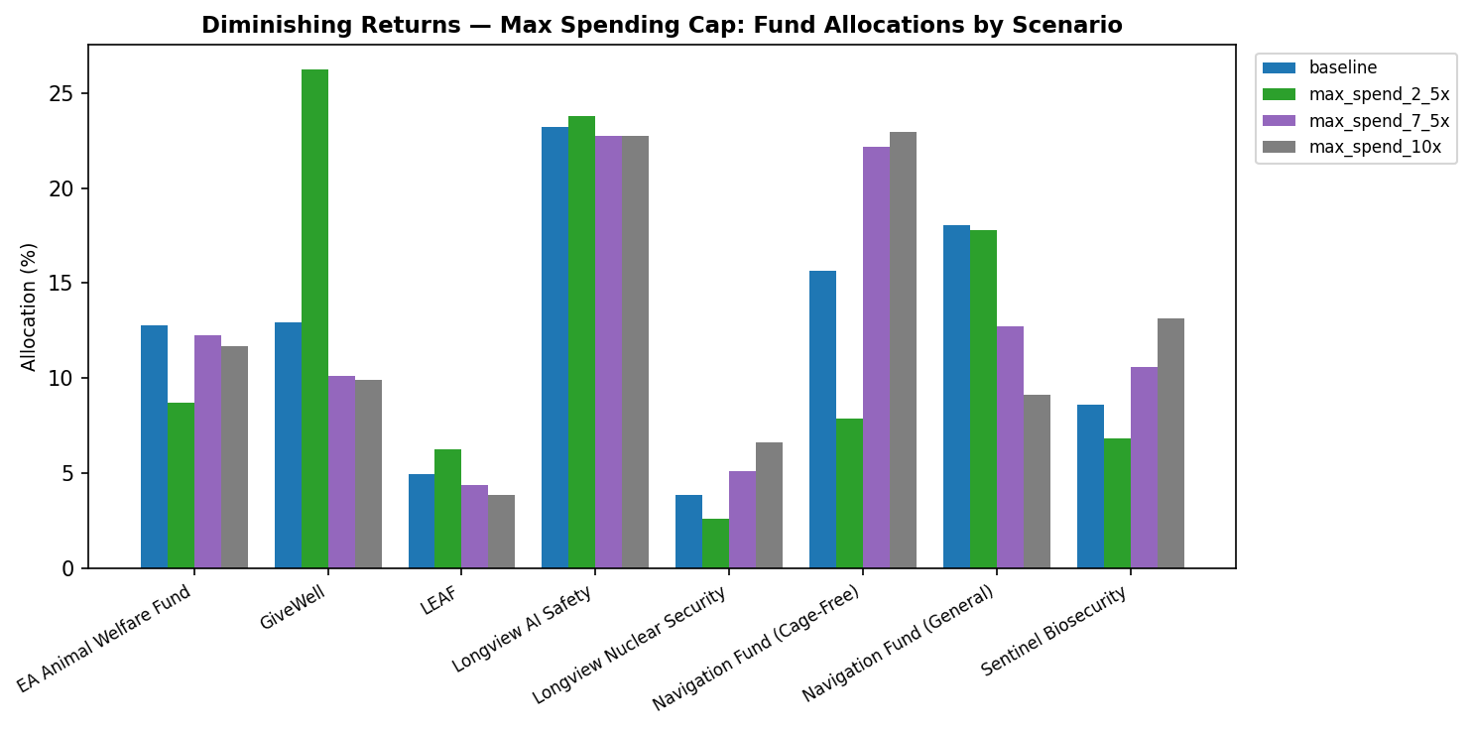

Fund Allocation Changes — Max-Spend Scenarios vs Baseline
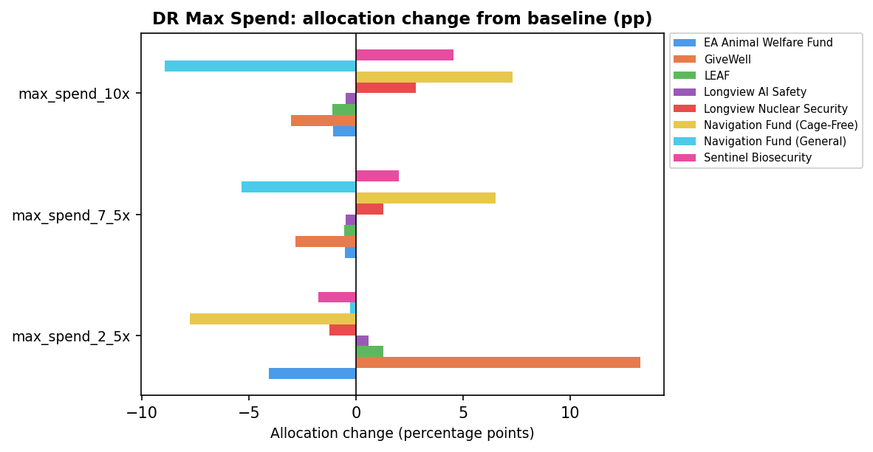

Key findings: At 2.5× cap, GiveWell gains ~13 pp because the tighter cap limits how much goes to Longview AI Safety, redistributing to the next-best GHD option. At 10× cap, Navigation General loses ~9 pp as funds spread to higher-CE options that are now unconstrained. The 7.5× cap produces intermediate effects.

3c. Combined: DR Power × Maximum Spending Cap
This sub-analysis crosses each of the 8 DR power scenarios with each of the 3 max-spend cap multipliers, producing 24 joint tests. It shows whether the effects of the two parameters reinforce or offset each other.

SI Heatmap: Power Scenario × Cap Multiplier
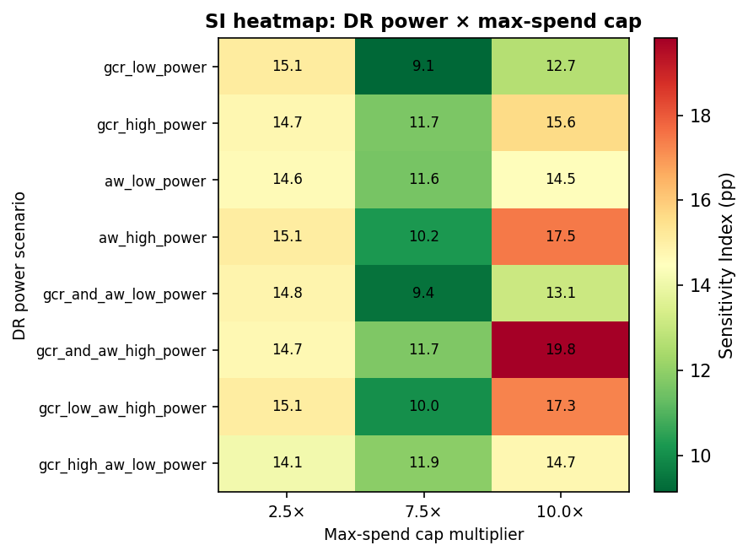

All 24 Tests — Ranked by SI
Power Scenario | Cap Multiplier | SI | Most Affected Fund | Max Δ
gcr_and_aw_high_power | 10.0× | 19.81 | Navigation Fund (Cage-Free) | +12.78 pp
aw_high_power | 10.0× | 17.47 | Navigation Fund (Cage-Free) | +12.84 pp
gcr_low_aw_high_power | 10.0× | 17.27 | Navigation Fund (Cage-Free) | +12.84 pp
gcr_high_power | 10.0× | 15.64 | Navigation Fund (General) | -9.33 pp
gcr_low_power | 2.5× | 15.13 | GiveWell | +13.53 pp
aw_high_power | 2.5× | 15.07 | GiveWell | +13.29 pp
gcr_low_aw_high_power | 2.5× | 15.07 | GiveWell | +13.51 pp
gcr_and_aw_low_power | 2.5× | 14.84 | GiveWell | +13.26 pp
gcr_high_aw_low_power | 10.0× | 14.74 | Navigation Fund (General) | -11.05 pp
gcr_high_power | 2.5× | 14.73 | GiveWell | +10.97 pp
gcr_and_aw_high_power | 2.5× | 14.68 | GiveWell | +10.95 pp
aw_low_power | 2.5× | 14.64 | GiveWell | +12.84 pp
aw_low_power | 10.0× | 14.54 | Navigation Fund (General) | -10.85 pp
gcr_high_aw_low_power | 2.5× | 14.14 | GiveWell | +10.50 pp
gcr_and_aw_low_power | 10.0× | 13.14 | Navigation Fund (General) | -9.45 pp
gcr_low_power | 10.0× | 12.67 | Navigation Fund (General) | -8.03 pp
gcr_high_aw_low_power | 7.5× | 11.90 | Navigation Fund (General) | -9.44 pp
gcr_and_aw_high_power | 7.5× | 11.70 | Navigation Fund (Cage-Free) | +7.94 pp
gcr_high_power | 7.5× | 11.66 | Navigation Fund (General) | -7.05 pp
aw_low_power | 7.5× | 11.60 | Navigation Fund (General) | -9.34 pp
aw_high_power | 7.5× | 10.25 | Navigation Fund (Cage-Free) | +8.00 pp
gcr_low_aw_high_power | 7.5× | 10.05 | Navigation Fund (Cage-Free) | +8.00 pp
gcr_and_aw_low_power | 7.5× | 9.40 | Navigation Fund (General) | -7.14 pp
gcr_low_power | 7.5× | 9.14 | Navigation Fund (Cage-Free) | +6.50 pp

Fund Allocation Changes — Top 4 Most Sensitive Combos
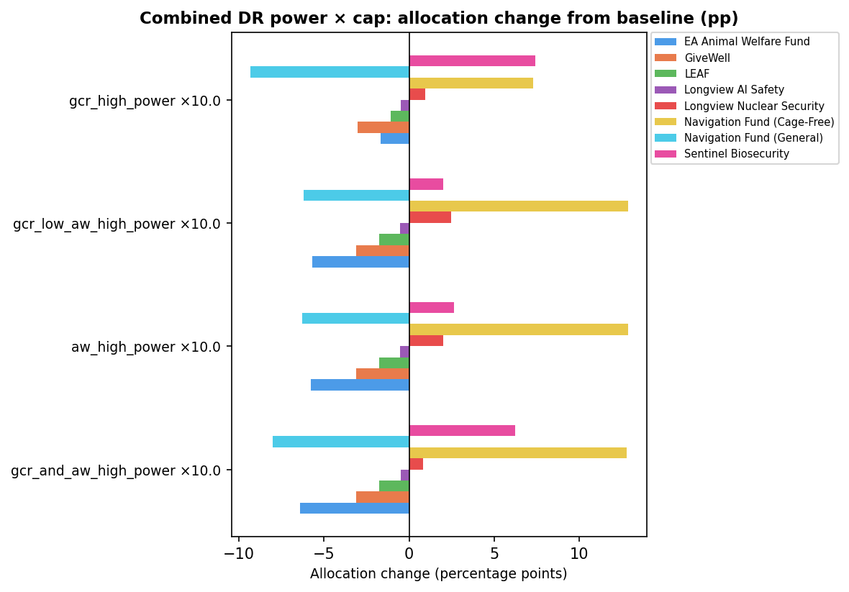

Key findings: The highest SI across all 24 combinations is gcr_and_aw_high_power × 10× (SI 19.81), driven by Navigation Fund (Cage-Free) gaining ~13 pp. The 2.5× cap dominates at most power settings — it consistently produces the largest GiveWell gains (10–14 pp) by constraining the preferred GCR/AW cluster. At 7.5× and 10× caps, high AW power scenarios redirect money toward Navigation Fund (Cage-Free), while low AW power scenarios redirect it toward EA Animal Welfare Fund. The GCR power parameter has little additional impact once the cap multiplier is fixed, suggesting the two parameters interact primarily through the AW cluster.

4. Aggregation Method Weights
Seven voting/aggregation methods are used to combine worldview scores into an allocation. Each method carries a credence weight. This dimension shifts each method's credence from its best-guess value to its low or high uncertainty bound, one method at a time. NashBargaining: 35% (range 15–50%); Marketplace: 30% (20–50%); MEC: 15% (10–20%); MET: 10% (5–15%); SplitCycle: 8% (2–10%); Borda: 2% (0–5%); LexMaximin: 0% (0–5%). Single-method (100% credence) scenarios are presented in Section 7.
Test | Bound | Credence Range | SI | Scaled SI* | Most Affected Fund | Max Δ
nashBargaining_low | low | 35% → 15% | 4.72 | 0.24 | Longview AI Safety | -3.61 pp
marketplace_high | high | 30% → 50% | 4.38 | 0.22 | Longview AI Safety | +3.35 pp
lexicographicMaximin_high | high | 0% → 5% | 4.15 | 0.83 | GiveWell | +4.15 pp
nashBargaining_high | high | 35% → 50% | 3.54 | 0.24 | Longview AI Safety | +2.71 pp
MEC_low | low | 15% → 10% | 2.36 | 0.47 | Longview AI Safety | +1.37 pp
MEC_high | high | 15% → 20% | 2.36 | 0.47 | Longview AI Safety | -1.37 pp
splitCycle_low | low | 8% → 2% | 2.31 | 0.39 | Longview AI Safety | +1.51 pp
marketplace_low | low | 30% → 20% | 2.19 | 0.22 | Longview AI Safety | -1.68 pp
MET_low | low | 10% → 5% | 1.58 | 0.32 | Navigation Fund (General) | -1.33 pp
MET_high | high | 10% → 15% | 1.58 | 0.32 | Navigation Fund (General) | +1.33 pp
borda_high | high | 2% → 5% | 1.09 | 0.36 | Navigation Fund (General) | +0.72 pp
splitCycle_high | high | 8% → 10% | 0.77 | 0.39 | Longview AI Safety | -0.50 pp
borda_low | low | 2% → 0% | 0.73 | 0.36 | Navigation Fund (General) | -0.48 pp
lexicographicMaximin_low | low | 0% → 0% | 0.00 | — | EA Animal Welfare Fund | -0.00 pp
* Scaled SI = SI ÷ absolute credence change (pp).

Same Tests — Ranked by Scaled SI
Rank | Test | Bound | Credence Range | SI | Scaled SI | Most Affected Fund | Max Δ
1 | lexicographicMaximin_high | high | 0% → 5% | 4.15 | 0.83 | GiveWell | +4.15 pp
2 | MEC_low | low | 15% → 10% | 2.36 | 0.47 | Longview AI Safety | +1.37 pp
3 | MEC_high | high | 15% → 20% | 2.36 | 0.47 | Longview AI Safety | -1.37 pp
4 | splitCycle_low | low | 8% → 2% | 2.31 | 0.39 | Longview AI Safety | +1.51 pp
5 | splitCycle_high | high | 8% → 10% | 0.77 | 0.39 | Longview AI Safety | -0.50 pp
6 | borda_low | low | 2% → 0% | 0.73 | 0.36 | Navigation Fund (General) | -0.48 pp
7 | borda_high | high | 2% → 5% | 1.09 | 0.36 | Navigation Fund (General) | +0.72 pp
8 | MET_high | high | 10% → 15% | 1.58 | 0.32 | Navigation Fund (General) | +1.33 pp
9 | MET_low | low | 10% → 5% | 1.58 | 0.32 | Navigation Fund (General) | -1.33 pp
10 | nashBargaining_low | low | 35% → 15% | 4.72 | 0.24 | Longview AI Safety | -3.61 pp
11 | nashBargaining_high | high | 35% → 50% | 3.54 | 0.24 | Longview AI Safety | +2.71 pp
12 | marketplace_high | high | 30% → 50% | 4.38 | 0.22 | Longview AI Safety | +3.35 pp
13 | marketplace_low | low | 30% → 20% | 2.19 | 0.22 | Longview AI Safety | -1.68 pp
No tests exceed SI = 10. The most sensitive test by raw SI is NashBargaining at its low bound (credence 35% → 15%, SI 4.72), which reduces Longview AI Safety by 3.6 pp. The allocation is relatively stable to changes in method weights within their uncertainty ranges.

Fund Allocation Changes — All Credence-Variation Tests
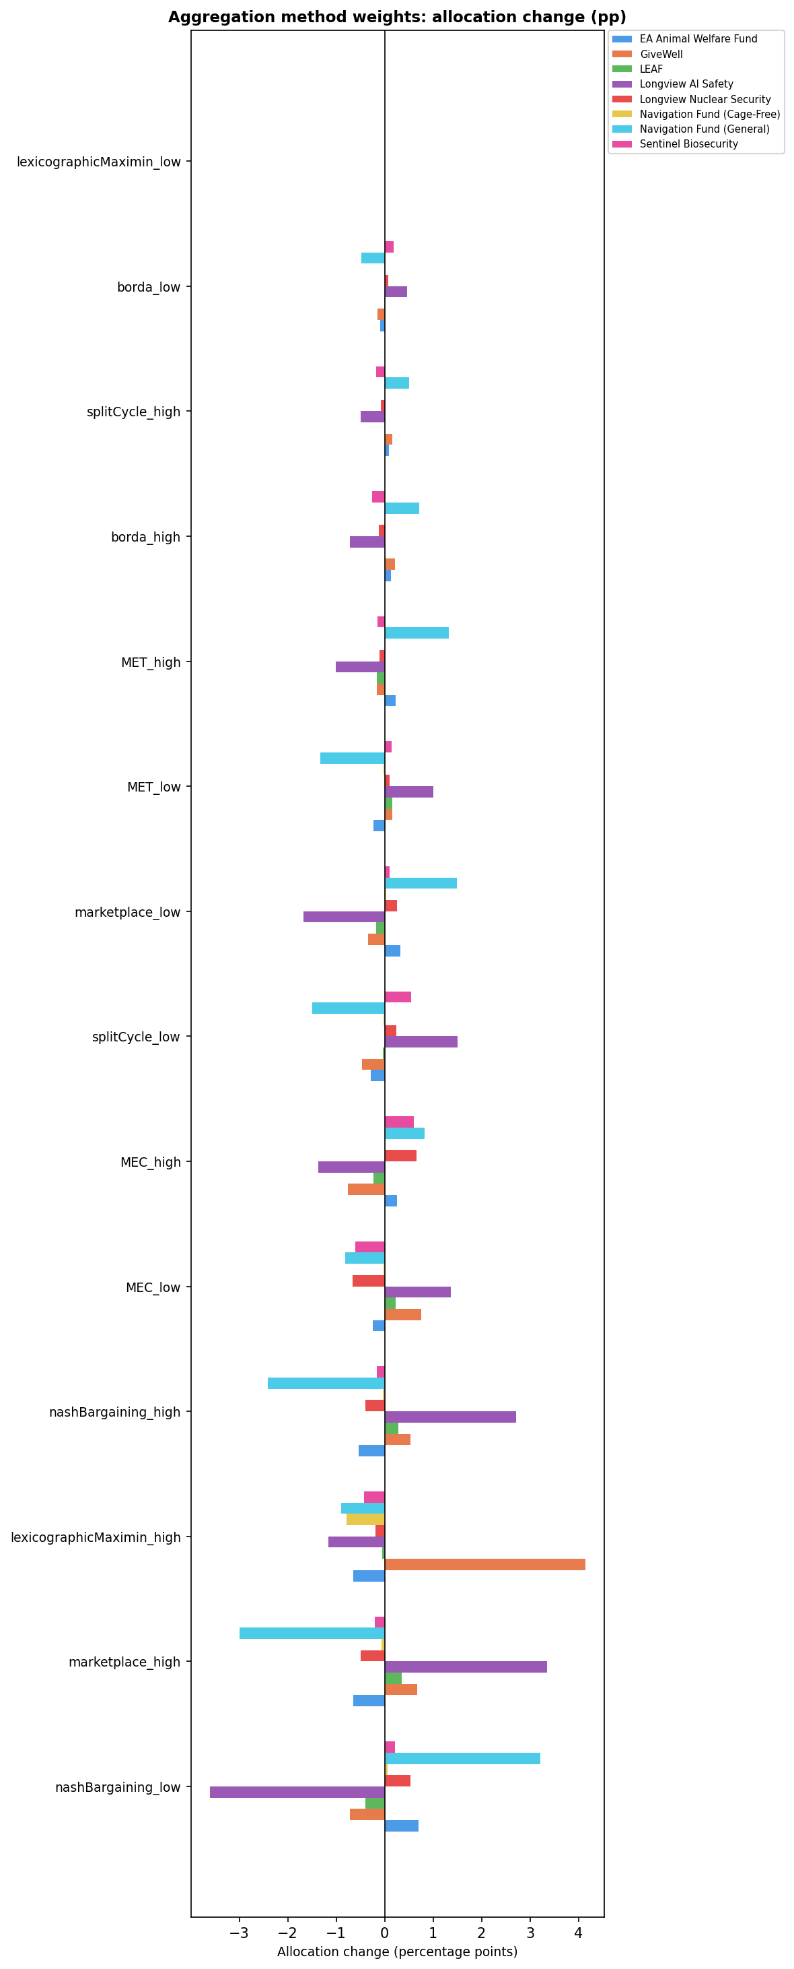

Least Sensitive Tests (SI < 2.5)
The following main-analysis tests produced a maximum fund allocation change of less than 2.5 percentage points. These assumptions can be considered robust within their tested range. Illustrative single-perspective scenarios are excluded here and appear in Section 7.
Aggregation Methods
- SI = 0.00 · Method weight shift: lexicographicMaximin_low (0%→0%)
- SI = 0.73 · Method weight shift: borda_low (2%→0%)
- SI = 0.77 · Method weight shift: splitCycle_high (8%→10%)
- SI = 1.09 · Method weight shift: borda_high (2%→5%)
- SI = 1.58 · Method weight shift: MET_low (10%→5%)
- SI = 1.58 · Method weight shift: MET_high (10%→15%)
- SI = 2.19 · Method weight shift: marketplace_low (30%→20%)
- SI = 2.31 · Method weight shift: splitCycle_low (8%→2%)
- SI = 2.36 · Method weight shift: MEC_low (15%→10%)
- SI = 2.36 · Method weight shift: MEC_high (15%→20%)
CE Multipliers
- SI = 0.62 · Multiply navigation_fund_cagefree CE by 1.5×
- SI = 0.79 · Multiply sentinel_bio CE by 0.8×
- SI = 0.88 · Multiply navigation_fund_cagefree CE by 2.0×
- SI = 0.99 · Multiply longview_ai CE by 2.0×
- SI = 1.30 · Multiply longview_nuclear CE by 1.5×
- SI = 1.38 · Multiply all_ghd CE by 0.5×
- SI = 1.56 · Multiply longview_nuclear CE by 0.1×
- SI = 1.83 · Multiply all_aw CE by 2.0×
- SI = 2.11 · Multiply ea_awf CE by 1.5×
- SI = 2.15 · Multiply navigation_fund_general CE by 1.5×
- SI = 2.40 · Multiply longview_nuclear CE by 2.0×
Dim. Returns (Power)
- SI = 0.95 · DR power combo: gcr_low_power
Moral Weights
- SI = 1.84 · Scale all animal moral weights by 2.0×
Time Discounts
- SI = 0.00 · Scale discount factor(s) by 0.1× in group 'discount 500+'
- SI = 0.00 · Scale discount factor(s) by 0.01× in group 'discount 500+'
- SI = 0.00 · Scale discount factor(s) by 0.001× in group 'discount 500+'
- SI = 0.00 · Scale discount factor(s) by 0.1× in group 'discount 100-500 and 500+'
- SI = 0.00 · Scale discount factor(s) by 0.01× in group 'discount 100-500 and 500+'
- SI = 0.00 · Scale discount factor(s) by 0.001× in group 'discount 100-500 and 500+'
Worldview Credences
- SI = 1.28 · Non-Utilitarian Consequentialism — Weighted Linear (low bound: 5%→2%)
- SI = 1.29 · Total Utilitarianism — High life value, risk avers (low bound: 5%→2%)
- SI = 1.32 · Non-Utilitarian Consequentialism — Person-Affectin (low bound: 5%→2%)
- SI = 1.34 · Non-Utilitarian Consequentialism — Default (low bound: 5%→2%)
- SI = 1.34 · Non-Utilitarian Consequentialism — High Life Value (low bound: 5%→2%)
- SI = 1.34 · Total Utilitarianism — Suffering forward, clueless (low bound: 5%→2%)
- SI = 2.05 · Kantianism — Low animals (low bound: 5%→1%)
- SI = 2.10 · Contractualism — Default + cluelessness (low bound: 5%→2%)
- SI = 2.19 · Total Utilitarianism — Person-Affecting/Cluelessne (low bound: 10%→5%)

Note: GCR-params sub-directory contains only analysis scripts with no output CSV files and is not included in this report.

5. Time Discounts
This analysis tests how the allocation shifts when the weights assigned to far-future effects are reduced. Two scenario groups were tested: 'Discount 500+' modifies only the 500-year-plus timeframe weight (index 5 of the discount_factors array); 'Discount 100–500 and 500+' modifies both the 100–500 and 500+ year weights (indices 4 and 5). Within each group, multipliers of 0.1×, 0.01×, 0.001×, and 0× were applied to the target discount factor(s).

Sensitivity by Test — All Scenarios
Scenario Group | Multiplier | SI | Biggest Gainer | Biggest Loser
discount 500+ | 0.1× | 0.00 | — | —
discount 500+ | 0.01× | 0.00 | — | —
discount 500+ | 0.001× | 0.00 | — | —
discount 500+ | 0× | 15.38 | Navigation Fund (General) (+8.36 pp) | Sentinel Biosecurity (-6.63 pp)
discount 100-500 and 500+ | 0.1× | 0.00 | — | —
discount 100-500 and 500+ | 0.01× | 0.00 | — | —
discount 100-500 and 500+ | 0.001× | 0.00 | — | —
discount 100-500 and 500+ | 0× | 20.87 | Navigation Fund (General) (+10.74 pp) | Longview AI Safety (-8.77 pp)

Fund Allocation Changes — 0× Scenarios (Complete Elimination)
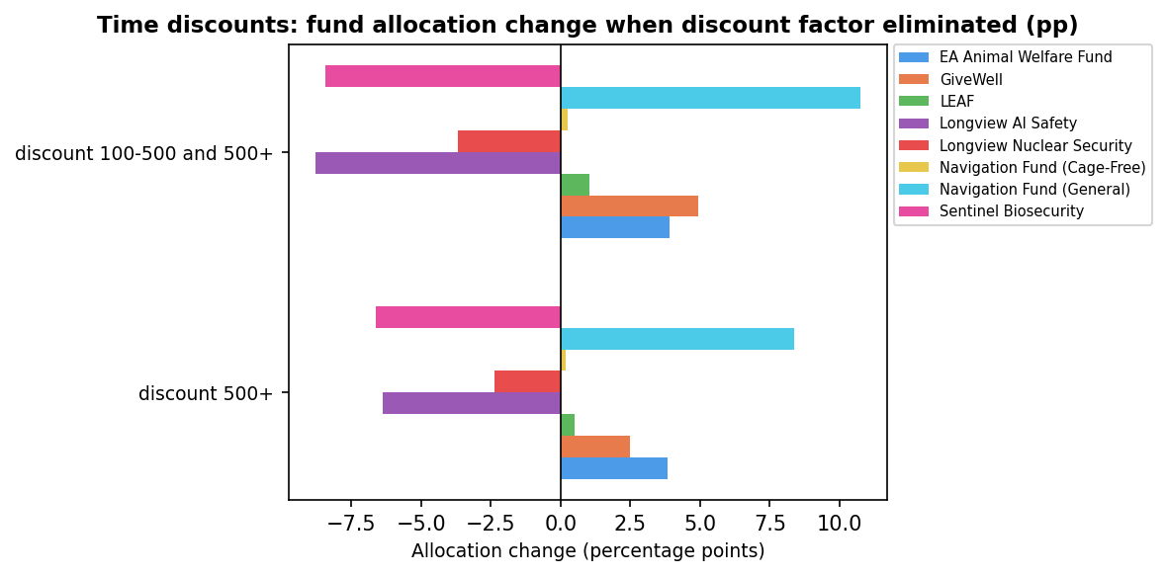

Key findings: The allocation is completely insensitive to any partial reduction in far-future discount factors — multipliers of 0.1×, 0.01×, and 0.001× all produce SI = 0 pp. Only complete elimination (0×) of the 500+ year weight shifts the allocation significantly (SI = 15.38 pp), primarily redistributing from GCR (Longview AI Safety −6.39 pp, Sentinel Bio −6.63 pp) to Animal Welfare (Navigation General +8.36 pp, EA AWF +3.84 pp). Including the 100–500 year weight in the elimination amplifies the effect (SI = 20.87 pp, with Navigation General gaining +10.74 pp). The insensitivity to fractional reductions reflects that these timeframe factors are already small in most worldviews, so partial scaling barely changes effective scores.

6. Animal Moral Weights
This analysis scales the moral weights assigned to animal welfare effects across two levels: (1) the overall blend — all worldviews' animal weights scaled simultaneously, measuring aggregate portfolio sensitivity; and (2) per-worldview — each worldview run at 100% credence independently, measuring how sensitive each worldview's own recommended allocation is to its animal weight assumptions. Multipliers tested: 0.1×, 2×, 5×, 10×, 100×. Weights are capped at species-level upper bounds: chickens 0.75, fish 0.60, shrimp 0.25, invertebrates 0.20, mammals 0.90.

6a. Overall Blend Sensitivity
Multiplier | SI | Scaled SI* | Biggest Gainer | Biggest Loser
0.1× | 24.18 | 24.18 | GiveWell (+20.94 pp) | Navigation Fund (General) (-14.92 pp)
0.2× | 14.15 | 20.24 | GiveWell (+11.01 pp) | Navigation Fund (General) (-10.90 pp)
100.0× | 14.01 | 7.01 | Navigation Fund (General) (+9.92 pp) | GiveWell (-5.75 pp)
10.0× | 6.31 | 6.31 | EA Animal Welfare Fund (+3.41 pp) | Longview AI Safety (-2.71 pp)
0.5× | 6.08 | 20.21 | GiveWell (+3.60 pp) | Navigation Fund (General) (-4.91 pp)
5.0× | 4.91 | 7.02 | EA Animal Welfare Fund (+2.67 pp) | Longview AI Safety (-2.67 pp)
2.0× | 1.84 | 6.12 | EA Animal Welfare Fund (+0.81 pp) | LEAF (-0.99 pp)
* Scaled SI = SI ÷ orders-of-magnitude change in multiplier.

Fund Allocation Changes — All Multipliers
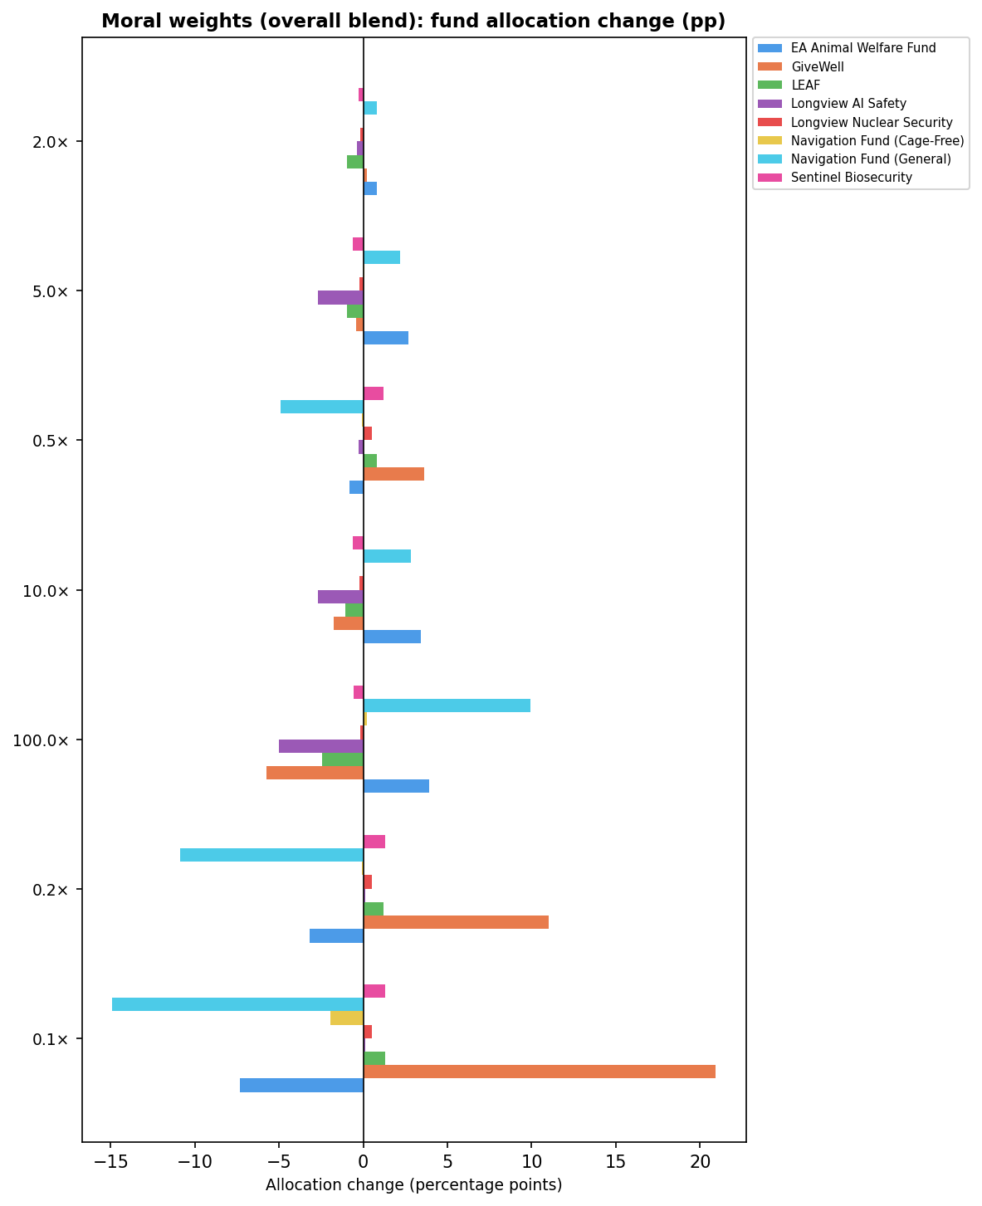

6b. Per-Worldview Sensitivity — Ranked Summary (Top 15)
Each worldview is run in isolation (100% credence) with its animal weights scaled. SI is measured against that worldview's own unmodified baseline, not the special-blend baseline. Only non-zero scenarios are shown.
Idx | Worldview | Risk | Mult. | SI | Scaled SI* | Biggest Gainer | Biggest Loser
11 | Contractualism | 2 | 100.0× | 75.00 | 37.50 | Navigation Fund (General) (+42.00 pp) | GiveWell (-73.00 pp)
2 | Total Utilitarian | 2 | 0.1× | 60.00 | 60.00 | GiveWell (+59.00 pp) | Navigation Fund (General) (-41.00 pp)
6 | Consequentialism (Non-Utilit | 0 | 100.0× | 53.00 | 26.50 | Navigation Fund (General) (+20.00 pp) | Longview AI Safety (-53.00 pp)
3 | Total Utilitarian | 6 | 0.1× | 51.00 | 51.00 | GiveWell (+50.00 pp) | Navigation Fund (General) (-39.00 pp)
8 | Consequentialism (Non-Utilit | 2 | 100.0× | 47.00 | 23.50 | Navigation Fund (General) (+37.00 pp) | GiveWell (-46.00 pp)
8 | Consequentialism (Non-Utilit | 2 | 10.0× | 47.00 | 47.00 | Navigation Fund (General) (+37.00 pp) | GiveWell (-46.00 pp)
7 | Consequentialism (Non-Utilit | 0 | 100.0× | 44.00 | 22.00 | Navigation Fund (General) (+23.00 pp) | Longview AI Safety (-44.00 pp)
7 | Consequentialism (Non-Utilit | 0 | 10.0× | 43.00 | 43.00 | Navigation Fund (General) (+22.00 pp) | Longview AI Safety (-43.00 pp)
1 | Total Utilitarian | 7 | 0.1× | 42.00 | 42.00 | GiveWell (+40.00 pp) | Navigation Fund (General) (-35.00 pp)
2 | Total Utilitarian | 2 | 0.2× | 42.00 | 60.09 | GiveWell (+41.00 pp) | Navigation Fund (General) (-35.00 pp)
8 | Consequentialism (Non-Utilit | 2 | 5.0× | 39.00 | 55.80 | Navigation Fund (General) (+29.00 pp) | GiveWell (-38.00 pp)
9 | Contractualism | 5 | 0.1× | 39.00 | 39.00 | GiveWell (+33.00 pp) | Navigation Fund (General) (-29.00 pp)
7 | Consequentialism (Non-Utilit | 0 | 5.0× | 35.00 | 50.07 | EA Animal Welfare Fund (+14.00 pp) | Longview AI Safety (-35.00 pp)
3 | Total Utilitarian | 6 | 0.2× | 34.00 | 48.64 | GiveWell (+34.00 pp) | Navigation Fund (General) (-31.00 pp)
12 | Kantianism | 3 | 100.0× | 33.00 | 16.50 | Navigation Fund (Cage-Free) (+16.00 pp) | GiveWell (-32.00 pp)
* Scaled SI = SI ÷ orders-of-magnitude change in multiplier.

Per-Worldview SI — Tornado Chart (Top 20 Scenarios)
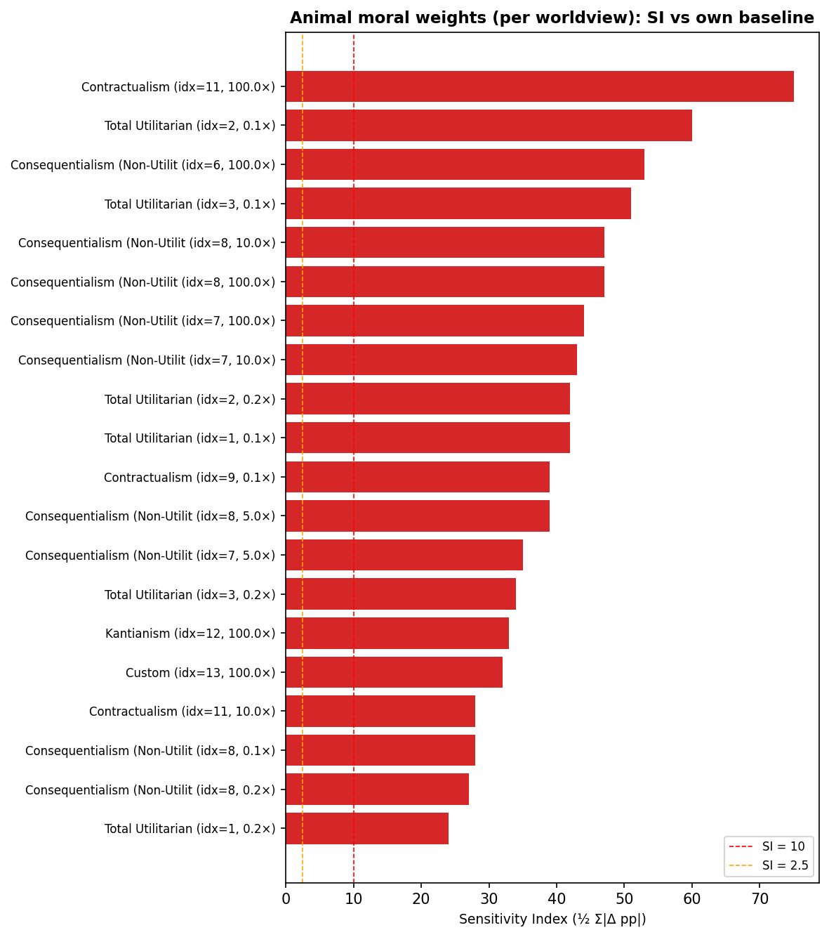

Key findings (overall blend): Reducing all animal weights to 10% (0.1×) is the most impactful scenario (SI = 24.18 pp), shifting funds from AW to GHD as lower animal weights depress AW fund scores. Increasing weights (2×–100×) is less impactful (SI 1.84–14.01 pp) because many TU worldviews are already at or near species caps and cannot move further upward. Key findings (per worldview): Contractualism idx 11 (risk-averse) is the most sensitive single worldview at 100× (SI = 75 pp, full GHD→AW reversal) — its baseline animal weights are so low that no species caps are hit. Non-Utilitarian Consequentialist worldviews (idx 7, 8) show a hard plateau: SI is essentially unchanged between 10× and 100× (~43–47 pp), because AW funds hit their diminishing-returns ceiling at approximately 10×. Their shift is GCR→AW rather than GHD→AW. TU worldviews are almost exclusively sensitive in the downward direction — they are already near the species caps at baseline so upward multipliers produce SI = 0.

7. Illustrative: Single-Perspective Analyses
The analyses in this section place 100% credence in one ethical perspective — a single risk profile applied to all worldviews, a single worldview, or a single aggregation method. We do not endorse any of these positions; they are included to show the range of outcomes implied by individual views taken alone. Because the credence shifts here are far larger than in the main sensitivity analyses, higher thresholds apply: SI ≥ 50 pp is considered highly sensitive (red); SI < 15 pp is considered low-sensitivity (orange threshold line).

7a. Risk Aversion
Each test assigns one risk-attitude profile uniformly to all worldviews. Two starting baselines are compared: "Special blend" (the default mixed profiles) and "Neutral" (all worldviews risk-neutral). Alternative profiles: Neutral, Downside Critical, Continuous Upside Skeptic, Bilateral Skeptic, WLU-5, WLU-10, and Combined. Tests are named <baseline>_to_<new_profile>.
Test | SI | Most Affected Fund | Max Δ
neutral_to_combined | 90.15 | Longview AI Safety | -89.14 pp
neutral_to_downside_critical | 89.14 | Longview AI Safety | -89.14 pp
neutral_to_cont_upside_skep | 80.69 | Longview AI Safety | -79.69 pp
specialblend_to_bilateral_skep | 66.81 | Longview AI Safety | +66.80 pp
specialblend_to_neutral | 65.93 | Longview AI Safety | +65.93 pp
specialblend_to_combined | 35.75 | Longview AI Safety | -23.22 pp
specialblend_to_wlu_5 | 35.63 | Longview AI Safety | -23.22 pp
specialblend_to_wlu_10 | 35.63 | Longview AI Safety | -23.22 pp
specialblend_to_cont_upside_skep | 27.12 | Longview AI Safety | -13.76 pp
specialblend_to_downside_critical | 26.68 | Longview AI Safety | -23.22 pp
neutral_to_bilateral_skep | 1.20 | Longview AI Safety | +0.88 pp

Fund Allocation Changes — All Tests
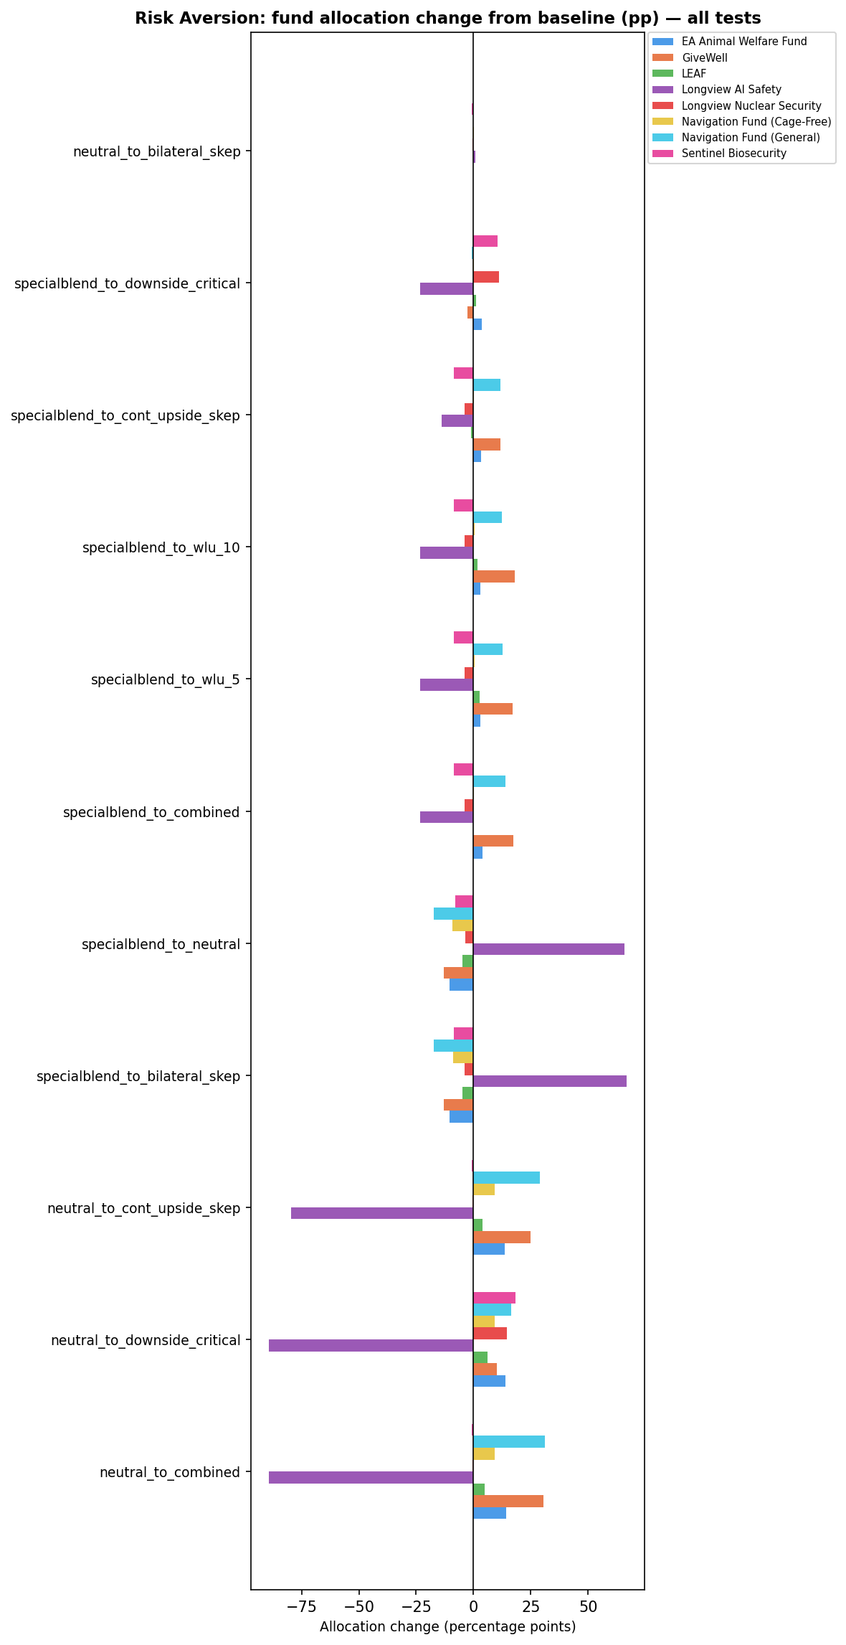

Cause-Area Allocation Changes (GHD / GCR / AW)
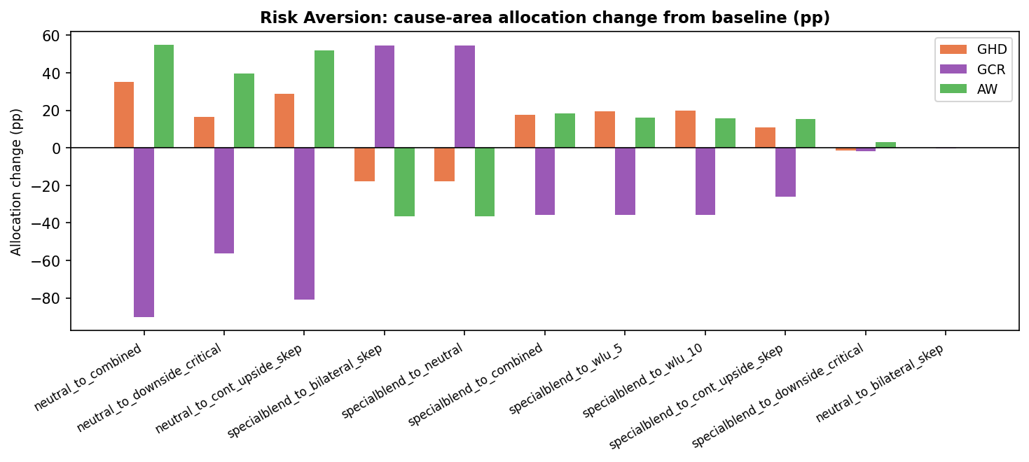

Key findings: Moving from the special-blend baseline to risk-neutral or bilateral-skeptic profiles causes Longview AI Safety to dominate (≤89% of budget) because risk-neutral worldviews heavily favour the highest-EV option. Switching to WLU, Combined, or Downside Critical profiles redistributes sharply toward GiveWell, Navigation General, and EA Animal Welfare Fund. The neutral → combined test shows the largest SI (90 pp), driven by Longview AI collapsing from 89% to 0%.

7b. 100% Credence in One Worldview
Each worldview is run in isolation — as if it received 100% credence — to show the allocation it would produce on its own. SI is measured against the baseline special-blend allocation. SIs are large (30–84 pp) because the credence shift (from a small best-guess weight to 100%) is extreme.
Worldview | Base Credence | SI | Scaled SI* | Most Affected Fund | Max Δ
Kantianism — Low animals / downside critical | 10% | 84.05 | 0.93 | GiveWell | +84.05 pp
Contractualism — Default + cluelessness | 5% | 82.11 | 0.86 | GiveWell | +80.05 pp
Kantianism — Low animals | 5% | 82.11 | 0.86 | GiveWell | +82.05 pp
Non-Utilitarian Consequentialism — High Life Value / Clueles | 5% | 76.78 | 0.81 | Longview AI Safety | +76.78 pp
Total Utilitarianism — Default | 10% | 76.78 | 0.85 | Longview AI Safety | +76.78 pp
Non-Utilitarian Consequentialism — Default | 5% | 76.78 | 0.81 | Longview AI Safety | +76.78 pp
Contractualism — Person-Affecting/Cluelessness and Animals B | 10% | 76.78 | 0.85 | Longview AI Safety | +76.78 pp
Non-Utilitarian Consequentialism — Person-Affecting/Clueless | 5% | 64.78 | 0.68 | Longview AI Safety | +64.78 pp
Non-Utilitarian Consequentialism — Weighted Linear Utility | 5% | 54.47 | 0.57 | GiveWell | +51.05 pp
Contractualism — Person-Affecting/Cluelessness and Animals B | 10% | 41.11 | 0.46 | Longview AI Safety | -23.22 pp
Total Utilitarianism — Weighted Linear Utility | 10% | 35.63 | 0.40 | Navigation Fund (General) | +23.94 pp
Total Utilitarianism — High life value, risk averse, and ske | 5% | 35.63 | 0.38 | Navigation Fund (General) | +23.94 pp
Total Utilitarianism — Person-Affecting/Cluelessness, Sentie | 10% | 32.57 | 0.36 | Navigation Fund (General) | +23.94 pp
Total Utilitarianism — Suffering forward, clueless, and only | 5% | 30.30 | 0.32 | Navigation Fund (General) | +23.94 pp
* Scaled SI = SI ÷ absolute credence change (pp). Normalises for the fact that smaller-credence worldviews have a larger shift to 100%.

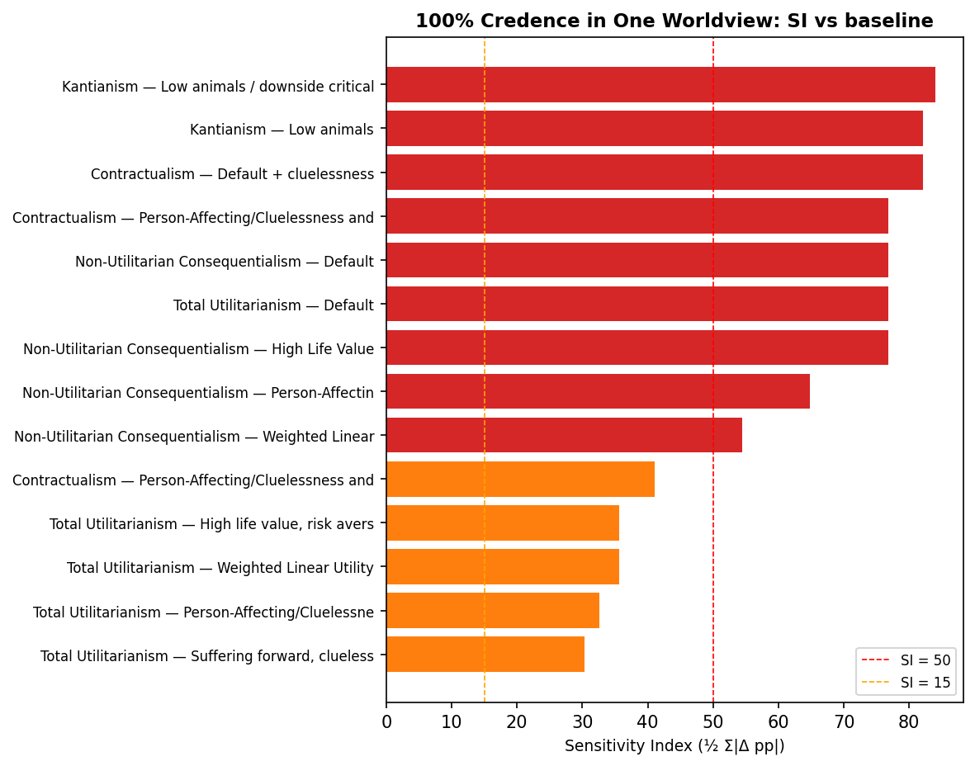

7c. 100% Credence in One Aggregation Method
Each aggregation method is run on the full budget with all worldviews, as if it were the only method used. SI is measured against the baseline weighted-average allocation.
Method | Base Credence | SI | Scaled SI* | Most Affected Fund | Max Δ
lexicographicMaximin | 0% | 83.05 | 0.83 | GiveWell | +83.05 pp
MEC | 15% | 40.11 | 0.47 | Longview AI Safety | -23.22 pp
borda | 2% | 35.63 | 0.36 | Navigation Fund (General) | +23.44 pp
splitCycle | 8% | 35.43 | 0.39 | Longview AI Safety | -23.22 pp
MET | 10% | 28.52 | 0.32 | Navigation Fund (General) | +23.94 pp
marketplace | 30% | 15.34 | 0.22 | Longview AI Safety | +11.73 pp
nashBargaining | 35% | 15.34 | 0.24 | Longview AI Safety | +11.73 pp
* Scaled SI = SI ÷ absolute credence change (pp).

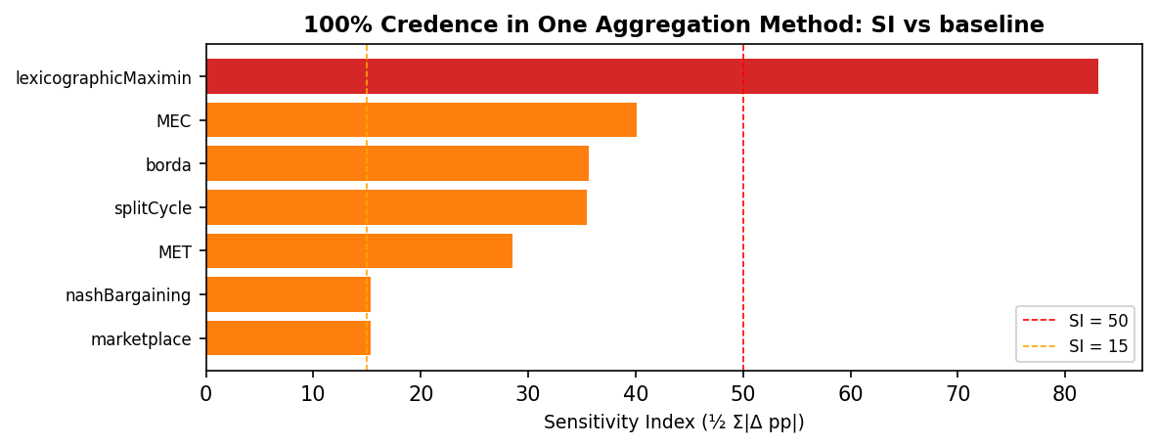

Key findings: LexicographicMaximin produces the most extreme single-method allocation (SI 83 pp), placing nearly 96% of the budget into GiveWell. MEC and the cycle/Borda methods produce high SIs (35–40 pp) by concentrating on Navigation General. NashBargaining and Marketplace, which dominate the baseline blend, produce the smallest single-method SIs (≈15 pp each) because the baseline already reflects their preferences heavily.

8. Fund-Level vs Cluster-Level Sensitivity
Every test in this report has two sensitivity indices: a fund-level SI (how much money moves across the eight individual funds) and a cluster-level SI (how much moves across the three cause-area clusters: GHD, GCR, and AW). The fund-level SI is always at least as large as the cluster-level SI — aggregating fund deltas by cluster can only cancel out offsetting movements, never amplify them.
We define the cross-cluster share as cluster_SI / fund_SI. This ratio is bounded in [0, 1]:
- share ≈ 1: the parameter genuinely redistributes money across cause areas; fund-level movement is entirely cross-cluster.
- share ≈ 0: the parameter only reshuffles money between funds inside the same cause area — the fund-level SI overstates how much the cause-area mix actually changes.
A high fund-level SI combined with a low cross-cluster share is a signal that an apparent sensitivity is mostly within-cluster churn rather than a real reallocation between cause areas.

Overview across analyses
Analysis | # tests | Max fund SI | Max cluster SI | Median share | Min share
CE Multipliers | 42 | 27.40 | 27.40 | 51% | 6%
Time Discounts | 2 | 20.87 | 20.87 | 100% | 100%
Diminishing Returns (Power) | 8 | 6.66 | 2.73 | 41% | 17%
Diminishing Returns (Max Spend) | 3 | 15.13 | 14.55 | 47% | 35%
DR Combined | 24 | 19.81 | 14.77 | 46% | 23%
Worldview Credences | 28 | 27.38 | 21.33 | 94% | 56%
Risk Aversion | 11 | 90.15 | 90.15 | 97% | 11%
Moral Weights | 7 | 24.18 | 24.18 | 100% | 88%
Analyses with median share near 1 (worldview credences, aggregation methods, risk aversion, moral weights, time discounts) are dominated by genuine cross-cluster reallocation. Analyses with lower median share (diminishing returns, CE multipliers on intra-cluster groups) include a substantial portion of within-cluster reshuffling.

CE Multipliers
Top 8 scenarios by lowest cross-cluster share (most within-cluster reshuffling first):
Scenario | Fund SI | Cluster SI | Cross-cluster share
leaf ×0.5 | 5.30 | 0.30 | 6%
sentinel_bio ×0.1 | 5.74 | 0.50 | 9%
givewell ×0.5 | 12.95 | 1.77 | 14%
ea_awf ×0.5 | 3.15 | 0.46 | 15%
leaf ×1.5 | 11.30 | 1.72 | 15%
longview_nuclear ×1.5 | 1.30 | 0.20 | 15%
longview_nuclear ×2 | 2.40 | 0.40 | 17%
ea_awf ×1.5 | 2.11 | 0.46 | 22%
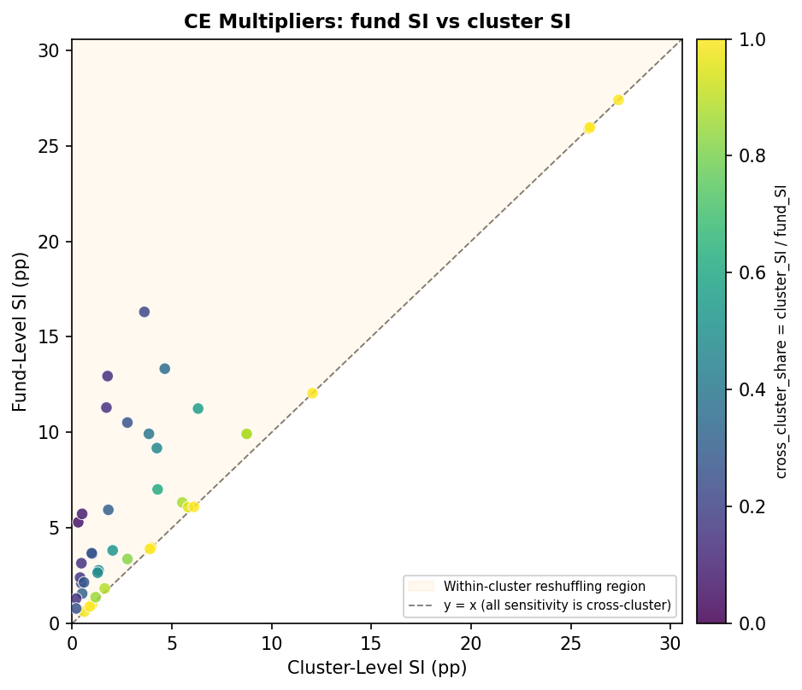

Time Discounts
Top 2 scenarios by lowest cross-cluster share (most within-cluster reshuffling first):
Scenario | Fund SI | Cluster SI | Cross-cluster share
discount 500+ ×0 | 15.38 | 15.38 | 100%
discount 100-500 and 500+ ×0 | 20.87 | 20.87 | 100%
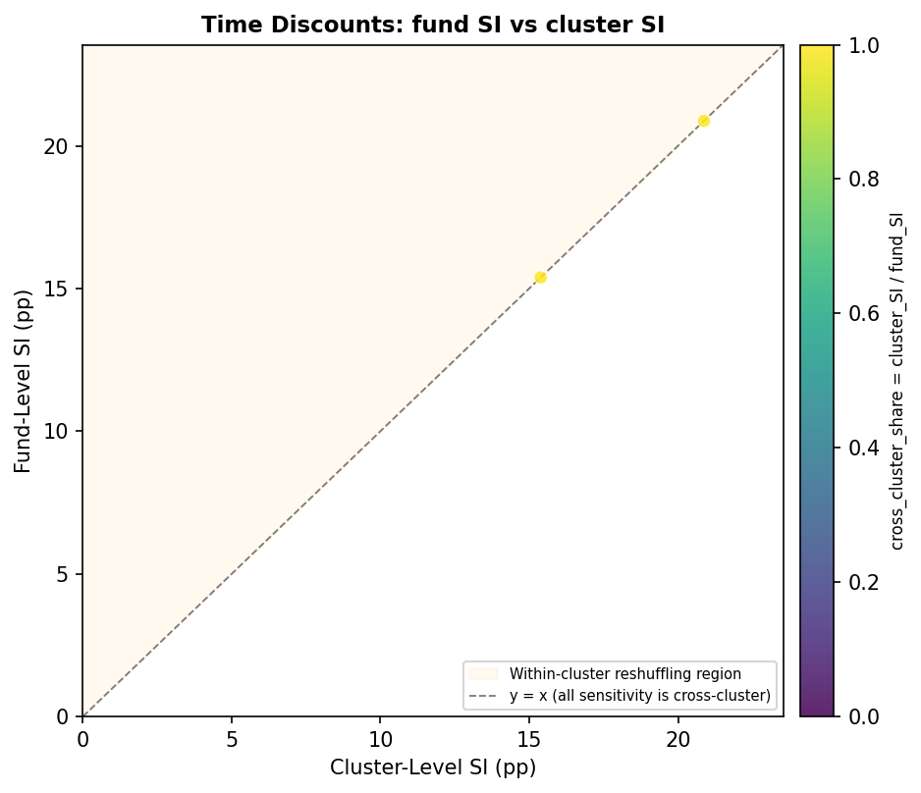

Diminishing Returns (Power)
Top 8 scenarios by lowest cross-cluster share (most within-cluster reshuffling first):
Scenario | Fund SI | Cluster SI | Cross-cluster share
aw_high_power | 3.08 | 0.53 | 17%
gcr_and_aw_high_power | 4.87 | 0.96 | 20%
gcr_low_aw_high_power | 3.46 | 0.73 | 21%
gcr_high_aw_low_power | 6.66 | 2.42 | 36%
gcr_high_power | 2.67 | 1.20 | 45%
gcr_and_aw_low_power | 5.94 | 2.73 | 46%
aw_low_power | 5.19 | 2.42 | 47%
gcr_low_power | 0.95 | 0.60 | 63%
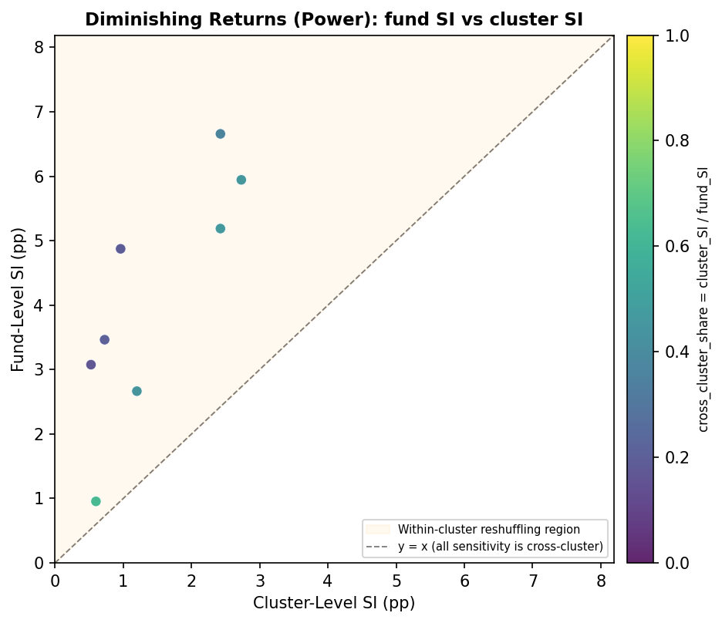

Diminishing Returns (Max Spend)
Top 3 scenarios by lowest cross-cluster share (most within-cluster reshuffling first):
Scenario | Fund SI | Cluster SI | Cross-cluster share
max_spend_7_5x ×7.5 | 9.74 | 3.37 | 35%
max_spend_10x ×10 | 14.64 | 6.83 | 47%
max_spend_2_5x ×2.5 | 15.13 | 14.55 | 96%
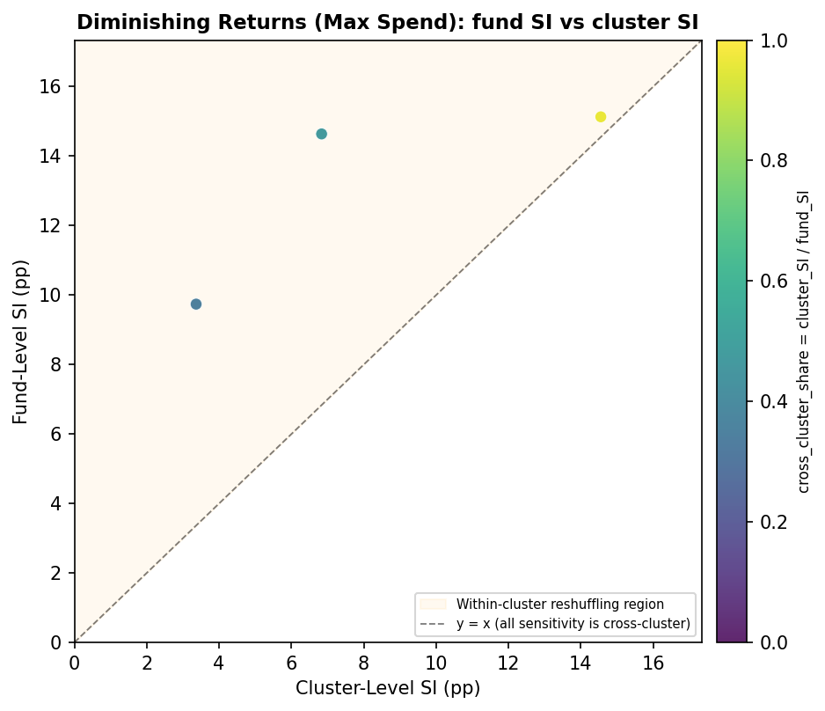

DR Combined
Top 8 scenarios by lowest cross-cluster share (most within-cluster reshuffling first):
Scenario | Fund SI | Cluster SI | Cross-cluster share
gcr_and_aw_low_power ×7.5 | 9.40 | 2.17 | 23%
aw_high_power ×10 | 17.47 | 4.87 | 28%
gcr_low_aw_high_power ×10 | 17.27 | 4.87 | 28%
gcr_and_aw_high_power ×10 | 19.81 | 6.53 | 33%
gcr_low_power ×7.5 | 9.14 | 3.37 | 37%
gcr_and_aw_low_power ×10 | 13.14 | 4.86 | 37%
gcr_high_aw_low_power ×7.5 | 11.90 | 4.47 | 38%
aw_low_power ×7.5 | 11.60 | 4.37 | 38%
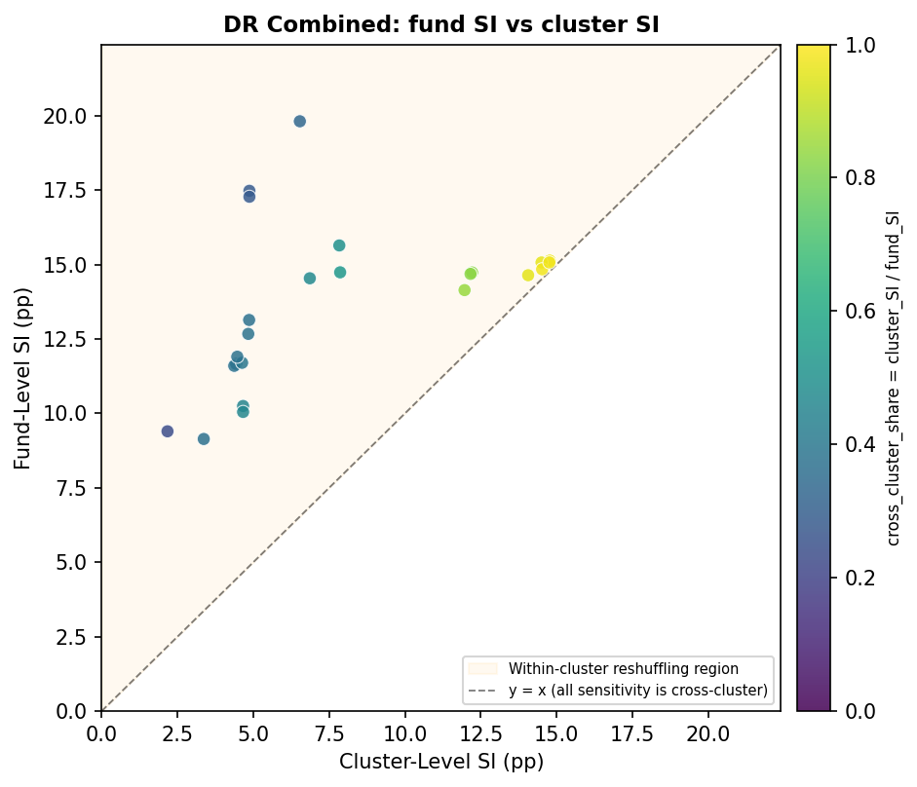

Worldview Credences
Top 8 scenarios by lowest cross-cluster share (most within-cluster reshuffling first):
Scenario | Fund SI | Cluster SI | Cross-cluster share
Contractualism — Person-Affecting/Cluelessness and Animals B | 3.57 | 1.98 | 56%
Contractualism — Person-Affecting/Cluelessness and Animals B | 13.45 | 9.16 | 68%
Non-Utilitarian Consequentialism — Weighted Linear Utility_l | 1.28 | 0.92 | 72%
Total Utilitarianism — Default_high | 27.38 | 21.33 | 78%
Non-Utilitarian Consequentialism — Default_high | 26.67 | 21.15 | 79%
Non-Utilitarian Consequentialism — High Life Value / Clueles | 1.34 | 1.11 | 83%
Contractualism — Default + cluelessness_low | 2.10 | 1.77 | 84%
Non-Utilitarian Consequentialism — Person-Affecting/Clueless | 1.32 | 1.13 | 85%
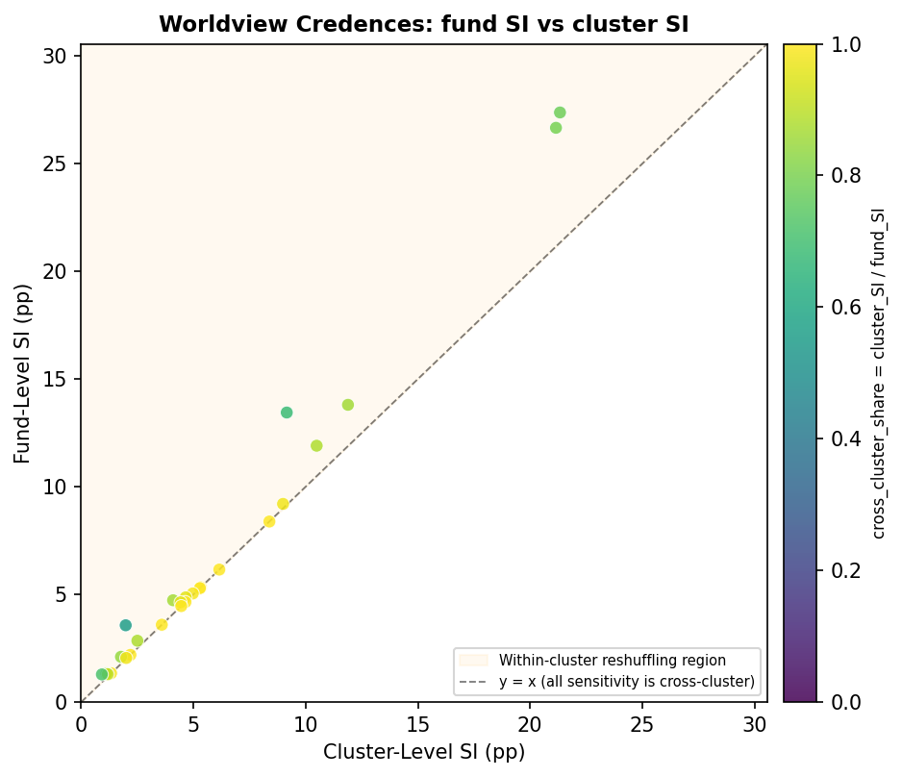

Risk Aversion
Top 8 scenarios by lowest cross-cluster share (most within-cluster reshuffling first):
Scenario | Fund SI | Cluster SI | Cross-cluster share
neutral_to_bilateral_skep | 1.20 | 0.13 | 11%
specialblend_to_downside_critical | 26.68 | 3.10 | 12%
neutral_to_downside_critical | 89.14 | 56.15 | 63%
specialblend_to_bilateral_skep | 66.81 | 54.39 | 81%
specialblend_to_neutral | 65.93 | 54.52 | 83%
specialblend_to_cont_upside_skep | 27.12 | 26.18 | 97%
specialblend_to_combined | 35.75 | 35.63 | 100%
neutral_to_cont_upside_skep | 80.69 | 80.69 | 100%
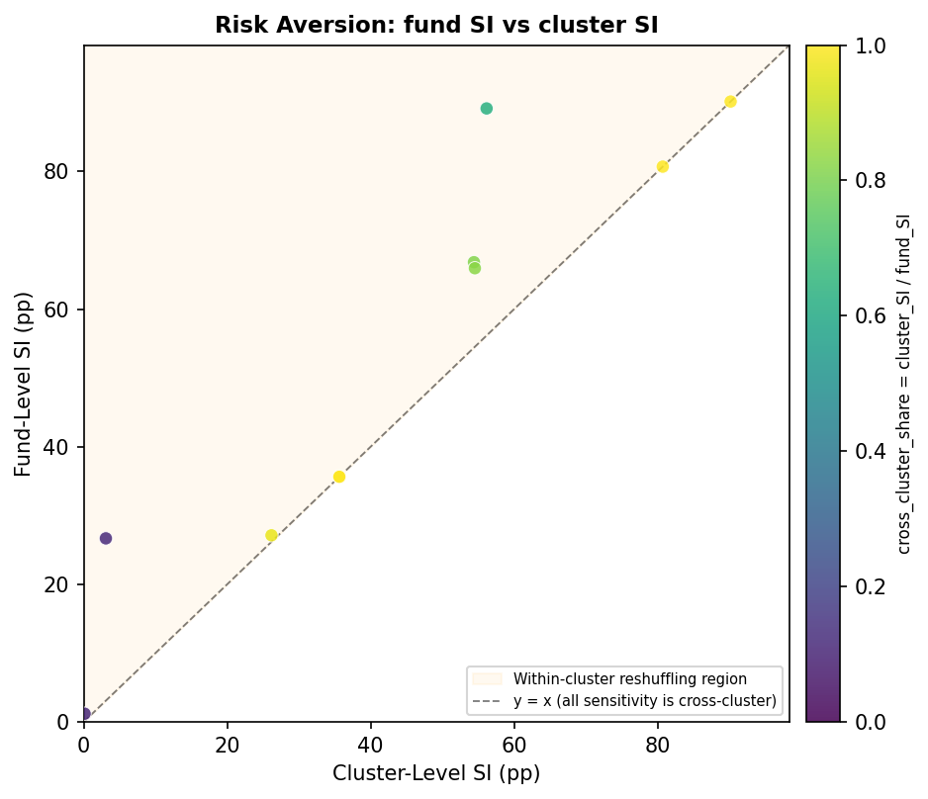

Moral Weights
Top 7 scenarios by lowest cross-cluster share (most within-cluster reshuffling first):
Scenario | Fund SI | Cluster SI | Cross-cluster share
weight ×2 | 1.84 | 1.62 | 88%
weight ×0.5 | 6.08 | 5.82 | 96%
weight ×0.2 | 14.15 | 14.15 | 100%
weight ×0.1 | 24.18 | 24.18 | 100%
weight ×100 | 14.01 | 14.01 | 100%
weight ×10 | 6.31 | 6.31 | 100%
weight ×5 | 4.91 | 4.91 | 100%
