Learning Design Toolkit (M.Ed. in IDET)

  - Brigid Kosgey

Table of Contents
Learning Theories 3
Behaviorism 3
Cognitivism 4
Constructivism 6
Connectivism 7
Pedagogy vs. Andragogy 9
TPACK | Technological Pedagogical Content Knowledge 9
TAWOK | Technology Andragogy Work Content Knowledge 10
Learning Process Models 12
Kolb’s Experiential Learning Theory 12
Gagne’s Nine Events of Instruction 14
Continuous Improvement 15
PDSA Cycle | Plan Do Study Act Cycle 15
Design Models 18
Instructional Design (ID) vs. Learning Experience Design (LXD) 18
First Principles of Instruction 19
Merrill’s Principles of Instruction 19
Merrill’s Four-Phase Cycle of Instruction 21
Project Management Models 22
Agile 22
SAM | Successive Approximation Model 24
SAMR | Substitution, Augmentation, Modification, and Redefinition 25
Waterfall 27
ADDIE | Analysis, Design, Development, Implementation, and Evaluation 28
Cognitive Load 30
Cognitive Load Theory 30
Managing Cognitive Load 31
Multimedia Principle 31
Signaling 32
Chunking 33
Visual Cognitive Load/C-R-A-P 34
Strategies for Student Learning 36
Scaffolding 36
Levels of Challenge 37
Active Learning 38
Problem-Solving Tasks 39

Learning Design Toolkit

Learning Theories
Module 1

Behaviorism
In behavioral theory, emphasis is on how human beings learn from interacting with their environments. Behaviorism helps to establish that behaviors are learned through the process of conditioning. Skinner believes that conditioning is a process that involves punishment and reinforcement. The behavioral model allows an organized framework for instruction in which expectations can be established and routines provided (Samoila et al., 2023). There is a way to do things to get the desired result, which is known to behavioral theorists. The teacher defines what that way looks like (Samoila et al., 2023). Praise is one of the most practical reinforcers in a secondary classroom. O’Handley et al. (2023) found that behavior-specific praise delivered about once every two minutes produced large, immediate gains in engagement and drops in disruptive behavior in secondary classrooms.

Example
The problem. Off-task behavior in my classes is a constant challenge. Students yell, walk around, and begin side conversations at the beginning of the class period. I frequently have to stop my instruction to redirect students. When misbehavior is the only thing getting any attention, redirection may become the best way of getting students' attention, which results in further off-task behavior and wastes instructional time. I wanted a plan that would make it possible to focus on the expected behavior.
I created a behavior plan at the beginning of the class, taking into consideration the behaviorist strategy of defining behavior, reinforcing it immediately, and then reinforcing it less often because of the habit formation (Samoila et al., 2023):
- Define the target behavior: I select one behavior I can observe and measure: the student is seated and working on the Do Now assignment within two minutes of the bell ringing. The expectations are posted on the board with the Do Now assignment.
- Track the starting point: I create a quick tally on my list for one week regarding who starts the class on time. It helps me to understand which students require more help.
- Select the reinforcer: My reinforcers include specific and private praise ("You started right away, thank you") and class chart points that the students can exchange for privileges, such as choosing a desk for the day or selecting the warm-up problem.
- Provide immediate reinforcement: I praise or provide a point once the student performs the targeted behavior. Delayed reinforcement will not be related to the particular instance of the behavior.
- React calmly to the undesired behavior: The student who did not start his or her work will receive a reminder of the target and another opportunity to do it correctly. I prefer not to give a lecture in front of other students because the attention will reinforce the inappropriate behavior.
- Fade the reinforcement: When most of the students are performing the targeted behavior, the teacher gives the points every few days and praises randomly, allowing the desirable behavior to become a habit.
The new strategy will focus my attention from the off-task students to those on-task, and this is the key requirement made by behaviorism.

Reference(s)
O’Handley, R. D., Olmi, D. J., Dufrene, B. A., Radley, K. C., & Tingstrom, D. H. (2023). The effects of different rates of behavior-specific praise in secondary classrooms. Journal of Positive Behavior Interventions, 25(2), 118–130. https://doi.org/10.1177/10983007221091330
Samoila, C., Ursutiu, D., & Munteanu, F. (2023). The remote experiment in the light of the learning theories. International Journal of Online and Biomedical Engineering, 19(14), 26–44. https://doi.org/10.3991/ijoe.v19i14.43163

Cognitivism
While cognitivism directs attention from overt behavior to the internal processes necessary for learning, such as attention, perception, encoding, memory, and retrieval, the cognitivist theorists consider the learner as an information processor whose current knowledge structure in the form of schemas determines the acquisition and retention of any new information (Sweller, 2023). Instruction based on this paradigm includes gaining attention, activation of prior knowledge, structuring information in coherent chunks, and practice that helps transfer information from the working memory to long-term memory. Recent work in cognitive load theory supports this view: working memory is severely limited in capacity and duration, while long-term memory has no known limits, so instruction works best when it helps learners move new information into long-term memory (Sweller, 2023). Krieglstein et al. (2023) built and tested a questionnaire that separates intrinsic, extraneous, and germane load, which gives teachers and designers a way to check how much mental effort a lesson demands. The information processing approach described in Figure 1 serves as the foundation of many cognitive models.
Figure 1
Simplified Information Processing Model
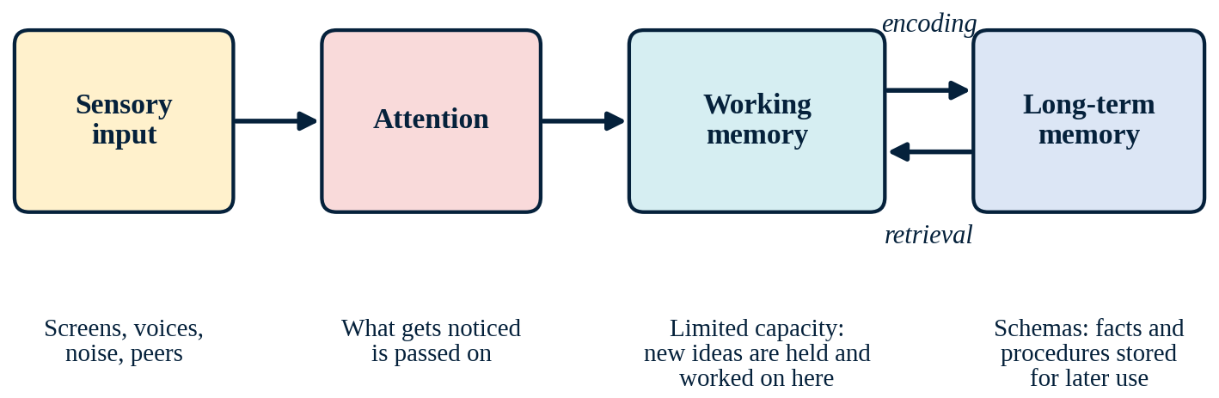
Note. Created by the author, based on Sweller (2023) and Krieglstein et al. (2023).

Example
The problem. I am teaching Algebra 2 at a public high school. My students have numerous gaps in their basic math facts acquired in elementary and middle schools. If I ask my students to factor a trinomial but they are unable to quickly compute 7 × 8 or add/subtract integers, the computations take up all working memory that would be needed to process the new concept.
Now I structure my lessons based on the information-processing model’s sequence of events:
- Attention: At the start of class, I write an introductory task without any sound for the students to focus on.
- Sensory input: I display problems one at a time, clear unnecessary visual distractions, and use uniform directions for the students daily.
- Working memory: I introduce one concept per chunk, and provide a multiplication table and rules of integers for each desk so that recalling previous knowledge does not interfere with gaining new skills.
- Encoding: I associate the new concept with the students’ prior knowledge, e.g., illustrate factoring as the opposite process to determining the area of a rectangle.
- Long-term memory and retrieval: There is an exit ticket at the end of each unit with five questions, followed the next day by Do Nows asking two of those questions so that students have to retrieve the concept after some time has passed.
Since the model allows me to see where the process falls apart, I can address the actual barrier. It is not about reducing the level of rigor for Algebra 2, but about freeing up working memory to get there.

Reference(s)
Krieglstein, F., Beege, M., Rey, G. D., Sanchez-Stockhammer, C., & Schneider, S. (2023). Development and validation of a theory-based questionnaire to measure different types of cognitive load. Educational Psychology Review, 35(1), Article 9. https://doi.org/10.1007/s10648-023-09738-0
Sweller, J. (2023). The development of cognitive load theory: Replication crises and incorporation of other theories can lead to theory expansion. Educational Psychology Review, 35(4), Article 95. https://doi.org/10.1007/s10648-023-09817-2

Constructivism
According to the constructivism theory, knowledge is constructed as a result of an interpretation of new experiences based on prior knowledge (rather than received ready-made from a teacher), and therefore learners play an active role in this process (Wibowo et al., 2025). In his theory of cognitive development, Piaget stressed the importance of conflict resolution in learning, whereas Vygotsky stressed its social nature: learners grow most within their zone of proximal development, where a teacher or peer provides scaffolding until they can work alone (Wibowo et al., 2025). Constructivist instruction involves authentic tasks, discussion, and reflection. Novices who lack background knowledge may easily feel lost under insufficiently guided instruction, so effective designs combine exploration with guidance. Kaldaras et al. (2024) found that students learned most from computer simulations when the tools’ built-in feedback was paired with deliberate teacher scaffolding. A typical sequence moves from prior knowledge to a challenging problem, peer talk, new understanding, and reflection (Figure 2).
Figure 2
A Constructivist Learning Sequence
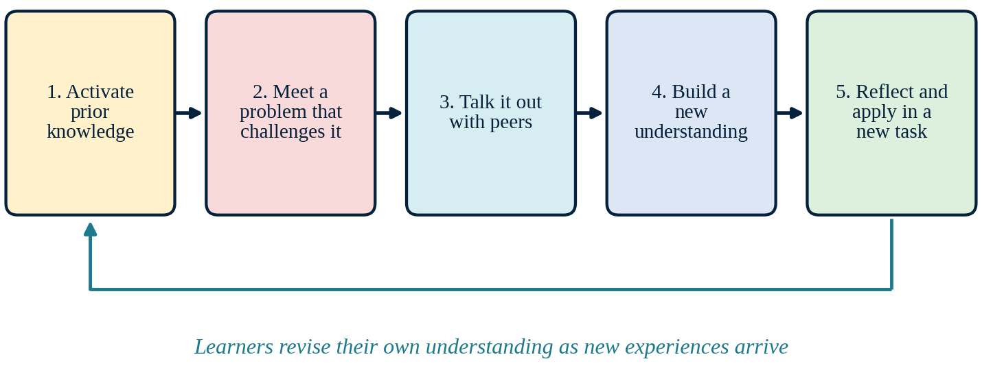
Note. Created by the author, based on Wibowo et al. (2025) and Kaldaras et al. (2024).

Example
The problem. Many of my students memorize procedures, without knowing their meaning. The procedure memorized from the board has no relation whatsoever to what students already understand, and thus will disappear in days' time. For the topic of exponential growth, I wanted to create a way for my students to generate an idea, rather than being presented with a formula from the board.
The lesson was arranged in the following way, according to the constructivist approach:
- Activate prior knowledge: I ask students to describe how rumors or videos spread at our school. They understand that it is becoming bigger.
- Experience a difficult problem: Each group is given a different problem with different initial values; for example, one account starts with 4 followers and triples each week. The problem is different for each group.
- Communicate with peers: The group creates a table, identifies the pattern, and predicts Week 6.
- Develop new knowledge: Each group shares its patterns, and I relate the terms in their description to the equation y = a·bˣ, making the equation emerge as a synthesis of their findings.
- Reflect and apply: Students use an exit ticket to articulate in one sentence how the table pattern leads to the equation and apply it in a different situation.
Following Kaldaras et al. (2024), I do not leave students to discover everything alone. I keep the activity short, provide a partly filled table and sentence frames, and step in with a sample solution if a group gets stuck.

Reference(s)
Kaldaras, L., Wang, K. D., Nardo, J. E., Price, A., Perkins, K., Wieman, C., & Salehi, S. (2024). Employing technology-enhanced feedback and scaffolding to support the development of deep science understanding using computer simulations. International Journal of STEM Education, 11, Article 30. https://doi.org/10.1186/s40594-024-00490-7
Wibowo, S., Wangid, M. N., & Firdaus, F. M. (2025). The relevance of Vygotsky’s constructivism learning theory with the differentiated learning primary schools. Journal of Education and Learning (EduLearn), 19(1), 431–440. https://doi.org/10.11591/edulearn.v19i1.21197

Connectivism
According to connectivism, learning in the digital age is about making and managing connections within people, information, and technology and understanding that knowledge is not only contained by individuals but also in networks and machines (Downes, 2022). Downes (2022) explains that knowledge is the set of connections between people and resources, so learning means building and strengthening those connections. This theory emphasizes diversity, cultivation of connections, currency of information, and ability to recognize connections between concepts. However, Apostolidou (2022) argues that connectivism can overlook human agency and the social context of learning, so it works best as an approach for creating networked learning in tandem with other learning theories. In Figure 3, the learner occupies the central position within the network.
Figure 3
Learning as a Network of Connections
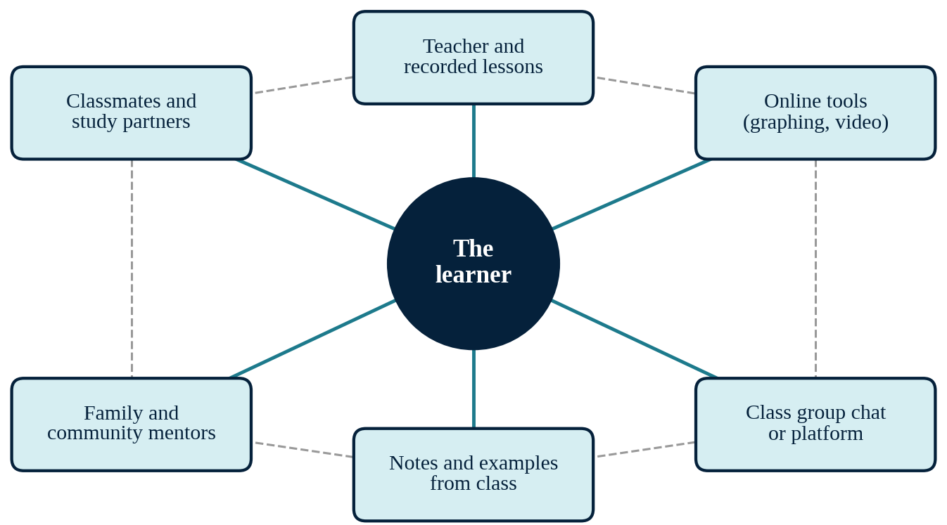
Note. Created by the author, based on Downes (2022) and Apostolidou (2022).

Example
The problem. Poor attendance is one of my greatest obstacles. Students miss classes, and even when they attend school, many stay absent from the classroom during the lesson period, missing the "I do" part of the lesson. Then, they tend to sit quietly, not knowing what was taught and whom they should ask. Moreover, my students are part of a community where reliable internet connection at home cannot be taken for granted.
I apply the concepts of connectivism in creating a small learning network for each learner:
- Diversity of sources: All lessons are provided in multiple formats: notes from class, a brief video of the worked problem solution, and a peer who attended the class.
- Development of connections: Each learner has two learning partners selected at the beginning of the unit. On the return of the student, the first task is contacting one of the partners.
- Currency: Notes and the video are uploaded to the class website on the same day. Catch-up folders in print are created for those who do not have access to the internet.
- Making connections: The re-entry form requires the absent student to watch the video, solve three problems, and write one sentence that draws the connection between today's skill and the previous unit.
The network will not take my place in teaching, but it will continue to facilitate learning even if the child is absent from class. More importantly, the network will also allow the student to reach out to more than one person, considering the school’s situation where some children do not feel noticed.

Reference(s)
Apostolidou, A. (2022). Digitally situated knowledge: Connectivism, anthropology and epistemological pluralism. International Journal of Educational Research, 115, Article 102047. https://doi.org/10.1016/j.ijer.2022.102047
Downes, S. (2022). Connectivism. Asian Journal of Distance Education, 17(1), 58–87. https://doi.org/10.5281/zenodo.6173510

Pedagogy vs. Andragogy

TPACK | Technological Pedagogical Content Knowledge
TPACK refers to the knowledge that teachers require in order to make effective use of technology. Building on Shulman’s idea of pedagogical content knowledge, the framework holds that there should be an interaction between three different kinds of knowledge that would ensure effective teaching; these include content knowledge (CK), pedagogical knowledge (PK), and technological knowledge (TK). These intersections give rise to three additional kinds of knowledge, namely PCK, TCK, and TPK; at the intersection of all the three lies TPACK. Mishra et al. (2023) argue that the framework still applies to generative AI, but teachers now need stronger contextual knowledge to judge when and how these tools support learning. Celik (2023) extended the framework to artificial intelligence and showed that teachers also need knowledge of how to use AI-based tools ethically. This framework is intended for teaching children and adolescents, and hence, it is included here alongside the adult version that will follow.
Figure 4
The TPACK Framework
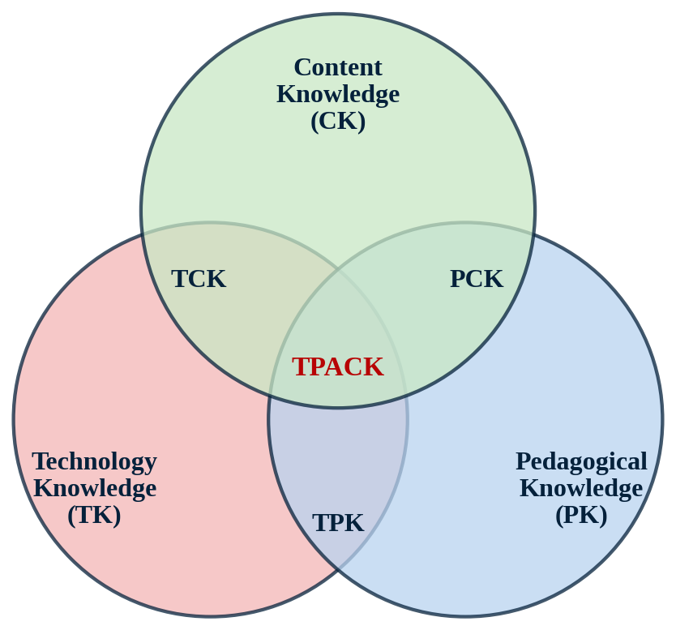
Note. Created by the author, based on Mishra et al. (2023) and Celik (2023).

Example
The problem. In a 50-minute lesson, I need to know if each of my students has grasped the concept. Any distractions for behavior modification would take away time from the grading process of the paper. By the time I hand the worksheet back, the class is already through with that part of the lesson, and I needed a means of checking for understanding that would give me timely information and not distract the lesson.
Using the TPACK components for this decision-making on the lesson on graphing quadratic functions in vertex form:
- Content knowledge: The basic principle is that changes in a, h, and k change the shape of the parabola. One of the misconceptions is about the sign of h.
- Pedagogical knowledge: I use chunked teaching, gradual release of responsibility, and immediate feedback since attention quickly fades in my lessons.
- Technological knowledge: I compare technologies like a graphing calculator, an online graphing software, and quick quiz-form technology in terms of what students can get, how easy it is to learn, and how distracting it is.
- The intersections. PCK: I know that students misinterpret the sign of h. TCK: a graphing tool enables students to see the movement of the parabola as the value of h varies, something which is impossible in paper. TPK: a three-question digital check will give me a picture of the entire class without interrupting my teaching process.
- TPACK. Students vary the values of h and k using the graphing tool in the “we do” stage, make predictions on how the graph should appear and finally take part in the three-question check. The results inform me on the students to engage in small group activities during independent practice.
Students without a functional computing device use a graphing calculator or graph on a printed grid so that the lesson doesn’t depend on the computing technology available to all students.

Reference(s)
Celik, I. (2023). Towards Intelligent-TPACK: An empirical study on teachers’ professional knowledge to ethically integrate artificial intelligence (AI)-based tools into education. Computers in Human Behavior, 138, Article 107468. https://doi.org/10.1016/j.chb.2022.107468
Mishra, P., Warr, M., & Islam, R. (2023). TPACK in the age of ChatGPT and generative AI. Journal of Digital Learning in Teacher Education, 39(4), 235–251. https://doi.org/10.1080/21532974.2023.2247480

TAWOK | Technology Andragogy Work Content Knowledge
TAWOK (abbreviated TAWOCK by Arifin et al., 2020) stands for Technology, Andragogy, Work, and Content Knowledge. Arifin et al. (2020) proposed it as an extension of the TPACK model with pedagogy replaced by andragogy and knowledge of work added in technical and vocational education. Andragogy is based on various assumptions such as self-direction, experiences which serve as a learning resource, readiness to learn what one needs for life roles, and desire to apply learning to problem-solving. Desta and Gugssa (2022) studied how these adult learning principles are put into practice in an adult education program. The TAWOCK framework calls for integration of technology, adult learning principles, work requirements, and content to equip students for job competition (Figure 5).
Figure 5
The TAWOCK Framework
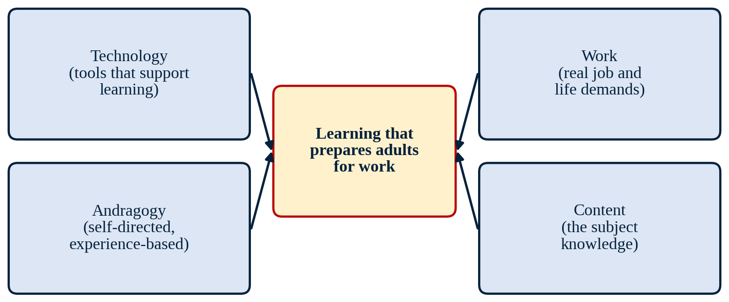
Note. Created by the author, based on the TAWOCK framework described by Arifin et al. (2020).

Example
The problem. I teach students who are usually 17 to 19 years old; some have jobs after school, and some carry out adult duties at home. They want to know why they should study Algebra 2, and completing a worksheet filled with abstract math problems does not give them an answer. TAWOCK was developed for adult learners, and my students are mostly teens. However, the rationale behind the model makes sense for my students who already play adult roles.
Each component was used in a unit about linear equations and systems:
- Content: Students create linear equations and systems and graph them to determine their point of intersection.
- Work: The work context is salary. Two options for a part-time job are compared by students: one pays students an hourly wage, and another one – a lower hourly rate plus commission.
- Andragogy: Students select the version that is closest to their experience, like advice, working extra hours, or doing a weekend job. I see what they know about work and money as a resource. In addition, students also have a checklist to self-manage their progress in doing the assignment.
- Technology: Students put the two pay systems into a spreadsheet or graphing program and read the break-even point off the graph.
- Outcome: Every student tells his or her partner which of the jobs will be taken by him or her and explains why with the help of the equations and the graph.
This assignment responds to the question “Why do I need Algebra II?” with the decision that will be made by many of my students shortly. The same idea can start in middle school with simpler numbers, such as comparing two pay plans for babysitting or lawn care, so students see early why algebra matters.

Reference(s)
Arifin, Z., Nurtanto, M., Kholifah, N., Nurhaji, S., & Warju, W. (2020). The technology andragogy work content knowledge model framework on technical and vocational education and training. Journal of Education and Learning (EduLearn), 14(3), 442–448. https://doi.org/10.11591/edulearn.v14i3.15946
Desta, S. Z., & Gugssa, M. A. (2022). The implementation of andragogy in the adult education program in Ethiopia. Education Research International, 2022, Article 2028248. https://doi.org/10.1155/2022/2028248

Learning Process Models

Kolb’s Experiential Learning Theory
In Kolb’s experiential learning theory, learning involves the creation of knowledge through the transformation of experience. The cycle (Figure 6) has four components: concrete experience, reflective observation, abstract conceptualization, and active experimentation. Students can begin in any stage of the cycle but must complete all four for effective learning. Egan et al. (2023) describe the cycle as ongoing and lifelong: each new experience builds on earlier ones, so learning environments should give students time to talk, reflect, and act. A recent systematic review found that few studies applied all four stages fully; concrete experience and active experimentation were the stages most often cut short (Villarroel Henríquez et al., 2025).
Figure 6
Kolb’s Experiential Learning Cycle
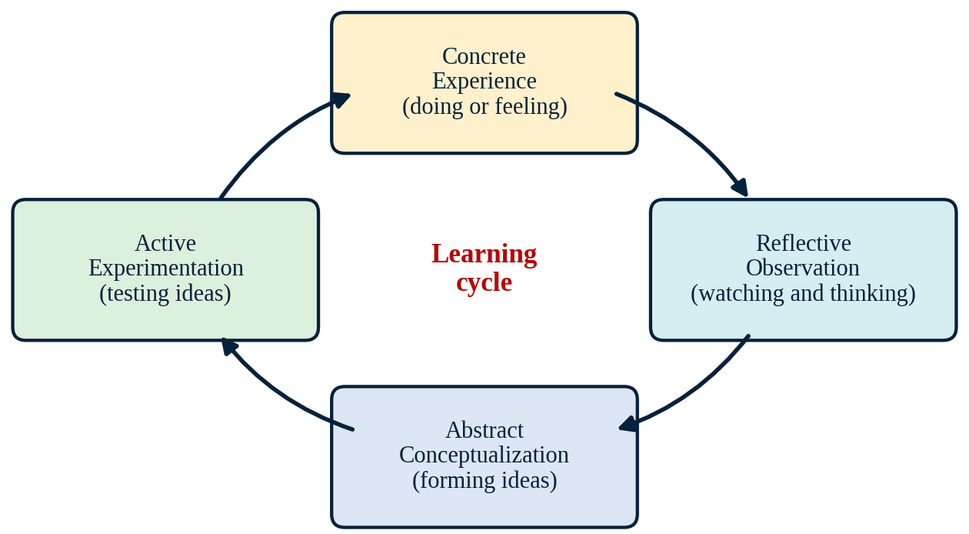
Note. Created by the author, based on Egan et al. (2023) and Villarroel Henríquez et al. (2025).

Example
The problem. Students who are sleeping or hiding in the back of my classroom check out on the direct instruction I give them, although many of them spring to life when they are allowed to manipulate objects or move their bodies. A lecture on rate of change does not work for most of them.
I taught rate of change using slope and progressing through Kolb’s four stages:
- Concrete experience: The class is split into groups of three; one student walks along a taped line on the classroom floor three times at different paces while two students in the group time the walking, and another student in a separate group marks the distance. Everyone in the group has an assigned task.
- Reflective observation: Students put their findings in a table and consider, “What was different every time, and what did not change?” They then discuss their conclusions with another group.
- Abstract conceptualization: I introduce the concept that the slope equals the change in distance divided by the change in time. We determine the units together.
- Active experimentation: Using their rate, students make predictions about how far the walker will get in some additional time. Students check the prediction by walking.
In this way, students who do not participate in lectures and disengage during activities will be engaged by doing the work that the lecture would require them to write down. Concluding the lesson with a brief written reflection allows me to see if students are making the transition from activity to concept.

Reference(s)
Egan, J. D., Tolman, S., McBrayer, J. S., & Ballesteros, E. (2023). Reconceptualizing Kolb’s learning cycle as episodic and lifelong. Experiential Learning and Teaching in Higher Education, 6(1), 24–33. https://doi.org/10.46787/elthe.v6i1.3607
Villarroel Henríquez, V., Castillo Rabanal, I., & Santana Abásolo, J. (2025). Applying Kolb’s experiential learning cycle for deep learning: A systematic literature review. Social Sciences & Humanities Open, 12, Article 102096. https://doi.org/10.1016/j.ssaho.2025.102096

Gagne’s Nine Events of Instruction
Gagné’s nine events of instruction are designed to support the internal process of learning. The sequence can be used by designers to create a reliable structure for a lesson, from attracting the learners’ attention to transferring their newly acquired knowledge. The events are still considered the basis of modern instruction formats, as evidenced by recent studies. For instance, McNeill and Fitch (2023) analyzed microlearning online using the framework of the nine instruction events. Nasrullah et al. (2024) also used the nine events to design mobile-assisted vocabulary learning in higher education. The events are described in Table 1.
Table 1
Gagné’s Nine Events of Instruction
Event | Purpose
1. Gain attention | Capture interest with a question, problem, or surprise.
2. Inform learners of the objective | Tell learners what they will be able to do and how they will know.
3. Stimulate recall of prior learning | Bring earlier knowledge into working memory as a foundation.
4. Present the content | Show new information in organized, meaningful pieces.
5. Provide learning guidance | Support learners with examples, cues, and questions.
6. Elicit performance | Ask learners to practice the new skill.
7. Provide feedback | Tell learners how well they did and how to improve.
8. Assess performance | Check whether the objective has been met.
9. Enhance retention and transfer | Help learners remember and apply the skill in new situations.
Note. Created by the author, based on McNeill and Fitch (2023) and Nasrullah et al. (2024).

Example
The problem. Time interruptions steal huge chunks of my 50 minutes. Redirecting behaviors, waiting for materials, or requesting that a disruptive student be excused are common occurrences. Inconsistent structure means no lesson; I must figure out where to begin anew. I will employ Gagné’s events to develop a consistent, structured lesson with specific time requirements for each event in order to resume lessons when interrupted.
Below is a structured lesson plan on solving quadratic equations by factoring:
- Gain attention (3 minutes). A “damaged” worked problem is presented on the board. The class locates the error.
- Inform learners of the objective (2 minutes). The objective is presented: “I can solve x² + 5x + 6 = 0 by factoring.”
- Stimulate recall (5 minutes). Find factor pairs of 6, 12, and 20 from memory, checking with a multiplication chart.
- Present the content (8 minutes). I demonstrate two questions through a think-aloud.
- Provide learning guidance (8 minutes). Two more are worked out in cooperation with partial workings.
- Elicit performance (10 minutes). In pairs, students solve three problems using mini whiteboards.
- Provide feedback (5 minutes). I go through the whiteboards and correct any misunderstandings right away.
- Assess performance (5 minutes). Individual completion of an exit ticket with three problems.
- Enhance retention and transfer (4 minutes). The students make a connection between factoring and a problem involving the area of a rectangle, and I preview the Do Now for tomorrow.
In case of interruption, I am aware of the event I am working with, and I can continue from there, or I can reduce the length of another event instead of scrapping the lesson altogether.

Reference(s)
McNeill, L., & Fitch, D. (2023). Microlearning through the lens of Gagne’s nine events of instruction: A qualitative study. TechTrends, 67(3), 521–533. https://doi.org/10.1007/s11528-022-00805-x
Nasrullah, M., Ulfa, S., & Rochmahwati, P. (2024). Gagne’s nine events in mobile-assisted vocabulary learning for higher education. Al-Hayat: Journal of Islamic Education, 8(4), 1366–1382. https://doi.org/10.35723/ajie.v8i4.69

Continuous Improvement

PDSA Cycle | Plan Do Study Act Cycle
The Plan-Do-Study-Act (PDSA) cycle is a strategy for testing a change on a small scale before implementing it fully (Anderson, 2025; Odell et al., 2025). In the plan phase, the team sets an objective and makes a prediction. In the do phase, the team runs the test and records what happens. In the study phase, the team compares the results with the prediction. In the act phase, the team decides whether to adopt the change, adjust it, or abandon it. The cycle then repeats (see Figure 7). Each new cycle builds on what the last one taught, and this ongoing repetition is what makes PDSA a model of continuous improvement. Anderson (2025) describes PDSA cycles as rapid tests of change that improvement teams run again and again as they learn. Odell et al. (2025) describe schools that built repeated PDSA cycles into their daily work and refined their teaching practices over several years.
Figure 7
The Plan-Do-Study-Act Cycle
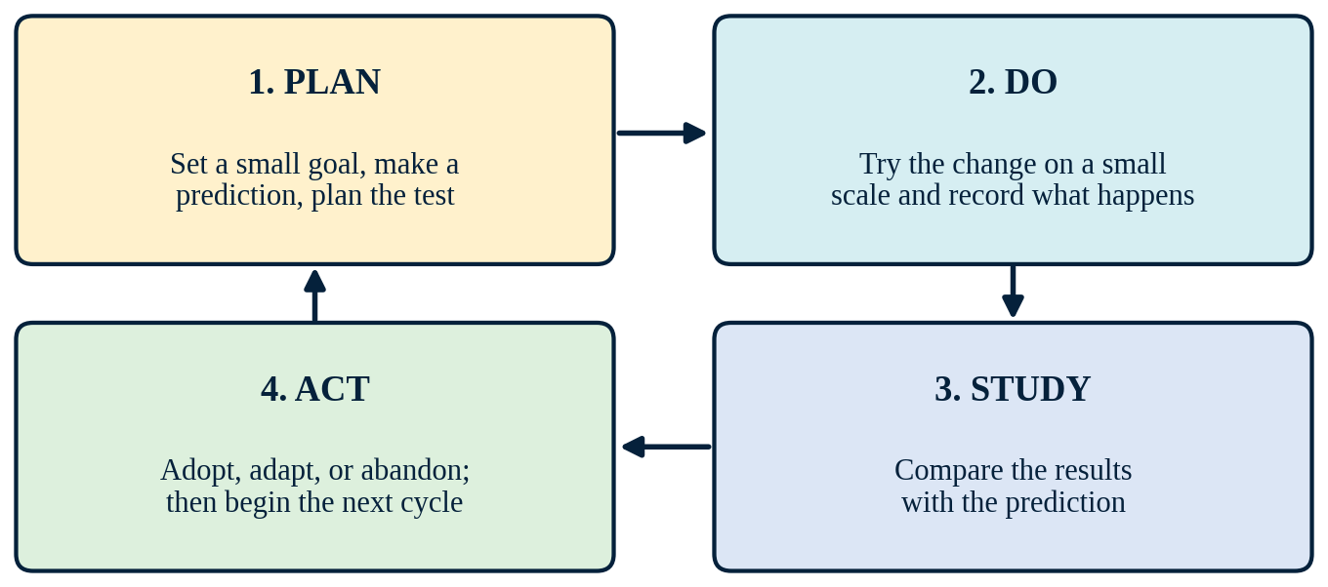
Note. Created by the author, based on Anderson (2025) and Odell et al. (2025). The return arrow shows that the cycle repeats.

Example
The problem. While my students are practicing independently, they rest their heads on the table or never begin their practice. The practice supposed to help them memorize the skill is not taking place. I am sure that my whole routine needs to change but I need to make sure of it.
This test is designed as a PDSA cycle:
- Plan. My aim is to get my students to solve the problems on their own, showing me what they have done. To achieve this aim, I am going to give them a partially solved first problem to start with and then look at the first problem in two minutes. I am predicting that my students will try to solve the problems since I have shown them how it should be done. My measurement plan includes counting how many of my students actually write down the solution to the first problem after three minutes, completed exit tickets, and the number of redirections.
- Do. I run the test for three days in one class period. I give students the partly solved first problem and check in at two minutes. I keep a tally of how many students write a solution to the first problem within three minutes, how many exit tickets are completed, and how many redirections I give. I also note anything unexpected.
- Study. I examine how my prediction worked when compared to the number of students who did the assignment correctly compared to the previous week. I also make notes on any surprising events like students starting the assignment but not being able to proceed with the second problem.
- Act. If the change helps, I adopt it. If it helps only slightly, I adjust it, for example, by adding a quick peer check. If it does not help, I drop it and try a new idea. Either way, the cycle repeats: I start a new Plan phase based on what I learned and test it in another class period. Each cycle refines the routine a little more.
Writing down my prediction beforehand ensures that I stay objective and see what data say. Moreover, the limited scope of testing means that failing a small test will cost me just three days in one of my classes instead of the whole semester in all of them. Because the cycle repeats, small gains build on each other over the semester.

Reference(s)
Anderson, E. (2025). Preparing improvement teams to manage complex change in a continuous improvement program. Frontiers in Education, 10, Article 1566862. https://doi.org/10.3389/feduc.2025.1566862
Odell, M., Kennedy, T. J., & Simmons, J. A. (2025). The university academies: An improvement science research platform for P-20 education. Frontiers in Education, 10, Article 1529939. https://doi.org/10.3389/feduc.2025.1529939

Design Models
Module 2

Instructional Design (ID) vs. Learning Experience Design (LXD)
ID and LXD share the same goal: helping people learn. Where they differ is the question each one asks first. ID asks what learners should be able to do when instruction ends, then builds objectives, content, practice, and assessments to get them there. LXD asks what the learning will be like for the person going through it. Schmidt and Huang (2022) describe LXD as human-centered and grounded in theory, with close attention to learners’ social and cultural backgrounds. Designers who use it borrow tools from user experience design, such as learner interviews, personas, and quick prototypes.
To settle what the term means, Tawfik et al. (2024) had a panel of experts refine the definition of LXD over several rounds. The panel agreed that LXD draws on human-centered methods from several fields and looks at the whole learning environment, not just the content. In my view, the two approaches are strongest together: ID keeps a unit tied to the standards, and LXD makes sure the route to those standards works for real students. Table 2 summarizes the main contrasts.
Table 2
Key Differences Between Instructional Design and Learning Experience Design
Feature | Instructional design (ID) | Learning experience design (LXD)
Starting question | What must learners be able to do? | What will this experience be like for the learner?
Main focus | Objectives, content, and assessment | Motivation, emotion, usability, and context
Role of the learner | Receives a planned sequence of instruction | Helps shape the design through feedback
Typical tools | Task analysis, objectives, and test blueprints | Interviews, personas, and prototypes
How success is judged | Learners meet the stated objectives | Learners meet objectives and stay engaged
Note. Created by the author, based on Schmidt and Huang (2022) and Tawfik et al. (2024).

Example
Background. Our math department asked me to build a two-week Algebra 1 unit on data displays. Many of my students tune out when the examples have nothing to do with their lives, so I planned the unit twice, once through each lens.
The ID lens. I started the traditional way. Students would build dot plots, histograms, and box plots. I wrote a learning goal for each display, then matched examples and quiz items to each goal. The pacing guide made progress easy to track.
The LXD lens. Next, I asked my students what data they actually cared about. They named sneaker prices, bus arrival times, and daily screen time. I wrote a lesson around anonymous screen-time data and tried it with one class. Students enjoyed comparing their own habits on box plots, but they told me the directions were too long, so I cut them down before the next class.
Reflection. ID showed me where the unit needed to end up. LXD showed me how to get my students there. The final unit kept the objectives and quiz items from the ID plan and used the screen-time data from the LXD lesson.

Reference(s)
Schmidt, M., & Huang, R. (2022). Defining learning experience design: Voices from the field of learning design & technology. TechTrends, 66(2), 141–158. https://doi.org/10.1007/s11528-021-00656-y
Tawfik, A. A., Schmidt, M., Payne, L., & Huang, R. (2024). Advancing understanding of learning experience design: Refining and clarifying definitions using an eDelphi study approach. Educational Technology Research and Development, 72(3), 1539–1561. https://doi.org/10.1007/s11423-024-10355-z

First Principles of Instruction

Merrill’s Principles of Instruction
Merrill’s first principles describe conditions that appear again and again in effective instruction. Learning is strongest when instruction is:
- Task-centered: learners work on real-world tasks instead of isolated facts.
- Activation: new learning starts from what learners already know.
- Demonstration: learners see the skill modeled, not just described.
- Application: learners practice the skill and get feedback.
- Integration: learners use the skill in their own lives and reflect on it.
Research continues to back these principles. In a comparison of two versions of a massive open online course (MOOC), Badali et al. (2022) found that learners in the version built on the first principles scored higher and were more satisfied than learners in the control version. Frick et al. (2022) traced the paths of more than 172,000 learners through an online tutorial. Those who worked through sections designed with the first principles were nearly four times as likely to pass the mastery test. In Figure 8, the principles surround a central real-world task.
Figure 8
The First Principles Arranged Around a Real-World Task
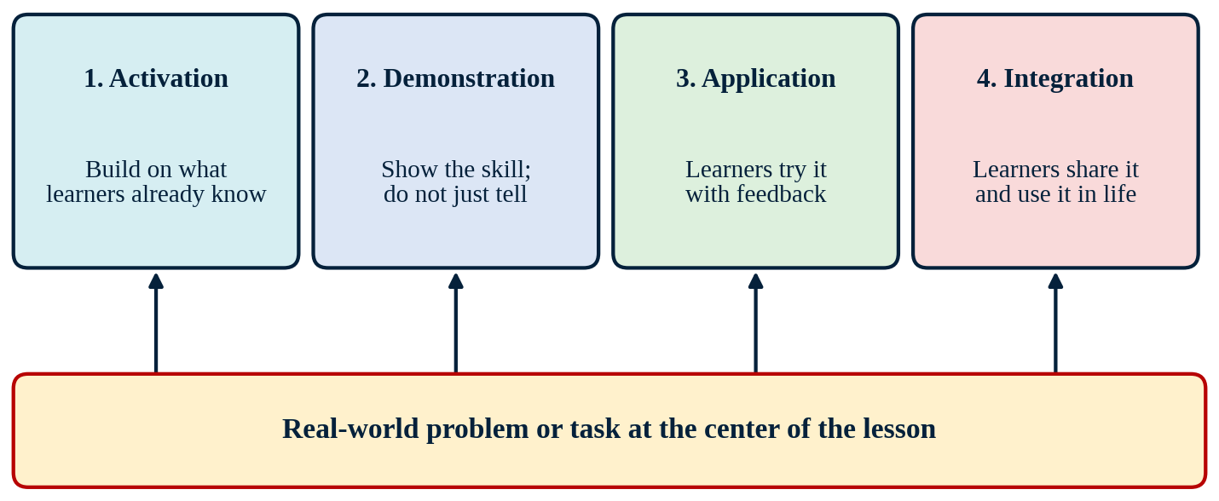
Note. Created by the author, based on Badali et al. (2022) and Frick et al. (2022).

Example
Context. I wanted my Algebra 2 students to see why linear inequalities matter. They could already graph them, but they had no reason to care about the graph. This time, I built the whole unit around one real problem.
Here is how each principle shaped the unit:
- Task: Each team plans a class field trip with a $1,200 budget, a $250 bus fee, and ticket prices for two venues. Teams must find every combination of students and adult chaperones the class can afford.
- Activation: Students share what they already know about budgeting from shopping, paying bills, or part-time jobs.
- Demonstration: I model one constraint from start to finish, writing the inequality and graphing it in Desmos.
- Application: Groups write and graph the remaining constraints while I circulate and give feedback on shading and boundary lines.
- Integration: Teams present their best plan and defend it with their graphs. For homework, each student writes an inequality based on a personal budget.
Reflection. Because the lesson centered on one task, students asked better questions, such as whether a point on the boundary line counts as a solution. The math finally had a purpose.

Reference(s)
Badali, M., Hatami, J., Farrokhnia, M., & Noroozi, O. (2022). The effects of using Merrill’s first principles of instruction on learning and satisfaction in MOOC. Innovations in Education and Teaching International, 59(2), 216–225. https://doi.org/10.1080/14703297.2020.1813187
Frick, T. W., Myers, R. D., & Dagli, C. (2022). Analysis of patterns in time for evaluating effectiveness of first principles of instruction. Educational Technology Research and Development, 70(1), 1–29. https://doi.org/10.1007/s11423-021-10077-6

Merrill’s Four-Phase Cycle of Instruction
Merrill organized the principles into a four-phase cycle that surrounds the problem. In activation, learners recall or experience something connected to the new skill. In demonstration, the teacher shows the skill in the setting where it will be used. During application, learners practice with coaching and feedback, and in integration they reflect on the skill and carry it into new situations.
Classroom studies suggest the cycle works across subjects. Hao et al. (2023) used it to design a 15-hour content and language integrated learning course, and students improved in language proficiency, intercultural understanding, and writing. The problem-solving and integration phases made the biggest difference. Sarfo et al. (2022) applied the same cycle in junior high science, and the phases worked equally well whether they were presented through a low-cost printed chart or a computer animation. The return arrow in Figure 9 reflects how each new task starts the cycle again.
Figure 9
The Four Phases of Merrill’s Instructional Cycle
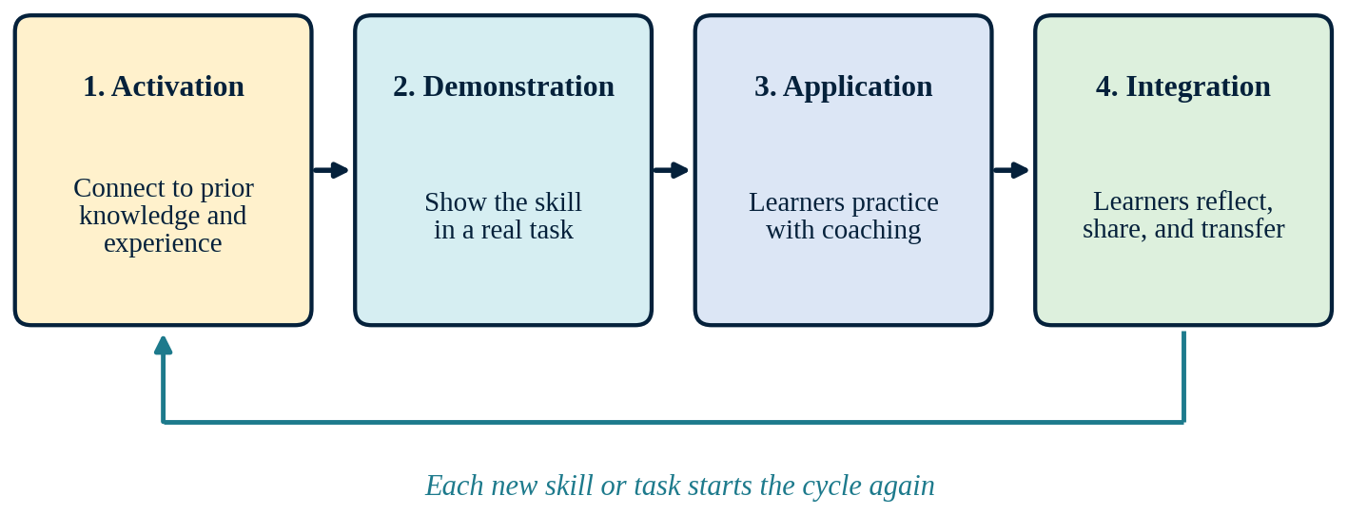
Note. Created by the author, based on Hao et al. (2023) and Sarfo et al. (2022).

Example
Background. Logarithms are one of the hardest topics in Algebra 2. When students first see logs, they treat them as something completely new. I used the four phases to plan a two-day lesson.
- Activation: I show the pH of lemon juice, milk, and bleach. Students use what they know about powers of 10 to work out how many times more acidic lemon juice is than milk.
- Demonstration: I show that “What power of 10 gives 1,000?” is the same question as “What is log base 10 of 1,000?” We work three examples together and look for the pattern.
- Application: Partners complete a card sort that matches exponential and logarithmic forms. I check each pair’s first three matches before they move on.
- Integration: Each student writes a short note to a younger student explaining what a logarithm “asks.” Then the class uses the decibel scale to compare a whisper with a fire alarm.
Reflection. The next lesson, Properties of Logarithms, starts a new cycle. It activates what students learned here, so each skill builds on the last.

Reference(s)
Hao, H., Susono, H., Geng, X., Chen, L., & Yamada, M. (2023). Effects of using the first principles of instruction in a content and language integrated learning class. Asian-Pacific Journal of Second and Foreign Language Education, 8(1), Article 2. https://doi.org/10.1186/s40862-022-00173-2
Sarfo, F. K., Debrah, P., Amankwah, F., & Mensah, F. O. (2022). Development of expertise in science at basic schools: The effect of first principles of instruction with computer animation and chart and their functional effect on gender. Cogent Education, 9(1), Article 2016557. https://doi.org/10.1080/2331186X.2021.2016557

Project Management Models

Agile
Agile replaces one large, fixed plan with a series of short work cycles. It began in software development. The team keeps a ranked list of requirements, called a backlog, and works through the top items in sprints that usually last one to four weeks. At the end of each sprint, users review what was built, and the team adjusts. Agile expects requirements to change and treats those changes as useful information.
Thesing et al. (2021) explain that the biggest difference between agile and waterfall is how much planning happens up front, and that agile fits projects whose requirements are unclear or likely to change. In education, Shidende and Moebs (2025) combined design-based research with Scrum sprints to build an accessible augmented reality authoring tool, testing and revising it with users in each round. A typical sprint cycle is outlined in Figure 10.
Figure 10
The Agile Sprint Cycle
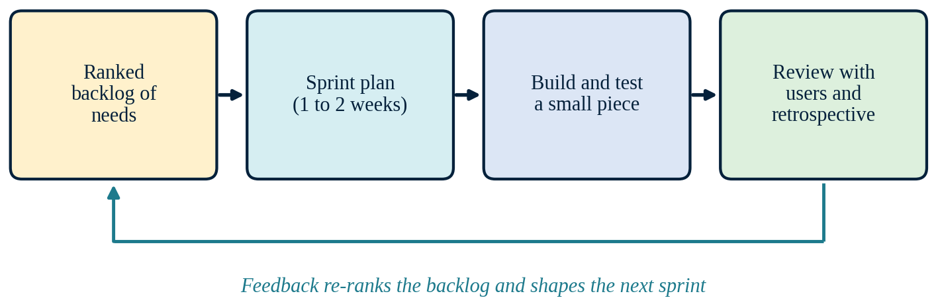
Note. Created by the author, based on Thesing et al. (2021) and Shidende and Moebs (2025).

Example
Background. Our Algebra 1 students needed an online review course in our learning management system before the end-of-course test. I did not know which topics they needed most, and I had little time, so I used an agile approach.
- Backlog: I ranked review topics using benchmark results. Linear functions and systems of equations came out on top.
- Sprint 1: In one week, I built a linear functions module with a short video lesson, 10 practice problems, and automatic grading.
- Review: Twenty students completed the module. A two-question survey showed that the video helped, but 10 problems were too many for one sitting.
- Adjustment: I split the practice into two sets of five and started systems of equations in Sprint 2.
- Repeat: Each week, I released a new module and re-ranked the backlog based on scores and student comments.
Reflection. By test time, students had six modules built around what they actually needed, not around my guesses in August.

Reference(s)
Shidende, D., & Moebs, S. (2025). Integrating design-based research and agile Scrum for inclusive educational technology design: Best practices and challenges from an accessible augmented reality learning authoring tool project. Multimedia, 1(2), Article 6. https://doi.org/10.3390/multimedia1020006
Thesing, T., Feldmann, C., & Burchardt, M. (2021). Agile versus waterfall project management: Decision model for selecting the appropriate approach to a project. Procedia Computer Science, 181, 746–756. https://doi.org/10.1016/j.procs.2021.01.227

SAM | Successive Approximation Model
The Successive Approximation Model (SAM) is an iterative approach to instructional design. Instead of long planning, SAM starts with a quick, rough draft and improves it in each round. It has three phases. The preparation phase gathers background information and ends with a Savvy Start, a short meeting where designers, subject experts, and learners sketch ideas together. The iterative design phase cycles through design, prototype, and review. In the iterative development phase, the product is built in alpha, beta, and gold versions, and each version is tested with learners.
Iskandar et al. (2022) used SAM to develop digital media for project-based learning and found the process time-efficient and flexible. Looking across online learning research, Özkan et al. (2025) describe a shift away from linear models toward adaptive, learner-centered ones, and SAM’s repeated cycles fit that trend. Figure 11 maps the three phases and the loops within them.
Figure 11
Phases of the Successive Approximation Model
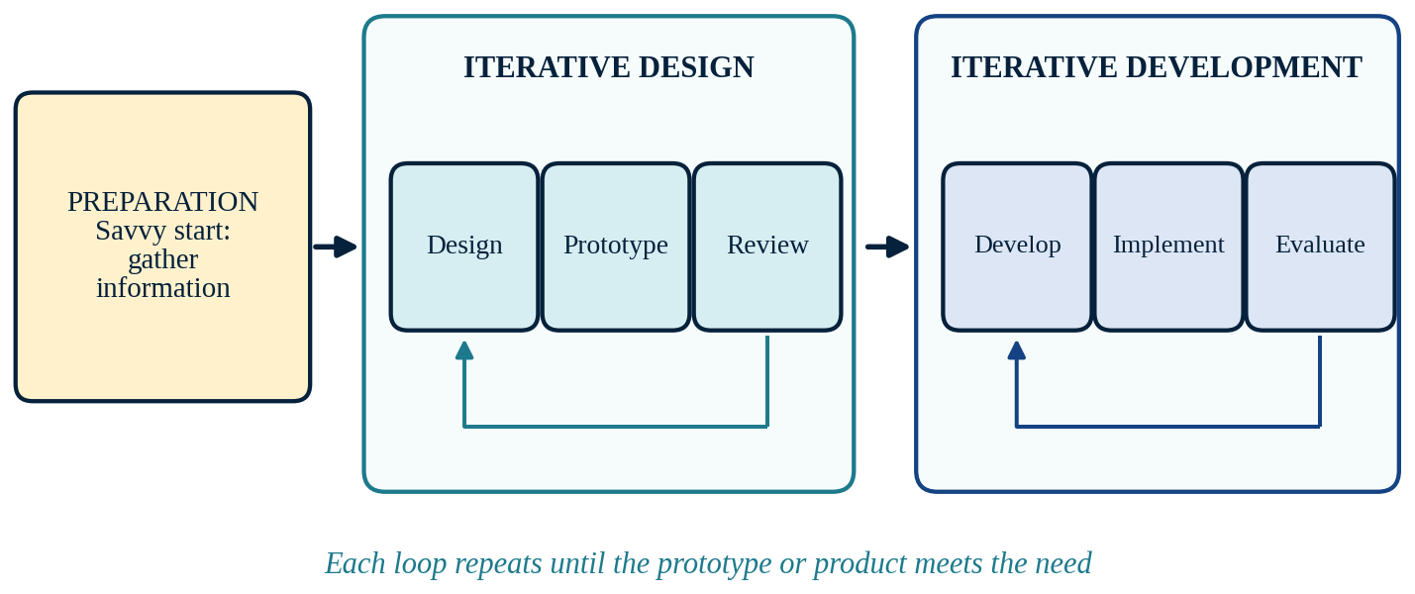
Note. Created by the author, based on Iskandar et al. (2022) and Özkan et al. (2025).

Example
Background. Many of my students miss class often, so I decided to teach quadratic functions through short videos. I had never made instructional videos before.
- Preparation and Savvy Start: I met with a colleague and three students for about 30 minutes. The students said they watch videos on their phones and usually stop after about five minutes. Together we sketched a storyboard for one video on finding the vertex.
- Design iteration: I recorded a rough four-minute draft on my phone. Three students watched it and paused whenever they got confused. Two of them stopped at the same spot, so I redrew that part of the storyboard.
- Beta version: I re-recorded the video with captions and used it with one class. Exit slips showed that students could find the vertex.
- Gold version: I repeated the same steps for four more videos, then posted the full set for all my classes.
Reflection. My first draft was far from perfect, and it did not need to be. Each round brought the videos closer to what my students needed.

Reference(s)
Iskandar, H., Koto, I., Yulanto, D. M., & Marlan, M. (2022). Instructional design of successive approximations model (SAM) for project-based learning media development. In Proceedings of the 4th International Conference on Innovation in Education, Science and Culture (ICIESC 2022). EAI. https://doi.org/10.4108/eai.11-10-2022.2325511
Özkan, A., Çevik, İ., Saylan, E., & Çakıroğlu, Ü. (2025). The past and present of instructional design in online learning: Trends and emerging directions. International Review of Research in Open and Distributed Learning, 26(3), 126–148. https://doi.org/10.19173/irrodl.v26i3.8507

SAMR | Substitution, Augmentation, Modification, and Redefinition
SAMR helps teachers think about how technology changes a learning task. It has four levels. At the substitution level, technology simply replaces a tool, and the task stays the same. Augmentation adds a useful improvement, such as instant feedback. Modification redesigns a large part of the task, and redefinition makes possible tasks that could not happen without the technology.
In a scoping review of research that applied SAMR, Blundell et al. (2022) found that studies mostly used the model to classify what teachers and students do with technology. They also noted that SAMR does not account for context or teachers’ prior experience, so the same activity can be placed at different levels in different studies. Boonmoh and Kulavichian (2023) observed that most of the pre-service teachers they studied stayed at substitution and augmentation, largely because of limited equipment and unfamiliarity with the tools. For these reasons, I treat SAMR as a tool for reflection rather than a ladder every lesson must climb (see Figure 12).
Figure 12
The Four Levels of the SAMR Model
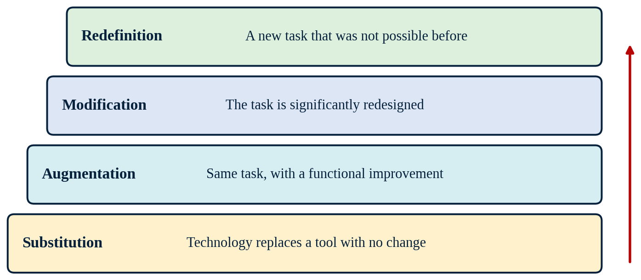
Note. Created by the author, based on Blundell et al. (2022) and Boonmoh and Kulavichian (2023).

Example
Context. In our probability unit, students compare experimental and theoretical probability. With paper tallies and real coins, a class can only collect a few hundred flips, which is not enough to see the pattern settle. SAMR helped me plan how technology could solve that problem.
- Substitution: Students record coin flips in a spreadsheet instead of on paper. The task itself does not change.
- Augmentation: The spreadsheet calculates and graphs the cumulative relative frequency as students enter data.
- Modification: Students use an online simulator to run 10,000 flips in seconds and compare results across the class.
- Redefinition: Students design a probability game for our school’s family night, test its fairness with the simulator, and present their evidence to families.
Reflection. Not every lesson needs to reach redefinition. As Blundell et al. (2022) point out, context matters. Some of my students do not have internet at home, so we run simulations in class, and I keep printed data sets ready when needed.

Reference(s)
Blundell, C. N., Mukherjee, M., & Nykvist, S. (2022). A scoping review of the application of the SAMR model in research. Computers and Education Open, 3, Article 100093. https://doi.org/10.1016/j.caeo.2022.100093
Boonmoh, A., & Kulavichian, I. (2023). Exploring Thai EFL pre-service teachers’ technology integration based on SAMR model. Contemporary Educational Technology, 15(4), Article ep457. https://doi.org/10.30935/cedtech/13567

Waterfall
The waterfall model moves through five phases in a fixed order: requirements, design, implementation, verification, and maintenance. Each phase must be finished before the next one begins. The weakness of this model is that mistakes found late are hard and costly to fix, because earlier phases are already closed.
According to Thesing et al. (2021), waterfall works best when a project’s requirements are clear and unlikely to change. Özkan et al. (2025) note that instructional design for online learning has moved away from strictly linear models. Still, a sequential plan like the one in Figure 13 makes sense when the rules of a project are fixed from the start.
Figure 13
Sequential Phases of the Waterfall Model
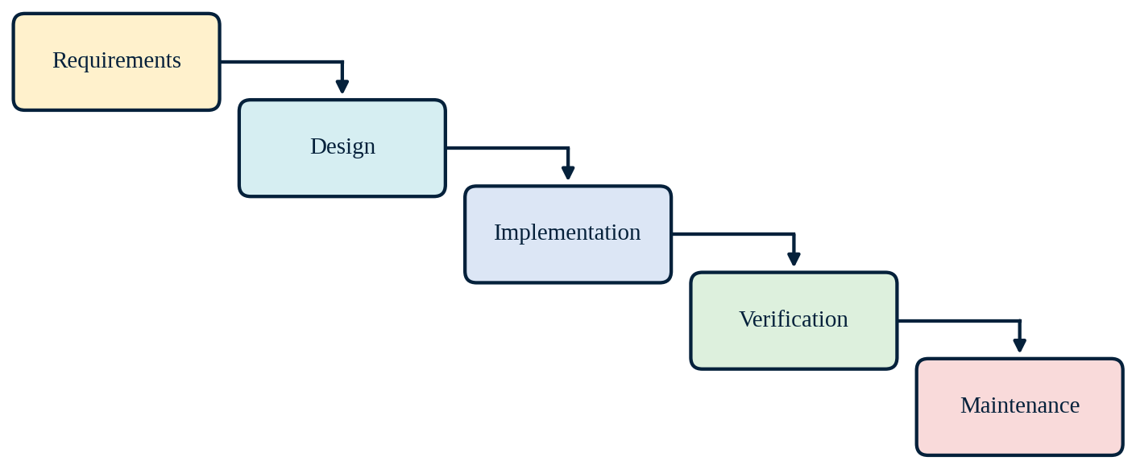
Note. Created by the author, based on Thesing et al. (2021) and Özkan et al. (2025).

Example
Context. Every year, our Algebra 2 students take a common end-of-year test. The standards, testing dates, and accommodations are set before the school year begins and do not change, which makes this project a good fit for the waterfall model.
- Requirements: Our team decides which standards to assess, how many items each standard gets, and which accommodations are needed.
- Design: We plan the item formats, scoring, and difficulty levels in a test blueprint.
- Implementation: Each teacher writes questions for assigned standards, and one teacher assembles the full test.
- Verification: Two teachers take the test and check every question against the blueprint and answer key.
- Maintenance: After the test, we review item results, note problem areas, and leave records for next year’s team.
Conclusion. Waterfall worked here because the requirements were clear from the start. It would not have worked for my online review course, where the needs changed every week.

Reference(s)
Özkan, A., Çevik, İ., Saylan, E., & Çakıroğlu, Ü. (2025). The past and present of instructional design in online learning: Trends and emerging directions. International Review of Research in Open and Distributed Learning, 26(3), 126–148. https://doi.org/10.19173/irrodl.v26i3.8507
Thesing, T., Feldmann, C., & Burchardt, M. (2021). Agile versus waterfall project management: Decision model for selecting the appropriate approach to a project. Procedia Computer Science, 181, 746–756. https://doi.org/10.1016/j.procs.2021.01.227

ADDIE | Analysis, Design, Development, Implementation, and Evaluation
ADDIE stands for analysis, design, development, implementation, and evaluation. Instructional designers use it as a general framework for planning instruction, and many newer models grew out of it. Analysis identifies the learners, the performance gap, and the constraints. Design sets goals, assessments, and teaching methods. Development produces the materials, and implementation delivers the instruction. Evaluation happens both during the process (formative) and at the end (summative), and its findings feed back into earlier phases, as the return arrow in Figure 14 indicates.
Spatioti et al. (2022) compared studies that used ADDIE in distance education. The model supported learning in many online settings, especially when designers built in multimedia, feedback, interaction, collaboration, and active instructor involvement. Özkan et al. (2025) describe ADDIE as the traditional foundation that newer, more adaptive models build on.
Figure 14
The Five Phases of ADDIE
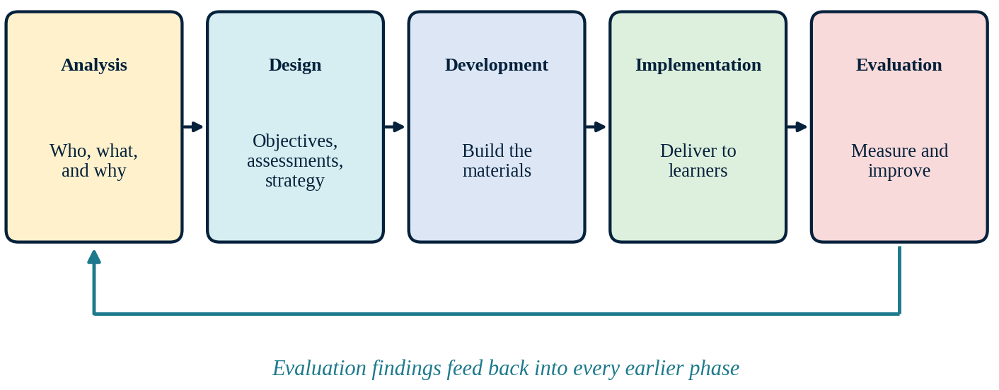
Note. Created by the author, based on Spatioti et al. (2022) and Özkan et al. (2025).

Example
Background. Some juniors at my school take the ACT in the spring, and their math scores are too low for college placement. Our counselor asked me to design a six-week ACT math prep program.
- Analysis: I reviewed students’ practice tests. Most errors were in geometry and word problems, not algebra. Students could also attend only twice a week.
- Design: The goal was a two-point gain on the practice test. Each session would open with a warm-up, teach one strategy, and end with ten practice problems.
- Development: I wrote twelve lesson plans, one for each question type, plus a strategy reference chart.
- Implementation: I ran the program for six weeks with 24 students.
- Evaluation: Weekly quizzes guided small changes, such as adding more geometry figures. I also surveyed students at the start and end about which study strategies helped most.
Reflection. The analysis phase kept me from reteaching algebra skills my students already had. The evaluation results will shape next year’s program.

Reference(s)
Özkan, A., Çevik, İ., Saylan, E., & Çakıroğlu, Ü. (2025). The past and present of instructional design in online learning: Trends and emerging directions. International Review of Research in Open and Distributed Learning, 26(3), 126–148. https://doi.org/10.19173/irrodl.v26i3.8507
Spatioti, A. G., Kazanidis, I., & Pange, J. (2022). A comparative study of the ADDIE instructional design model in distance education. Information, 13(9), Article 402. https://doi.org/10.3390/info13090402

Cognitive Load
Module 3

Cognitive Load Theory
Cognitive load theory explains how the limits of working memory shape learning. Working memory can hold and process only a few new elements at a time, and only for a short time. Long-term memory, on the other hand, has no known limit. Learning happens when new information is organized into schemas and stored in long-term memory (Sweller, 2023). When a lesson asks for more processing than working memory can handle, learning breaks down.
The theory describes three types of load, and all three draw on the same limited working memory (Figure 15). Intrinsic load comes from the difficulty of the content itself and depends on what the learner already knows. Extraneous load is wasted effort caused by poor design, such as cluttered slides or confusing directions. Germane load is the productive effort learners spend building schemas. Krieglstein et al. (2023) developed and validated a questionnaire that measures these three types separately. Hanham et al. (2023) show how cognitive load theory is now being combined with other theories, within and beyond educational psychology, which widens its use.
Figure 15
Three Types of Cognitive Load
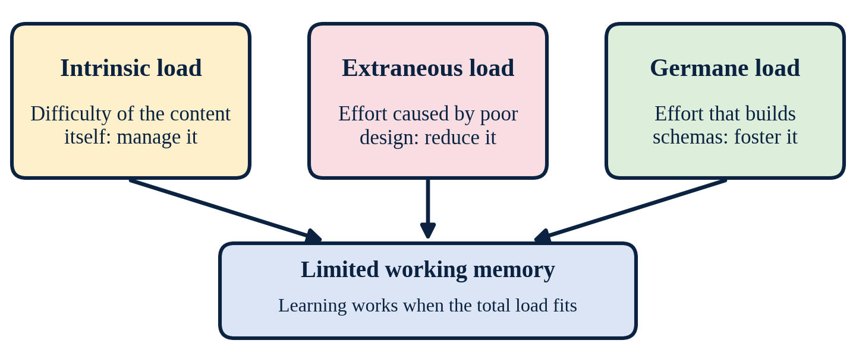
Note. Created by the author, based on Sweller (2023) and Krieglstein et al. (2023).

Example
Context. Our school is moving to a new online gradebook, and I was asked to train my math colleagues. Many of them are busy and anxious about the change.
I planned the session around the three types of load:
- Intrinsic load: I matched each new menu to a feature teachers already knew in the old gradebook, so the new system felt familiar.
- Extraneous load: I removed extra screenshots and alerts from my slides and used one simple callout per step.
- Germane load: Teachers worked in pairs to set up their own real grading categories during the session.
Reflection. By controlling the load, I kept the session short and practical. Most teachers left with their gradebooks already set up.

Reference(s)
Hanham, J., Castro-Alonso, J. C., & Chen, O. (2023). Integrating cognitive load theory with other theories, within and beyond educational psychology. British Journal of Educational Psychology, 93(S2), 239–250. https://doi.org/10.1111/bjep.12612
Krieglstein, F., Beege, M., Rey, G. D., Sanchez-Stockhammer, C., & Schneider, S. (2023). Development and validation of a theory-based questionnaire to measure different types of cognitive load. Educational Psychology Review, 35(1), Article 9. https://doi.org/10.1007/s10648-023-09738-0
Sweller, J. (2023). The development of cognitive load theory: Replication crises and incorporation of other theories can lead to theory expansion. Educational Psychology Review, 35(4), Article 95. https://doi.org/10.1007/s10648-023-09817-2

Managing Cognitive Load

Multimedia Principle
The multimedia principle states that people learn better from words and pictures together than from words alone. It rests on the idea that the mind has two channels, one for words and one for images (see Figure 16). When both channels carry related information, learners can build connections between them (Mayer, 2024). The pictures must teach, not decorate. A graph that shows the idea helps; a clip-art image does not. Noetel et al. (2022) reviewed decades of meta-analyses and found solid support for several multimedia design principles, with the largest benefits for signaling and for placing related words and pictures close together in space and time.
Figure 16
The Dual-Channel Model Behind the Multimedia Principle
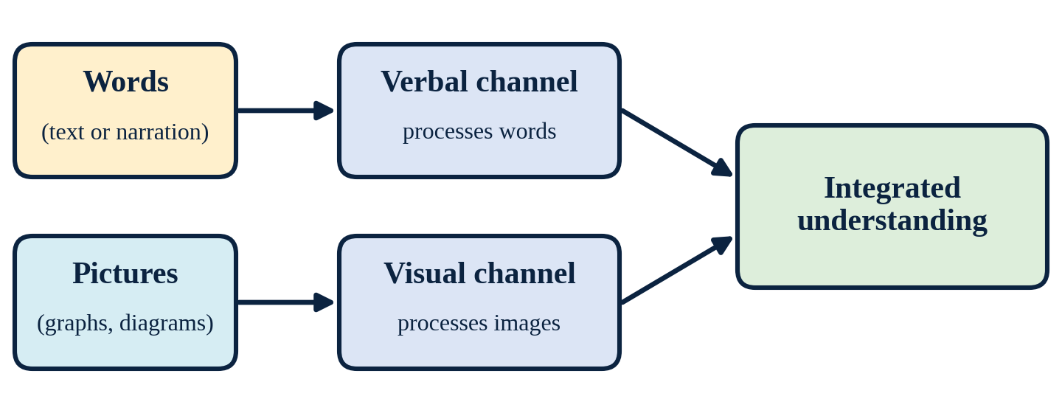
Note. Created by the author, based on Mayer (2024) and Noetel et al. (2022).

Example
Context. My students often copy the steps for finding the vertex of a parabola but cannot picture what the vertex is.
Application. I replaced my text-only slide with a clean graph of y = (x − h)² + k. Short labels sit right next to the vertex point and the values of h and k. As I change h and k in Desmos, students watch the vertex move while reading the matching words.
Reflection. Students now describe the vertex with both words and the graph. The picture carries the meaning, and the words name it.

Reference(s)
Mayer, R. E. (2024). The past, present, and future of the cognitive theory of multimedia learning. Educational Psychology Review, 36, Article 8. https://doi.org/10.1007/s10648-023-09842-1
Noetel, M., Griffith, S., Delaney, O., Harris, N. R., Sanders, T., Parker, P., del Pozo Cruz, B., & Lonsdale, C. (2022). Multimedia design for learning: An overview of reviews with meta-meta-analysis. Review of Educational Research, 92(3), 413–454. https://doi.org/10.3102/00346543211052329

Signaling
Signaling means adding cues that point learners to the most important information. Cues can be color, arrows, outlines, headings, or spoken phrases such as “notice this sign,” and several are pictured in Figure 17. Signals do not add new content. They reduce extraneous load because learners spend less effort searching the page. Noetel et al. (2022) found signaling to be one of the multimedia principles with the largest benefits. In an eye-tracking study, Rodemer et al. (2022) showed that dynamic signals in instructional videos helped students focus on the right parts of complex representations, improved retention, and lowered extraneous load.
Figure 17
Common Signaling Cues
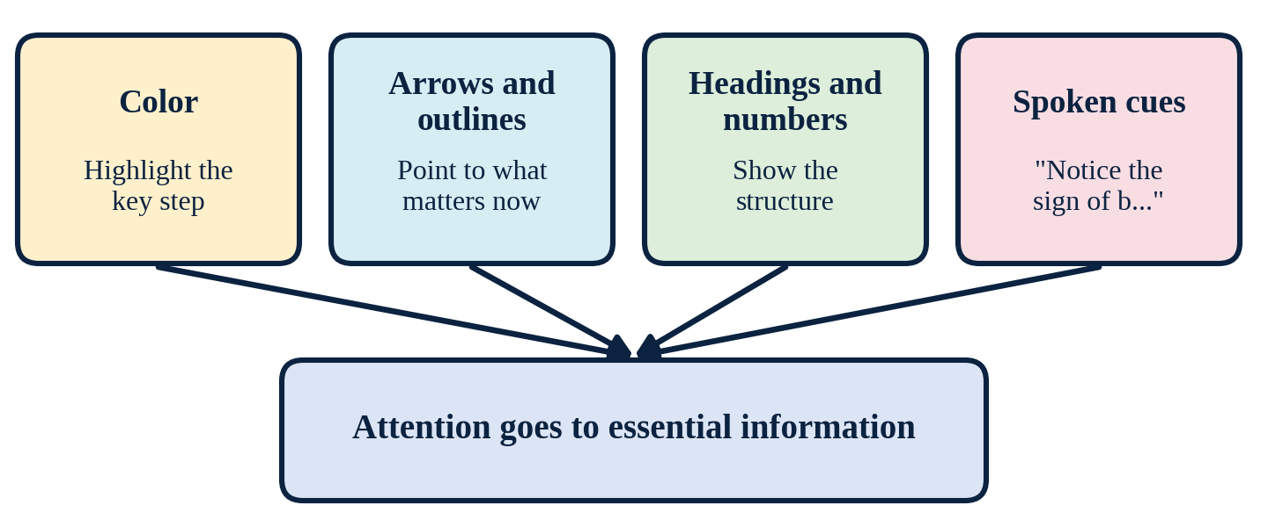
Note. Created by the author, based on Noetel et al. (2022) and Rodemer et al. (2022).

Example
Context. When students use the quadratic formula, many make errors inside the square root.
Application. On the board, I draw a red box around b² − 4ac and say, “Start here.” Each worked example uses the same red box. Students learn to compute the discriminant first, before anything else.
Reflection. The red box costs nothing to add, yet errors inside the square root dropped. The cue told students where to look first.

Reference(s)
Noetel, M., Griffith, S., Delaney, O., Harris, N. R., Sanders, T., Parker, P., del Pozo Cruz, B., & Lonsdale, C. (2022). Multimedia design for learning: An overview of reviews with meta-meta-analysis. Review of Educational Research, 92(3), 413–454. https://doi.org/10.3102/00346543211052329
Rodemer, M., Lindner, M. A., Eckhard, J., Graulich, N., & Bernholt, S. (2022). Dynamic signals in instructional videos support students to navigate through complex representations: An eye-tracking study. Applied Cognitive Psychology, 36(4), 852–863. https://doi.org/10.1002/acp.3973

Chunking
Chunking breaks complex material into small, meaningful units that learners handle one at a time (Figure 18). In multimedia research, the related idea is segmenting, which splits a lesson or video into learner-paced parts. Chunking manages intrinsic load because working memory never has to hold the whole task at once. Seidel (2024) reviewed research on learning videos and argued that dividing longer videos into meaningful segments with navigation supports learning. Herman et al. (2026) found that segmented instruction in a 3D learning environment improved far transfer and reduced cognitive load.
Figure 18
Breaking a Multi-Step Problem Into Chunks
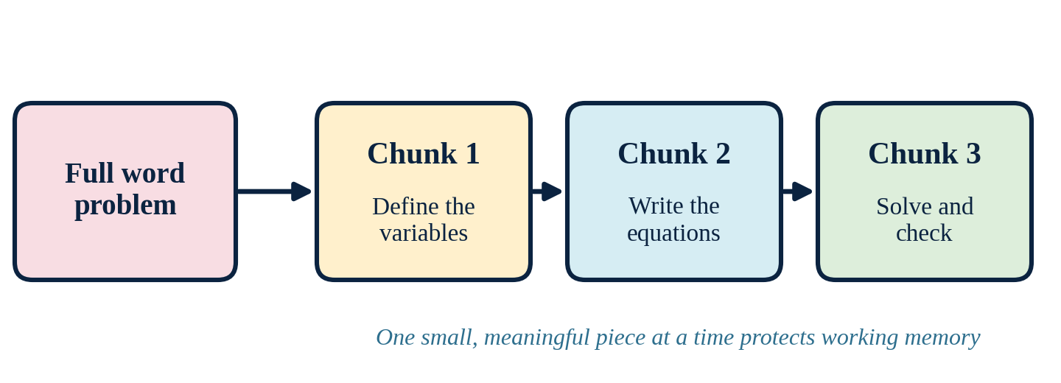
Note. Created by the author, based on Seidel (2024) and Herman et al. (2026).

Example
Context. Word problems with systems of equations overwhelm many of my students. They see a long paragraph and give up.
Application. I no longer show the whole problem at once. The first slide asks students only to name the variables. The second slide builds one equation, and the third builds the other. The last slide asks them to solve and check. Students finish each chunk before moving on.
Reflection. More students now reach the solving step. Each chunk is small enough to feel possible.

Reference(s)
Herman, K., Yang, M., Shifflet, J., & Glaser, N. (2026). Impacts of segmenting principle on learner performance and attitude in a 3D environment: A mixed-method multiple case study. Journal of Computing in Higher Education, 38(3), 1107–1134. https://doi.org/10.1007/s12528-025-09484-y
Seidel, N. (2024). Short, long, and segmented learning videos: From YouTube practice to enhanced video players. Technology, Knowledge and Learning, 29(4), 1965–1991. https://doi.org/10.1007/s10758-024-09745-2

Visual Cognitive Load/C-R-A-P
C-R-A-P stands for four visual design principles: contrast, repetition, alignment, and proximity, summarized in Figure 19. Contrast makes key elements stand out. Repetition keeps fonts, colors, and icons consistent so learners know where to look. Alignment places items on a clear grid. Proximity keeps related items close together. These principles reduce extraneous load by making a page easy to scan. Proximity matches the spatial contiguity principle, which Noetel et al. (2022) found to have one of the largest benefits in multimedia learning. Visual features such as color and shape can also affect motivation, but Désiron et al. (2026) warn that their effects vary across studies, so they should support the content, not distract from it.
Figure 19
The Four C-R-A-P Design Principles
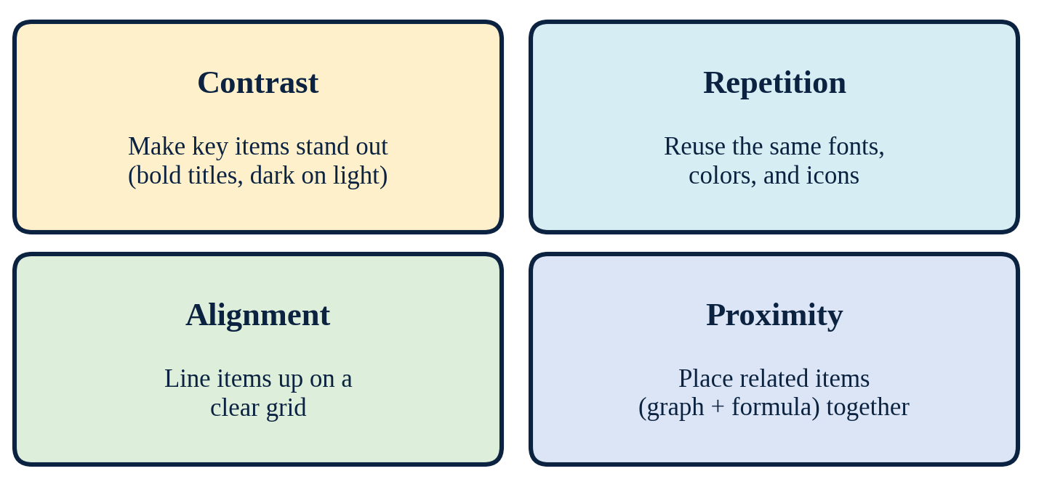
Note. Created by the author, based on Noetel et al. (2022) and Désiron et al. (2026).

Example
Context. My Algebra 2 formula sheet was a crowded page of equations in different fonts. Students struggled to find what they needed during tests.
I redesigned it using the four principles:
- Contrast: Formulas appear in bold navy text on a white background.
- Repetition: Every example box uses the same icon and border.
- Alignment: All formulas line up on one left edge.
- Proximity: Each formula sits right next to a small graph of the function it describes.
Reflection. Students now find formulas faster, and the sheet looks calm instead of crowded.

Reference(s)
Désiron, J. C., Venni, J., & Bétrancourt, M. (2026). Mapping the heterogeneity of emotional design features in multimedia research: A systematic review. Educational Psychology Review, 38, Article 36. https://doi.org/10.1007/s10648-026-10138-3
Noetel, M., Griffith, S., Delaney, O., Harris, N. R., Sanders, T., Parker, P., del Pozo Cruz, B., & Lonsdale, C. (2022). Multimedia design for learning: An overview of reviews with meta-meta-analysis. Review of Educational Research, 92(3), 413–454. https://doi.org/10.3102/00346543211052329

Strategies for Student Learning

Scaffolding
Scaffolding is temporary support that helps learners complete a task they cannot yet do alone. Supports can include worked examples, prompts, hints, and teacher questions. The key feature is fading: support is removed step by step as students gain skill, until they work independently, as the shrinking supports in Figure 20 suggest. Thomann and Deutscher (2025) analyzed 68 experimental studies on prompts in digital learning. Prompts improved achievement, and high school students benefited most, but effects depended on careful design. Kaldaras et al. (2024) found that simulation feedback worked best when combined with deliberate teacher scaffolding.
Figure 20
Fading Scaffolds Toward Independence
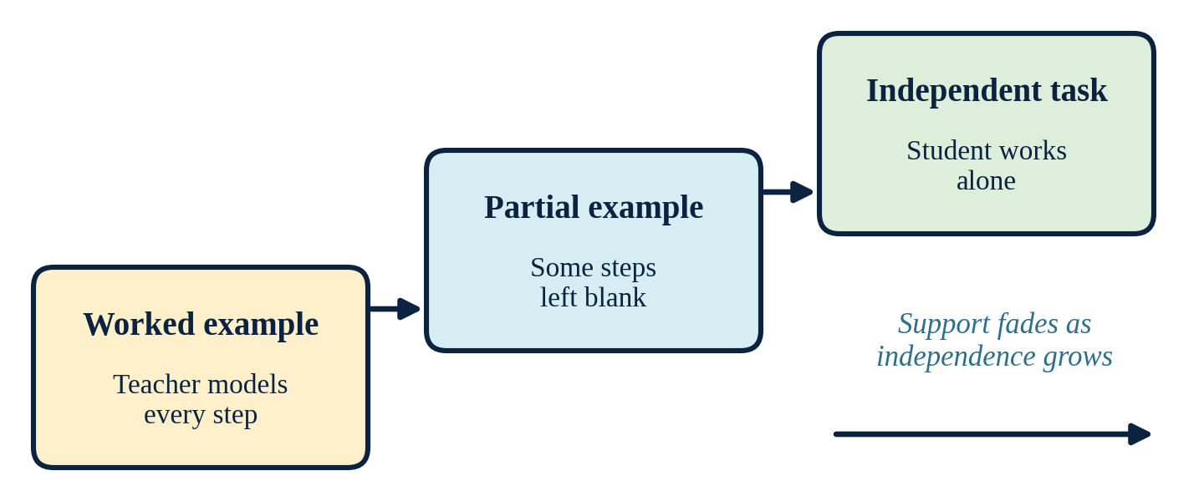
Note. Created by the author, based on Thomann and Deutscher (2025) and Kaldaras et al. (2024).

Example
Context. Factoring trinomials is hard for many of my Algebra 2 students.
I plan three stages of support:
- Worked example: I solve one trinomial with the area model, explaining each step aloud.
- Partial example: Students receive area models with the boxes drawn but some numbers missing.
- Independent task: Students factor on a blank grid, with a hint card available only if they ask.
Reflection. By the end of the week, most students no longer request the hint card. That tells me it is time to remove it.

Reference(s)
Kaldaras, L., Wang, K. D., Nardo, J. E., Price, A., Perkins, K., Wieman, C., & Salehi, S. (2024). Employing technology-enhanced feedback and scaffolding to support the development of deep science understanding using computer simulations. International Journal of STEM Education, 11, Article 30. https://doi.org/10.1186/s40594-024-00490-7
Thomann, H., & Deutscher, V. (2025). Scaffolding through prompts in digital learning: A systematic review and meta-analysis of effectiveness on learning achievement. Educational Research Review, 47, Article 100686. https://doi.org/10.1016/j.edurev.2025.100686

Levels of Challenge
Levels of challenge means offering tasks at different difficulty levels so every student works in a range that is hard but possible. This idea comes from differentiated instruction and from Vygotsky’s zone of proximal development. Bahurudin Setambah et al. (2025) reviewed studies on differentiated mathematics instruction and found that most focus on adapting teaching methods to students’ needs. How the levels are presented also matters. Herset et al. (2023) found that lower secondary students reported lower self-efficacy when tasks were labeled as “difficult.” Neutral labels can protect confidence while still offering challenge, as in the three-path design in Figure 21.
Figure 21
Three Paths Toward One Learning Goal
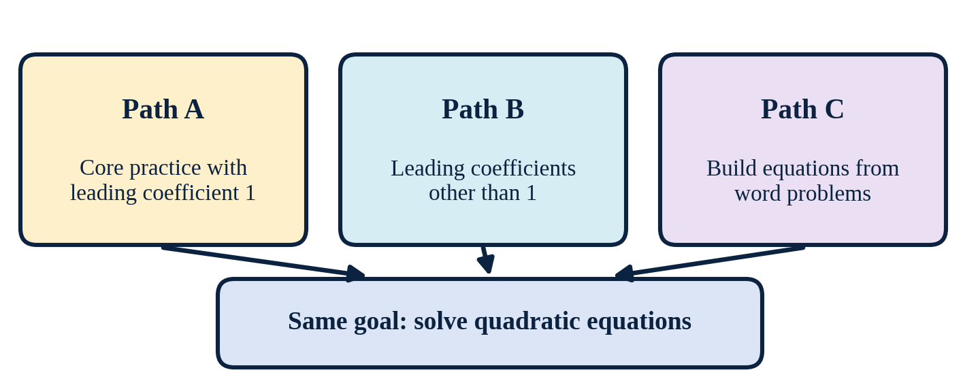
Note. Created by the author, based on Bahurudin Setambah et al. (2025) and Herset et al. (2023).

Example
Context. In my quadratic equations unit, some students still need basic practice while others are ready for harder problems.
Application. I created a choice board with three paths, labeled A, B, and C instead of “easy” and “hard.” Path A has equations with a leading coefficient of 1. Path B has leading coefficients other than 1. Path C asks students to write and solve equations from word problems. Students can move to another path at any time.
Reflection. Because no path is called “hard,” more students try Path B or C. Everyone works toward the same goal.

Reference(s)
Bahurudin Setambah, M. A., Mat Saad, M. I., Che Md Ghazali, N. H., & Adnan, M. (2025). A comprehensive synthesis of differentiated instruction approaches in mathematics. LUMAT: International Journal on Math, Science and Technology Education, 12(4), Article 3. https://doi.org/10.31129/LUMAT.12.4.2371
Herset, M., El Ghami, M., & Bjerke, A. H. (2023). The effect of level-marked mathematics tasks on students’ self-efficacy: An experimental study. Frontiers in Psychology, 14, Article 1116386. https://doi.org/10.3389/fpsyg.2023.1116386

Active Learning
Active learning asks students to do something with new content, such as solve, discuss, explain, or compare, instead of only listening. Short cycles of individual thinking and peer discussion, like the think-pair-share loop in Figure 22, help students catch their own misconceptions. Kozanitis and Nenciovici (2023) analyzed 104 studies and found that students under active instruction scored about half a standard deviation higher than students in traditional lectures. For secondary mathematics, Du et al. (2025) found that students’ enjoyment and their teachers’ beliefs were the strongest predictors of active participation.
Figure 22
A Think-Pair-Share Loop
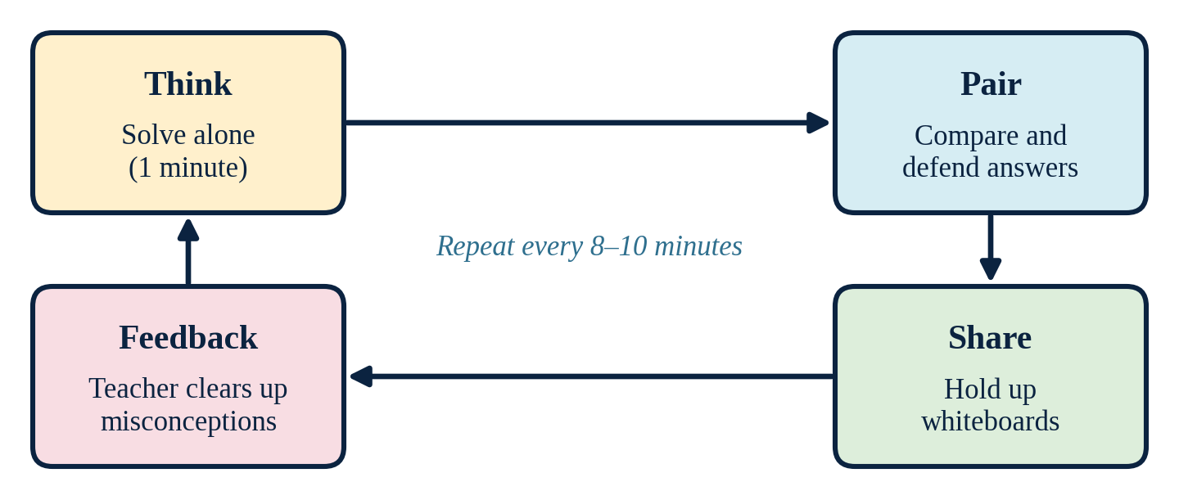
Note. Created by the author, based on Kozanitis and Nenciovici (2023) and Du et al. (2025).

Example
Context. Long explanations of matrix operations lose my students after a few minutes.
Application. I now teach in eight-minute blocks. After each block, I post one problem. Students solve it alone for a minute, then compare with a partner and agree on an answer. Everyone holds up mini-whiteboards at the same time, and I address any errors right away.
Reflection. The pauses turn listening into doing. I also see every student’s thinking several times per class.

Reference(s)
Du, W., Wijaya, T. T., Cao, Y., & Li, X. (2025). What factors influence secondary students’ active participation in mathematics classrooms: A theory of planned behavior perspective. Acta Psychologica, 253, Article 104694. https://doi.org/10.1016/j.actpsy.2025.104694
Kozanitis, A., & Nenciovici, L. (2023). Effect of active learning versus traditional lecturing on the learning achievement of college students in humanities and social sciences: A meta-analysis. Higher Education, 86(6), 1377–1394. https://doi.org/10.1007/s10734-022-00977-8

Problem-Solving Tasks
Problem-solving tasks place mathematics inside real situations that are not solved by a single routine step. Students must decide what matters, build a model, solve it, and check whether the answer makes sense. This process is often called the modelling cycle (Figure 23). Vogelsanger-Holenstein et al. (2025) found that teaching students a structured solution plan for modelling problems improved their modelling skills right away and three months later. Kohen (2025) showed that secondary students could complete the full modelling cycle within normal lesson time when tasks were structured and set in an authentic engineering context.
Figure 23
The Mathematical Modelling Cycle
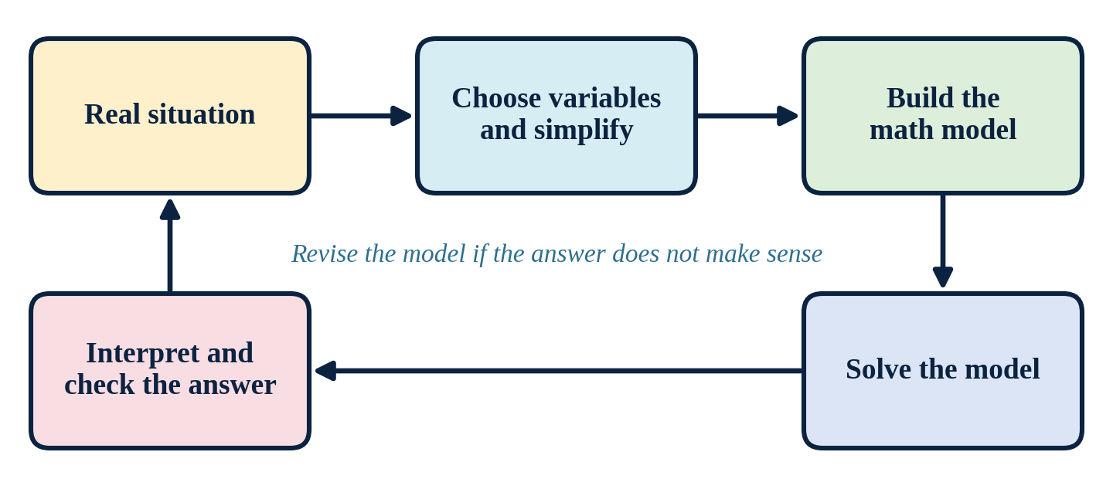
Note. Created by the author, based on Vogelsanger-Holenstein et al. (2025) and Kohen (2025).

Example
Context. My students ask why quadratic functions matter outside school.
Application. I built a project around ticket pricing for a local event. Students receive data showing how attendance drops as the price rises. They choose variables, write a revenue model in the form R(x) = x(a − bx), find the maximum, and check if the price is realistic. Each group follows a printed solution plan and presents its recommended price.
Reflection. The solution plan keeps groups from getting lost, and the real context gives the vertex a clear meaning: the best price.

Reference(s)
Kohen, Z. (2025). Structured mathematical modelling in an authentic scientific-engineering context. ZDM – Mathematics Education, 57(2), 317–332. https://doi.org/10.1007/s11858-025-01654-7
Vogelsanger-Holenstein, M., Schukajlow, S., & Bruckmaier, G. (2025). Mathematical modelling and self-efficacy: Immediate and long-lasting effects of teaching mathematical modelling with a solution plan. ZDM – Mathematics Education, 57(2), 489–502. https://doi.org/10.1007/s11858-025-01674-3

