Examen 2 – Tópicos Avanzados de Base de Datos
Laura Londoño – 316613
13 de octubre de 2026
Consulta 1:
Plan de ejecución en texto:
QUERY PLAN
Sort (cost=1244.01..1257.26 rows=5300 width=60) (actual time=86.300..86.307 rows=101.00 loops=1)
Sort Key: (count(DISTINCT e.id_usuario)) DESC, b.codigo
Sort Method: quicksort Memory: 33kB
Buffers: shared hit=1646 read=287 dirtied=210
-> GroupAggregate (cost=9.26..916.16 rows=5300 width=60) (actual time=11.552..86.198 rows=101.00 loops=1)
Group Key: b.codigo, o.nombre
Buffers: shared hit=1640 read=287 dirtied=210
-> Incremental Sort (cost=9.26..823.41 rows=5300 width=56) (actual time=10.750..85.185 rows=5035.00 loops=1)
Sort Key: b.codigo, o.nombre, e.id_usuario
Presorted Key: b.codigo
Full-sort Groups: 100 Sort Method: quicksort Average Memory: 29kB Peak Memory: 29kB
Pre-sorted Groups: 6 Sort Method: quicksort Average Memory: 31kB Peak Memory: 31kB
Buffers: shared hit=1640 read=287 dirtied=210
-> Nested Loop (cost=2.15..605.48 rows=5300 width=56) (actual time=6.505..82.992 rows=5035.00 loops=1)
Join Filter: (b.id = e.id_brecha)
Buffers: shared hit=1637 read=287 dirtied=210
-> Nested Loop (cost=1.86..358.50 rows=106 width=60) (actual time=6.487..78.088 rows=101.00 loops=1)
Buffers: shared hit=1329 read=277 dirtied=210
-> Nested Loop Semi Join (cost=1.71..342.06 rows=106 width=47) (actual time=6.462..77.424 rows=101.00 loops=1)
Buffers: shared hit=1225 read=277 dirtied=210
-> Index Scan using uq_brechas_codigo on brechas b (cost=0.28..98.26 rows=106 width=43) (actual time=3.617..7.095 rows=101.00 loops=1)
Filter: (((severidad)::text = ANY ('{Alta,Critica}'::text[])) AND (fecha_deteccion >= ((CURRENT_DATE - '1 year'::interval))::date))
Rows Removed by Filter: 699
Index Searches: 1
Buffers: shared hit=713 read=16 dirtied=10
-> Hash Join (cost=1.44..13.41 rows=10 width=4) (actual time=0.695..0.695 rows=1.00 loops=101)
Hash Cond: (e2.id_tipo_dato = t.id)
Buffers: shared hit=512 read=261 dirtied=200
-> Index Scan using idx_exposiciones_id_brecha_id_usuario on exposiciones e2 (cost=0.29..12.07 rows=50 width=8) (actual time=0.155..0.690 rows=5.65 loops=101)
Index Cond: (id_brecha = b.id)
Index Searches: 101
Buffers: shared hit=511 read=261 dirtied=200
-> Hash (cost=1.12..1.12 rows=2 width=4) (actual time=0.021..0.022 rows=2.00 loops=1)
Buckets: 1024 Batches: 1 Memory Usage: 9kB
Buffers: shared hit=1
-> Seq Scan on tipos_dato t (cost=0.00..1.12 rows=2 width=4) (actual time=0.016..0.017 rows=2.00 loops=1)
Filter: ((categoria_sensibilidad)::text = 'Critica'::text)
Rows Removed by Filter: 8
Buffers: shared hit=1
-> Memoize (cost=0.15..0.28 rows=1 width=21) (actual time=0.005..0.005 rows=1.00 loops=101)
Cache Key: b.id_organizacion
Cache Mode: logical
Hits: 49 Misses: 52 Evictions: 0 Overflows: 0 Memory Usage: 7kB
Buffers: shared hit=104
-> Index Scan using pk_organizaciones on organizaciones o (cost=0.14..0.27 rows=1 width=21) (actual time=0.005..0.005 rows=1.00 loops=52)
Index Cond: (id = b.id_organizacion)
Index Searches: 52
Buffers: shared hit=104
-> Index Only Scan using idx_exposiciones_id_brecha_id_usuario on exposiciones e (cost=0.29..1.71 rows=50 width=8) (actual time=0.005..0.042 rows=49.85 loops=101)
Index Cond: (id_brecha = e2.id_brecha)
Heap Fetches: 0
Index Searches: 101
Buffers: shared hit=308 read=10
Planning:
Buffers: shared hit=389 read=44 dirtied=15
Planning Time: 43.660 ms
Execution Time: 86.520 ms

Árbol de operaciones del plan de ejecución: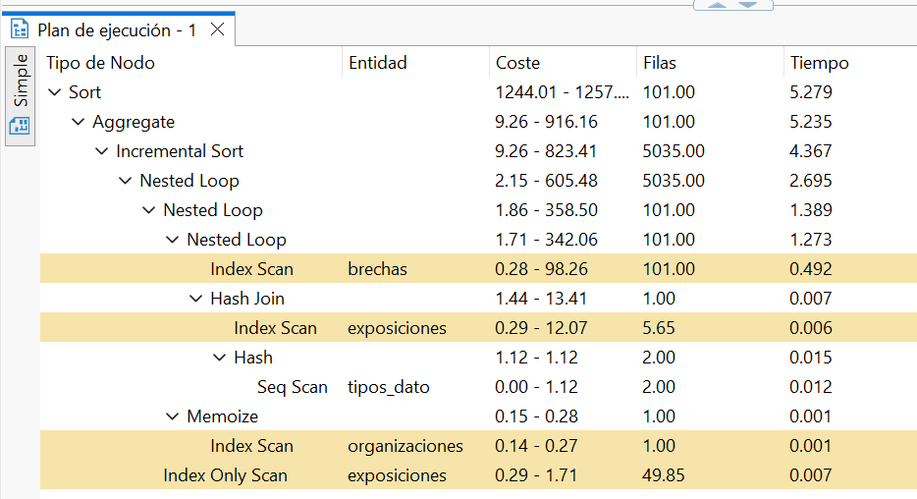
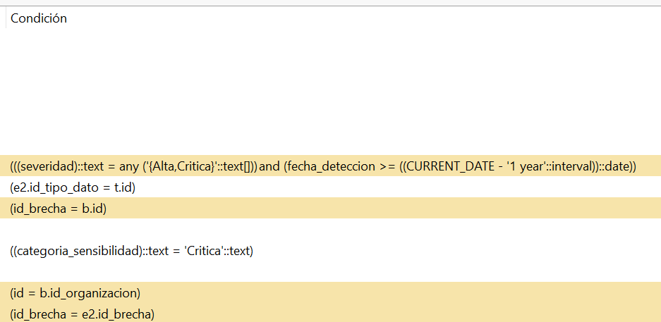
Registros Resultantes:
-- 1.a Resultado
SELECT o.nombre AS organizacion,
b.codigo AS codigo_brecha,
b.fecha_deteccion,
b.vector_ataque,
COUNT(DISTINCT e.id_usuario) AS usuarios_afectados
FROM brechas_seguridad.brechas b
JOIN brechas_seguridad.organizaciones o ON o.id = b.id_organizacion
JOIN brechas_seguridad.exposiciones e ON e.id_brecha = b.id
WHERE b.severidad IN ('Alta', 'Critica')
AND b.fecha_deteccion >= (CURRENT_DATE - INTERVAL '1 year')::DATE
AND EXISTS (
SELECT 1
FROM brechas_seguridad.exposiciones e2
JOIN brechas_seguridad.tipos_dato t ON t.id = e2.id_tipo_dato
WHERE e2.id_brecha = b.id
AND t.categoria_sensibilidad = 'Critica'
)
GROUP BY o.nombre, b.codigo, b.fecha_deteccion, b.vector_ataque
ORDER BY usuarios_afectados DESC, b.codigo
organizacion | codigo_brecha | fecha_deteccion | vector_ataque | usuarios_afectados
Reed Group | BR-00408 | 2026-09-22 | Insider Malicioso | 58
Gallegos-Wilkerson | BR-00133 | 2026-03-14 | Ataque de Fuerza Bruta | 55
Combs, Kent and Higgins | BR-00432 | 2026-06-28 | Phishing | 54
Walton LLC | BR-00682 | 2026-09-22 | Configuracion Erronea de Servidor | 52
Ward Ltd | BR-00715 | 2026-04-19 | Insider Malicioso | 52
Combs, Kent and Higgins | BR-00036 | 2026-02-03 | Credenciales Filtradas de Terceros | 51
Combs, Kent and Higgins | BR-00247 | 2026-02-09 | Phishing | 51
Cruz PLC | BR-00412 | 2026-09-22 | Configuracion Erronea de Servidor | 50
Cruz PLC | BR-00417 | 2026-04-19 | Phishing | 50
Lynn-Garcia | BR-00286 | 2026-09-22 | Phishing | 49
Hughes LLC | BR-00478 | 2026-07-14 | Phishing | 49
Murphy, Ashley and Hutchinson | BR-00214 | 2026-05-03 | Inyeccion SQL | 48
Murphy-Mullins | BR-00332 | 2026-09-22 | Insider Malicioso | 48
Freeman-Martin | BR-00541 | 2026-07-07 | Configuracion Erronea de Servidor | 48
Brown and Sons | BR-00508 | 2026-07-22 | Ataque a Cadena de Suministro | 47
Cruz PLC | BR-00529 | 2026-01-16 | Ransomware | 47
Johnson Group | BR-00601 | 2026-04-28 | Phishing | 47
Wood-Clarke | BR-00605 | 2026-07-29 | Insider Malicioso | 47
Vargas PLC | BR-00052 | 2026-09-22 | Credenciales Filtradas de Terceros | 46
Gallegos-Wilkerson | BR-00145 | 2026-05-06 | Ataque de Fuerza Bruta | 46
Harris-Allen | BR-00178 | 2026-08-10 | Credenciales Filtradas de Terceros | 46
Pierce-Roberts | BR-00195 | 2025-10-16 | Credenciales Filtradas de Terceros | 46
Collins-Harris | BR-00293 | 2026-01-06 | Insider Malicioso | 46
Jacobs, Santiago and Phelps | BR-00407 | 2026-09-22 | Inyeccion SQL | 46
Weaver, Garcia and Hunter | BR-00555 | 2026-04-10 | Configuracion Erronea de Servidor | 46
Collins-Harris | BR-00676 | 2025-12-17 | Inyeccion SQL | 46
Mack, White and Mckinney | BR-00766 | 2026-07-06 | Credenciales Filtradas de Terceros | 46
Boone, Cole and Aguilar | BR-00788 | 2026-08-02 | Ataque a Cadena de Suministro | 46
Harris-Allen | BR-00166 | 2026-07-11 | Credenciales Filtradas de Terceros | 45
Brown and Sons | BR-00253 | 2025-11-13 | Insider Malicioso | 45
Martinez Ltd | BR-00635 | 2025-11-02 | Ataque de Fuerza Bruta | 45
Wood-Clarke | BR-00115 | 2026-02-15 | Malware | 44
Clark, Cox and Schmidt | BR-00119 | 2026-09-22 | Credenciales Filtradas de Terceros | 44
Farmer-Hurst | BR-00284 | 2026-05-30 | Phishing | 44
Conrad PLC | BR-00430 | 2026-04-14 | Configuracion Erronea de Servidor | 44
Johnson Group | BR-00440 | 2026-01-21 | Ransomware | 44
Stephens, Hayes and Holmes | BR-00545 | 2025-11-21 | Malware | 44
Collins-Harris | BR-00735 | 2026-04-25 | Phishing | 44
Mack, White and Mckinney | BR-00010 | 2026-08-22 | Ataque de Fuerza Bruta | 43
Mills, Li and Brooks | BR-00037 | 2026-04-11 | Ataque a Cadena de Suministro | 43
Cruz PLC | BR-00295 | 2026-09-22 | Ataque a Cadena de Suministro | 43
Boyd, Rodriguez and Barnett | BR-00411 | 2025-11-27 | Ataque de Fuerza Bruta | 43
Wood-Clarke | BR-00733 | 2026-05-21 | Configuracion Erronea de Servidor | 43
Cruz-Schultz | BR-00075 | 2026-04-26 | Insider Malicioso | 42
Walton LLC | BR-00085 | 2025-10-28 | Ransomware | 42
Little-Garcia | BR-00103 | 2025-11-08 | Ataque a Cadena de Suministro | 42
Gallegos-Wilkerson | BR-00415 | 2025-10-25 | Ataque a Cadena de Suministro | 42
Pierce-Roberts | BR-00439 | 2026-06-14 | Ataque a Cadena de Suministro | 42
Murphy-Mullins | BR-00499 | 2026-05-08 | Ransomware | 42
Conrad PLC | BR-00531 | 2026-09-22 | Credenciales Filtradas de Terceros | 42
Murphy, Ashley and Hutchinson | BR-00553 | 2026-07-29 | Explotacion de Vulnerabilidad Sin Parche | 42
Hunt, Brown and Hudson | BR-00712 | 2026-07-28 | Ransomware | 42
Adams-Fowler | BR-00073 | 2026-02-21 | Ransomware | 41
Kemp-Perez | BR-00077 | 2026-09-17 | Ataque de Fuerza Bruta | 41
Boone, Cole and Aguilar | BR-00228 | 2026-02-09 | Malware | 41
Murphy-Mullins | BR-00381 | 2026-07-12 | Phishing | 41
Hughes LLC | BR-00486 | 2026-07-26 | Malware | 41
Boyd, Rodriguez and Barnett | BR-00503 | 2026-09-22 | Phishing | 41
Cline, Hampton and Perez | BR-00702 | 2026-03-18 | Credenciales Filtradas de Terceros | 41
Collins-Harris | BR-00705 | 2026-09-22 | Ataque de Fuerza Bruta | 41
Perkins Inc | BR-00019 | 2026-01-24 | Credenciales Filtradas de Terceros | 40
Wood-Clarke | BR-00078 | 2026-09-22 | Inyeccion SQL | 40
Mills, Li and Brooks | BR-00083 | 2026-01-06 | Explotacion de Vulnerabilidad Sin Parche | 40
Wood-Clarke | BR-00084 | 2026-09-22 | Malware | 40
Coleman Ltd | BR-00108 | 2026-01-29 | Malware | 40
Wood-Clarke | BR-00158 | 2025-10-13 | Phishing | 40
Mccormick PLC | BR-00441 | 2026-06-27 | Insider Malicioso | 40
Adams LLC | BR-00513 | 2026-09-14 | Credenciales Filtradas de Terceros | 40
Shaw Group | BR-00598 | 2026-08-08 | Malware | 40
Glover, Dunn and Barker | BR-00706 | 2026-09-22 | Configuracion Erronea de Servidor | 40
Fox, Odom and Colon | BR-00015 | 2026-03-10 | Insider Malicioso | 39
Conrad PLC | BR-00018 | 2026-09-22 | Insider Malicioso | 39
Acosta, Williams and Mcmillan | BR-00047 | 2026-01-06 | Ataque de Fuerza Bruta | 39
Glover, Dunn and Barker | BR-00230 | 2026-05-12 | Insider Malicioso | 39
Combs, Kent and Higgins | BR-00463 | 2026-04-21 | Ataque de Fuerza Bruta | 39
Bell-Williams | BR-00620 | 2026-08-31 | Credenciales Filtradas de Terceros | 39
Wood-Clarke | BR-00449 | 2026-09-22 | Ataque a Cadena de Suministro | 38
Perkins Inc | BR-00498 | 2026-04-05 | Ataque a Cadena de Suministro | 38
Goodman PLC | BR-00540 | 2026-08-01 | Insider Malicioso | 38
Boyd, Rodriguez and Barnett | BR-00626 | 2026-09-22 | Ataque de Fuerza Bruta | 38
Mitchell, Reyes and Bender | BR-00793 | 2026-05-14 | Ransomware | 38
Gallegos-Wilkerson | BR-00298 | 2026-03-08 | Malware | 37
Brown, George and Hernandez | BR-00496 | 2026-09-22 | Phishing | 37
Collins-Harris | BR-00505 | 2026-09-22 | Explotacion de Vulnerabilidad Sin Parche | 37
Davis-Kelley | BR-00543 | 2025-12-05 | Explotacion de Vulnerabilidad Sin Parche | 37
Murphy, Ashley and Hutchinson | BR-00784 | 2026-08-08 | Ataque de Fuerza Bruta | 37
Perkins Inc | BR-00031 | 2026-03-26 | Explotacion de Vulnerabilidad Sin Parche | 36
Mills, Li and Brooks | BR-00585 | 2026-09-22 | Explotacion de Vulnerabilidad Sin Parche | 36
Chambers, Ward and Melendez | BR-00664 | 2026-09-22 | Insider Malicioso | 36
Kemp-Perez | BR-00194 | 2026-05-12 | Explotacion de Vulnerabilidad Sin Parche | 35
Shaw Group | BR-00549 | 2026-08-29 | Insider Malicioso | 35
Powell Ltd | BR-00742 | 2026-08-23 | Malware | 35
Vargas PLC | BR-00152 | 2026-09-22 | Malware | 34
Boyd, Rodriguez and Barnett | BR-00438 | 2026-01-21 | Explotacion de Vulnerabilidad Sin Parche | 34
Norton, Foster and Pacheco | BR-00749 | 2026-09-22 | Ransomware | 34
Adams-Fowler | BR-00213 | 2025-10-21 | Insider Malicioso | 33
Cruz PLC | BR-00080 | 2026-09-22 | Ataque de Fuerza Bruta | 32
Gallegos-Wilkerson | BR-00242 | 2026-03-19 | Explotacion de Vulnerabilidad Sin Parche | 32
Brown, George and Hernandez | BR-00368 | 2025-10-16 | Ataque a Cadena de Suministro | 32
Acosta, Williams and Mcmillan | BR-00617 | 2026-09-22 | Configuracion Erronea de Servidor | 31
Miller-Smith | BR-00163 | 2025-10-21 | Inyeccion SQL | 27

Consulta 2:
Plan de ejecución en texto:
QUERY PLAN
Sort (cost=33.62..33.64 rows=5 width=54) (actual time=0.151..0.153 rows=20.00 loops=1)
Sort Key: e.fecha_notificacion, b.codigo, t.nombre
Sort Method: quicksort Memory: 26kB
Buffers: shared hit=164
-> Nested Loop (cost=5.16..33.57 rows=5 width=54) (actual time=0.041..0.136 rows=20.00 loops=1)
Buffers: shared hit=164
-> Nested Loop (cost=5.03..32.80 rows=5 width=34) (actual time=0.038..0.114 rows=20.00 loops=1)
Buffers: shared hit=124
-> Nested Loop (cost=4.89..31.94 rows=5 width=21) (actual time=0.036..0.093 rows=20.00 loops=1)
Buffers: shared hit=84
-> Nested Loop (cost=4.61..30.46 rows=5 width=12) (actual time=0.032..0.058 rows=20.00 loops=1)
Buffers: shared hit=24
-> Index Scan using uq_usuarios_codigo on usuarios u (cost=0.28..8.30 rows=1 width=4) (actual time=0.009..0.009 rows=1.00 loops=1)
Index Cond: ((codigo)::text = 'US-003386'::text)
Index Searches: 1
Buffers: shared hit=3
-> Bitmap Heap Scan on exposiciones e (cost=4.33..22.11 rows=5 width=16) (actual time=0.021..0.043 rows=20.00 loops=1)
Recheck Cond: (u.id = id_usuario)
Heap Blocks: exact=19
Buffers: shared hit=21
-> Bitmap Index Scan on pk_exposiciones (cost=0.00..4.33 rows=5 width=0) (actual time=0.006..0.006 rows=20.00 loops=1)
Index Cond: (id_usuario = u.id)
Index Searches: 1
Buffers: shared hit=2
-> Index Scan using pk_brechas on brechas b (cost=0.28..0.29 rows=1 width=17) (actual time=0.001..0.001 rows=1.00 loops=20)
Index Cond: (id = e.id_brecha)
Index Searches: 20
Buffers: shared hit=60
-> Index Scan using pk_organizaciones on organizaciones o (cost=0.14..0.17 rows=1 width=21) (actual time=0.001..0.001 rows=1.00 loops=20)
Index Cond: (id = b.id_organizacion)
Index Searches: 20
Buffers: shared hit=40
-> Index Scan using pk_tipos_dato on tipos_dato t (cost=0.14..0.15 rows=1 width=28) (actual time=0.001..0.001 rows=1.00 loops=20)
Index Cond: (id = e.id_tipo_dato)
Index Searches: 20
Buffers: shared hit=40
Planning:
Buffers: shared hit=40
Planning Time: 3.190 ms
Execution Time: 0.219 ms

Árbol de operaciones del plan de ejecución:
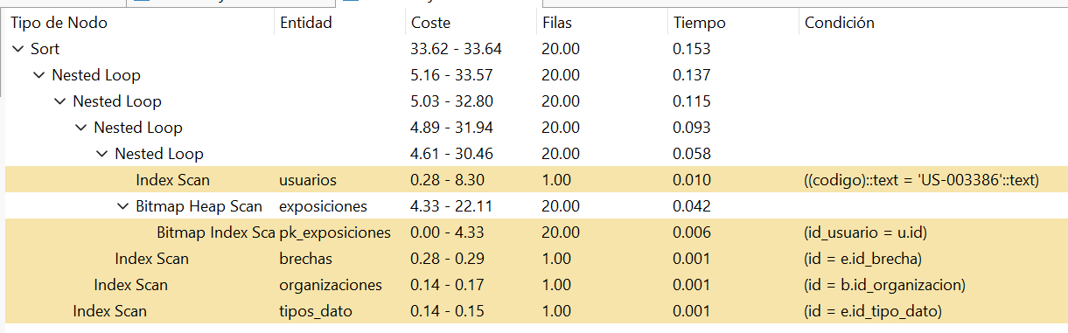
Registros resultantes:
-- 2.a Resultado
SELECT b.codigo AS codigo_brecha,
t.nombre AS tipo_dato,
t.categoria_sensibilidad,
o.nombre AS organizacion_responsable,
e.fecha_notificacion
FROM brechas_seguridad.usuarios u
JOIN brechas_seguridad.exposiciones e ON e.id_usuario = u.id
JOIN brechas_seguridad.brechas b ON b.id = e.id_brecha
JOIN brechas_seguridad.organizaciones o ON o.id = b.id_organizacion
JOIN brechas_seguridad.tipos_dato t ON t.id = e.id_tipo_dato
WHERE u.codigo = 'US-003386'
ORDER BY e.fecha_notificacion, b.codigo, t.nombre
codigo_brecha | tipo_dato | categoria_sensibilidad | organizacion_responsable | fecha_notificacion
BR-00535 | Historial de Transacciones | Alta | Wood-Clarke | 2022-03-31
BR-00535 | Nombre Completo | Baja | Wood-Clarke | 2022-05-10
BR-00535 | Numero Telefonico | Baja | Wood-Clarke | 2022-05-23
BR-00615 | Nombre Completo | Baja | Wood-Clarke | 2023-09-12
BR-00292 | Contrasena | Alta | Wood-Clarke | 2023-10-11
BR-00292 | Direccion Fisica | Media | Wood-Clarke | 2023-11-15
BR-00074 | Numero de Identificacion | Alta | Wood-Clarke | 2024-04-05
BR-00238 | Numero de Tarjeta de Credito | Critica | Wood-Clarke | 2024-06-26
BR-00238 | Numero Telefonico | Baja | Wood-Clarke | 2024-09-03
BR-00732 | Direccion Fisica | Media | Wood-Clarke | 2024-11-05
BR-00732 | Historial Medico | Critica | Wood-Clarke | 2024-11-17
BR-00371 | Direccion Fisica | Media | Wood-Clarke | 2025-08-13
BR-00734 | Direccion Fisica | Media | Wood-Clarke | 2025-08-24
BR-00734 | Numero de Identificacion | Alta | Wood-Clarke | 2025-09-12
BR-00645 | Historial de Transacciones | Alta | Wood-Clarke | 2026-01-02
BR-00645 | Numero de Tarjeta de Credito | Critica | Wood-Clarke | 2026-01-07
BR-00733 | Numero de Tarjeta de Credito | Critica | Wood-Clarke | 2026-06-20
BR-00232 | Numero Telefonico | Baja | Wood-Clarke | 2026-09-22
BR-00232 | Numero de Identificacion | Alta | Wood-Clarke | 2026-09-22
BR-00449 | Historial de Transacciones | Alta | Wood-Clarke | 2026-09-22

