Trying out Rmarkdown

Laura Linnea Määttä

16/6/2021

1. Laura Linnea Määttä
2. Danish Pain Research Center
3. Department of Clinical Medicine, Aarhus University

# Intro

# Methods and results

## Analysis

This is where **data analysis** is *supposed* to be.

# Discussion

source(here::here("R/package_loading.R"))

## Warning: package 'tidyverse' was built under R version 4.0.5

## -- Attaching packages --------------------------------------- tidyverse 1.3.1 --

## v ggplot2 3.3.3 v purrr 0.3.4  
## v tibble 3.1.2 v dplyr 1.0.6  
## v tidyr 1.1.3 v stringr 1.4.0  
## v readr 1.4.0 v forcats 0.5.1

## Warning: package 'ggplot2' was built under R version 4.0.5

## Warning: package 'tibble' was built under R version 4.0.5

## Warning: package 'tidyr' was built under R version 4.0.5

## Warning: package 'dplyr' was built under R version 4.0.5

## Warning: package 'forcats' was built under R version 4.0.5

## -- Conflicts ------------------------------------------ tidyverse_conflicts() --  
## x dplyr::filter() masks stats::filter()  
## x dplyr::lag() masks stats::lag()

load(here::here("data/nhanes_small.rda"))

## `summarise()` has grouped output by 'diabetes'. You can override using the `.groups` argument.

Table caption. Mean values of Age and BMI for each sex and diabetes status.

|  |  |  |  |
| --- | --- | --- | --- |
| Diabetes status | Sex | Mean age | Mean BMI |
| No | Female | 36.5 | 26.2 |
| No | Male | 34.3 | 26.1 |
| Yes | Female | 59.9 | 33.7 |
| Yes | Male | 58.6 | 31.5 |

```r  
knitr::include_graphics(here::here("doc/images/kitten.jpg"))

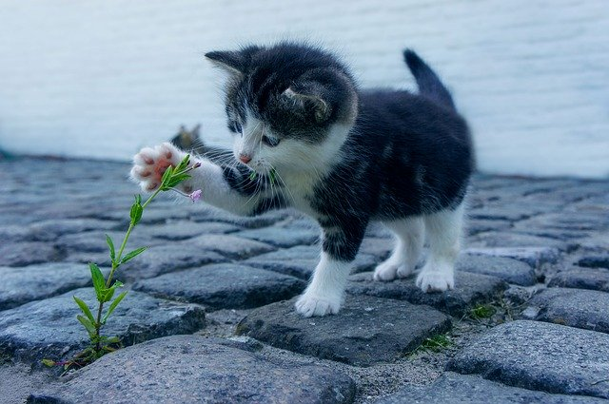

Kitten attacking flowers!



Image by Dimitri Houtteman from Pixabay.