**[Hospital Name] Among First in United States to Offer Innovative New Implant  
 for Chronic Sinusitis Patients**

*Breakthrough Treatment Improves Outcomes for Sinus Surgery*

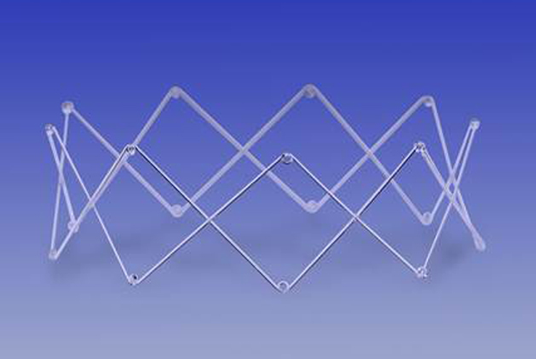Physicians at [Hospital Name] are among the first in the United States to offer patients with chronic sinusitis an innovative new technology for maintaining the results of sinus surgery.

Chronic sinusitis is a condition in which patients’ sinuses become swollen and inflamed, leading to difficulty breathing, facial pain or headache, and reduced sense of smell and taste. The condition is common, affecting 31 million people in the U.S., and greatly impacts quality of life.

Although sinus surgery is an effective treatment for chronic sinusitis, the majority of patients experience recurrent symptoms within the first year, and as many as 25 percent then undergo revision surgery due to recurrent obstruction of the sinus cavity.

The PROPEL™ mometasone furoate implant, approved last year by the U.S. Food and Drug Administration (FDA), is a new weapon in the battle to improve quality of life for patients with chronic sinusitis. PROPEL is a spring-like implant that is inserted by a physician following endoscopic sinus surgery. The implant expands to prop open the sinus, gradually delivers an advanced steroid with anti-inflammatory properties directly to the sinus lining, then dissolves into the body. The result is improved surgical outcomes, reducing the need for additional surgical procedures and for systemic steroids, which can have serious side effects1.

“This PROPEL implant offers new hope for chronic sinusitis sufferers,” said [physician]. “Three studies have shown that PROPEL maintains the results of sinus surgery, translating into significant benefits for patients with chronic sinusitis. After PROPEL, many of my patients have once again been able to enjoy life without the symptoms of chronic sinusitis.” PROPEL is the only product used in sinus surgery to be supported by level 1-A evidence.

The goal of surgical treatment for chronic sinusitis is to enlarge the inflamed or obstructed sinus passageways. Post-surgery check-ups are required to clean the sinus cavities and ensure that they are open, healing well and without scarring.  
  
For more information about PROPEL, please visit [www.propelopens.com](http://www.propelopens.com) or contact [insert contact name or hospital web site].

___________________________________

1 Meta-analysis: Han JK, Marple BF, Smith TL et al. Int Forum Allergy Rhinol. 2012; 2 :271-279.

Patients should talk with their physicians to determine if PROPEL is the right option for them. Please visit [www.intersectENT.com](http://www.intersectENT.com) for instructions for use for full prescribing information for the PROPEL sinus implant, including indications, contraindications, warnings, precautions and adverse events.