**CS2U: Web App Development**

**Design Report**

**(Federated Health Search Application)**



**LB06 Group A**

**Ong Cher Wei, Mohsin Ullah, Bartek Juszczak and Laura Moreby**

Contents

* 1. Briefing of the Application
  2. Two Personas of the Application
  3. List of Specifications
  4. High-Level System Architecture
  5. ER Diagram
  6. Original Wireframes
  7. **Briefing of the Application**

The application we are building is a ‘Federated Health Search Application’. The purpose of this web application is to provide information about conditions, treatments and medicines to people who are searching for it. At the moment, one of the problems people face is that when people have illnesses or conditions, they gather unreliable information from unreputable sources, make misinformed decisions and then go to the doctors/hospital when they do not need to, or don’t go when they do need to. Our application will aim to tackle this problem by providing a metric by which people can gather information from reputable sources and make more of an informed decision about what to do. The application will work by using APIs to retrieve the data from reputable medical sites and this will allow users to ‘self-diagnose’, finding out what condition that they or a family member/friend may have, given the present symptoms. The application also allows people to create a user account and save pages that they find useful, for easy access in the future.

We have called our application ‘HealthApple’ as apples are associated with health and nutritional value. This will be the logo for our application:



* 1. **Two Personas of the Application**

The users of our application will not be medical researchers or health professionals, but people at home who have little extensive knowledge of different health conditions and treatments and want a reputable source to find out information when they need to. The two personas we have specified is a parent looking for information about their child who they think might have a short term illness, and a student who is looking for information on a more long term issue the think that they have.

1. Parent with child

 Julie is a 32 year old mother with a 5 year old daughter. One morning she notices that her daughter has what seems like a rash on one of her arms. It doesn’t appear bad at first but the next day she notices it getting worse. She doesn’t know what it is, how bad it is or where it came from. She is worried that it may be an allergic reaction but she does not know. She looks on the internet including unofficial news forums and gets nowhere, but she then consults HealthApple and finds information about different possible conditions and treatments. She was initially considering going to the doctors but then finds out that a medicine bought from the pharmacy could help the rash. Within days the rash disappears and her daughter is back to her healthy self.

1. Student



Joe is a 20 year old student living away from home. One day after going to the gym he notices he has some pain in his knee but doesn’t think much of it. After this pain does not seem to go away after a few days, he fears he may have damaged a muscle or a ligament. He doesn’t know whether it is work going to the doctors about it, so consults HealthApple to gain reputable information. He discovers that it may be a long term problem and decides to create an account so that he can save pages for reference later. He originally wouldn’t have gone to the doctors but he finds a number of treatments for what he believes his condition is and seeks physiological treatment over the course of a few months.

* 1. **List of Specifications**
* The web application will take queries inputted by the user and send them off to three different applications (and bing) and bring back the results from these APIs
* Users can search for conditions, treatments and medicines, and then the website will present results to the user. For people with short term conditions, the website has to allow the user to access information quickly and easily. For people with long term conditions, the website has to allow people to gather and collect more information over time and save it for reference later
* Users will be able to create an account and profile, which they can update and manage. Users can log in and log out
* Users will be able to create a category in which they save pages they think are of particular interest or would like to come back to later
* All categories and links should be private unless the user explicitly makes them public or shares them. The benefit of a user sharing a category of useful links is that someone else with a similar condition could benefit from the links that another user has accumulated
* Any page that is saved into a category has its HTML saved and is then processed using a Python module called *textstat*, which then computes the ‘readability score’ of the page
* Any page that is saved into a category has its HTML saved and is processed using another Python module called *textblob* to compute the sentiment and subjectivity of the page and produces scores for these
* The search interface needs to provide:
  + A mashup of results from each of the three different health sites and an annotation to say where each result is from
  + Tabs to see what results come from each website
  + Easy ways to save results to a particular category
* When you click onto a category to see a list of your saved pages, we will see for each link:
  + Title of page
  + Summary of page
  + Source of page and URL of that page
  + Readability score, sentiment score and subjectivity score

Our Additional Features

* Search box can provide query suggestions and spelling correction for users as medical words can be difficult to spell
* Frequent searches based on location – this will allow users to see what illnesses are going around in their area. This is useful to know if the illness is contagious e.g. chicken pox or the flu
  1. **High-Level System Architecture**

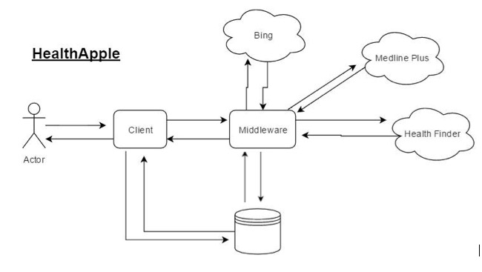

* 1. **ER Diagram**

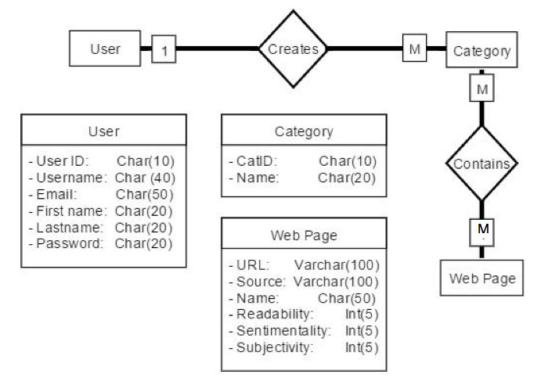

* 1. **Original Wireframes**

Home Screen

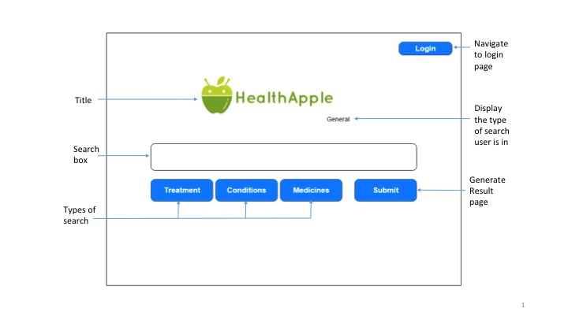

Results Screen

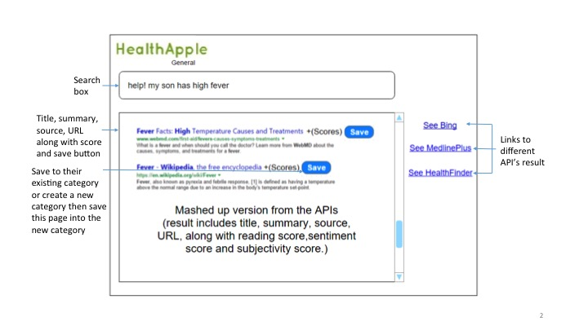

Register Account

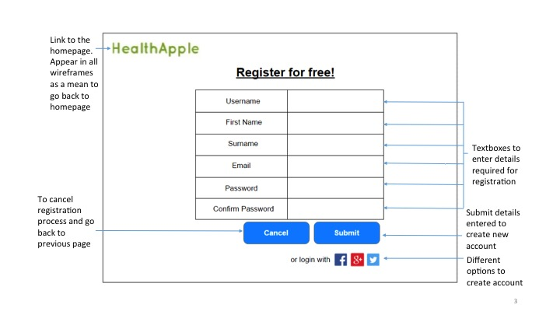

User Profile

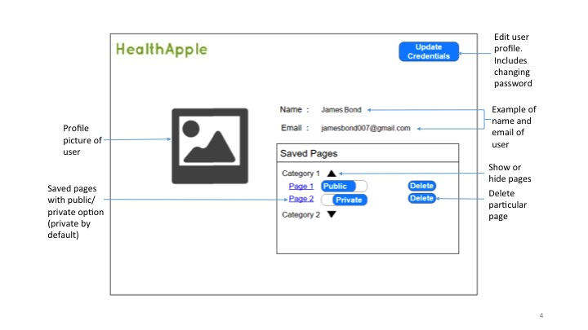

Edit Profile

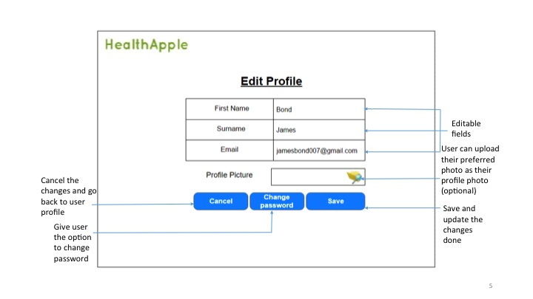

Change Password

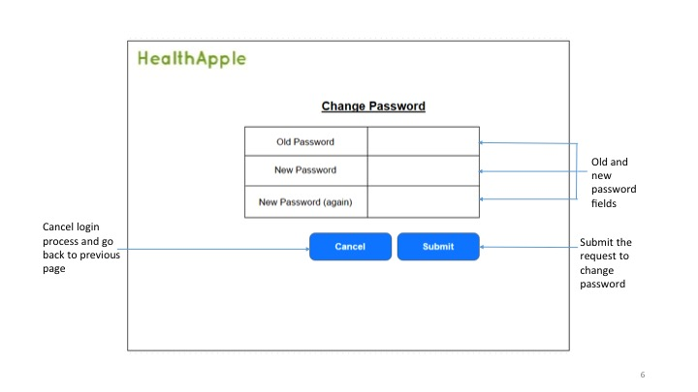

Login Page

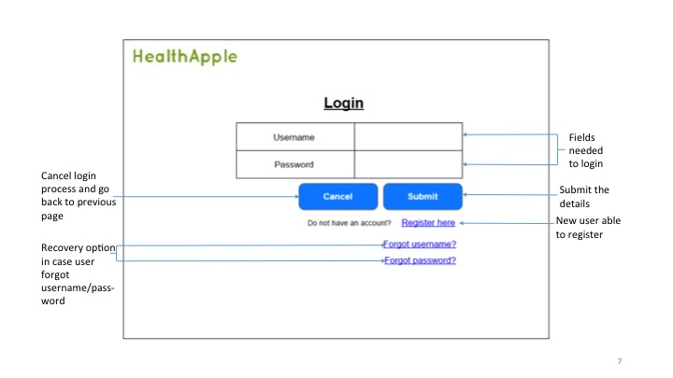

Diseases based on current location (Additional Feature)

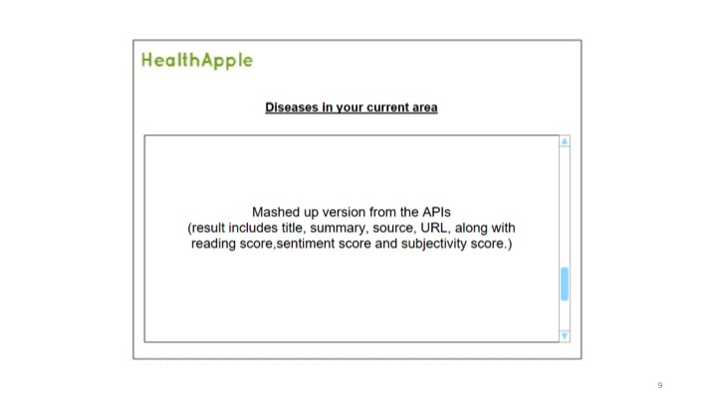

Walkthrough

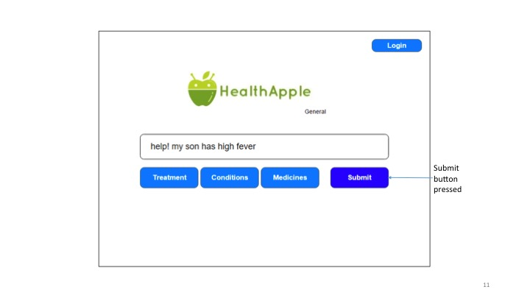

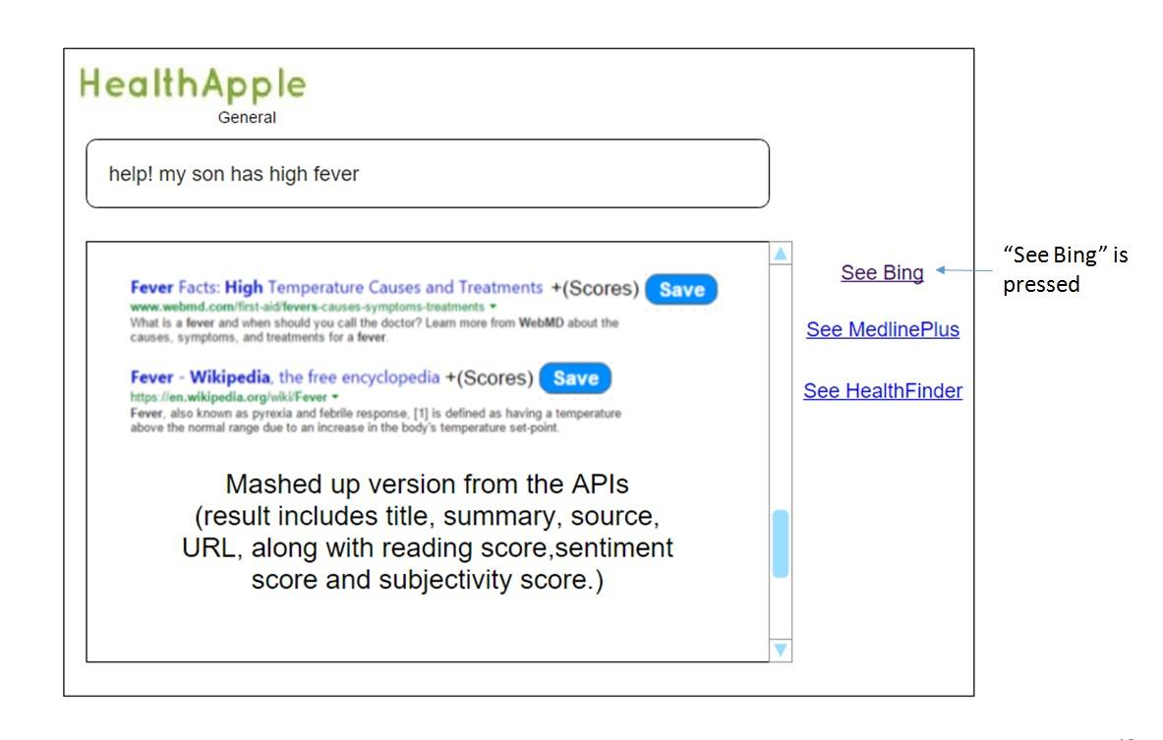

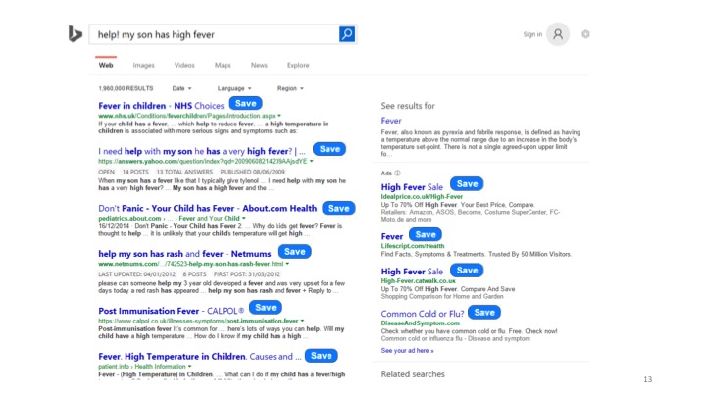

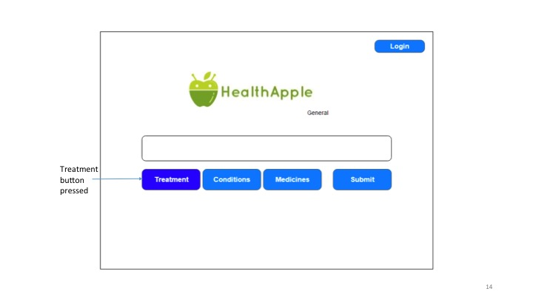

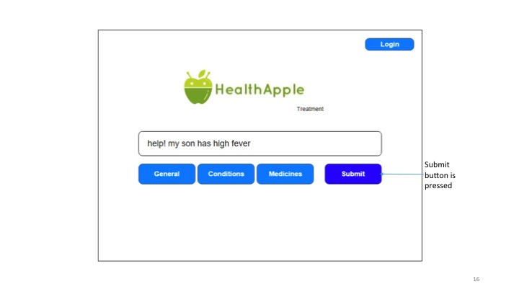

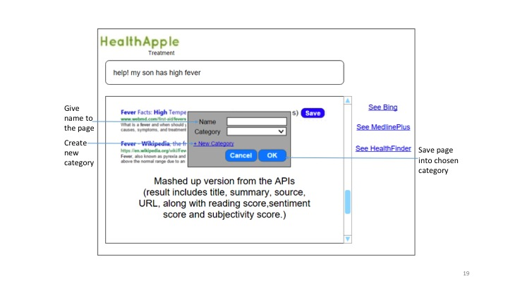

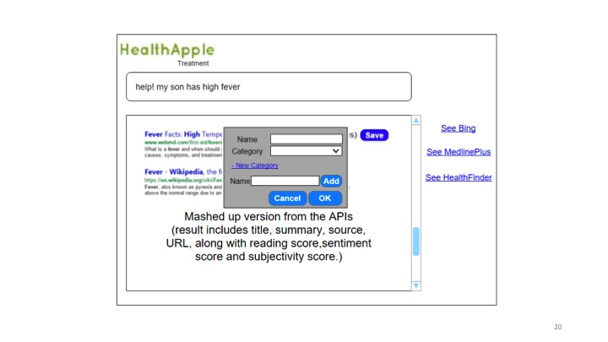

The user is prompted to log in if they try to save a page when not logged in:

