# Burgers equation

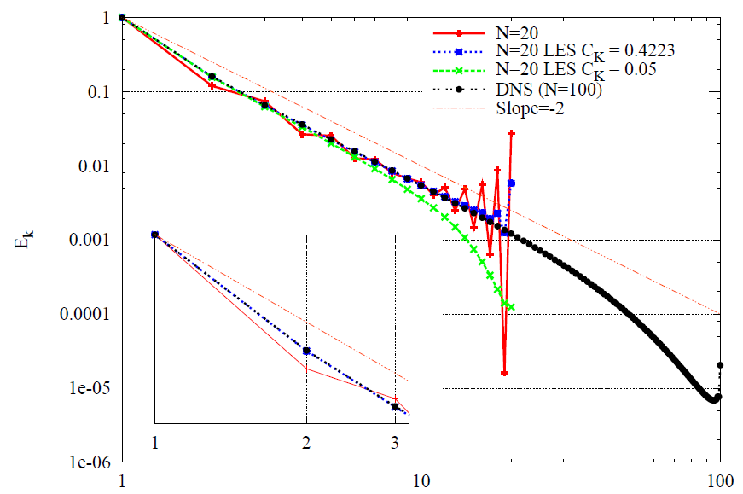

Figure 1: Reference values

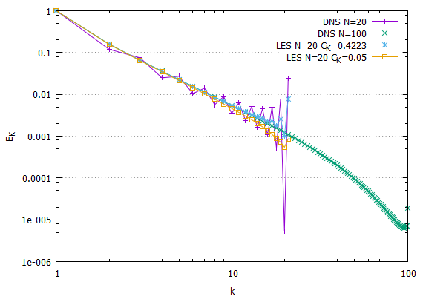

Figure 2: Solution of the program