|  |
| --- |
| ESEIAAT - UPC |
| Study for the computational resolution of conservation equations of mass, momentum and energy. Possible application to different aeronautical and industrial engineering problems: Case 1B |
| Report |
|  |
| **Laura Pla Olea** |
| **10/06/2017** |

|  |
| --- |
| [Escriba aquí una descripción breve del documento. Normalmente, una descripción breve es un resumen corto del contenido del documento. Escriba aquí una descripción breve del documento. Normalmente, una descripción breve es un resumen corto del contenido del documento.] |

Content

1 Introduction 5

2 State of the art 6

2.1 Conservation equations 6

2.2 Numerical methods 6

2.2.1 Finite difference method 7

2.2.2 Finite volume method 7

2.3 Time integration 8

2.4 Evaluation of the convective term 9

2.4.1 The central differencing scheme (CDS) 9

2.4.2 The upwind scheme (UDS) 9

2.4.3 The exponential scheme (EDS) 9

2.4.4 The hybrid scheme (HDS) and the power-law scheme (PLDS) 10

3 Four materials 11

3.1 Conduction equation 12

3.2 Discretization 12

3.2.1 Space discretization 12

3.2.2 Time discretization 13

3.2.3 Boundary conditions 15

3.3 Algorithm 16

3.4 Results 18

4 Smith-Hutton problem 19

4.1 General convection-diffusion equation 19

4.2 Discretization 20

4.3 Boundary conditions 24

4.4 Algorithm 24

4.5 Results 24

5 Driven cavity problem 28

5.1 Navier-Stokes equation 28

5.2 Fractional step method 28

5.3 Discretization 29

5.4 Boundary conditions 31

6 Differentially heated cavity 32

7 Burger’s equation 33

7.1 Fourier space 33

Figure 1: Three successive grid points 7

Figure 2: Control volume (2D) 8

Figure 3: Explicit method () 8

Figure 4: Implicit method () 8

Figure 5: Crank-Nicholson () 8

Figure 6: General scheme of the four materials problem 11

Figure 7: Heat fluxes through the faces of a control volume 12

Figure 8: Instantaneous isotherms at 18

Figure 9: Instantaneous results at 18

Figure 10: General scheme of the Smith-Hutton problem 19

Figure 11: Mesh of the Smith-Hutton problem 20

Figure 12: Comparative of the different methods 25

Figure 13: Comparative of the different methods 25

Figure 14: Comparative of the different methods 26

Figure 15: Representation of the whole domain for 26

Figure 16: Representation of the whole domain for 27

Figure 17: Representation of the whole domain for 27

Figure 18: General scheme of the driven cavity problem 28

Figure 19: Staggered meshes (2D) 30

Figure 20: Representation of all the possible interactions between the modes in the convective term4 35

Table 1: Particular cases of the convection-diffusion equation 6

Table 2: Problem coordinates 11

Table 3: Physical properties of the materials 11

Table 4: Boundary conditions 11

Table 5: Function for different schemes1 23

Table 6: Discretization coefficients of the boundary points 24

Table 7: Discretization coefficients in the boundary 31

# Introduction

# State of the art

The laws governing the processes of heat transfer and fluid flow are usually expressed in terms of differential equations. Some of these equations are the momentum equation, the energy equation and the mass conservation equation, among others. However, these expressions usually don’t have an analytical solution except for some simple cases. To solve complex problems it is necessary to use numerical methods.

## Conservation equations

The three most important conservation equations are the mass conservation equation, the momentum conservation equation and the energy conservation equation:

For incompressible flows with no viscous dissipation, the energy conservation equation can be written as:

All these equations can be seen as a particular case of the generic convection-diffusion equation:

Where is the density, the velocity, the diffusion coefficient, the source term, and the general variable that is going to be studied.

|  |  |  |  |
| --- | --- | --- | --- |
| Equation | φ | Γ | Sφ |
| Mass conservation | 1 | 0 | 0 |
| Momentum |  | μ |  |
| Energy (for a semi perfect gas) | u | λ/cv |  |

Table 1: Particular cases of the convection-diffusion equation

## Numerical methods

Numerical methods are based in dividing the domain that is going to be studied in different pieces. Instead of calculating the unknowns in the whole domain, they are studied in the finite number of points defined by these pieces, the grid points. This process is called discretization.

Once the domain is discretized, it is also necessary to discretize the equations. The relations between the grid points have to be established. It is assumed that the value of a grid point only influences the distribution of in its immediate neighbours. For this reason, as the number of grid points becomes larger, the numerical solution approaches the real solution of the problem.

There are different methods of discretizing the equations, but the most common ones are exposed in the following lines.

### Finite difference method

The finite difference method (FDM) is based in the Taylor-series expansion. It is used to approximate the derivatives in the differential equation. Taking the three successive points represented in Figure 1, the approximation of the values in the left point (west) and in the right point (east) is easily calculated with Taylor series:

Using a second order approximation and combining both expressions, it can be easily obtained:

These expressions are substituted in the differential equation to obtain the finite-differential equation. This approach is very simple, but it is not used in complex geometries. It also does not enforce the conservation, as it is simply a mathematical approach, which may lead to some problems.

P

W

E

Figure 1: Three successive grid points

### Finite volume method

The finite-volume method (FVM) is more used than the FDM. It consists in dividing the domain in different control volumes, so that each control volume surrounds one grid point. Then, the differential equation is integrated over each control volume, ensuring that each of them satisfy the conservation.

P

W

E

S

Figure 2: Control volume (2D)

## Time integration

Time is a one-way variable, which means that the unknowns only depend on the values in the previous instant of time, and do not depend on the values in the next instant of time. Taking this property into account, to obtain the results of an unsteady problem, the method is to discretize the time and calculate the values for each time step. When the unknowns of one time step are obtained, the calculation moves on to the next time step.

|  |  |  |
| --- | --- | --- |
| Figure 3: Explicit method () | Figure 4: Implicit method () | Figure 5: Crank-Nicholson () |

Time integration can be done using different methods. The ones that are widely used are:

* Explicit method: The simplest method. All the terms are evaluated using the known values of the previous time step . It is a first order approximation and easy to compute, but it requires very small time steps in order to achieve convergence.
* Implicit method: It is a very stable first order approximation, useful in problems with large time steps. The terms are evaluated with the values in the next instant of time .
* Crank-Nicholson: It is a second order approximation. The terms are evaluated using the values of the previous and the next time step.

## Evaluation of the convective term

There are different schemes to evaluate the convective term of the convection-diffusion equation. This term is evaluated in the faces, not in the nodes, so it is necessary to know the value in the faces of the control volume. Some of the most common schemes are listed below1,2, all of them studied in a one-dimensional case to simplify their explanation.

### The central differencing scheme (CDS)

It is the most natural scheme. It is a linear interpolation between the two nearest nodes:

However, CDS is only valid in cases with low Reynolds number. It is a second order approximation, but may produce oscillatory solutions.

### The upwind scheme (UDS)

It assumes that the value of in the interface is equal to the value of at the node on the upwind side of the face.

if

if

The solutions of the UDS will always be physically realistic, but they may not be completely accurate because it is a first order approximation. However, this method is widely used because of its stability.

### The exponential scheme (EDS)

Taking the generic convection-diffusion equation and assuming a steady one-dimensional problem with a constant and no source term, the analytic solution of the equation is an exponential function:

Where and are the values of the function at and respectively and is the Péclet number, a non-dimensional number:

In the EDS, this analytic solution is used to determine the value on the faces, using the following expression:

Though this solution is exact for the steady one-dimensional problem it is not for two or three-dimensional cases, unsteady problems… so it is not widely used.

### The hybrid scheme (HDS) and the power-law scheme (PLDS)

Both methods are an approximation of the exponential function used in the EDS. Since exponentials are expensive to compute, the HDS and the PLDS are meant to provide a good result but with simpler functions. They divide the function given by the EDS in different parts and approximate the solution with simpler functions.

# Four materials

The four materials problem is a two-dimensional transient conduction problem. It consists in a long rod composed of four different materials with different properties. The general scheme of the problem is represented in Figure 6:

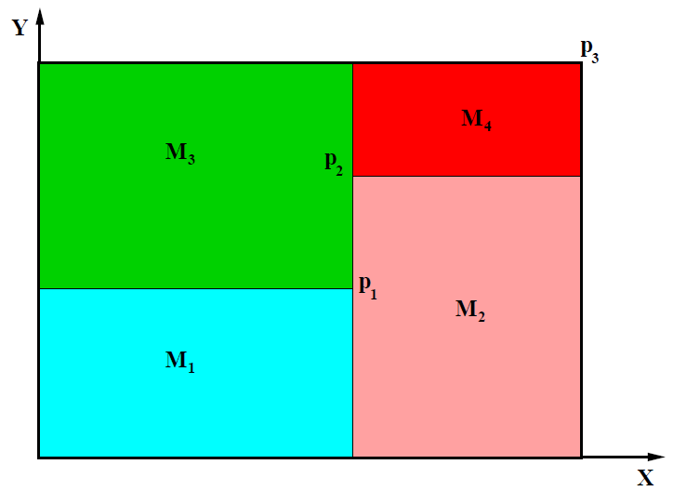

Figure 6: General scheme of the four materials problem

|  |  |  |
| --- | --- | --- |
|  | x [m] | y [m] |
| p1 | 0.50 | 0.40 |
| p2 | 0.50 | 0.70 |
| p3 | 1.10 | 0.80 |

Table 2: Problem coordinates

|  |  |  |  |
| --- | --- | --- | --- |
|  | ρ [kg/m3] | cP [J/kgK] | λ [W/mK] |
| M1 | 1500.00 | 750.00 | 170.00 |
| M2 | 1600.00 | 770.00 | 140.00 |
| M3 | 1900.00 | 810.00 | 200.00 |
| M4 | 2500.00 | 930.00 | 140.00 |

Table 3: Physical properties of the materials

|  |  |
| --- | --- |
| Cavity wall | Boundary condition |
| Bottom | Isotherm at |
| Top | Uniform length |
| Left | In contact with a fluid at and heat transfer coefficient |
| Right | Uniform temperature (where is the time in seconds) |

Table 4: Boundary conditions

The initial temperature field is .

## Conduction equation

The conduction heat transfer is described by Equation 1:

Equation 1: Conduction equation

Where is the density, the temperature, the conductivity of the material, the specific heat of the material and the inner heat of the material (source term).

## Discretization

The domain is discretized using the node centred distribution, to avoid having conflictive control volumes between the different materials. Since it is a transitory problem, it is necessary to discretize in space and time. The method used to discretize the equation is the finite volume method.

### Space discretization

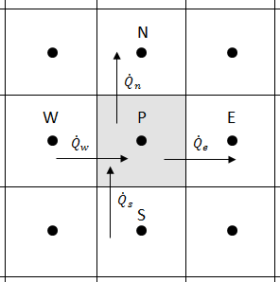

Figure 7: Heat fluxes through the faces of a control volume

The heat fluxes through the walls represented in Figure 7 are integrated:

Equation 2: Discretized heat fluxes through the walls

Where is the temperature at the given node, the distance between two nodes, and the conductivity at the given face.

However, since there are different materials there are faces in which the conductivity can have two values: one on the left side of the face and the other one on the right side of the face. This problem is solved with the harmonic mean. It can be calculated with the heat fluxes through the wall:

Equation 3: Harmonic mean

The inner heat of the material can be discretized as:

Equation 4: Discretized inner heat flux (source term)

### Time discretization

The time discretization is done using the First law of thermodynamics:

Where is the internal energy of the control volume.

Assuming an incompressible material, the First law of thermodynamics is integrated over time. Taking as the previous instant of time and the instant of time that is going to be calculated:

Rearranging the first term of the equation:

And the second term:

The discretized equation is finally obtained:

Equation 5: Discretized conduction equation

To simplify the equation, it can be rewritten with coefficients, dependant on the properties of the nearest nodes in the following form:

The coefficients are called discretization coefficients, and they are different for each node. The discretization coefficients are:

Equation 6: Discretization coefficients for the four materials problem

### Boundary conditions

The outer walls of the rod have special conditions, so each of them has to be studied in order to determine the coefficients of the boundary nodes.

In the left wall (), there is convection, so some coefficients have to be recalculated:

Equation 7: Discretization coefficients of the left wall

In the top wall () there is a constant heat flux. The new coefficients are:

Equation 8: Discretization coefficients of the top wall

In the right wall (), the temperature is given, and it changes over time. The coefficients are very similar to those of the general case. The only differences are:

Equation 9: Discretization coefficients of the right wall

Finally, in the bottom () the temperature is also given, but it is constant. The approach is very similar to that of the right wall. So that the coefficients are:

Equation 10: Discretization coefficients of the bottom wall

## Algorithm

YES

YES

Input data:

Previous calculations:

Initial temperature map:

Calculation of the next time step:

Evaluation of the constant coefficients:

Solve the set of equations:

Final calculations and print results

END

?

New time step?

NO

NO

Evaluation of the non-constant coefficients:

## Results

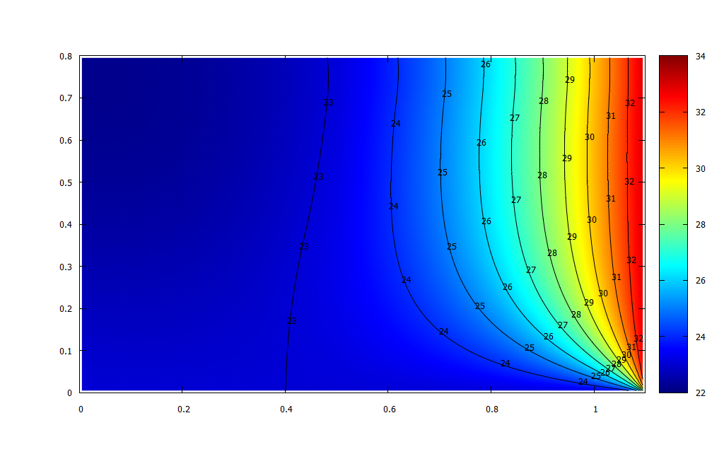

Figure 8: Instantaneous isotherms at

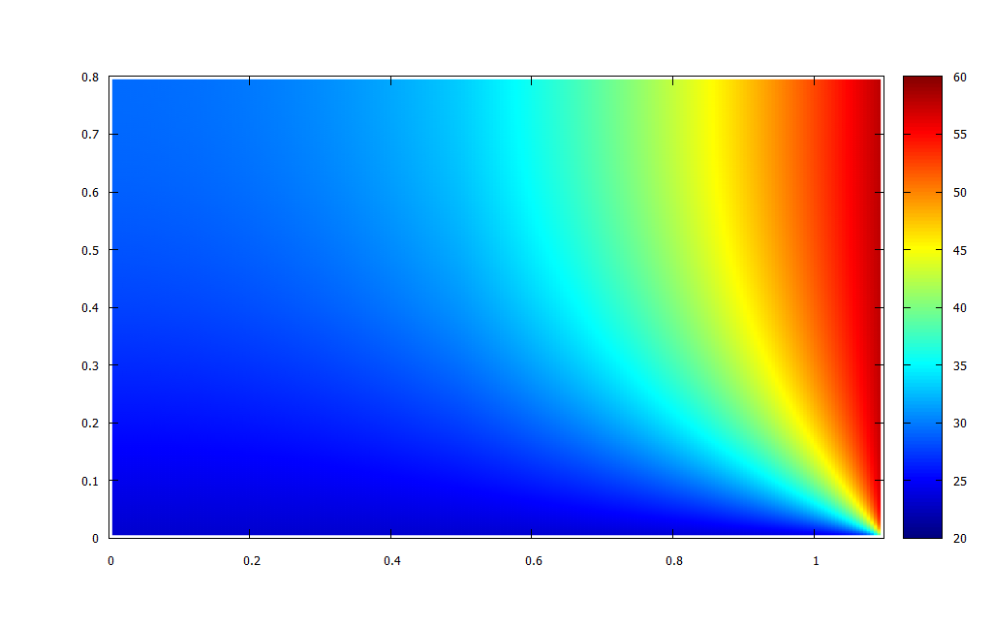

Figure 9: Instantaneous results at

# Smith-Hutton problem

The following problem is a two-dimensional steady convection-diffusion problem, represented in Figure 10:

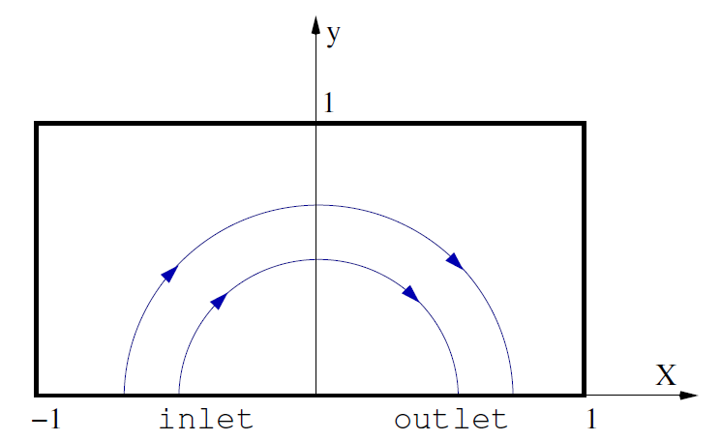

Figure 10: General scheme of the Smith-Hutton problem

The velocity field is given by:

Equation 11: Prescribed velocity

And the boundary conditions for the variable are:

Equation 12: Boundary conditions of the Smith-Hutton problem

Where .

## General convection-diffusion equation

The mathematical formulation needed to solve this problem is the convection diffusion-equation:

Equation 13: Generic convection-diffusion equation

## Discretization

It is necessary to discretize Equation 13 in space and time. The control volume used to discretize the problem is specified in Figure 11. The boundary nodes are in blue and the inner nodes in black.

Figure 11: Mesh of the Smith-Hutton problem

To do so, it is easier to start with the discretization of the mass equation:

Equation 14: Mass conservation equation

The first step is to integrate Equation 14 over time and space. Taking only the first term of the equation:

Using the Divergence Theorem, the second term of the equation transforms into a surface integral:

In the second term, to integrate over time an implicit scheme is used. The final discretized mass equation is:

Equation 15: Discretized mass equation (2D)

The discretization of the convection-diffusion equation is very similar to that of the mass equation. Integrating over the volume the transport term of Equation 13 and applying the Divergence Theorem:

The same procedure is used for the diffusion term:

Where:

To simplify the source term, it is linearized:

So that the resulting equation is:

Multiplying by the discretized mass equation (Equation 15) and subtracting the result in this equation, the discretized convection-diffusion equation is obtained:

To simplify the problem, a new variable is introduced to the problem: the total flux. But this variable is split in the two dimensions of the problem, the flux in the x-direction and the flux in the y-direction.

Equation 16: Total (convection plus diffusion) fluxes

Introducing the expressions of the total flux, the discretized convection diffusion equation becomes:

Equation 17: Final discretization of the convection diffusion equation

Where the flow rates are:

However, it is necessary to know how the fluxes are going to be evaluated. In order to use non-dimensional numbers, a new variable is defined:

Where is the Péclet number and is the distance between the point that is going to be studied *i*, and the point next to it, *i+1*. The value of φ and the value of the gradient are a combination of the and , so that can be expressed as:

The coefficients and are dimensionless and depend on the Péclet number. However, since B is a combination of A and the Péclet number, and both coefficients are symmetric, it can be deduced that:

Equation 18: Dimensionless coefficients A and B

Where is an operator that denotes the greater of A and B.

Combining Equation 17 and Equation 18, the following formulation is obtained:

Where

Equation 19: Discretization coefficients of the Smith-Hutton problem

And the Péclet numbers are:

The only operation that should be defined is the value of the coefficient . This value depends on the integration scheme that is going to be used. Some of its values are listed in Table 5:

|  |  |
| --- | --- |
| Scheme | Formula for |
| Central difference (CDS) |  |
| Upwind (UDS) |  |
| Hybrid (HDS) |  |
| Power law (PLDS) |  |
| Exponential (EDS) |  |

Table 5: Function for different schemes1

## Boundary conditions

To apply the boundary conditions to the problem, some modifications on the coefficients defined by Equation 19 have to be done. The easiest one is for the points in the left, top and right sides of the domain, in which the value of is defined.

In the bottom it is necessary to distinguish between the inlet and the outlet. A similar approach to that of the left, top and right side is used to determine the coefficients of the points in the inlet. However, in the outlet the only condition is that the derivative of in the vertical direction is equal to zero. The following reasoning leads to:

The implementation of the boundary conditions in the problem is done with the discretization coefficients listed in Table 6.

|  |  |  |  |
| --- | --- | --- | --- |
| Coefficients | Left, top and right | Inlet (bottom) | Outlet (bottom) |
|  |  |  |  |
|  |  |  |  |
|  |  |  |  |
|  |  |  |  |
|  |  |  |  |
|  |  |  |  |

Table 6: Discretization coefficients of the boundary points

## Algorithm

## Results

The computation of the results has been done using different schemes. In order to compare them with the reference solutions, some plots have been done using a mesh of 200x100.

Since the velocity and the dimensions are constant in this problem, the parameter is somehow equivalent to the Péclet number. In Figure 12, when the Péclet number is low, all the methods have similar results, and there is almost no error compared to the reference values. However, as the Péclet number increases, the error increases, as it can be seen in Figure 13 and Figure 14.

In the case is where the different methods give different results, but in they are similar again. It is important to notice that in both cases CDS diverges, and no results can be obtained with this method.

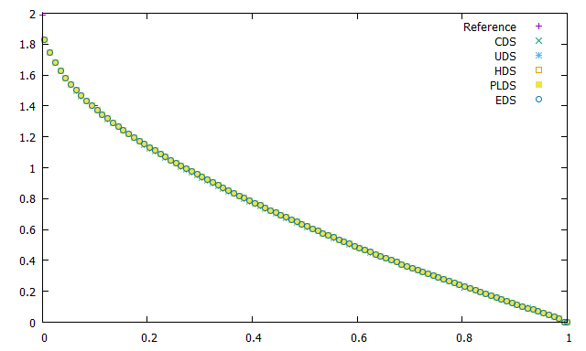

Figure 12: Comparative of the different methods

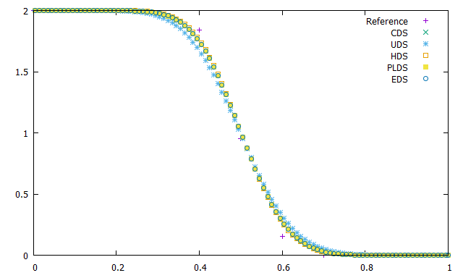

Figure 13: Comparative of the different methods

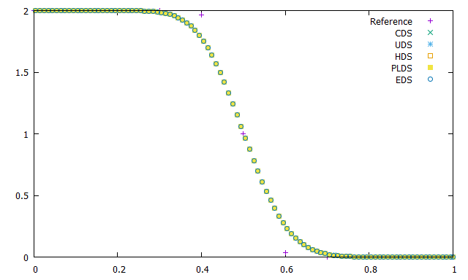

Figure 14: Comparative of the different methods

It is also important to understand the variation of the variable in the whole domain. For a low Péclet number (Figure 15), the variation is very gradual. But as it increases (Figure 16 and Figure 17), the change is more abrupt, and there is almost no variation except for the centre bottom zone. The shape of the variation becomes more symmetrical as the Péclet number increases.

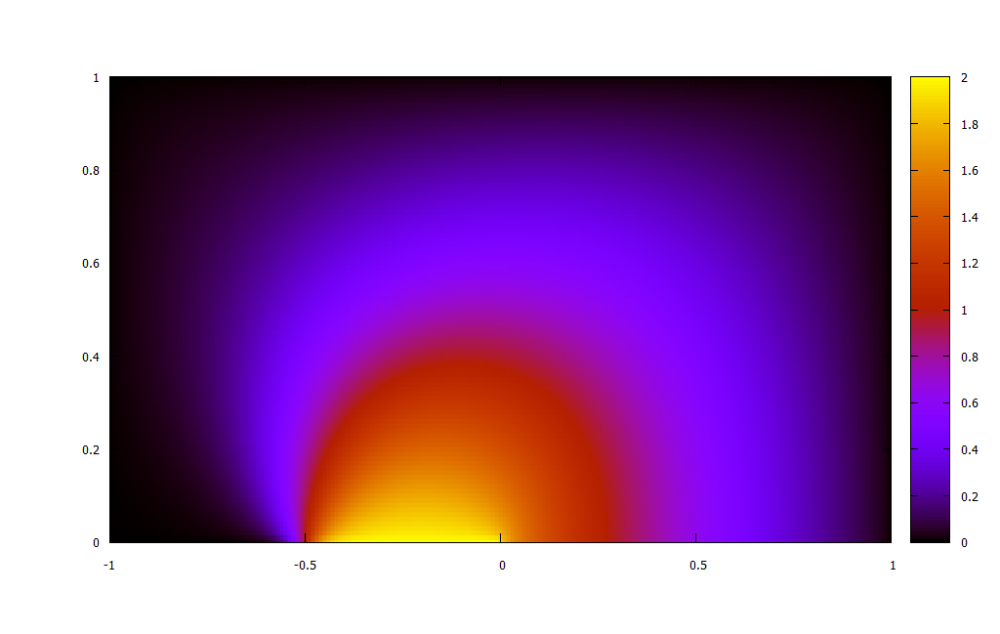

Figure 15: Representation of the whole domain for

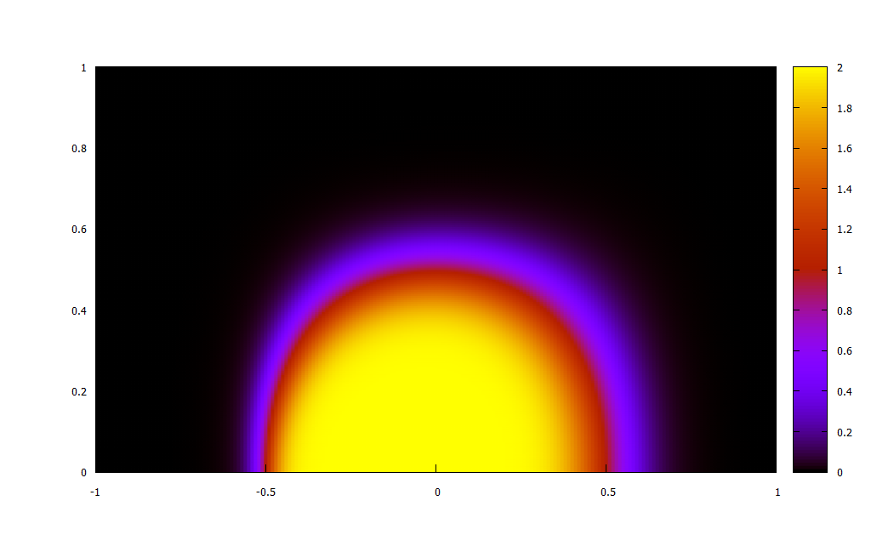

Figure 16: Representation of the whole domain for

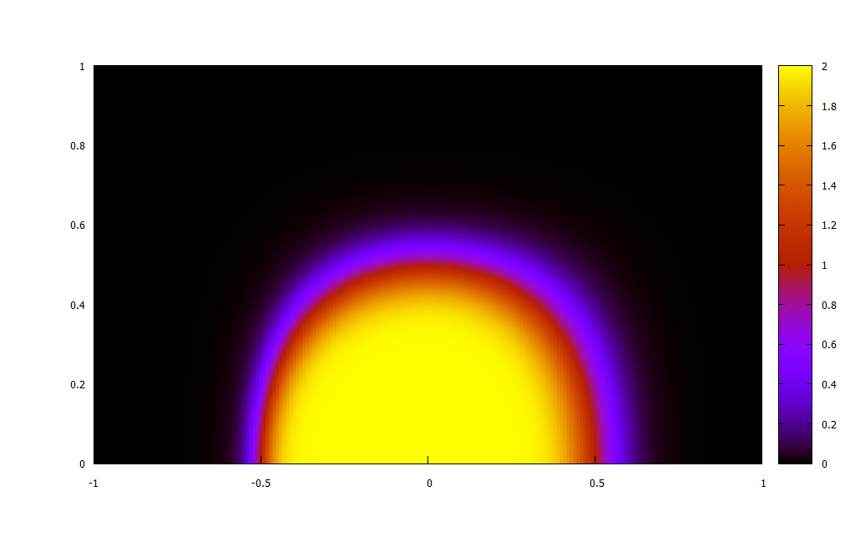

Figure 17: Representation of the whole domain for

As a conclusion, it can be stated that when convergence dominates over diffusion (low Péclet numbers), velocity distributes the properties of the inlet to a great part of the domain. However, as diffusion becomes more important (the Péclet number increases), the influence of the inlet becomes less important.

# Driven cavity problem

The driven cavity problem consists in a two-dimensional cavity with an incompressible fluid. The upper wall of the cavity moves at a given velocity, as shown in Figure 18. The aim of the problem is to obtain the distribution of velocities inside the cavity.

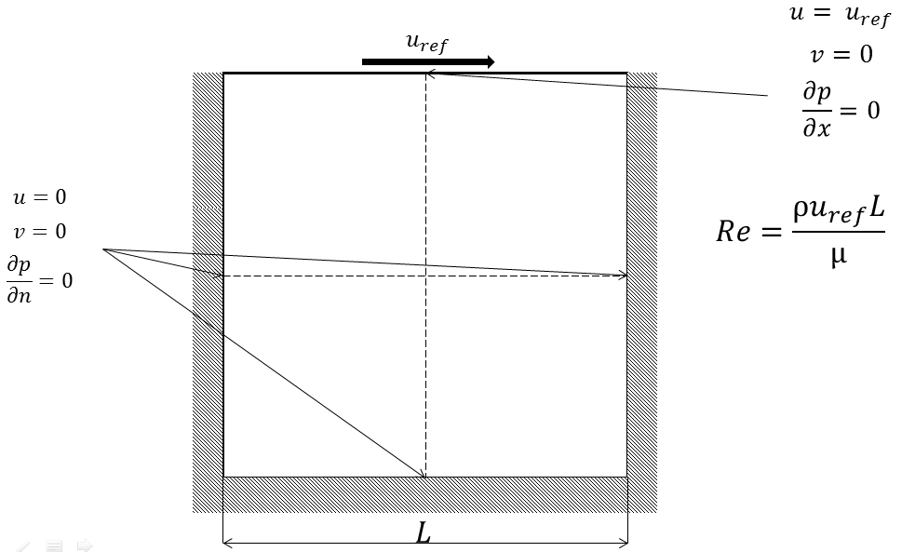

Figure 18: General scheme of the driven cavity problem

## Navier-Stokes equation

The equations to be solved are:

## Fractional step method

According to the Helmholtz-Hodge theorem, it is possible to decompose any vector in a divergence-free vector parallel to the boundary and a gradient field, and this decomposition is unique3.

Assuming constant density and viscosity, the Navier-Stokes equation can be rewritten as:

Where .

Integrating the equation over time:

However, the term is not easy to evaluate. To do so, the Adams-Bashforth second-order scheme is used:

Applying the Helmholtz-Hodge Theorem, the intermediate velocity is easily obtained:

Introducing this expression to the integrated equation:

And finally, applying the divergence to the expression of the intermediate velocity , the Poisson equation is obtained:

With all these expressions the fractional step method (FSM) can be finally implemented, following the next scheme:

1. Evaluate .
2. Calculate the intermediate velocity: .
3. Calculate the pressure from the Poisson equation using a linear solver.
4. Calculate the velocity at the next time step: .

However, this method can be problematic if the mesh of the problem is not correctly implemented. To avoid having solutions with no physical sense, it is important to use staggered meshes or collocated meshes.

## Discretization

To avoid convergence problems or incorrect solutions, the staggered meshes are used. As shown in Figure 19, in a two-dimensional case there are 3 control volumes, one for each variable: , and . They are coloured in black, red and green respectively.

Figure 19: Staggered meshes (2D)

Knowing the space discretization of the domain, the discretized Poisson equation can be calculated. Integrating the expression over the domain and applying the divergence theorem, the following expression can be easily obtained:

Rewriting the equation using discretization coefficients:

## Boundary conditions

It is necessary to impose the conditions defined by Figure 18. These boundary conditions modify the discretization coefficients in the boundary nodes.

There are two types of conditions: the prescribed velocity, and the boundary layer conditions. The last ones are defined by assuming that the pressure gradient normal to the wall is 0. For example, in the left wall:

The prescribed velocity is defined using a similar approach. It is assumed that . To obtain this solution, the pressure gradient has to be equal to zero, so the same expression as in the boundary layer conditions is obtained.

|  |  |  |  |  |
| --- | --- | --- | --- | --- |
| Coefficients | Top | Bottom | Left | Right |
|  |  |  |  |  |
|  |  |  |  |  |
|  |  |  |  |  |
|  |  |  |  |  |
|  |  |  |  |  |

Table 7: Discretization coefficients in the boundary

# Differentially heated cavity

# Burger’s equation

Burger’s equation, also known as Burgulence, is a one dimensional approach to the Navier-Stokes equations in an incompressible flow. Taking the dimensionless equations:

And writing its one-dimensional form, the Burger’s equation is easily obtained:

Where is the source term.

Since the equation is one-dimensional, the continuity equation is removed. The pressure gradient is also removed because it depends on the continuity equation.

## Fourier space

The easiest way to solve this equation is to solve it in Fourier space. The basic approach of this space is that any function can be represented as a sum of sinus and cosines known as Fourier series in the following way:

Where .

Nonetheless, in a numerical calculation, it is impossible to have an infinite number of terms, it is necessary to have a finite number. This is not a problem, because in spectral methods, the biggest amount of information is in the lowest frequencies, which means that it is not necessary to have a huge amount of terms in order to have a proper solution of the equation. Taking this into account, the functions that are represented in the Fourier space become a sum of a finite number of sinus and cosines:

Using this expression, the Burger’s equation can be transformed into the Fourier space. However, the derivatives have to be calculated. Applying the derivative to the Fourier function definition:

The same procedure is applied to the second derivative in order to obtain the diffusive term:

The transient and forcing terms are straightforward:

However, the convective term is more complicated. This non-linear term is a multiplication of the function and its derivative, and when this term is transformed into Fourier space there are some things that need to be taken into account. The terms in question are:

As it is noted, the variable k has been renamed in both terms in order to avoid confusions when the expressions are multiplied to obtain the convective term. It is finally calculated as:

Taking all these expressions, integrating them into the Burger’s equation and applying the Fourier transform, the final expression is:

For ; and where .

As it can be seen, one of the main advantages of spectral methods is that all the modes can be solved separately. However, due to the convective term, there is still a sum of terms in the equation, which can be named triadic interactions. This summation can be easily interpreted with Figure 20.

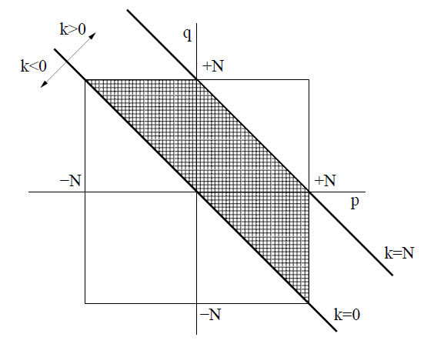

Figure 20: Representation of all the possible interactions between the modes in the convective term4

In Fourier space, , so only the positive modes need to be solved. Moreover, since the Fourier series are truncated for , the only possible interactions are those of . Therefore, only the interactions between the lines and have to be considered in the computation of the convective term.

## Discretization

In order to solve the equation it is necessary to discretize it over time. The time-integration scheme used is the fully implicit one:

However, the time step needs to be small enough. To guarantee good results, a CFL-like condition is imposed: