# Smith-Hutton problem: Results

In Figure 1, Figure 2 and Figure 3, the numerical solution of the variable $ϕ$ in the outlet is represented.

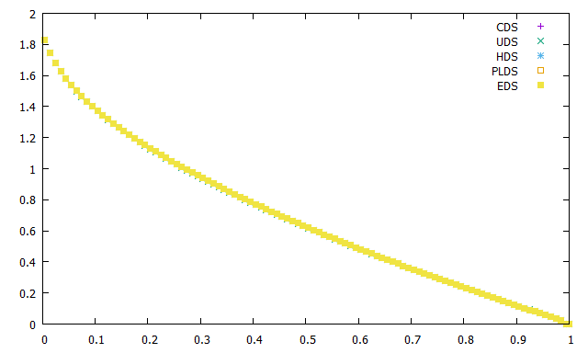

Figure 1: $ρ/Γ=10$

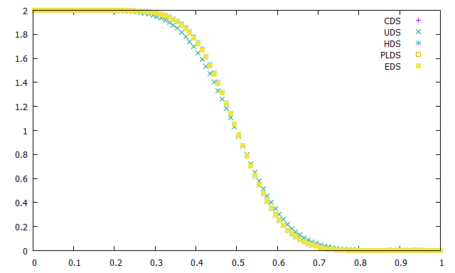

Figure 2: $ρ/Γ=10^{3}$

In Figure 2 and Figure 3 the results of CDS are not represented because this method diverges and no results are obtained. The results for all the other methods are represented, but they cannot be seen because the different methods have similar results.

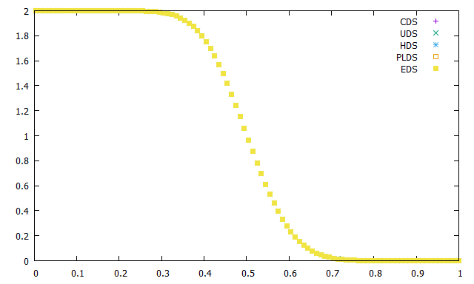

Figure 3: $ρ/Γ=10^{6}$

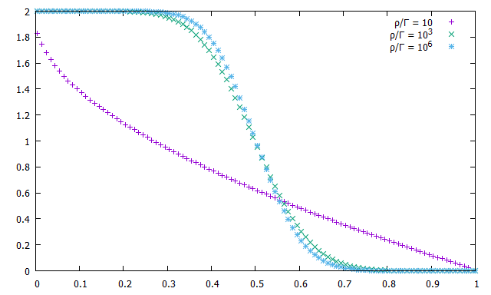

Figure 4: Comparison of the results for the different $ρ/Γ$ values using UDS

As the value of $ρ/Γ$ increases, the difference between the values of the inlet and the outlet increases, and the curve becomes more vertical.

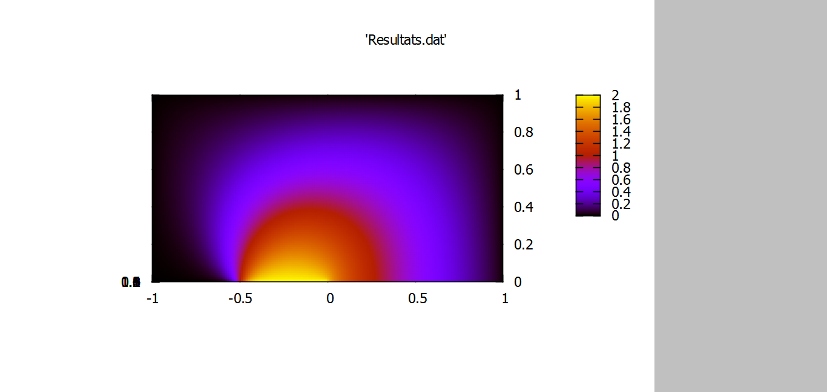

Figure 5: $ρ/Γ=10$ (UDS)

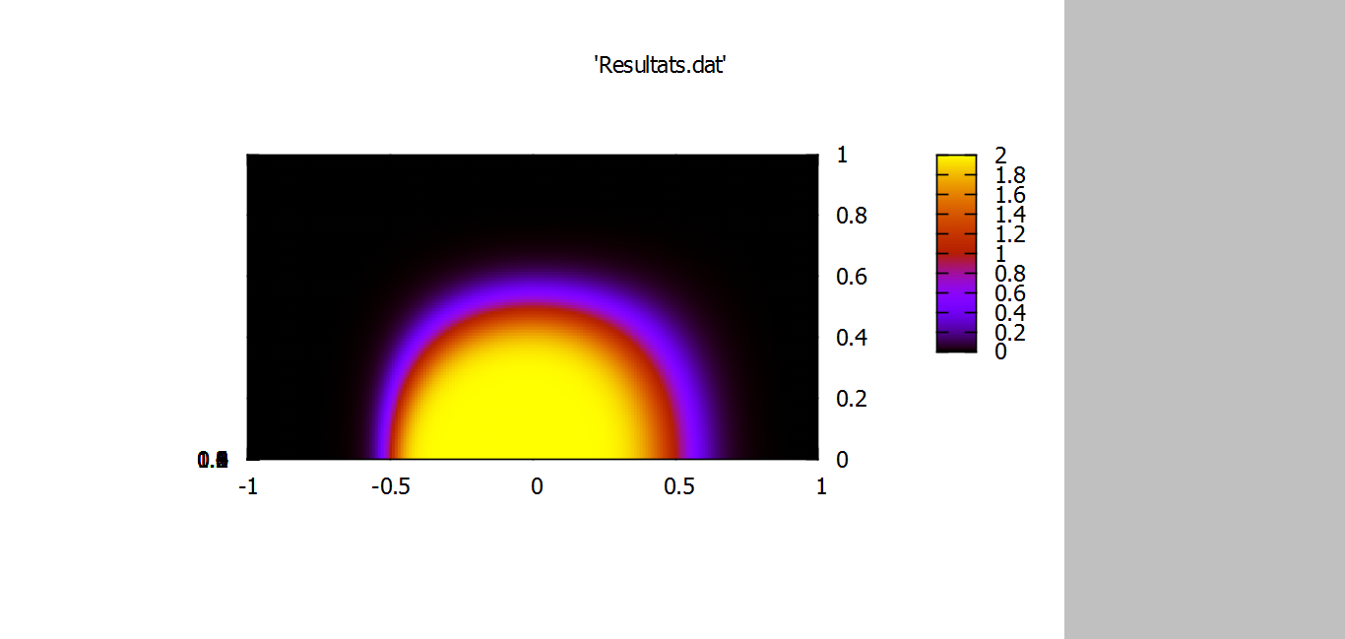

Figure 6: $ρ/Γ=10^{3}$ (UDS)

In Figure 5, Figure 6 and Figure 7, the results are plotted for the whole domain of the problem. The method used was UDS. In the three cases, the maximum value of $ϕ$ is always at the bottom, near $x = 0$.

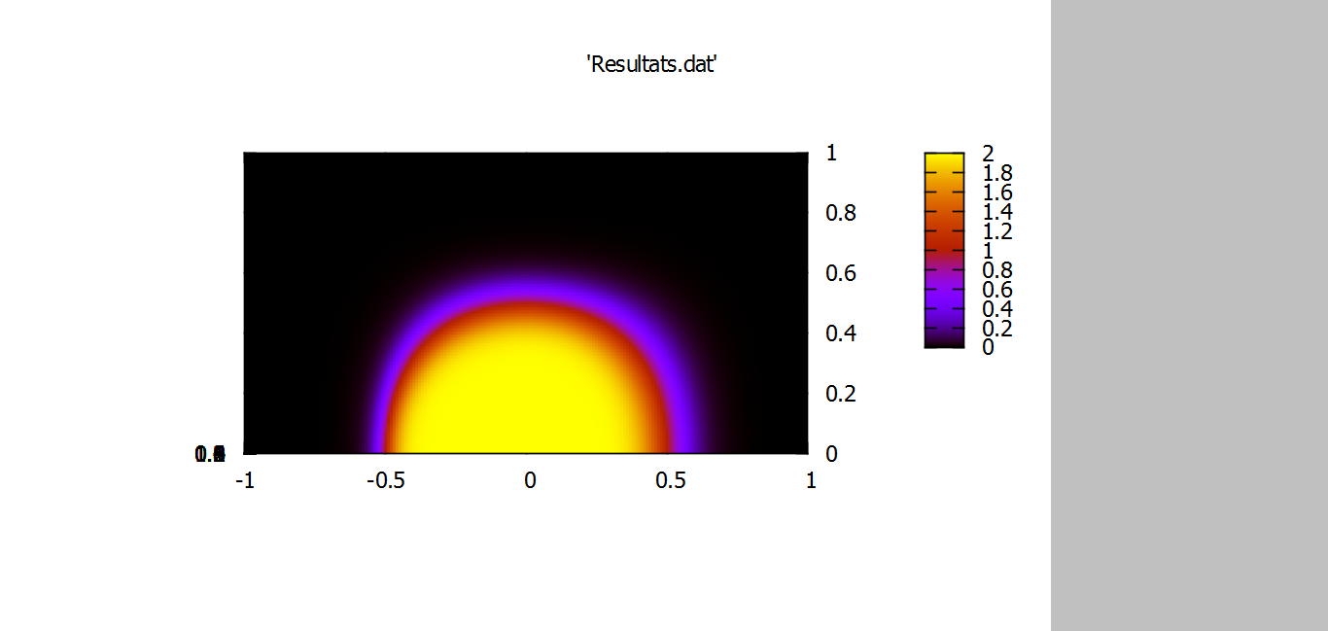

Figure 7: $ρ/Γ=10^{6}$ (UDS)