challenge

#load packages  
library(tidyverse)

## Loading tidyverse: ggplot2  
## Loading tidyverse: tibble  
## Loading tidyverse: tidyr  
## Loading tidyverse: readr  
## Loading tidyverse: purrr  
## Loading tidyverse: dplyr

## Conflicts with tidy packages ----------------------------------------------

## filter(): dplyr, stats  
## lag(): dplyr, stats

# read the data and save it as an object  
dat <- read.csv("data.csv")  
  
# create plot of oxygen by depth   
O2_plot <- quickplot(data=dat,  
 x=O2_uM,   
 y=Depth_m,   
 colour=Season,   
 main="Saanich Inlet: Seasonal oxygen depth profile")  
O2_plot

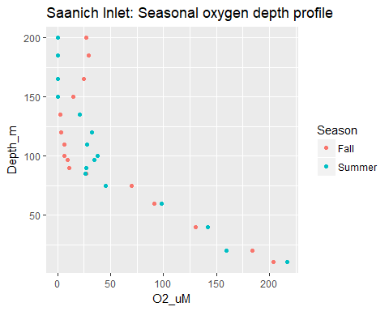

# save the plot   
ggsave("O2_plot.png")

## Saving 5 x 4 in image

###Change the axes  
O2_plot1 <- quickplot(data=dat,  
 x=O2_uM,   
 y=Depth_m,   
 colour=Season,  
 xlab="Oxygen",  
 ylab="Depth profile",  
 main="Saanich Inlet: Seasonal oxygen depth profile")  
O2_plot1

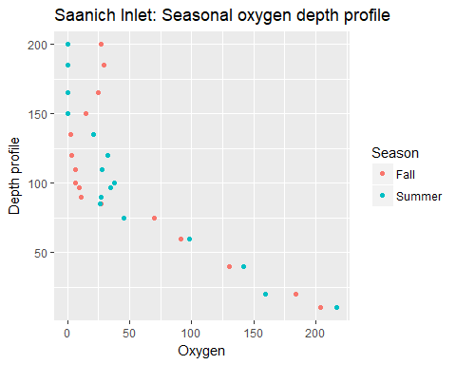

# save the plot   
ggsave("O2_plot1.png")

## Saving 5 x 4 in image

## R Markdown

This is an R Markdown document. Markdown is a simple formatting syntax for authoring HTML, PDF, and MS Word documents. For more details on using R Markdown see <http://rmarkdown.rstudio.com>.

When you click the **Knit** button a document will be generated that includes both content as well as the output of any embedded R code chunks within the document. You can embed an R code chunk like this:

summary(cars)

## speed dist   
## Min. : 4.0 Min. : 2.00   
## 1st Qu.:12.0 1st Qu.: 26.00   
## Median :15.0 Median : 36.00   
## Mean :15.4 Mean : 42.98   
## 3rd Qu.:19.0 3rd Qu.: 56.00   
## Max. :25.0 Max. :120.00

## Including Plots

You can also embed plots, for example:



Note that the echo = FALSE parameter was added to the code chunk to prevent printing of the R code that generated the plot.