Activity 11: Production-Ready Code: Documentation
Laura Rodriguez — AI Driven App Development

What changed from the Activity 10 MVP
Starting from my Activity 10 app.py, I refactored (PEP 8 import groups, DATA_DIR constant used everywhere, docstrings on every function), added fail-fast configuration checks that run before any work starts, moved the Settings lines inside the cached get_query_engine(api_key) function so the embedding model loads only once, passed the validated API key directly into GoogleGenAI, and wrapped both the engine build (fail fast) and each query (fallback) in try/except. One note: the slides use gemini-2.5-flash, but that model is no longer available to new API users (Google's API returns 404 and recommends gemini-3.8-flash), so my app uses gemini-3.8-flash.

The checks
Check | What it protects against | Where in my code | Fail fast or fallback?
API key | Missing or misnamed GEMINI_API_KEY in .env | get_api_key(), lines 14–23 | Fail fast (st.error + st.stop)
Data folder exists | Renamed, moved, or missing data/ folder | validate_data_dir(), lines 26–33 | Fail fast (st.error + st.stop)
Data folder has documents | Empty folder; hidden files like .DS_Store are ignored so they can't fake a non-empty folder | validate_data_dir(), lines 34–41 | Fail fast (st.error + st.stop)
Engine build | Corrupt PDF, failed embedding-model download, or any indexing error after the config checks pass | try/except around get_query_engine(), lines 61–69 | Fail fast (st.error + st.stop)
Per-question query | Rate limits, dropped Wi-Fi, or API errors on a single question — one bad request must not kill the app | try/except around query_engine.query(), lines 85–97 (APIError caught first, catch-all Exception last) | Fallback (st.error only, no st.stop; user can ask again)

Breaking it on purpose (screenshots)
For each test I stopped the app, made the change, and restarted with uv run streamlit run app.py, since a running app keeps the old key in memory and the old engine in its cache.
- Renamed GEMINI_API_KEY in .env:
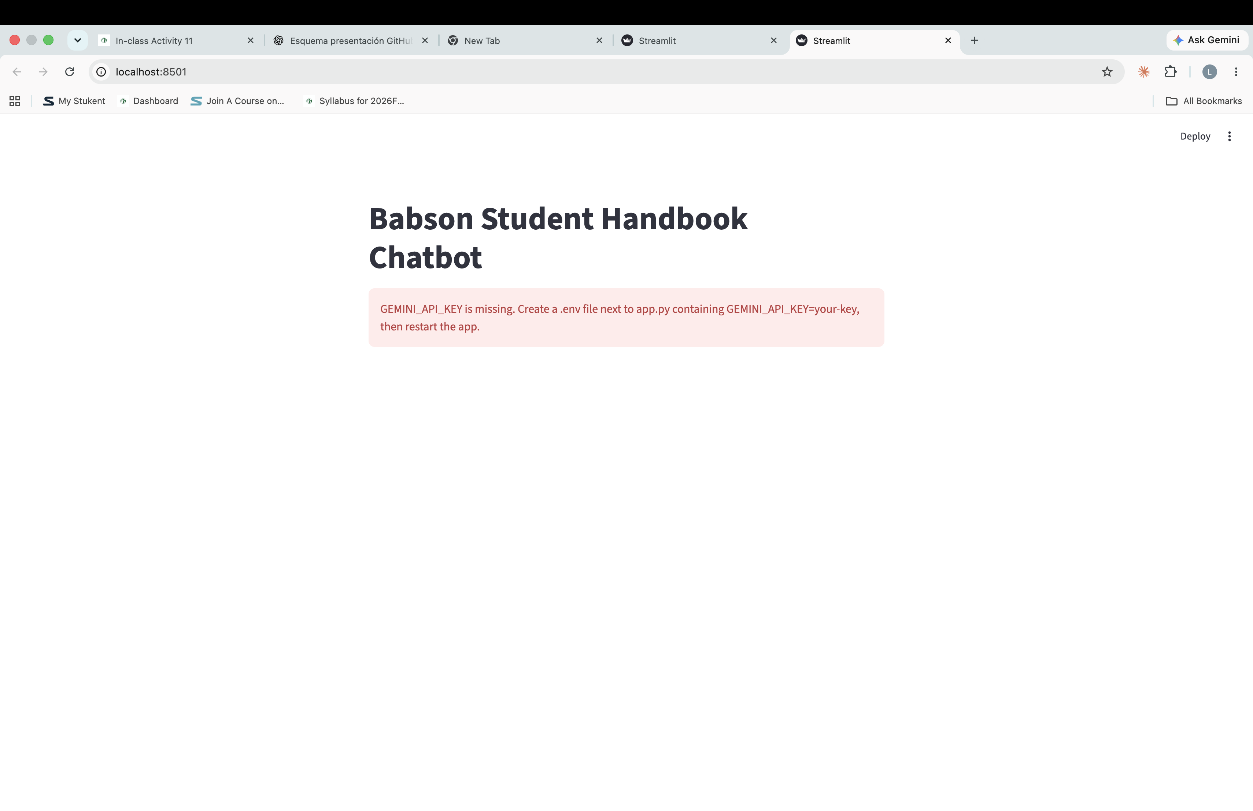
- Renamed the data folder:
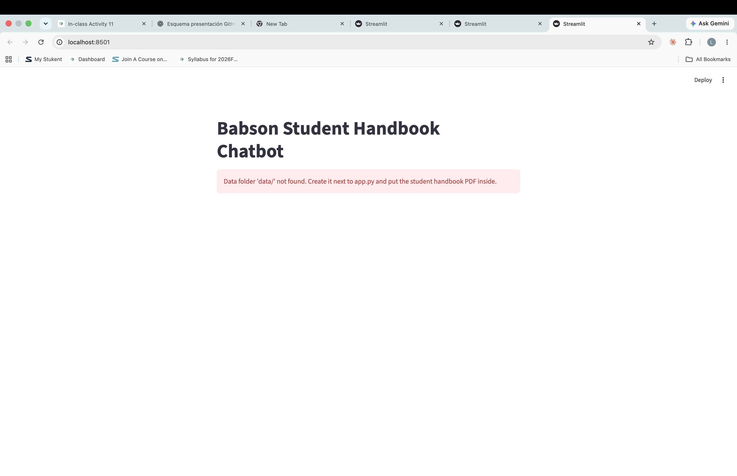
- Emptied the data folder:
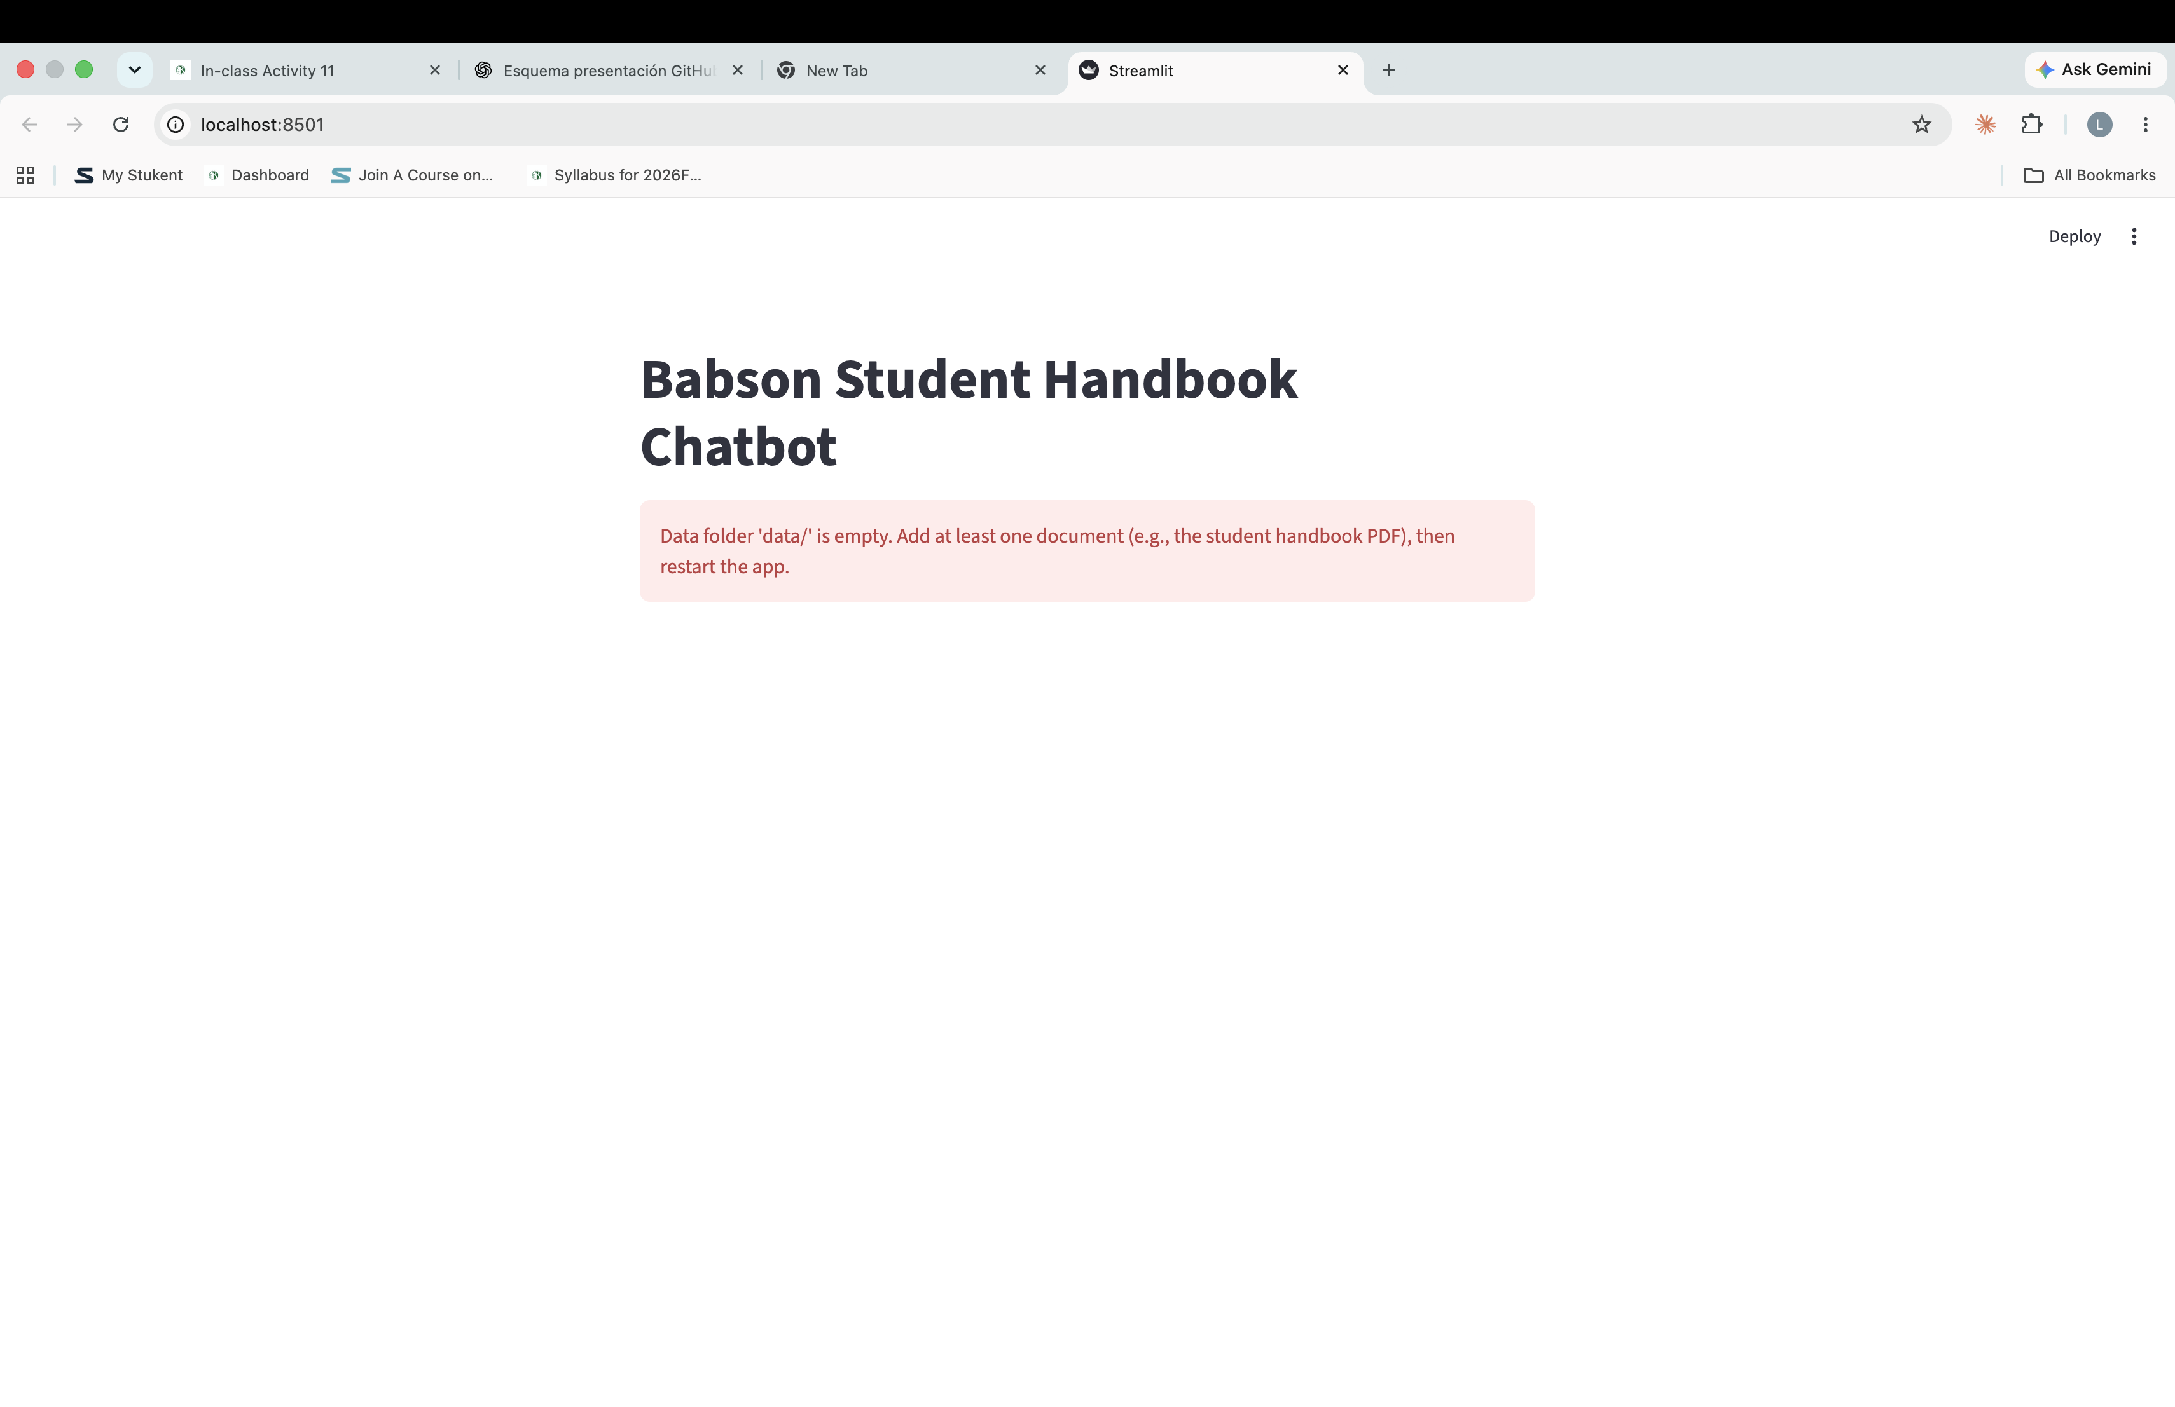
- Turned off Wi-Fi and asked a question:
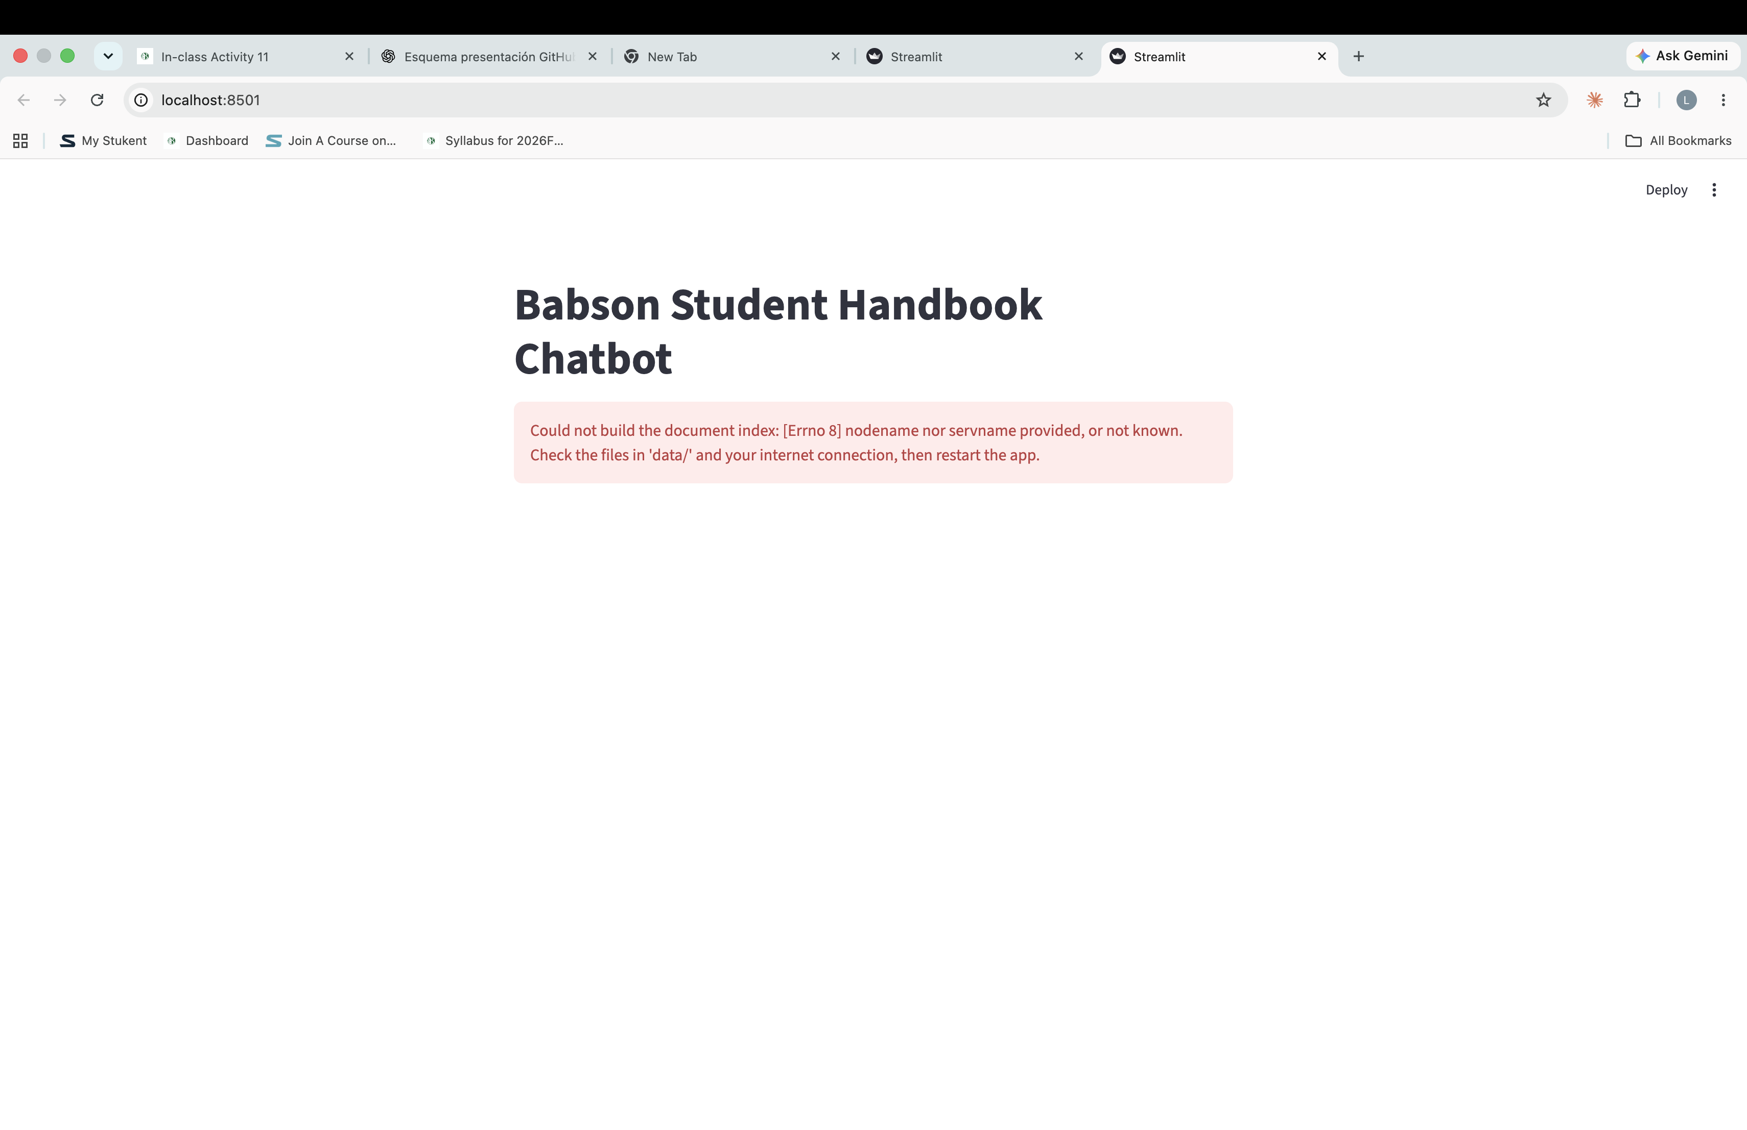

Stretch goals
Chat history with st.session_state + st.chat_message and a spinner while the query runs were already part of my Activity 10 app, and both survive the refactor. I did not persist the index to disk; the cached engine already avoids re-embedding within a session.

