Activity 10

RAG Chatbot: Observations
Laura Rodriguez, AI Driven App Development

Setup
I built a RAG chatbot with Streamlit and LlamaIndex that answers questions about the Babson undergraduate student handbook. The handbook is indexed locally with the BAAI/bge-small-en-v1.5 embedding model, and the final question-answering call goes to Google's Gemini (gemini-3.8-flash — the slides' gemini-2.5-flash is no longer available to new API users). I then asked the same three questions to my chatbot and to ChatGPT.

Screenshots
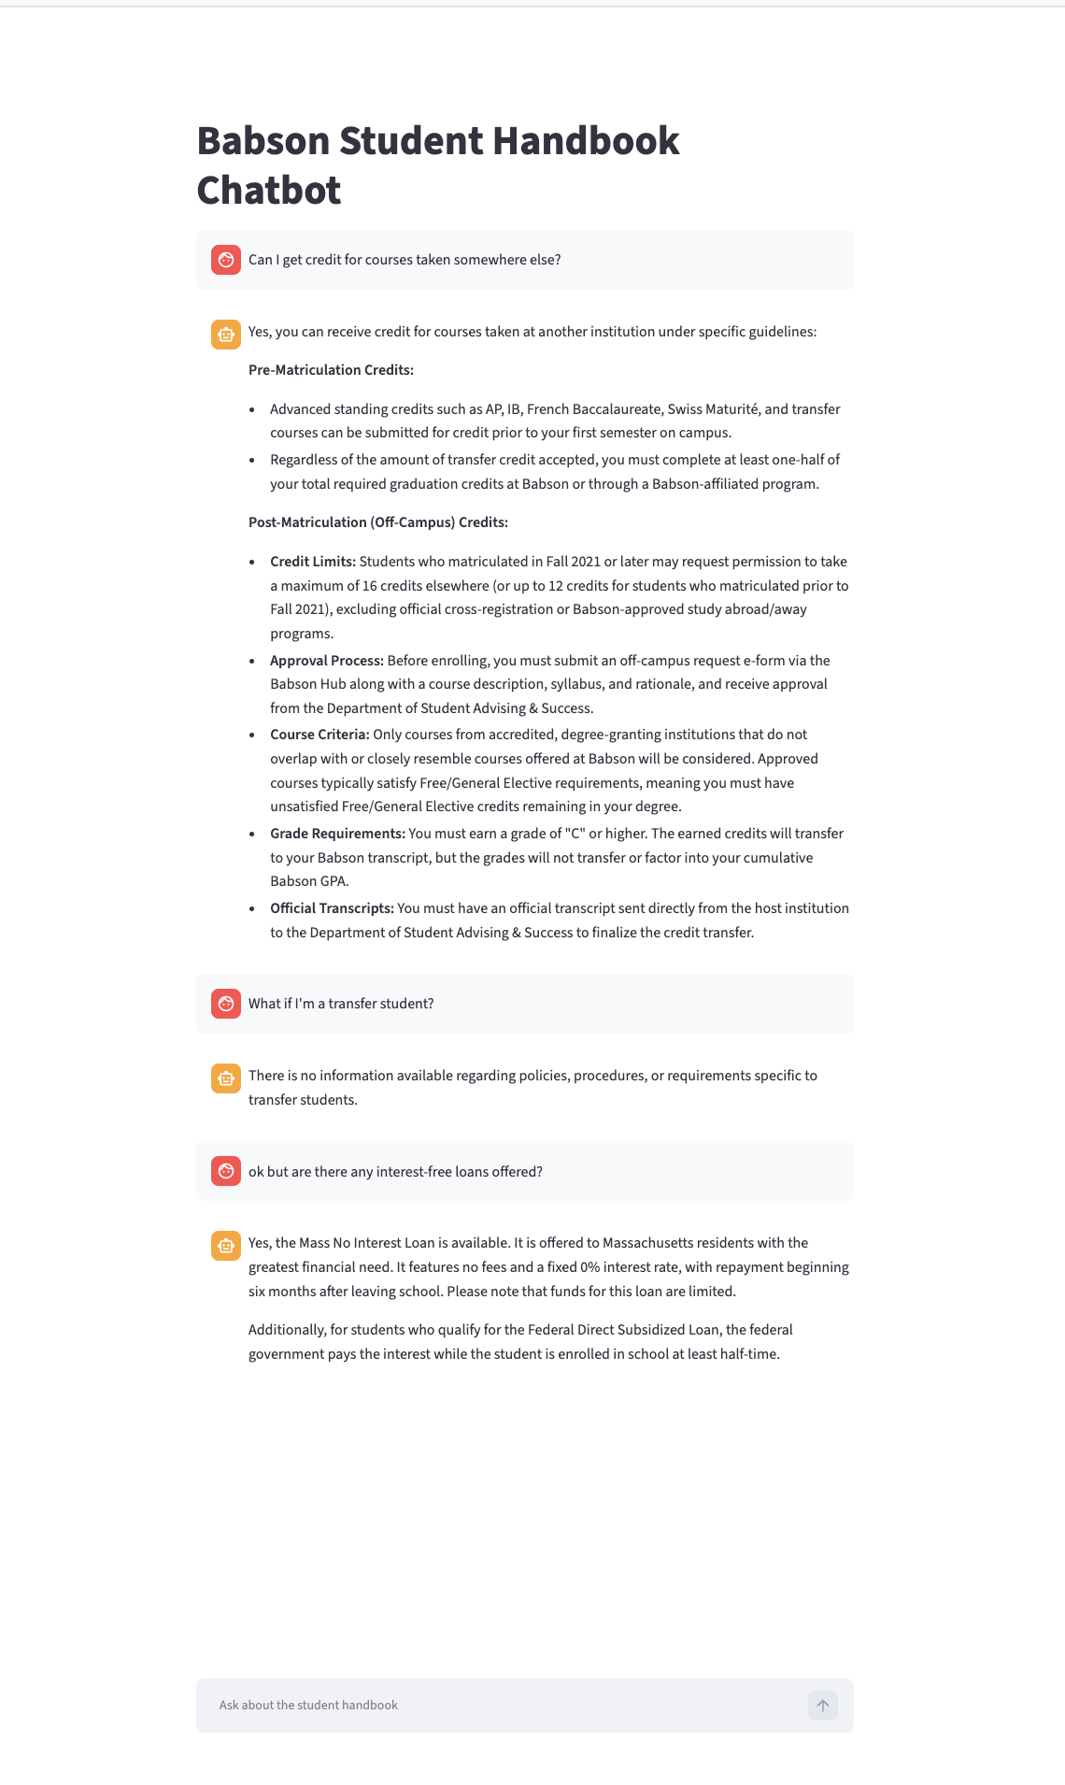 | 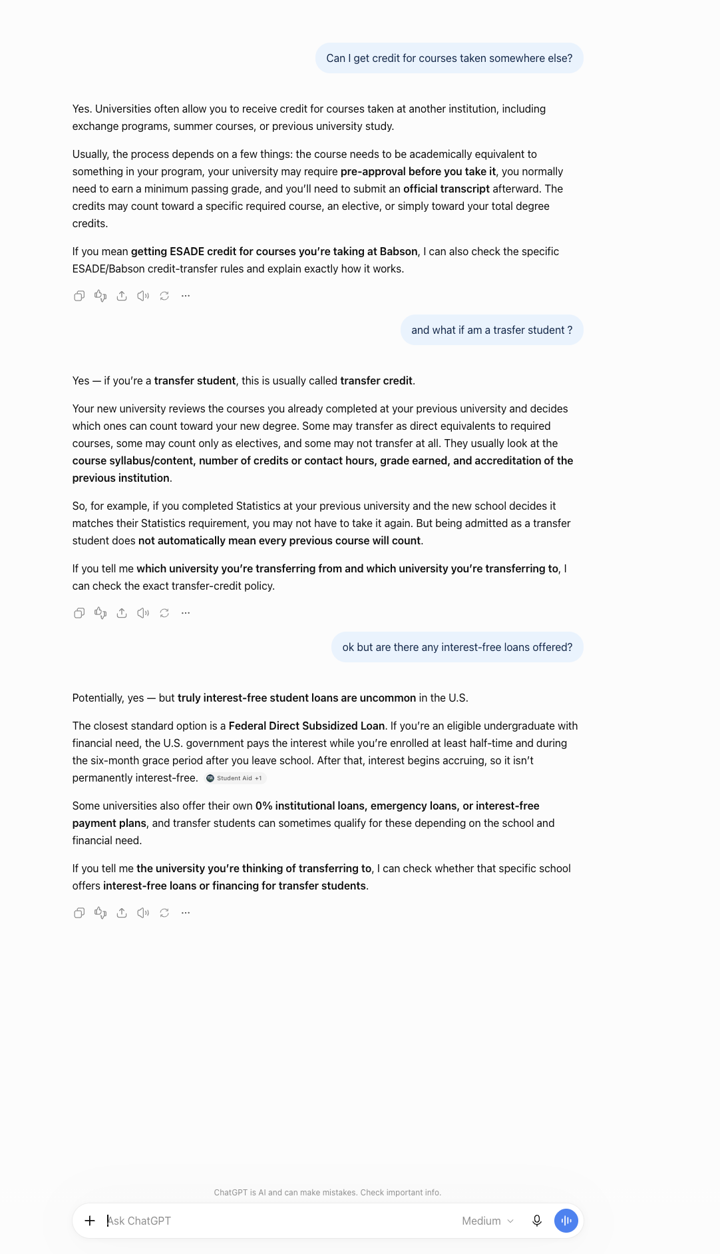

Observations
Specificity. My chatbot answered from the actual handbook: it cited the 16-credit maximum for off-campus courses (12 for pre-Fall 2021 matriculation), the off-campus request e-form on the Babson Hub, the minimum grade of C, and the Department of Student Advising & Success. For the loan question it named the Mass No Interest Loan with its exact terms (0% fixed rate, no fees, Massachusetts residents with greatest need, repayment starting six months after leaving school). ChatGPT's answers were correct but generic, "universities often allow...", the Federal Direct Subsidized Loan, because it has never seen Babson's handbook and can only describe how schools work in general.
The follow-up question. This is where the two bots flipped. When I asked my chatbot "What if I'm a transfer student?" right after the credit question, it answered "There is no information available regarding policies, procedures, or requirements specific to transfer students" even though the handbook mentions transfer students dozens of times. My app sends only the current question to the query engine, so the retrieval step had no idea the conversation was about transfer credit; the question alone was too vague to retrieve the right pages. ChatGPT handled the same follow-up smoothly, because it receives the whole conversation history with every message and understood the question continued the previous one.
Other kinds of context. Interestingly, ChatGPT also brought in context I never gave it in this conversation: it suggested checking "ESADE credit for courses you're taking at Babson," pulling my schools from its stored user memory, and it used web search for the loan question. So, the general chatbot compensates for not having the document with other context sources, but it still could not quote a single actual handbook policy.

Reflection: how do LLMs handle the "memory problem"?
LLMs themselves are stateless, every API call starts from zero. Chat applications create the illusion of memory by re-sending the entire conversation history inside every request, so the model re-reads the whole chat each time it answers. In longer chats this growing prompt eventually hits the context-window limit, so products like ChatGPT also summarize older turns and keep separate stored "memories" about the user (which is how it knew about Babson and ESADE).
My chat bot doesn’t have memory, but it looks like it does. I store every message in st.session_state and redraw them on each rerun, so the screen shows a conversation. But the line that actually answers is get_query_engine().query(question), it sends only the current question, never the history. The transfer-student follow-up exposed exactly that gap: my bot displays memory without having it.

