Activity 12: The Hugging Face Ecosystem
Laura Rodriguez - AI Driven App Development

Part 1: Explore the Hub

1. The four main sections
Models is a registry of hundreds of thousands of pretrained models you can download or call, each with a model card, files, and license; it matters because you can start from a working model instead of training one from scratch.
Datasets hosts ready-to-load datasets (text, audio, images) with documentation of where the data came from; developers care because training and evaluating models is impossible without good data, and these come in a standard format one line of code can load.
Spaces are small hosted web apps (usually Gradio or Streamlit) that demo models in the browser; they matter because you can try a model on your own inputs, or share your own demo, without installing anything.
Docs is the documentation for the Hugging Face libraries (transformers, datasets, hub client, etc.); it matters because it shows the exact code patterns, like pipeline(), that turn a Hub model into working Python.

2. A model I already use: BAAI/bge-small-en-v1.5
License: MIT — a very permissive license that allows commercial use, modification, and redistribution with attribution.
What it's for: the model card describes it as an English text-embedding model that maps sentences to vectors for retrieval and similarity tasks, exactly the job it does in my RAG chatbot, where it embeds the student-handbook chunks and my questions. This was used for a previous course in my home university.

Part 2: Licenses

3. A hypothetical GPL 3.0 model (big_finance_predictor)
(a) Internal use only: no problem. GPL obligations trigger on distribution, and running software inside the team for our own analysis is not distribution, so we owe nothing beyond complying when we got it.
(b) Behind our web app: under GPL 3.0 this is still generally safe — users interacting with our app over the network only see results, and we never hand them the software, so plain GPL's copyleft is not triggered (this is the well-known 'SaaS loophole'; it is exactly what the stricter AGPL license exists to close, so we would double-check the license really is GPL and not AGPL).
(c) Packaged in software we sell or give to customers: this is distribution, so the copyleft kicks in, we must license our combined work under GPL 3.0 and give customers the source code. For a commercial product that usually makes a GPL model a deal-breaker, and we would pick a permissively licensed alternative instead.

4–5. A real finance model and its license
I picked mrm8488/distilroberta-finetuned-financial-news-sentiment-analysis, whose license tag says apache-2.0. Apache 2.0 is one of the common permissive licenses from the article: it allows commercial use, modification, and redistribution (with attribution and a patent grant), and mainly restricts you from using contributors' trademarks or suing over the included patent rights. That means my team could ship it inside our app, commercially, without open-sourcing our own code.
Interestingly, the most famous finance model, ProsusAI/finbert, has no license tag on its model card and no LICENSE file in its repository. No license means the default rules of copyright apply: we have no granted rights at all, so legally we cannot redistribute it or build a product on it without getting permission from the authors — a good reminder that popular does not mean usable.

Part 3: Try a Model

6. My pick for our project
Model | mrm8488/distilroberta-finetuned-financial-news-sentiment-analysis
Task | Text classification (financial sentiment: positive / negative / neutral)
Size | model.safetensors is 328 MB — easily fits on a laptop
License | Apache 2.0
Popularity | ~271,000 downloads last month, 479 likes, 100+ Spaces using it
Feature it could power | In our stock-analysis app: classify the sentiment of news headlines for a ticker and show a sentiment signal next to the price chart — a narrow, repeatable task that runs locally and free, while Gemini handles the open-ended explanation.

7. Model card vs. a Space
On the model card, Hugging Face provides an inference panel (built by HF, served through its Inference Providers): a bare text box where you type one sentence. When I pressed Generate it did not work, I got 'You have no remaining credits for Inference Providers.' The panel runs on paid hosted inference, and a free account's small credit allowance runs out, so the official way to try the model failed for me.
The Space I tried, Kush27/news-based-stock-analyser, is built by a community member and wraps the model in a whole workflow: instead of classifying my sentence, it takes an asset name, fetches recent real news articles about it, and classifies each one. It was free and worked, though noticeably slower than a text box because it fetches live news first. I ran it twice, and the query mattered as much as the model: searching my full test headline surfaced the drug-trial coverage (almost all negative, including a Reuters headline nearly identical to my test sentence), while searching just 'Novo Nordisk' returned today's broader mix — buyback news positive, 'down more than 70% from its peak' negative, Jim Cramer commentary neutral. The model was also not perfectly consistent: one run labeled 'Novo Nordisk Stock Plunges After Disappointing Obesity Drug Data' neutral while nearly identical 'plunge' headlines were negative, the same overconfidence issue I saw locally with my Apple headline.
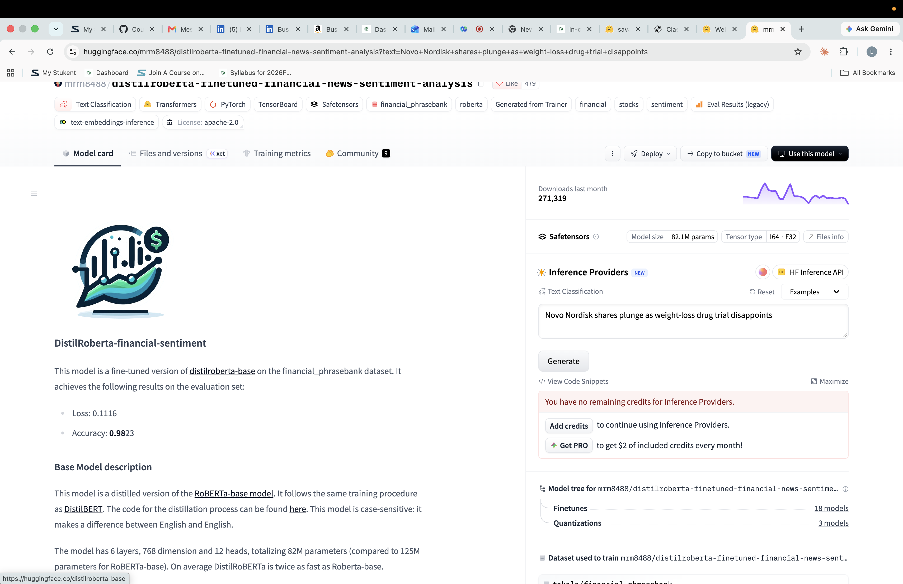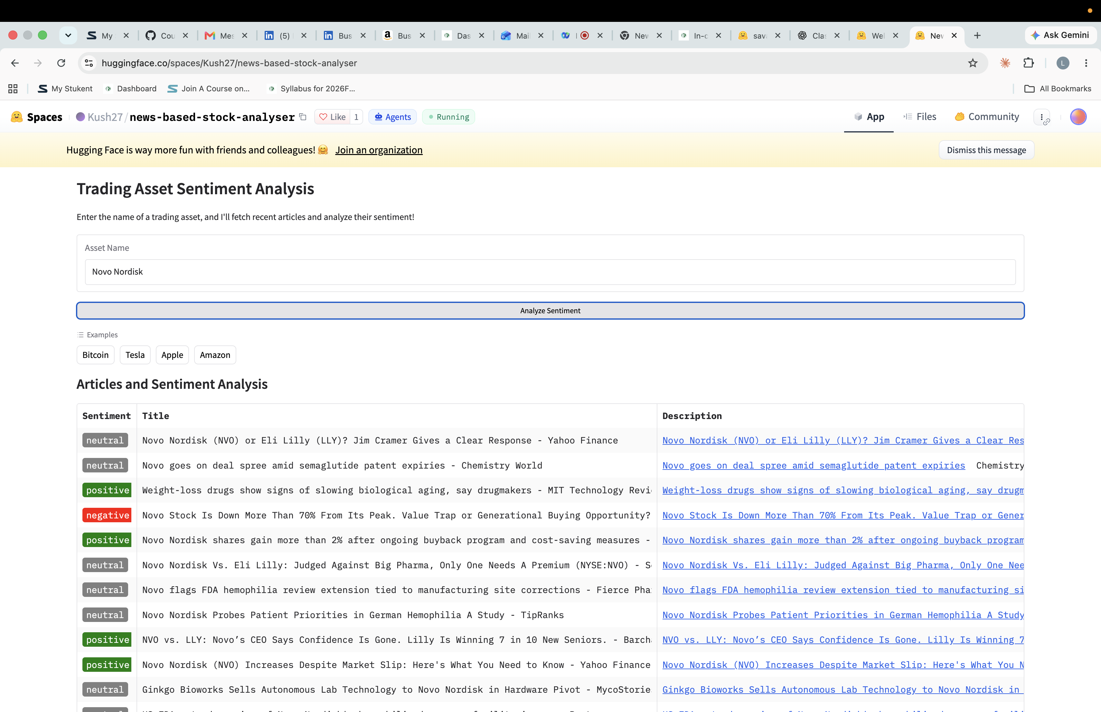

8. Why do Spaces break?
1) Spaces run on free, shared hardware that sleeps when idle — a cold start has to re-download and reload the model, which looks like the Space hanging. 2) The Space's code pins old library versions; when dependencies or the underlying model files change, the app crashes on startup. 3) They are community-built demos, not maintained products — the author may have deleted the model, renamed it, or hit usage limits (free CPU quotas, API rate limits) that silently kill it. A fourth: many Spaces call the hosted inference API behind the scenes, so when the provider stops serving that model, the Space breaks through no fault of its own.

Part 4: Run It Locally
Project setup: uv init hf-explore, then uv add transformers torch. My main.py runs my chosen model on three headlines:
from transformers import pipeline

MODEL = "mrm8488/distilroberta-finetuned-financial-news-sentiment-analysis"

classifier = pipeline("text-classification", model=MODEL)

headlines = [
"Eli Lilly raises full-year guidance after strong obesity-drug sales",
"Novo Nordisk shares plunge as weight-loss drug trial disappoints",
"Apple reports quarterly revenue roughly in line with expectations",
]

for headline, result in zip(headlines, classifier(headlines)):
print(f"{result['label']:>8} ({result['score']:.1%}) {headline}")

Output of uv run main.py:
positive (100.0%) Eli Lilly raises full-year guidance after strong obesity-drug sales
negative (99.9%) Novo Nordisk shares plunge as weight-loss drug trial disappoints
positive (99.9%) Apple reports quarterly revenue roughly in line with expectations

Reflection
The first run took about 46 seconds and the second about 5, because the first run downloads the 328 MB model from the Hub and caches it on disk; after that only loading and inference remain. The results match what the model is supposed to do, though not perfectly: the two clearly directional headlines were classified correctly with near-100% confidence, but the deliberately neutral Apple headline ('roughly in line with expectations') came back positive at 99.9%, which shows the model overcommits on borderline cases — worth remembering before trusting the confidence scores in our app.
Compared to the Space: my local run and the Space agreed on the Novo Nordisk story (negative — the Space's Reuters headline 'Novo Nordisk shares plunge after CagriSema obesity drug trial disappoints' was nearly identical to my test sentence and also came out negative), but locally I control exactly which text gets classified and it costs nothing, while the Space classifies whatever articles its news search returns on someone else's hardware.

Part 5: Put It in an App
My app.py loads the pipeline once with @st.cache_resource, takes a headline with st.text_input, and shows the label with an emoji and a confidence bar instead of the raw list of dictionaries. For robustness (Activity 11 style) it fails fast if the model cannot load, warns on whitespace-only input, and wraps the model call in try/except so one bad input cannot crash the app:
import streamlit as st
from transformers import pipeline

MODEL = "mrm8488/distilroberta-finetuned-financial-news-sentiment-analysis"

EMOJI = {"positive": "🟢", "negative": "🔴", "neutral": "⚪"}

@st.cache_resource(show_spinner="Loading the sentiment model (first run only)...")
def get_classifier():
"""Load the Hugging Face pipeline once per session."""
return pipeline("text-classification", model=MODEL)

st.title("Financial Headline Sentiment")
st.caption(f"Runs {MODEL} locally — no API, no cost")

# Fail fast: the app is useless if the model cannot load
try:
classifier = get_classifier()
except Exception as e:
st.error(
f"Could not load the model: {e}. "
"Check your internet connection for the first-run download, then restart."
)
st.stop()

headline = st.text_input("Enter a financial headline")

if headline:
# Robustness: ignore whitespace-only input
if not headline.strip():
st.warning("Please enter a real headline, not just spaces.")
else:
# Fallback: a failed classification should not kill the app
try:
result = classifier(headline)[0]
except Exception as e:
st.error(f"Classification failed: {e}. Try a shorter headline.")
else:
label = result["label"].lower()
st.subheader(f"{EMOJI.get(label, '')} {label.capitalize()}")
st.progress(result["score"], text=f"Confidence: {result['score']:.1%}")
elif headline == "":
st.info("Type a headline above, e.g. “Novo Nordisk shares plunge as trial disappoints”.")
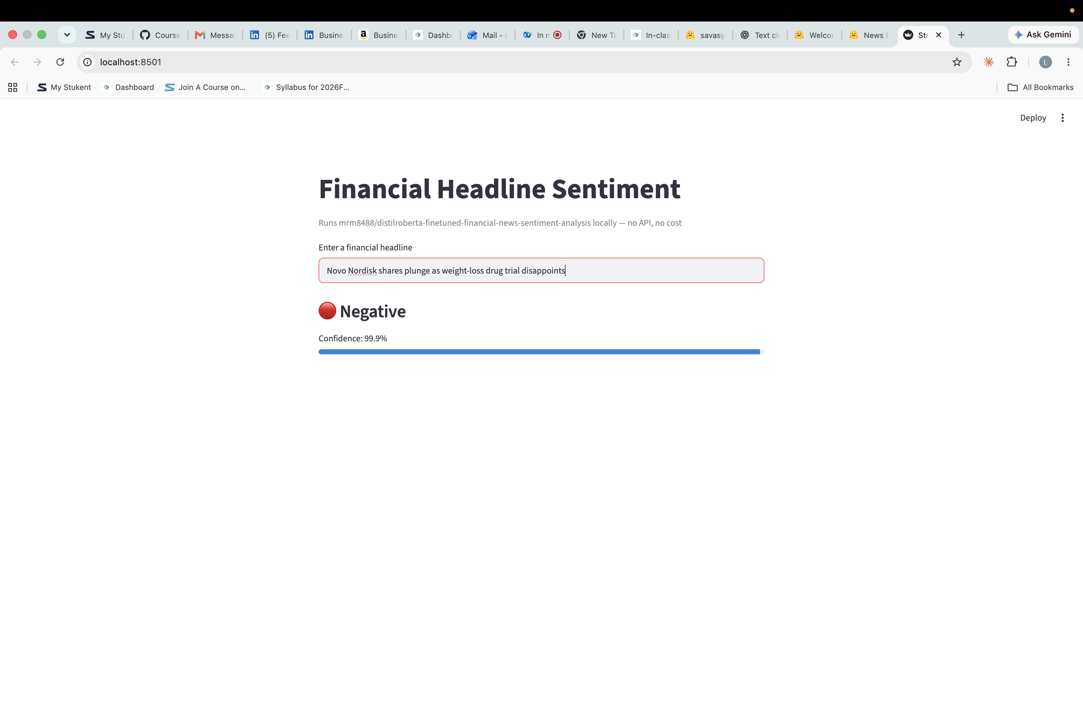

Stretch: combining the two kinds of AI
stretch.py classifies a headline locally, then sends the label, confidence, and headline to Gemini and asks it to explain the reading, the local model does the narrow repeatable task for free, and Gemini does the open-ended reasoning:
import os

from dotenv import load_dotenv
from google import genai
from transformers import pipeline

MODEL = "mrm8488/distilroberta-finetuned-financial-news-sentiment-analysis"

load_dotenv()

headline = "Novo Nordisk shares plunge as weight-loss drug trial disappoints"

classifier = pipeline("text-classification", model=MODEL)
result = classifier(headline)[0]
print(f"Local model: {result['label']} ({result['score']:.1%}) {headline}\n")

client = genai.Client(api_key=os.getenv("GEMINI_API_KEY"))
response = client.models.generate_content(
model="gemini-3.1-flash-lite",
contents=(
f"A local sentiment model classified this financial headline as "
f"{result['label']} with {result['score']:.0%} confidence: '{headline}'. "
"In 2-3 sentences, explain why investors might read it that way."
),
)
print("Gemini explains:", response.text)

Output of uv run stretch.py:
Local model: negative (99.9%) Novo Nordisk shares plunge as weight-loss drug trial disappoints

Gemini explains: Investors interpret this headline as negative because the
clinical trial disappointment directly threatens the company's future revenue
growth in the high-stakes weight-loss market. A significant share price
"plunge" signals a rapid loss of market confidence, reflecting investor fears
that the firm's competitive advantage or pipeline efficacy is weaker than
previously anticipated.

One practical note: gemini-3.8-flash was returning 503 'high demand' errors the whole session, so this script uses gemini-3.1-flash-lite — the lighter models tend to have spare capacity. Handling exactly this kind of failure is what Activity 11 was about.

