Politecnico di Milano AA 2018/2019



Usability Evaluation Report

*Hypermedia web applications*

Website address: <http://polimi-hyp-2019-team-10594805.herokuapp.com>

Ana Pesko – 904193 Jefimija Zivkovic – 916921 Laura Schiatti – 904738

Table of Contents

Usability evaluation 3

1. Usability heuristics 3
   1. Navigation 3
   2. Content 4
   3. Layout 4
   4. Inspection sheets 5

1.5. Mean usability heuristics results 12

1. User testing 12
   1. Preparation 13
   2. Execution 13
   3. Analysis of the results 14
2. Final section 18

# Usability evaluation

The subject of this usability evaluation is the Shelf Awareness Bookstore website, which can be found at:

The purpose of this document is to measure "the effectiveness, efficiency and satisfaction with which specified users can achieve specified goals in particular environments", or, to put it simply, to evaluate the easiness of the use of the website which is the subject of this report.

This will be done in two ways, by producing the usability heuristics and by completing user testing.

1. Usability heuristics

Inspection methods for usability have achieved widespread use in idustrial environments, and the most popular of them is the method of Heursitic evaluation, also called the expert review. Heuristics is a set of principles that guide in the discovery of usability flaws by using checklists and usability principles.

Bellow, we present all the heuristics used for the evaluation, with an overview of each one and it's explanation. For the purpose of this evaluation, the heuristics have been divided into three categories: navigation, content and layout. Afterwards the inspection sheets are given organized by pages evaluated.

If the heuristics is not applicable to the particular page, the score N/A is given. Other scores range from 0 to 5, where:

* 0 = the heuristic is NOT satisfied; severe violations have been detected
* 5 = the heuristic is FULLY satisfied; no severe violations have been detected
  1. Navigation

H1. Interaction consistency

This heuristic answers the question 'do pages of the same type have same links and interaction capability?' For example, this checks if pages /all_books.html and /all_authors.html have the same structure and the same interaction capability.

H2. Group navigation

This heuristic answers the question 'is it easy to navigate among group members and from a group introductory page to group members, and also vice versa, from group members to group introductory page?' For example, this checks if the group introductory page is located on the navigation bar of the website and it is easily accessible from every page.

H3. Structural navigation

This heuristic answers the question ' is it easy to navigate among the semantic components of a Topic?' Taking the example of a single book page, this checks how simple it is to navigate between its semantic components. More precisely, can the general descriptive information about the book (the author, price, abstract of the book and so on) be found at the top of the page, followed by the reviews of the book on the same page.

H4. Semantic navigation

This heuristic answers the question 'is it easy to navigate from a Topic to a related one?'

H5. Landmarks

This heuristic answers the question 'are landmarks useful to reach the key parts of the web site?'

* 1. Content

H6. Information overload

This heuristic answers the question 'is the information in a page too much, or too little perhaps?' This checks if the user will be overwhelmed by all the types of information on any single page, most importantly on the homepage.

* 1. Layout

H7. Text layout

This heuristic answers the questions ' is the text readable?', 'is font size appropriate?' This checks if all of the same types of components have the same font and font size. It also checks if the most important information is written in the largest and most highlighted font, followed by a smaller font for less important information.

H8. Interaction placeholder

This heuristic answers the question All the interaction labels with the user, directions when logging in or registering are clearly stated. The directions about inserting credentials for logging in are clearly visually expressed, and the user unified of any mistakes made textually.

H9. Spatial allocation

This heuristic answers the questions ' are textual or visual labels of interactive elements “expressive”? i.e. do they reflect the meaning of the interaction and its effects?',' are they consistent?'

H10. Consistency of page structure

This heuristic answers the question ' do pages of the same type have the same layout, i.e. same visual properties of each component and similar layout organization of the various elements?' For this heuristic to be met, all the topic groups have to have the same components and same lay-out marking them clearly as the groups of topics pages. Every topic needs to have a similar feel, taking into account the differences between the actual information needed to represent on the pages.

* 1. Inspection sheets
     1. *Home page*

|  |  |  |  |
| --- | --- | --- | --- |
| **CATEGORY** | **Heuristics** | **Score** | **Comment** |
| **Navigation** | H1 | 5 | Access to the same types of pages is the is  the same |
|  | H2 | 5 | Navigation bar is  present and makes it easy to access pages |
|  | H3 | 5 | Everything is structurally well  grouped |
|  | H4 | 4 | Yes, for example it is easy to navigate from sign in button to the  sign up button |
|  | H5 | 3 | Not particularly, haven’t noticed any landmarks, but also haven’t had the need  for them |
| Mean |  | 4.4 |  |
| **Content** | H6 | 4 | Yes, but I wish there was more information on the home page and I didn’t access  everything manually |
| **Layout** | H7 | 5 | Yes, all the components in the navigation bar have the same font as well as commands  concerning the user |
|  | H8 | 3 | Have not seen any  notifications about mistakes |
|  | H9 | 5 | Yes, components are very well grouped |
|  | H10 | 4 | Similar pages are shown in a similar way |
| Mean |  | 4.2 |  |

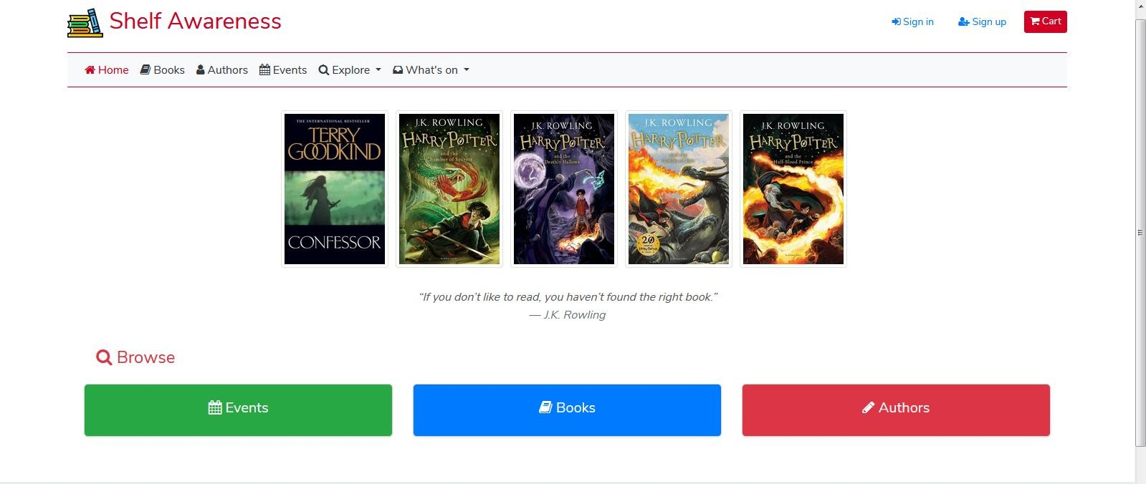

*Screenshot 1 Home page*

* + 1. *Login/Register page*

|  |  |  |  |
| --- | --- | --- | --- |
| **CATEGORY** | **Heuristics** | **Score** | **Comment** |
| **Navigation** | H1 | 3 | Don’t have access to  any other pages |
|  | H2 | 4 | Navigation easy, but  don’t have access to any other pages |
|  | H3 | 5 | Very easy to navigate through the  components |
|  | H4 | 5 | Quite easy navigation |
|  | H5 | 4 | Haven’t noticed any landmarks, but also  haven’t had the need for them |
| Mean |  | 4.2 |  |
| **Content** | H6 | 5 | The page has just the  right amount of information |
| **Layout** | H7 | 5 | The same groups of components are of the same font, very easy to  understand |
|  | H8 | 5 | Mistakes clearly stated as well as guidance for providing required  information |

|  |  |  |  |
| --- | --- | --- | --- |
|  | H9 | 5 | Visually components  well structured |
|  | H10 | 4 | Yes, pages have the same feel, similar in the way they ask for  information |
| Mean |  | 4.8 |  |

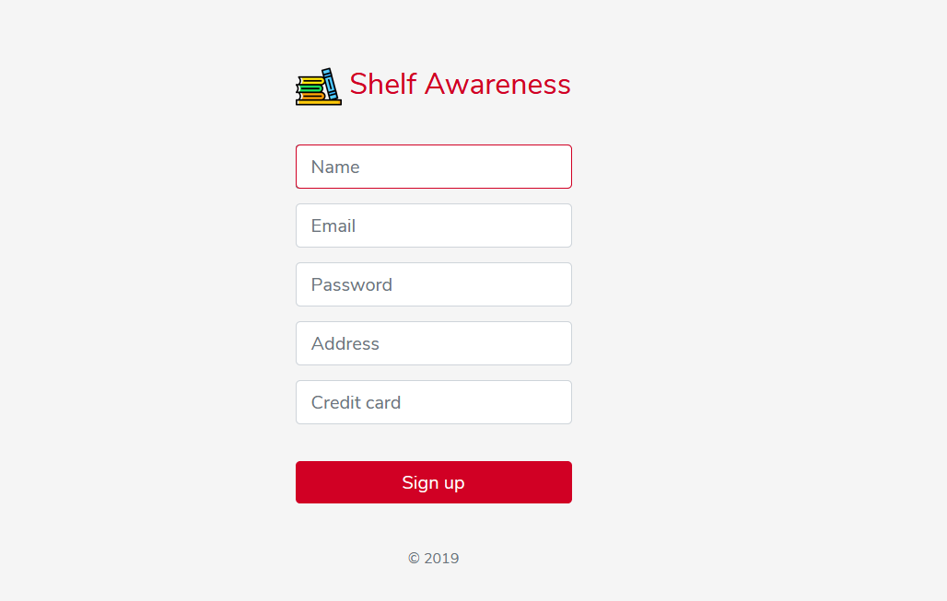

*Screenshot 2 Login page*

* + 1. *Cart page*

|  |  |  |  |
| --- | --- | --- | --- |
| **CATEGORY** | **Heuristics** | **Score** | **Comment** |
| **Navigation** | H1 | 5 | Access to the same  types of pages is the is the same |
|  | H2 | 5 | Yes, navigation bar present and easily  accessible |
|  | H3 | 5 | Very good semantic  navigation |
|  | H4 | N/A | Doesn’t have related |
|  | H5 | 5 | Present |
| Mean |  | 5 |  |
| **Content** | H6 | 5 | The page has just the right amount of  information |
| **Layout** | H7 | 5 | Good font distribution |
|  | H8 | 4 | On purchase page  reacts visually |
|  | H9 | 5 | Good spatial allocation |
|  | H10 | 4 | Yes, page has the same  feel as the rest of the website |
| Mean |  | 4.6 |  |

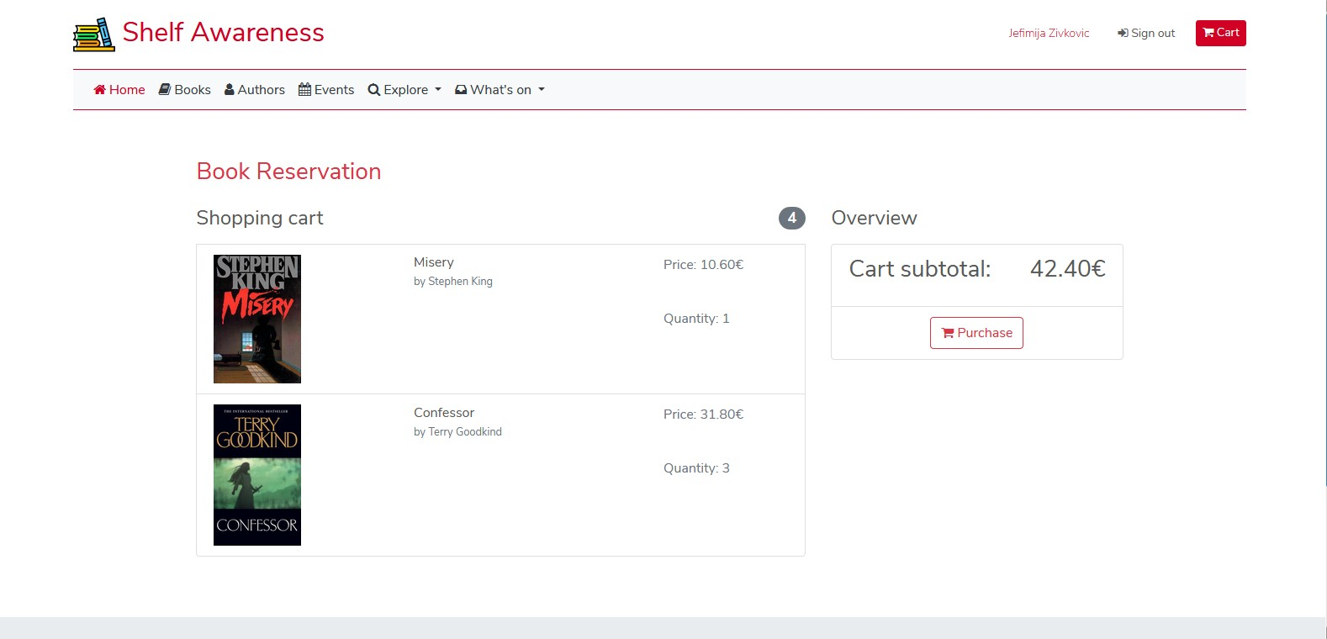

*Screenshot 3 Cart page*

* + 1. *All Books/Authors/Events/Themes/Genres page*

|  |  |  |  |
| --- | --- | --- | --- |
| **CATEGORY** | **Heuristics** | **Score** | **Comment** |
| **Navigation** | H1 | 5 | Access to the same  types of pages is the is the same |
|  | H2 | 5 | Yes, navigation bar present and easily  accessible |
|  | H3 | 5 | Very good structural  navigation |
|  | H4 | 5 | Yes, all the page links  are located in the navigation bar |
|  | H5 | 5 | Present |
| Mean |  | 5 |  |
| **Content** | H6 | 5 | Every page has just the right amount of  information |
| **Layout** | H7 | 4 | Some of the text is a  little small |
|  | H8 | N/A |  |
|  | H9 | 5 | Good spatial allocation |
|  | H10 | 5 | Yes, all of the pages  have the same feel as the rest of the website |
| Mean |  | 4.7 |  |

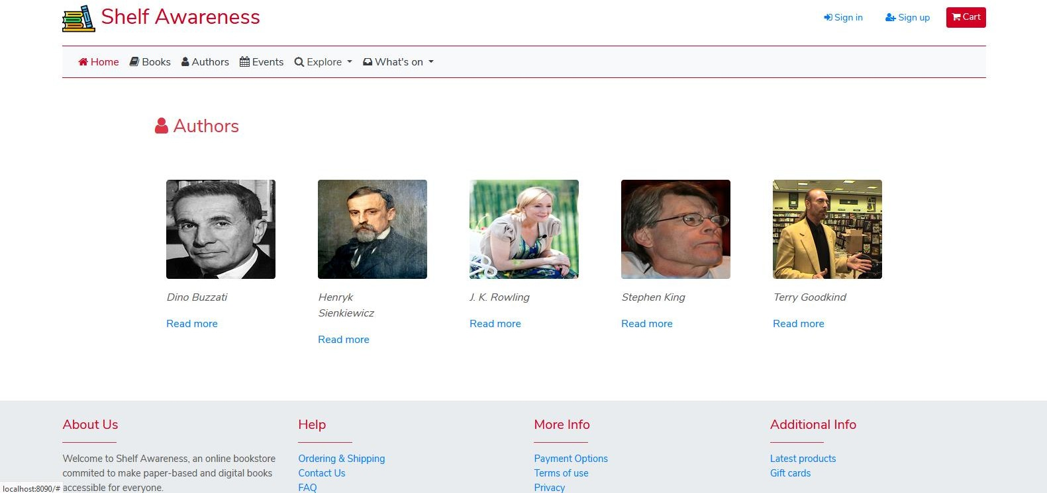

*Screenshot 4 Multiple topics page representative*

* + 1. *Single Book page*

|  |  |  |  |
| --- | --- | --- | --- |
| **CATEGORY** | **Heuristics** | **Score** | **Comment** |
| **Navigation** | H1 | 4 | Doesn’t have similar  pages but acceptably similar to other pages |
|  | H2 | 5 | Yes, navigation bar present and easily  accessible |
|  | H3 | 5 | Very good structural  navigation |
|  | H4 | 5 | Yes, all the page links  are located in the navigation bar |
|  | H5 | 5 | Present |
| Mean |  | 4.8 |  |
| **Content** | H6 | 5 | Every page has just the right amount of  information |
| **Layout** | H7 | 4 | Some of the text is a  little small |
|  | H8 | 3 | Doesn’t notify on cart  additions |
|  | H9 | 4 | Carousels on the same  side |
|  | H10 | 5 | Yes, page has the same  feel as the rest of the website |
| Mean |  | 4.2 |  |

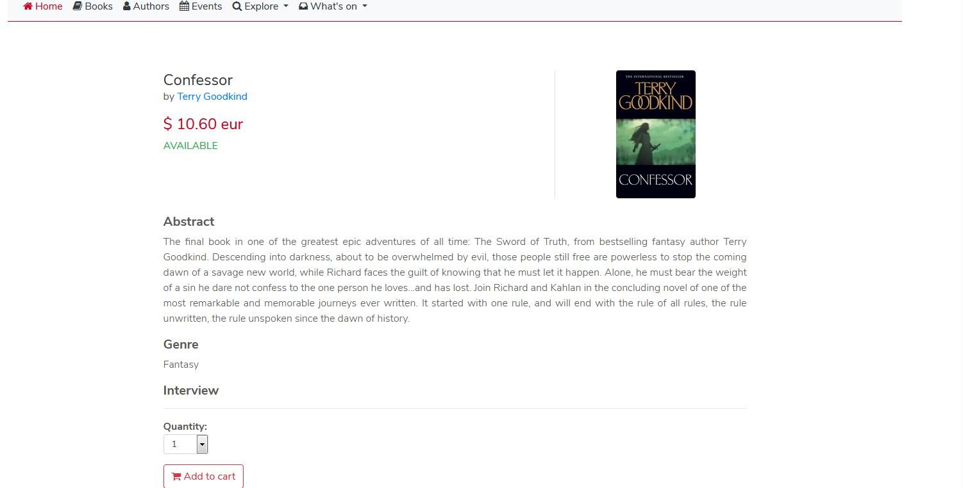

*Screenshot 5 Single book page*

* + 1. *Single Author/Event page*

|  |  |  |  |
| --- | --- | --- | --- |
| **CATEGORY** | **Heuristics** | **Score** | **Comment** |
| **Navigation** | H1 | 5 | Access to the same types of pages is the is  the same |
|  | H2 | 5 | Yes, navigation bar  present and easily accessible |
|  | H3 | 5 | Very good structural  navigation |
|  | H4 | 5 | Yes, all the page links  are located in the navigation bar |
|  | H5 | 5 | Present |
| Mean |  | 5 |  |
| **Content** | H6 | 5 | Every page has just the  right amount of information |
| **Layout** | H7 | 4 | Some of the text is a little small |
|  | H8 | N/A |  |
|  | H9 | 5 | Good spatial allocation |
|  | H10 | 5 | Yes, pages have the same feel as the rest of  the website |
| Mean |  | 4.7 |  |

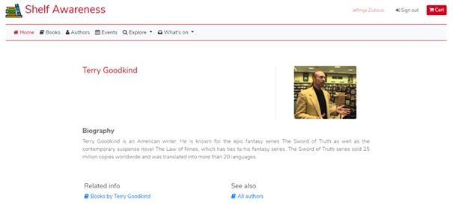

*Screenshot 6 Single Author page*

1.5. Mean usability heuristics results

The aggregated results from the inspection sheets are shown below.

Navigation Content Layout

Cart

Multiple topics

Single topic

Login/Register

Home

6

5

4

3

2

1

0

Mean heuristic scores

*Chart 1 Mean heuristics score*

1. User testing

The user testing evaluation takes a completely different approach in evaluating a web application. Here, the focus is not on experts of the field, rather, the focus is on everyday ordinary users. The goal is to measure their response to the website, by recording their behavior and analyzing it.

The problems with the evaluation presented above, are that sometimes the experts forget to view a website with ''fresh eyes''. They are comfortable, experienced users themselves, and something that is glaringly obvious to them, may not be so for someone less experienced. This is why it is important to do user testing as well – we want to uncover actual difficulties users have when interacting with the application.

User testing answers the following questions, and more:

* Can users *complete* the expected tasks?
* Can they do it in *acceptable* times?
* What *difficulties* do they encounter?
* What is their *perception* of these difficulties?

The general process of a user testing evaluation is done in three "phases". First comes the preparation phase, where the time, scope, samples, materials, technology are defined. User profiles are analyzed and it is decided how and which users to recruit, based on user goals. Recruiting the ''right'' users is crucial for the usefulness of the results. The next phase is execution and then comes the analysis of the results.

* 1. Preparation

For the preparation phase we first need to define the test goals. What is the purpose of the test, and what do we want to achieve by running it? Next we need to define qualitative and quantitative variables to measure and data to collect. In other words, what will we be observing of users reaction during the test. The third step is to define scenarios and tasks to assign to the users. This needs to be some real task on the application, which can't be too simple and must reflect a true use case the system will encounter in its use. This is one of the most important steps – the test must be well thought out and designed.

The study was designed to show a realistic opinion of users of the given website. The users in the study were chosen to represent people with different amount of experience with using this type of websites. Since the goal is for the bookstore is to branch out, we selected two user profiles. One is "an old school bookstore customer" – people who maybe do not have much experience with online book shopping. We wanted to see how accesible the website is, and would this type of user be convinced to start using it. The other user profile is a person who is familiar with using services like this, and uses them regularly in their every day life. This is to check how much does this website application hold up when compared to other solutions already available. To this end, we have selected 4 users in total, 2 for each profile, 3 tasks per user.

**Task1**: Return similar books to book Wizard's First Ryle by Terry Goodkind This task, although simple, is designed to familiarize user with the website.

**Task2**: Find a book by your favorite author, and check when the next book signing event is

This task test the user's ability to check a few different but related things, walks them through most of the website and displays an important feature of the website – Events.

**Task3**: Leave a review on your favorite book

This task tests a lot of functionalities, since to be able to leave a review, the user has to register on the website, login and then find the option of leaving a review.

* 1. Execution

The scoring method used for Task Success:

* Complete success (without assistance) = 1.0
* Partial success, or if assistance given = 0.5
* Gives up or wrong answer = 0.0

Users 1 and 2 are users of profile "Old school bookstore customer". Users 3 and 4 are users of profile "Regular users".

The overview of the test results are shown in the table, followed by a more detailed description of the flow of each User's experience in the next section, *Analysis of results*.

|  |  |  |  |  |  |  |
| --- | --- | --- | --- | --- | --- | --- |
| USER | TASK 1 | | TASK 2 | | TASK 3 | |
| Succeeded | Time | Succeeded | Time | Succeeded | Time |
| User 1 | 1.0 | 1 min 15 sec | 0.5 | 2 mins | 1.0 | 4 mins |
| User 2 | 1.0 | 1 min 45 sec | 1.0 | 1 min 15 sec | 0.5 | 5 mins |
| User 3 | 1.0 | 55 sec | 1.0 | 1 min 15 sec | 1.0 | 2 mins |
| User 4 | 1.0 | 50 sec | 1.0 | 1 min 30 sec | 1.0 | 2 mins 15 sec |

*Table 1 Test results*

* 1. Analysis of the results

First, we provide a more detailed description of the flow of each User's experience with each Task. User 1 / Task 1:

User 1 went to the home page of the application and saw in the navbar link “Books”. They also saw the the middle button on the bottom of the page entitled “Books”. They spent some time deciding which button to click and decided to click on the navbar. They saw a list of all the books and scrolled slowly to find the one with the title “Wizard's First Rule”. They pressed “Read more” and opened the single book page. They spent time reading the information displayed on the page and then saw on the bottom of the page the “Related info page” with a link to “Similar books to Wizard's First Rule” and clicked the link. The test was successfull.

User 1 / Task 2:

User 1 went to the home page of the application and saw in the navbar link “Authors”. They also saw the the right most button on the bottom of the page entitled “Authors”. This time they immediately decided to click on the navbar. They saw a list of all the authors and immediately saw the name of their favorite author, Stephen King. They pressed “Read more” and opened the author's page. They spent little time reading the information displayed on the page and then saw on the bottom of the page the “Related info page” with a link to “Books by Stephen King” and clicked the link. They saw a new page with the list of only one book written by Stephen King available in the bookstore, “Misery”. They clicked on the book and saw again the book page, as in the first test. They immediately went to the bottom of the page and saw the “Book signing events” and clicked it. The test was partially successfull, since the user became a bit anxious with the amount of pages they needed to visit and started doubting themselves.

User 1 / Task 3:

User 1 first went to “Books” and looked the books for a couple of seconds to find their favorite. Then they clicked “Read more” beside the book “In Dessert and Wilderness” and scanned the page for a couple of seconds while searching the review part. At the end of the page, User 1 found the review part but when they tried to write, the website sent them to the login page. They got confused because they don't have an account at the website and couldn't find a way to go back. Eventually, with assistance they went to the previous

page and found the “Sign up” button in the top right corner and then they went to sign up. They saw that they weren't signed in after signing up so they signed in easily and then repeated the first part. User 1 succeeded the Task 3.

User 2 / Task 1:

User 2 acted exactly like User 1 with a slightly slower time. The test was successfull.

User 2 / Task 2:

User 2 went to the home page of the application and saw in the navbar link “Authors”. They also saw the the right most button on the bottom of the page entitled “Authors”. This time they immediately decided to click on the navbar. They saw a list of all the authors and immediately saw the name of their favorite author, Terry Goodkind. They pressed “Read more” and opened the author's page. They spent time reading the information displayed on the page and then saw on the bottom of the page the “Related info page” with a link to “Books by Terry Goodkind” and clicked the link. They saw a new page with the list of only one book written by Terry Goodkind available in the bookstore, “Phantom”. They clicked on the book and saw again the book page, as in the first test. They immediately went to the bottom of the page and saw the “Book signing events” and clicked it. The test successfull.

User 2 / Task 3:

User 2 first went to “Books” and looked the books for a couple of seconds to find their favorite. Then they clicked “Read more” beside the book “Harry Potter and the Deathly Hallows” and scanned the page for a couple of seconds while searching the review part. At the end of the page, User 2 found the review part but when they tried to write, the website sent them to the login page. They got confused because they don't have an account at the website and couldn't find a way to go back. Eventually, with assistance they went to the previous page and found the “Sign up” button in the top right corner. They found relatively quickly the “Sign up” page and then they went to sign up and then repeated the first part. However, they did not see that they weren't signed in after signing up so had to distrupt their flow again. User 2 partially succeeded the Task 3.

User 3 / Task 1:

User 3 went to the home page of the application and saw in the navbar link “Books”. They also saw the the middle button on the bottom of the page entitled “Books”. They spent some time deciding which button to click and decided to click on the navbar. They saw a list of all the books and scrolled slowly to find the one with the title “Wizard's First Rule”. They pressed “Read more” and opened the single book page. They spent time reading the information displayed on the page and then saw on the bottom of the page the “Related info page” with a link to “Similar books to Wizard's First Rule” and clicked the link. The test was successfull.

User 3 / Task 2:

User 2 went to the home page of the application and saw in the navbar link “Authors”. They also saw the the right most button on the bottom of the page entitled “Authors”. This time they immediately decided to click on the navbar. They saw a list of all the authors and immediately saw the name of their favorite author, Terry Goodkind. They pressed “Read more” and opened the author's page. They spent time reading the

information displayed on the page and then saw on the bottom of the page the “Related info page” with a link to “Books by Terry Goodkind” and clicked the link. They saw a new page with the list of only one book written by Terry Goodkind available in the bookstore, “Phantom”. They clicked on the book and saw again the book page, as in the first test. They immediately went to the bottom of the page and saw the “Book signing events” and clicked it. The test successfull.

User 3 / Task 3:

User 3 first went to “Books” and looked the books for a couple of seconds to find their favorite. Then they clicked “Read more” beside the book “In Dessert and Wilderness” and scanned the page for a couple of seconds while searching the review part. At the end of the page, User 1 found the review part but when they tried to write, the website sent them to the login page. They immediately knew that they needed to register on the website and that there's no way to go back so they clicked the browser's back page. They found quickly the “Sign up” page and then they went to sign up. They saw that they weren't signed in after signing up so they signed in easily and then repeated the first part. User 3 succeeded the Task 3.

User 4 reacted similarly to User 3 with similar response times for all tests.

The aggregated results of the testing are shown below. First chart visualizes average time for finishing each task by all four users:

Task 3

Task 2

Task 1

0

50

100

150

200

250

300

Average time in seconds

*Chart 2 Average time to complete a task*

On the next chart we see how much time users needed to finish all three tasks.

User 1 User 2 User 3 User 4

Task 3

Task 2

Task 1

350

300

250

200

150

100

50

0

Time in seconds to complete the task

*Chart 3 Time to complete a task by user*

After the test, the users were given the following form to fill out their opinions on the tests.

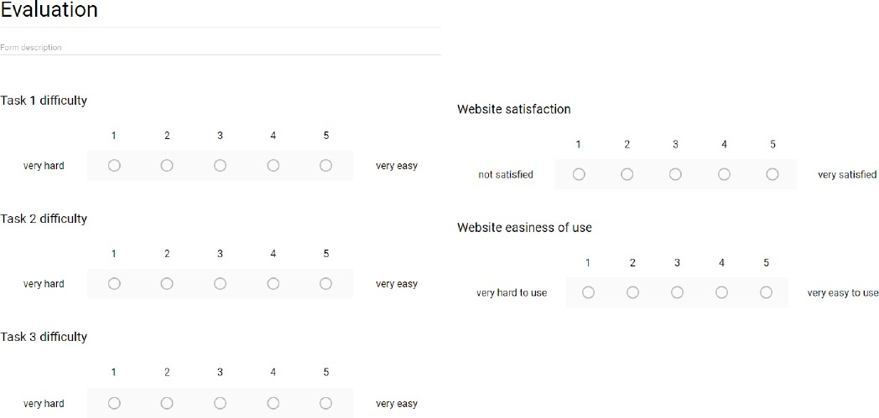

*Screenshot 7 Evaluation sheet*

This is the average result.

Task 1 Task 2 Task 3 Overall

Satisfcation

Easiness of use

Tasks difficulty

6

5

4

3

2

1

0

User form results

*Chart 4 Results of evaluation sheet form*

1. Final section

The expert review was satisfactory. As far as testing is concerned, most tests went as expected, the users did not struggle too much. Overall, the users were satisfied with the functionalities of the application. However, the results show there is space for improvement.