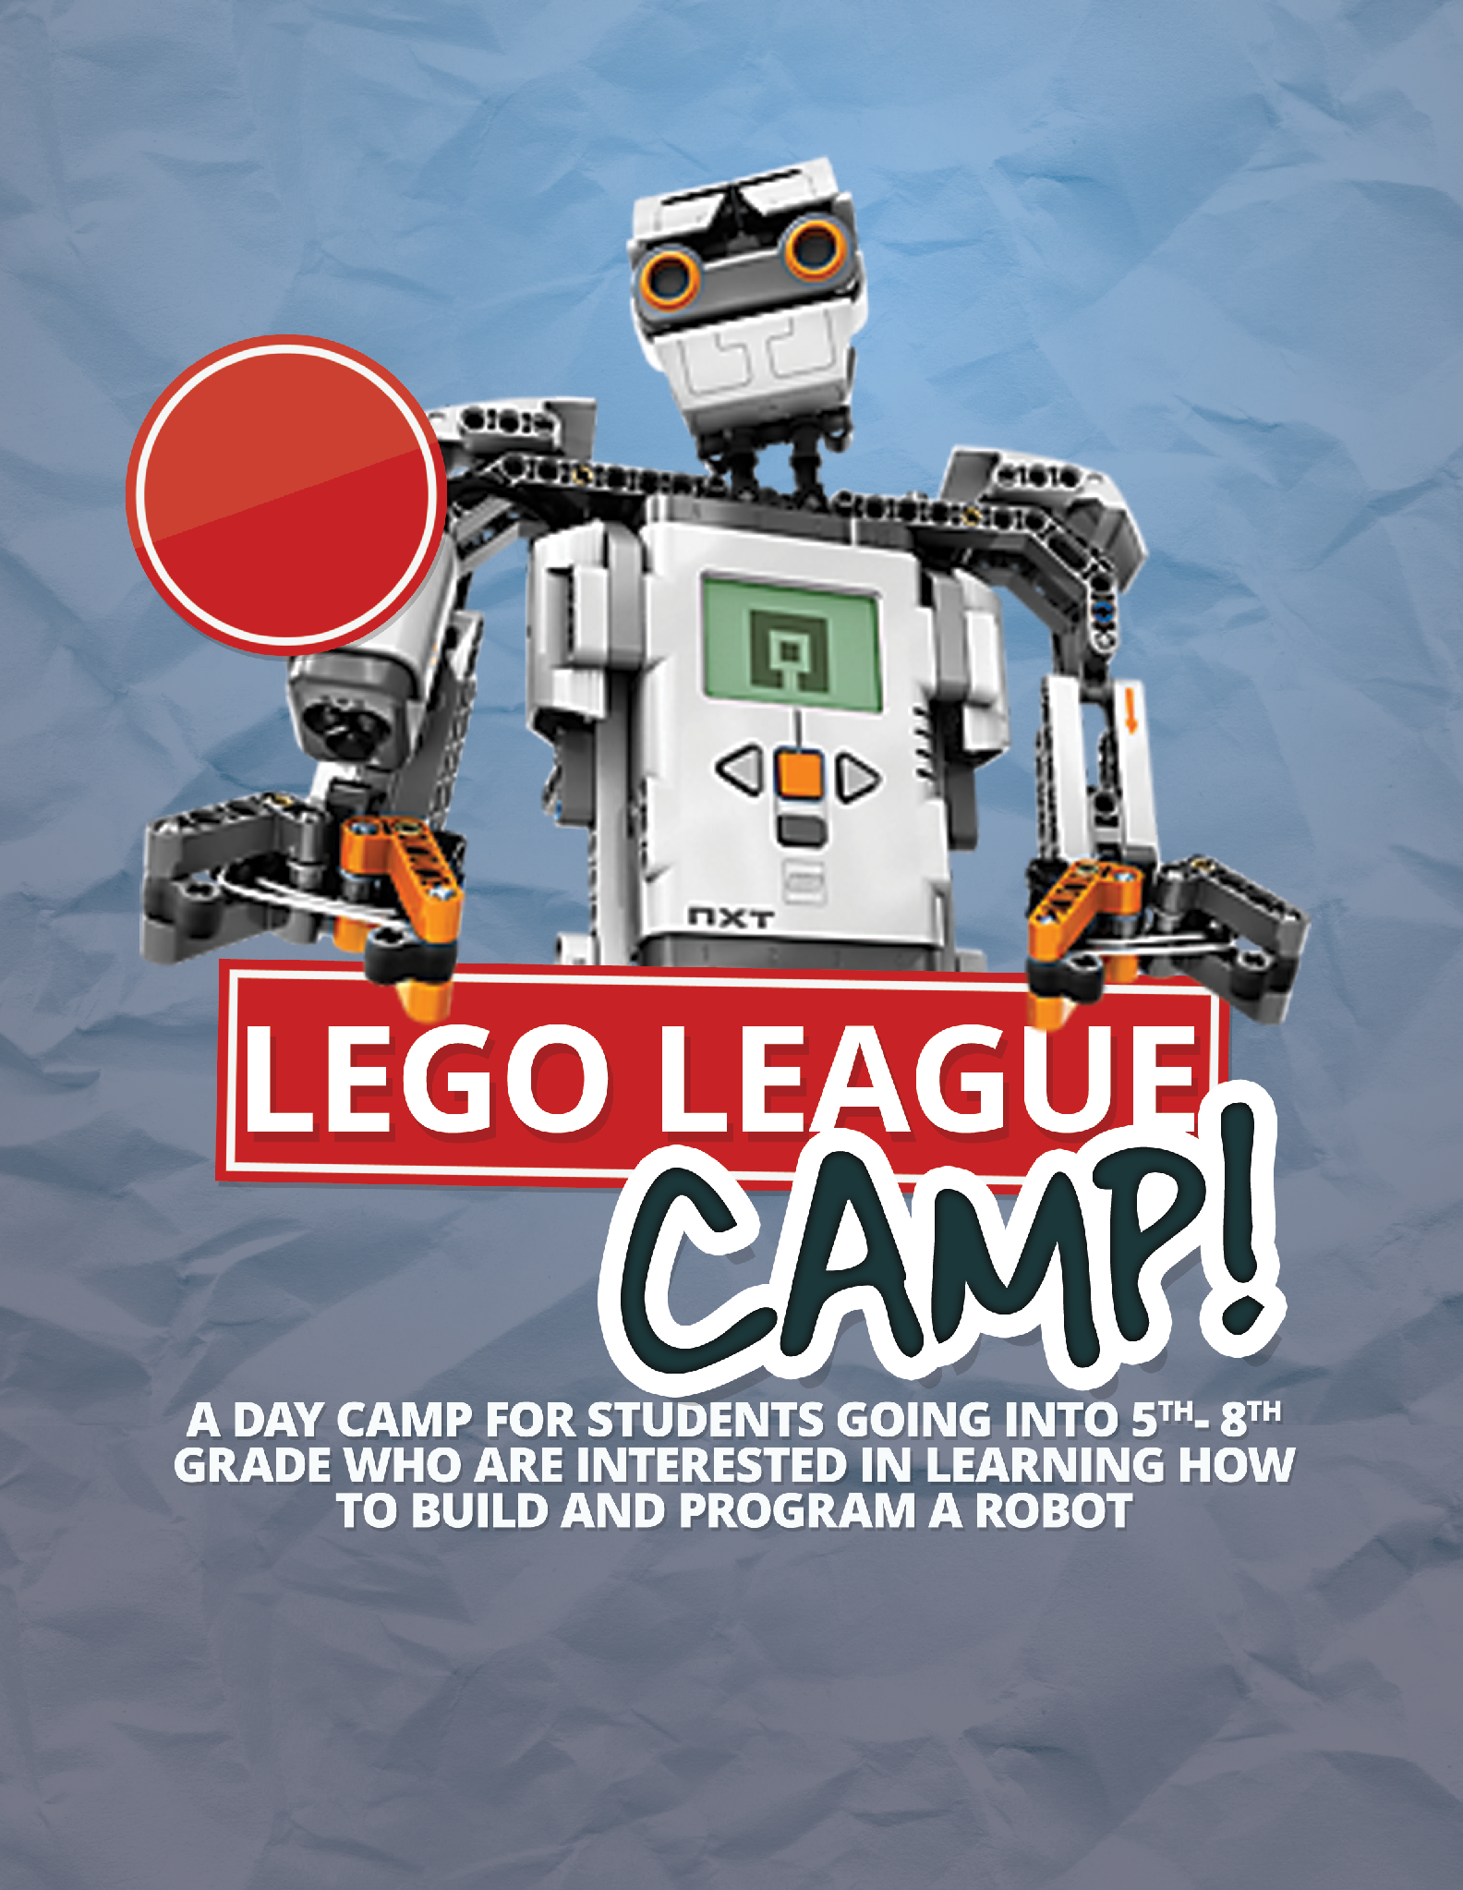

Questions?

Email [email]

**[Location]**

**[Dates and time]**

**Go to [URL] to register for camp**

*[School or team name] presents*

July 1st – July 5th