**References**

**Image references**

<https://store.networkchuck.com/cdn/shop/products/Default-Route.jpg?v=1679945286&width=768> – green_coffee.jpg date downloaded 01.04.2024

<https://store.networkchuck.com/cdn/shop/products/On-Call.jpg?v=1679945473&width=768> – blue_coffee.jpg date downloaded 01.04.2024

<https://store.networkchuck.com/cdn/shop/products/200-OK.jpg?v=1679945240&width=768> – red_coffee.jpg date downloaded 01.04.2024

<https://store.networkchuck.com/cdn/shop/products/Sudo.jpg?v=1679945500&width=768> – yellow_coffee.jpg date downloaded 01.04.2024

<https://coffeeperfection.ie/wp-content/uploads/2023/08/DECAF-BLEND_500g-mockup_FRONT_WHOLE1.png> - light_blue_beans.png date downloaded 01.04.2024

<https://coffeeperfection.ie/wp-content/uploads/2023/08/14-BLEND_500g-mockup_FRONT_WHOLE1.png> - purple_beans.png date downloaded 01.04.2024

<https://coffeeperfection.ie/wp-content/uploads/2023/08/5-BLEND_500g-mockup_FRONT_WHOLE1.png> - blue_beans.png date downloaded 01.04.2024

<https://coffeeperfection.ie/wp-content/uploads/2023/08/9-BLEND_500g-mockup_FRONT_WHOLE1.png> - green_beans.png date downloaded 01.04.2024

<https://coffeeperfection.ie/wp-content/uploads/2023/08/21-BLEND_500g-mockup_FRONT_WHOLE1.png> - yellow_beans.png date downloaded 01.04.2024

<https://cdn11.bigcommerce.com/s-90rhh09dph/images/stencil/1280x1280/products/8755/9728/Eletta_Cappuccino_Bean_to_Cup_ECAM44_660_B__10239.1707220035.jpg?c=1> – eletta.jpg date downloaded 01.04.2024

<https://www.keanscm.ie/cdn/shop/products/BaristaExpress_Sage_Stainless_VeloCoffee_1600x_96d42b5b-f3f0-4ced-aa9a-07ef6fa7af96_1200x1200.jpg?v=1611843194> – sage.jpg date downloaded 01.04.2024

<https://www.grahamsofmonaghan.ie/cdn/shop/files/0132106170.jpg?v=1705667890> – delonghi.jpg date downloaded 01.04.2024

<https://sunbeam-app-prod.s3.ap-southeast-2.amazonaws.com/SDP1000BK-Iced-Coffee-Machine-With-Coffee-1340x1340_38220bf1c8.jpeg> - iced.jpeg date downloaded 01.04.2024

<https://donaghybros.ie/media/catalog/product/e/c/ecf02whuk.jpg> - smeg.jpg date downloaded 01.04.2024

<https://donaghybros.ie/media/catalog/product/e/c/ecf02bluk.jpg> - smeg_black.jpg date downloaded 01.04.2024

<https://www.electrocity.ie/wp-content/uploads/2023/05/delonghi-magnifica-evo-automatic-bean-to-cup-coffee-machine-black-1.jpg> - magnifica.jpg date downloaded 01.04.2024

<https://www.nespresso.com/ecom/medias/sys_master/public/16929576288286/M-2028-ResponsiveStandard-Front.png> - nespresso.jpg date downloaded 01.04.2024

<https://cdn11.bigcommerce.com/s-f5f38/images/stencil/1080x1080/products/1568/9714/Magimix_Nespresso_Vertuo_Next_Deluxe_in_Chrome_1__60320.1625059714.jpg?c=2> – nespresso_vertuo.jpg date downloaded 01.04.2024

**Bootstrap templates references**

<https://getbootstrap.com/docs/4.0/examples/checkout/> - used as a template for sign up page and modified to suit my website. I used this for my checkout page also but unfortunately was unable to get my shopping cart functional to reach this page.

<https://getbootstrap.com/docs/4.0/examples/product/> - used as template for index page and modified to suit my website.

<https://getbootstrap.com/docs/4.0/examples/pricing/> - used as template for subscriptions page and modified to suit my website.

**Testing**

**Username and password is checked against details in database, if incorrect you will get message below**

**Cannot access account details page unless logged in**

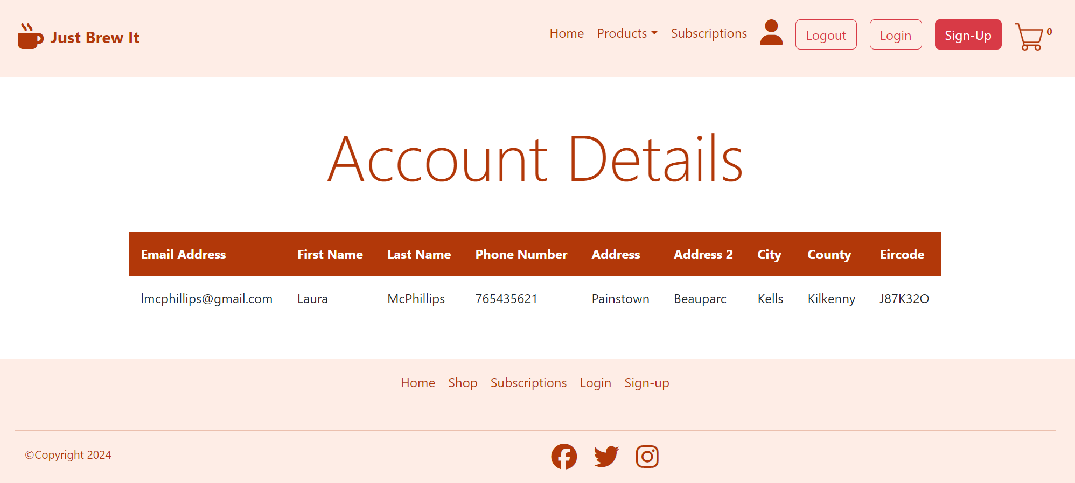

**If you click logout page it will kill the session bringing you back to log in page**

**When a user signs up, their details are stored in a database**

**Declaration**

I/We declare that this material, which I/We now submit for assessment, is entirely my/our own work and has not been taken from the work of others, except where otherwise stated. I/We have identified and included the source of all facts, ideas, opinions, and viewpoints of others in the assignment references. Direct quotations from books, journal articles, internet sources, module text, or any other source whatsoever are acknowledged and the source cited are identified in the assignment references.

I/We understand that plagiarism, collusion, and copying are grave and serious offences and accept the penalties that would be imposed should I/we engage in plagiarism, collusion or copying. I acknowledge that copying someone else’s assignment, or part of it, is wrong, and that submitting identical work to others constitutes a form of plagiarism. I/We have read and understood the colleges plagiarism policy 3AS08 (available [here](https://www.itb.ie/AboutITB/QualityAssurancePolicies/3AS08%20Institute%20Procedural%20Guidelines%20for%20Dealing%20with%20Instances%20of%20Plagiarism%20in%20Assignments%20and%20Examinations%20%2013%20June%202014.pdf)).

This material, or any part of it, has not been previously submitted for assessment for an academic purpose at this or any other academic institution.

I have not allowed anyone to copy my work with the intention of passing it off as their own work.

Name: ____Laura Mc Phillips______________ Dated: __28.04.2024__

(Printing your name here will be taken as a digital signature)