Laura Truong

May 11, 2021

Introduction to SQL

Assignment06

Github url:

Views, Functions, and Stored Procedures

**Introduction**

In Assignment 6 of IT FDN 130 A with Professor Randall Root, we learn about views, functions, stored procedures, and how to post to Github. By the end of this lesson, we will be able to explain when you would use a SQL view and explain the differences and similarities between a View, Function, and Stored Procedure.

Explain when you would use a SQL View.

A view is essentially a type of virtual table that allows a user to structure data for users in a user-friendly interface, restrict access to data so that a user is given read/write privileges accordingly, and to summarize data from multiple tables to use for generating reports. We would use a SQL view when we want to save simple, or complex select statements that we may want to call later. Figure 1 shows the query to create a view and Figure 2 shows the view being called and executed. Complex statements are more typical to save in views because they can save an end user some time from having to type the Select statement out every time.

Figure 1

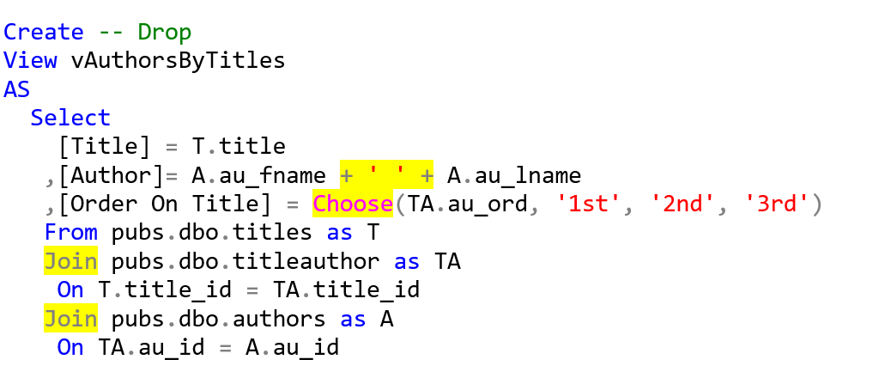

Figure 2

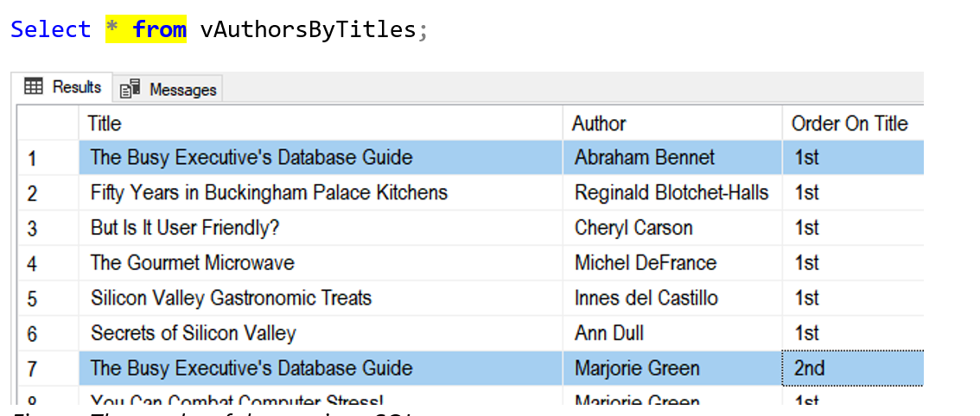

Explain the differences and similarities between a View, Function, and Stored Procedure.

SQL server has several ways to store queries that can be accessed and used later on. When developers start to build a lot of code, it gets difficult for them to maintain. Having Views, Functions and Stored Procedures can help centralize frequently used code. While the three have many similarities, they also offer distinguishing differences.

As mentioned earlier, a view is a type of virtual table that allows a user to structure data for users in a user-friendly interface, restrict access to data so that a user is given read/write privileges accordingly, and to summarize data from multiple tables to use for generating reports. There are two types of views, a reporter and base. A reporter view a view that is used to extract data for reporting purposes. A base view allows people to use your data in an abstract manner. While making a table, it would be best practice to create a base view and then restrict access to the table while allowing access to the view. Order by is not intended to be used in view or functions but is something that is done anyway. The result set of a view can be used in another query and the view can be indexed to cache data upfront to make it perform faster. Additionally, views can use schema-binding to stop changes from occurring in the database that may be done by mistake. The one downside to a view is that you cannot use a parameter.

Functions on the other hand, can use parameters to change the results of the query. Functions and Views are both created in a similar manner. The one difference is a function may have a ‘dbo’ preface in front of the function name. This preface is used when you create the function and when you use it. Unlike a view, a function allows you to return either a single value or a table of values. When you select against a function, you select all from the function and treat it as if it were a table. Parenthesis will also need to be used in the select statement of a function so that you can use parameters to change the results of the query when it is executed. Unlike views, Functions can be defined as scalar or table functions. When a scalar function is executed inside of a Select clause, the return value is output in every row of data in the table that is specified by the Select statement. Table functions on the other hand, are functions that execute in the function body and return multiple values. The function can be used as an expression in a From clause depending on the return value.

Stored Procedures are a named set of SQL statements. Stored procedures are created very similar to views and functions, except that they are called with an Execute statement. They are similar to multi-statement-table value functions. You can run multiple statements in them, and they will return a result-set. Stored procedures also have code to restrict privileges. They are similar to views and functions because they save Select statements. However, stored procedures can store other code beyond the Select statements. They also allow you to pass parameters, much similar to functions. The drawback is that you cannot use the results of the stored procedure in another query.

**Summary**

In Assignment 6 of IT FDN 130 A with Professor Randall Root, we learn about SQL views, functions, stored procedures, and how to post our code to Github. We explained when you would use a SQL view and explored the differences and similarities between a View, Function, and Stored Procedure. As SQL queries begin to get more complex, saving them in a view, function, or stored procedure can save a developer a lot of time by making it easy for them to save and access redundant code.