StarterBook Report

1. 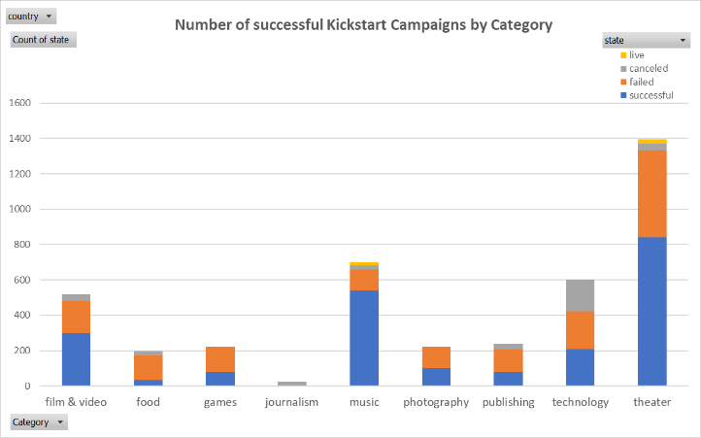Given the provided data, what are three conclusions we can draw about Kickstarter campaigns?

* *Overall campaigns in Music were the most successful with a success rate of 77%, followed by Theater (60%) and Film&Video (58%)*

*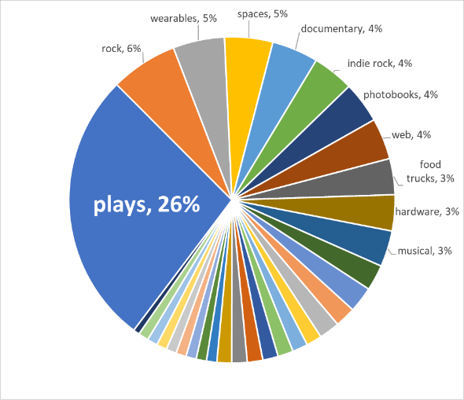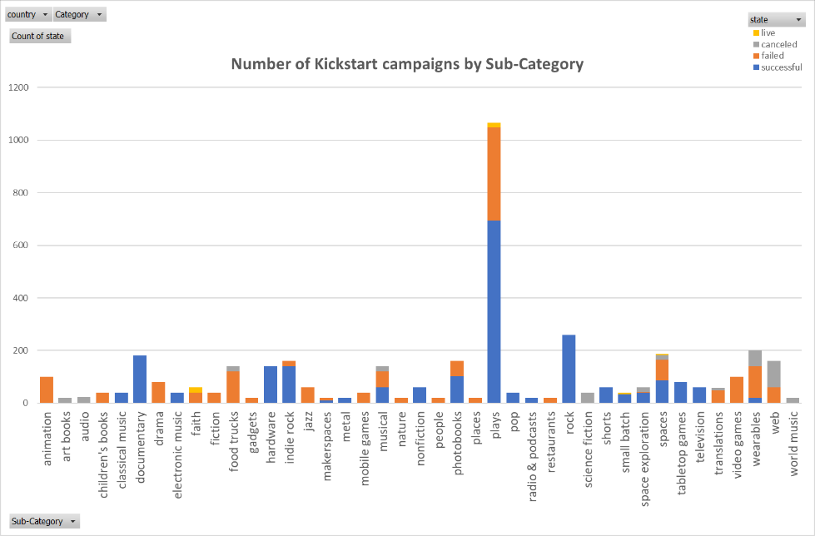*

* 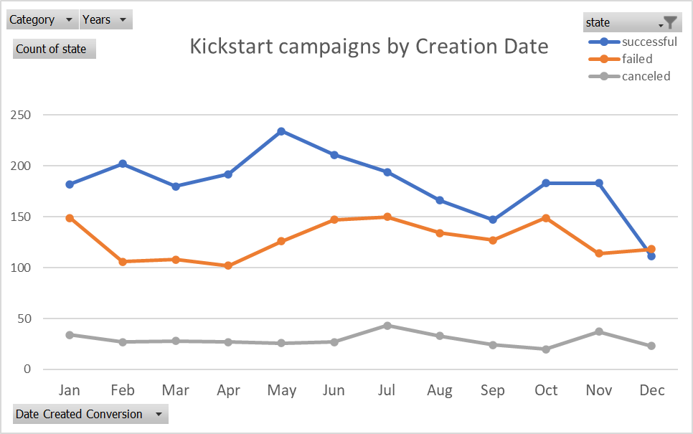*Plays were by far the most common sub-category, representing a quarter of all projects.*
* Overall, campaigns created during the first six months of the year were more likely to be successful. The lowest success was seen for campaigns created in December

1. What are some limitations of this dataset?

* Most recent data in this dataset is from 2017, trends could have changed since then.
* From the dataset it is unsure whether this is a complete list or just a sample

1. What are some other possible tables and/or graphs that we could create?

A table comparing successful campaigns in the top 10 sub categories by country

A box and whisker plot of the column called “AverageDonations”