# doc-graph

doc-graph is a network visualization of publications based on their textual similarities.

## Table of Contents

1. Getting Started

* Overview
* Running TextExtractor.java
* Installing Dependences

1. File Descriptions

* main.py
* text-extractor/src/text-extractor/TextExtractor.java
* extract_abstract.py
* bulk_download.py
* create_json.py
* visualiz/index.html

1. Folder Descriptions

* Papers
* xml-files
* extracted-text
* visualiz
* NLP

1. General Notes
2. Resources for NLP
3. Updates

## I. Getting Started

### Overview

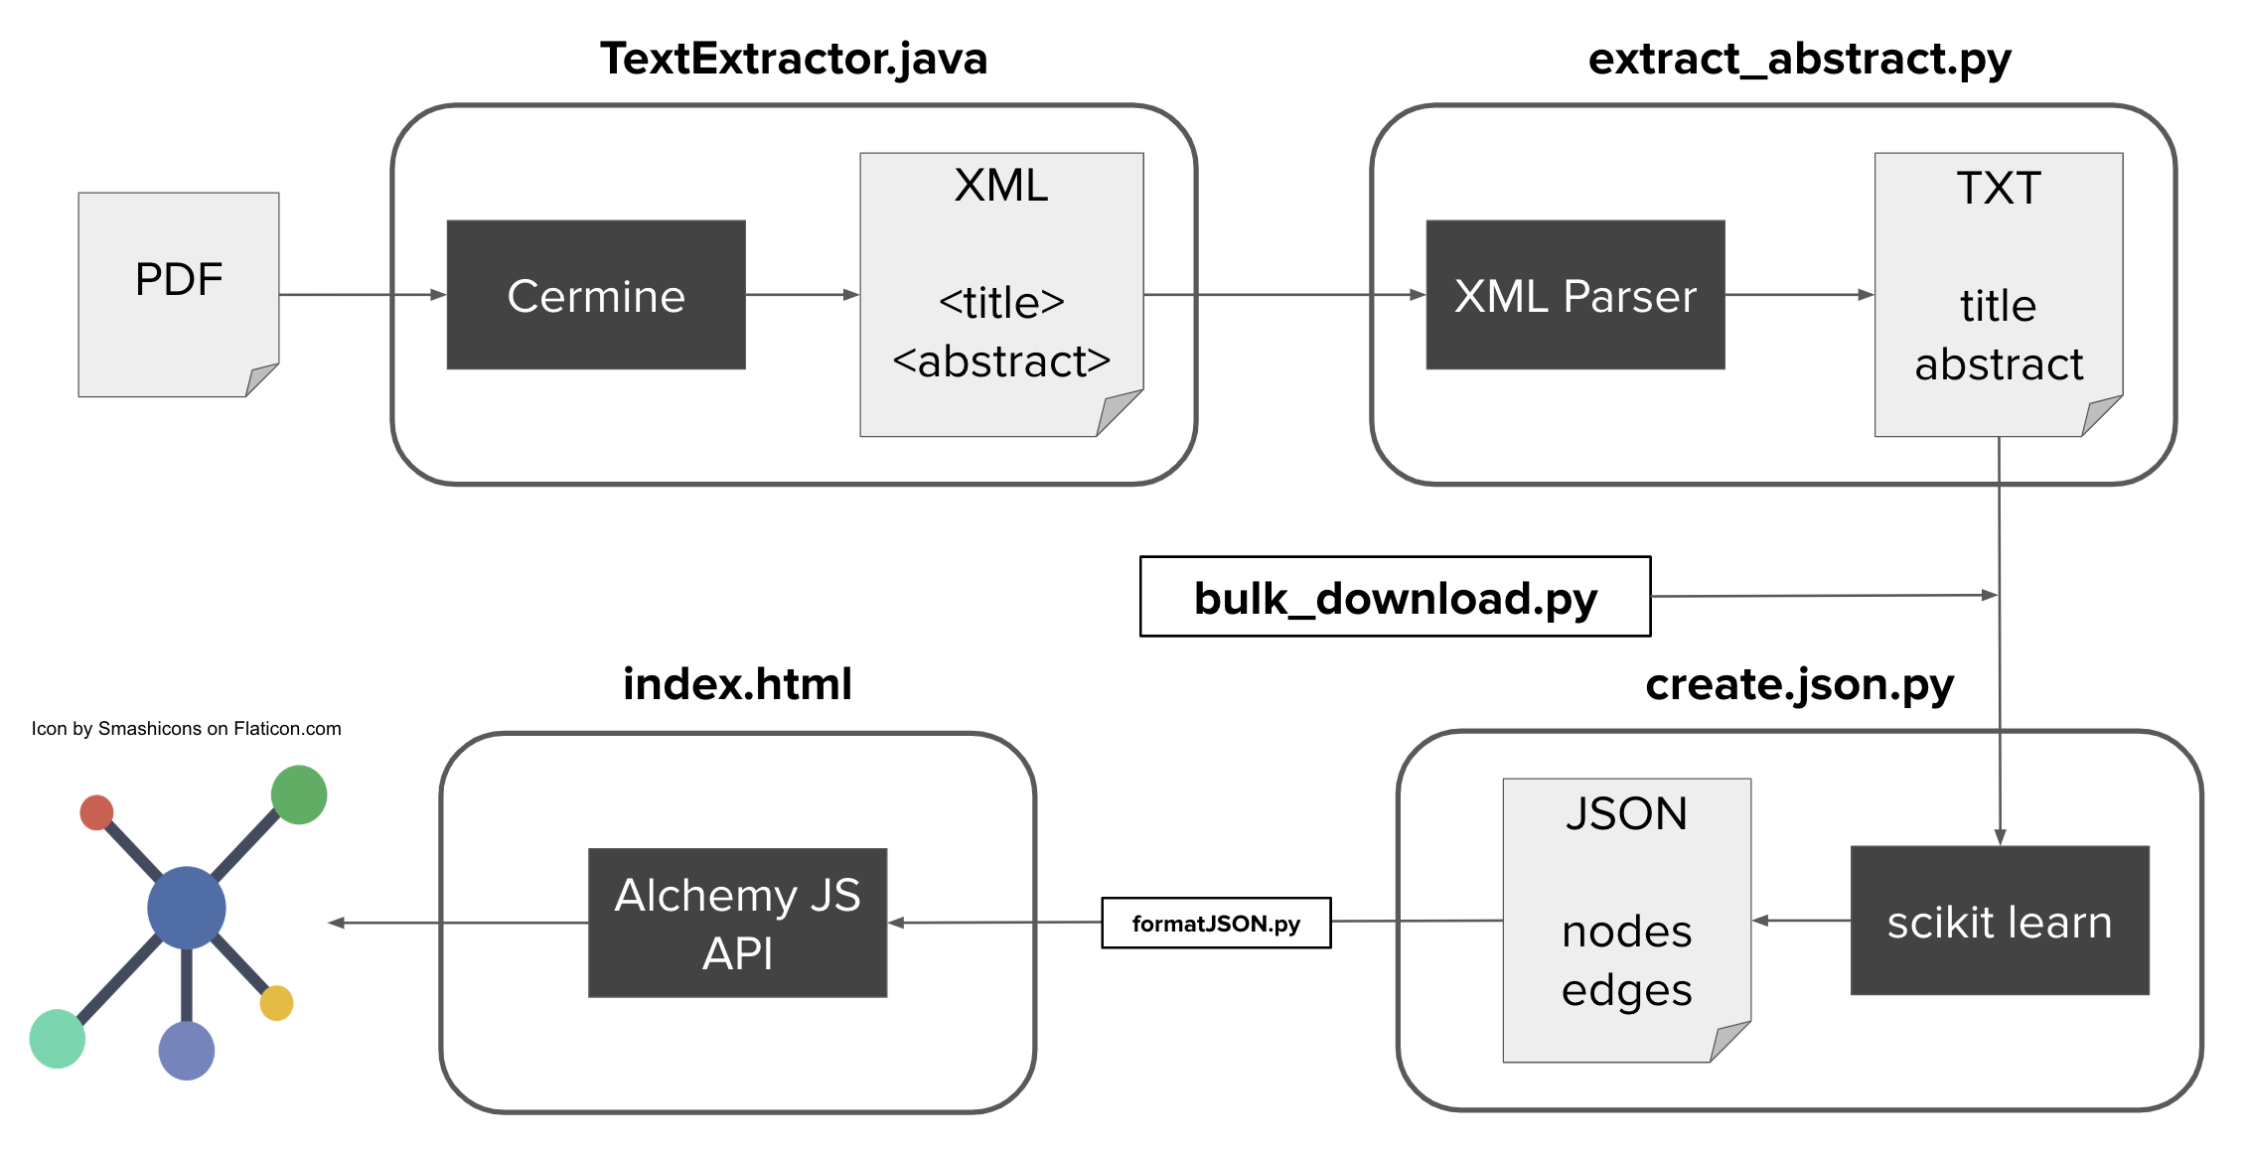

Framework

* *Note: TextExtractor.java needs to be running as main.py is executed. See next section for details.*
* to simply run the project as-is, run these files:
  + TextExtractor.java in text-extractor folder
  + main.py
    - main.py calls bulk_download, cermine, extract_abstract, create_json
  + data.json contents need to be run through formatJSON.py
* make sure to have the dependencies installed, as detailed below #### Details on the framework pictured above is available in section II

### Running TextExtractor.java

* import the text-extractor folder as a Maven project in Eclipse, or whatever editor is used to run Java code
  + Eclipse (from https://stackoverflow.com/questions/2061094/importing-maven-project-into-eclipse):
    1. Open eclipse
    2. Click **File** > **Import**
    3. Type Maven in the search box under **Select an import source:**
    4. Select **Existing Maven Projects**
    5. Click **Next**
    6. Click **Browse** and select *text-extractor*
    7. Click **Next**
    8. Click **Finish**
* Run the TextExtractor.java class in src folder before running main.py
  + it essentially starts a local server

### Installing Dependencies

***Note: py4j needs to be installed for both python and Java*** #### Maven * Cermine * make sure Maven is installed as a plug-in on Eclipse * https://stackoverflow.com/a/25993960/1971003 * already taken care of in pom.xml file, no need to download anything * https://github.com/CeON/CERMINE * py4j * git clone https://github.com/bartdag/py4j * navigate to py4j-java folder * run mvn install * already included in pom.xml file

#### Python

* requirements.txt
  + for most other dependencies, run
  + pip install --user --requirement requirements.txt

#### AlchemyJS

* https://graphalchemist.github.io/Alchemy/#/
  + library no longer maintained, website examples have issues
* a working example without any installations is available at visualiz/index.html
* replaced VisJS due to support for weights on edges and better visualizations
* like VisJS, reads from a graph JSON file

#### ~~VisJS in Jupyter Notebook~~

* ~~Vis.js ZIP download~~
  + ~~https://github.com/almende/vis/archive/v4.19.1.zip~~
* ~~Expand and move contents into local system, and take note of its paths~~
* ~~open ~/.jupyter/jupyter_notebook_config.py~~
* ~~add c.NotebookApp.extra_static_paths = ["$(path-to-expanded-folder)/dist"] to the config file~~
* ~~should now be able to run viz-prototype.ipynb~~

## II. File Descriptions

### main.py

* main script that parses and analyzes text and builds the json file needed for visualization
* calls Maven project TextExtractor.java, extract_abstract.py and create_json.py

### text-extractor/src/text-extractor/TextExtractor.java

* Java code that utilizes Cermine

### extract_abstract.py

* uses BeautifulSoup to extract abstracts from XML files
* if abstract tag does not exist, takes contents of the first paragraph
* tag

### *Alternative to TextExtractor & extract_abstract: bulk_download.py*

* mass downloads titles and abstracts from arXiv based on queries in the URL
* contains URLs pertaining to machine learning and earth science
  + URLs lead to XML page, which is parsed for its info, similar to extract_abstract.py
* PROs: downloads way more abstracts accurately and efficiently straight to text files
* CONs: limited to arXiv database of publications accessible by query
* good to use a combination of both the CERMINE method and this web query

### create_json.py

* uses sci-kit learn modules to generate similarities between abstracts, which comes out to be a coefficient
* uses similarity information to generate a JSON file that can be used to visualize relationships between publications
* can further be improved to implement better NLP methods

### visualiz/index.html

* example web page file that visualizes data from JSON
* standalone, **there was an issue importing data.json**. just copy and pasted the data straight into the html file.
  + use *formatJSON.py* on data.json to correctly format it for copy/paste into the HTML file.

### ~~viz-prototype.ipynb~~

* ~~Jupyter Notebook that visualizes the JSON file~~
* ~~still the prototype version, would like to move away from Jupyter in the future~~

## III. Folder Descriptions

### Papers

* contains PDF files of publications downloaded from the internet

### xml-files

* contains XML files that are parsed from PDFs
* organized based on source: Cermine or arXiv

### extracted-text

* contains .txt files that contain article titles and abstracts of XML files

### visualiz

* contains all files pertaining to visualization of data extracted
  + includes standalone index.html file that implements AlchemyJS

### NLP

* contains all other files used to analyze extracted_text text. not as relevant to visualization of data, but pertains more to analysis. includes: LDA, decision tree classifiers, XGBoost implementation, tfidf similarities, document classification, etc.
* methods that did not work are in NLP/did-not-work
* attempted to vectorize abstracts based on similarity to phrases (lots of inherent problems), the data for that is in *data.csv*

## IV. General Notes

* Please do not change the names of the folders if cloned, since the scripts rely on these directory names
* If these directories need to be changed, they can simply be modified in main.py
* Java code *is* a Maven project.

## V. Resources for NLP

* Libraries
  + [Sci-kit Learn](https://scikit-learn.org/stable/)
  + [Spacy](https://spacy.io/)
  + [NLTK](https://www.nltk.org/)
* Deep Learning
  + [Keras](https://keras.io/)
  + [XGBoost](https://xgboost.readthedocs.io/en/latest/)
* Text Classification
  + https://www.analyticsvidhya.com/blog/2018/04/a-comprehensive-guide-to-understand-and-implement-text-classification-in-python/
* Keyword Extraction
  + https://medium.com/analytics-vidhya/automated-keyword-extraction-from-articles-using-nlp-bfd864f41b34
* Decision Tree Classification
  + https://www.datacamp.com/community/tutorials/decision-tree-classification-python

## VI. Updates

#### 8-5-2019 Update

Lots happened. Switched to AlchemyJS. Here’s the preview: 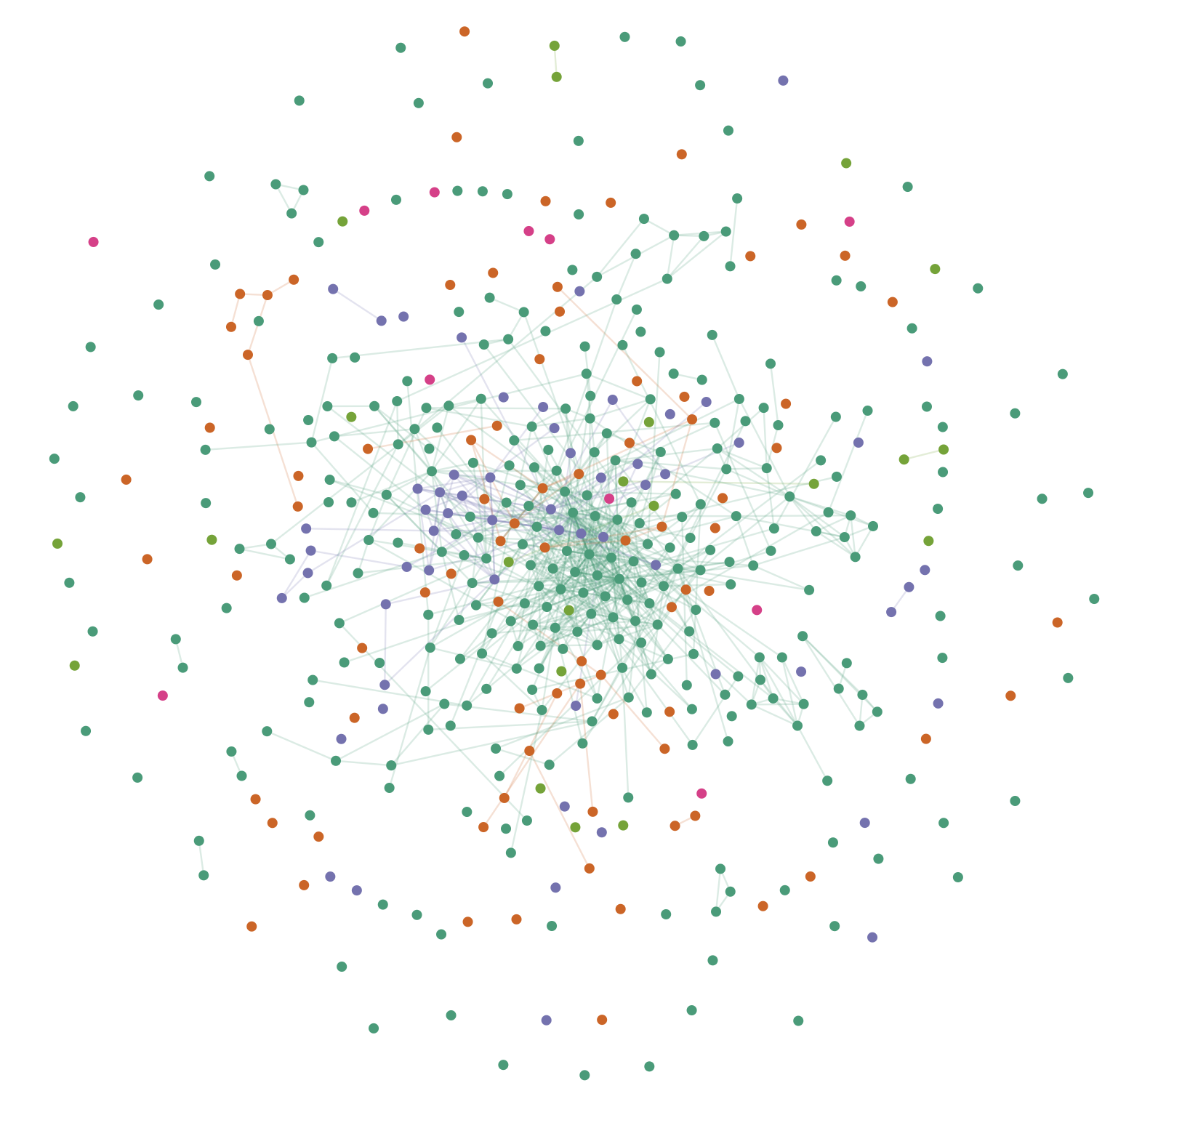

Next step: Extracting meaningful analysis from the graph.

#### 7-15-2019 Update

Tried a different method from [this article](https://medium.com/analytics-vidhya/automated-keyword-extraction-from-articles-using-nlp-bfd864f41b34). Basically tried to extract keywords, and this particular article was interesting because it also dealt with abstracts from (machine learning!!!) papers. Here are example results and pictures I got from implementing this on my project.

This one is frequent trigrams: 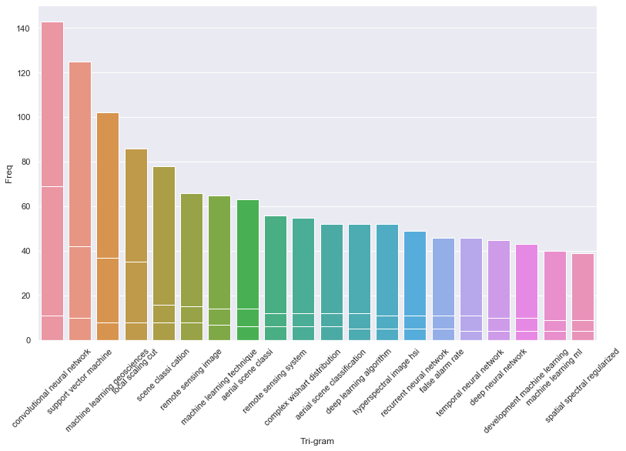

This one is frequent bigrams: 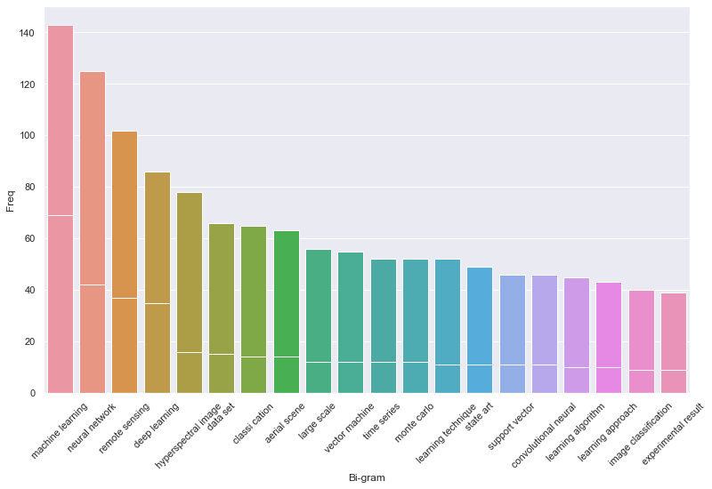

This is a sample of TF-IDF word frequency scores based on context for one document: 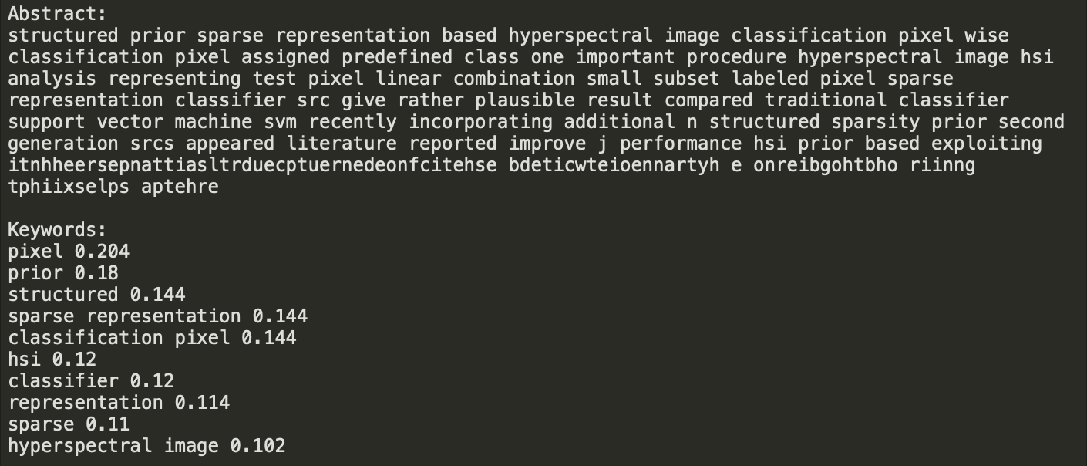

Also, I copied the config from other VisJS graphs so that my network graph would look a little more pleasing. Then, I added colors based on algorithms used in each abstract. This might be a little janky in implementation– I basically took the argmax of the method that had the highest textual similarity to each abstract. There were 10 algorithms that I tested for, and I think only 4 are represented here, with the majority being neural networks and support vector machines… 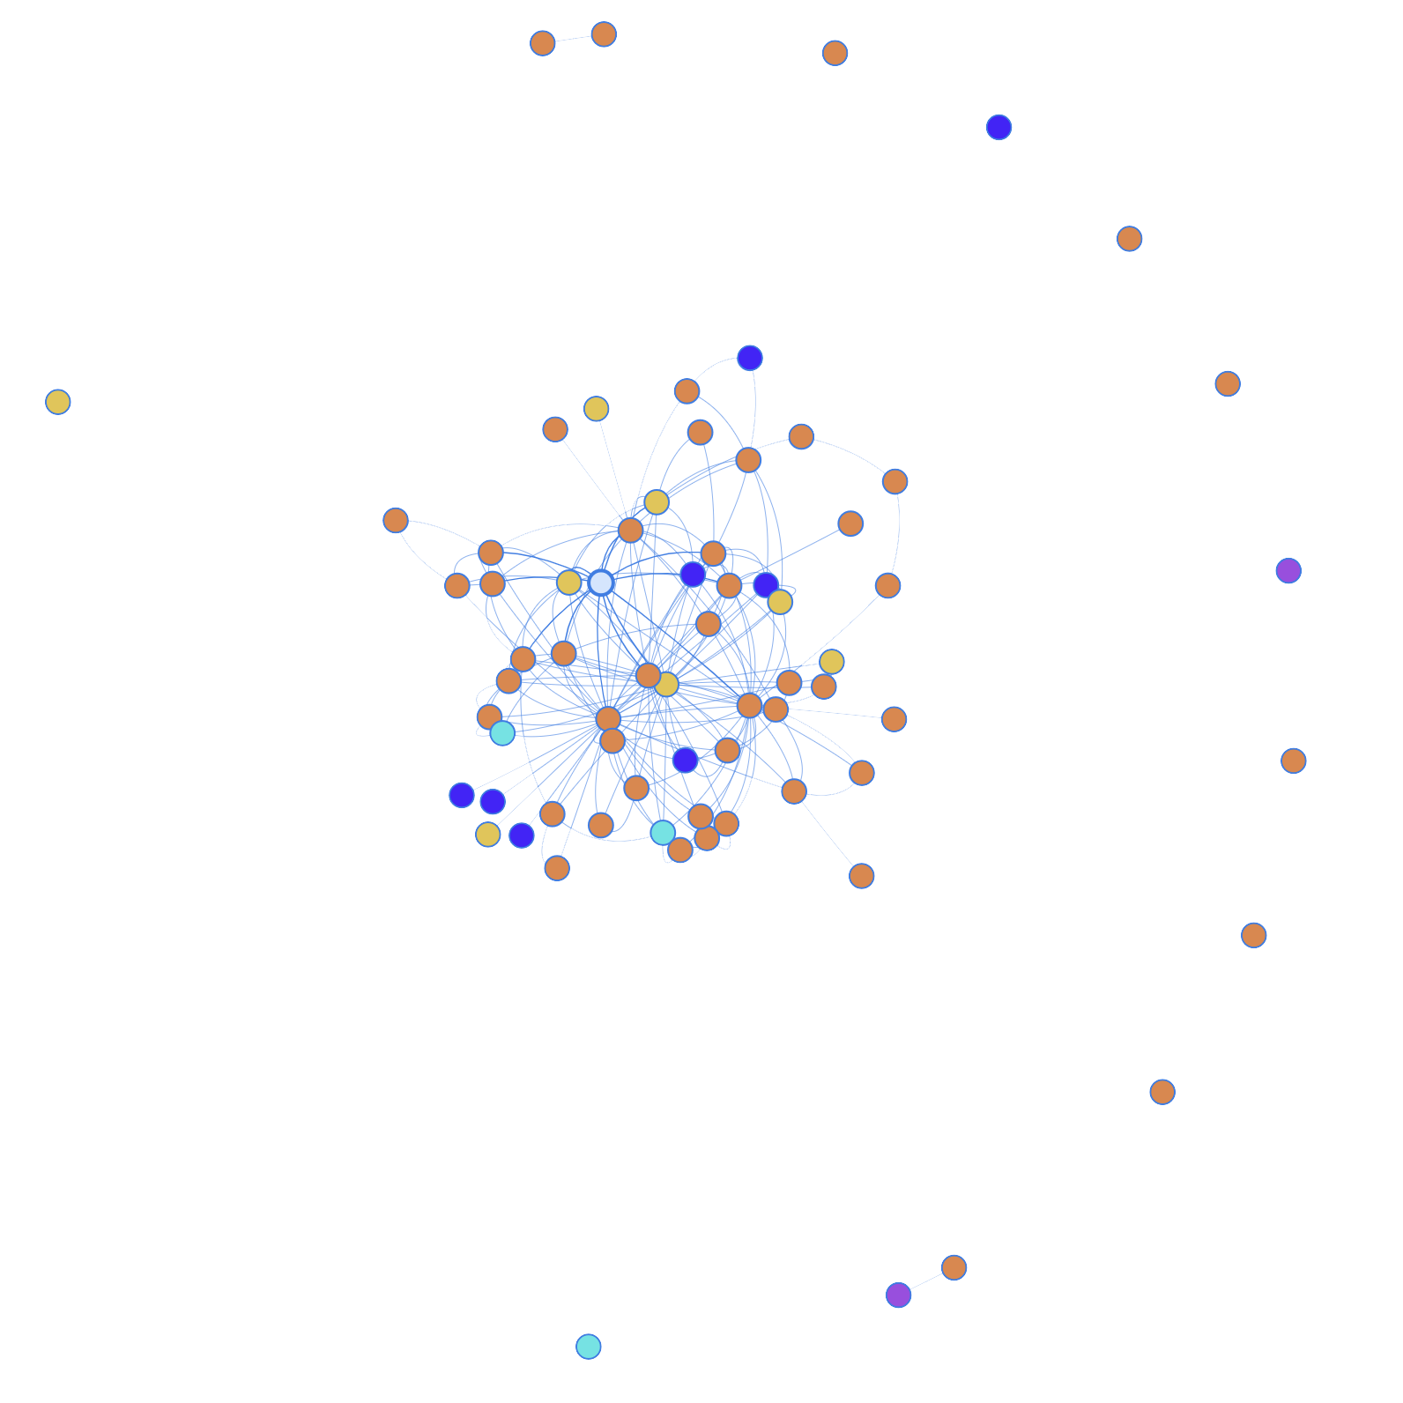

Conclusions: It looks like the frequent bigrams and trigrams yield better intuitive results than the TDIDF– I think TDIDF somehow rules out machine learning methods as relevant to the context. Might focus on that more as a direction for algorithm extraction this week.

#### 7-12-2019 Update

Added more documents to consider from arXiv. arXiv came with its own parsed XML that gave a clean title name and “summary”, which I’m assuming is equivalent to the abstract. Here’s a preview of the updated visualization, with no changes to the configuration in VisJS. 