Martin Paulus, M.D. and his collaborators at Laureate Institute for Brain Research are conducting a research study to find out more about individuals' attitude in experiencing certain life events and to test the reliability of psychological tasks. There will be approximately 100 subjects that will participate in this study.

If you agree to be in this study, these are the things to be completed on **your** **smartphone.**

**Session 1**

*Total Duration: approx. 30 minutes*

Part 1: We will ask you 2 Surveys regarding your demographics and various psychological measurements about your well being. Please answer them as best as you can.

1. Demographics Survey
2. PANAS-X

Part 2: Driving Task

This is a psychological task where you will complete 20 trials of a driving task where you use your thumbs to control a car in front of a stop light. The exact instructions will be given to you when you reach this portion of this HIT.

Once you have completed this HIT, you will be given a **code** at the very end where you may submit on Amazon Mechanical Turk to receive your $3 reward for your time and effort.

Here are the instructions to start the study:

1. Go to this link on your **phone**: <https://tasks.laureateinstitute.org/?study=Driving&session=T1>
2. Enter Your Mturk ID in the ‘Subject ID’ field.
3. 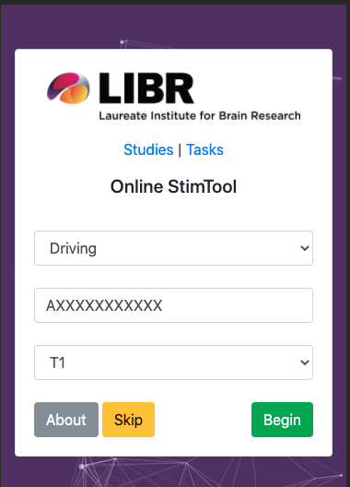Click ‘Begin’ button.

Step 2: Example Image showing what to enter in the field if your id was AXXXXXXXXXXX.

Step 3: Click here to Begin!

**Session 2: (Can be done once you are given qualifications)**

* Instructions are included in that particular HIT

Participation in this research is entirely voluntary. You may stop this HIT at any moment when you feel uncomfortable. For any other question, please contact us at [jtouthang@libr.net](mailto:jtouthang@libr.net?Subject=Amazon%20MKTURK%20TASK).

No personally identifiable information will be collected in this study.

Welcome back to Session 2.

You must complete session 1 in order to be qualified for session 2.

**Session 2**

*Total Duration: approx. 30 minutes*

Part 1: We will ask you 2 Surveys regarding your demographics and various psychological measurements about your well-being. Please answer them as best as you can.

1. Demographics Survey
2. PANAS-X

Part 2: Driving Task

This is a psychological task where you will complete 20 trials of a driving task where you use your thumbs to control a car in front of a stop light. The exact instructions will be given to you when you reach this portion of this HIT.

Once you have completed this HIT, you will be given a **code** at the very end where you may submit on Amazon Mechanical Turk to receive your $3 reward for your time and effort.

Here are the instructions to start the study:

1. Go to this link on your **phone**: <https://tasks.laureateinstitute.org/?study=Driving&session=T2>
2. Enter Your Mturk ID in the ‘Subject ID’ field.
3. Click ‘Begin’ button.

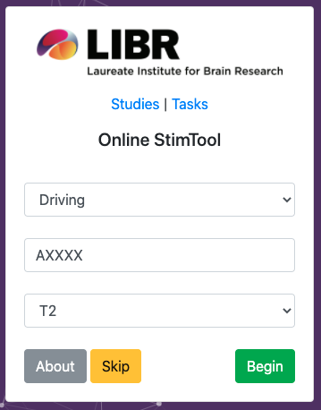

Step 2: Example Image showing what to enter in the field if your id was AXXXXXXXXXXX.

Step 3: Click here to Begin!

Participation in this research is entirely voluntary. You may stop this HIT at any moment when you feel uncomfortable. For any other question, please contact us at [jtouthang@libr.net](mailto:jtouthang@libr.net?Subject=Amazon%20MKTURK%20TASK).

No personally identifiable information will be collected in this study.