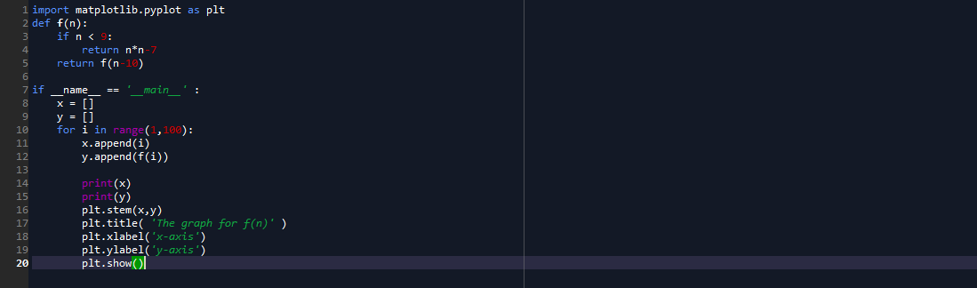

-the program continuously plots the graph for every value of n from 0 to 99 depending on which function the value applies

