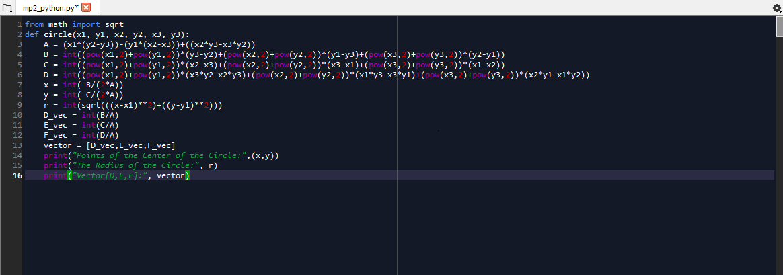

-the program asks the user to input 6 values, for the Circle() function, and outputs the points of the center of the circle, the radius and the vector for the coefficients of D, E, and F.

