Investigation of thermal processes during mass accretion of a protoplanet
Laurel Farris
ASTR 621
25 February 2015

Introduction
Investigating how stars and planetary systems form is key to understanding them in their current state.

Methods
Assumptions: This is a very simple model, with no time dependence and no mass loss. All of the initial potential energy possessed by the accreting material was retained and converted into thermal energy.

Parameters: Initially, the protoplanet was given a radius of 6.4x10⁶ cm and (constant) density of 5.5 g cm⁻³. The accretion process was modeled by increasing the total mass by adding the product of the mass accretion rate and the time step. The model was made to run until the physical variables of the planet reached Earth-like dimensions, ie. M ~ 6x10²⁷ g and R ~ 6400 km (where M and R are the total mass and radius, respectively).

Code: The radius was calculated in two ways. This was done for two values of the mass accretion rate, namely, 1/10,000 and 1/1,000 of the Earth's mass per time step.

Results
All results were plotted with the same axis range for comparison. Figures 1 and 2 show the temperature variance with radius as the total mass is increased by a certain amount (the mass accretion rate) per time step, which in this case was one second. Figures 3 and 4 also show the temperature variance with radius, but evolving with the radius increasing by a certain amount (the radius expansion rate) per time step. All four plots show the temperature increasing to just over 60,000 K.

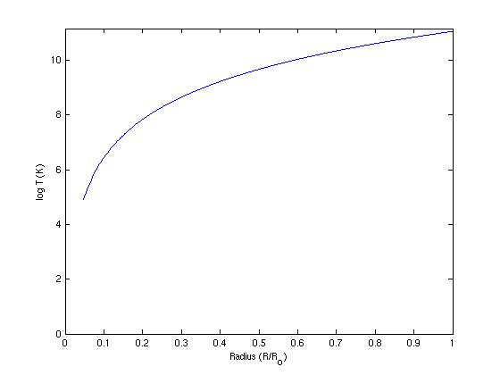

Figure 1: This figure shows the change in temperature as mass is accreted. The mass accumulation rate is 1/10,000 of Earth's mass (~6x10²⁷g). The mass stopped accumulating as soon as the total mass reached that of the Earth.
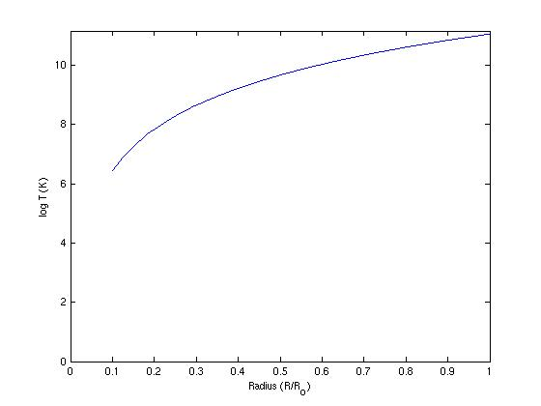

Figure 2: This is the same as Figure 1, only with a mass accretion rate of 1/1,000 of Earth's mass.

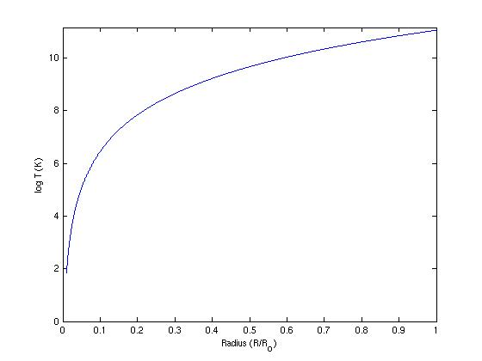

Figure 3: This figure shows the change in temperature as mass accretion progresses. The radial expansion rate is 1/10,000 of Earth's radius (~6.4x10⁸cm). The mass stopped accumulating as soon as the total radius reached the radius of the Earth.

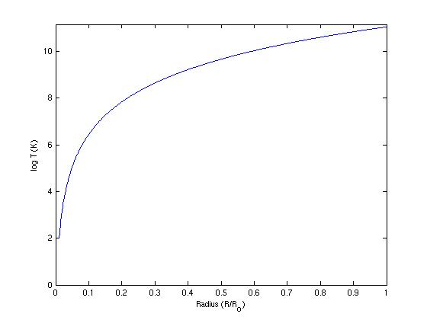

Figure 4: This is the same as Figure 3, only with a radial expansion rate of 1/1,000 of Earth's radius.
Conclusions
Each temperature had an initial value between roughly 200 and 600 K, which is reasonable for pre-accretion material. As material accretes onto the surface of a protoplanet, the subsequent material gains more and more potential energy (U), as U scales directly with the total mass (M). For this model, the energy is then converted completely into heat, thus increasing the temperature of the planet's surface as it grows. While U does scale inversely with radius, radius itself is proportional to the cube root of the mass, so the mass growth has a greater effect on potential energy.

