The original dataset pulled in R-studio for analysis comes from the General Social Survey for 2016. The dataset focuses on three variables; education, drugs, and city. It was further broke down by ethnicity and gender.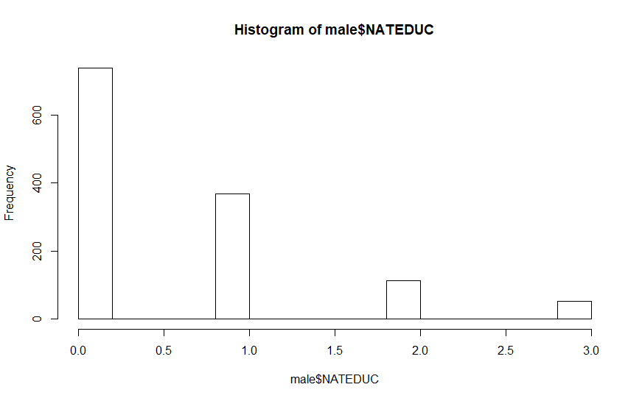 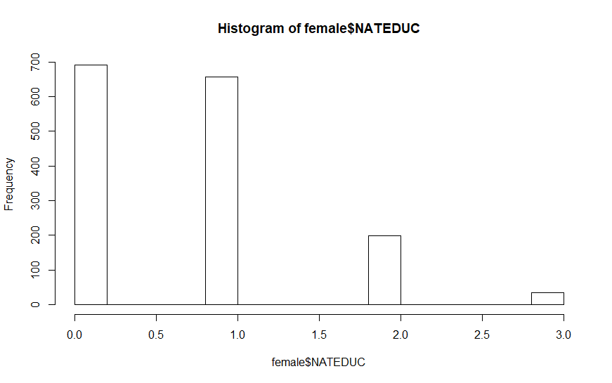

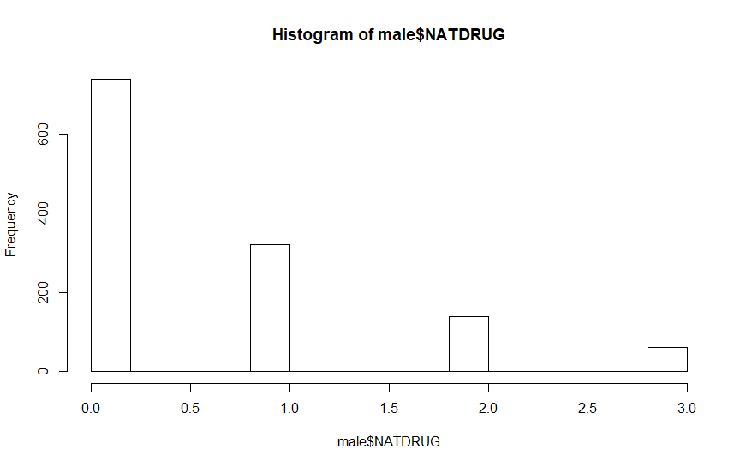

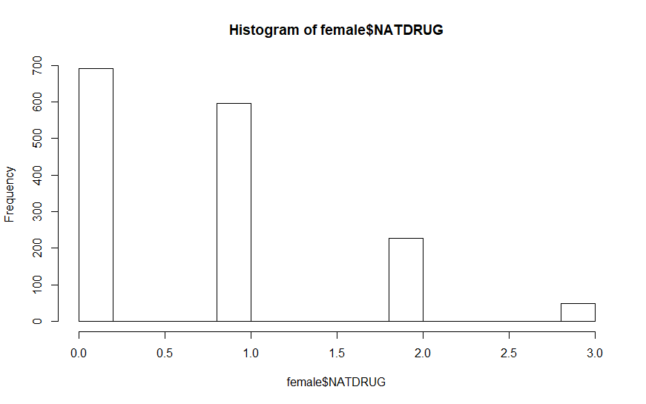

|  |
| --- |
| Df Sum Sq Mean Sq F value Pr(>F)  as.factor(male$NATCITY) 3 1109 369.6 1.975e+30 <2e-16 ***  Residuals 1231 0 0.0  ---  Signif. codes: 0 ‘***’ 0.001 ‘**’ 0.01 ‘*’ 0.05 ‘.’ 0.1 ‘ ’ 1  41 observations deleted due to missingness |
|  |
| |  | | --- | | > | |

As shown above, the result is statistically significant because <2e-16 is less than 0.05.

`as.factor(male$NATCITY)`

diff lwr upr p adj

1-0 1 1 1 0

2-0 2 2 2 0

3-0 3 3 3 0

2-1 1 1 1 0

3-1 2 2 2 0

3-2 1 1 1 0

As shown above, p value is less than 0.01 and therefore, it is statistically significant.