Complete the following tasks:

* Find a dataset that you find interesting. You can look at a variety of sources for data including:
  + Religion, health, etc.: [www.Thearda.com](http://www.Thearda.com)
  + Census, Education, Wealth, Time-Use, etc: [www.ipums.org](http://www.ipums.org)
  + Education: [www.nces.ed.gov](http://www.nces.ed.gov)
  + Mental Health: [www.cdc.gov/mentalhealth/data_publications/index.htm](http://www.cdc.gov/mentalhealth/data_publications/index.htm)
  + Many Other Sources
* Once you have identified a dataset, explain how you accessed it. What links did you click?

Was there any registration required? Did you download directly or was there an online system you navigated?

[https://www.census.gov](https://www.census.gov/)

Topics>Education> Education Attainment>Education Attainment in the United States:2017>Table 1. Education Attainment of the Population 18 years and Over, by Age, Sex, Race, and Hispanic Origin: 2017> All Races

There was no registration needed and document was opened in excel. I deleted both genders and male to focus on female data. I reformatted table to take unnecessary spacing and imported to R from my computer using an excel document.

* In R:
  + Import the data
  + Provide a list of variables in the dataset
* [1] "Age" "Total" "None"
* [4] "1st - 4th grade" "5th - 6th grade" "7th - 8th grade"
* [7] "9th grade" "10th grade" "11th grade2"
* [10] "High school graduate" "Some college, no degree" "Associate's degree, occupational"
* [13] "Associate's degree, academic" "Bachelor's degree" "Master's degree"
* [16] "Professional degree" "Doctoral degree"

* + What is the structure of the data? Which variables are character and which are numeric?

|  |
| --- |
| > str(Copy_of_Education_table)  Classes ‘tbl_df’, ‘tbl’ and 'data.frame': 14 obs. of 17 variables:  $ Age : chr ".18 years and over" "..18 to 24 years" ".25 years and over" "..25 to 29 years" ...  $ Total : num 127155 14559 112597 11335 10795 ...  $ None : num 410 29 380 5 22 33 28 25 36 41 ...  $ 1st - 4th grade : num 761 24 737 29 28 35 43 56 57 75 ...  $ 5th - 6th grade : num 1575 27 1548 37 94 ...  $ 7th - 8th grade : num 1800 59 1740 82 129 118 145 135 117 126 ...  $ 9th grade : num 1746 120 1626 110 157 ...  $ 10th grade : num 2056 271 1785 161 110 ...  $ 11th grade2 : num 4923 1536 3388 323 261 ...  $ High school graduate : num 35010 3794 31216 2678 2359 ...  $ Some college, no degree : num 24247 5721 18525 2126 1860 ...  $ Associate's degree, occupational: num 5399 364 5035 492 481 ...  $ Associate's degree, academic : num 8278 654 7624 832 734 ...  $ Bachelor's degree : num 26145 1788 24357 3264 2864 ...  $ Master's degree : num 11680 137 11543 969 1294 ...  $ Professional degree : num 1426 19 1407 110 167 ...  $ Doctoral degree : num 1700 16 1685 116 235 ... |
|  |
| |  | | --- | | > Age is a character and all other variables are numeric | |

* + Describe the data through Central Tendencies:
  + Mean
* #mean
* > mean(Copy_of_Education_table$`High school graduate`)
* [1] 7231
* > mean(Copy_of_Education_table$`Associate's degree, academic`)
* [1] 1727.214
* > mean(Copy_of_Education_table$`Bachelor's degree`)
* [1] 5474.714
* > mean(Copy_of_Education_table$`Master's degree`)
* [1] 2493
* > mean(Copy_of_Education_table$`Doctoral degree`)
* [1] 363.1429
  + Median
* str(Copy_of_Education_table)
* Classes ‘tbl_df’, ‘tbl’ and 'data.frame': 14 obs. of 17 variables:
* $ Age : chr ".18 years and over" "..18 to 24 years" ".25 years and over" "..25 to 29 years" ...
* $ Total : num 127155 14559 112597 11335 10795 ...
* $ None : num 410 29 380 5 22 33 28 25 36 41 ...
* $ 1st - 4th grade : num 761 24 737 29 28 35 43 56 57 75 ...
* $ 5th - 6th grade : num 1575 27 1548 37 94 ...
* $ 7th - 8th grade : num 1800 59 1740 82 129 118 145 135 117 126 ...
* $ 9th grade : num 1746 120 1626 110 157 ...
* $ 10th grade : num 2056 271 1785 161 110 ...
* $ 11th grade2 : num 4923 1536 3388 323 261 ...
* $ High school graduate : num 35010 3794 31216 2678 2359 ...
* $ Some college, no degree : num 24247 5721 18525 2126 1860 ...
* $ Associate's degree, occupational: num 5399 364 5035 492 481 ...
* $ Associate's degree, academic : num 8278 654 7624 832 734 ...
* $ Bachelor's degree : num 26145 1788 24357 3264 2864 ...
* $ Master's degree : num 11680 137 11543 969 1294 ...
* $ Professional degree : num 1426 19 1407 110 167 ...
* $ Doctoral degree : num 1700 16 1685 116 235 ..
* median(Copy_of_Education_table$`High school graduate`)
* [1] 2897
* > median(Copy_of_Education_table$`Associate's degree, academic`)
* [1] 740
* > median(Copy_of_Education_table$`Bachelor's degree`)
* [1] 2353.5
* > median(Copy_of_Education_table$`Master's degree`)
* [1] 1030.5
* > median(Copy_of_Education_table$`Doctoral degree`)
* [1] 155
* > summary(t$High.school.graduate)
* Min. 1st Qu. Median Mean 3rd Qu. Max. NA's
* NA NA NA NaN NA NA 14
  + - Give me the mean, median, and mode of **five variables**.
* > mean(Copy_of_Education_table$`High school graduate`)
* [1] 7231
* > mean(Copy_of_Education_table$`Associate's degree, academic`)
* [1] 1727.214
* > mean(Copy_of_Education_table$`Bachelor's degree`)
* [1] 5474.714
* > mean(Copy_of_Education_table$`Master's degree`)
* [1] 2493
* > mean(Copy_of_Education_table$`Doctoral degree`)
* [1] 363.1429
* > median(Copy_of_Education_table$`High school graduate`)
* [1] 2897
* > median(Copy_of_Education_table$`Associate's degree, academic`)
* [1] 740
* > median(Copy_of_Education_table$`Bachelor's degree`)
* [1] 2353.5
* > median(Copy_of_Education_table$`Master's degree`)
* [1] 1030.5
* > median(Copy_of_Education_table$`Doctoral degree`)
* [1] 155
* do<-table(as.vector(t$Doctoral.degree))
* > names(do[do==max(do)])
* [1] "1,685" "1,700" "108" "116" "117" "137" "140" "16" "170" "189" "192" "200" "235" "79"
  + Describe the data through variation:

#create subset:

edu<-Copy_of_Education_table[(1:14),(15:15)]

#variance:

var(edu)

var(t$High.school.graduate)

[1] NA

#standard deviation

a.-c(11680)

sd(t$High.school.graduate)

[1] NA

Histogram:

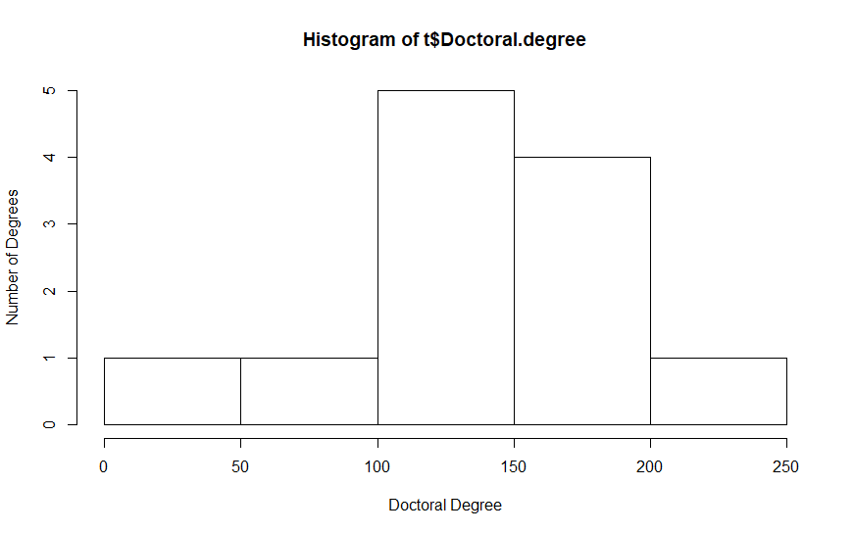

Barplot:

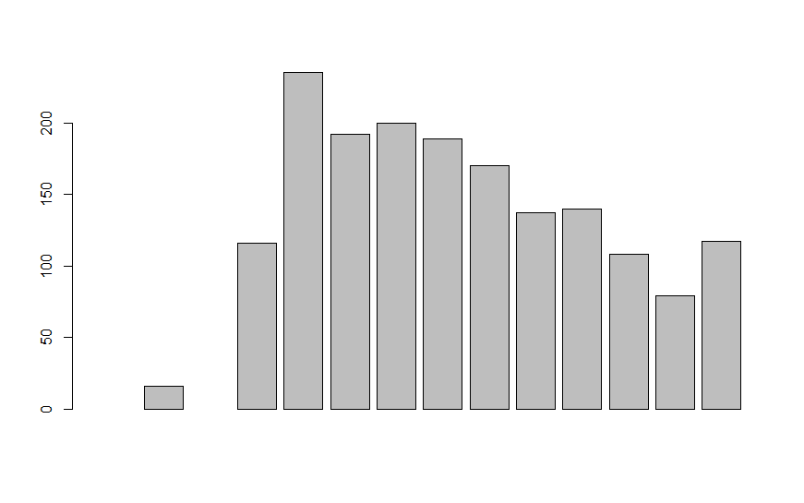

Boxplot:

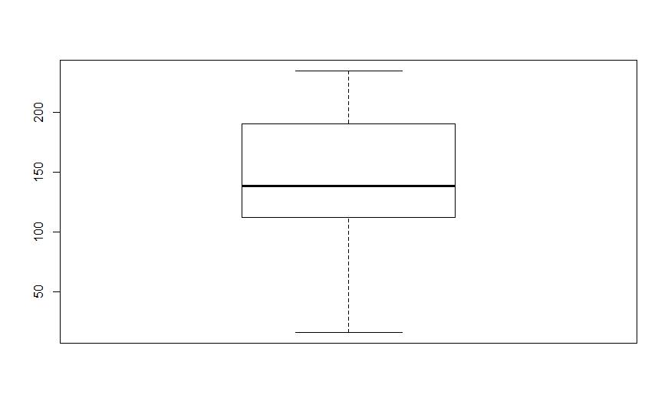

**What to turn in**

* Publish your homework to GitHub under your user account, the appropriate format (check syllabus for instructions). This means turn in a separate document from your code that answers the questions above.
* Upload the code you used to GitHub.
* Provide me the links of these two files via e-mail no later than Thursday, September 20th at 6:00pm.